

Exploring the Impact of Criminality on Recognition-Induced Forgetting for faces.
1701737
Dissertation in Psychology
April 2020
University of Wales Trinity St David

Dissertation submitted in partial fulfilment of the requirements for the degree of: Bachelor of Science (hons) in Psychology

DECLARATION

This work has not previously been accepted in substance for any degrees and is not being concurrently submitted in candidature for any degrees.

Signed ...S L JOHNSON……………. (candidate)
Date …21/04/2020……….

STATEMENT 1:
This dissertation is being submitted in partial fulfilment of the requirements for the degree of BSc Psychology (Hons)
Signed …S L JOHNSON…………. (candidate)
Date …18/03/2020……….
STATEMENT 2:
This dissertation is the result of my own independent work/investigation, except where otherwise stated. Other sources are acknowledged by giving explicit references. A reference list is appended.

Signed …S L JOHNSON…………. (candidate)
Date …18/03/2020……….
STATEMENT 3:
I hereby give consent for my dissertation, if accepted, to be available for photocopying and for inter-library loan, and for the title and summary to be made available to outside organisations.

Signed …S L JOHNSON…….…. (candidate)
Date …18/03/2020.…….

Acknowledgements
As the last three years come to a close, and somewhat more importantly the last seven months, it is only right to acknowledge all the individuals who have helped and supported me during the most crucial time in my career thus far. I would firstly like to thank the Psychology team at University of Wales Trinity Saint David, who have greatly influenced not only my knowledge through the various modules but also my confidence in myself through all the assignments and exams, throughout my time at University.
To my supervisor and personal tutor, Dr Kate Williams, I would personally like to say a huge thank you for pushing me throughout my dissertation to produce the best work I possibly can. Through the many rewrite’s and the never-ending creation of Super lab! I feel I have had the best and most attentive support system within Kate, who as I said was not only my supervisor but my personal tutor too.
I must also acknowledge all the students who took the time to participate in my study, as without them I would not have anything to discuss! I understand that they often came in on their days off to take part in third year studies, whether it be because they needed to gain credits or because they simply wanted to help out and take part. I am equally extremely grateful for their time.
Lastly, I would like to thank my friends and peers in University who have shared this experience with me and have been a great class to work alongside the last three years. I would specifically like to acknowledge my class peer and close friend Lauren Williams, who without I would have been at a loss! We have cried, laughed and been extremely stressed together, but most importantly we have been each other’s biggest supporters through the times where we may have even doubted ourselves.

Table of contents
Declaration…………………………………………………………………………………2
Acknowledgements………………………………………………………………………..3
Abstract…………………………………………………………………………………….6
Chapter 1 - Literature Review……………………………………………………………..7-13
Chapter 2 - Methods..……………………………………………………………………14-20
2.1 - Participants...………………………………………………………………14
2.2 - Design……………………………………………………………………...15
2.3 - Materials…………………………………………………………………..15-17
2.4 - Procedure………………………………………………………………….17-20
Chapter 3 - Results……………………………………………………………………….21-24
Table 1 - Table of descriptive statistic results from the one-way ANOVA…….22
Table 2 – Table to show results from pairwise comparisons test……………….23

Chapter 4 - Discussion…………………………………………………………………….25-34
References…………………………………………………………………………………35
Appendix A - Consent form………………………………………………………………36
Appendix B - Debrief form………………………………………………………………37-38
Appendix C - Super Lab output……………….………………………………………….39
Appendix D – Images of faces used in Super lab…………………………………………40-41
Appendix E – Ethics Form……………………………………………………………42-59
Appendix F – Proposal Form…………………………………………………............60-63
Appendix G – SPSS output……………………………………………………………64

Abstract
Extensive research on Retrieval-induced forgetting already exists. However, less is known about Recognition-induced forgetting (RIF) and how it links to memory for faces, especially those associated with certain characteristics or labels. The objectives of this study were to explore whether RIF would emerge for faces, and specifically whether levels of RIF would differ depending on whether faces were associated with a criminal conviction or not. The specific hypothesis was that the faces presented with a criminality label would be susceptible to more RIF than others not criminally labelled. The study involved a within-subjects, experimental design. The independent variable was the RIF condition with four levels, Rp+ (practiced items), NRP (baseline items to measure RIF), and two Rp- items (non-practiced items from the practiced categories of criminality and occupation). A total of 40 undergraduate psychology students at UWTSD took part (age range 18-57, m= 27.87, sd= 0.05). The results from a one-way analysis of variance (ANOVA) revealed a significant main effect. Pairwise comparisons revealed practiced images were remembered significantly better than the other Rp categories (showing a facilitation effect). The Rp- Criminal and Rp- Occupation categories were remembered less than the NRP items, this was significant. Finally, there was no significant difference in levels of RIF between the two Rp- categories themselves. Overall, implications for these findings suggest that RIF does somewhat occur for faces, but levels are not any greater for those associated with an emotionally arousing label (criminality).

Chapter 1: Literature Review
There are many connotations and preconceived conceptions within today’s society regarding those who have a criminal conviction. Viukari, Rimón, and Söderholm (1979) investigated staff and nurses’ attitudes towards mentally ill/ abnormal criminal offenders as shown during drug trials. The employed staff’s opinions were 79% negative towards the drug treatment, as they felt the drugs would not help the offenders with mental health conditions. 21 general physicians also took part in a self-rating scale, supplying a 10cm line technique, both the drug treatment and the self-rating scale assessment were least favoured when compared to other somatic illnesses. This evidence supports much of societal norms today, whereby the average individual is ignorant towards most kinds of criminal offenders, especially when deemed they have mental health issues too. It’s important to consider the possible implications these opinions of criminal offenders can have on Eyewitness testimony, or general remembrance of criminal faces (during tasks). This is because if an individual’s opinion toward an offender (prior) is likely to be negative, this may affect the recall process in terms of stereotypes. This would essentially have a knock-on effect with convicting the correct offender of a crime, which is a serious task and should not be taken lightly.
Previous studies have shown stereotypical black features are often associated with crime/violence, so a study by Kleider, Cavrak and Knuycky (2012) aimed to find out whether there was a bias toward the categories of remembering/ recategorizing faces as criminals, based on certain stereotypes. Kleider et al. (2012) tested whether these two categories were driven by an individual’s facial features and their linked stereotype category (black faces are associated with crime, for example). The results depicted how stereotypical faces were either; more often linked with the stereotype (consistent) label, remembered correctly and recalled as criminals, or when memory failed the individual the subjects were still miscategorised as criminals. These results meaning that in any scenario, the stereotypical labels and facial features which are linked together, are often always recalled as the answer. The most important aspect of the results was that these effects occurred regardless of race and gender, even though the initial interest of the study was behind the race aspect. This therefore leads into the notion of criminal labels being emotive and leading to a person correctly/incorrectly being identified as a criminal in any scenario, if the individual detects an aspect associated with criminality. It’s important to understand how being associated with a criminal conviction can influence memory for faces. With regards to other faces which aren’t associated with a crime, will they be remembered even less due to the facilitation for criminally labelled faces?
Long term memory is widely researched and is thought to be enhanced when emotion is involved, either impairing or restoring memory (Fernández-Rey and Redondo, 2007). Their study premise was built around how words or pictures are more likely to be remembered when having a negative or even positive connotation, as opposed to a neutral one. 108 international affective picture system pictures were used to represent the valence and arousal dimensions of emotion. The results showed greater discrimination with regards to response bias, so responses were moderate for pleasant and unarousing images compared to unpleasant/ arousing images. This supports the initial thought that a harsher criminal label will evoke a more prominent response in an individual being tested or asked to recall within a trial (due to the emotive aspect). This emotion-induced recognition bias in long term memory has been an important foundation of work to build on, leading onto the present research study.
Another method to examine the mechanisms of long-term memory comes from the ‘Retrieval induced forgetting’ or RIF paradigm, which is where remembering certain information can cause the forgetting of other information within long term memory. Anderson, Bjork and Bjork (1994) explored how the memory recall process can impair the long-term retention of related representations. The premise of this was that items within memory that are seen to have the same cue (with regards to retrieval) are possibly more likely to be forgotten due to the strength of some of the newer and more memorable items. In other words, the cue may be similar or the same with regards to certain objects, but the retrieval process pull is stronger towards one, meaning the other is seen to be vulnerable to being forgotten. The Rp+ items (practiced) will be remembered more readily, even when compared to non-practiced items from the practiced category (Rp-) and items from non-practiced categories (NRP) are even more susceptible to forgetting, according to this theory. When relating this premise back to the remembrance for criminal faces, the ‘pull’ towards a more intense or ‘shocking’ image will likely make for the other (possibly semantically similar) images with no criminal label vulnerable to forgetting.
Further research was carried out following the work of Anderson et al. (1994). Given the nature of stimuli under investigation (i.e., pictures of faces) a method to examine RIF would need to be established within a recognition paradigm instead. Hicks and Starns (2004) were one of the first to establish the recognition-induced forgetting (RIF) paradigm, where their results saw the non-practised items from semantically similar categories were remembered less. This result is due to the objects not being strictly the same but having a similar cue, causing the non-practised items to be forgotten. This is due to the practised items inhibiting any other memory recall. The result from this study ultimately links into the previous by Anderson et al. (1994) as the ‘pull’ towards an item which otherwise has the same cue, can cause an item to be remembered more so. Hick’s and Starns (2004) depicted how non-practiced items from semantically similar categories also led to less memory recall, so in theory, the cue will be the same but the strength of the ‘pull’ towards remembering an item or object is dependent on practice. The counter argument to this inhibitory theory, is the non-inhibitory theory (Verde, 2011). Verde acknowledges the work put forward previously by the Anderson et al. (1994) that retrieving the practised Rp+ items during the practice phase causes the forgetting or ‘burial’ of the Rp- items, which are unpractised but are in the same category. However, Verde argued that the reasons and implications behind cue independence are far more complicated than initially expected. He refers to one other theory that suggests the success of recognition is reliant on two processes: familiarity and recollection. This theory being the dual-process theory (Yonelinas, 2002). Familiarity is said to be a fast-paced process which occurs when an item is remembered due to it being context free, a simple memory. Recollection, however, is a slower process and requires context and episodic details in order to be recalled. These theories propose opposing views as to why the Rp- items are forgotten, whether that be we remember specific items because the cue is stronger and overshadows other items with a similar cue. Or on the other hand, whether the familiarity with a certain item is what makes it easy to remember, not that it supresses any other in particular. The interesting point to note is that these studies and research areas have all been surrounding the idea of similar category items being practiced, or not practiced, to see what the outcome is. These studies hadn’t considered how well human faces would be remembered.
Rugo, Tamler, Woodman and Maxcey. (2017) acknowledged the previous work with recognition-induced forgetting, that recognising an object induces the forgetting of other semantically similar objects (from the same category). However, they delve into the consideration that faces may not be susceptible to this recognition-induced forgetting (RIF) effect due to faces being areas of expertise for us as humans. The idea behind this was that as we see faces every day, we are well versed in their various features: skin tones, face shape etc. So, faces with different features or ethnicity will belong in the same category (humans) but the theory is they will all be remembered to the same extent as they are well practiced ‘items’. This is the opposite to the previous research carried out on object recognition-induced forgetting, which has shown individuals struggle with remembering items from the same category even though they may look semantically similar. A more recent paper has examined whether the RIF effect will not occur for objects that are grouped together temporarily, unless they are semantically similar (Maxcey, Glenn and Stansberry, 2018). This study investigated whether temporarily grouped objects suffer recognition induced forgetting, so (across four experiments) they modified the RIF paradigm so that objects were temporarily clustered at the study. The results supported their hypothesis, stating that RIF only occurred when the temporarily clustered objects were in fact semantically similar. This research suggests the objects being shown will be more susceptible to being forgotten when they are similar in stature. This supports the previous work by Anderson et al. (1994) but rejects the work by Rugo et al. (2017) with regards to their theory of faces being more susceptible to RIF. The fact that practicing an object can lead to forgetting of related memories would suggest why we may forget semantically similar objects, and not possibly remember unrelated objects more. The theory suggests the more we practice the more likely we are to forget various linked objects. However, it could be said that the semantically similar aspect of these research articles may only be able to be applied to objects, as opposed to faces. The difference between faces and objects is very difficult to apply directly, however the principles are interesting to consider. This is another reason as to why research with faces relating to the RIF paradigm must be delved into more so.
Research by Fitzgerald, Price and Oriet. (2013) examined whether we can intentionally forget a specific race when viewing images of faces. This type of research is primarily used in relation to eyewitness testimony research, however it also links into this topic area surrounding the theory of RIF. The directed-forgetting procedure suggested that when certain information is encouraged or ‘cued’ to be forgotten to an individual, the remembrance of other information should therefore be enhanced. To a degree this is what the current research will be exploring, as the RIF study is set up in such a way to also encourage certain aspects of the study to be forgotten, meaning these two share a common similarity with forgetting ‘cues’ being present in some form. Their study was set up across three experiments so that ‘directed forgetting’ conditions could be compared to control conditions. This was to evaluate potential negatives or positives of forgetting other race faces. The results of Fitzgerald et al. (2013) research depicted how faces can be forgotten on cue, but the shear act of forgetting some faces did not necessarily lead to remembrance of other faces (as suggested at the beginning of the paper). This was interesting as the hypothesis in Fitzgerald et als. (2013) study was not supported with the forgetting of faces not leading to the remembering of others, therefore could the same principal be applied to the RIF theory? Could the remembering of some faces (practiced Rp+) not necessarily lead to forgetting of others? In order to uncover this (and to contrast to previous studies), the current study will be applying this knowledge to see if the same outcome occurs. By applying the field of criminality to the study, we can hopefully establish whether the criminality labels (with relation to remembrance) will compare to the likes of the previous literature and how often (or not) images of faces/objects had been forgotten.
Based on previous research, the current study should expect to find facilitation effects for the Rp+ category (practiced images). However, as the criminality variable is emotive, the question remains as to whether this will result in competition in the RIF paradigm (all Rp- images of faces remembered less) or alternatively will the Rp- criminal faces receive facilitation and be better remembered. The ‘dangerous’ aspect associated with criminal labels, may either make it harder to remember the faces or easier (so less RIF). Essentially, the objective of this research is to make use of a modified version of the RIF paradigm to obtain and analyse results to establish whether there is greater RIF for the ‘criminally convicted’ faces compared to other ‘non-criminally convicted’ faces (due to the emotional strength of the label associated with them), causing greater suppression of those faces during the RIF task. The emotionality associated with the face may make them stand out and enhance memory for them (leading to no or little RIF). Finally, it may be the case that the faces shown are not susceptible to the RIF effect, in which case all categories of faces would be remembered to a similar degree or in full remembrance (as suggested by Rugo et al., 2017). The main focus of criminality for this study and what the outcome will be can ultimately allow further insight into the usefulness of eyewitness testimony in society today.

Chapter 2: Methods
2.1: Participants
The participant group for this study included 40 students from the SA1 university campus, who would be studying one of the Psychology degree programmes at the University of Wales Trinity Saint David. The participants were recruited through the Psychology Department’s Experiment Management System (EMS) where participants received one credit in exchange for participation. Students could sign up to the study using their own unique code, at their own convenience, when the study was made live via the EMS. There were various dates and timeslots made available for the students to sign up to, some being across various days in the week and some slots being available across one day nine till five, depending what the availability was in the dedicated lab of the researcher. Most of the sample were expected to be either completing their undergraduate or post graduate degrees and would all be over the age of eighteen. There were no specific inclusion or exclusion criteria, however participants were warned through the EMS summary of the study about the nature of it involving aspects related to criminality. Both males and females took part, although this data was not imperative to the study results, their age’s and gender were recorded for the latter thirty participants as the researcher realised after the first ten that this would add further depth to the descriptive statistics within the study. The thirty participants whose descriptive statistics were recorded consisted of 10 males (33.3%) and 20 females (66.7%). The ages for those participants recorded ranged from 18-57 (m= 27.87, sd= 0.05). The reasoning for the larger number of females taking part may be due to the majority of the Psychology degree/ counselling courses consisting of females, or it may be down to pure coincidence that females signed up to this study more so.

2.2: Design
The design of this study was a within-subjects, experimental design, meaning all participants took part in all conditions in the study and as there is a form of manipulation in the experiment within a lab setting, its classed as experimental. Each participant saw the same 80 pictures of faces included in the study phase, practice phase and the test phase. The independent variable for this study was the Recognition induced forgetting for faces, analysed across four levels. These levels being Rp+ (practiced faces), Rp- Criminality and Rp- Occupation (Non-practiced faces from practiced categories) and NRP (Non-practiced categories). The dependent variable was the Recognition accuracy for each Rp category of faces in the test phase, with the data being primary in nature and quantitative, as new data was being collected. The quantitative element comes from each participant having a numerical score of the total number of faces they correctly recalled from the test phase that falls into each of the Rp conditions. The data once collected, was analysed with a programme called ‘SPSS’, using a one-way ANOVA (analysis of variance) of the independent variable across the four levels (Rp+, Rp- Criminality, Rp- Occupation and NRP) to check for any patterns and then comparing this to the previous hypothesis set out. Once the results from the ANOVA had been obtained, if they were significant, a follow up Bonferroni corrections test will have to be carried out to examine potential differences. This is due to the independent variable having four levels, and therefore not knowing where the significance of the results lies.
2.3: Materials
The first material in this study that the participants came into contact with was the consent form (Appendix A), which needed to be read thoroughly and signed to show they consented to taking part. The study itself included eighty images in total, these were sourced from the university lab computer file database ‘Feret1’ and ‘Feret2’ from NIST (https://www.nist.gov/itl/products-and-services/color-feret-database). The images chosen (Appendix D) were all in colour and only showed the neck upwards of the individual, with only white males being chosen (for less confounding variables with a standardised viewing). The images were also ensured to not have any distinguishing features which would allow them to stand out and be remembered more readily (glasses, facial hair, jewellery etc). These images were then stored in separate folders depicting each phase (study, practice and test), for easy access and convenience, The study phase folder included four separate files for the original criminal, occupation, hobby and colour labelled images (ten images in each category). These categories were chosen based off my own interest in criminality and how this label would affect the remembrance of the accompanied images, the occupation category was chosen as a comparative (to see what participants deem more important to remember). The colour and hobby categories were included to build the study and give the participant various images and labels to view. The practice phase folder had two separate files for the five criminal and five occupation labelled images of faces, which were to be rehearsed. Finally, the test phase folder included two separate files for all forty old images (already seen, but this time unlabelled) and the forty new images (not previously seen and not labelled).
The images which were accompanied with a label (Appendix D), prior to being saved into the designated file, had to have the label placed underneath the image (so that it was in the same place for each photo, and the same font size/style). This was achieved through copying the image into Microsoft word and scaling it to an appropriate size and then placing the designated label underneath. This then had to be print screened and copied into paint, this was in order to save the file image as a JPEG and use within the super lab programme (Appendix C) for the creation of the study. This meant the image and label were joined and could be transported into the programme as one file (JPEG image), as within Super lab it is not an option to import an image and a text portion to one event/trial. The images were all kept to the same size using word scaling (8.9cm by 12.7cm), the font style was also kept the same (Arial) and the size for each word label was 72, to be clear and prominent when being viewed.
The study itself was created using a computer programme called Super Lab (Appendix C), which throughout the study, displayed the eighty original images of faces (Appendix D). These were the labelled images from the four categories: criminal, hobbies, colour and occupation. Midway through the study, the participants were required to complete a distracter task involving a one-thousand-piece jigsaw puzzle, which displayed an image of Disney characters. A stopwatch on a mobile phone was used to time this task for two minutes. The results obtained from the participants data were analysed through a programme called ‘SPSS’ (Appendix G) using an analysis of variance (ANOVA) across the four levels of interest (Rp+, Rp- Criminality, Rp- Occupation and NRP). During the data collection period of the study, a password encrypted USB stick was also used for safe keeping of the results. Finally, following completion of the study, the participants were given a debrief form (Appendix B) to keep. This detailed the aims and details of the task they had just completed, including emails for myself and supervisor should there be any queries after they had left the study that day.
2.4: Procedure
The participants were recruited through the psychology departments internal study system (EMS). This is whereby psychology students can log into their respective accounts and sign up to various studies which are made available, alongside various time slots. Each individual possesses their own unique code when accessing EMS and signing up to studies, so anonymity is provided from the start. Each study has a brief overview/ description of what task it will require the participant to carry out. Prior to the actual start of data collection, the study was piloted using some of the students in the same class as the researcher, to trial it before it went live with the timeslots on EMS. This was to find any errors or issues with the running of the study and to find out how long the study would take. There were no issues raised by participants, but the researcher noticed that Super Lab tended to go to a blank screen at the start of some run throughs. To prevent this happening with the live data collection, a run through of the study was conducted once before each participant arrived. The study itself was carried out in the Psychology Labs, on a computer which supplied the Super Lab programme (Appendix C). In accordance with the BPS, consent and debrief forms were provided (Appendix A and B). The necessary conditions, such as a quiet environment, were ensured by the researchers by storing their bags in a separate room and not conversing in the halls outside the lab rooms. Instead, researchers would wait within a designated room for them, and check on their participant every few minutes. Consideration regarding the length of time the study would take to complete comfortably came from the pilot study (fifteen minutes) this time frame was used when making the time slots for participants to sign up to. This was so every individual had their appropriate amount of time to complete the study, and so the researcher had time to reset the lab for the next participant.
Upon arrival, participants were greeted and handed a consent form (Appendix A) to read thoroughly and were told to sign at the bottom if they were still comfortable to continue with the study. After completing this, the participants were briefly told again what they would have to do (view images of faces) and told to follow first set of instructions that appeared on the screen. They were also told to call the researcher upon reaching the point of the jigsaw (so they could be timed) During the study phase 40 randomised images of faces were presented, individually in the centre of the screen, for three seconds each. There was also a one second fixation cross presented between each image to re-focus the individual’s attention. Each face presented in the study phase was provided with a label which fell into one of the following categories Hobbies, Occupation, Criminal conviction or Colour, and there were ten faces in each category (forty in total). An example of a label from each category would be Arson, Teacher, Reading, and Red. The practice phase occurred following the study phase, which involved the participant viewing five faces (out of the original ten) from the categories of criminal conviction and occupation. Faces were again shown individually, in the centre of the screen, for three seconds each. The same fixation cross separated each displayed image, and each face was shown three times (randomly) to practice. Once the practice phase was complete, instructions appeared on the screen to state that was the end of that phase, and to inform the researcher of this. The researcher would then provide the participants with the jigsaw distractor task and then time the participant completing as much of the jigsaw as possible within a two-minute period. Following this, the participant would move onto the test phase, with the instructions displayed on the computer screen as to what the next phase included. They were told to press the respective keys if they had seen the image before (Q) or even if they had not (P). The Test phase was the final part of the study, whereby the 40 images which had already been seen (in the study and practice phase) were shown again, alongside 40 new images which had not been viewed already. These images of faces were presented randomly and individually, in the centre of the screen, for three seconds each (separated by a fixation cross as before). The difference in the test phase is there were no descriptions presented alongside any of the images, this was to test the participants ability on the face itself. The participant would only be able to move on to the next image after they have pressed either the ‘Q’ key if they have seen the face before or alternatively ‘P’ if they had not seen the face before. These response options would be counterbalanced.
Upon all 80 images having been presented in the test phase, instructions were displayed on the computer screen to state that the study was complete and to inform the researcher that this was the case. The participant was then handed a debrief form which explained the premise/aims of the study and what the researcher was looking or hoping to find out. They were told to email the researcher or supervisor should there be any follow up queries, with the emails provided at the bottom of the debrief form. They were asked immediately after this (before they left the labs) if they had any questions right away to ask and also reassured, they were anonymised from the start. The participant was also asked how they found the study, and if they found it difficult, enjoyable or easy etc. If they did not have any questions and were happy with how the study went they were thanked for taking part and escorted out of the labs. It is vital for any researcher to ensure each of their participant’s leave their study in the same state of mind they entered with. This ensures protection from harm and allows for a successfully upheld ethical study. Although this study was not particularly graphic, due to the nature of some of the criminal labels it was important to check the participant’s felt happy when leaving. Another aspect to consider was the drive and pressure many individuals feel to be successful when completing tasks, especially when they know their peers may have completed the same study and may report feeling confident in their results (even though they will not be told them). So, for this reason, the researcher made sure to make it clear the results of the (impossible) 1000 piece jigsaw distractor task to be completed in two minutes was not to be recorded and their results from the study as a whole would not be able to be traced back to them.

Chapter 3: Results
This section will depict the total score of correct ‘yes’ answers from the participant’s during the test phase of the study, where they viewed images and were tested on whether they had seen them before. Once the data had been collected, it needed to be ‘cleaned’ in preparation for inputting into the programme SPSS, this was arguably the longest process throughout the treatment of the data. This involved copying the results (in full) into the Microsoft programme ‘Excel’, whereby these were stored in one sheet and a second sheet was made for the test phase results to copied into. The second sheet of test phase results needed to then be condensed further, and so the ‘new’ image results and ‘fixation cross’ points were deleted from the data sheet, this only leaving the ‘old’ image data results. These were essentially the only data results the researcher was concerned with, as the participant had seen the old images before and so this is what they were being tested on, so their response to whether they believed they had seen them before was the only data that needed to be analysed.
With this fully cleaned data it was then necessary to make the data ‘simpler’ for SPSS to recognise it when running the analysis. The ‘cleaned’ results were copied into a third and final sheet, in order for a pivot table to be made. This meant that a break down of all the scores were shown clearly, as to how many times the individual clicked ‘yes’ and ‘no’ for each Rp category. This pivot table was then able to be used to transfer the data results into percentages, as SPSS would recognise these readily as opposed to a ‘yes’ or ‘no’ response. This is where the final data laid, whereby the yes response data columns (for each Rp category) were transferred into SPSS, where the one-way analysis of variance (ANOVA) was conducted.

Table 1: Table of descriptive statistic results
 | Mean total of: Percentages of ‘correct’ responses | SD
NRP | 48.63 | 21.303
RP+ | 85.50 | 13.765
Rp- Criminal | 44.00 | 27.624
Rp- Occupation | 40.50 | 22.865

The table above shows the Mean and Standard deviation for each correct response of the Rp categories in the study. NRP being the non-practiced images of faces, Rp+ being the practiced images of faces (five criminal and five occupational) and the Rp- are the non-practiced images from the practiced categories (again, five criminal and five occupational). The NRP category acts as a baseline (hobbies and colour) on which to measure levels of facilitation for the Rp+ items and for measuring the levels of RIF for the Rp- images of faces. The NRP category is arguably the most important category as without this there would be no baseline to measure facilitation of RIF against, which is necessary for definitive results.
A one-way within subject’s analysis of variance (ANOVA) was carried out through the programme SPSS to see if Recognition induced forgetting occurred for faces and if there would be a difference between those criminal faces to those non-convicted faces shown. There was a statistically significant result with F(3,117) = 58.86, p < .0005 suggesting RIF does occur for faces as a whole, and more specifically for those images not practiced, with the greatest RIF occurring for the occupational category. This contradicts the likes of Rugo et al. (2017) who stated faces would not be susceptible to the RIF effect at all.
In order to establish or definitively state exactly where the significance in the results was, pairwise comparisons were conducted (also through SPSS) between each of the four Rp conditions using a Bonferroni style analysis. This was to see whether there was a significant difference specifically between the NRP & Rp+ categories (to show facilitation of practised items), between the NRP and Rp-Criminal and Rp – occupation categories (to show a RIF effect), or the Rp+ and the Rp- Criminal and Occupation. The final comparison was to see if there was a difference between the Rp- criminal & Rp- Occupation categories, to see if one received more RIF than the other.
 | Sig. values
NRP (1)  2  3  4 | .000  1.000  .139
Rp+ (2)  1  3  4 | .000  .000  .000
Rp- Criminal (3)  1  2  4 | 1.000  .000  1.000
Rp- Occupation (4)  1  2  3 | .139  .000  1.000

Table 2: Table of Pairwise comparison results

The table above shows the pairwise comparisons conducted on each of the Rp categories in order to distinguish where the significant difference was within the results. The Rp+ or ‘practiced images’ were remembered far more readily (as anticipated) than the other Rp categories and showed great facilitation against the NRP category (significant at p < .0005). Whereas the Rp- Criminal and Rp- Occupation categories when compared to the NRP baseline showed more RIF than the NRP images (so Rp- categories remembered less), which is interesting and significant. The Rp+ category compared to the Rp- categories showed a significant result, with p < .0005 for both Rp- Criminal and Rp- Occupation. The final difference to consider was between the Rp- categories themselves, which showed no significant difference in levels of RIF. It was suspected that the Rp- criminality would show more RIF than Rp- occupation due to the harsh nature of the label, and this was not the case. Overall, implications for these findings suggest that RIF does somewhat occur for faces, but levels are not any greater for those associated with an emotionally arousing label (criminality).

Chapter 4: Discussion
This study aimed to explore the phenomenon of ‘Recognition induced forgetting’ or RIF and examine whether it emerges for human faces. The more specific interest was to find out whether there was greater RIF for faces associated with a criminal conviction compared to other faces which were not associated with a criminal conviction. The idea was that the strength of emotion associated with the criminally labelled faces could either lead to suppression/forgetting of those faces or they would stand out due to the nature of the label and be remembered more readily (i.e., receive facilitation). Previous studies had used this paradigm with relation to objects but not with faces (Anderson et al., 1994). It is important to highlight this as the research with RIF and images of items may be rather different when compared to new research regarding images of faces.
The first key finding within this research was that the Rp+ or practiced faces showed a facilitation effect when compared to the NRP (non-practiced) baseline category of faces. This result echoes the Recognition induced forgetting notion put forward by Hicks and Starns (2004) whereby the pull towards remembering an item will be dependent on the practice of it. The cue for two semantically similar images may be the same due to label or face details, but the practice allows the pull for that image to be remembered more readily, causing the alternative to be remembered far less. This finding also supports the work of Anderson et al. (1994), although this work examined Retrieval induced forgetting, the premise of non-practiced items from semantically similar categories, being forgotten more, was still apparent. Therefore, this first key finding supports these two papers perfectly. It is important and interesting to have findings from this study to support studies which have ten years difference between them and were up to 26 years ago from the eldest study to this one today. This shows the level to which humans have not altered in certain aspects, whereby the mere practice and repetition allows for memory success. It has been a known notion that practice ‘makes perfect’, however, within this study it was uncertain whether the facilitation effect for practiced faces would still emerge due to the addition of the criminal aspect.
In addition to this finding, it was evident to notice the Rp- categories (non-practiced images of faces from practiced categories) were recalled noticeably less when compared against the Rp+ category and more importantly to the NRP baseline category, thereby supporting the Recognition-induced forgetting effect. This evidence also supports Hicks and Starns (2004) who stated these non-practiced images from practiced categories are remembered far less due to the pull being stronger towards the practiced images. This means the individual must decide which to remember as both may have a similar cue, having seen certain images more than others (practice) the features and detail of the images are easier to remember upon seeing them again in the test phase of the study. Although these results resonate with each other, it must be recognised that these studies were performed with different subjects of interest. The prior studies had involved objects or images of objects but not images of faces. This makes this study specialised and different in that aspect, and further extends the RIF finding to other stimuli categories beyond that of objects.
Rugo et al. (2017) acknowledged previous research to examine the RIF effect, however stated that faces would not be susceptible to the RIF effect at all due to the advantage we possess with seeing faces on a daily basis. The current study results did not provide support for this theory, as there was clear RIF occurring with non-practiced images. This goes to show we are not necessarily ‘experts’ when viewing faces, as Rugo et al. (2017) suggested. When considering this theory though, it could be said that because we are ‘experts’ with human faces, that would make them more susceptible to the RIF effect due to the strength of competition they enforce. Even though we pass faces and communicate with them daily, it is clear the remembrance requires full attention and interaction/ practice with a certain image, person or even object in order to remember them readily (and for the subsequent RIF effect to occur). This is an important bit of information to consider, within branches of life involving eye-witness testimony. If the witness does not have full attention on the criminal looking for identifying features, but rather is avoiding eye contact out of fear, this could result in suppression of actual features of the individual in question and therefore be detrimental to the success of the investigation. This could open up a potential confound in the investigation. Whereby when witnesses are asked to view images of suspects or to look through a physical line up, the act of seeing other images of faces/ other suspects in the line-up while discussing with the police can cause RIF for the real criminal.
When considering the work of Maxcey et al. (2018) this theory suggested RIF only occurred for temporarily clustered objects which were semantically similar. Therefore, this study does support the official outcome of the study within the sense of semantically similar objects but also did not with reference to the gathering of objects. As within this study, the differences were apparent with faces not objects being explored and also the faces were shown individually to really test the ability on one face alone, each with a different label. Although all images were semantically similar in race, gender etc this difference in clustering and use of objects cannot allow for the result of this study to fully support or echo the result of Maxcey et al. (2018). Moreover, with regards to Fitzgerald et al. (2013), whereby the forgetting of faces did not lead to the remembrance of others, this RIF study showed that the remembering of certain images of faces (Rp+) did in fact lead to the forgetting of others. Therefore, the reversed alternative to Fitzgerald’s theory is essentially the result of this study. What Fitzgerald et al. (2013) proposed is still interesting for insight but does not support the result to the researcher’s study today.
A further paper to consider when analysing the outcome for this study is one by Reppa, Williams, Worth, Greville & Saunders, J. (2017). This study found object memorability (typicality) influenced RIF with significant amounts of forgetting occurring for the memorable (or non-typical), but not non-memorable (typical), objects. So similarly, this study could have shown more RIF for the Rp- Criminal faces as they were more memorable and therefore creating greater levels of competition, possibly due to the particularly shocking nature of the label.
When considering the NRP baseline, of non-practiced images, this was what the researcher was using as the initial level of remembrance for all who participated. This level was considerably lower than the practiced items, as previously expected at the start of the literature review for this study. When considering the comparison of the NRP baseline to the non-practiced items, its apparent to see memory recall was worse for both faces associated with a criminal conviction and those with an occupation label. This suggests non practiced images of faces are remembered more readily than semantically similar (category wise) images of faces which were also not practiced, but which were from a practiced category. This is extremely interesting, as images that were not practiced at all (seen once until the test phase) were remembered more readily than those images that had an emotionally arousing or everyday label but came from practiced categories. This supports the RIF notion further as semantically similar objects, or faces in this case, are rejected more so due to the practice aspect of the same category.
Comparing the Rp+ items to the Rp- criminal and occupation items there was even more of a difference in RIF occurring, again, based on the literature reviewed articles and theories. By practicing some images from this category, it allows for the remembrance of those but not for the latter images of the same category as easily. Individuals found not practicing a category easier to recall in the test phase as there was no competition making certain images stand out, allowing for no second guessing. Within the categories of criminal conviction and occupation, the practiced five out of the ten images were recalled well, but the latter five images were recalled even less than faces from a non-practiced category.
However, the most interesting point from the evidence found, after the difference in Rp+ compared to Rp- categories, was the difference in level of recall between the Rp- categories. Although these categories were recalled drastically less than the Rp+ and NRP face categories, the Rp- criminal category faces were recalled more readily than the Rp- occupation faces, suggesting that between these types of images there is less RIF for criminal labels and more RIF for occupation labels. This could be due to further suppression occurring during the practicing phase, for occupation, as this category in comparison to crime was not as important to remember. Therefore, the criminal aspect is showing to be more prominent, and not as susceptible to the RIF effect, even if it is by a few percent.
This evidence is very interesting as it sets out to firmly answer the initial research question that yes, faces associated with a criminal conviction are susceptible to the RIF effect. When comparing the Rp- Criminal category to the Rp+ practiced images and the NRP baseline, there is a significant difference. One of the original hypotheses set out was that there would be a difference in memory for the convicted images of faces compared to non-convicted, being that criminal images may not be susceptible to the RIF affect like others may be. The evidence shows there was a difference, although slight, between remembrance showing more RIF for the occupation or ‘non-convicted category’. As the evidence swayed towards there being RIF for faces, the hypotheses suggesting criminally convicted faces would not be susceptible to RIF was rejected in this case. This is essentially new evidence for this field of RIF, as Rugo suggested there would be no RIF at all for faces, which this study does not support. Furthermore, the evidence surrounding EWT and the severity of criminal acts allowing for the faces to be remembered more readily was not the case when compared against the practiced images. However, this was the result when solely compared against occupation, further research may find alternative results with other categories remembered more or less than criminality.
The methodological implications of these findings could mean a different stance needing to be taken regarding EWT, whether witness’ describing the criminal will even be considered a priority in criminal investigations when there may be stronger DNA evidence found. This can be considered as during this study, the results found more RIF for the criminal category compared to the practiced images, so in the real world these results could mean a failure to recognise the suspect at fault. The reason this research does not support some past research (Rugo et al., 2017) could be due to a number of causations, the particular participants who took part may not have behaved the same as a further 40 participants who took part. This study initially was set out to have 80 participants, and yet due certain unforeseen issues such as timing or lack of sign-ups to participate possibly, the researcher only had 40 participants to take part and analyse their results. Although still a large enough sample to generate results for a within subject’s design, this study would have been even more reliable or robustness in the outcome of the study, having had the 80 participants. Another key consideration would be that the stimuli for this study was specifically comprised of all white males, this could ultimately affect the differences in RIF levels that may emerge for the Rp- Criminal convicted category. If the study was repeated with females or other ethnic groups, or a mixture of both alongside the males, this could impact the level to which the Rp- criminal category would be remembered. This ultimately depends upon the individual’s personal discriminative preferences, as to what they hold as a criminal and whether this will allow them to remember the picture more readily or not.
If this study were to be repeated, there would be far better timing considerations with regards to initially starting data collection as soon as possible, not just assuming there is plenty of time, this would essentially create a bigger sample to study. If there had been a greater data collection, there would be room for error whether it be during Super lab or data saving. There was one issue the researcher came across whereby Super lab did not always run through smoothly and save data as it should, but instead would often cut straight to the end of the study half-way through practising images. This issue did only happen a handful of times and was possibly a teething problem at the beginning, but nonetheless this allowed for around five participants data to either be lost or not recorded. Every study is likely to have some issues that it runs into, however each issue this study encountered was successfully over-come and the outcome showed very distinct results towards supporting a lot of research found prior to data collection, and also provided a clear answer to the main research question. Even though the main hypothesis was not supported (that there would be no RIF for criminally convicted images of faces, due to the emotionally arousing nature of the label) the results found there was in fact RIF for criminally associated faces (more so than the NRP baseline category). There was a further interesting find that there was more RIF for occupation labelled faces compared to criminally labelled ones. This is what data collection is about- trial and error, but also building upon an initial idea and finding something different. It cannot be a disappointing result when the results take research in an unexpected but still very important and interesting direction to build on in the future.
Future researchers could easily expand and build upon this study, and sometimes it is better when the results do not echo the initial hypotheses as these were built based on previous research. Therefore, by creating a study based upon research and having it result in different findings to that past research, this has allowed the initial inspiration to create new understandings within human memory. With these findings, future research could incorporate the criminal aspect alongside different baselines (such as fruit), but also expand into the possible result for different races or even gender. This study was carried out with only male images of faces, all with no stand-out features thus participants would not be able to pin-point them when remembering in the test phase. Therefore, a new study could look at participants reaction to an all-female array of images and then cross compare the studies to see the difference in results for criminality, or alternatively conduct a study with a mixture of both genders. It would be very interesting to see if criminally labelled images (which were not practiced) would be recalled more for males and females. It may be the case that female criminals would be recalled more readily as the statistics surrounding criminality supports males committing more crimes. Therefore, this could play a part and influence the outcome of the study and ultimately the level of RIF occurring for the female criminals. Whereby, if statistics show males dominating the figures, then the shock factor of seeing a female with the label ‘murderer’ may allow for less RIF (remembered more) to occur for these females. Alternatively, the shock factor of seeing females could lead to more RIF due to the surprise nature of the label paired with the image of a woman, this could allow for the images of females to be forgotten more readily, as it may be something the individual would not want to remember. Having some people convinced females can be trusted more than males, the idea they can be capable of the same major crimes as men, some may not want to imagine this. A key aspect which would also need to be considered if future research was to be carried out, is that the facilitation and the RIF effect seen was not solely based upon the visual component of the faces shown. Rather, the categories to which the faces belonged to had to be verbally implied through text, meaning that the RIF effect could be argued not to have been induced by pure facial recognition alone, but also the textual category label too. Therefore, a future study could build upon this present study by presenting the images of each given category by wearing a uniform to denote a doctor’s occupation or be presented as a mug shot or prisoner jumpsuit to show a criminal act of robbery, for example, which could be denoted on the sign they hold in front of themselves.
It is also relevant to remember the previous study by Rugo et al., (2017) stated faces would not be susceptible to the RIF effect at all. This has not been supported by the outcome of this study as there was clear RIF for all categories in the study, but more so for the NRP and even more for the Rp- categories. In order to further support the notion RIF does in fact occur for faces further studies with varying stimuli and categories could be carried out in order to firmly say that this is the case, that faces are firmly susceptible to the RIF effect in several scenarios.
In summary to this research study and also comparing against the prior literature research surrounding the topic of retrieval induced forgetting for faces (which then stemmed into the topic of interest of recognition induced forgetting) its apparent interesting findings emerged. The SPSS output results, and the tables of means show there was very apparent RIF occurring for faces, which was the first major question that the researcher wanted to find out. When delving into the specifics of the results, and the sought-after affect criminality has on RIF, the findings clearly show that rehearsed images of faces were far easier to be recalled during the test phase (generally) and non-practiced faces from a practiced category were less well recalled compared to the NRP baseline, thereby showing a RIF effect. This shows the shear impact practice has on memory inhibition, which goes to show that humans cannot simply see a face or maybe even an object once and instantly recognise it when shown it again. The important aspect to remember in this study was the lack of variation in images of faces, with there being no ethnic diversity or standout features to enable the memory process. Although this makes for a clear result of memory on images with fairly similar facial features, it could also be said to negatively affect results due to the lack of distinguishing features. A randomly gathered population would be very different with ethnicity, gender and piercings etc, unlike this carefully selected array of faces. This possible confusion of similar images may have made the participants select ‘yes’ they remember an image when in fact it a was a shear guess.
When comparing NRP baseline to Rp- categories, this saw participants more likely to remember the NRP baseline images, than those non-practiced images which were from practiced categories (Rp- Criminal conviction or occupation). This shows a preference towards the presence of competition which emerges when practicing a certain image from one category compared to others. As in order to remember the practiced images of faces, the non-practiced items from the practiced categories were competing with each other, therefore they were supressed, and the RIF effect came in to being. With regards to the criminal aspect, arguably the most important aspect, this received less RIF than the occupation images. This shows that criminality does play a part (although somewhat small in this study) dominating memory recall, with it perhaps being seen as a more important label to remember. In biological terms, humans are built on survival instincts, and the recognition of what someone may consider a danger, or if they have been told a certain person is a danger, means an individual is more likely to recall this as part of a natural process (Winston, L. R., 2011). The innate survival pull could offer an explanation as to why this occurs.
In conclusion, when considering the most prominent and important findings within this study its clear to see when comparing them to prior literature that there is a real gap in human understanding of memory recall, and it may not be as simple as previously thought. This needs to be improved upon within further research, in order to gain further insight into promising EWT ventures but also even Dementia and Alzheimer’s research. The way we look at memory and the cues an individual may need to successfully recall an event, object or person could change how long these diseases could be prolonged. Overall, this dissertation project has shown to provide support for prior theories and papers and has also created a new insight into how criminality effects the ability to recall images of faces. This research has contributed to the new field of Recognition induced forgetting of faces which has limited literature thus far, but will undoubtedly grow further in the coming years.

Reference list
Addis, M. E., & Mahalik, J. R. (2003). Men, masculinity, and the contexts of help seeking. American psychologist, 58(1), 5.
Anderson, M. C., Bjork, R. A., & Bjork, E. L. (1994). Remembering can cause forgetting: retrieval dynamics in long-term memory. Journal of Experimental Psychology: Learning, Memory, and Cognition, 20(5), 1063.
APA (2019). Publication manual of the American Psychological Association (Seventh Edition). APA: Washington, DC.
Fernández-Rey, J., & Redondo, J. (2007). Recognition memory for pictorial stimuli: Biasing effects of stimulus emotionality. Psicothema, 19(3), 375-380.
Fitzgerald, R. J., Price, H. L., & Oriet, C. (2013). Intentionally forgetting other-race faces: Costs and benefits?. Journal of Experimental Psychology: Applied, 19(2), 130.
Forshaw, M. (2013). Your undergraduate psychology project: A BPS guide. Oxford: Blackwell.
Hicks, J. L., & Starns, J. J. (2004). Retrieval-induced forgetting occurs in tests of item recognition. Psychonomic Bulletin & Review, 11(1), 125-130.
Kleider, H. M., Cavrak, S. E., & Knuycky, L. R. (2012). Looking like a criminal: Stereotypical black facial features promote face source memory error. Memory & cognition, 40(8), 1200-1213.
Maxcey, A. M., Glenn, H., & Stansberry, E. (2018). Recognition-induced forgetting does not occur for temporally grouped objects unless they are semantically related. Psychonomic bulletin & review, 25(3), 1087-1103.
Reppa, I., Williams, K. E., Worth, E. R., Greville, W. J., & Saunders, J. (2017). Memorable objects are more susceptible to forgetting: Evidence for the inhibitory account of retrieval-induced forgetting. Acta psychologica, 181, 51-61.
Rugo, K. F., Tamler, K. N., Woodman, G. F., & Maxcey, A. M. (2017). Recognition-induced forgetting of faces in visual long-term memory. Attention, perception & psychophysics, 79(7), 1878-1885
Verde, M. F., & Perfect, T. J. (2011). Retrieval-induced forgetting in recognition is absent under time pressure. Psychonomic Bulletin & Review, 18(6), 1166-1171.
Viukari, M., Rimón, R., & Söderholm, S. (1979). Attitudes towards criminal and other patients. Acta Psychiatrica Scandinavica, 59(1), 24-30.
Winston, L. R. (2011). Human instinct. Random House.
Yonelinas, A. P. (2002). The nature of recollection and familiarity: A review of 30 years of research. Journal of memory and language, 46(3), 441-517.

Academic Discipline of Psychology and Counselling
SA1 Campus
Swansea
Appendix A


Study Consent Form
I understand that this research study is being carried out by a 3rd year Psychology Student for their dissertation. I understand that taking part in this study will involve viewing various images of faces on the computer screen. These faces will be accompanied by a written description detailing some further information about the person in the picture. I will then be required to re-view some of the faces again, and then take part in a jigsaw puzzle. I will then undergo a memory test for the faces. All instructions for each of the phases within the study will be presented on the computer.
This study will take approximately 15 minutes to complete.
I understand that participation in this study is voluntary and I am free to withdraw participation during or at the end of the study without giving a reason. I understand that once I leave the study, I will not be able to withdraw my data, as it will be anonymised. I am aware that if I have concerns about the study, I can discuss these concerns with the researcher at any time during or after the study. I understand that I will be provided with the contact details of the research supervisor at the end of the study, should I have any concerns.
I understand that the information provided by me will be held confidentially, with a code assigned in place of my name. These data will be stored indefinitely in accordance with the Data Protection Act.
I also understand that at the end of the study I will be provided with a debrief form and the opportunity to discuss any issues with the researcher.
I, ___________________________________(NAME) consent to participate in the study conducted by Sophie Johnson. Academic Discipline of Psychology and Counselling, University of Wales Trinity Saint David, Swansea, under the supervision of Dr Kate Williams.

Participant Signature: ______________________________________
Date: ___________________
Name and signature of researcher taking consent


Academic Discipline of Psychology and Counselling
SA1 Campus
Swansea
Appendix B

Study Debrief Sheet
“Exploring the impact of Criminality on Recognition-Induced Forgetting for faces”

Thank you for taking part in the study.
The aim of this study was to explore whether faces associated with a criminal conviction are susceptible to the Recognition-induced forgetting (RIF) effect. The RIF paradigm suggests that recognising an object (for any reason) induces the likelihood of forgetting other objects from the same category. This theory was applied to faces for this study.
I specifically wanted to explore whether faces associated with a criminal conviction would be remembered more readily than those not labelled with a criminal conviction. Only some faces from the criminal and occupation category were practiced (not from the hobbies or colour category), this was to have a balance between criminal images and non-criminal faces in order to make a comparison within the RIF paradigm. Rugo et al. (2017) suggest that faces are not susceptible to the RIF effect because they are aspects of expertise for us as humans. However, the current research wanted to establish whether this is indeed the case, and to establish whether certain types of associated contextual information about a face can induce the RIF effect.
It is important to stress that the images used in this study were gathered via reliable sources, and each was assigned a random label, whether that be a criminal label or otherwise. The crime labels presented in this study were hypothetical to the faces and were chosen at random from the Office of National Statistic’s “crimes in England and Wales” section of the website. The labels and images have no relation to each other, these were assigned at random for the purpose of the study.
It is also important to note that during this study, the forgetting of certain items would have been expected, due to the nature of the paradigm design. Therefore, you should not feel discouraged if you were unable to remember some of the faces seen during the test phase.
Finally, the jigsaw puzzle was used as a distractor task and was intended to not be completed (1000 piece in two minutes), nor will the end result of the jigsaw be noted down.
If you wish to withdraw your data from the study, you must tell the researcher now. After this point, all of your data will remain anonymous for analysis and i will not be able to trace it back to you.
If taking part in this study has raised any questions, please speak to the researcher Sophie Johnson (1701737@student.uwtsd.ac.uk) or contact the academic supervisor, Dr Kate Williams (kate.williams@uwtsd.ac.uk).
Thank you once again for taking time to participate in this study.
Sophie Johnson,
BSc Honours Psychology,
University of Wales Trinity Saint David, Swansea.

Super lab showing the initial screen as seen throughout the creation of the study.
Appendix C
Super lab
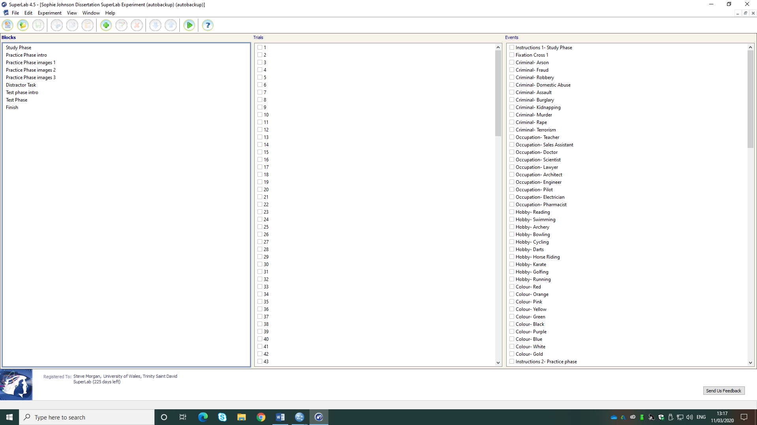

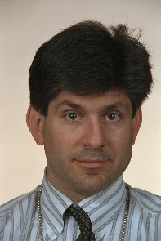
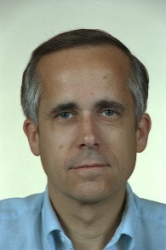
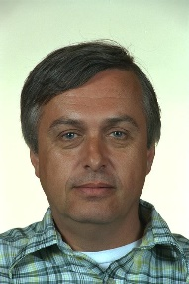
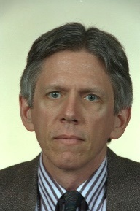
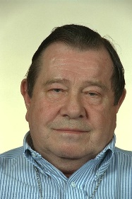
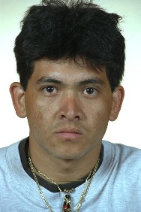
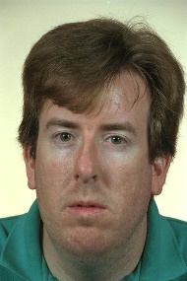
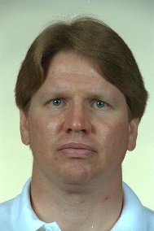
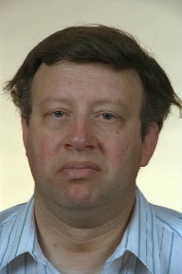
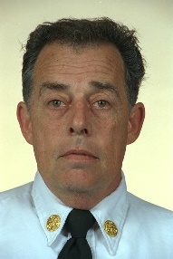
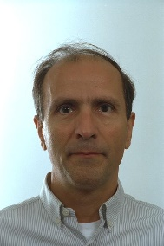
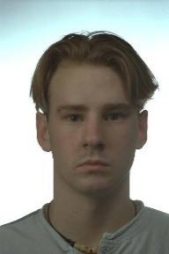
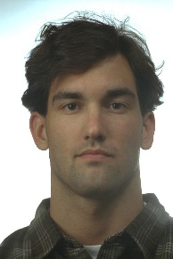
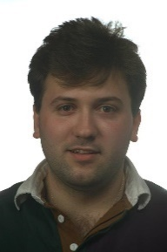
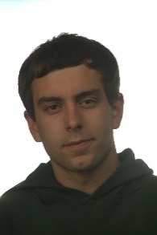
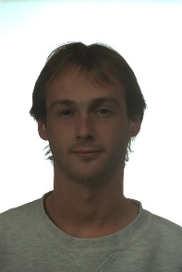
Appendix D
Images of faces used in Super lab

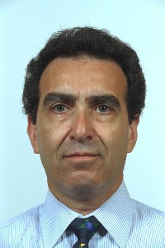
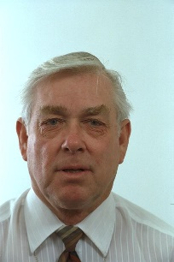
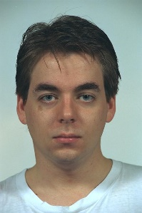
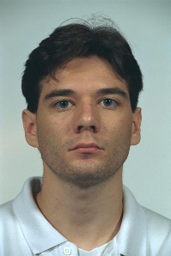
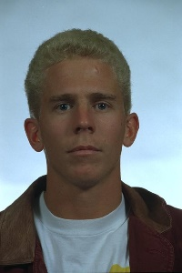
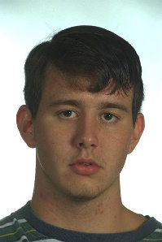
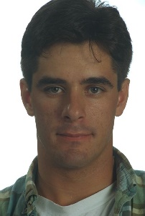
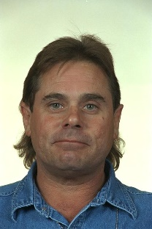
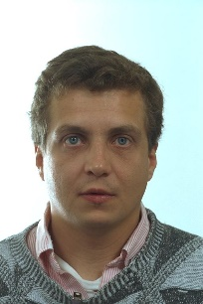
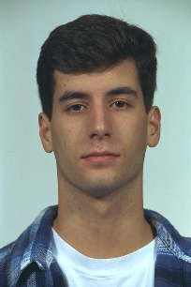
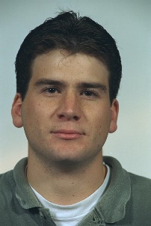
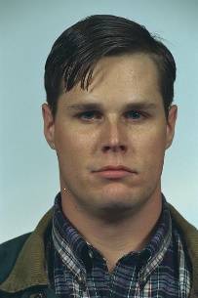
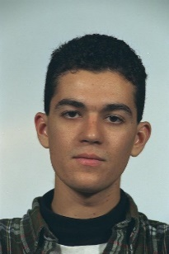
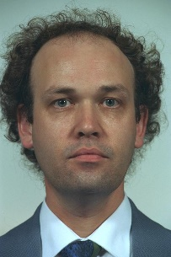
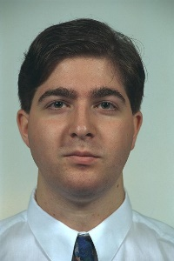
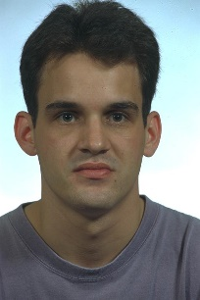
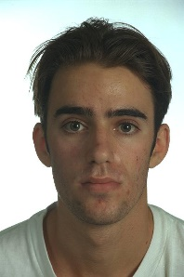
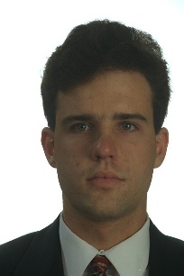
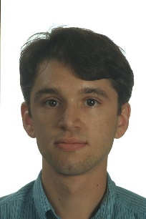
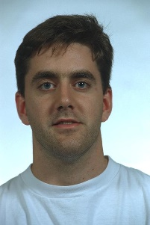
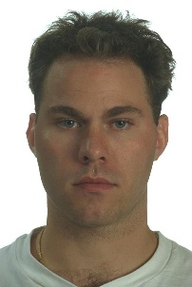
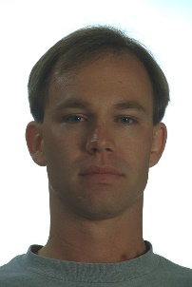
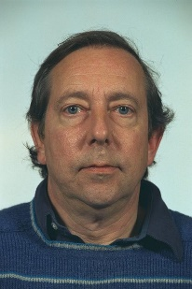
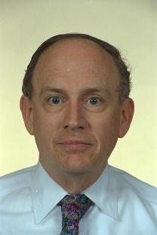
These images are the 40 ‘new’ or previously unseen images, shown during the test phase only.

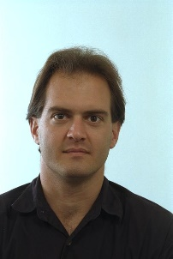
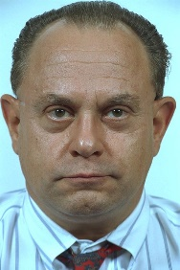
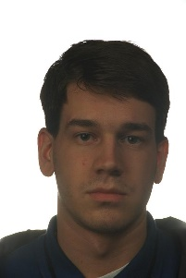
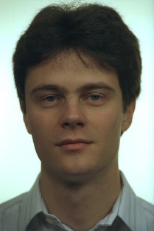
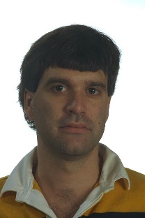
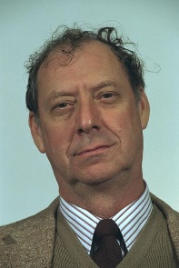
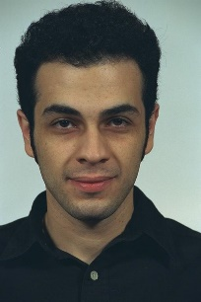
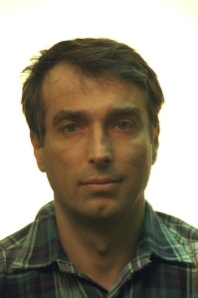
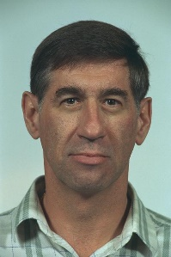
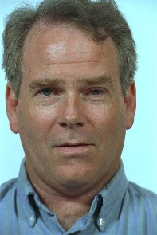
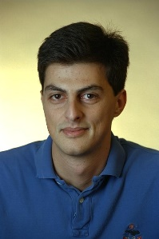
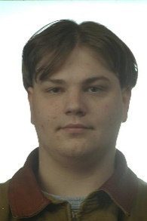
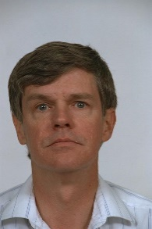
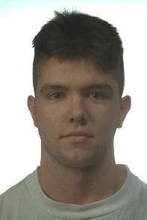
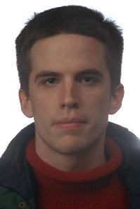
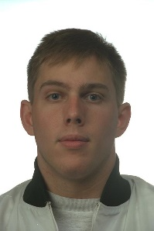
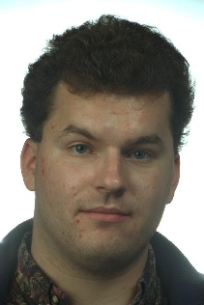
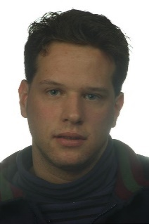
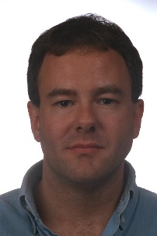
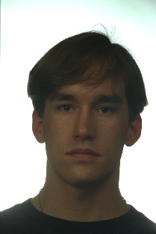
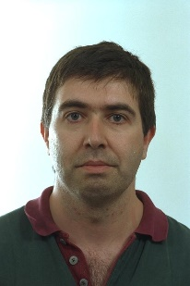
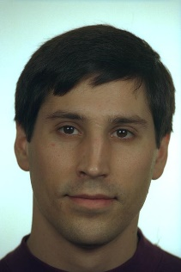
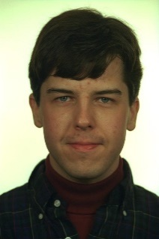
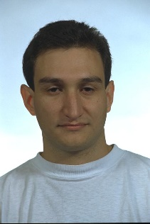
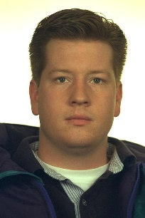
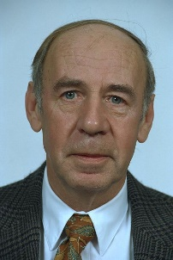
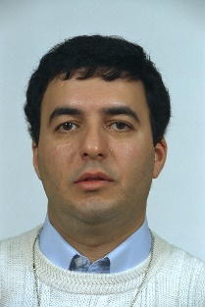
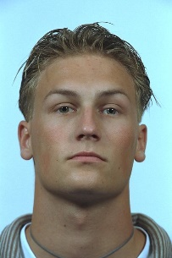
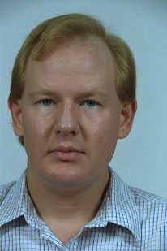
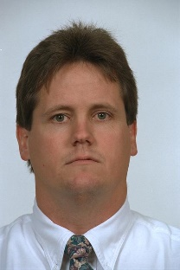
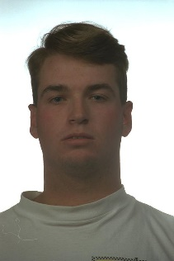
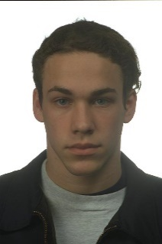
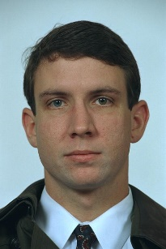
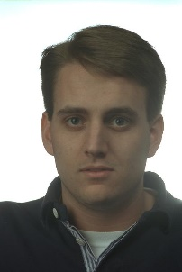
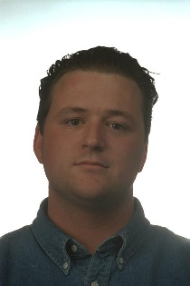
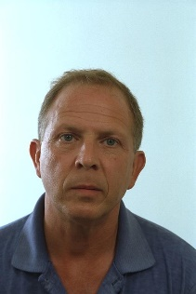
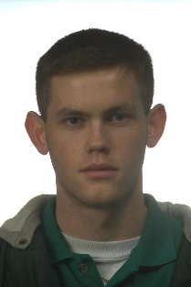
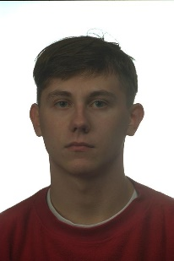
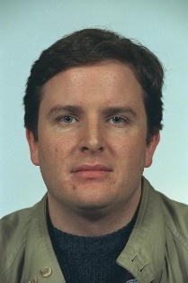
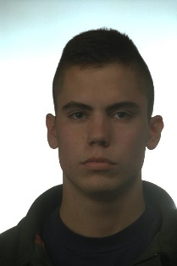
These are the 40 ‘original’ images previously seen in the study/ practice phase.
The Labels used in this study were:
- Criminal; Arson, Fraud, Robbery, Domestic Abuse, Assault, Burglary, Kidnapping, Murder, Rape, Terrorism
- Occupation; Teacher, Sales Assistant, Doctor, Scientist, Lawyer, Architect, Engineer, Pilot, Electrician, Pharmacist
- Hobby; Reading, Swimming, Archery, Bowling, Cycling, Darts, Horse Riding, Karate, Golfing, Running
- Colour; Red, Orange, Pink, Yellow, Green, Black, Purple, Blue, White, Gold
Appendix E
APPLICATION FOR ETHICAL APPROVAL

In order for research to result in benefit and minimise risk of harm, it must be conducted ethically. A researcher may not be covered by the University’s insurance if ethical approval has not been obtained prior to commencement.

The University follows the OECD Frascati manual definition of research activity: “creative work undertaken on a systematic basis in order to increase the stock of knowledge, including knowledge of man, culture and society, and the use of this stock of knowledge to devise new applications”. As such this covers activities undertaken by members of staff, postgraduate research students, and both taught postgraduate and undergraduate students working on dissertations/projects.

The individual undertaking the research activity is known as the “principal researcher”.

Ethical approval is not required for routine audits, performance reviews, quality assurance studies, testing within normal educational requirements, and literary or artistic criticism.

Please read the notes for guidance before completing ALL sections of the form.

This form must be completed and approved prior to undertaking any research activity. Please see Checklist for details of process for different categories of application.

Delete the Guidance Notes at the end of the form BEFORE submitting your application

SECTION A: About You (Principal Researcher)
Full Name: |  | Sophie Leigh Johnson
Tick all boxes which apply: |  | Member of staff: | ☐ | Honorary research fellow: | ☐
Undergraduate Student | ☒ | Taught Postgraduate Student | ☐ | Postgraduate Research Student | ☐

Faculty/School/Centre: | University of Wales Trinity St David
Campus: | SA1
E-mail address: | 1701737@student.uwtsd.ac.uk
Contact Telephone Number: | 07727305355
For students:
Student Number: | 1701737
Programme of Study: | BSc (Hons) Psychology
Director of Studies/Supervisor: | Dr Paul B. Hutchings/ Dr Kate Williams

SECTION B: Approval for Research Activity
Has the research activity received approval in principle?  (please check the Guidance Notes as to the appropriate approval process for different levels of research by different categories of individual) |  | YES | ☐ | NO | ☐
 |  |  |  | Date
If Yes, please indicate source of approval (and date where known): Approval in principle must be obtained from the relevant source prior to seeking ethical approval | Research Degrees Committee |  | ☐
 | Faculty Research Committee |  | ☐
 | Other (Dr Kate Williams) |  | ☒ | 23/10/19

SECTION C: Internal and External Ethical Guidance Materials
Please list the core ethical guidance documents that have been referred to during the completion of this form (including any discipline-specific codes of research ethics, and also any specific ethical guidance relating to the proposed methodology). Please tick to confirm that your research proposal adheres to these codes and guidelines.
UWTSD Research Ethics & Integrity Code of Practice | ☒
UWTSD Research Data Management Policy | ☒
BPS Code of Ethics (2018) | ☒
BPS Code of Human Ethics (2014) | ☒
UWTSD Data Protection and storage protocol | ☒

SECTION D: External Collaborative Research Activity
Does the research activity involve collaborators outside of the University? |  | YES | ☐ | NO | ☒
If Yes, please provide the name of the external organisation and name and contact details for the main contact person and confirmation this person has consented to their personal data being shared.as part of this collaboration.
Institution
Contact person name
Contact person e-mail address

Has this individual consented to sharing their details on this form? |  | YES | ☐ | NO |  |  | ☐
Are you in receipt of a KESS scholarship? |  | YES | ☐ | NO |  |  | ☐
Is your research externally funded |  | YES | ☐ | NO |  |  | ☐
Are you specifically employed to undertake this research in either a paid or voluntary capacity? | Voluntary | YES | ☐ | NO |  | ☐
 | Employed | YES | ☐ | NO |  | ☐
Is the research being undertaken within an existing UWTSD Athrofa Professional Learning Partnership (APLP) | If YES then the permission question below does not need to be answered. | YES | ☐ | NO |  |  | ☐
Permission to undertake the research has been provided by the partner organisation | (If YES attach copy)  If NO the application cannot continue | YES | ☐ | NO |  |  | ☐

Where research activity is carried out in collaboration with an external organisation
Does this organisation have its own ethics approval system? | YES | ☐ | NO | ☐
If Yes, please attach a copy of any final approval (or interim approval) from the organisation

SECTION E: Details of Research Activity
Indicative title: | Exploring the impact of Criminality on Recognition induced forgetting for faces.
Proposed start date: | November 2019 | Proposed end date: | July 2020
Introduction to the Research (maximum 300 words)
Ensure that you write for a Non-Specialist Audience when outlining your response to the three points below:
- Purpose of Research Activity
- Proposed Research Question
- Aims of Research Activity
- Objectives of Research Activity
Demonstrate, briefly, how Existing Research has informed the proposed activity and explain
- What the research activity will add to the body of knowledge
- How it addresses an area of importance.
Purpose of Research Activity

The Purpose of this research activity is to extend on previous research, which initially starts with the ‘Retrieval induced forgetting’ paradigm. This is the phenomena where remembering certain information can cause the forgetting of related information within long term memory. The research aiming to be conducted is the Recognition induced forgetting, which of course depicts that recognising an object induces forgetting of other objects from the same category. In this case, I have chosen to explore faces instead of objects, with relation to RIF. There is very little research on recognition induced forgetting, and even less with regards to faces. One paper by Rugo et al. (2017) proposes that faces would not be susceptible to the RIF effect due to faces being areas of expertise for us as humans. Therefore, the purpose of this study is to explore whether this is the case and to assess whether certain types of associated contextual information about a face can induce the RIF effect.

(this box should expand as you type)
Research Question

Are faces associated with a criminal conviction susceptible to recognition induced forgetting.

(this box should expand as you type)
Aims of Research Activity

Rugo et al. (2017) acknowledges the previous work with recognition-induced forgetting, that recognising an object induces the forgetting of other semantically similar objects (from the same category). This paper, however, delves into the consideration that faces may not be affected by this recognition-induced forgetting, as they are objects of expertise. The idea behind this was that as we see faces every day, we are well versed in various different features, skin tones, hair length and colour etc. So, faces with different features or ethnicity will belong in the same category (humans) but will all be remembered to the same extent as they are well practiced ‘item’s’. This is the opposite to the proposed idea of the object recognition-induced forgetting paradigm.

The basic understanding of this Recognition-induced forgetting has been considered prior to this dissertation. Therefore, the aim of this study is to expand on a new area of research and build upon the work that has already been proposed, while adding the criminality aspect to develop ones understanding of how the brain acknowledges these types of faces. Also, the aim is to uncover what theory the results reimburse too. Will they fall into the same effect as Rugo et al proposed (whereby criminal faces will all be remembered to the same degree as ‘non-convicted’ criminals, due to the face expertise element), or will the contextual information linked to the criminality label either create better memory for those faces or create greater competition within the RIF paradigm thereby leading to worse memory for those faces (i.e., RIF).

(this box should expand as you type)
Objectives of Research Activity

The objective of this research is to make use of a modified version of the RIF paradigm to obtain and analyse results to establish whether there is greater RIF for the ‘criminally convicted’ faces compared to other ‘non-criminally convicted’ faces (due to the emotional strength of the label associated with them causing greater suppression of those faces during the RIF task). Whether the emotionality associated with the face may make them stand out and enhance memory for them (leading to no RIF.). Finally, it may be the case that the faces are not susceptible to RIF and all categories of faces are remembered to a similar degree (as suggested by Rugo et al., 2017).

(this box should expand as you type)
Proposed methods (maximum 600 words)
Provide a brief summary of all the methods that may be used in the research activity, making it clear what specific techniques may be used. If methods other than those listed in this section are deemed appropriate later, additional ethical approval for those methods will be needed.
The Independent variable for this study is the Recognition induced forgetting for faces, which is analysed across 4 levels. These levels being; Rp+ (practiced faces), Rp- Criminality and Rp- Occupation (Non-practiced faces from practiced categories) and NRP (Non-practiced categories). The dependent variable is the Recognition accuracy for each Rp category in the test phase. The design of this study is a within-subjects design, meaning the same person tests all conditions in the study. So, each participant will see the same pictures included in the study phase, practice phase and the test phase. The study phase will present 40 randomised images of faces, which will be presented individually for 3 seconds each. There will also be a 1 second fixation cross presented between each image to re-focus the individual’s attention. Each face will be provided with a label which will fall into either the category; Hobbies, Occupation, Criminal conviction or colour, and there will be 10 images in each category (40 total). An example of a label from each category would be; Arson, Teacher, Reading and Red. The practice phase will involve the participant viewing 5 images (out of the original 10) from the categories criminal conviction and occupation, faces will again be shown individually for 3 seconds each. The same fixation cross will separate each displayed image, and each face is shown 3 times randomly. A distractor jigsaw task will then be instructed for completion, this will be timed at 2 minutes. Following this the individual will move onto the test phase. This is where the 40 images which have already been seen (in the study phase) are shown again, alongside 40 new images which had not been viewed already. These images will be presented randomly and individually for 3 seconds each.

The difference in the test phase is there will be no description presented alongside the images, this is to test the ability of the individual on the face itself. Throughout this test phase, when each face is presented, the individual will be instructed to press ‘Q’ for yes if they have seen the face before, or alternatively ‘P’ if they haven’t seen the face before. These response options will be counterbalanced.

(this box should expand as you type)

Location of research activity
Identify all locations where research activity will take place.
Psychology Lab, at UWTSD SA1 Campus.

(this box should expand as you type)
Research activity outside of the UK
If research activity will take place overseas, you are responsible for ensuring that local ethical considerations are complied with and that the relevant permissions are sought. Specify any local guidelines (e.g. from local professional associations/learned societies/universities) that exist and whether these involve any ethical stipulations beyond those usual in the UK (provide details of any licenses or permissions required). Also specify whether there are any specific ethical issues raised by the local context in which the research activity is taking place, for example, particular cultural and/or legal sensitivities or vulnerabilities of participants.
(this box should expand as you type)
Use of documentation not in the public domain: Are any documents NOT publicly available? | NO | ☐
 | YES | ☐
If Yes, please provide details here of how you will gain access to specific documentation that is not in the public domain and that this is in accordance with prevailing data protection law of the country in question and England and Wales.

(this box should expand as you type)

SECTION F: Scope of Research Activity
Will the research activity include: | YES | NO
Use of a questionnaire or similar research instrument? | ☐ | ☒
Use of interviews? | ☐ | ☒
Use of diaries? | ☐ | ☒
Participant observation with their knowledge? | ☐ | ☒
Participant observation without their knowledge? | ☐ | ☒
Use of video or audio recording? | ☐ | ☒
Access to personal or confidential information without the participants’ specific consent? | ☐ | ☒
Administration of any questions, test stimuli, presentation that may be experienced as physically, mentally or emotionally harmful / offensive? | ☐ | ☒
Performance of any acts which may cause embarrassment or affect self-esteem? | ☐ | ☒
Investigation of participants involved in illegal activities? | ☐ | ☒
Use of procedures that involve deception? | ☐ | ☒
Administration of any substance, agent or placebo? | ☐ | ☒
Working with live vertebrate animals? | ☐ | ☒
Other primary data collection methods, please explain in this box  For example, ‘focus groups’. Please indicate the type of data collection method(s) in this box and tick the accompany box. | ☒ | ☐
Details of any other primary data collection method:  My Primary research collection technique is experimental. It will involve the participant completing a task viewing various images on a computer. The data that will be collected will be the participants total correct recognition score for the faces presented in the test phase of the study.  (this box should expand as you type) | ☒ | ☐
If NO to every question, then the research activity is (ethically) low risk and may be exempt from some of the following sections (please refer to Guidance Notes).

If YES to any question, then no research activity should be undertaken until full ethical approval has been obtained.

SECTION G: Intended Participants
Who are the intended participants: | YES | NO
Students or staff at the University? | ☒ | ☐
Adults (over the age of 18 and competent to give consent)? | ☒ | ☐
Vulnerable adults? | ☐ | ☒
Children and Young People under the age of 8? (Consent from Parent, Carer or Guardian will be required) | ☐ | ☒
Prisoners? | ☐ | ☒
Young offenders? | ☐ | ☒
Those who could be considered to have a particularly dependent relationship with the investigator or a gatekeeper? | ☐ | ☒
People engaged in illegal activities? | ☐ | ☒
Others (please identify specifically any group who may be unable to give consent) please indicate here and tick the appropriate box. | ☐ | ☒
Other – please indicate here:  (this box should expand as you type) | ☐ | ☒

Participant numbers and source
Provide an estimate of the expected number of participants. How will you identify participants and how will they be recruited?
How many participants are expected? | The number of participants expected to take part is 80.  (this box should expand as you type)
Who will the participants be? | The participants will be Psychology student’s from UWTSD SA1 campus. This is as the study will be made live for signing up to via the Experimental management system (EMS) which is only available to psychology students. It’s expected that they will mainly be undergraduate or postgraduate student’s.  (this box should expand as you type)
How will you identify the participants? | The participants will be identified by their unique experimental code only, when signing up via the EMS, this is what they use to log in and sign up to studies.  (this box should expand as you type)

Information for participants: | YES | NO | N/A
Will you describe the main research procedures to participants in advance, so that they are informed about what to expect? | ☒ | ☐ | ☐
Will you tell participants that their participation is voluntary? | ☒ | ☐ | ☐
Will you obtain written consent for participation? | ☒ | ☐ | ☐
Will you explain to participants that refusal to participate in the research will not affect their treatment or education (if relevant)? | ☒ | ☐ | ☐
If the research is observational, will you ask participants for their consent to being observed? | ☐ | ☐ | ☒
Will you tell participants that they may withdraw from the research at any time and for any reason? | ☒ | ☐ | ☐
With questionnaires, will you give participants the option of omitting questions they do not want to answer? | ☐ | ☐ | ☒
Will you tell participants that their data will be treated with full confidentiality and that, if published, it will not be identifiable as theirs? | ☒ | ☐ | ☐
Will you debrief participants at the end of their participation, in a way appropriate to the type of research undertaken? | ☒ | ☐ | ☐
If NO to any of above questions, please give an explanation
(this box should expand as you type)

Information for participants: | YES | NO | N/A
Will participants be paid? | ☐ | ☒ | ☐
Is specialist electrical or other equipment to be used with participants? | ☐ | ☒ | ☐
Are there any financial or other interests to the investigator or University arising from this study? | ☐ | ☒ | ☐
Will the research activity involve deliberately misleading participants in any way, or the partial or full concealment of the specific study aims? | ☒ | ☐ | ☐
If YES to any question, please provide full details
With this research, there is slight deception. This being in terms of the images the participants will view have hypothetical labels attached (for example; murderer, teacher, blue, swimming). The participant will not be told at the start that these are hypothetical, therefore during the debriefing process it will be stressed to the participant that these labels were not literal. Especially when it comes to the criminal labels, it is essential to reassure the participant that the images they viewed were not of actual crimes committed by the person in the image showed.

(this box should expand as you type)

SECTION H: Anticipated Risks

Outline any anticipated risks that may adversely affect any of the participants, the researchers and/or the University, and the steps that will be taken to address them.

If you have completed a full risk assessment (for example as required by a laboratory, or external research collaborator) you may append that to this form.
Full risk assessment completed and appended? |  | Yes | ☐
 |  | No | ☒
Risks to participants
For example: emotional distress, financial disclosure, physical harm, transfer of personal data, sensitive organisational information
Risk to Participant:  - Exposure to sensitive wording (criminal labels)  - Participants leaving the study feeling worse than when they entered (not completing the jigsaw in time, or recognising many or any faces)  - Possibility of being uncomfortable in the lab setting (small room?)  (this box should expand as you type) | How will you mitigate the Risk to Participant  - Reassure and make it clear to the participant that the labels are hypothetical and have no relation to the accompanied image.  - Stress to the participant that the jigsaw was used as a distractor task and was intended to not be completed (1000 piece in two minutes), nor will the end result of the jigsaw be noted down. Also, with regards to the participant not recognising the faces as often as they would have hoped, I will explain that the RIF study is set up in such a way to encourage certain aspects of the study to be forgotten. To just further assure them not to be disheartened if they felt they did poorly.  - If the participant appears to be uncomfortable or verbally state they are, I will remind them it is not compulsory they take part and that they can withdraw as and when they wish to do so. This will be stated to them on the consent form before the start of the study.  (this box should expand as you type)
If research activity may include sensitive, embarrassing or upsetting topics (e.g. sexual activity, drug use) or issues likely to disclose information requiring further action (e.g. criminal activity), give details of the procedures to deal with these issues, including any support/advice (e.g. helpline numbers) to be offered to participants. Note that where applicable, consent procedures should make it clear that if something potentially or actually illegal is discovered in the course of a project, it may need to be disclosed to the proper authorities
N/A

(this box should expand as you type)
Risks to investigator
For example: personal safety, physical harm, emotional distress, risk of accusation of harm/impropriety, conflict of interest
Risk to Investigator:  - Possible abuse from the participant towards the researcher. Either via email or in person  - Risk of accusation of harm/impropriety  (this box should expand as you type) | How will you mitigate the Risk to Investigator:  - In any instance where abuse towards the researcher would take place, I (the researcher) would stop the study immediately and debrief the participant appropriately. If the situation got too intense or aggressive then I would remove myself from the situation and inform my supervisor immediately. This would be to make them aware what has happened, and then they would take any further necessary actions at a higher level.  - To avoid researchers being in a position of isolation with a participant, data collection in the laboratory will only take place between the hours of 9am – 5pm on Mondays to Fridays during term-time to ensure that members of university staff are on hand in the laboratory should any issues arise.  - As the researcher, I will ensure to adhere to the BPS and UWTSD guidelines of appropriate conduct.  (this box should expand as you type)
University/institutional risks
For example: adverse publicity, financial loss, data protection
Risk to University:  - There should be minimal risks to the university due to the strict following of ethical guidelines. However, if any of these were not followed then that would put the university at risk of ethical misconduct.  (this box should expand as you type) | How will you mitigate the Risk to University:  - Make sure all ethical standards are upheld in accordance with the BPS, and the university’s code of ethics. If any problem was to arise, the supervisor would be made aware directly to deal with this efficiently and in the best manner.  (this box should expand as you type)

Disclosure and Barring Service
If the research activity involves children or vulnerable adults, a Disclosure and Barring Service (DBS) certificate must be obtained before any contact with such participants. | YES | NO | N/A
Does your research require you to hold a current DBS Certificate? | ☐ | ☐ | ☒

SECTION I: Feedback, Consent and Confidentiality
Feedback
What de-briefing and feedback will be provided to participants, how will this be done and when?
There will be a debrief form handed to the participant upon completion of the study. This will depict the study aims and objectives in depth, explicitly assuring the participants that the criminal aspect was hypothetical, for example. As this is handed over, I will ask if they have any immediate question’s they wish to ask me. If not, I will just reiterate that my email, along with my supervisors, are located at the end of the debrief form (which they are able to keep) should there be any queries following the study ceasing. If participants chose to withdraw before the end of the study, they will be provided with a written debrief form at the point at which they chose to remove themselves.

(this box should expand as you type)
Informed consent
Describe the arrangements to inform potential participants, before providing consent, of what is involved in participating. Describe the arrangements for participants to provide full consent before data collection begins. If gaining consent in this way is inappropriate, explain how consent will be obtained and recorded in accordance with prevailing data protection legislation.
The study will be made live on the EMS for any psychology student to sign up to. The study display will provide a brief overview of what the study will involve. So, it will state they will be viewing images on the computer and completing a memory task. After signing up, this will confirm the participant is happy to attend the study upon reading the basics of what will be involved. Upon arrival to the study, I will present each participant with a consent form (stating the task ahead in a brief overview form again). If they are, again, happy to continue after being physically at the study, they sign their name on the consent form to give me the written consent I ethically need to carry out the study.

(this box should expand as you type)
Confidentiality / Anonymity
Set out how anonymity of participants and confidentiality will be ensured in any outputs. If anonymity is not being offered, explain why this is the case.
The participants initially sign up to take part via EMS which provides them with a unique code, so they are anonymised from the offset in that sense. Following this, the consent form (which contains their names) will all be kept securely in a separate pile to the data sets. So, a participant’s consent form will never be linked to their data in order to keep that anonymity upheld. When the results are fully obtained following the completion of the task on super lab, these will be transferred onto a password encrypted USB stick. This is to ensure the results are held confidential, even though there won’t be any names attached to each data set result.

(this box should expand as you type)

SECTION J: Data Protection and Storage
In completing this section refer to the University’s Research Data Management Policy and the extensive resources on the University’s Research Data Management web pages (http://uwtsd.ac.uk/library/research-data-management/).
Does the research activity involve personal data (as defined by the General Data Protection Regulation 2016 “GDPR” and the Data Protection Act 2018 “DPA”)? | YES | NO
“Personal data” means any information relating to an identified or identifiable natural person (‘data subject’). An identifiable natural person is one who can be identified, directly or indirectly, in particular by reference to an identifier such as a name, an identification number, location data, an online identifier or to one or more factors specific to the physical, physiological, genetic, mental, economic, cultural or social identity of that natural person. | ☒ | ☐
If YES, provide a description of the data and explain why this data needs to be collected:
The participant’s names will be taken on the consent forms, so I have written consent that they are willing to take part. These will not be stored in relation to their specific data sets, but rather separately and securely to any data collected. Age and gender details of participants will also be collected but these will be separate to consent.

(this box should expand as you type)
Does it involve special category data (as defined by the GDPR)? | YES | NO
“Special category data” means sensitive personal data consisting of information as to the data subjects’ –  (a) racial or ethnic origin,  (b) political opinions,  (c ) religious beliefs or other beliefs of a similar nature,  (d) membership of a trade union (within the meaning of the Trade Union and Labour Relations (Consolidation) Act 1992),  (e) physical or mental health or condition,  (f) sexual life,  (g) genetics,  (h) biometric data (as used for ID purposes), | ☐ | ☒
If YES, provide a description of the special category data and explain why this data needs to be collected:
(this box should expand as you type)
Will the research activity involve storing personal data and/or special category data on one of the following: | YES | NO
Manual files (i.e. in paper form)? | ☒ | ☐
University computers? | ☐ | ☒
Private company computers? | ☐ | ☒
Home or other personal computers? | ☐ | ☒
Laptop computers/ CDs/ Portable disk-drives/ memory sticks? | ☐ | ☒
“Cloud” storage or websites? | ☐ | ☒
Other – specify: | ☐ | ☒
For all stored data, explain the measures in place to ensure the security of the data collected, data confidentiality, including details of password protection, encryption, anonymisation and pseudonymisation:
The data kept will be stored on a secure network on the lab PC, with password encryption. In order to analyse the data, it will be transferred from the lab PC to the researchers own password protected laptop via a password protected USB stick. The data sets will not contain any information linking the results to a specific person (names etc). Consent forms will be locked away securely and separately to the data until a time they can be submitted to the SA1 lab storage facility.

(this box should expand as you type)
All Data Storage
Will the research activity involve any of the following activities: | YES | NO
Electronic transfer of data in any form? | ☒ | ☐
Sharing of data with others at the University? | ☐ | ☒
Sharing of data with other organisations? | ☐ | ☒
Export of data outside the European Union or importing of data from outside the UK? | ☐ | ☒
Use of personal addresses, postcodes, faxes, emails or telephone numbers? | ☐ | ☒
Publication of data that might allow identification of individuals? | ☐ | ☒
Use of data management system? | ☐ | ☒
Data archiving? | ☐ | ☒
If YES to any question, please provide full details, explaining how this will be conducted in accordance with the GDPR and DPA (and/or any international equivalent):
The transfer of data obtained will be the initial copying of the results from the psychology lab computer (obtained via super lab) to my password secured USB stick. From this USB stick I will transfer the data to my university cloud storage account on the lab PC, which is also password encrypted. To allow me to work on the data analysis from home too, I will also transfer the data to my own personal laptop to work (again this is password protected). This acts as a safety precaution too, in the event the USB was lost or stopped working.

(this box should expand as you type)
List all who will have access to the data generated by the research activity:
The researcher (myself), and supervisor (Dr Kate Williams)

(this box should expand as you type)
List who will have control of, and act as custodian(s) for, data generated by the research activity:
The researcher (myself), and supervisor (Dr Kate Williams)

(this box should expand as you type)
Give details of data storage arrangements, including security measures in place to protect the data, where data will be stored, how long for, and in what form. Will data be archived – if so how and if not why not.
Data results will be stored on my own personal password encrypted USB stick. This USB will remain with me (the researcher) until a time where it can be submitted to the SA1 storage facility. It will be stored here until the module has been confirmed to be completed by the relevant examination board. This is to ensure there is no tampering to any of the data sets, the data won’t include any personal information (including their names). At no point throughout the study will I be able to link a person’s identity with their data results from the study. The participant’s names will be on the consent forms, but these will be kept completely separate from any data collected from that individual. Similarly with the USB stick, the consent forms will be kept safe with me until they can be stored at the SA1 storage facility, for the same amount of time (until completion of the module.)
(this box should expand as you type)
Please indicate if your data will be stored in the UWTSD Research Data Repository (see https://researchdata.uwtsd.ac.uk/ ). If so please explain. (Most relevant to academic staff)
N/A

(this box should expand as you type)
Confirm that you have read the UWTSD guidance on data management (see https://www.uwtsd.ac.uk/library/research-data-management/) | YES | ☒
 | NO | ☐
Confirm that you are aware that you need to keep all data until after your research has completed or the end of your funding | YES | ☒
 | NO | ☐

SECTION K: Declaration
The information which I have provided is correct and complete to the best of my knowledge. I have attempted to identify any risks and issues related to the research activity and acknowledge my obligations and the rights of the participants.

In submitting this application I hereby confirm that I undertake to ensure that the above named research activity will meet the University’s Research Ethics and Integrity Code of Practice
Signature of applicant: | S L Johnson | Date: 15/10/19

For STUDENT Submissions:
Director of Studies/Supervisor: | Dr Kate Williams | Date: 25/10/2019
Signature: |  | Date: 25/10/2019

For STAFF Submissions:
Head of School/Assistant Dean: |  | Date:
Signature: |  | Date:

Checklist: Please complete the checklist below to ensure that you have completed the form according to the guidelines and attached any required documentation:
☒ | I have read the guidance notes supplied before completing the form.
☒ | I have completed ALL RELEVANT sections of the form in full.
☒ | I confirm that the research activity has received approval in principle
☐ | I have attached a copy of final/interim approval from external organisation (where appropriate)
☐ | I have attached a full risk assessment (and have NOT completed Section H of this form) (where appropriate) ONLY TICK IF YOU HAVE ATTACHED A FULL RISK ASSESSMENT
☒ | I understand that it is my responsibility to ensure that the above named research activity will meet the University’s Research Ethics and Integrity Code of Practice.
☒ | I understand that before commencing data collection all documents aimed at respondents (including information sheets, consent forms, questionnaires, interview schedules etc.) must be confirmed by the DoS/Supervisor, module tutor or Head of School.
☒ | I have deleted the guidance notes before submitting the PG2 for consideration

RESEARCH STUDENTS AND STAFF ONLY
All communications relating to this application during its processing must be in writing and emailed to pgresearch@uwtsd.ac.uk , with the title ‘Ethical Approval’ followed by your name.
You will be informed of the outcome of your claim by email; therefore it is important that you check your University and personal email accounts regularly.

STUDENTS ON UNDERGRADUATE OR TAUGHT MASTERS PROGRAMMES should submit this form (and receive the outcome) via systems explained to you by the supervisor/module leader.

This form is available electronically from the Academic Office web pages: http://www.uwtsd.ac.uk/academic-office/

Application Process
All staff research projects and all research students must submit the Ethical Approval Form to the University Ethics Committee via the Academic Office (pgresearch@uwtsd.ac.uk). Staff research directly in relation to personal study for taught undergraduate or Masters programmes should be submitted via the Faculty procedures explained below.
Taught masters and taught undergraduate research Ethical Approval Forms are considered within Faculties. Faculties will provide details of the specific processes for this. Where the Ethical issues within any single ethical application are of particular concern the Faculty will refer these to the University Ethics Committee. Any student activity that involves the collection of primary data needs to undergo Ethical approval, this includes assignment work as well as dissertations.
Dissertation proposal 2019-2020
Appendix F

Student Name | Sophie Leigh Johnson
Dissertation Supervisor | Dr Kate Williams
Date submitted | 12pm midday, 11th October 2019

Title of Research (this must reflect the essence of your proposed research question, study design and study population and should be more specific than the broad topic area provided in the dissertation topics selection book).

Exploring the impact of criminality on recognition induced forgetting for faces.

Please state your main research question(s) and hypothesis/hypotheses

Are faces associated with a criminal conviction susceptible to the recognition induced forgetting effect. The proposed hypothesis suggests that there could be a difference in memory for ‘criminal’ faces compared to other ‘non convicted’ faces shown to the participant during the recognition-induced forgetting paradigm. That is, a face associated with a criminal conviction may not be susceptible to recognition-induced forgetting, whereas other non-convicted faces are susceptible.

What empirical evidence supports your research question? (Please provide a 1500 word review of relevant psychological literature and theory and a minimum of eight references). If you have already drafted a review of literature, please attach it to the end of this document – you do not need to complete this section if so).

This topic stems from the extensively researched ‘Retrieval induced forgetting’ paradigm, which is the phenomena where remembering certain information can cause the forgetting of related information within long term memory. Anderson, Bjork and Bjork (1994), have explored how the memory recall process can impair the long-term retention of related representations. The premise of this was that items within memory which are seen to have the same cue (with regards to retrieval) are possibly more likely to be forgotten due to the strength of some of the newer and more memorable items. The cue may be similar or the same with regards to certain object’s, but the retrieval process pull is stronger towards one, meaning the other is seen to be vulnerable to being forgotten. Further research was carried out following the work of Anderson et al. Hicks and Starns (2004) investigated whether retrieval induced forgetting could be displayed in item recognition tests, which ultimately links and would soon be followed on by the recognition induced forgetting of faces paradigm. The results saw that non practised items from semantically similar categories were remembered less. This result is due to the objects not being strictly the same but having a similar cue, causing the non-practised items to be almost lost in memory. This is as the practised items are inhibiting any other memory recall (Hicks & Starns, 2004). The counter argument to this inhibitory theory, is that of a non-inhibitory theorist (Verde, 2011). Verde acknowledges the work put forward previously by the likes of Anderson et al, that retrieving the practised RP+ items during the practice phase causes the forgetting or ‘burial’ of the RP- items, which are unpractised but are in the same category. However, Verde argued that the reasons and implications behind cue independence are far more complicated than initially expected. He refers to one other theory which suggests the success of recognition is reliant on two processes; familiarity and recollection. This theory being the dual-process theory (Yonelinas, 2002). Familiarity is a fast-paced process which occurs when an item is remembered due to it being context free, a simple memory. Recollection, however, is a slower process and requires context and episodic details in order to be recalled. These articles show both sides to the spectrum of remembrance, whether that be we remember specific items because the cue is stronger and overshadows other items with a similar cue. Or on the other hand, whether the familiarity with a certain item is what makes it easy to remember, not that it supresses any other in particular.

The interesting point to note is that these studies and research areas have all been surrounding the idea of similar category items being practiced, or not practiced, to see the outcome. These studies did not consider how well human faces would be remembered.

Rugo et al. (2017) acknowledges the previous work with recognition-induced forgetting, that recognising an object induces the forgetting of other semantically similar objects (from the same category). However, they delve into the consideration that faces may not be affected by this recognition-induced forgetting, as they are objects of expertise. The idea behind this was that as we see faces every day, we are well versed in various different features, skin tones, hair length and colour etc. So, faces with different features or ethnicity will belong to the same category (humans) but will all be remembered to the same extent as they are well practiced ‘item’s’. This is the opposite to the proposed idea of object recognition-induced forgetting.

The basic understanding of this Recognition-induced forgetting has been considered prior to this dissertation. Therefore, the outcome of this study could potentially result in similar findings to that of Rugo et al. (2017). Whereby in this study Criminal faces and non-convicted criminal faces will not be susceptible to the Recognition-induced forgetting effect, due to the face expertise element. Alternatively, the heightened emotion associated with the criminally convicted faces may lead to greater RIF compared to other ‘non-criminally convicted’ faces, due to the emotional strength of the label associated with them causing greater suppression of those faces during the RIF task. On the other hand, the emotionality associated with the face may make them stand out and enhance memory for them, leading to RIF for the non-criminally convicted faces but no RIF to the criminally convicted faces.

Please describe your participant group (including anticipated number of participants required) and any specific inclusion/exclusion criteria.

The participant group for this study will include 80 students from the SA1 university campus, who will be studying one of the Psychology degree programmes at the University of Wales Trinity Saint David. The participants will be recruited through the Psychology Department’s Experiment Management System (EMS) where participants receive credits in exchange for participation. Students can sign up to the study when it is made live via the EMS, where various timeslots will be available. The majority of the sample are expected to be either completing their undergraduate or post graduate degrees, and therefore will all be over the age of 18. There are no specific inclusion or exclusion criteria.

Please provide brief details of the anticipated design (e.g., between, within, mixed, regression, focus groups, interviews, experimental, questionnaires) and main procedure for your study (it should be clear from this how you are actually planning to carry out your study, and what will be happening to your participants).

The Independent variable for this study is the Recognition induced forgetting for faces, which is analysed across 4 levels. These levels being; Rp+ (practiced faces), Rp- Criminality and Rp- Occupation (Non-practiced faces from practiced categories) and NRP (Non-practiced categories). The dependent variable is the Recognition accuracy for each Rp category in the test phase. The design of this study is within-subjects, meaning the same person tests all conditions in the study. So, each participant will see the same pictures included in the study phase, practice phase and the test phase. The study phase will involve the presentation of 40 randomised images of faces, which will be presented individually for 3 seconds each. There will also be a 1 second fixation cross presented between each image to re-focus the individual’s attention. Each face will be provided with a label which will fall into either the category; Hobbies, Occupation, Criminal conviction or colour, and there will be 10 images in each category (40 total). An example of a label from each category would be; Arson, Teacher, Reading and Red. The practice phase will involve the participant viewing 5 images (out of the original 10) from the categories criminal conviction and occupation and faces will again be shown individually for 3 seconds each. The same fixation cross will separate each displayed image, and each face will be shown 3 times randomly. A distractor jigsaw task will then be given, this will be timed at 2 minutes. Following this the individual will move onto the test phase. This is where the 40 images which have already been seen (in the study phase) are shown again, alongside 40 new images which had not been viewed already. These images will be presented randomly and individually for 3 seconds each.

The difference in the test phase is there will be no description presented alongside the faces, this is to test the ability of the individual on the face itself. Throughout this test phase, when each face is presented, the individual will be instructed to press ‘Q’ for yes if they have seen the face before, or alternatively ‘P’ if they haven’t seen the face before. These response options will be counterbalanced.

What measures are you planning to use for data collection and how will this data be used in the analysis in order to answer your research question? (Be as specific as possible here – what type of data will you be obtaining, what specific topics/measures/scales/instruments will you be using and what will you do with this data?)

The data I will be obtaining will be primary in nature and quantitative, this being because I am collecting new data, and not using data which already exists. The quantitative element is due to when the results are obtained, each participant will have a numerical score of the total number of faces they correctly recalled from the test phase that falls into each of the RP conditions. The data once collected, will be analysed using SPSS, using a one-way ANOVA of the independent variable across the four levels (Rp+, Rp- Criminality, Rp- Occupation and NRP) to check for any patterns and then comparing this to the previous hypothesis set out. Once the results from the ANOVA have been obtained, if they are significant, a follow up Bonferroni corrections test will have to be carried out to examine potential differences. This is due to the Independent variable having four levels, and therefore I wouldn’t know where the significance of the results lies.

What are the main ethical issues that you will need to address in this study? (Please note all students will need to complete the full ethics form prior to final approval for data collection being given).

Although this study does not ‘appear’ to have any major ethical implications, with any experiment the researcher must be conscious and constantly thinking about the welfare of the participant. So, in order to uphold the standards and ethical considerations in accordance with the BPS (protection from harm, confidentiality etc), procedures such as a consent and debrief form will be used. This is so the participant fully understands the type of study they will be taking part in and gives their written consent to do so. Following the study, a debrief form is provided to fully explain to the participant what the study was intending to find out. It’s also important to stress to the participant that the images labelled criminally are merely hypothetical labels and are not actual images of criminals. As this could be a sensitive topic of observance to some, it’s of high importance to make the participant aware that the RIF study is set up in such a way to encourage certain aspects of the study to be forgotten. This is so those taking part don’t leave feeling any worse about themselves if they may have been unsure what faces they had seen before etc. Although this is not direct deception, it must still be acknowledged for ethical purposes, and therefore stressed to the participant following the study completion.

Student Name (Please print clearly): SOPHIE LEIGH JOHNSON

Student Signature: S L Johnson Date: 10/09/2019

Proposal Outcome |  | Supervisor to tick one only
Satisfactory proposal (all final materials have been approved by the supervisor; proceed to submitting the ethics form to the discipline research ethics committee). |  | X
Minor revisions (some areas require clarification before submitting ethics to the discipline research ethics committee - see below for required actions)

Unsatisfactory (proposal lacks significant detail and must be resubmitted to supervisor within seven days following feedback - see below for required actions)

Unsatisfactory - proposal is considered unethical/unworkable in practice. New proposal to be developed following feedback from supervisor (see below)

Proposal is satisfactory but requires full consideration by the Faculty research ethics committee due to the nature of the study

Supervisory team additional comments/feedback:

Action required:

Date of comments/feedback :

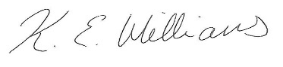

Supervisor’s Signature: ___________________________ Date: _25/10/2019_____

Appendix H
SPSS Output Results of One-way ANOVA

Within-Subjects Factors
Measure: MEASURE_1
List | Dependent Variable
1 | NRP
2 | RP_PLUS
3 | RP_MINUS_Crim
4 | RP_MINUS_Occ

Descriptive Statistics
 | Mean | Std. Deviation | N
NRP | 48.63 | 21.303 | 40
RP_PLUS | 85.50 | 13.765 | 40
RP_MINUS_Crim | 44.00 | 27.624 | 40
RP_MINUS_Occ | 40.50 | 22.865 | 40

Multivariate Testsª
Effect |  | Value | F | Hypothesis df | Error df | Sig. | Partial Eta Squared
List | Pillai's Trace | .829 | 59.857^{b} | 3.000 | 37.000 | .000 | .829
List | Wilks' Lambda | .171 | 59.857^{b} | 3.000 | 37.000 | .000 | .829
List | Hotelling's Trace | 4.853 | 59.857^{b} | 3.000 | 37.000 | .000 | .829
List | Roy's Largest Root | 4.853 | 59.857^{b} | 3.000 | 37.000 | .000 | .829
a. Design: Intercept
Within Subjects Design: List
b. Exact statistic

Mauchly's Test of Sphericityª
Measure: MEASURE_1
Within Subjects Effect | Mauchly's W | Approx. Chi-Square | df | Sig. | Epsilon^{b}
 |  |  |  |  | Greenhouse-Geisser | Huynh-Feldt | Lower-bound
List | .651 | 16.199 | 5 | .006 | .767 | .818 | .333
Tests the null hypothesis that the error covariance matrix of the orthonormalized transformed dependent variables is proportional to an identity matrix.
a. Design: Intercept
Within Subjects Design: List
b. May be used to adjust the degrees of freedom for the averaged tests of significance. Corrected tests are displayed in the Tests of Within-Subjects Effects table.

Tests of Within-Subjects Effects
Measure: MEASURE_1
Source |  | Type III Sum of Squares | df | Mean Square | F | Sig. | Partial Eta Squared
List | Sphericity Assumed | 52066.719 | 3 | 17355.573 | 54.860 | .000 | .584
List | Greenhouse-Geisser | 52066.719 | 2.302 | 22621.045 | 54.860 | .000 | .584
List | Huynh-Feldt | 52066.719 | 2.454 | 21214.700 | 54.860 | .000 | .584
List | Lower-bound | 52066.719 | 1.000 | 52066.719 | 54.860 | .000 | .584
Error(List) | Sphericity Assumed | 37014.531 | 117 | 316.364
Error(List) | Greenhouse-Geisser | 37014.531 | 89.766 | 412.344
Error(List) | Huynh-Feldt | 37014.531 | 95.717 | 386.709
Error(List) | Lower-bound | 37014.531 | 39.000 | 949.091

Tests of Within-Subjects Contrasts
Measure: MEASURE_1
Source | List | Type III Sum of Squares | df | Mean Square | F | Sig. | Partial Eta Squared
List | Linear | 8679.031 | 1 | 8679.031 | 25.878 | .000 | .399
List | Quadratic | 16301.406 | 1 | 16301.406 | 66.625 | .000 | .631
List | Cubic | 27086.281 | 1 | 27086.281 | 73.397 | .000 | .653
Error(List) | Linear | 13079.719 | 39 | 335.377
Error(List) | Quadratic | 9542.344 | 39 | 244.675
Error(List) | Cubic | 14392.469 | 39 | 369.038

Tests of Between-Subjects Effects
Measure: MEASURE_1
Transformed Variable: Average
Source | Type III Sum of Squares | df | Mean Square | F | Sig. | Partial Eta Squared
Intercept | 477968.906 | 1 | 477968.906 | 487.662 | .000 | .926
Error | 38224.844 | 39 | 980.124

