03/07/2026
Raluca-Cornelia Vasiu(2241085)
University of Wales Trinity Saint David
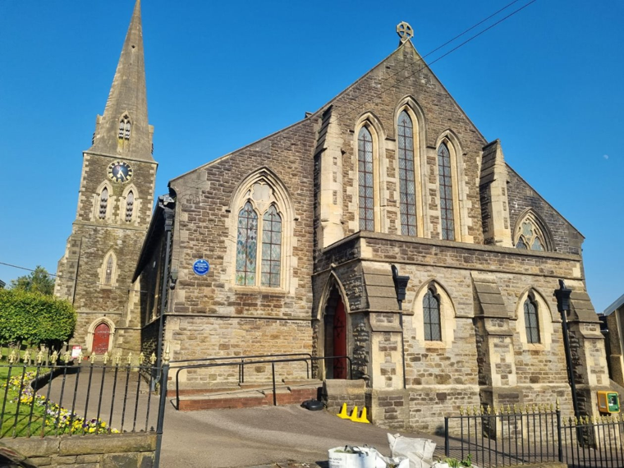
ST. Thomas Church Food Donation Project
Managing Projects in the Organisation (BMSW5009_SWAN)
Module Lead: Giulia Chifari

Executive Summary
This report critically evaluates the management of the St Thomas Church Food Donation Project, a community initiative that supports individuals and families experiencing food insecurity in Swansea. The project followed the complete project lifecycle, from initiation to closure, and applied recognised project management tools and techniques to coordinate planning, stakeholder engagement, communication and project delivery. The report examines the strengths and limitations of key project management approaches before evaluating how these tools were applied throughout the project. Attention is given to planning, stakeholder management, communication and project monitoring. The report concludes that although recognised project management methodologies provided an effective framework for organising the project, successful delivery relied equally on collaboration, stakeholder engagement and adaptability. Finally, recommendations are presented to improve future projects through enhanced risk management, structured communication and continuous professional development.

Table of contents
Executive Summary 1
1. Introduction 3
2. Findings 3
3. Critical Evaluation of Project Management Tools and Techniques 4
4. Application of Project Management Tools and Techniques in the St Thomas Church Food Donation Project 6
5. Communication and Stakeholder Engagement 10
6. Future Improvements and Personal Reflection 11
7. Conclusion 11
Reference List: 13

1. Introduction
Project management provides a systematic approach to achieving objectives by planning, organising and controlling activities within agreed constraints of time, cost and quality. While these principles are frequently associated with commercial organisations, they are equally valuable within community-based initiatives where projects often depend on voluntary participation, limited resources and effective stakeholder collaboration. Kerzner (2022) argues that successful projects require management approaches that reflect the project's objectives and stakeholder environment, while Clegg, Skyttermoen and Vaagaasar (2020) emphasise that project management should focus on creating value rather than simply applying management tools.
The St Thomas Church Food Donation Project originated from an idea I proposed during the team's initial discussions and was developed through consultation with St Thomas Church and collaborative planning with the project team.
The project aimed to organise a food donation campaign to support individuals and families experiencing food insecurity by collecting non-perishable food and financial donations from Amazon colleagues, Tesco and the local community. Objectives included identifying stakeholder requirements, coordinating donations and delivering them to St Thomas Church within the agreed timeframe.
This report critically evaluates the project management tools and techniques used during the project, assesses their contributions to project delivery and stakeholder engagement, and provides recommendations to improve the management of future community projects.

2. Findings
The St Thomas Church Food Donation Project was completed over three weeks and followed the recognised project lifecycle of initiation, planning, execution, monitoring and control, and closure (Turner, 2014). Following my initial contact with representatives from St Thomas Church, the project team met with the organisation to discuss its requirements and to establish the project's purpose, objectives and expected outcomes. These discussions enabled the team to define a realistic project scope, identify the principal stakeholders and ensure that the proposed food donation campaign addressed genuine community needs before planning commenced.
The planning stage also required the team to reconsider several initial project ideas before agreeing on a food donation campaign. Although this resulted in minor changes to the project timetable, it ensured that the final project was realistic, achievable and aligned with stakeholder requirements. The planning stage focused on allocating responsibilities, identifying risks, and producing key project documentation, including a Work Breakdown Structure (WBS), a Gantt Chart, a stakeholder analysis, and a Power–Interest Grid. These tools provided a structured framework for organising project activities, allocating responsibilities and planning stakeholder communication.
During execution, the team promoted the campaign through the Facebook page, collected food and monetary donations from Amazon colleagues and the local community, collaborated with Tesco to secure additional support (discounts and vouchers), and purchased additional food using donated funds. Progress was monitored through regular team meetings and WhatsApp group messaging to ensure activities remained aligned with the project schedule. The project concluded with the successful delivery of donations to St Thomas Church and a review of outcomes to identify lessons for improving future community initiatives.

3. Critical Evaluation of Project Management Tools and Techniques
However, no single technique guarantees project success, as their effectiveness depends on the project's objectives, complexity and stakeholder environment (Kerzner, 2022). Clegg, Skyttermoen and Vaagaasar (2020) similarly argue that project management should focus on creating value by supporting informed decision-making rather than simply following established processes. Consequently, project managers should select tools appropriate to the project's specific requirements rather than adopting a standard approach.
Planning is essential because it organises project activities and monitors progress. The WBS clarifies responsibilities, while Gantt Charts schedule activities and track progress (Burke, 2013; Heagney, 2016). Although each has limitations, they are most effective when used together (Geraldi and Lechter, 2012).
Project performance has traditionally been assessed using the Iron Triangle of time, cost, and quality. While these factors are important, they do not fully capture success. Atkinson (1999) emphasises the need to consider stakeholder satisfaction and long-term benefits. Baccarini (1999) differentiates between project management success (delivery efficiency) and overall project success (goal achievement). Serrador and Turner (2015) argue that stakeholder value is a more meaningful indicator of success than simply meeting operational targets. This perspective is especially relevant for community projects, where social impact can be more significant than financial results.
People and stakeholders are equally important to successful project delivery. Belbin (2010) argues that balanced teams perform more effectively because members contribute complementary strengths rather than identical skills. However, Fisher, Hunter and Macrosson (1998) suggest that team roles should remain flexible, as individuals frequently perform multiple roles depending on project requirements. Stakeholder management also requires flexibility. Freeman (1984) argues that projects should consider all stakeholders affected by project outcomes, while Mitchell, Agle and Wood (1997) propose that stakeholder priority depends on the interaction of power, legitimacy and urgency. The Power–Interest Grid provides a practical method for prioritising communication according to stakeholder influence, although stakeholder expectations should be reviewed throughout the project rather than only during planning.
Finally, monitoring and control enable project managers to identify issues before they affect project performance. The PMI (2021) emphasises that monitoring should occur throughout the project lifecycle, supported by regular communication and performance reviews. Meredith, Shafer, and Mantel (2017) argue that proactive risk management improves decision-making by reducing uncertainty, while Ward and Chapman (2003) suggest that project managers should focus on managing both uncertainty and individual risks. Together, these approaches demonstrate that successful project management depends on integrating planning, stakeholder engagement and continuous monitoring throughout the project lifecycle.
These principles provided the theoretical foundation for managing the St Thomas Church Food Donation Project and informed the selection and application of project management tools throughout its lifecycle.

4. Application of Project Management Tools and Techniques in the St Thomas Church Food Donation Project
The St Thomas Church Food Donation Project demonstrates that project management tools are more effective when adapted to the project's needs rather than applied mechanically. As a short-term community initiative with limited resources and multiple stakeholders, the project required practical planning techniques that supported coordination while remaining flexible enough to respond to changing circumstances.

Planning combined the Work Breakdown Structure (WBS) and Gantt Chart to allocate responsibilities, schedule activities and monitor progress throughout the project. Their complementary use improved coordination and accountability by ensuring that tasks were completed within the agreed timescale (Burke, 2013). During the planning stage, the team faced a challenge as we considered several alternative project ideas before agreeing that a food donation campaign offered the greatest opportunity to achieve meaningful outcomes within the available time and resources. Although this required revisions to the initial plan and minor adjustments to the project schedule, it resulted in a clearer project scope and demonstrated the importance of flexibility during implementation. The Work Breakdown Structure for the project is shown in Figure 1, and the project schedule is shown in Figure 2.
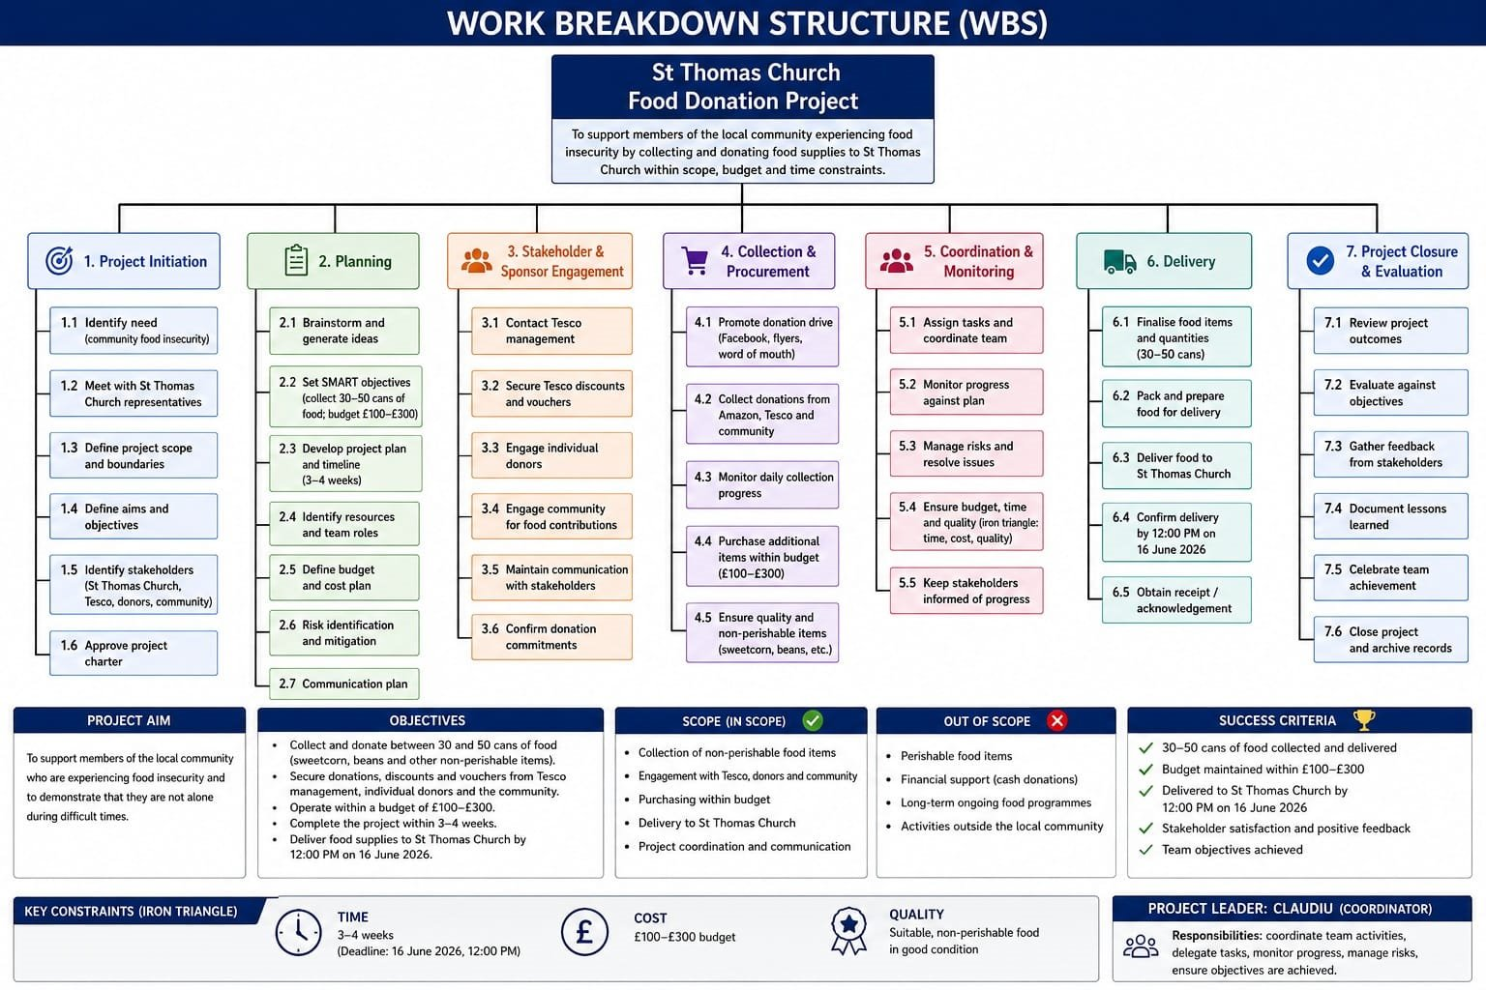
Figure 1. Work Breakdown Structure for the St Thomas Church Food Donation Project
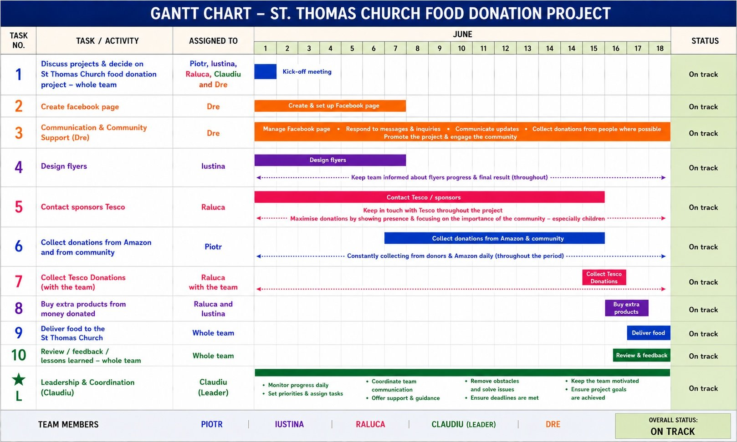
Figure 2. Gantt Chart for the St Thomas Church Food Donation Project

The project also illustrated that success extended beyond the traditional Iron Triangle. Although the project was completed within the agreed timeframe, with limited financial resources, and met the required quality standards, its greatest achievement was the positive impact on the local community. This supports Atkinson's (1999) argument that stakeholder satisfaction and project outcomes provide a more meaningful measure of success than time, cost and quality alone.
Stakeholder analysis proved particularly valuable because it enabled the team to prioritise communication and allocate limited resources effectively. St Thomas Church was identified as a high-power, high-interest stakeholder because it acted as both the project sponsor and beneficiary. Maintaining regular communication ensured that project decisions reflected the charity's changing requirements. Tesco was also recognised as a high-power stakeholder due to its ability to provide additional resources, while Amazon colleagues represented a high-interest stakeholder group whose food and financial donations directly influenced project outcomes. The stakeholder communication priorities are summarised in Figure 3, and the Power–Interest Grid is presented in Figure 4.
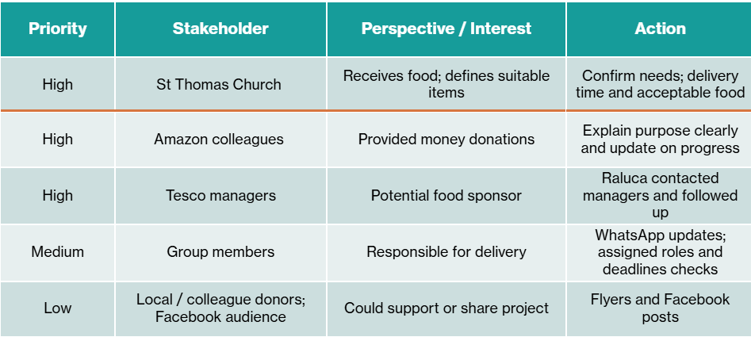
Figure 3. Stakeholder Analysis Matrix

The Power–Interest Grid therefore supported more effective communication by ensuring that stakeholder engagement reflected levels of influence and interest. However, stakeholder priorities were reviewed informally rather than through scheduled reviews. Introducing regular stakeholder evaluations would strengthen future projects by ensuring communication strategies remain appropriate as stakeholder expectations evolve.
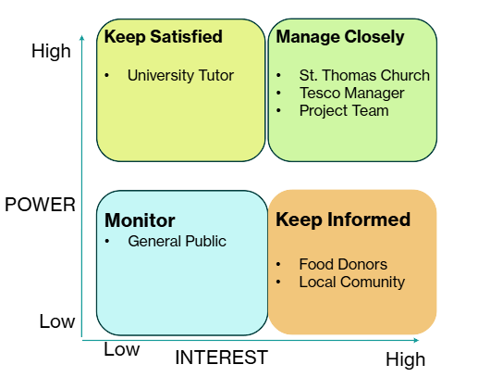
Figure 4. Power–Interest Grid

Effective teamwork contributed significantly to the success of the project. Responsibilities were allocated according to individual strengths, reflecting Belbin's (2010) Team Role Theory. My Belbin profile identified Teamworker as my strongest role, supported by Shaper and Monitor Evaluator characteristics. These roles aligned closely with my responsibilities throughout the project. I proposed the initial project idea, contacted St Thomas Church to identify its requirements, liaised with Tesco to secure additional support and worked collaboratively with the team to refine the project into a realistic community initiative. My Teamworker strengths supported effective communication and cooperation with stakeholders, while my Shaper characteristics helped maintain momentum and overcome challenges during the planning stage. The Monitor Evaluator role also enabled me to assess alternative project ideas before the team agreed on the food donation campaign. This experience demonstrated that aligning individual strengths with project responsibilities improved collaboration, stakeholder engagement and decision-making throughout the project, supporting Belbin's (2010) argument that balanced teams achieve more effective project outcomes.
Monitoring was achieved through regular meetings and WhatsApp group communication, enabling progress to be reviewed and minor issues to be addressed before they affected project delivery. While this informal approach was appropriate for a project of this size, introducing a formal risk register and scheduled review meetings would improve project governance and provide a clearer record of decisions for future community initiatives.

5. Communication and Stakeholder Engagement
Effective communication was essential to the success of the St Thomas Church Food Donation Project because it enabled collaboration between the project team, St Thomas Church, Tesco, Amazon colleagues and members of the local community. According to PMI (2021), effective communication supports informed decision-making, stakeholder engagement, and successful project delivery.
Communication with external stakeholders began during the initiation phase when I contacted representatives from St Thomas Church to establish the charity's requirements before meeting with the project team. Maintaining regular communication throughout the project ensured that stakeholder expectations remained aligned with the project's objectives and community needs.
I also contacted Tesco management to secure additional support, which resulted in increased donations and demonstrated the value of effective stakeholder engagement.
Within the team, communication was maintained through regular meetings and digital messaging, enabling progress to be monitored and responsibilities adjusted where necessary. Although this informal approach was appropriate for a small community project, a formal communication plan would improve accountability and provide a clearer record of project decisions. Too and Weaver (2014) argue that structured communication strengthens project governance by improving transparency and stakeholder confidence. This would be particularly beneficial in future projects involving larger teams or more complex stakeholder relationships.

6. Future Improvements and Personal Reflection
Although the project achieved its objectives, it also identified opportunities to improve future project management practice.
The first area for improvement is risk management. Potential risks were identified and discussed throughout the project but were not formally documented. Developing a risk register during the planning stage would improve project control by assigning ownership, monitoring mitigation strategies and supporting more proactive decision-making (PMI, 2021). Regular project reviews would also strengthen organisational learning by enabling future projects to benefit from previous experience (Crawford and Bryce, 2003).
A second improvement concerns communication planning. Although communication was effective, introducing a formal communication plan would clarify stakeholder responsibilities, determine how project updates should be shared and ensure that key decisions were consistently recorded.
Using Gibbs' (1988) Reflective Cycle enabled me to evaluate both my contribution and the project's overall management. Developing the original project idea, engaging with St Thomas Church and securing support from Tesco strengthened my confidence in stakeholder management, leadership and communication. At the same time, the experience demonstrated the importance of structured risk management, formal communication planning and more consistent documentation of project decisions. These lessons will influence my approach to future projects by encouraging a stronger balance between interpersonal skills and project governance. As part of my continuing professional development, I intend to strengthen my knowledge of project planning, risk management and stakeholder engagement through further experience and professional learning.

7. Conclusion
The St Thomas Church Food Donation Project demonstrated how recognised project management tools and techniques can support the successful delivery of a community-based initiative. Planning tools, stakeholder analysis and effective communication enabled the project to achieve its objectives within the agreed timeframe while responding to stakeholder needs.
The report also demonstrated that project success extends beyond the traditional measures of time, cost and quality. Consistent with the literature, stakeholder satisfaction, collaboration, and community impact proved to be equally important indicators of success. Although future projects would benefit from more formal communication planning and risk management, the project provided valuable practical experience of applying project management theory within a real community setting and contributed to my ongoing professional development.

Reference List:

Atkinson, R. (1999) ‘Project management: Cost, time and quality, two best guesses and a phenomenon, it’s time to accept other success criteria’, International Journal of Project Management, 17(6), pp. 337–342. Available at: https://doi.org/10.1016/S0263-7863(98)00069-6.
Baccarini, D. (1999) ‘The logical framework method for defining project success’, Project Management Journal, 30(4), pp. 25–32. Available at: https://doi.org/10.1177/875697289903000405.
Belbin, R.M. (2010) Team Roles at Work. 2nd edn. Butterworth-Heinemann.
Burke, R. (2013) Project Management: Planning and Control Techniques. 5th edn. John Wiley & Sons.
Clegg, S., Skyttermoen, T. and Vaagaasar, A.L. (2020) Project Management: A Value Creation Approach. Sage.
Crawford, P. and Bryce, P. (2003) ‘Project monitoring and evaluation: A method for enhancing the efficiency and effectiveness of aid project implementation’, International Journal of Project Management, 21(5), pp. 363–373. Available at: https://doi.org/10.1016/S0263-7863(02)00060-1.
Fisher, S.G., Hunter, T.A. and Macrosson, W.D.K. (1998) ‘The structure of Belbin’s team roles’, Journal of Occupational and Organizational Psychology, 71(3), pp. 283–288. Available at: https://doi.org/10.1111/j.2044-8325.1998.tb00678.x.
Freeman, R.E. (1984) Strategic Management: A Stakeholder Approach. Pitman.
Geraldi, J. and Lechter, T. (2012) ‘Gantt charts revisited: A critical analysis of their roots and implications to the management of projects today’, International Journal of Managing Projects in Business, 5(4), pp. 578–594. Available at: https://doi.org/10.1108/17538371211268889.
Gibbs, G. (1988) Learning by Doing: A Guide to Teaching and Learning Methods. Oxford Polytechnic.
Heagney, J. (2016) Fundamentals of Project Management. 5th edn. AMACOM.
Kerzner, H. (2022) Project Management: A Systems Approach to Planning, Scheduling, and Controlling. 13th edn. John Wiley & Sons.
Meredith, J.R., Shafer, S.M. and Mantel, S.J. (2017) Project Management: A Managerial Approach. 9th edn. John Wiley & Sons.
Mitchell, R.K., Agle, B.R. and Wood, D.J. (1997) ‘Toward a theory of stakeholder identification and salience: Defining the principle of who and what really counts’, Academy of Management Review, 22(4), pp. 853–886. Available at: https://doi.org/10.2307/259247.
Müller, R. and Turner, J.R. (2010) ‘Leadership competency profiles of successful project managers’, International Journal of Project Management, 28(5), pp. 437–448. Available at: https://doi.org/10.1016/j.ijproman.2009.09.003.
Project Management Institute (2021) A Guide to the Project Management Body of Knowledge (PMBOK® Guide). 7th edn. Project Management Institute.
Serrador, P. and Turner, R. (2015) ‘The relationship between project success and project efficiency’, Project Management Journal, 46(1), pp. 30–39. Available at: https://doi.org/10.1002/pmj.21468.
Too, E.G. and Weaver, P. (2014) ‘The management of project management: A conceptual framework for project governance’, International Journal of Project Management, 32(8), pp. 1382–1394. Available at: https://doi.org/10.1016/j.ijproman.2013.07.006.
Turner, J.R. (2014) Handbook of Project-Based Management: Leading Strategic Change in Organizations. 4th edn. McGraw-Hill Education.
Ward, S. and Chapman, C. (2003) ‘Transforming project risk management into project uncertainty management’, International Journal of Project Management, 21(2), pp. 97–105. Available at: https://doi.org/10.1016/S0263-7863(01)00080-1.

