Assignment 1 Strategic Management and Sustainability
LCBB6004
Written Report

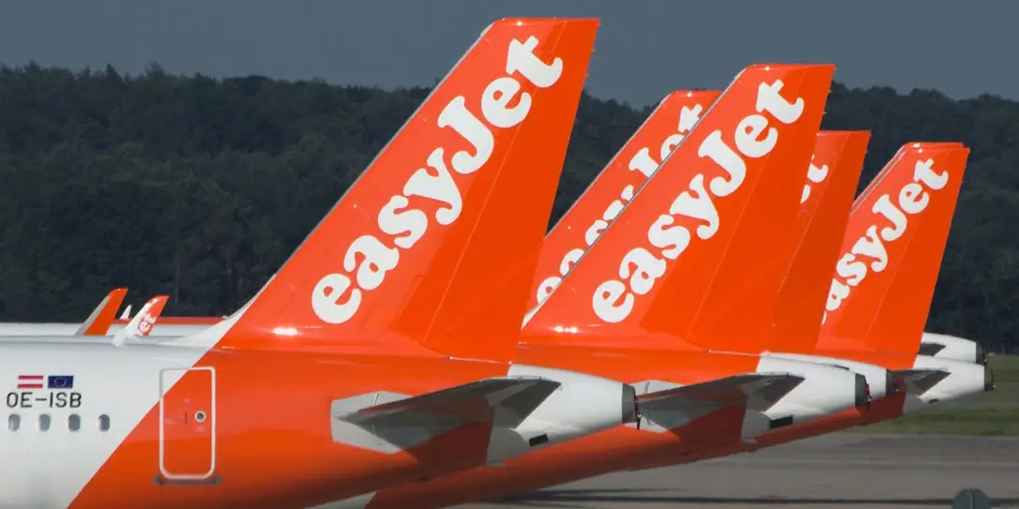

Lecturer Name: Dr. Jaya Gopalkrishnan
Student Name: Tsvetelin Brankov
Student ID: 2024471
Contents
Strategic Review and Evaluation of EasyJet Plc. 3
Introduction 3
Strategic Analysis and Strategies 3
Ansoff’s Growth Matrix 4
Resources and Capabilities 4
Capabilities 5
Market Position 6
Sustainability Initiatives 6
Strategic Options for Growth Recommendation 6
Recommendations to Enhance Sustainability 7
Conclusion 7
References 8

Strategic Review and Evaluation of EasyJet Plc.
Executive Summary.
This paper explores the strategic management of EasyJet Plc, a major low-cost airline traded on the London Stock Exchange. The study focuses on identifying and analyzing the company's business and corporate strategies, rating how successfully these strategies have been executed, and making suggestions for future strategic orientations that prioritize sustainability. Key findings show that EasyJet's cost leadership strategy, backed by strong operational capabilities and a dedication to sustainability, has been critical to the company's competitive advantage. To preserve its market position in a highly competitive climate, the firm must continue to innovate and develop its sustainable practices.

Introduction
EasyJet Plc, founded in 1995 by entrepreneur Stelios Haji-Ioannou, has risen quickly to become one of Europe's leading low-cost carriers (LCC). With its base in Luton, the firm has established a powerful presence throughout Europe, flying a fleet of over 300 aircraft to more than 150 locations. EasyJet's objective is to offer economical air travel while maintaining high levels of customer service and operational efficiency. The airline's strategy has always focused on cost leadership, with the goal of offering low pricing in a market with fierce competition and significant consumer price sensitivity (plc, 2024).
This report will undertake a strategic evaluation of EasyJet's corporate and business strategies, assess their execution, and give insights into future strategic initiatives, notably in terms of sustainability. The analysis will use several strategic management frameworks, such as Porter's Generic Strategies, Ansoff's Growth Matrix, and the VRIO framework, to determine how well EasyJet has matched its resources and capabilities with its strategic objectives.

Strategic Analysis and Strategies

Based on Michael Porter's Generic Strategies, organizations can gain a competitive advantage through cost leadership, differentiation, or focus (Porter, 1985). EasyJet's strategy is consistent with the cost leadership approach, with the primary objective of becoming the lowest-cost manufacturer in the industry. This strategy is achieved via many main initiatives. EasyJet has reduced its processes to reduce expenses. This features high aircraft utilization, rapid airport turnaround times, and a point-to-point route concept that eliminates the complications and expenses associated with traditional carriers' hub-and-spoke networks (CAPA, 2022).
Direct Sales Channels: EasyJet has used digital channels to cut distribution expenses. The majority of its sales take place through its website and mobile app, eliminating the need for travel agencies and other intermediaries. This reduces costs and provides valuable data on customer preferences (EasyJet, 2022).
Cost Control: The airline keeps costs under rigorous control, including fuel hedging measures to reduce fuel price volatility, which is one of the most important expenses for airlines. EasyJet also negotiates advantageous agreements with suppliers and airport authorities to keep operating expenses down (CAPA, 2022).
By concentrating on cost leadership, EasyJet can sustain profitability while offering competitive prices. This method works particularly well in the price-sensitive European airline industry, where customers value money above elegance.

Ansoff’s Growth Matrix
The Ansoff Growth Matrix helps to comprehend EasyJet's business strategy, notably in terms of market expansion and product development (Ansoff, 1957). EasyJet's expansion plan may be divided into two main categories. Market Penetration: EasyJet has concentrated on growing its market share in existing areas. This approach includes boosting flying frequency on key routes, maximizing capacity, and improving customer loyalty programs. Market penetration has been especially effective in key areas such as the United Kingdom, France, and Italy, where EasyJet has a strong brand presence (Johnson et al., 2020).
Market Development of EasyJet has also targeted market expansion by entering new geographic regions. This includes expanding into Eastern Europe, such as Poland and the Czech Republic, and, more recently, the Middle East and North Africa (MENA) area. These markets provide development prospects due to increased demand for low-cost air travel and reduced competition from other LCCs (CAPA, 2022).
Product Development while keeping its basic LCC concept, EasyJet has looked into new product development prospects. This involves the development of supplementary services like seat selection, in-flight sales, and vacation packages, which generate extra income streams. EasyJet has also improved its digital products, such as mobile applications and self-service choices, in order to improve customer experience and promote loyalty (EasyJet, 2022).
Resources and Capabilities
EasyJet's strategy rely on a strong collection of resources and competencies. These resources are assessed using the VRIO Framework (Barney, 1991), which determines if they are valuable, rare, imitablility, and organization to capture value. EasyJet runs a contemporary fleet mostly made up of Airbus A320 family aircraft. The fleet's consistency provides for lower maintenance costs, improved training efficiency, and greater operational flexibility. Furthermore, the fleet's fuel economy helps to reduce operational expenses, which is critical for the company's cost leadership objective (EasyJet, 2022).
EasyJet has significant takeoff and landing slots at major airports in Europe, including London Gatwick, Milan Malpensa, and Paris Charles de Gaulle. These slots are significant assets because they allow EasyJet to provide regular service on popular routes, increasing its market presence and competitiveness (CAPA, 2022).
EasyJet has a healthy balance sheet, ample cash, and access to financial markets. This financial stability has allowed the firm to weather industry downturns, such as the COVID-19 pandemic, while also investing in development possibilities like as fleet expansion and digital transformation (EasyJet, 2022).
Capabilities
Operational Efficiency of EasyJet's ability to attain high levels of operational efficiency is one of its key strengths. This includes short turnaround times, maximum aircraft usage, and a concentration on direct sales. These efficiencies are important to sustaining EasyJet's low-cost structure and competitive advantage (CAPA, 2022).
EasyJet has made major investments in its digital infrastructure, which includes a website, mobile applications, and data analytics tools. These investments allow the organization to provide a more seamless client experience, enhance pricing and capacity management, and lower distribution costs. Digital skills are becoming increasingly crucial in the aviation business, as customer demands for ease and personalization rise (Grant, 2016).
Using the VRIO Framework, the resources and capabilities of EasyJet may be evaluated as follows:
Value: EasyJet's fleet, brand, and operational efficiency are important assets that directly contribute to the company's cost leadership strategy and market competitiveness. Rarity: While other airlines may have comparable tangible resources, EasyJet's mix of brand equity, customer loyalty, and digital skills is uncommon in the LCC business. Competitors may copy operational efficiency, but Imitating EasyJet's brand value and consumer devotion is more difficult. Furthermore, the company's size and experience running a low-cost business provide hurdles to replication. Organization: EasyJet is well-organized to capitalize on these resources and competencies, as indicated by its consistent financial success, strong market position, and capacity to adapt to changing markets.
EasyJet's financial success is a key measure of the effectiveness of its strategy. The corporation has regularly produced solid financial results, especially before to the disruption caused by the COVID-19 epidemic. The key financial measures are EasyJet's income has steadily grown, owing to growing passenger numbers, market expansion, and auxiliary revenue. For example, EasyJet recorded total sales of £6.4 billion in 2019, representing an 8.3% rise over the previous year (EasyJet, 2019).
Profit Margins despite operating in a low-margin business, EasyJet has maintained competitive profit margins by implementing strict cost-cutting initiatives and operational efficiency. In 2019, EasyJet had an operating margin of 7.3%, making it one of the highest among European LCCs (EasyJet, 2019).
Market Position
EasyJet's market position is another evidence of effective plan implementation. The business has established itself as a leader in the European LCC sector, having a significant presence in major markets:
Market proportion: EasyJet has a sizable proportion of the European short-haul market, notably in the United Kingdom, where it is the leading airline by passenger volume. The company's emphasis on high-density routes between key European cities has helped it gain a significant proportion of the business travel category, bolstering its market position (CAPA, 2022).
Network Expansion of EasyJet's market expansion strategy has been effective, with the company growing its network throughout Europe and beyond. The company's expansion into new areas, such as the MENA region, has generated new income streams and diversified its route portfolio, reducing reliance on mature European markets (CAPA, 2022). The company's excellent market position and high customer satisfaction levels demonstrate the efficacy of its plan in action.
Sustainability Initiatives
Sustainability has become an important part of EasyJet's strategy, reflecting both legislative requirements and shifting consumer expectations. The firm has made many steps to improve its environmental performance.
Carbon Offset Program: In 2019, EasyJet became the first major airline to offset carbon emissions throughout its full network. This program invests in carbon-reducing programs such as reforestation and renewable energy efforts (EasyJet, 2021).
EasyJet has pledged to reduce its carbon footprint by investing in next-generation aircraft that are more fuel efficient. The company's fleet renewal plans involves the deployment of Airbus A320neo aircraft, which are 15% more fuel efficient and emit 50% less noise than prior versions (Airbus, 2022).
Strategic Options for Growth Recommendation
As EasyJet looks ahead, it must evaluate many strategic choices to maintain its growth and competitive edge. The following techniques are advised. EasyJet might consider entering the long-haul low-cost market, as competitors such as Norwegian Air Shuttle have done. This would include developing a new business model, maybe through partnerships or joint ventures, to reduce the risks involved with long-haul operations.
EasyJet should continue to invest in digital innovation to improve the customer experience, increase operational efficiency, and generate new income sources. This might involve creating AI-powered tailored services, integrating more digital tools for operational improvement, and using big data to get consumer insights.
Sustainability Leadership, EasyJet should strive to become a sustainable aviation leader by decreasing its carbon footprint and investing in green technology. This might include expediting the use of SAFs, investigating electric or hybrid aircraft technology, and establishing ambitious carbon reduction objectives.
Strategic partnerships creating strategic partnerships with other airlines, particularly in places where EasyJet has a limited presence, might help with market entrance and expansion. Such collaborations may also offer prospects for cost-sharing and collaborative ventures in new markets.

Recommendations to Enhance Sustainability
Given the increasing relevance of sustainability in the aviation business, EasyJet should focus the following measures to get a competitive edge. Adoption of Sustainable Aviation Fuels (SAFs): EasyJet should enhance its investment in SAFs, which have significantly lower carbon emissions than regular jet fuel. Collaborating with fuel providers and investing in SAF production infrastructure might help EasyJet establish itself as a green aviation pioneer. Carbon-Neutral Growth: EasyJet should pledge to achieve carbon-neutrality by offsetting all additional emissions from future expansions. This might include increasing its carbon offset program, investing in renewable energy projects, and funding research on carbon capture and storage technology.
Transparency in Sustainability Reporting by increasing openness in its sustainability reporting, EasyJet can create confidence with stakeholders and strengthen its reputation as an ecologically responsible airline. This involves setting more aggressive carbon-reduction objectives and delivering frequent progress reports.
Adopting these procedures would not only help EasyJet satisfy regulatory standards, but would also boost its brand and market competitiveness. As customers and investors choose firms with excellent environmental credentials, these activities may become a critical driver of long-term competitive advantage.
Conclusion
EasyJet's strategy decisions, notably its emphasis on cost leadership and market development, have cemented its position as Europe's premier low-cost carrier. The company's success is driven by strong operational capabilities and an increasing commitment to sustainability. To retain and improve its competitive edge, EasyJet must continue to innovate, particularly in terms of technology innovation and sustainability. This allows the airline to negotiate the difficulties of an ever-changing industry landscape while also securing its position as a pioneer in inexpensive and environmentally friendly air travel.

References
Airbus (2022) Airbus and EasyJet partner to explore the future of sustainable aviation. Available at: https://www.airbus.com/newsroom/press-releases (Accessed: [Open on 24 08 2024]).
Ansoff, H. I. (1957) ‘Strategies for diversification’, Harvard Business Review, 35(5), pp. 113-124.
Barney, J. (1991) ‘Firm resources and sustained competitive advantage’, Journal of Management, 17(1), pp. 99-120.
CAPA (2022) Market analysis: EasyJet’s position in the European LCC market. Available at: https://www.capa.com/insights (Accessed: [open on 24 08 2024]).
EasyJet Plc (2019) Annual report and accounts 2019. Available at: https://corporate.easyjet.com/investors (Accessed: [Open on 23 08 2024]).
EasyJet Plc (2021) Carbon offset program and environmental initiatives. Available at: https://www.easyjet.com/en/sustainability (Accessed: [Open on 23 08 2024]).
EasyJet Plc (2022) Annual report and accounts 2022. Available at: https://corporate.easyjet.com/investors (Accessed: [Open on 22 08 2024]).
Grant, R. M. (2016) Contemporary strategy analysis. Wiley.
IATA (2021) The future of sustainable aviation fuels (SAFs). International Air Transport Association. Available at: https://www.iata.org (Accessed: [Open on 25 08 2024]).
Johnson, G., Scholes, K. and Whittington, R. (2020) Exploring corporate strategy. Pearson Education.
Porter, M. E. (1985) Competitive advantage: creating and sustaining superior performance. Free Press.
Skytrax (2022) Airline customer satisfaction surveys 2022. Available at: https://www.skytraxratings.com (Accessed: [Open on 24 08 2024]).

