Unity Game Assignment 2
Module: Indie Games Development
Module Code: M5X01043
Module tutor: Kemi Ademoye
Name: Ethan Randell
Course Studying: Video Games Development

Table of Contents
Contents
Introduction 2
Design 2
Implementation of Code 3
Evaluation 8
Bibliography 9

Introduction
The content of this report will be based around the 3D game that the class has been asked to create. There will be a design section which will contain a description of the created game, how you play the game, all of the challenges and actions of the game and what the goal of the game is and other conditions that could end the game or change the level of the game.
In the game there is also a User Interface which shows the player’s health bar and the amount of rocket ammo the player has to use against the infected.
Also there are screenshots of the used scripts that are written in the C# programming language and also of the game itself running also in this report there will be an evaluation of the game as well and how the game can be improved upon for later versions.

Design
Brief description of the game
The game that has been asked to be created is a third person shooter game. The game world is set in a world called titan town the world has been ravaged by a zombie outbreak. You are a cyborg named Sassy who must survive the zombie outbreak until the zombies in the world have been disposed of.
How to play the Game?
In this section of the report the controls of the game will be shown, first is the controls which allow the game character Sassy to move the W key which allows the character to move forward. The S key which allows the character to move backwards, the A key which allows the character to move left and the D key which allows the character to move right.
The space key allows the character to jump, the shift key allows the character to sprint and the C key which allows the character to crouch.
There is no weapon system (due to time constraints this element of the game could not be implemented) but if it was the left mouse click would allow the character to shoot a rocket. Also the health system is created (but sadly could not be implemented due to time constraints).

The gameplay identifying player-centric challenges and actions
The challenges that have been implemented to stop the player from winning the game are many artificial intelligence characters who if the player touches would die and would have to restart the game. (due to time constraints there is no point scoring for how many zombies you kill in the game). The main goal of the game is basically just to survive the zombie outbreak until there are no zombies left in the world.

Implementation of Code
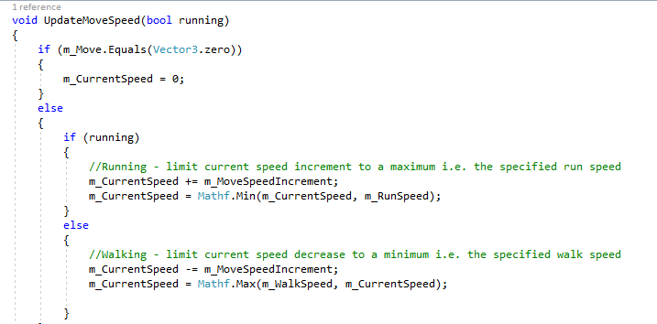

In the screen shot up above this piece of code will update the player’s characters’ movement speed and will also limit the speed to either a maximum for sprinting and a minimum for walking speeds. (this bit of code can be found at the end of the Third Person Control script) inside the script is a lot more code which helps the player model to move around the world.

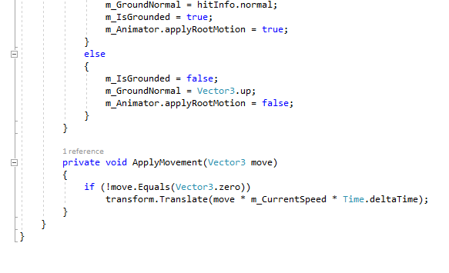

In the screen shot above shows the apply movement method which allows the character to move in real time (This piece of code can be found in the Third Person User Control script) inside the script it has all the code which allows all characters including the artificial characters to move and do other actions like jumping and crouching.
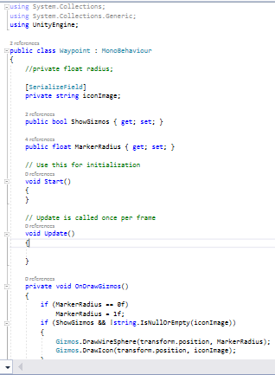
The code in the screenshot above creates waypoints by using gizmos to set the path for the artificial intelligence character to move in a certain route in with the waypoints there are six points each of those points has a little marker image to represent them. It also sets the marker radius’s and will display the markers by using Show gizmos.
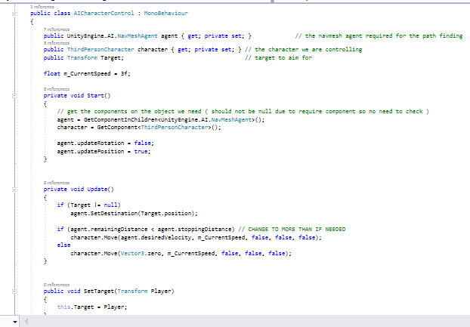

In the screenshot above it shows the code for the AI character Control which controls the character’s movement speed it also sets the target for the AI character and the target for the AI character is the player so if the player comes within a certain distance of the character the character will start attacking the player.
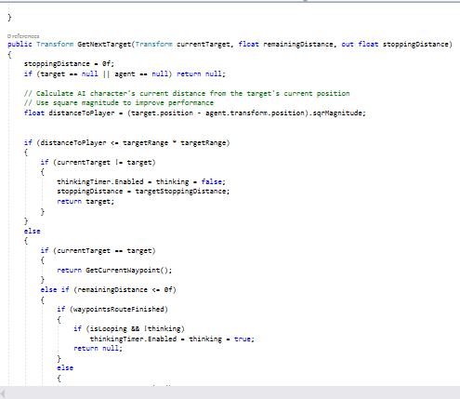
In the screenshot above shows some of the methods used in waypoint collection this specific method is used to find the AI’s next target which will be the player because that’s the only target.

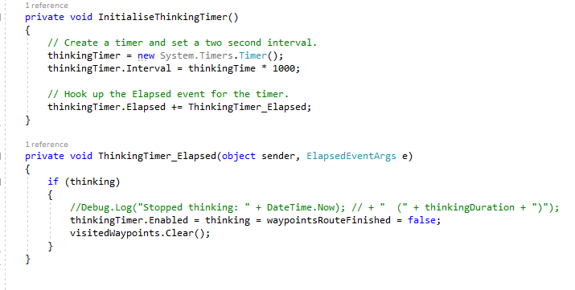

In the screen shot above which is still from the Waypoint collection script gives a thinking timer to the AI to think where to go next and where it has already been in the game world and will stop the AI from going to the previous waypoint.

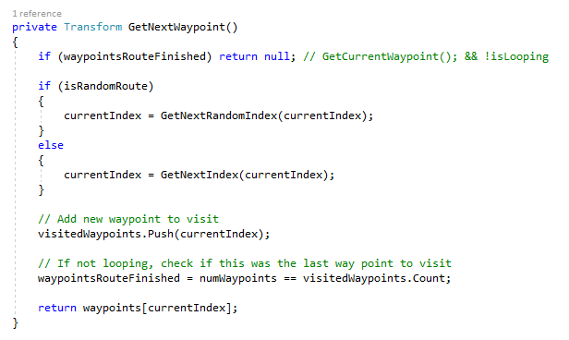
In the screen shot above shows the function which will allow the AI to get the next waypoint for its route and if the AI has finished it will loop through the route again.

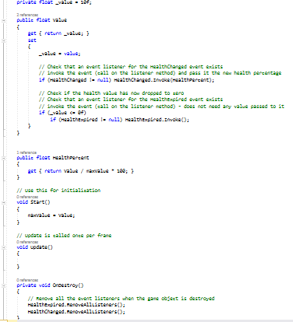
In the code above allows the game character to have health in the method health percent shows how much health the player has, in the method below that gets rid of the health percentage once the character is destroyed. [1]
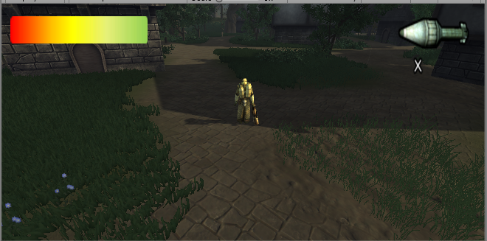
In the screen shot above it shows the game running with the player starting in a little village inside of titan town, in the game a User Interface has been created with a health bar (which will not change if the player takes damage due to time constraints) and also has a little ammunition counter.
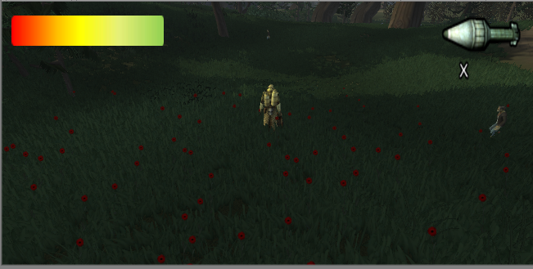

In the screenshot above shows the character sassy in the forest with two AI characters which are zombies and the enemy of the game and you need to avoid them otherwise the character will die.

Evaluation
Discuss any errors and challenges encountered during the implementation and how you have fixed these problems, if you managed to.
During the creation of the game there were many bugs and challenges during its creation one of these was when the sassy character did not move due to not creating a NAV Mesh for the terrain to allow the game character Sassy and the other AI characters to walk on.
The solution to the fixing the problem was simple to fix the problem the terrain had to be selected and go to the navigation tab within unity select the terrain and press the bake button then unity will create a NAV Mesh based around the terrain being used.
The next problem was the AI characters once the Sassy character comes near the AI it goes in an opposite direction due to not setting its target to Sassy some of the AI will come up to you but it’s still a bit broken.
Another problem is the waypoints they have been set up but for some unknown reason the zombie AI’s will not follow the path.
Evaluation of the completed game
Considering that some parts of the game do not work the game can still be loaded and the user can control the Sassy and the AI can move. The design of the game is flawed but still playable to some degree. The Aesthetics of the game all the assets used are really well created even if it is a unity based game also the sassy character does have a life like movement to him but still a bit buggy in his movements.
Improvements for later versions of the game
There can be a lot to improve on in the game one of the improvements would be to make the character’s motion look less buggy and more fluent and life like, another is to get the AI characters to come towards the character much easier and allow them to follow their waypoint collection path,
Another improvement will be to add the missing features within the game such us the reducing health bar, be able to fire rockets and kill enemies and to also implement a player death animation as well. Another improvement will be to allow the AI character to attack you once you are near them, also to include a score counter for points for when you kill one of the AI zombies.

Bibliography

[1] | Uwtsd, “Indie Games Development,” Uknown Unknown Unknown. [Online]. Available: https://moodle.uwtsd.ac.uk/mod/lesson/view.php?id=103354&pageid=760. [Accessed 15 April 2018].

marking criteria and Student FEEDBACK

This section details the assessment criteria. The extent to which these are demonstrated by you determines your mark. The marks available for each criterion are shown. Lecturers will use the space provided to comment on the achievement of the task(s), including those areas in which you have performed well and areas that would benefit from development/improvement.

Common Assessment Criteria Applied (Assignment 2) | Marks available | Marks  awarded
1. Research-informed Literature
Extent of research and/or own reading, selection of credible sources, application of appropriate referencing conventions.
A very basic reference list consisting of a link to the Moodle lecture notes has been provided. Expand the scope of references consulted to help you improve the quality of your work. (Grade mark: 10.00%) | 5 | 0.5
2. Knowledge and Understanding of Subject
Extent of knowledge and understanding of concepts and underlying principles associated with the discipline.
Demonstrates only a basic knowledge of the concepts and principles used to build a game. The submitted work is an incomplete and non-working version of some of the class tutorial exercises. Aim to improve your understanding of basic programming concepts. (Grade mark: 30.00%) | 20 | 6
3. Analysis
Analysis, evaluation and synthesis; logic, argument and judgement; analytical reflection; organisation of ideas and evidence
A brief evaluation and discussion of the challenges faced has been provided. Generally, a more critical review and evaluation of the work is required. (Grade mark: 33.33%) | 15 | 5
4. Practical Application and Deployment
Deployment of methods, materials, tools and techniques; application of concepts; formulation of innovative and creative solutions to solve problems.
A very basic attempt which has mostly just dragged the provided assets into the scene. There is no implemented goal and character interaction is very basic and the player character is simply just wandering around the game world. (Grade mark: 32.73%) | 55 | 18
5. Skills for Professional Practice
Attributes in professional practice: individual and collaborative working; deployment of appropriate media; presentation and organisation.
The report is of average standard. (Grade mark: 50.00%) | 5 | 2.5

Assignment Mark (Assessment marks are subject to ratification at the Exam Board. These comments and marks are to give feedback on module work and are for guidance only until they are confirmed. ) | Late Submission Penalties (tick if appropriate) |  | 32%
 | Up to one week late |  | 32%
 | 1st/2nd/3rd attempt? |  | 32%

