Critical Review

Year 1

My first year at University provided an introduction to as well as understanding of various aspects involved with animation both 2D and 3D. Within first year I was able to identify strengths and weaknesses which I would later expand and develop on in future year.

Visual Studies

For Visual studies, 8 pieces of digital artwork needed to be produced and then Presented via a PowerPoint presentation. Visuals studies was my first introduction to creating artwork digitally, specifically using Photoshop and drawing tablets. This was a major hurdle for me as I was only familiar with sketching on paper.

This assignment allowed me to explore my passion of horror and creature design and drew me into the idea of being a concept artist. Several images of creatures were produced as well as taking old sketches from my sketchbook and turning them into to digital versions. I practiced life drawing in lectures and complimented the work with practicing drawing characters in poses as well as drawing hand gestures.

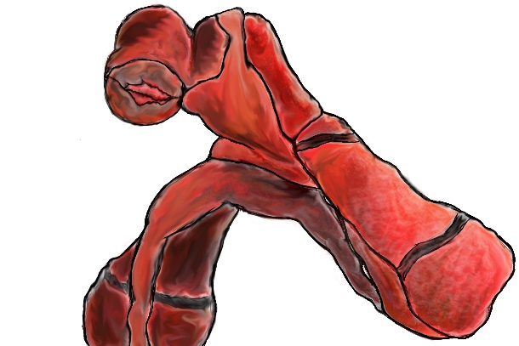
The franchise Silent Hill was my biggest inspiration for my work that inspired me to attempt to create unusual creatures that made the audience feel uncomfortable. Doing research into the development of the game I came across an interview with the Lead monster designer which I returned to multiple times and still do to this day. The interview described what to look for when designing creatures and the importance of symbolism. Two words that stuck with me during the interview was attraction and repulsion. The audience should be first repulsed by the creature but then attracted to the creature though relatability and curiosity.

Ways of Thinking and Perceiving

Ways of thinking and perceiving introduced to more academic thinking as well as trying to expand my perception of art. This assignment as well as the lectures were a struggle for me mainly due to learning difficulties, as I didn’t have much interest in the topics as well as being in what felt like a cramped and crowded environment, I began to lose interest and become restless within the class. Unfortunately, this led to me losing interest and motivation for these classes. This became ongoing problem for these classes, but I was determined to find a way around the problem for future classes.

Creative Practice 1 and 2

Creative Practice was my first time working within groups and was also an introduction to using Adobe Premiere and film editing. Creative practice 2 demonstrated the stages of pre-production which interest me immensely and allowed me to experiment and practice creature design. The primary factor taken from these assignments was primarily working with others and how all members of the group have strengths and weaknesses and how to utilize them effectively to progress the assignments.

Environmental Modelling

The Environmental modelling assignment was my first introduction to Maya. For the assignment we had to create a 3D space based on several themes provided to us. The theme I chose was the Catacombs as it was closest to a potential horror theme. I decided to put my own twist on theme by displaying bodies in an unusual fashion, I created a vent which acted as lair for a serial killer who displayed dead body almost like an exhibition.

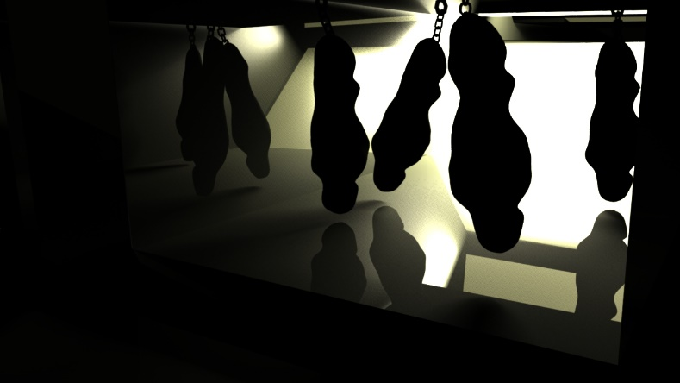
For the assignment Maya was used to create the vent. It was a challenging task learning the basics of Maya, but I was fortunate to have help from my friends who were a year ahead of me in the course.

Many issues were encountered creating the vent the most notable ones being working in a small space and rendering. Moving around inside the vent was difficult with the perspective camera clipping and being obstructed by the walls of the vent. Rendering was an issue to as I underestimated the time it required to render out the scene and some features such as lighting look different once they are rendered.

The assignment gave me an overview of basic modeling and composition within Maya but mainly gave me an understanding of how long creating a piece of 3D work can take and to ensure enough time was left for the next assignment.

Organic Modelling

For Organic modelling we had to design a 3D character. For the assignment Zbrush was introduced as an alternative to Maya for 3D modelling, Zbrush went on to be my preferred software for 3D modelling.

Using Zbrush was a very challenging task as I didn’t feel it was as user friendly as Maya but with over time found that Zbrush was better suited for me than Maya. The assignment allowed me to create a creature from start to finish

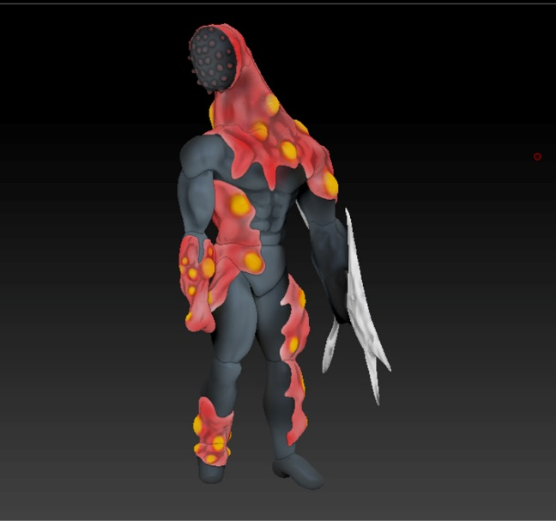
The inspiration for my creature was the Tyrant monster from the game Resident Evil. The Tyrant provided a great combination of human and creature which allowed me to practice creating humanoid characters as well as adding horror elements to the design.

The freedom of creating my own character as well as giving it a backstory and watch it go from 2D to 3D further amplify my passion for horror and creature design.

Year 2

During my second year I was able to expand on skills developed in first year while also trying to achieve a higher level and marks for assignments. I also wanted to tackle issues I encountered for first year mainly being my difficulty with written projects.

Creative Practice 3 and 4

Creative practice 3 and 4 introduced new elements to me such as creating a live action film and using node based compositing software such as Nuke. For the live action film, we worked as a class to create the film. This proved troublesome at times with conflicts on the story and concept of the film, this led to the film becoming very over the top and feeling unachievable.

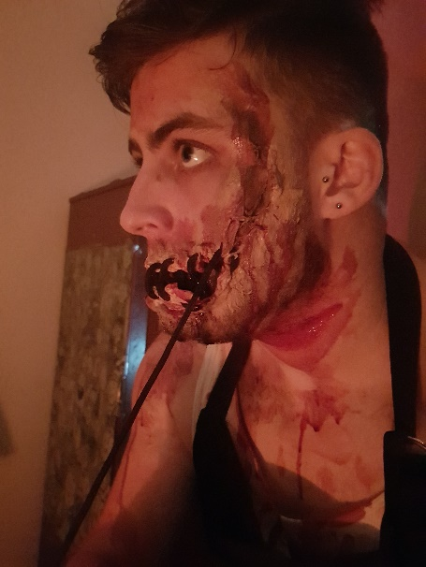
Unfortunately, I became unwell which led to large absence from that class which led to me becoming somewhat disconnected from the project. Once I was healthy, I suggested to the class to use the treatment I created which was simpler and felt more achievable. I was tasked with creature design as well as playing the role of the creature. For the creature design I was able to further practice creating a monster for a specific scenario which was challenging but taught me how to design a creature which fits with and is believable in the story.

I found using Nuke incredibly challenging as I felt more comfortable with the creation and visuals over the more technical elements. After many attempts I was unable to adapt to using Nuke but luckily had help form the VFX students who were able to help me get a basic understanding of the software which added in the completion of the assignment.

Character and Creature

Character and Creature focused heavily on animation and allowed a good level of freedom for me to explore various animation styles. For this assignment the goal I set myself was providing some variety in the animations. We had to choose four animations which were 6 seconds long. I chose to do an unusual movement to help with the animation of the creature for my major project.

The other animations involved a character being dragged, a weightlifting exercise and a tarantula striking. The creature and the tarantula animations were very challenging but gave me a greater understanding of the importance of timing and how far the human body can be pushed whilst still looking believable. The skills learned here were beneficial for future animations.

Art Direction & 3D filmmaking

This assignment to me feels like my best work. I had as much freedom as required to use my imagination and combine it with the skills learned so far. I worked with a classmate who I have worked really well with before, they allowed me to have creative freedom and as we both liked horror and darker themes we were able to combine our ideas into an engaging story for us both whilst both being on the same wavelength.

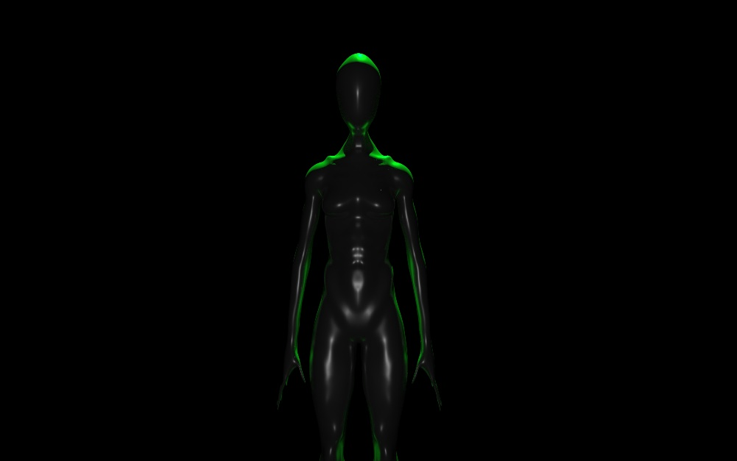
The assignment allowed for the creation of a 3D short created from entirely from scratch. This allowed for me to get a real feel for the entire process of creating a short film. This acted as the key point that made me realize how passionate I was about 3D animation and the ability to make my imagination come to life.

Entrepreneurship

Entrepreneurship I felt was not necessary but as we got into the module more the importance of having knowledge of business and applying to the creation of our own business as well as showing multiple business opportunities to be considered for the future.

Creative Research

Creative research was a purely written assignment which once again proved to be extremely challenging for me. I found myself not being able to engage with the lectures and the topics covered within them. This led to me seeking help from student services but due to stubbornness I decided to continue trying new techniques and refusing help.

I found that listening for key parts in lectures and writing them down allowed me to keep notes for revision, this came at a price requiring my full attention to do so which left me being not to engaged with the lecture, but this method worked.

Year 3

After a successful second year achieving firsts and high 2:1’s I wanted the third year to be my best and to use it to prepare me for Masters. Unfortunately, I encountered multiple personal problems and health problems which left me almost completely disconnected from the course. The course along with other outside projects lead to a great deal of stress but my own stubbornness made me refuse to fail.

I was able to catch up with my assignments as well as reach all the deadlines for outside projects. This required large amounts of organization from me which was never a strong point of mine as well as managing my time efficiently and effectively. Though I was able to hit my deadlines due to consistent health problems it felt like I was constantly playing catch up throughout the year. Due to this unable to commit the amount of time and effort into my assignments as I would have liked.

Advanced Animation

Advanced Animation was linked in with my major project focusing on certain forms of animation and research to help improve the animation within the major project. I chose to do some casting animations for the creature within my major project.
This was an interesting topic as I was able to explore various cultures and rituals linked to spellcasting and magic. Though I was able to put the time in for the research the animation itself suffered due to my absence leaving me little time to complete the animations.

Dissertation

Dissertation is my biggest obstacle to date during the course boasting a very large word count and requiring a great deal of in-depth research. I didn’t have much time to complete the dissertation, but with help and advice on researching and structuring the dissertation I was able to complete the it whilst achieving my highest mark for a written piece of work so far.

Major Project pre-production and production

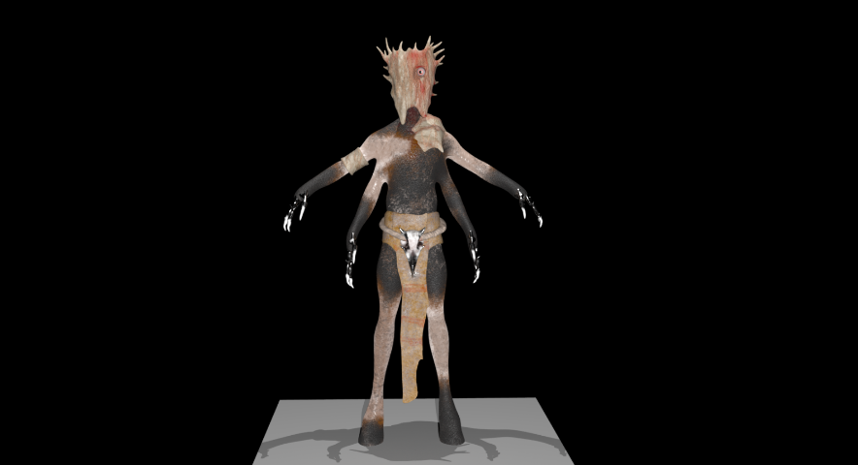
For the major project I teamed up with the same classmate. We learnt from last year how important planning and preparation is from the last project so decided to start the pre-production during second year. For this project we aimed to create a 3D short which was of a higher level compared to our last. My main role was to create an eye-catching creature which tested my skills in the whole creation process from 2D to 3D.

For the 2D side of the pre-production I felt that my skills in concept art improved by a large amount compared to last year. For the 3D creation I tested my modelling abilities by incorporating multiple limbs whilst considering the next steps being rigging and texturing. I was able to learn the process of texturing that proved beneficial for my creature creation that also helped improve my work in my outside projects.

Though Silent Hill is still my biggest reference I started to expand my inspirations more looking into the works of Guillermo Del Toro and Peter Morbacher. The creators produced work that I instantly connected with that caused me to study their work and learn their processes to improve my own.

Conclusion

My skills have developed noticeably throughout the course with both my strengths and weaknesses improving. I have become confident in my work and my knowledge especially with creature design. My skills with creature design have led to me working external projects which has given me great experience working for a client. My written skills still prove to be my biggest weakness, but improvements are being made. For Masters I aim to try to provide work at a high standard possible to prepare myself for work. I will also be searching for job opportunities and planning which path to take once the course is complete.

