
APPENDIX GA36d

LEVEL 7 ASSESSMENT SPECIFICATION

Student name: | Luk Yau Yee | Student ID number: | 2247753
Programme: | MBA
Module: | Human Resource Management
Module code: | HKBM 7007 | Contribution to Overall Module Assessment (%): | 50%
Lecturer: | Dr Leo Ho | Internal Verifier: | Dr Terence Li
Assignment Title: | Assignment 1 – Essay | Word count (or equivalent): | 2,500 words
Submission deadline: | 8 January 2024 | Return date of provisional marks & written feedback: | Within 20 days after submission

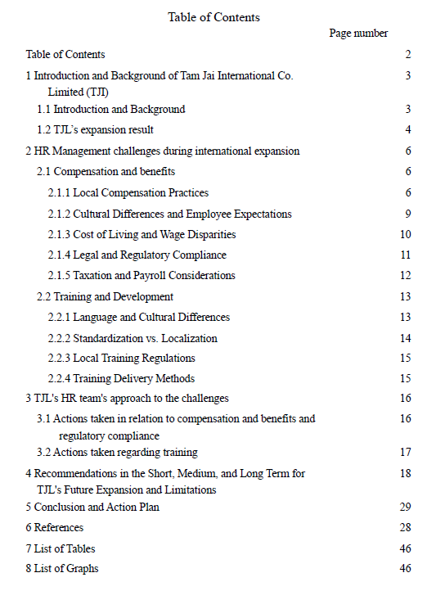
- Introduction and Background of Tam Jai International Co. Limited (TJI)

1.1 Introduction and Background
International Human Resource Management (IHRM) deals with the challenges and strategies organizations face when expanding globally (Reiche, Harzing, & Tenzer, 2018). It includes planning, organizing, directing, and controlling human resource functions like recruitment, development, compensation, integration, and retention. The aim is to contribute to organizational, individual, and societal objectives at both international and domestic levels (Tarique, Briscoe, & Schuler, 2016).

Originally established in Sham Shui Po, Tam Jai Noodles later split into two brands, namely Tam Jai and Tam Jai Sam Gor. In 2018, it was acquired by the Japanese company TORIDOLL Holdings Corporation, forming of Tam Jai International Limited (TJL) to provide management services, responsible for overseeing the operations of Tam Jai and Tam Jai Sam Gor stores (Yahoo News, 2023). The company listed on the Hong Kong Stock Exchange in 2021 (stock number:2217) (Yahoo Finance, 2024). Currently, TJL manages 196 branches in Hong Kong and is also responsible for overseeing branches in Mainland China, Japan, and Singapore.

Aligned with TJL's vision of bringing their unique brand of food culture worldwide, TJI initiated its expansion efforts in 2019. As of November 30, 2023, TJI takes pride in its global presence, with a total of 235 stores, including 196 in Hong Kong, 25 in mainland China, 11 in Singapore, and 3 in Japan.

Table 1: TJL Stores' global allocation in 2023
TJL Stores' global allocation in 2023
Hong Kong | 196
Mainland China | 25
Singapore | 11
Japan | 3
Source: TJL official website

1.2 TJL’s expansion result
TJL's expansion of its restaurant business into China, Japan, and Singapore involves a management structure where a Hong Kong team oversees the operations while local staff are employed for daily operations. The team consists of Parent Country Nationals (PCNs), who are individuals from Hong Kong responsible for managing the foreign locations. On the other hand, the local staff, known as Host Country Nationals (HCNs), are citizens of China, Japan, and Singapore, respectively. HCNs contribute their local knowledge, language proficiency, and understanding of the host country's culture and business environment to ensure smooth daily operations. This approach of utilizing PCNs for management and HCNs for daily operations allows TJL to capitalize on the expertise and familiarity of PCNs with the parent company's culture and processes, while leveraging the local knowledge and understanding of HCNs for effective operations in the host countries (Scullion and Collings, 2006).

Despite a decline in profitability due to high initial costs and external factors impacting prices, the expansion of Tam Jai International Co. Ltd. has led to sustained revenue growth (Tam Jai International Co. Ltd., 2023). The combination of pandemic-related supply chain disruptions and tension in Ukraine has caused significant inflation in major items like energy, commodities, and food. Revenue growth serves as a crucial indicator of the expansion's success in generating income, attracting customers, and evaluating profitability and sustainability (Jindal, 2023). The consistent growth in revenue demonstrates the triumph of the expansion on a global scale).

Graph 1: TJL’s past five-year revenue

Source: TJL Annual report 2022-23

- HR Management challenges during international expansion

The HR department of TJL plays a significant role in the planning, execution, and oversight of the international integration process, acting as a vital connection between the organization and the newly integrated international workforce (Klippa Relocation, 2023).

2.1 Compensation and benefits
When expanding to Japan, Singapore, and China, Tam Jai may face various HR challenges in the area of compensation and benefits. Some of these challenges include:

2.1.1 Local Compensation Practices:
Each country has its own unique compensation practices and regulations. Understanding and adapting to the local compensation structures, such as salary scales, bonus systems, and benefits packages, can be a challenge for Tam Jai's HR team. They need to ensure that the compensation offered remains competitive and compliant with local market standards. Main differences as follow:
Table 2: Main differences between TJL's stores in different countries in terms of Local Compensation Practices
Hong Kong | China | Singapore | Japan
- Market-driven: Compensation practices in Hong Kong are typically market-driven, with salaries and benefits determined by supply and demand for specific roles (Equal Opportunities Commission, 2009)  - Performance-based: Bonuses and incentives based on individual and company performance are common in Hong Kong (Simmons Simmons, 2016)  - Mandatory Provident Fund (MPF): Employers are required to contribute to employees' retirement savings through the MPF scheme (Mandatory Provident Fund Schemes Authority, 2021)  - Competitive benefits: Hong Kong often offers competitive benefits packages, including health insurance, annual leave, and flexible working arrangements (Tham, 2023) | - Government regulations: Compensation practices in China are influenced by government regulations, including minimum wage requirements and social security contributions (Zhou and Zhang, 2023a).  - Regional variations: Compensation levels can vary across different regions in China, with higher salaries typically offered in major cities like Beijing, Shanghai, and Shenzhen. Sometime may also have summer high-temperature allowance (Zhou and Zhang, 2023b)  - Housing funds/benefits: Some employers in China provide housing allowances or accommodations as part of the compensation package (HROne, 2023)  - Double pay: It is common for employees in China to receive double pay (13th-month salary) at the end of the year as a bonus (Global Expansion, 2023) | - Meritocracy and performance-driven: Compensation in Singapore is often merit-based, with performance evaluations and individual contributions playing a significant role in determining salary increases and bonuses (Gilbert, 2023)  - Central Provident Fund (CPF): Employers and employees contribute to the CPF, which serves as a social security system and retirement savings plan (Ministry of Manpower, 2022)  - Bonuses and variable pay: Variable pay, such as performance bonuses and profit-sharing, is prevalent in Singapore (Payboy, 2022)  - Work-life balance benefits: Employers in Singapore often emphasize work-life balance and may offer benefits such as flexible working arrangements, wellness programs, and childcare support, for example Childcare leave and Government-Paid Paternity Leave (GPPL) (Government of Singapore, 2024) | - Seniority-based system: Japan has a strong emphasis on seniority, and compensation often reflects an employee's length of service within the company (Sueki, 2016)  - Bonus system is complicated: Japanese companies often provide semi-annual bonuses, known as 13th and 14th month pay, to their employees. The amount of bonuses is typically based on company profits and can range from one to three times the monthly wage. While discretionary, bonuses are commonly given in Japan, leading employees to view them as a customary part of their compensation (Yani, 2023a)  - Benefits and allowances: Employers in Japan may provide various benefits and allowances, including transportation allowances, housing allowances, and social insurance coverage, even dietary assistance. (asinta, 2023)  - Lifetime employment: Japanese companies often prioritize job security and long-term employment relationships, offering stability and benefits tied to long-term commitment (Ly, 2023)

2.1.2. Cultural Differences and Employee Expectations:
The differences in cultural norms and employee expectations regarding compensation and benefits across Japan, Singapore, and China necessitate that TJL's HR team adeptly navigate these variances and tailor their compensation and benefits offerings accordingly. This process entails acquiring an understanding of diverse attitudes towards benefits, incentives, and work-life balance. To effectively address these cultural disparities and align compensation and benefits offerings in Japan, Singapore, and China, TJL's HR team should engage in comprehensive research pertaining to local practices and values and cultural competence should be equipped for the TJL’s HR (Kornegay, 2023).
In Hong Kong, one of the most appealing employee benefits is the "TJI Education Support Scheme for Employees' Children." Under this scheme, employees' children who are accepted into one of the eight universities in Hong Kong receive an 80% tuition subsidy, while the children are required to work at Tam Jai for 72 hours as part of the experience, enabling them to understand the challenges of earning money through work. This welfare policy is highly regarded by employees in Hong Kong and significantly enhances their sense of belonging (HKET, 2022).

However, the same policy may not be as well-received in Japan and Singapore due to its lack of specificity. In Hong Kong, frontline employees at Tam Jai are generally middle-aged women with children, whereas in Japan and Singapore, they are typically students who are still pursuing their education (HK01, 2022b). Consequently, this benefit may not hold much appeal for them.

2.1.3 Cost of Living and Wage Disparities:
Regional disparities in living costs and wage levels exist within Japan, Singapore, and China. When establishing compensation packages for TJL employees, the HR team must carefully consider these variations. Ensuring equitable and consistent compensation across different locations can be complex, particularly when accounting for local wage norms and discrepancies in the cost of living (shrm, 2023a). This challenge is further compounded by potential differences in minimum wage requirements between nations and countries.
Table 3: Minimum hourly wage in 4 countries:
Hong Kong | HKD 40
China-Shenzhen | HKD 26.4 (RMB24)
Japan | HKD 61.03 (YEN1130)
Singapore | HKD 68.97 (SGD11.75)
By this research

Consequently, variations in wages are expected across these countries, potentially resulting in dissatisfaction among individuals holding the same job in countries with lower minimum wages when observing others receiving higher compensation for performing identical work. The HR team should be adequately prepared to address such inquiries in a professional and standardized manner.
2.1.4. Legal and Regulatory Compliance:
Each country has specific labor laws and regulations related to compensation and benefits. TJL's HR team needs to stay updated on these regulations to ensure compliance. This includes adhering to minimum wage requirements, overtime regulations, social security contributions, and other statutory benefits mandated by law in each country.
Table 4: Comprehensive Knowledge Required for Human Resource Professionals: Ordinances, Schemes, and Related Government Agencies in Compensation and Benefits
Regions | Ordinances/ Schemes | Government agency
Hong Kong | - Employment Ordinance  - Minimum Wage Ordinance  - Occupational Safety and Health Ordinance  - Disability Discrimination Ordinance  - Employees' Compensation Ordinance  - Mandatory Provident Fund (MPF) | Labour Department
China | - Employment Contract Law  - Labor Law  - Social Insurance Contributions  - Occupational Safety and Health Regulations | Ministry of Human Resources and Social Security
Japan | - Labor Standards Act  - Employment Security Act  - Industrial Safety and Health Act  - Act on Childcare Leave, Caregiver Leave, and Other Measures for the Welfare of Workers Caring for Children or Other Family Members | Ministry of Health, Labour and Welfare" (MHLW)
Singapore | - Employment Act  - Workplace Safety and Health Act  - Retirement and Reemployment Act  - Central Provident Fund (CPF) | Ministry of Manpower (MOM)
By this research

2.1.5. Taxation and Payroll Considerations:
The management of payroll and taxation can present intricate challenges when expanding operations across multiple countries. TJL's HR team is tasked with the responsibility of ensuring adherence to tax regulations, encompassing obligations such as withholding taxes and reporting requirements. Additionally, they must consider the administrative and logistical complexities associated with handling payroll in diverse currencies and coordinating with local accounting or payroll service providers (Jones, 2022).

2.2 Training and Development
In an interview with HK01, Mr. Daren Lau, CEO of TJL, expressed his commitment to preserving Tam Jai's distinctive culture and soup base flavor while expanding the brand globally (HK01, 2022b). The vision of TJL revolves around providing customers with a comforting bowl of Chinese noodle soup and warm, friendly service reminiscent of Hong Kong's hospitality. The objective is to bring Tam Jai's unique flavors and culinary heritage to different global locations, allowing people worldwide to experience the authentic taste of Hong Kong. Mr. Lau emphasized the importance of local staff members serving as guides to help customers explore their preferred ways of enjoying the noodles, including the option to customize ingredients and spice levels.

The training team has specific objectives to fulfill: ensuring cooks adhere to standardized protocols and procedures for soup base preparation, and aligning waitstaff greetings with Hong Kong's cultural practices while incorporating localized elements for specific markets.

TJL's HR team, responsible for overseeing these trainings, is expected to face various challenges, especially in the short term, requiring immediate attention (P. Nick Blanchard & Thacker, 2017). It is crucial to equip local staff with diverse skills to efficiently operate the stores.

2.2.1. Language and Cultural Differences:
Language barriers and cultural differences present challenges to training and development efforts at TJL. The HR team must ensure accurate translation and cultural adaptation of training materials and programs to meet the specific needs of employees in each country. For example, soup base recipes need to be translated into English, Simplified Chinese, and Japanese to enable local cooks to replicate the authentic taste of the Hong Kong soup bases.

Similarly, greeting protocols face similar challenges and require incorporation of local cultural factors. In Hong Kong, the "Tam Jai Je Je" culture is well-known, where customers feel a sense of warmth and familiarity as if cared for by their own mothers. This facilitates easier greetings and cross-selling. However, in Japan, the situation differs. Most staff members are younger and part-time, and they often forget to engage in cross-selling. This may be attributed to the Japanese cultural tendency of being more frugal and not actively pursuing cross-selling opportunities (HK01, 2022a).

The store manager also mentioned, "However, I have taught them the 'Tam Jai's spirit' so that they can work together like a family and serve customers with a smile and a friendly attitude. Unfortunately, it's really difficult for them to speak in Japanese like the waitresses in Hong Kong do! Only the Hong Kong waitresses can do it." (HK01, 2022a) No wonder, a Hong Kong Key Opinion Leader (KOL) visiting Tam Jai Sam Gor in Japan also expressed some discomfort, saying, "The waitresses in Japan are very polite, they even bow when serving the food. I'm not used to it!". The aforementioned scenario is also applicable in Singapore, emphasizing the necessity of tailoring staff training programs to specific regions. It is imperative to undertake an investigation to identify any potential skills gaps and take into account the local cultural elements in order to effectively address this issue.

2.2.2. Standardization vs. Localization:
Achieving a balance between standardization and localization poses a challenge for Tam Jai's HR team. They must determine which training elements should be standardized to maintain consistent quality and which elements should be adapted to suit the specific needs and cultural context of each country. For example, in Japan, where attentive and meticulous service is prioritized (Yani, 2023b), it becomes necessary to adapt training to the local culture and address cultural differences.

Identifying these differences and effectively delivering training to local employees can be challenging, especially when the trainer lacks prior experience or training in the specific cultural context. For instance, a trainer from TJL providing training to frontline staff in Hong Kong may not have been taught to offer aprons to customers wearing white clothes as a preventive measure against soup splatters, which is a necessary practice in Japan (Sing Tao News, 2022). This highlights the importance of understanding and incorporating local practices during training to ensure a seamless customer experience.

2.2.3. Local Training Regulations:
Each country has its own training regulations and requirements. Tam Jai's HR team needs to familiarize themselves with these regulations to ensure compliance. This may involve understanding mandatory training programs, certifications, and licensing requirements specific to each country. For example, the license and certificate of cooks. In japan, cooks are required to obtain a certification known as the "National Certificate of Cooking Skills" or "Kokka Shokuryo Ginou Kentei." But not in Singapore and China.

2.2.4. Training Delivery Methods:
Selecting appropriate training delivery methods poses a complex task, as it necessitates considering diverse factors, including technological infrastructure, accessibility, and employee preferences, which exhibit variations across countries (Chebium, 2015). Notably, research by Meyer (2014) highlights the preference of Japanese individuals for Programmed instruction, while Chinese individuals tend to favor lecture-based approaches. In light of these distinctions, the HR team at TJI faces the imperative of discerning the most suitable training delivery methods. This may involve a judicious blend of in-person training, e-learning platforms, on-the-job training, or other pedagogical approaches to optimize the effectiveness of the learning process.

- TJL's HR team's approach to the challenges

3.1 Actions taken in relation to compensation and benefits and regulatory compliance:
3.1.1 Established agreements with its parent company in Japan
TJI has established agreements with its parent company in Japan to access Business Consulting Services and Operations Support Services (Tam Jai International Co. Limited, 2023). These agreements enable TJL to tap into specialized expertise in areas relevant to human resources, such as payroll, tax, and compliance, as well as receive support in functions including human resources, administration, accounting, and finance.

The collaboration with the parent company in Japan for Business Consulting Services and Operations Support Services equips TJI with specialized expertise, support, and streamlined operations, particularly in HR-related areas. By leveraging the parent company's knowledge in payroll, tax, compliance, and accessing support in functions like human resources, administration, accounting, and finance, TJI can enhance operational efficiency, ensure regulatory compliance, manage risks, and potentially achieve cost savings by leveraging the parent company's existing resources.

As exemplified in TJL's annual report, the organization has successfully executed the following strategy: Employees engaged by TJL in locations beyond Hong Kong are actively enrolled in appropriate local defined contribution retirement schemes, ensuring compliance with the prevailing labor laws and regulations of the specific jurisdictions. In relation to the retirement benefits scheme, the organization's sole obligation lies in fulfilling the specified contributions as mandated by the relevant authorities.

3.2 Actions taken regarding training:

3.2.1 Knowledge exchange initiative
To preserve the distinctive culture of Tam Jai, TJL has facilitated a knowledge exchange initiative by inviting the general manager from Japan to undergo a one-month immersion in Hong Kong in 2021, aimed at acquiring a comprehensive understanding of the core values and cultural essence of Tam Jai. The objective behind this endeavor is for the general manager to assimilate the insights gained during their time in Hong Kong and subsequently apply them to the operations in Japan (譚仔三哥米線, 2022).

3.2.2 Cross-cultural training initiative
Furthermore, TJL has organized a cross-cultural training initiative by sending Hong Kong front-line staff, known as "Tam Jai Je Je," to both Hong Kong and Singapore. Their purpose is to provide training to local staff in Japan and Singapore, equipping them with the necessary skills and knowledge for effective daily operations for 3 days (譚仔三哥米線, 2020).

The aforementioned shared cultures model initiatives have yielded successful outcomes, as evidenced by customers' feedback indicating that their experiences at overseas Tam Jai outlets are comparable to those in Hong Kong in terms of taste and service quality (新假期, 2020).

The recognition of cultural differences and their impact on behavior and management practices in TJL would be beneficial. Through the facilitation of knowledge exchange and cross-cultural training, TJL demonstrates an acknowledgement of the significance of comprehending cultural subtleties and adjusting management approaches to suit diverse markets. This stance aligns with the notion of cultural sensitivity and underscores the necessity of cultural adaptation in international business operations (Doh and Luthans, 2018).

4. Recommendations in the Short, Medium, and Long Term for TJL's Future Expansion and Limitations:
Based on the annual report of TJL, the company expresses its intention to pursue further expansion in Hong Kong, Japan, Singapore, and second-tier cities within the Greater Bay Area. Additionally, TJL aims to enter the Western market, specifically targeting Australia and the Philippines. In light of these plans, the following recommendations are proposed for TJL's HR team:
Table 5: Major Challenges, TJL's Solutions, Recommendations for Future Expansion, and Limitations
Challenges on | TJL’s Solutions | Recommendations for future expansion |  | Limitations
Compensation and Benefits:  - Local compensations practices differences  - Cultural difference and employee expectation  - Wage disparities  - Legal and compliance  - Taxation and payroll | Established agreements with its parent company in Japan to seek expertise in different fields (tackle 1, 4, 5)  Prepare standardized replies and present clear and structured compensation policies (Jetso, 2022) (tackle 3) | Short Term | - Conducting thorough investigations and benchmarking exercises, facilitated by local consultants, is essential to understand the specific factors that truly appeal to employees in different countries. These factors can be influenced by various demographic characteristics, including age, gender, and cultural nuances. By tapping into the expertise of local consultants, organizations can gain valuable insights into prevailing compensation and benefits practices, enabling them to tailor their packages to meet employees' expectations and enhance their attractiveness as employers. The analysis should consider both quantitative and qualitative factors, such as salary ranges, bonus structures, non-monetary benefits, work-life balance preferences, and career progression opportunities. By adopting this approach, organizations can create a compensation and benefits package that resonates with employees in specific countries and contributes to higher satisfaction and retention rates (Zeuch, 2016).  - Sign agreements with local partners/mother company to leverage resources and gain a better understanding of the local market. This collaboration allows for optimal resource utilization and access to local expertise, insights, and networks. | These suggestions have limitations that should be considered. Conducting thorough investigations and benchmarking exercises with local consultants can be costly and time-consuming, potentially resulting in incomplete findings and limited generalizability. Similarly, signing agreements with local partners for resource leverage can lead to dependency and conflicts of interest. Organizations should carefully allocate resources, address potential biases, and continuously evaluate the effectiveness of these strategies to mitigate these limitations and maximize their impact.
 |  | Medium Term | - Implement a Total Rewards Strategy aligned with the development direction: Formulate a comprehensive Total Rewards Strategy that transcends monetary compensation and encompasses non-monetary benefits such as healthcare coverage, retirement plans, flexible work arrangements (at headquarters), and career development opportunities. This approach will foster a competitive and comprehensive employee value proposition. As innovation is a key theme at TJL, the company could initiate a campaign inviting employees at all levels to contribute their innovative ideas. Upon adoption of these ideas, employees could be eligible for non-monetary-based benefits as recognition for their contributions (shrm, 2023b).  - Implement Performance Management in global context, it involves aligning individual and team performance with organizational goals across different countries and cultures. It requires clear communication of performance expectations, adaptable appraisal systems to suit local practices, effective cross-cultural communication, training and development programs tailored to regional needs, regular feedback and recognition, support for performance improvement, utilization of technology for data management, and compliance with legal and ethical standards. By considering these factors, organizations can successfully implement performance management practices that promote employee development, engagement, and goal alignment in diverse international settings (Brown et al., 2018).  - Establish Employee Engagement Platform: Regularly communicate the value of the compensation and benefits package to employees and gather their feedback through surveys and focus groups to make necessary adjustments to meet their preferences. This iterative approach ensures alignment with employee needs and enhances their satisfaction (Segal Benz, 2023). | These suggestions, while beneficial, have certain limitations to consider. Implementing a Total Rewards Strategy may require significant investment and resources. Additionally, ensuring the alignment of individual and team performance with organizational goals in a global context can be challenging due to cultural differences and varying local practices. Establishing an Employee Engagement Platform requires ongoing communication and feedback gathering, which can be time-consuming. Organizations should carefully assess their capabilities, allocate resources effectively, and address potential challenges to maximize the success of these initiatives.
 |  | Long Term | - Global Mobility and Develop Expatriate scheme: To provide a global perspective and diverse experience within the organization, it is recommended to implement a Global Mobility program and expatriate scheme. This involves developing policies and practices for managing international assignments and transfers. By offering opportunities for employees to work in different divisions and functions abroad, the organization can support their professional development and broaden their understanding of the global operations. This can be achieved by carefully designing compensation packages that address the unique challenges and opportunities associated with working in diverse countries, considering factors such as cost of living, tax implications, and relocation support. By fulfilling the rising star's interest in gaining a global view of the organization, the company can foster talent development and enhance employee engagement. (Deloitte, 2010).  - Benefits Flexibility: Offer flexibility in benefits packages to accommodate diverse TJL’s employee needs and preferences. Consider implementing flexible spending accounts or cafeteria-style benefit programs that allow employees to choose benefits that best suit their individual circumstances (Kagan, 2023). But needs to pay attention to the specific regulations and requirements for implementing such plans may differ between jurisdictions.  - Market Monitoring: Multinational enterprises (MNEs) offer a variety of trendy benefits to attract and retain employees. Some popular offerings include flexible work arrangements like telecommuting and flextime, wellness programs promoting physical and mental health, financial wellness benefits such as retirement plans and financial education resources, diversity and inclusion initiatives like employee resource groups and mentorship programs, professional development and training opportunities, family-friendly benefits such as parental leave and childcare assistance, employee assistance programs for mental health support, and social responsibility initiatives like volunteer programs and sustainability initiatives. These benefits cater to employees' work-life balance, well-being, career growth, and their desire to contribute to meaningful causes (Enrich, 2023). | The suggested initiatives have certain limitations that should be considered. Implementing a Global Mobility program and expatriate scheme may require significant resources and careful management of international assignments. Ensuring fairness and addressing the unique challenges associated with working in diverse countries can be complex. Offering benefits flexibility may also present challenges due to varying regulations and requirements in different jurisdictions. Additionally, while monitoring the market for trendy benefits is important, it is crucial to align these offerings with the organization's goals and consider the specific needs and preferences of TJL employees. Careful planning, compliance with regulations, and regular evaluation are essential to maximize the effectiveness of these initiatives.
Training and Development:  - Language and culture differences  - Standardized and localization  - Local Training requirement  - Training Methods | Knowledge exchange initiative: Foreign staff come to HK to learn the essentials, that allows for customization while maintaining core standards (tackle 1,2)  Cross-cultural training initiative: HK staff go overseas to conduct training (tackle 1,2,4) | Short Term | - A comprehensive training needs analysis should be conducted to assess the existing skill gaps within the organization. Subsequently, collaboration with local trainers should be established to deliver training programs in a manner that aligns with the preferences and learning styles of the local staff. This approach aims to optimize the effectiveness of the training initiatives and facilitate seamless daily operations.  - Collaborate with local trainers or subject matter experts to customize training content to reflect local practices and regulations. | Conducting a comprehensive training needs analysis can be resource-intensive and time-consuming. It requires careful data collection and analysis to accurately identify skill gaps within the organization. Collaborating with local trainers may also present challenges, such as language barriers or differences in training methodologies. Additionally, customizing training content to reflect local practices and regulations requires a deep understanding of the specific requirements in each region. It is important to allocate appropriate resources, establish effective communication channels, and ensure the expertise and credibility of local trainers or subject matter experts. By addressing these limitations, organizations can enhance the relevance and impact of their training initiatives in different regions.
 |  | Medium Term | - Provide HR staff with cross-cultural competencies, which are considered a core competency for International Human Resource Management (IHRM). These competencies enable HR professionals to effectively execute HR functions in diverse regions, demonstrating their abilities to navigate and adapt to cultural differences while carrying out their roles (Farndale, 2000)  - Establish an e-learning platform and implement a blended learning approach, combining traditional classroom-style training with online learning methods. This strategy allows for greater flexibility and personalization in the learning experience, involving a combination of in-person workshops, seminars, and online modules or e-learning platforms (Raouna, 2021). By incorporating diverse learning modalities, employees can engage with the content according to their individual preferences and needs. This approach provides flexibility and reduces staff transportation costs associated with travel.  - Establish cross-cultural communication programs to enhance language skills and cultural competence among employees (CCP, 2023)  - Developing an ethical training program is crucial for TJL's long-term success. This program will instill ethical values, enhance employees' understanding of ethics, and equip them with the skills to make ethical decisions. It should include modules on ethical awareness, decision-making frameworks, and real-life case studies. Additionally, training for managers on ethical leadership is important. Regular evaluations will ensure the program's effectiveness in fostering an ethical culture, building trust, and maintaining a positive reputation (Small, 2021) | The suggestions provided have certain limitations that should be considered. Providing HR staff with cross-cultural competencies requires significant investment in training and development programs. It may also take time for HR professionals to acquire and apply these competencies effectively. Establishing an e-learning platform and implementing a blended learning approach requires careful planning and technological infrastructure. Not all employees may have access to reliable internet connections or possess the necessary digital literacy skills. Cross-cultural communication programs may require additional resources for language training and cultural immersion activities. Developing an ethical training program necessitates ongoing commitment and reinforcement to embed ethical values and behaviors within the organization's culture. It is important to allocate resources appropriately, assess the effectiveness of these initiatives, and provide continuous support and reinforcement to maximize their impact.
 |  | Long Term | - Establish a multicultural workforce group aimed at regularly disseminating news and promoting cohesiveness among different segments of the workforce, similar to the organizational structure of multiple functional shared service centers with both global and local members. This approach allows for the alignment and integration of best practices across the organization, fostering knowledge sharing and eliminating the need for redundant efforts in reinventing processes (Ely and Thomas, 2020)  - As part of the main development stream of "Uplifting people," establish a down-to-up approach to address the training needs of specific regions. This approach ensures that the training programs reflect the requirements of local and frontline staff, enabling them to enhance their performance and unleash their full potential. By actively soliciting input and feedback from these employees, their specific needs and challenges can be identified and incorporated into the training initiatives, resulting in improved performance outcomes (Bleich, 2018) | The suggested initiatives have certain limitations that should be considered. Establishing a multicultural workforce group requires careful structuring and coordination to ensure effective communication and collaboration among members from different segments of the workforce. It may be challenging to maintain active participation and engagement from all members, especially if there are conflicting priorities or limited resources. Implementing a down-to-up approach for training needs assessment and development requires effective mechanisms for gathering feedback and input from local and frontline staff. It may be time-consuming and resource-intensive to incorporate the specific needs and challenges of each region into the training initiatives. It is important to establish clear channels of communication, allocate resources appropriately, and continuously evaluate the effectiveness of these initiatives to maximize their impact on cohesiveness and performance improvement within the organization.

- Conclusion and action plan:

In conclusion, as TJL expands globally, its HR team is encountering various challenges in areas such as compensation and benefits, as well as training and development. While the company has already taken steps to address these obstacles, there is still room for improvement. By adopting a more comprehensive and strategic approach to enhance global HR practices, TJL can reap numerous benefits.

By addressing the challenges in compensation and benefits, TJL can attract and retain top talent, foster a competitive employee value proposition, and ensure employee satisfaction. Moreover, implementing effective training and development programs aligned with organizational goals can enhance performance, engage employees, and support their professional growth.

To prepare for future expansion into Western markets, TJL must learn from past experiences and continually strive for improvement. By refining their global HR practices, TJL can better navigate the complexities of international markets, meet the needs and preferences of a diverse workforce, and position themselves for success.

In summary, by proactively enhancing their global HR practices, TJL can address existing challenges, leverage opportunities, and create a foundation for sustained growth and success in the global marketplace.
(2732 words)
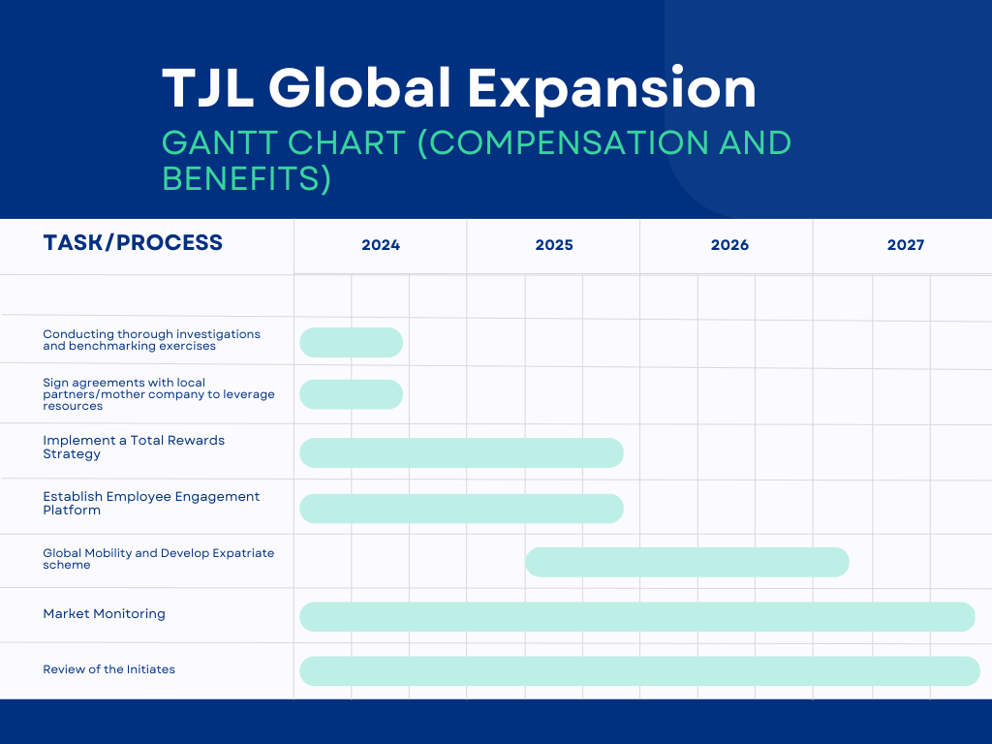
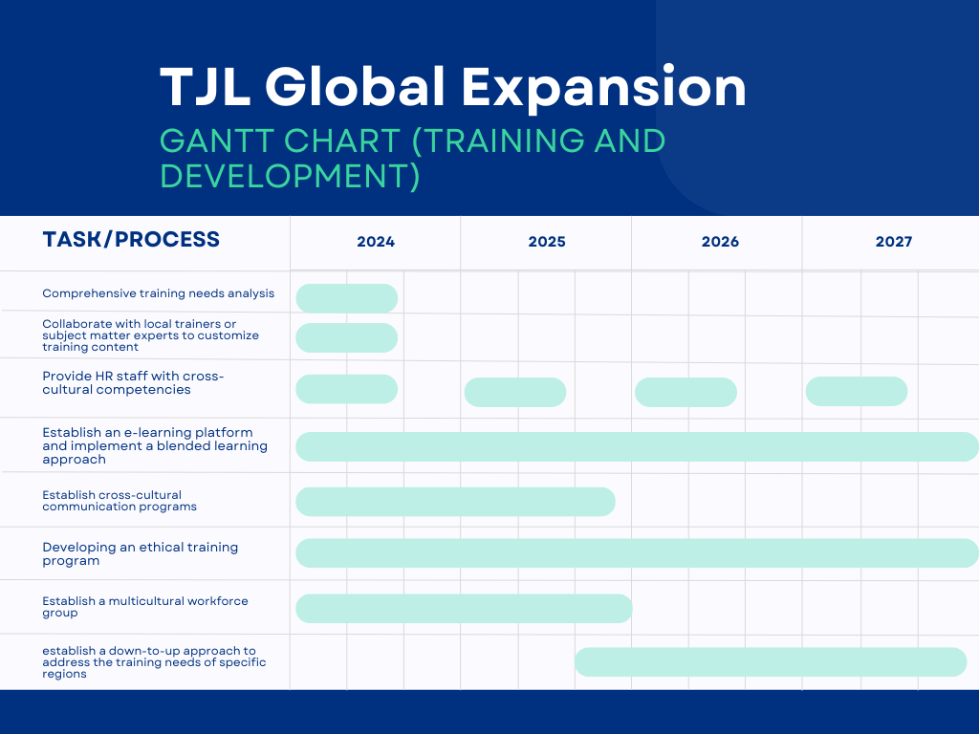

- References
asinta (2023). Mandatory Employee Benefits in Japan. [online] Asinta. Available at: https://www.asinta.com/countries/employee-benefits-in-japan/ [Accessed 6 Jan. 2024].
Bleich, C. (2018). How To Conduct A Training Needs Analysis. [online] EdgePoint Learning. Available at: https://www.edgepointlearning.com/blog/training-needs-analysis/ [Accessed 8 Jan. 2024].
Brown, T.C., O’Kane, P., Mazumdar, B. and McCracken, M. (2018). Performance Management: A Scoping Review of the Literature and an Agenda for Future Research. Human Resource Development Review, [online] 18(1), pp.47–82. Available at: https://journals.sagepub.com/doi/10.1177/1534484318798533 [Accessed 8 Jan. 2024].
CCP, D.K., MA (2023). How to Improve Cross-Cultural Communication Skills in Employees. [online] The Soft Skills Group. Available at: https://www.tssg.ca/improve-cross-cultural-communication-skills-for-global-business-success/ [Accessed 8 Jan. 2024].
Chebium, R. (2015). How to Create an Effective Cross-Cultural Training Program. [online] www.shrm.org. Available at: https://www.shrm.org/topics-tools/news/hr-magazine/how-to-create-effective-cross-cultural-training-program [Accessed 8 Jan. 2024].
Deloitte (2010). Smart moves A new approach to international assignments and global mobility. [online] Smart moves A new approach to international assignments and global mobility. Available at: https://www2.deloitte.com/content/dam/Deloitte/us/Documents/Tax/us-tax-talent-smartmoves-062410.pdf [Accessed 8 Jan. 2024].
Doh, J.P. and Luthans, F. (2018). International Management : Culture, Strategy, and Behavior. 10th ed. New York, Ny: Mcgraw-Hill Education.
Ely, R.J. and Thomas, D.A. (2020). Getting Serious About Diversity: Enough Already with the Business Case. [online] Harvard Business Review. Available at: https://hbr.org/2020/11/getting-serious-about-diversity-enough-already-with-the-business-case [Accessed 8 Jan. 2024].
Enrich (2023). The 5 Key Trends That Are Influencing Employee Benefits in 2023. [online] www.enrich.org. Available at: https://www.enrich.org/blog/the-key-trends-that-are-influencing-employee-benefits-in-2023/ [Accessed 8 Jan. 2024].
Equal Opportunities Commission (2009). Guide to Employers on Equal Pay Between Men and Women. [online] Available at: https://www.eoc.org.hk/Upload/files/Press%20Release/MainGuideWeb-e.pdf [Accessed 6 Jan. 2024].
Farndale, E. (2000). HR Competencies and Professional Standards. www.academia.edu. [online] Available at: https://www.academia.edu/7543857/HR_Competencies_and_Professional_Standards [Accessed 8 Jan. 2024].
Gilbert, B. (2023). Employee Benefits in Singapore: All You Need to Know. [online] Blog. Available at: https://remote.com/blog/singapore-employee-benefits [Accessed 6 Jan. 2024].
Global Expansion (2023). Definitive guide to hiring in China | Global Expansion. [online] www.globalexpansion.com. Available at: https://www.globalexpansion.com/countrypedia/china [Accessed 6 Jan. 2024].
Government of Singapore (2024). Government-Paid Leave (GPL) Portal. [online] www.profamilyleave.msf.gov.sg. Available at: https://www.profamilyleave.msf.gov.sg/schemes/paternity-leave [Accessed 6 Jan. 2024].
HK01 (2022a). 香港YouTuber率先試食日本譚仔三哥 店長親解譚仔姐姐變妹妹原因｜今日日本. [online] 香港01. Available at: https://www.hk01.com/%E9%96%8B%E7%BD%90/753178/%E9%A6%99%E6%B8%AFyoutuber%E7%8E%87%E5%85%88%E8%A9%A6%E9%A3%9F%E6%97%A5%E6%9C%AC%E8%AD%9A%E4%BB%94%E4%B8%89%E5%93%A5-%E5%BA%97%E9%95%B7%E8%A6%AA%E8%A7%A3%E8%AD%9A%E4%BB%94%E5%A7%90%E5%A7%90%E8%AE%8A%E5%A6%B9%E5%A6%B9%E5%8E%9F%E5%9B%A0 [Accessed 6 Jan. 2024].
HK01 (2022b). 香港YouTuber率先試食日本譚仔三哥 店長親解譚仔姐姐變妹妹原因｜今日日本. [online] 香港01. Available at: https://www.hk01.com/%E9%96%8B%E7%BD%90/753178/%E9%A6%99%E6%B8%AFyoutuber%E7%8E%87%E5%85%88%E8%A9%A6%E9%A3%9F%E6%97%A5%E6%9C%AC%E8%AD%9A%E4%BB%94%E4%B8%89%E5%93%A5-%E5%BA%97%E9%95%B7%E8%A6%AA%E8%A7%A3%E8%AD%9A%E4%BB%94%E5%A7%90%E5%A7%90%E8%AE%8A%E5%A6%B9%E5%A6%B9%E5%8E%9F%E5%9B%A0 [Accessed 8 Jan. 2024].
HK01 (2022c). 專訪｜譚仔國際拓海外攻心計 用「三哥」打國際線 大細超有原因. [online] 香港01. Available at: https://www.hk01.com/%E5%B0%88%E9%A1%8C%E4%BA%BA%E8%A8%AA/776414/%E5%B0%88%E8%A8%AA-%E8%AD%9A%E4%BB%94%E5%9C%8B%E9%9A%9B%E6%8B%93%E6%B5%B7%E5%A4%96%E6%94%BB%E5%BF%83%E8%A8%88-%E7%94%A8-%E4%B8%89%E5%93%A5-%E6%89%93%E5%9C%8B%E9%9A%9B%E7%B7%9A-%E5%A4%A7%E7%B4%B0%E8%B6%85%E6%9C%89%E5%8E%9F%E5%9B%A0 [Accessed 6 Jan. 2024].
HKET (2022). 【譚仔國際】譚仔今年派120萬元獎學金 助員工子女完成本地大學學位課程. [online] HKET. Available at: https://inews.hket.com/article/3333919/%E3%80%90%E8%AD%9A%E4%BB%94%E5%9C%8B%E9%9A%9B%E3%80%91%E8%AD%9A%E4%BB%94%E4%BB%8A%E5%B9%B4%E6%B4%BE120%E8%90%AC%E5%85%83%E7%8D%8E%E5%AD%B8%E9%87%91%E3%80%80%E5%8A%A9%E5%93%A1%E5%B7%A5%E5%AD%90%E5%A5%B3%E5%AE%8C%E6%88%90%E6%9C%AC%E5%9C%B0%E5%A4%A7%E5%AD%B8%E5%AD%B8%E4%BD%8D%E8%AA%B2%E7%A8%8B [Accessed 8 Jan. 2024].
HROne (2023). A Full Guide To Structure A Salary Package In China | HROne. [online] HROne. Available at: https://hrone.com/blog/salary-package-china/ [Accessed 6 Jan. 2024].
Jetso (2022). 東張西望｜利穎怡隨團遊日本採訪「譚仔姐姐」：屋企感覺返晒嚟. [online] 新假期. Available at: https://www.weekendhk.com/1335156/?utm_campaign=WW_ContentCopy&utm_source=Web-inventory&utm_medium=Content-Copy_WW [Accessed 8 Jan. 2024].
Jindal, R. (2023). What are the most important performance indicators to use when evaluating your expansion strategy? [online] www.linkedin.com. Available at: https://www.linkedin.com/advice/1/what-most-important-performance-indicators-use-g3scf#revenue-growth [Accessed 4 Jan. 2024].
Jones, S. (2022). Global Expansion: The Challenges of Payroll and Taxes. [online] The Staffing Stream. Available at: https://www.thestaffingstream.com/2022/12/12/global-expansion-the-challenges-of-payroll-and-taxes/ [Accessed 6 Jan. 2024].
Kagan, J. (2023). Cafeteria Plan: Definition and Typical Options for Employees. [online] Investopedia. Available at: https://investopedia.com/terms/c/cafeteriaplan.asp [Accessed 8 Jan. 2024].
Klippa Relocation (2023). Essential HR Considerations for International Business Expansion. [online] www.linkedin.com. Available at: https://www.linkedin.com/pulse/essential-hr-considerations-international-business-expansion-z41ke/ [Accessed 4 Jan. 2024].
Kornegay, D. (2023). The Benefits of Cultural Competence in the Global Business World. [online] www.linkedin.com. Available at: https://www.linkedin.com/pulse/benefits-cultural-competence-global-business-world-dasean-kornegay/ [Accessed 6 Jan. 2024].
Ly, F. (2023). Lifetime Employment in Japan. [online] Storm4. Available at: https://storm4.com/resources/industry-insights/lifetime-employment-japan/ [Accessed 6 Jan. 2024].
Mandatory Provident Fund Schemes Authority (2021). 僱員 - 積金局. [online] www.mpfa.org.hk. Available at: https://www.mpfa.org.hk/mpf-system/mandatory-contributions/employees [Accessed 6 Jan. 2024].
Meyer, E. (2014). The Culture Map: Breaking through the invisible boundaries of global business. 1st ed. New York: Publicaffairs.
Ministry of Manpower (2022). What is the Central Provident Fund (CPF). [online] Ministry of Manpower Singapore. Available at: https://www.mom.gov.sg/employment-practices/central-provident-fund/what-is-cpf [Accessed 6 Jan. 2024].
P Nick Blanchard and Thacker, J.W. (2017). Effective training : systems, strategies, and practices. Singapore: Pearson Education South Asia Pte Ltd.
Payboy (2022). Bonus guide for employers in Singapore. [online] Payboy - Singapore’s Leading HRMS system. Available at: https://payboy.sg/bonus-guide-for-employers-in-singapore/ [Accessed 6 Jan. 2024].
Raouna, K. (2021). Blended Learning: What It Is, Why It Matters & How to Apply. [online] Learnworlds. Available at: https://www.learnworlds.com/blended-learning/ [Accessed 8 Jan. 2024].
Reiche, B.S., Harzing, A.-W. and Tenzer, H. (2018). International human resource management. 5th ed. Los Angeles: Sage.
Scullion, H. and Collings, D.G. (2006). Global staffing. London ; New York: Routledge.
Segal Benz (2023). Key 4—Feedback. Listen to Your Employees to Create Better Solutions. [online] segalbenz.com. Available at: https://segalbenz.com/our-approach#key-4%E2%80%94feedback.-listen-to-your-employees-to-create-better-solutions [Accessed 8 Jan. 2024].
Shi Cheng News (2022). 9月起！新加坡20个重磅政策开始生效，准证、PR、公民都要注意. [online] www.shicheng.news. Available at: https://www.shicheng.news/v/OwZb0 [Accessed 6 Jan. 2024].
shrm (2023a). Designing Global Compensation Systems. [online] www.shrm.org. Available at: https://www.shrm.org/topics-tools/tools/toolkits/designing-global-compensation-systems [Accessed 6 Jan. 2024].
shrm (2023b). What are total rewards strategies? Can you give me some idea on how to develop a total rewards strategy? [online] www.shrm.org. Available at: https://www.shrm.org/topics-tools/tools/hr-answers/total-rewards-strategies-can-give-idea-how-to-develop-total-rewards-strategy [Accessed 8 Jan. 2024].
Simmons Simmons (2016). Simmons & Simmons. [online] www.simmons-simmons.com. Available at: https://www.simmons-simmons.com/en/publications/ck0aiucb16ri60b94aww5nqva/01-bonuses-in-hong-kong [Accessed 6 Jan. 2024].
Sing Tao News (2022). 副刊-飲食街-東京譚仔三哥-20-款配料唯缺-勿演-同魚蛋-依然大排長龍-那些年我們一起排隊等食的日本麵店. [online] Sing Tao News. Available at: https://std.stheadline.com/supplement/article/2497023/%E5%89%AF%E5%88%8A-%E9%A3%B2%E9%A3%9F%E8%A1%97-%E6%9D%B1%E4%BA%AC%E8%AD%9A%E4%BB%94%E4%B8%89%E5%93%A5-20-%E6%AC%BE%E9%85%8D%E6%96%99%E5%94%AF%E7%BC%BA-%E5%8B%BF%E6%BC%94-%E5%90%8C%E9%AD%9A%E8%9B%8B-%E4%BE%9D%E7%84%B6%E5%A4%A7%E6%8E%92%E9%95%B7%E9%BE%8D-%E9%82%A3%E4%BA%9B%E5%B9%B4%E6%88%91%E5%80%91%E4%B8%80%E8%B5%B7%E6%8E%92%E9%9A%8A%E7%AD%89%E9%A3%9F%E7%9A%84%E6%97%A5%E6%9C%AC%E9%BA%B5%E5%BA%97 [Accessed 8 Jan. 2024].
Small, G. (2021). 10 Ethical Training Programs | EdApp Microlearning. [online] EdApp Microlearning Blog. Available at: https://www.edapp.com/blog/10-ethical-training-programs/ [Accessed 8 Jan. 2024].
Sueki, N. (2016). Ageing society and evolving wage systems in Japan. management revu, [online] 27(1-2), pp.50–62. doi:https://doi.org/10.5771/0935-9915-2016-1-2-50.
Tam Jai International Co. Limited (2023). 2022-23 Annual Report. [online] p.100. Available at: https://www1.hkexnews.hk/listedco/listconews/sehk/2023/0713/2023071300250_c.pdf [Accessed 8 Jan. 2024].
Tam Jai International Co. Ltd. (2023). Tam Jai International Co. Ltd. Annual Report 2022-23. [online] Tam Jai International Co. Ltd., p.7. Available at: https://www1.hkexnews.hk/listedco/listconews/sehk/2023/0713/2023071300250_c.pdf [Accessed 4 Jan. 2024].
譚仔三哥米線 (2020). 為咗將三哥美食帶到新加坡，一班三哥姐姐（同哥哥）早前出發去咗星州. [online] www.facebook.com. Available at: https://www.facebook.com/tamsnoodle/photos/a.127957313927215/3553172764738969/?type=3 [Accessed 7 Jan. 2024].
譚仔三哥米線 (2022). Facebook. [online] www.facebook.com. Available at: https://www.facebook.com/tamsnoodle/posts/5106477312741832/?paipv=0&eav=AfbOrKVWEB_ifk_uPjaUr7zndHax30AMM2X3gcBUQz6PXl23AAiyS3_ojI7TbW255C8&_rdr [Accessed 7 Jan. 2024].
Tarique, I., Briscoe, D.R. and Schuler, R.S. (2016). International human resource management : Policies and practices for multinational enterprises. New York ; London: Routledge, Taylor & Francis Group.
Tham, C. (2023). The complete guide to offering employee benefits in Hong Kong. [online] Rippling. Available at: https://www.rippling.com/blog/guide-to-offering-benefits-in-hong-kong [Accessed 6 Jan. 2024].
新假期 (2020). 譚仔三哥米線開到新加坡！坡友實測：味道價位同香港差不多 配料鮮蝦雲呑+肥牛+魚柳｜飲食熱話. [online] 新假期. Available at: https://www.weekendhk.com/dining/%E8%AD%9A%E4%BB%94%E4%B8%89%E5%93%A5%E7%B1%B3%E7%B7%9A-%E6%96%B0%E5%8A%A0%E5%9D%A1-%E5%AF%A6%E6%B8%AC-%E9%9B%B2%E5%91%91-%E8%82%A5%E7%89%9B-1080027/ [Accessed 8 Jan. 2024].
Yahoo Finance (2024). Tam Jai International Co. Limited (2217.HK) Stock Price, News, Quote & History - Yahoo Finance. [online] finance.yahoo.com. Available at: https://finance.yahoo.com/quote/2217.HK/ [Accessed 3 Jan. 2024].
Yahoo News (2023). 譚仔 三哥 決裂分家 日資收購重組米線巨企. [online] Yahoo News. Available at: https://hk.news.yahoo.com/%E8%AD%9A%E4%BB%94-%E4%B8%89%E5%93%A5-%E6%B1%BA%E8%A3%82%E5%88%86%E5%AE%B6-%E6%97%A5%E8%B3%87%E6%94%B6%E8%B3%BC%E9%87%8D%E7%B5%84%E7%B1%B3%E7%B7%9A%E5%B7%A8%E4%BC%81-214500001.html [Accessed 3 Jan. 2024].
Yani, A.L. (2023a). How Bonuses Are Calculated In Japan. [online] www.tokhimo.com. Available at: https://www.tokhimo.com/post/how-bonuses-are-calculated-in-japan-1 [Accessed 6 Jan. 2024].
Yani, A.L. (2023b). Omotenashi: How Japanese Treat Their Customer with Extra Care. [online] www.tokhimo.com. Available at: https://www.tokhimo.com/post/omotenashi-how-japanese-treat-their-customer-with-extra-care-1 [Accessed 8 Jan. 2024].
Zeuch, M. (2016). Handbook of human resources management. Berlin: Springer Reference.
Zhou, Q. and Zhang, Z. (2023a). Minimum Wages in China 2023: A Complete Guide. [online] China Briefing News. Available at: https://www.china-briefing.com/news/minimum-wages-china/ [Accessed 6 Jan. 2024].
Zhou, Q. and Zhang, Z. (2023b). Minimum Wages in China 2023: A Complete Guide. [online] China Briefing News. Available at: https://www.china-briefing.com/news/minimum-wages-china/ [Accessed 6 Jan. 2024].

- List of Tables
Tables | Page
Table 1: TJL Stores' global allocation in 2023 | 4
Table 2: Main differences between TJL's stores in different countries in terms of Local Compensation Practices | 6
Table 3: Minimum hourly wage in 4 countries | 10
Table 4: Comprehensive Knowledge Required for Human Resource Professionals: Ordinances, Schemes, and Related Government Agencies in Compensation and Benefits | 11
Table 5: Major Challenges, TJL's Solutions, Recommendations for Future Expansion, and Limitations | 18

- List of Graph
Graph | Page
Graph 1: TJL’s past five-year revenue | 5

