ADFM5021

Location Set Design

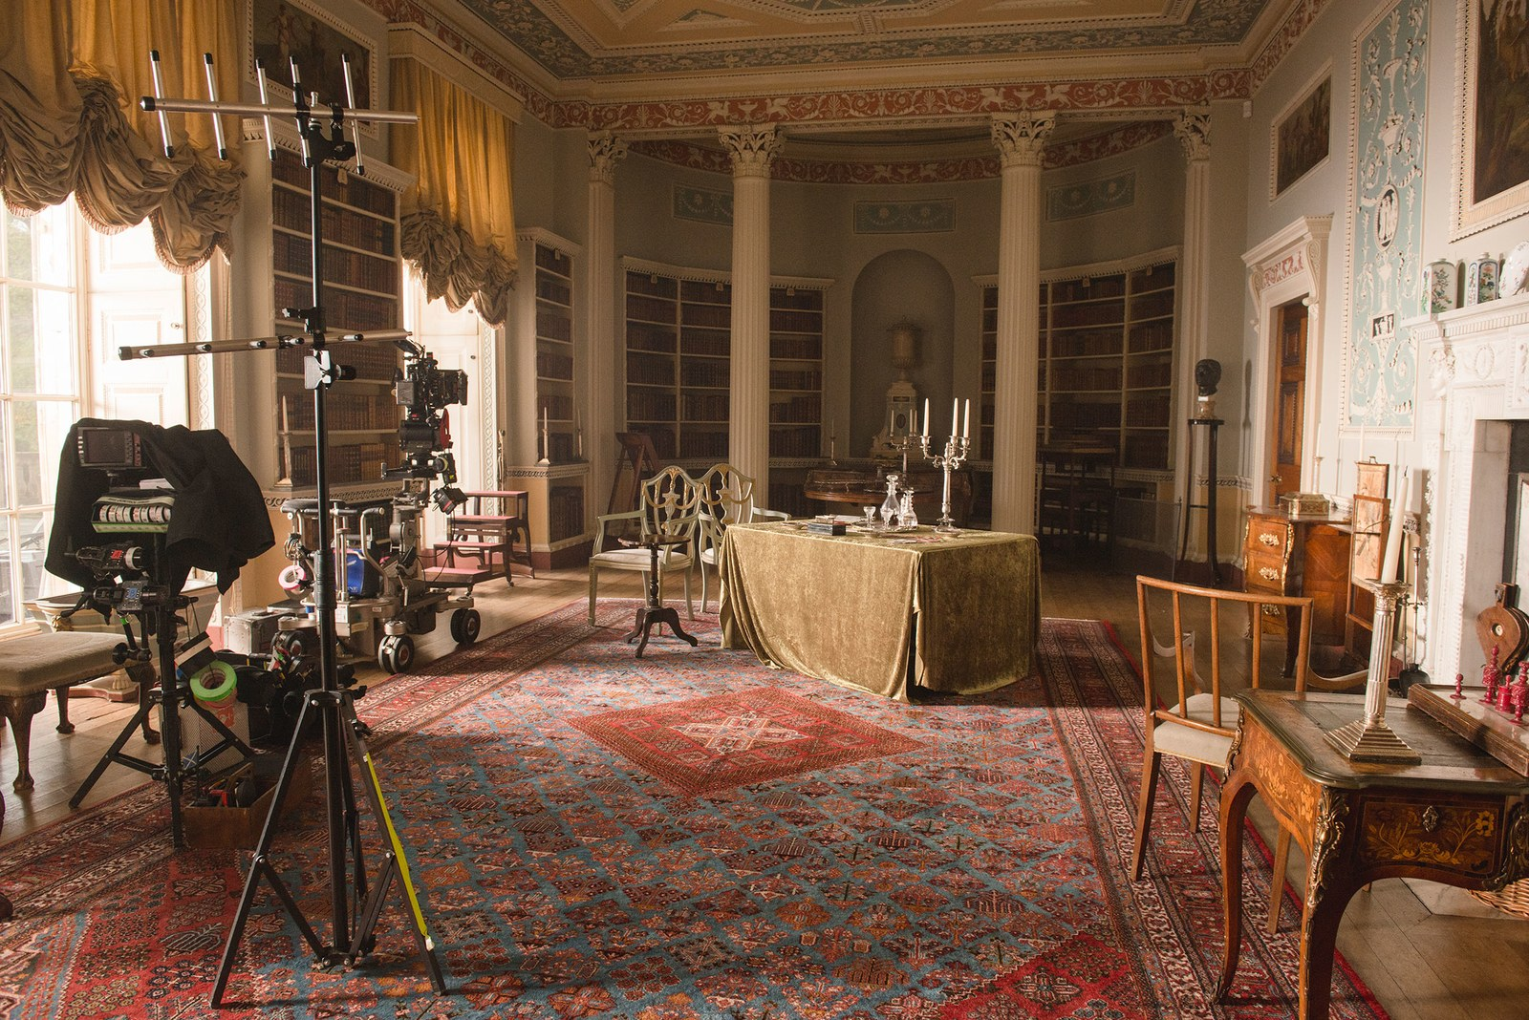

MODULE HANDBOOK
2019-2020

Location Set Design

Overview

To understand how location sets are realised and manifested.

Highlights

- Taking influence from a screenplay.
- Permissions and liabilities.
- Garbage mattes and digital compositing.
- Adapting the design to the physical location.

Level 5 – 20 credits

Assessment – 80% Practical, 20% Coursework

Teaching is by lecture, seminar and hands-on workshop.

Module Tutors

Nikki Joseph
John Hill john.hill@uwtsd.ac.uk

Tech Dem Artist
Oliver Jenner oliver.jenner@uwtsd.ac.uk
Adam Shailer adam.shailer@uwtsd.ac.uk

Please make an appointment with your tutor for a tutorial if you have additional questions not covered in the sessions. If you need to consult the course team urgently, please email the staff member concerned. Additional support times / production surgery will be indicated on your timetable. The room will be available at this time and there will be a member of staff available for support and to answer questions.

Module Outline

AIM (S)

- To analyse the working characteristics of a professional location set design.

- To identify the key health and safety considerations whilst on location.

- To dramatise a screenplay in a given location and document the results in an appropriate format.

LEARNING OUTCOMES

Upon successful completion of this module, a student should be able to demonstrate the ability to:

- Show competence in a range of appropriate set design techniques and processes, with particular emphasis on location.

- Modify a location design after directorial input.

CONTENT
This module is comprised of two components. Component one is worth 80%, component two is worth 20%

Indicative content
- Taking influence from a screenplay.
- Visualisation techniques for exterior locations.
- Adapting the design to the physical location.
- Safe working practices.
- Permissions and liabilities.
- Green screening and set extensions.
- Garbage mattes and digital compositing.

ASSIGNMENT OUTLINE
[See Assignment Brief for full details]

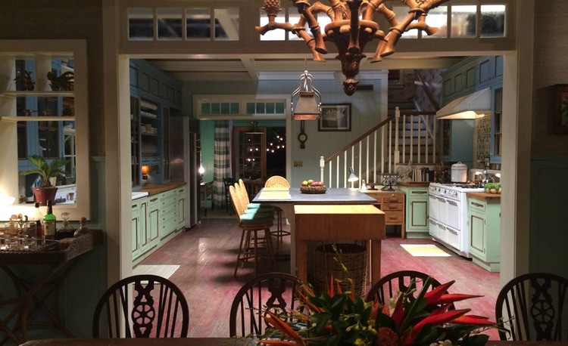

ASSESSMENT

Assessment will be comprised of two components. Each student will complete an industry compatible location scouting report.

Assessment Component 1 - Practical 80%

The portfolio comprises a body of work - research, planning, construction and in situ documentation derived from class exercises and location shoots. The work should be presented in a manner compatible with current industry practice.

Assessment Component 2 - Coursework 20%

This component is assessed by a written and illustrated, reflective blog that could be uploaded to a cloud-based interface such as Tumblr, WordPress or Blogger. The blog should comprise weekly written entries accompanied by:

- The individual’s collected technical file that must contain evidence of research into the design decisions made throughout the module.

- Evidence of engagement with the safe working practices involved in location set design.

Feedback

Feedback Date 20 days after the date of assessment

Feedback is an essential part of all education and training programmes. It helps learners to maximise their potential at different stages of training, raise their awareness of strengths and areas for improvement, and identify actions to be taken to improve performance. Feedback can be seen as informal (for example in day-to-day encounters between teachers and students or trainees, between peers or between colleagues) or formal (for example as part of written or clinical assessment). However, there is no sharp dividing line between assessment and teaching in the area of giving feedback on learning. Feedback is part of the overall dialogue or interaction between teacher and learner, not a one-way communication.

During your studies you will therefore receive feedback in many ways, including the following:

- Dialogue between lecturers and students in formal classes.
- Direct questions and responses from teachers inside and outside formal classes.
- Email correspondence between teachers and students.
- Interactions between students and teachers using the module message board on Moodle.
- Informal comments and responses to pitches and presentations in classes.
- Comments and annotations added to written submissions, such as essays and reflective journals.
- Formal written feedback in response to assignments recorded on the summative
- Assessment module feedback forms.
- You will have an opportunity to discuss your feedback with your tutor.
- Feedback will be returned on assessed work within 20 working days of submission.

MODULE TIMETABLE

** You will be expected to conduct non-assessed tasks as part of your development on this module. This will include filming outside of the classroom environment. **

Module Evaluation

At the end of this module, you will be asked to complete a module evaluation form. Please refer to the anticipated learning outcomes when making your evaluation.

SCHEME OF WORK

 | Indicative Content | Time | Date | Room
1 | - Overview - Assignment Brief  - Professional expectations  - Introducing location set design. | 2.00 to 5.00 |  | Studio
2 | - Selecting appropriate approaches for a particular purpose.  - Meeting expectations | 2.00 to 5.00 |  | Studio
3 | - Creating design for directors.  - Creating a range of approaches to the design process. | 2.00 to 5.00 |  | Studio
4 | - Finalise reports and adapt the location design. | 2.00 to 5.00 |  | Studio
Portfolio Submission Deadline and Presentation:
Monday 4th April, 2020

9 | - Feedback on Portfolio submissions | Feedback tutorials commencing 08/04/2020

This scheme of work is indicative and subject to change

MODULE RESOURCES

Reading List:

Module Code | ADFM5021
Module Title | Location Set Design
Classification | Reading List entry | Electronic*
Essential | Winslow, C., 2006. Handbook of Set Design. 1st ed. Grantham, UK: The Crowood Press Ltd. | ☐
Essential | Foster, J., 2014. The Green Screen Handbook: Real-World Production Techniques. 2nd ed. Massachusettes, USA: Focual Press. | ☐
Further | Brindle, M., 2013. The Digital Filmmaking Handbook. 1st ed. London, UK: Quercus. | ☐

Note: Students will also be directed to project-specific resources during the course of the module when they are available and appropriate.

