FILM ANALYSIS (HPMF5003)
What are the harmful effects of stereotyping in film, and how have filmmakers been instrumental in constructing – AND deconstructing – stereotypes?

One definition of ‘stereotype’ is:
“a set idea that people have about what someone or something is like, especially an idea that is wrong” (Cambridge Dictionary, 2019).
This definition refers to the fact that creating stereotypes can give the wrong impression. We use stereotypes to ‘box’ people up into recognisable entities. For example: usually the typical student = late to lectures + sleeps in late + goes to bed late + eats badly + has little money but is often found drinking alcohol.
In all seriousness, the essay title suggests that the use of stereotyping in film can cause ‘harmful effects’. This assumes that film can influence its audience and, by association, society. Then there is the chicken and egg dilemma: does film influence society or does society influence film? The obvious answer is ‘both’. The stereotypes in society can be depicted in film. Film can depict stereotypes which then influence society. The issue comes when those stereotypes are wrong or harmful. In particular, when stereotypes are focussed on gender or race and show bias or discrimination. The British Board of Film Classification (BBFC) states in its ‘18’ classification that adults should be free to choose their entertainment except:
…where material or treatment appears to us to risk harm to individuals or, through their behaviour, to society. For example, the detailed portrayal of violent or dangerous acts, or of illegal drug use, which may cause harm to public health or morals (BBFC, 2019).
This means that they are aware of the impact film may have on society and its morals.

The recent temporary banning of ‘Blue Story’ (Unwubolu, 2019) from British cinema screens is an example of people believing that a film can have a bad influence on viewers. When a machete-armed brawl broke out in the cinema queue, there was the assumption that the black street-gang genre film was the cause. In fact, this was not the case, but it was an interesting knee-jerk reaction influenced by the racial stereotype of ‘black youth equals violence’. It is also a current example of people believing film can have a harmful effect on society.
Stereotyping a group of people can have a life-long harmful and debilitating impact on them. Stereotyping leads to assumptions and judgements being made about people which do not allow them or their actions to be viewed impartially and without prejudice. This then affects their right to equality and freedom of choice. If portraying stereotypes, the film industry is responsible in each individual film for influencing the audience. The Western and gangster genres are good examples of this.
In John Ford’s Western ‘The Searchers’ (1956), the director depicts the stereotype of the powerful white man, played by John Wayne, seeking revenge on the native Comanche Indians who had ‘stolen’ his niece. At the time of release many viewers would probably not have identified any harmful stereotypes in this film. In the classic ‘Western’ genre, the white, gun-toting cowboy fights the native tomahawk-throwing, arrow-shooting Indian. The film based on the book ‘The Avenging Texans’ may or may not present a real case of child-theft in the late 1800s at the hands of Comanche Indians. From the outset of the film, Ford places no doubt that the righteous side lies with the white man seeking revenge for the evil Indian’s wrong-doing. The harmful effect of this portrayal is to plant the thought with viewers that Native Indians are all heathens and the white pioneers have a right to power over them.
In a 1964 interview with the ‘Cosmopolitan’ magazine cited in an American Film Industry (AFI) film review, Ford acknowledges his racial stereotyping:
There's some merit to the charge that the Indian hasn't been portrayed accurately or fairly in the Western, but again, this charge has been a broad generalization and often unfair. The Indian didn't welcome the white man ... and he wasn't diplomatic ... If he has been treated unfairly by whites in films, that, unfortunately, was often the case in real life. There was much racial prejudice in the West (AFI ‘The Searchers’, 2019).
‘The Searchers’, therefore, may well contain strong stereotypes depicting racial discrimination but it would seem it echoed the society of the day and the society of the 1850s’ Texas where it was set.
However, despite its stereotyping of the Native American Indians being evil, the film has still been named by the AFI ‘the greatest western of all time’ and was placed 12th on the American Film Institute’s 2007 list of the 100 greatest American movies of all time. And in 1989, it was deemed "culturally, historically, or aesthetically significant" by the United States Library of Congress.
This ongoing biased stereotyping still continues into modern day society. 63 years later, ‘The Searchers’ is still being aired (indeed it was aired on TV in the UK on 14/12/2019). Once produced, a film and its influence cannot be erased. The classic Western genre might be a thing of the past, but the stereotype still exists.
Playmobil (see pictures) still produce characters for children to play Cowboy and Indians with racial stereotyping.
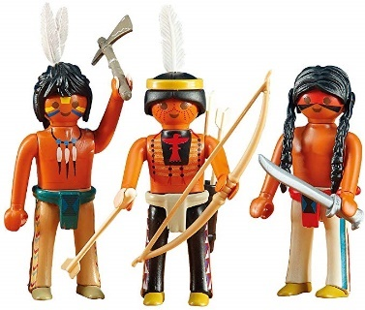


The Fort is called ‘Fort Brave’, sending a subliminal message that the ‘white’ man is brave and the Native American is not. Or the Natives are violent as they wield weapons.
Another genre, the ‘gangster’ movie and specifically the film ‘Scarface’ (1984), has been accused of racial stereotyping. De Palma’s film has been criticised for stereotyping Cuban immigrants as criminals.
From the opening credits, De Palma constructs a classic stereotype of a criminal Cuban immigrant in the guise of Tony Montana, played by Al Pacino. The introductory text describes the 25,000 criminals accompanying the other 100,000 Cuban refugees as the ‘dregs from the [Cuban] jails’. By the way Tony talks, dresses and acts, he oozes arrogance and defiance. The scar on his face acts as a symbol and warning of his criminal past. After just a few scenes Tony commits cold-blooded murder to gain a green card and escape from the detention camp. Next follows a drug deal gone wrong and chain-saw blood bath, with a few machine guns thrown in. The criminal stereotype De Palma creates deepens as Tony and his loyal Cuban followers behave lasciviously, ogling blonde bikini-clad white American girls, smoking, drinking, coke-snorting, wearing gold chains and fashionable clothes and driving fast cars. In one scene, Tony’s white American wife Elvira accuses him of being ‘an immigrant Spic who cannot stop talking about money’. Of all the Cuban characters in the film, De Palma only portrays one with any moral backbone, Tony’s Cuban god-fearing mother, who disowns him and throws him out. This one depiction of an inherently good Cuban immigrant cannot outweigh the impression De Palma creates that the typical Cuban was a criminal low-life.
25 years later, Damarys Ocana (2008) explains the harmful effects De Palma’s film had:
I, on the other hand, had lots of reasons to hate it when I first saw it as a kid. The problem was this: the movie's ruthless central character, Montana … was Cuban like me, and like me, came on the Mariel boatlift in 1980. During that mass immigration of 125,000 Cubans to Miami, Castro surreptitiously placed about 3,000 serious criminals along with the law-abiding families leaving the island. As they continued to commit crimes in Miami, they came to represent all of us.
We "Marielitos" were considered low-lifes, and a lot of us felt like we had to work extra hard to prove people wrong. You can see why a movie that reinforced that stereotype wouldn't go over well with us (Ocana, 2008).
(Ocana, ‘An Unfortunate Icon’, 2008, www.guardian.com)
When De Palma tried to shoot the film on location in Miami, the city refused permission on the grounds of racial stereotyping fearing that it would be tarred with the same brush.
Lehman and Luhr (2008) also highlight the harmful impact of ‘Scarface’s storyline:
Issues of class and ethnicity figure prominently… Central characters do not conform to the cultural ideal of white, middle-class male but they come from marginalised immigrant classes in the US and seek elevation through violent crime… their behaviour engages contemporary stereotypes about those types of people being inherently criminal (Lehman and Luhr, 2008, p. 25).
The racial stereotyping in Scarface (1984) is very similar to the iconic gangster movie genre which came before it. Francis Ford Coppola’s The Godfather (1972) tells the story of an Italian Mafia family. It too can be criticized for the harmful ever-lasting stereotype of anyone Italian equalling criminal.
There are, however, filmmakers who challenge and deconstruct stereotypes. Tarantino in ‘Django Unchained’ (2012) turns the whole stereotype of the white man holding supremacy over the black man upside down in his Western-style film. As Grant (2001) suggests, filmmakers, as authors, can ‘express a personal vision’ and ‘explore ethical issues’.
The film’s hero, Django, is black and is ‘unchained’ unlike the slaves in the chain gangs. Tarantino exaggerates this role reversal wherever he can. The film opens with an image of chained black, bare feet to depict the enslaved black man being led by the white man on horse-back towering over him. As soon as Django is freed, he takes on all the trappings of the white man, such as fancy clothes and riding everywhere rather than walking. One scene illustrates this when he rides through town and asks, ‘What are they staring at?’ with the reply, ‘They ain’t never seen no nigger on a horse.’ emphasising the strange atypical sight.
Tarantino also takes the Western genre and mimics it with comic twists, deconstructing many stereotypes along the way. The Klu Klux Klan, for instance, become a laughing stock when they cannot see through their holes in their white hoods because they are too small. Here the stereotype of white supremacy really does get attacked, undermined and disempowered.
Django sets out on a mission to free his wife from her slave master. In one scene, the stereotypical master watches as entertainment two black men fight to their death. To some extent Tarantino not only deconstructs stereotypes, but also, as shown in this scene, over-emphasises them to draw attention to their harmful impact.
The three films above glorify male central characters and leave women to be viewed as mere home-makers, property or sexual objects. In The Searchers, apron-wearing Martha rarely leaves the home-stead, standing on the threshold looking out into the big, wide world where she does not belong. Debbie has been kidnapped by the Comanches and is an object to become a wife and fought over. In Scarface women are objects to strut around half-dressed and be ogled at; or, like Elvira and Gina, they are trophy wives. Even in Django Unchained, Broomhilda, Django’s wife is enslaved and needs breaking free from white male supremacy.
The representation of women in film has been, and is, a serious issue. Continuous gender bias where men are supreme and women are there to serve no longer reflects society’s outlook on this issue. The harmful effect of this image is that in some sections of real-life as well as in film women continue to be considered to be discriminated against. If this stereotype is not constantly challenged, in film and in society, then women continue to have to fight for equality.
In 1991, Ridley Scott tried to deconstruct in his film ‘Thelma and Louise’ the stereotype of women as dependent on men and being chained to the sink and just sexual objects. Scott liberates his women and puts them behind the wheel of his ‘road-trip meets outlaw genre’ ground-breaking film. Two women, one who walks away from her abusive boyfriend and the other who leaves her waitressing job, gain freedom from the authoritarian white male, escaping from their trapped lives. However, the consequence of them stepping over the threshold and becoming ‘unchained’ from the sink leads them to crime and to escape on a dangerous journey to Mexico. They encounter several challenges resulting in killing a would-be rapist and turning to theft to survive. This results in Thelma and Louise having to flee from the police. Ultimately, they have a choice to either be captured or drive off a cliff. Choosing the latter option created the iconic film-ending, but more importantly showed two independent, liberated women.

Sturken (2019) states:
… we end with two women sitting in a car and making a decision. They have tasted power. They cannot go back, only forward… Clasping hands, they decide to continue onward. They make a choice. This is all we need to know. (Sturken, 2019, p. 87)
Whilst deconstructing the ‘inferior woman’ stereotype, Scott not only liberates women, but also challenges the happy-ever-after rom-com stereotypical genre.
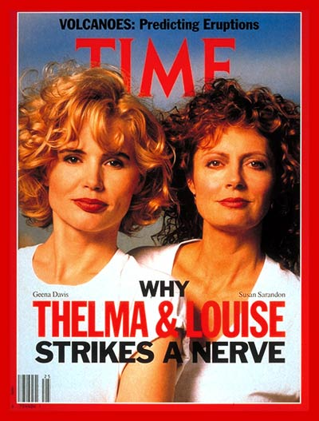
This film had an impact on society. The two actresses, Susan Sarandon and Geena Davis, appeared on the ‘Time’ magazine’s front cover (Time, 1991). Critics claimed the film undermined men. The AFI film review (AFI, 2019) cites the scriptwriter Callie Khouri writing in the New York Times (5 June, 1991) stating that “the film was not hostile toward men, but toward ‘idiots’.” She also claimed to have written the script with the aim to counter Hollywood’s tendency to portray women as “bimbos, whores and nagging wives.” This acknowledges the conscious effort to overturn the harmful stereotypes of women which was rife in the film industry.

This 28-year-old message that women have freedom to make choices and be equals is still being championed. The narrow-minded stereotype still exists in society and many women are fighting to ensure the film industry represents women fairly.

The website ‘UN Women’ (2014) reported startling statistics from the Geena Davis Institute on Gender in Media summarised in the infographics below.hare on
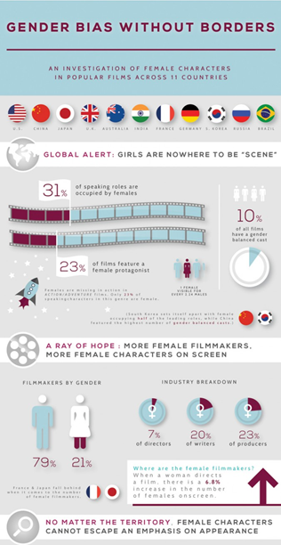
Embed
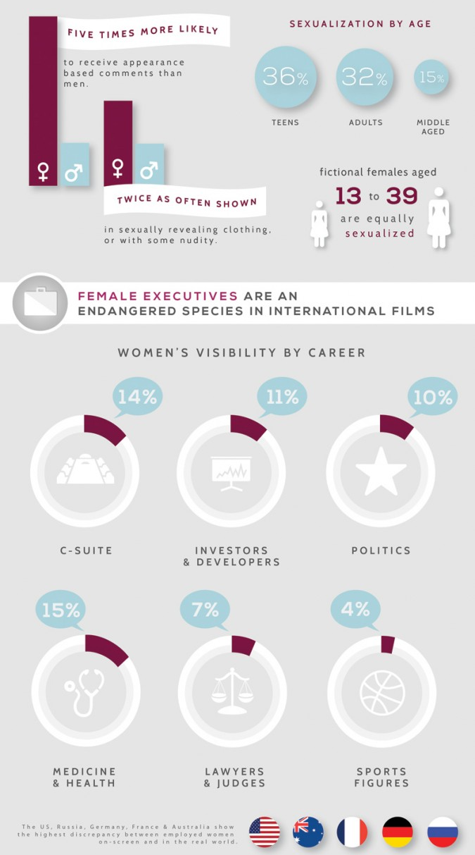

Geena Davis writes in the report:

The fact is – women are seriously under-represented across nearly all sectors of society around the globe, not just on-screen, but for the most part we’re simply not aware of the extent. And media images exert a powerful influence in creating and perpetuating our unconscious biases (UN Women, 2014).

These statistics, such as only 10% of films having a gender balance, clearly show that gender discrimination still needs to be tackled by the industry.

The Top 10 highest-grossing film list in 2019 (See Appendix 1) is littered with fantasy, sci-fi or comic book hero films. What does this say about the sphere of influence filmmakers have within these genres if they are the most popular? In an attempt to deconstruct stereotypes, there are black, female Avengers; a female Captain Marvel; black heroes and in 2020 we may even have a female ‘00’ agent. But is this enough? Films need to entertain, but where fiction merges with fact and fantasy merges with reality filmmakers must listen to the cry for equality and diversity.

Despite the need to cover costs and the focus on entertaining viewers, filmmakers need to continue to embrace their social and moral responsibility to avoid stereotyping and seek to reduce or even eradicate conscious and unconscious bias.
(Word Count 2489)

Appendix 1
Top 10 Films 2019
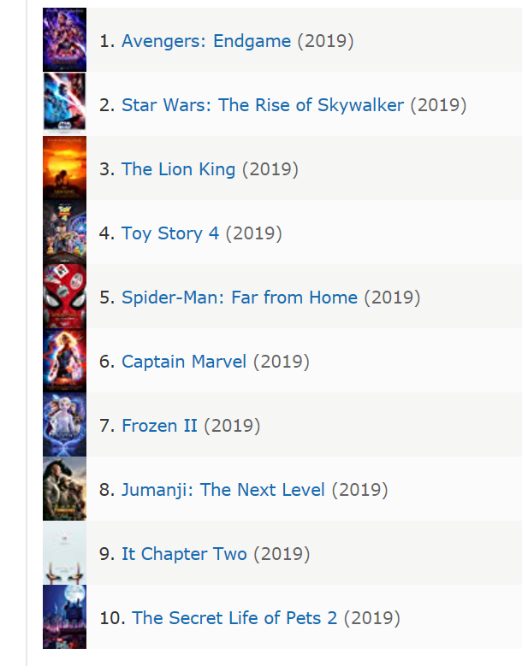
www.imdb.com

References
American Film Institute [website] The Searchers. Available at: https://www.afi.com/ (accessed 15th December 2019)
British Board of Film Classification [website] About Classification. Available at: https://bbfc.co.uk/ (accessed: 10th December 2019)
Cambridge Dictionary [website] Available at: https://dictionary.cambridge.org/ (accessed: 10th December 2019)
Django Unchained, 2012 [film] Directed by Q. Tarantino. USA: Columbia Pictures
Grant, B.K. (ed.) (2008) Auteurs and Authorship: A Film Reader. Oxford: Blackwell.
IMDb (2019) [website] Top 10 2019 Available at: https://www.imdb.com/list/ls041008874/?sort=list_order,asc&st_dt=&mode=simple&page=1&ref_=ttls_vw_smp (accessed 21st December 2019)
Lehman, P. and Luhr, W. (2008) Thinking About Movies: Watching, Questioning, Enjoying (3rd ed.). Oxford: Wiley-Blackwell.
Ocana, D. (2008) ‘An Unfortunate Icon’, The Guardian, 10th December. Available at: https://www.theguardian.com/commentisfree/cifamerica/2008/dec/10/scarface-al-pacino-anniversary-latinos (accessed 25th November, 2019).
Scarface (1984) [film] Directed by B. De Palma. USA: Universal Pictures.
Sturken, M (2019) Thelma and Louise. Bloomsbury: The British Film Industry
The Searchers,1956 [film] Directed by J. Ford. USA: Warner Bros..
Thelma and Louise, 1991 [film] Directed by R. Scott
Time (1991) Front page [picture] June 24th. Available at: http://content.time.com/time/covers/0,16641,19910624,00.html (accessed on 20th December 2019)
UN Women (2014) [website] Global film industry perpetuates discrimination against women Available at: https://www.unwomen.org/en/news/stories/2014/9/geena-davis-study-press-release (accessed 21st December 2019)

