

How does mental health affect a Police Officer on and off duty and is there enough support in place to reduce the effects of PTSD?

Ashleigh Tucker
Student Number – 2236646
BSc (Hons) Professional Policing Practice

Acknowledgements
These last three years have been very tough, physically and mentally. I have had challenges of starting a new career and adapting to life within the police force, I have also had the challenge of completing a degree alongside a shift rota. As a part of this dissertation, I would like to thank the staff at University of Wales Trinity Saint David. Without these, I would not be nearing the end of completing my degree in Professional Policing. I would also like to thank my family and friends, who have supported me through both a career change and supporting me through completing my degree.

Declaration
This work has not previously been accepted in substance for any degree and is not being concurrently submitted in candidature for any degree.
Signed: A.Tucker
Date: 10/01/2025

STATEMENT 1
This dissertation is being submitted in partial fulfilment of the requirements for the degree of BA.
Signed: A.Tucker
Date: 10/01/2025

STATEMENT 2
This dissertation is the result of my own independent work/investigation, except where otherwise stated.
Other sources are acknowledged by footnotes giving explicit references. A bibliography is appended.
Signed: A.Tucker
Date: 10/01/2025

STATEMENT 3
I hereby give consent for my dissertation, if accepted, to be available for photocopying and for interlibrary loan, and for the title and summary to be made available to outside organisations.
Signed: A.Tucker
Date: 10/01/2025

STATEMENT 4
I hereby give consent for my dissertation, if accepted, to be available on the university’s IT system to those who have consent to use the system.
Signed: A.Tucker
Date: 10/01/2025

Contents
Table of Contents
Acknowledgements 2
Declaration 3
Chapter 1 - Introduction 6
Research Questions 6
Chapter 2 - Literature review 7
2.0 Introduction 7
2.1 Trauma 7
2.2 The definition of Post Traumatic Stress Disorder 8
2.3 Decision making 9
2.4 Stigma of Mental Health in Policing 9
2.5 - Trauma Risk Management (TRiM) 10
2.6 - Oscar Kilo 12
Chapter 3 Methodology 13
3.0 Introduction 13
3.1 Research 13
3.2 Primary Research 13
3.3 Secondary Research 14
3.4 Participants 14
3.5 Quantitative Data 15
Chapter 4 – Analysis of Results 16
4.0 Introduction 16
4.1 Data analysis 16
4.2 Advantages of using Survey Monkey 17
4.3 Disadvantages of Survey Monkey 17
4.4 Participants of survey 17
4.5 Mental health on duty 18
4.6 Mental health off duty 18
4.7 Support from Gwent Police 19
Chapter 5 – Finding and Conclusions 19
5.0 Introduction 19
5.1 Objectives 20
5.2 Findings 20
Chapter 6 – Recommendations 22
6.1 Survey Recommendations 22
6.2 Self Reflection 23
7. Bibliography 23
8. Appendix 26
8.1 Survey Questions 26
8.2 Survey answers and graphs 29
8.3 Ethics Form 36
Application for Ethical Approval 36
8.4 Research Propsal 52

Chapter 1 - Introduction
This piece of writing will identify how mental health effect a police officer both whilst they are on and off duty. I will also explore the effects of Post Traumatic Stress Disorder (PTSD) and establish if there is enough support in place from police forces and other outside agencies regarding the effects of PTSD.
The Police Federation have identified that Police Officers will attend or experience between 400 and 600 traumatic incidents in their career. Member of the public will only encounter 3 or 4 in their lifetime (PolFed, 2021). These effects can lead to depression, mental breakdowns, fatigue and reduce the ability to make decisions at a critical and high-risk situation.
Whilst I will be referring my answer back to my original title, I will also be answering research questions, to support my main title.

Research Questions
- To research the effects of attending traumatic calls on serving police officers
- Explore the effects of poor mental health in police officers and how can it effect the ability to make critical decisions at incidents.
- Identify if there is substantial support available for police officers, once they have attended a traumatic call
- Explore the effects of PTSD and how this can affect a police officer both on and off duty

As part of this research, I will specifically be focusing on Gwent Police Officers to obtain their opinions and views as to whether there is enough support offered and available after a traumatic incident.

I will be conducting a literature review, to understand what existing research that has already been completed and expand my knowledge of this subject and understand how this topic can affect someone.
Following this I will produce a methodology and explain how I will complete my research and the steps that I will take to obtain my data and explain the reason why I have chosen that method. An analysis of results will then be conducted, which will summarise the data that has been collected. This will enable me to answer my research objective and prove or disprove the research that has already been completed.

Chapter 2 - Literature review

2.0 Introduction
As part of the literature review, I will be conducting quantitative research surrounding, Post Traumatic Stress Disorder, and the effects this can have on serving police officers whilst both on and off duty. I will also be looking at stats and figures around mental health in policing and what interventions and support is in place for a police officer after they have been exposure to a traumatic incident. During 2023-24 it was estimated that over 14,500 serving police officers were not fit for duty due to mental health related problems such as, stress, anxiety and Post Traumatic Stress Disorder. (Police Life, 2025)

Policing within the United Kingdom is a highly stressful and demanding job. Officers often dealing making decisions based up mitigating risk, to themselves, members of the public, victims of serious crimes, such as domestic abuse. Whilst dealing with these risks, it is guaranteed that officers will be exposed to physical and psychological trauma. Police officers are the people running towards that danger, whilst everyone else is running for safety. Police officers are now more than ever exposed to serious crimes, road traffic collisions, deaths, threats and abuse from members of the public. Being exposed to these incidents and scenes can both have a physiological and physical effects on an officer’s mental health. A study carried out by the University of Cambridge showed that there were high levels of mental health disorders which were mainly caused by poor working conditions, which included, little time to work on your own personal workload, derogatory behaviour and exposure to traumatic incidents and situations without any support in place after the incident. (University of Cambridge, 2022)

2.1 Trauma
Trauma is described as experiencing something that is frightening and distressing events, that are out of a person control and because of these events they can be difficult to cope with. It is believed that most people with suffer with trauma in their lifetime, but everyone gets affected in different ways and at different times. (Mind, 2023)
Police officers are often exposed to trauma on a regular basis. The most common type of trauma for police officers to suffer is known as secondary trauma. This can be described as connected, or witnessing a traumatic incident, but this incident has not had a direct effect towards the person witnessing it. The effects of this type of trauma are like general trauma, but people who experience secondary trauma often detach themselves from it or try to forget it happened. Frontline emergency services are often exposed to this trauma.

Due to the effects of trauma the University of Exeter has identified that police officers are two times more likely to sustain a traumatic brain injury than the general population. This is due to being on duty and being exposed to traumatic events and not obtaining the correct support at the conclusion of the incident. (Seymour, 2025)
As part of this survey, it was also found that police officers who report a multiple traumatic brain injuries are more than 2 times likely to meet the criteria for complex post-traumatic stress disorder and feel like they are worthless, guilt and a fear of not being able to control their emotions. (Seymour, 2025)
This shows that by suffering with PTSD, it can affect a police officer’s home and work life. PTSD effects relationships, both personal and work relationships and it can have an impact on decision making.

2.2 The definition of Post Traumatic Stress Disorder
Post Traumatic Stress Disorder is also commonly known as (PTSD). PTSD is defined as a mental health condition, and it can be developed through witnessing or experiencing traumatic events and incidents. Trauma incidents can include, physical, emotional, distressing, whereby these incidents can include a threat to life, or whereby a death has occurred. (PCRF, 2025)

There are several symptoms of are associated with PTSD, and these can have a noticeable impact on someone’s day to day life. As PTSD is complex, there are several different categories of symptoms that someone can experience. Someone who is suffering from PTSD can experience symptoms with in the first month of witnessing a traumatic incident, but there are some occasions whereby people have delayed PSTD and show symptoms many months after the incident or some cases years after the event. Symptoms of PTSD can include:

- Re-experiencing
This is the most common symptom which is associated with PTSD. This can involve flash back, nightmares, mental sensations and physical sensations, which can include pain, shaking and sweating.

- Avoidance and emotional numbing
This symptom is also common with signs and diagnosis of PTSD, this can often mean that someone who is suffering from PTSD they will avoid certain places or people that may be associated with the initial trauma incident. This symptom can often isolate a person from certain events/activities and personal family events. This can be seen as someone who is trying to avoid a situation of reliving the incident and trying not to feel any emotion.

- Hyperarousal
This symptom can lead to someone being anxious and constantly being on edge and unable to rest and relax. As a result of this, angry outbursts, sleeping issues and lack of concentration can occur, if this is left untreated.
(NHS,2022)

2.3 Decision making
Decision making is defined as the process and logic by which a person or group of people conclude to a result. There are different types of decision making which can lead to several different outcomes. The two types of decision making are objective rational outcomes and logic of appropriateness outcomes. (Britannica, 2025)
Decision making in the police can often be the matter between life and death, it is described as highly stressful, whereby rapid decisions need to be made in unpredictable situations, whereby there could be a risk to everyone involved. Studies and research have shown that poor mental health, such as stress, PTSD and anxiety can have an impact on the person making the decision and impair their judgement. As a result of this impairment, this can lead to decisions being made incorrectly and have an impact on the focused goal at the end of that specific incident. (Miller, 2006)

As shown throughout this literature review, police officers are exposed to highly dangerous traumatic events, whereby the effects of this could last a lifetime. These effects can heighten vigilance both whilst on and off duty, and it could lead to emotional exhaustion. As a result of these effects, the way decisions are made by that person are altered, which could lead to them making a decision that is aggressive or defensive. (Woody, 2005)
Someone who is suffering from mental health related disorders creates a challenge for them when making decisions. The decisions that are made may not even benefit anyone else and could put other people at risk, because they could be making a decision that solely relies on their health and their own outcome that they have come up with. (Adams, 20215)
Due to this, it could pose risks to other attending officers and members of the public, when trying to resolve a high dangerous and stressful situation.

2.4 Stigma of Mental Health in Policing
As police forces in the UK continue to progress and grow, one major concern is the number of officers who are absence from work due to sickness. There are approximately 130,000 police officers employed in the UK, half of these officers taking sick leave due to mental health related issues. (Police Firearms Officer Association, 2017)
Stigma is when someone, or a group of people have openly had negativizes towards something, which this is a situation or a person. The person or group will judge someone for openly expressing their feelings. This can include speaking out about mental health illnesses. This can cause the person who is suffering to feel embarrassed or in the future not reach out for support and they may suffer in silence because someone, or a group of people expressed their opinion. (Our Time, 2025)
A survey carried out by (NFOP, 2021) showed that police officers are still reluctant to report their own mental health problem or seek support, as they believe a colleague would act negatively and treat the suffering officer in a different way. It is thought that with this stigma still being present, this can present police officers from receiving early support and intervention to prevent conditions and disorders deteriorating. (Officer Survey, 2025). Between 2020 to 2024, a freedom of information request was submitted to the Office of National Statistics (ONS) requesting data surrounding the number of suicides from officers within police forces across the UK. Below are the figures released by the (ONS) for this request:
- 1162 Senior police officers
- 3312 Police officers
- 6311 Police community support officers
(ONS, 2025)

From viewing these statistics show that over 10,000 police officers and staff members committed suicide between 2020 and 2024, whilst it is unknown if all these deaths were mental health related, it still provides an indicator that further intervention needs to be considered to prevent officer suicide. Whether this is surrounding stigma in the workplace or the lack of support provided by police forces.

2.5 - Trauma Risk Management (TRiM)
A Trauma Risk Management is an assessment that is offered following a traumatic event. Following the incident, an email or text notification is sent to your company email address or mobile phone, offering an appointment. This appointment should be taken 72 hours after the initial incident has taking place. (March on Stress, 2025)
With in the first 24 hours of a traumatic incident taking place, a TRiM is considered from the following list:
- Death or threatened life to staff or members of the public
- Serious injury
- Kidnap or hostage situations on both staff and members of the public
- Serious abuse, injury or death of a child
- Any incident where the circumstances could influence someone’s mental health.

Once the 24 hours has passed and it has been decided a TRiM is required, the planning stages commence. This is where, TRiM practitioners discuss the incident and agree upon the appropriate response to this incident. Once this has been completed, post 72 hours a Trauma Incident Briefing (TIB) is held, whereby a risk assessment is carried out and following this it is decided if follow up meetings are required, or if referrals need to be made to other agencies for further support for that individual. (BSMHFT, 2020)

TRiM referrals are not only just used by police, but they are also used by the ambulance service. In 2015 the Northwest Ambulance Service started a trial on issuing TRiM referrals. Prior to this being implemented it was identified that there were no support networks being offered to paramedics and staff following a traumatic incident. (Journal of Paramedic Practice, 2023).

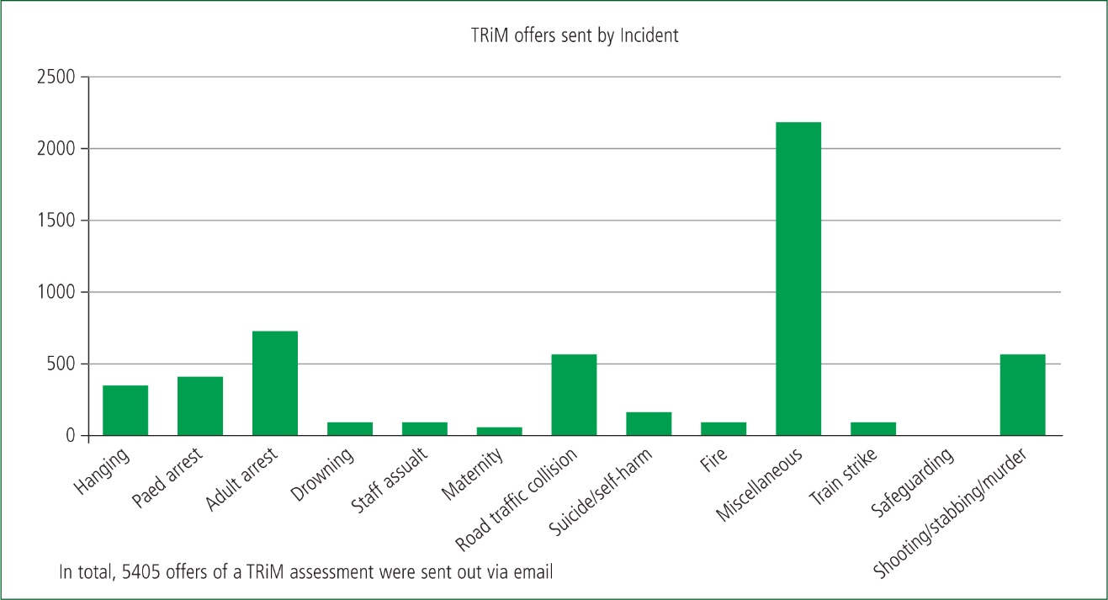
As a result of this implementation of TRiM’s being introduced 5405 TRiM referrals were sent to paramedics and staff, following several serious and traumatic incidents. These figures are from between 2015 to 2022. The below shows what type of incidents have triggered for a referral to be sent.
(Journal of Paramedic Practice, 2023).

The next graph shows the number of paramedics and staff who accepted the TRiM referral and completed the assessment. 377 referrals were completed, and from these figures it shows that out of the 5000 referrals 14.3% accepted the support.
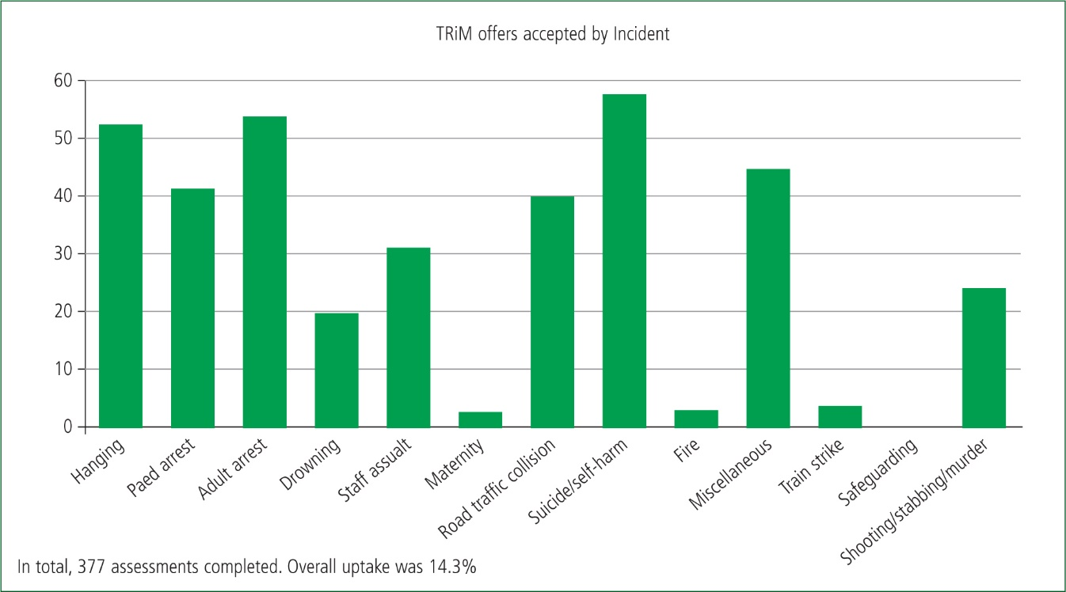

(Journal of Paramedic Practice, 2023).

From viewing these graphs, it shows that only a small number of paramedics accepted the support, and the other staff members dealt with the effects of these incidents with no requirement for direct support.
Following this study a few key points were identified, one of these points being that emergency service responders respond to many stressful and mentally demanding incidents, but they are reluctant to seek support.
It also shows that structural support systems need to be implemented based on evidence, to increase success and provide support for first responders who are suffering because of a traumatic incident they attended. (Romano, 2023)

2.6 - Oscar Kilo
In 2019 the Oscar Kilo program was created with Home Officer funding to support wellbeing in police forces across England and Wales. This program was created with the aim to deliver evidence-based sector-specific support, that is unique to policing. (Oscar Kilo, 2025)
The Oscar Kilo program aims to deliver support by allowing officers to complete self-assessments and providing guidance notes around the specific persons mental health. The program also conducts National Surveys and takes park in national practitioner events to gain a better understanding of mental health and take on board other strategies and guidance on how more effective support can be implemented to have a beneficial effect on someone who has reached out for support. (Oscar Kilo, 2025)
Oscar Kilo also delivers several programs that are data led, which are focused on the following:
- Healthy living
- Operation Hampshire – This program focuses on officers who have been assaulted whilst on duty
- Trauma risk management (TRiM)
- Support for families who family members in the police
- - Support for police officers who decide to leave the police force
These are just some of the initiative and programs that Oscar Kilo focus on, to support serving and ex-serving police officers with their mental health and wellbeing.
(Oscar Kilo, 2025)

As part of the Oscar Kilo program, they also have a fleet of wellbeing vans, which carry out, physical and psychological health checks. Since the program has started over 10,000 people have received these health checks and obtained support following these checks being completed. (Oscar Kilo, 2025).

A survey that was coordinated by the Oscar Kilo program, identified that 66% of police officers and police staff are still proud of their work and that 80% of their teams pull together as one. (Oscar Kilo, 2025). The survey also highlighted that officers that work in high-risk policing roles such as response and CID, showed higher levels of low wellbeing. (Oscar Kilo, 2025). This survey involved 33 police forces across the United Kingdom and over 40,000 police officers and staff took part. This survey is one of the most recent surveys to take place of date. It shows that there are still obvious signs of stress and low wellbeing in the police force, which does require further interventions for, but it also shows that there are strong connections with shifts via support for each other and that they are still proud of the job that they are doing. Following this survey Andy Rhodes who is the service director for the National Police Wellbeing Service stated that wellbeing is critical for yourself, family and team/colleagues. (Rhodes, 2025). This shows that wellbeing and good mental health can have an impact whilst on duty, but also off duty.

Chapter 3 Methodology

3.0 Introduction
Throughout this study I am aiming to identify if there is enough support offered and provided to a police officer following the aftermath of being exposed to a traumatic incident, which could include, fatal or serious road traffic collisions, deaths/suicides and serious crimes such as serious assaults and sexual offences. I am also looking to identify what support is in place and if it effective and fit for purpose in helping and assisting someone who has experienced traumatic incident.

3.1 Research
Research is the process that explores and reveals different subjects and issues. This is carried out in a meticulous and systematic way. Research can be conducted in a methodical way and the aim is to collect, analyse and produce and insightful interpretation of information into a chosen topic of your choice. (N.Jain, 2023)

3.2 Primary Research
Primary research is obtained by the means of interviews, surveys and any other means whereby information is collected by that person. This type of information has not been collected before. Primary research can be conducted if there is little data available and following this a comparison can be made with existing data, related to the same topic. (University of Southhampton, U.D)
There are many positives to carrying out primary research, one of these advantages identified shows that the data collected is up to date and current with what is going on at present, and it also allows the data to be tailored to the persons requirements for their study. (M.Poonam, 2025). By having primary data as part of study, this allows for more accurate answers and detailed information which my not be found if other types of research are carried out.
Whilst primary data is vital for studies, and analysis, there are also some disadvantages that come with conducting primary research. On of the main setbacks is the time it takes to create, collect and process the data. Collection of data requires questionnaires to be created, interviews to be set up and possible scenarios to be conducted to obtain data and answers. (Essays UK, 2025). Whilst this is time consuming, this also comes at a cost and can involve large amounts of money being used due to the time and effort that is required to obtain new and specific answers.

3.3 Secondary Research
Secondary research is defined as research and data that has already been completed, and it can be useful for a person who is carrying out a study to identify what research has already been completed and they are able to understand and analyse the research and locate any missed data and research opportunities, to enhance a study. (Teeside University, 2025)
Secondary research is described as a the most common research method as this research can be conducted quicker and it cost’s less to carry out. Below as some types of secondary research:
- Biographies
- Government statistics/data
- Journal articles
- Newspaper articles
- Industry statistics
- History books
- Surveys that were not conducted by yourself
- Textbooks
- Websites.
(J.Spacey, 2022)
One of the main advantages of using secondary data is that most data is available and easy to obtain from websites and libraries. This method is also more cost-effective and is a good identifier for gaps of knowledge within the study. If these knowledge gaps can be identified earlier on with in the study, primary research can be considered to remove these gaps with more niche answers directed to the study. (Taylor, U.D)
Again, the same as primary research, there are also some negative points to carrying out secondary research. One of main disadvantages of carrying out secondary research is the quality and reliability if data that is produced. When using secondary data, the source of the data needs to be checked for validity and authenticity. This can add doubts and may need questions to be asked, if this data is combined with your own research. (J.Walker, 2021)

3.4 Participants
As part of the researcher’s data collection, a survey will be sent to out asking serving Gwent Police officers and staff to complete a survey which will be based around the support they received after being involved in a traumatic incident. This questionnaire will also be aimed to determinate if the support received was helpful and if there are any recommendations that could be considered to make the support more successful.
As this topic can recall traumatic events for some people, the researcher will ensure that all participants will remain anonymous. At the end of the survey, there will be several mental health contact numbers for anyone who may been affected by the survey regarding recalling significant events.

The researcher aims for approximately 50 people to complete the survey for an understanding to be made surrounding this topic. This questionnaire will consist of closed ended questions. A closed ended question is a question asked, whereby there is already a “pre-defined” answer such as “yes of no”, or a direct question where an answer is applicable to everyone who participates. (C.Bonneau, 2024).
A study carried out by Snap Surveys showed that closed ended questionnaires are quicker and easier to respond to, they are also easier to analyse and produce in graph formats, so the results are visible for the reader. Close ended questionnaires also improve the consistency for answers.
Whilst closed ended questionnaires are beneficial, they also come with some disadvantages. When someone is completing a closed ended questionnaire, there might not be the exact answer on the list, and due to this the responder may have to respond to the question with the closest possible answer. Also, whilst there isn’t an option for people to give their own opinion, responders may just answer it with no opinion and no interest in the topic. (DeFranzo, 2018)

3.5 Quantitative Data
To obtain the results primary research was conducted to obtain quantitative data. This data was obtained using Survey Monkey. This survey was sent out to all Gwent Police officers and police staff on the force’s intranet, with an accessible hyperlink to access the website and the survey. Prior to starting the survey, it was highlighted that all participants would remain anonymous, and information was all added to the questionnaire on how to gain support from mental health services if required following the completion of the questionnaire.
Quantitative data is defined as obtain information that has a numerical value, and it can be used to carry out a statical analysis and review. This can allow for patterns and correlations to be identified. This type of data can be used alongside qualitative data. This can provide a better understanding of a topic if used correctly together. (Timonera, 2024)

Chapter 4 – Analysis of Results

4.0 Introduction
Throught this chapter of this study, I will be analysing the result from a survey that has been sent out to both police officers and police staff, who work for Gwent Police. The aim of this analysis is to identify if there is enough support provided and if it is effective for Gwent Police officer and staff members following a traumatic incident. Throughout my literature review, it has been outlined the effects people suffer from a traumatic incident and the effects of PTSD if it is left without any support networks or intervention being sought.

4.1 Data analysis
Data analysis is defined as the process of obtaining and collecting data, whereby this is done methodically, and allows the data to been cleansed, prior to it being examined. Data analysis is a vital part of both scientific and business research which allows for growth and for decision to be made and processed. (Eldridge, 2025)

4.2 Advantages of using Survey Monkey
As part of my data gathering, as previously mentioned in my introduction, I utilised Survey Monkey to create and share my questionnaire with serving police officers and police staff who are employed by Gwent Police. I found that using Survey Monkey, it was easy to use, and I found it easily accessible online and user friendly for participants completing the questionnaire. Prior to creating my survey, I used the different features on the website and established the best way to produce my questionnaire and it allowed me to customise the questions and answer section to suit the participants. I also found that Survey Monkey upon the participants completing the survey, the website created graphs based upon the results. This was a time saver and allowed me to focus on other parts of the data collection stage. Survey Monkey also gave me the option to ensure that all questions were answered. This option avoided questions being skipped by participants.

4.3 Disadvantages of Survey Monkey
One of the main disadvantages of using Survey Monkey, was the fact the I could only have 25 respondents to the questionnaire, and it would only produce graphs from these 25 participants before subscription fees are required from the creator. As a result of this, this could have an impact on my data and results collected, as it may not show a true and accurate representation of what participants have said. Another disadvantage to Survey Monkey is that it is only accessible online and if I was to share this survey across to other forces, this would need to be done electronically, and the participant would require internet access.

4.4 Participants of survey
48 serving Gwent Police officers and police staff completed my survey, but I have only been provided with the results from the first 25 participants due to their being a subscription fee for a remainder of the rest of the results. The first two questions of my survey were to identify the participants length of service and their department they are working in at the time of completing the survey. By identifying the length of service and their department can influence the results, as longer serving officers may have experienced more traumatic incidents and suffered from more mental health issues compared to newer serving officer or police staff employee.
From reviewing the results of the 25 people who answered the survey 3 participants had 0-1 years’ service which made up 12% of participants. 8 respondents had 1-3 years’ service which made up 32% of the participants. 4 people stated that had 3-5 years’ service which made up 16% of the participants. 3 respondents to the survey started they had 5-8 years’ service which was 12% of the participants. 2 people stated they had 8-10 years’ service which made up 8% of all respondents and 5 people stated they had more than 10 years’ service within the police force, which made up 20% of the participants.
The second question of my survey was to identify which departments the participants worked in. Out of the 25 people who answered the survey, 19 of the respondents were operational police officers and the other 6 participants were employed by Gwent Police as a staff role. 28% of the participants worked on response policing, 12% of the participants worked on the roads policing team, 8% of participants worked on the dog section. 8% work on the firearms section. 16% of participants worked on CID and 4% work as a PCSO. 24% of the participants work as a staff role, which could include call handing in the force control room, police staff investigators and other various roles within the police force. Whilst police staff roles may not be exposed to traumatic incidents, they may be the person who has the first initial contact with that person requesting help.

4.5 Mental health on duty
To gain an understanding surrounding mental health in policing the third question of my survey was to establish if any of the participants had experienced any mental health experiences and issues which was work related. 18 participants stated that they had sufferance with mental health experiences from work. This made up 72% of the participants of the survey. 6 people stated they had not experienced any mental health related issues. Which made up 24% of the participants and 1 person stated they were unsure if they had experienced any mental health issues because of work which made up 4% of the participants. The 7 participants who answered “NO” and “UNSURE” may be staff roles or they may be new in service and may not have attended an incident whereby it has affected them. There is also a possibility that the participants who have answered this may not have answered this truthfully due to the sigma surrounding mental health and talking about it openly. This has previously been identified by (Our Time, 2025). This has been highlighted in the literature review section of this paper.
The next question “How often does mental health affect your ability to perform at your duties? (Stress, depression, anxiety, PTSD, etc)” was aimed to identify if mental health affects a person’s performance whilst they are at work. 40% of the participants stated it sometimes affects their ability to perform their duties, 24% stated that it often affects their ability to carry out their duties, 12% stated that it rarely affects their ability and 24% it never affects their ability. No one answered “Always”.
Following this question I have then asked, “Do you believe that suffering from mental health affects your decision making and the ability to carry out your role safely?” 32% of respondents answered “yes – always”. 40% of participants answered “yes – sometimes” and 28% of people stated they are “unsure” if it affects their ability to carry out their role safely. Nobody answered “No” for this question. 72% of the participants believe that their decision making is affected in one way or another, when they are suffering from mental health symptoms. This statistic coincides what (Millar, 2006) stated with following a study, whereby mental health can affect someone’s decision when working towards a final goal.

4.6 Mental health off duty
The next two question I asked where aimed to identify if work related mental health has an impact on a person personal and home life and if they have experienced symptoms of PTSD whilst being off duty. 36% of participants stated they have slightly been affected by work related stress whilst at home. The second highest answer was 32%, and they stated they have been moderately affected by work related stress at home. 1 participant stated that it always affects them whilst at home, and 28% of respondents stated it does not affect them whilst at home.
Following this question over half of the participants stated that they “sometime” experience symptoms of PTSD whilst outside of the workplace. 52% of participants stated this answer. 10 people stated that they have never experienced symptoms of PTSD outside of the workplace. 1 person stated they always experience symptoms, and another person stated they are unsure if they have ever experienced symptoms outside of work.

4.7 Support from Gwent Police
This section of the questionnaire was aimed to identify if employees of Gwent Police were aware that there was support in place for them following a traumatic incident. It is also aimed to identify if participants of the questionnaire received a TRiM referral following and traumatic incident, and if they were helpful.
24 participants of the survey stated they were aware that Gwent Police offer support with mental health. 1 participant stated they were not aware that there was any support in place. 72% of participants stated that they received a TRiM referral following a traumatic incident. 20% of the participants stated they did not receive an email inviting them to a TRiM assessment and 2 respondents stated they don’t know what a TRiM is.
Following this, 12 participants of the questionnaire have stated they have attended a TRiM assessment following a traumatic incident. Out of the 12 participants 11 of them stated they found the TRiM assessment helpful. 12 Participants have stated that they have never attended a TRiM referral before. 7 participants stated that they would consider attending a TRiM referral in the future and 5 participants stated they would not consider taking up this opportunity to speak with someone. This may revert to the sigma of not speaking up about mental health within the police. 1 person stated that they were unaware that there was any support in place.

Chapter 5 – Finding and Conclusions

5.0 Introduction
As part of this piece of writing my aim was to identify and establish if mental health can affect someone whilst they are on duty and whilst they are off duty. I also wanted to understand if Gwent Police’s employees believed there was enough support in place to reduce the effects of mental health disorders such as PTSD.
The literature review allowed the researcher to gain an understanding on mental health within the police force and how it can affect a police officer’s ability to make a decision upon suffering from mental health. This review was conducted based upon previous studies and research that had already taking place. The literature review also allowed the research to understand what support is already in place for police officers to seek support.
Following this a methodology has been completed, which has details of how the research is going to be conducted and the reason why this certain method was chosen. It also outlines different types of data collection and the advantages and disadvantages of these. A questionnaire was chosen to form the primary research data. This was sent out to all police officers and police staff the Gwent Police’s intranet.
A data analysis has been conducted following the completions of the surveys. This section of the study allows the researcher to review the data to form a conclusion and identify any anomalies.

5.1 Objectives
Prior to completing this project, I set out a number of smaller objectives that I believed could enable me to gain a further understanding on my main objective which is the project title. These objectives were:
- To research the effects of attending traumatic calls on serving police officers
- Explore the effects of poor mental health in police officers and how can it effect the ability to make critical decisions at incidents.
- Identify if there is substantial support available for police officers, once they have attended a traumatic call
- Explore the effects of PTSD and how this can affect a police officer both on and off duty

To achieve these objectives, I have used quantitative research methods to obtain an understanding from serving Gwent Police officers their views and opinions on mental health and the support that is provided.

5.2 Findings
To research the effects of attending traumatic calls on serving police officers
This objective was aimed to identify if attending traumatic incidents can have an effect on police officers. From conducting a survey, it showed that 72% of participants stated that they have suffered mental health related issues, because of work. From conducting the literature review it also outlines that police officers have developed PTSD from attending traumatic incidents and that it can affect their ability to perform their duties as a police officer. 19 participants of the survey stated that their ability to perform their duties in the workplace have been affected.

Explore the effects of poor mental health in police officers and how can it effect the ability to make critical decisions at incidents.

The literature review outlined that the effects of mental health can have a detrimental impact on decision making when at an incident. Studies already completed have shown that poor mental health and people suffering from mental health disorders such as PTSD can impair someone’s decision making and impact the outcome of the incident. It was also found that it could pose risks to other colleagues and members of the public, due to the persons mental state at the time of the incident.
From conducting a questionnaire 18 participants of this questionnaire stated that the believe suffering from mental health affects their decision making and the ability to carry out their role safely. This coincides with the literature research conducted prior to this questionnaire being completed.

Identify if there is substantial support available for police officers, once they have attended a traumatic call
Evidence from the questionnaires suggest that Gwent Police are mental health and wellbeing driven, and they aim to inform their employees of the mental health support that is available to them when they are employed by Gwent Police. From analysing the questionnaire results, 96% of the participants were aware of the support that is offered by Gwent Police, and 44% of the participants stated that they had taking part in a TRiM assessment, and they found them helpful following the completion of the assessment. 28% of the participants stated they had not taken part in a TRiM assessment, but they would consider completing one in the future if required.
Apart from the TRiM process, there are also other means of support for serving and ex-police officers via the OscarKilo program, which was set up in 2019 with Home Office funding to support wellbeing and mental health across police forces in England and Wales. Since this program has been set up, it has helped over 10,000 people.
This shows that support is available for police officers and police staff, but it also shows that further work is being undertaking to improve the support provided and ensure that police officers are aware of the support in place.

Explore the effects of PTSD and how this can affect a police officer both on and off duty
As evidenced in the literature review PTSD can be developed through witnessing or experiencing traumatic events. PTSD can affect someone’s day to day life and there are several different symptoms that can affect someone’s ability to live a normal life. This can be concerning as a police officer needs to be fit for duty and have the ability to make decisions that can protect themselves, the public and other colleagues.
The primary research conducted from Gwent Police officers and police staff showed that 24 participants have experienced symptoms of PTSD whilst they have been off work. The survey also stated that 18 participants have experienced work-related stress, whilst they have been off duty. This stress has impacted, them at social events, relationships and even sleeping.
This shows that PTSD can affect an officer whilst they are on duty and this is supported in the literature review, but it also outlines how PTSD can affect an officer whilst they off duty.

In relation to my main study title, it is evidenced that police officers do suffer from mental health issues and disorders and that this does affect a police officer whilst on an off duty. From carrying out primary research, it also shows that there is support in place and it is evidenced in the literature review that this is continuing to grow with both partner agency support and funding from the Home Office.

Chapter 6 – Recommendations

6.1 Survey Recommendations
If I was to conduct this study again, I would consider sending my questionnaire to different forces across England and Wales, to obtain their views and opinions surrounding mental health and if they feel that there is enough support in place. I believe this would provide a wider sample size and I would be able to obtain a wider range of data surrounding this topic.
Whilst looking back at my study, I would consider using multiple questionnaires to obtain further details on a specific topic and add depth to my data. By both expanding the primary research field and number of questions on the questionnaire, this would enable me to answer the main study question with further data conclusions.
Next time I would consider using a different questionnaire platform as I was limited to viewing a certain number of completed questionnaire answers, due to a subscription fee being required. Next time I would consider using Google Docs to compile and complete the questionnaires.
From reviewing my answers, I would also consider adapting my questions to allow participants to add an opinion/view to the answered question, to obtain personalised views and opinions. As this is a sensitive topic, I would not consider making this a permanent feature and participants would be allowed to skip this section if they wanted to.

6.2 Self Reflection
If I was to complete another study of this type in the future, I will use my time more conservatively. Due to working shifts, I have struggled to balance my time between completing my dissertation and working on my police workload. I believe if I prepared further, I could research this topic further and make use of the questionnaire and primary further to obtain further results and obtain wider research data. I believe I have completed this study to the best of my ability, and I have been able to answer the main topic question.

7. Bibliography
Adams,A. (2015). How mental health alters decision making. [Online]. Standford Univeristy. Last Updated: 16 October 2015. Available at: https://neuroscience.stanford.edu/news/how-mental-health-alters-decision-making [Accessed 22 September 2025].
Avon and Somerset Police Federation. (2021). Capture Data On Traumatic Incidents. [Online]. Avon and Somerset Police Federation. Last Updated: 15 September 2021. Available at: https://www.polfed.org/avonsom/news/news-articles/capture-data-on-traumatic-incidents/ [Accessed 4 September 2025].
Birmingham and Solihull Mental Health Foundation Trust. (2020). Trauma Risk Management (TRiM) Policy. [Online]. Birmingham and Solihull Mental Health Foundation Trust. Last Updated: May 2020. Available at: https://www.bsmhft.nhs.uk/wp-content/uploads/2023/09/Final-Version-TRiM-Policy-BSMHFT-1-1.pdf [Accessed 21 September 2025].
Bonneau,C. (2024). Closed-ended questions: Overview, uses, and examples. [Online]. Dovetail. Last Updated: March 20 2024. Available at: https://dovetail.com/surveys/close-ended-questions/ [Accessed 19 September 2025].
DeFranzo,S. (2018). Advantages and Disadvantages of Closed Questions in Course Evaluations. [Online]. Snap Surveys. Last Updated: 16 November 2018. Available at: https://www.snapsurveys.com/blog/advantages-disadvantages-closed-questions-course-eval/ [Accessed 19 September 2025].
Edwards,A. (2020). Mental Health in the UK Police Force: a Qualitative Investigation into the Stigma with Mental Illness. [Online]. Springer Nature Link. Last Updated: 15 January 2020. Available at: https://link.springer.com/article/10.1007/s11469-019-00214-x#ref-CR58 [Accessed 22 September 2025].
Eldridge,S. (2025). data analysis. [Online]. Britannica. Last Updated: 19 September 2025. Available at: https://www.britannica.com/science/data-analysis [Accessed 05 October 2025].
Essays UK. (2014). Understanding the Disadvantages of Primary Research -A Guide for UK Students. [Online]. Academia. Last Updated: 2014. Available at: https://www.academia.edu/128196710/Understanding_the_Disadvantages_of_Primary_Research_A_Guide_for_U [Accessed 18 September 2025].
Jain,N. (2023). What is Research? Definition, Types, Methods and Process. [Online]. IdeaScale. Last Updated: 25 July 2025. Available at: https://ideascale.com/blog/what-is-research/ [Accessed 15 September 2025].
March on Stress. (N.D). Trauma Risk Management. [Online]. March on Stress. Last Updated: N.D. Available at: https://www.marchonstress.com/page/p/trim [Accessed 21 September 2025].
Miller,L. (2006). Practical Police Psychology Stress Management and Crisis Intervention for Law Enforcement. [Online]. Google Books. Last Updated: 2006. Available at: https://www.google.co.uk/books/edition/Practical_Police_Psychology/M17RoQEACAAJ?hl=en [Accessed 22 September 2025].
Mind. (2023). What is trauma?. [Online]. Mind. Last Updated: December 2023. Available at: https://www.mind.org.uk/information-support/types-of-mental-health-problems/trauma/about-trauma/ [Accessed 21 September 2025].
NHS. (2022). Symptoms - Post-traumatic stress disorder. [Online]. NHS. Last Updated: 13 May 2025. Available at: https://www.nhs.uk/mental-health/conditions/post-traumatic-stress-disorder-ptsd/symptoms/ [Accessed 4 September 2025].
Nitta,K. (2025). decision making. [Online]. Britannica. Last Updated: 01 September 2025. Available at: https://www.britannica.com/topic/decision-making [Accessed 22 September 2025].
Office for National Statistics. (2025). Police officers who have died by suicide 2020 to 2024. [Online]. Office for National Statistics. Last Updated: 22 August 2025. Available at: https://www.ons.gov.uk/aboutus/transparencyandgovernance/freedomofinformationfoi/policeofficerswhoha [Accessed 22 September 2025].
Officer Survey. (N.D). Reducing Stigma Around Mental Health in Policing. [Online]. Officer Survey. Last Updated: N.D. Available at: https://officersurvey.com/reducing-stigma-around-mental-health-in-policing/ [Accessed 22 September 2025].
Oscar Kilo. (2025). National police wellbeing survey results published. [Online]. Oscar Kilo. Last Updated: 6 August 2025. Available at: https://www.oscarkilo.org.uk/news/national-police-wellbeing-survey-results-published [Accessed 15 September 2025].
Oscar Kilo. (U.D). Oscar Kilo - About Us. [Online]. Oscar Kilo. Last Updated: U.D. Available at: https://production.oscarkilo.aws.college.police.uk/about-us [Accessed 21 September 2025].
Our Time. (N.D). What is stigma?. [Online]. Our Time. Last Updated: N.D. Available at: https://ourtime.org.uk/resource/what-is-stigma/ [Accessed 22 September 2025].
PCRF. (ND). What Is Post-Traumatic Stress Disorder?. [Online]. Palestine Children Relief Fund. Last Updated: ND. Available at: https://www.pcrf.net/information-you-should-know/what-is-post-traumatic-stress-disorder.html?msclkid [Accessed 4 September 2025].
Police Life. (2025). UK police forces see year-on-year rise in mental health staff absences as officers are left mentally broken. [Online]. Police Life. Last Updated: 23 April 2025. Available at: https://www.policelife.co.uk/story/2025/04/23/uk-police-forces-see-year-on-year [Accessed 10 September 2025].
Romano,V. (2023). Peer support after exposure to trauma: an evaluation. [Online]. Journal of Paramedic Practice. Last Updated: 02 July 2023. Available at: https://www.paramedicpractice.com/content/features/peer-support-after-exposure-to-trauma-an-evaluati [Accessed 23 September 2025].
Seymour,T. (2025). Police officers face twice the risk of traumatic brain injuries and PTSD, survey finds. [Online]. University of Exeter. Last Updated: 11 April 2025. Available at: https://news.exeter.ac.uk/faculty-of-health-and-life-sciences/police-officers-face-twice-the-risk-of [Accessed 23 September 2025].
Spacey,J. (2022). 19 Examples of Secondary Research. [Online]. Simplicable. Last Updated: June 30 2022. Available at: https://simplicable.com/science/secondary-research [Accessed 19 September 2025].
Targgart,M. (2025). Primary Research Advantages and Disadvantages: What You Need to Know. [Online]. Martin Targgart. Last Updated: 10 September 2025. Available at: https://martintaggart.com/primary-research-advantages-and-disadvantages-what-you-need-to-know/ [Accessed 18 September 2025].
Taylor,E. (N.D). Advantages of Secondary Research. [Online]. Ivory Research. Last Updated: N.D. Available at: https://www.ivoryresearch.com/library/dissertation-articles/advantages-of-secondary-research/ [Accessed 19 September 2025].
Teeside Univeristy. (2025). Research methods. [Online]. Teeside University. Last Updated: July 11 2025. Available at: https://libguides.tees.ac.uk/researchmethods/secondary [Accessed 18 September 2025].
Timoera,K. (2024). What Is Quantitative Data? Characteristics & Examples. [Online]. Datamation. Last Updated: 12 January 2024. Available at: https://www.datamation.com/big-data/what-is-quantitative-data/ [Accessed 05 October 2025].
University of Cambridge. (2022). UK policing: psychological damage among officers heightened by bad working conditions. [Online]. University of Cambridge. Last Updated: 19 October 2022. Available at: https://www.cam.ac.uk/research/news/uk-policing-psychological-damage-among-officers-heightened-by-ba [Accessed 11 September 2025].
University of Southampton. (2025). Primary research. [Online]. University of Southampton. Last Updated: 11 August 2025. Available at: https://library.soton.ac.uk/sash/primary-research [Accessed 15 September 2025].
Walker,J. (2021). Disadvantages of Secondary Research – A Definitive Guide. [Online]. Research Prospect. Last Updated: October 19 2021. Available at: https://www.researchprospect.com/disadvantages-of-secondary-research/ [Accessed 19 September 2025].
Woody,R. (2005). The Police Culture: Research Implications for Psychological Services. [Online]. Pro Quest. Last Updated: October 2005. Available at: https://www.proquest.com/docview/614430516?pq-origsite=primo&sourcetype=Scholarly%20Journals [Accessed 22 September 2025].

8. Appendix

8.1 Survey Questions
Question 1
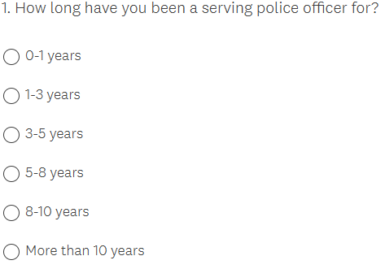

Question 2
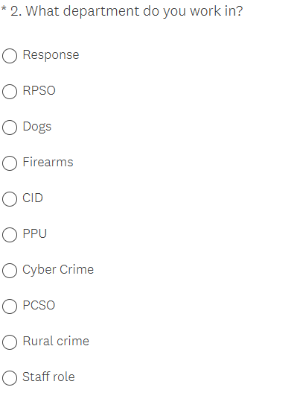

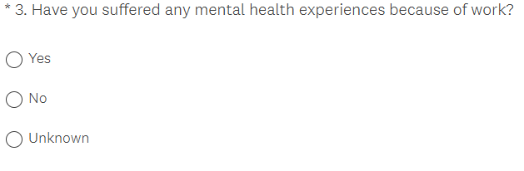
Question 3

Question 4
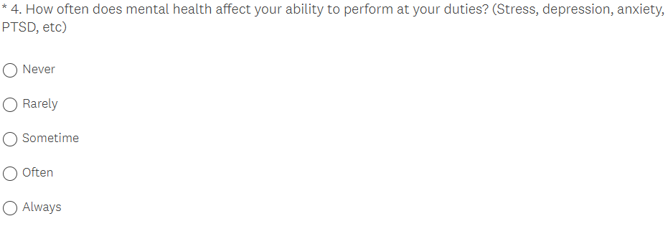

Question 5
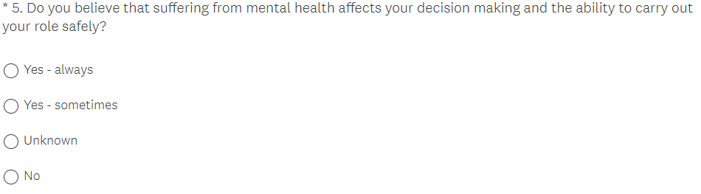

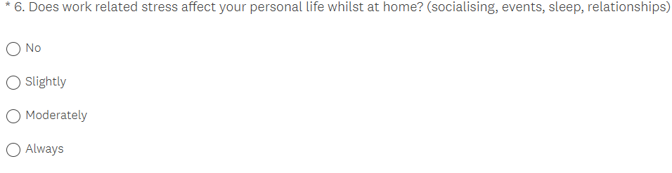
Question 6

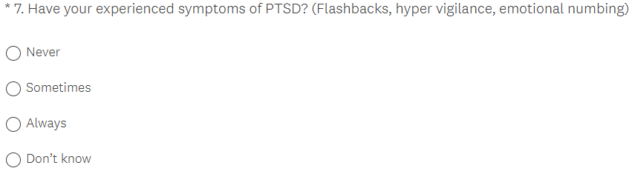
Question 7

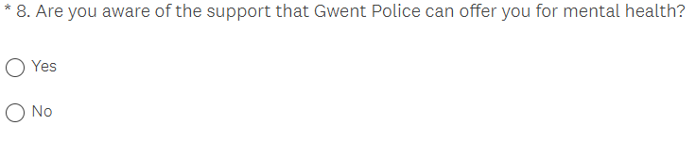
Question 8

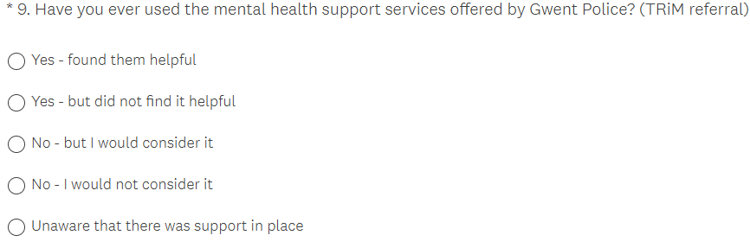
Queston 9

Question 10
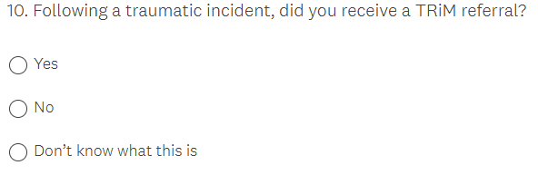

8.2 Survey answers and graphs
Question 1
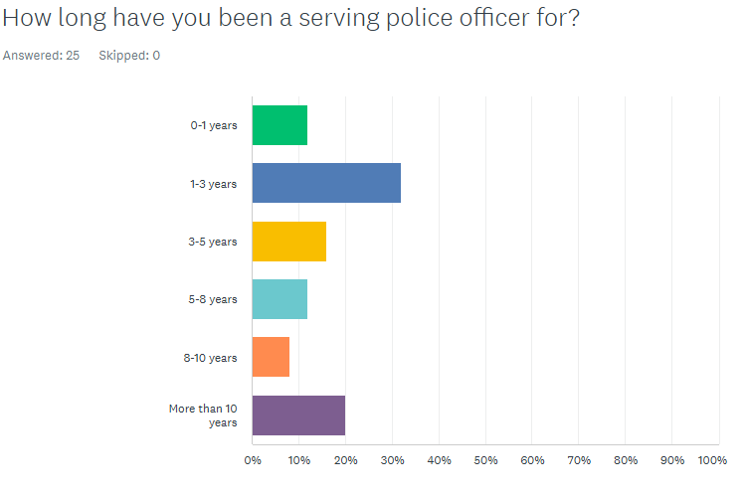

Question 2
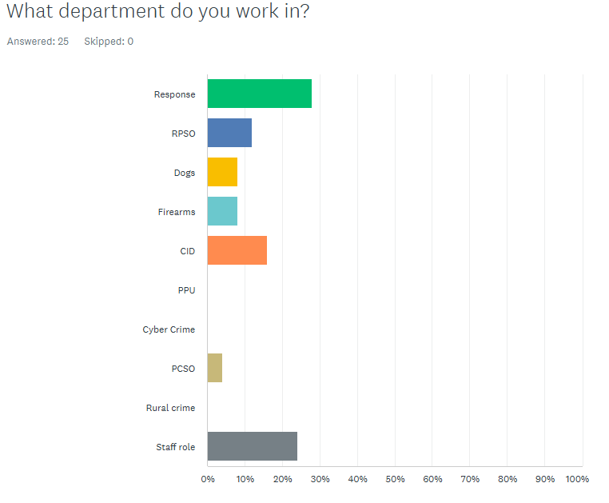

Question 3
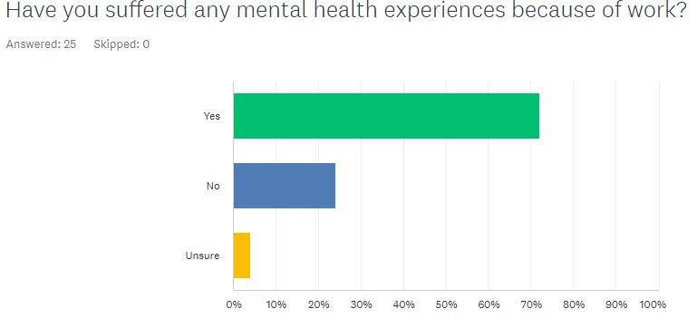

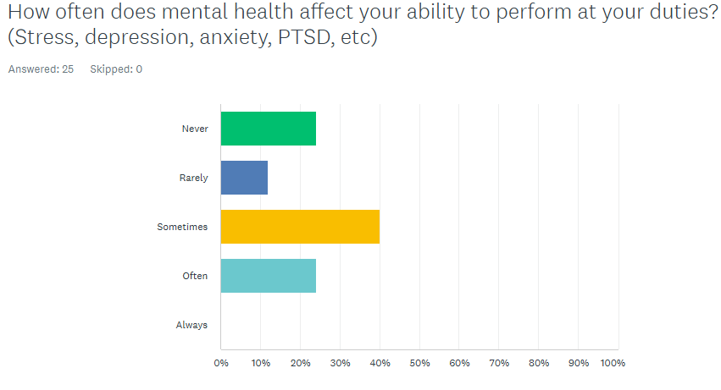
Question 4

Question 5
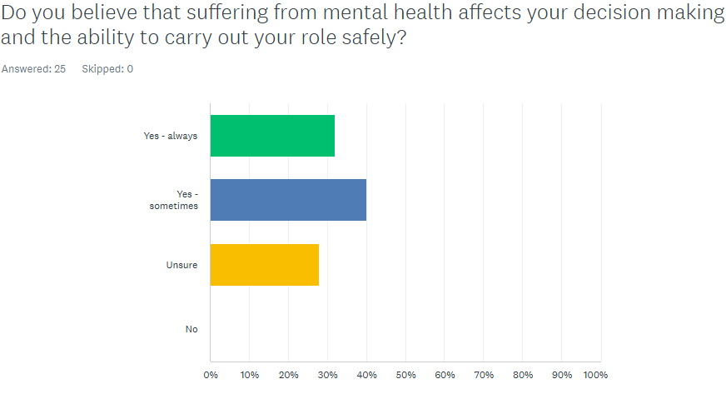

Question 6
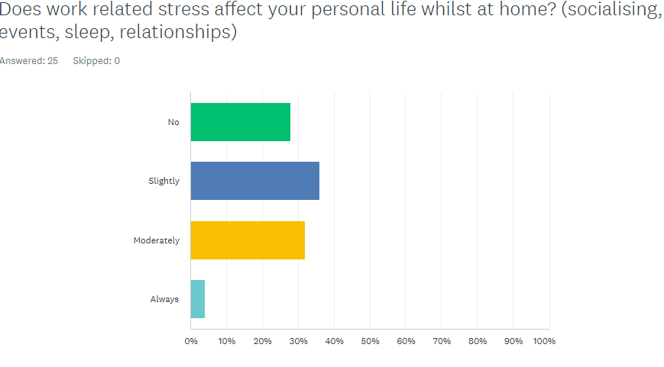

Question 7
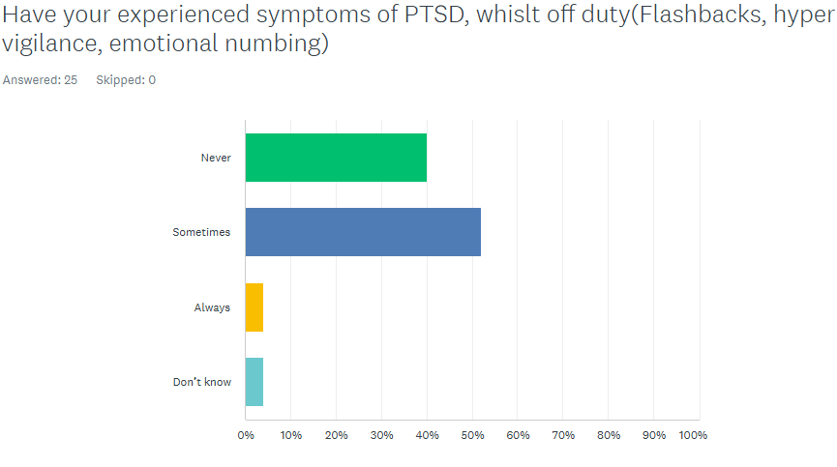

Question 8
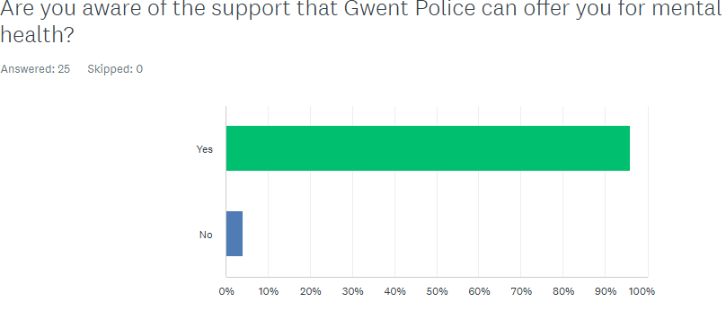

Question 9
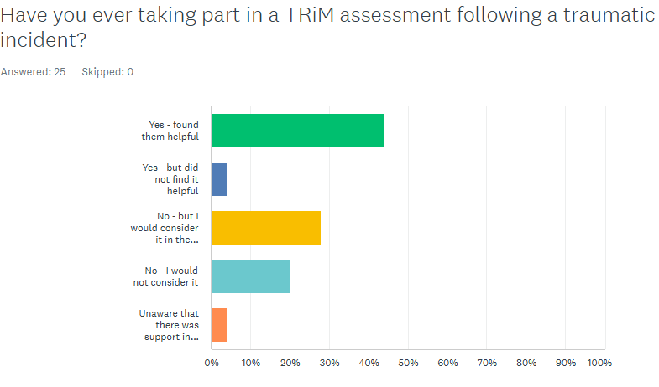

Question 10
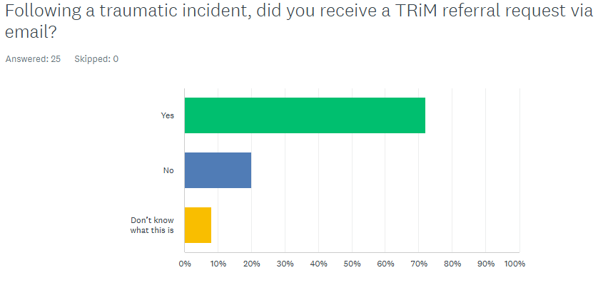

8.3 Ethics Form

Application for Ethical Approval
APPLICATION FOR ETHICAL APPROVAL

RESEARCH STUDENTS
This form is to be completed by the student within SIX months for full-time students and TWELVE months for part time students, after the commencement of the research degree or following progression to Part Two of your course.

Once complete, submit this form via the MyTSD Doctoral College Portal at (https://mytsd.uwtsd.ac.uk).

This document is also available in Welsh.

RESEARCH STAFF ONLY
All communications relating to this application during its processing must be in writing and emailed to pgresearch@uwtsd.ac.uk , with the title ‘Ethical Approval’ followed by your name.

STUDENTS ON UNDERGRADUATE OR TAUGHT MASTERS PROGRAMMES should submit this form (and receive the outcome) via systems explained to you by the supervisor/module leader.

In order for research to result in benefit and minimise risk of harm, it must be conducted ethically. A researcher may not be covered by the University’s insurance if ethical approval has not been obtained prior to commencement.

The University follows the OECD Frascati manual definition of research activity: “creative work undertaken on a systematic basis in order to increase the stock of knowledge, including knowledge of man, culture and society, and the use of this stock of knowledge to devise new applications”. As such this covers activities undertaken by members of staff, postgraduate research students, and both taught postgraduate and undergraduate students working on dissertations/projects.

The individual undertaking the research activity is known as the “principal researcher”.

Ethical approval is not required for routine audits, performance reviews, quality assurance studies, testing within normal educational requirements, and literary or artistic criticism.

Please read the notes for guidance before completing ALL sections of the form.

This form must be completed and approved prior to undertaking any research activity. Please see Checklist for details of process for different categories of application.

SECTION A: About You (Principal Researcher)
1 | Full Name: |  | Ashleigh Tucker
2 | Tick all boxes that apply: |  | Member of staff: | ☐ | Honorary research fellow: | ☐
 | Undergraduate Student | ☒ | Taught Postgraduate Student | ☐ | Postgraduate Research Student | ☐

3 | Institute/Academic Discipline/Centre: | UWTSD
4 | Campus: | Swansea
5 | E-mail address: | 2236646@student.uwtsd.ac.uk
6 | Contact Telephone Number: | 07977600320
 | For students:
7 | Student Number: | 2236646
8 | Programme of Study: | Professional Policing Practice Degree
9 | Director of Studies/Supervisor:

SECTION B: Approval for Research Activity
1 | Has the research activity received approval in principle?  (please check the Guidance Notes as to the appropriate approval process for different levels of research by different categories of individual) |  | YES | ☐ | NO | ☒
 |  |  |  |  | Date
2 | If Yes, please indicate source of approval (and date where known): Approval in principle must be obtained from the relevant source prior to seeking ethical approval | Research Degrees Committee |  | ☐
2 |  | Institute Research Committee |  | ☐
2 |  | Other (write in) |  | ☐

SECTION C: Internal and External Ethical Guidance Materials
 | Please list the core ethical guidance documents that have been referred to during the completion of this form (including any discipline-specific codes of research ethics, location-specific codes of research ethics, and also any specific ethical guidance relating to the proposed methodology). Please tick to confirm that your research proposal adheres to these codes and guidelines. You may add rows to this table if needed.
1 | UWTSD Research Ethics & Integrity Code of Practice | ☒
2 | UWTSD Research Data Management Policy | ☒
3 | [List any other relevant documents here] | ☐

SECTION D: External Collaborative Research Activity
If there are external collaborators then you should gain consent from the contact persons to share their personal data with the university. If there are no external collaborators then leave this section blank and continue to section E.
1 | Institution
2 | Contact person name
3 | Contact person e-mail address
4 | Is your research externally funded? |  | YES | ☐ | NO |  | ☐
5 | Are you in receipt of a KESS scholarship? |  | YES | ☐ | NO |  | ☐
6 | Are you specifically employed to undertake this research in either a paid or voluntary capacity? | Voluntary | YES | ☐ | NO | ☐
7 |  | Employed | YES | ☐ | NO | ☐
8 | Is the research being undertaken within an existing UWTSD Athrofa Professional Learning Partnership (APLP)? | If YES then the permission question below does not need to be answered. | YES | ☐ | NO |  | ☐
9 | Has permission to undertake the research has been provided by the partner organisation? | (If YES attach copy)  If NO the application cannot continue | YES | ☐ | NO |  | ☐

Where research activity is carried out in collaboration with an external organisation
10 | Does this organisation have its own ethics approval system? | YES | ☐ | NO | ☒
 | If Yes, please attach a copy of any final approval (or interim approval) from the organisation (this may be a copy of an email if appropriate).

SECTION E: Details of Research Activity
1 | Indicative title: | How does mental health affect a Police officer on and off duty and is there enough support in place to reduce the effects of PTSD
2 | Proposed start date: | 01/01/2025 | Proposed end date: | 06/10/2025
Introduction to the Research (maximum 300 words per section)
Ensure that you write for a Non-Specialist Audience when outlining your response to the points below:
- Purpose of Research Activity
- Proposed Research Question
- Aims of Research Activity
- Objectives of Research Activity
Demonstrate, briefly, how Existing Research has informed the proposed activity and explain
- What the research activity will add to the body of knowledge
- How it addresses an area of importance.
3 | Purpose of Research Activity  The purpose of this research will be to identify the effects of mental health on serving police officers whilst on duty and off duty. I will research if mental health can affect a police officer’ ability to think whilst at a critical incident. I will also research how mental health can have an impact on a police officer whilst outside of work, and how home and social life can be affected. I will also explore if there is enough support for police officers once they have attended a call, to reduce the effects of PTSD  (this box should expand as you type)
4 | Research Question  How does mental health affect a Police Officer on and off duty and is there enough support in place to reduce the effects of PTSD  (this box should expand as you type)
5 | Aims of Research Activity  - To research the effects of attending traumatic calls on serving police officers  - Explore the effects of poor mental health in police officers and how can it effect the ability to make critical decisions at incidents.  - Identify if there is substantial support available for police officers, once they have attended a traumatic call  - Explore the effects of PSTD and how this can affect a police officer both on and off duty  (this box should expand as you type)
6 | Objectives of Research Activity  - To research the effects of attending traumatic calls on serving police officers  - Explore the effects of poor mental health in police officers and how can it effect the ability to make critical decisions at incidents.  - Identify if there is substantial support available for police officers, once they have attended a traumatic call  - Explore the effects of PSTD and how this can affect a police officer both on and off duty  (this box should expand as you type)
Proposed methods (maximum 600 words)
Provide a brief summary of all the methods that may be used in the research activity, making it clear what specific techniques may be used. If methods other than those listed in this section are deemed appropriate later, additional ethical approval for those methods will be needed. You do not need to justify the methods here, but should instead describe how you intend to collect the data necessary for you to complete your project.
7 | To obtain research for this project, I propose to use a questionnaire which I will offer to serving staff members and police officers of Gwent Police to obtain their views surrounding mental health and the support that it is offered following a traumatic incident.  I will also obtain facts and figures surrounding this topic, from the internet to assist with answering this question.  (this box should expand as you type)
Location of research activity
Identify all locations where research activity will take place.
8 | Serving staff members and Police officers of Gwent Police  Internet research  (this box should expand as you type)
Research activity outside of the UK
If research activity will take place overseas, you are responsible for ensuring that local ethical considerations are complied with and that the relevant permissions are sought. Specify any local guidelines (e.g. from local professional associations/learned societies/universities) that exist and whether these involve any ethical stipulations beyond those usual in the UK (provide details of any licenses or permissions required). Also specify whether there are any specific ethical issues raised by the local context in which the research activity is taking place, for example, particular cultural and/or legal sensitivities or vulnerabilities of participants. If you live in the country where you will do the research then please state this.
9 | I will not be conducting any research outside of the UK  (this box should expand as you type)

10 | Use of documentation not in the public domain: Are any documents NOT publicly available? | NO | ☒
10 |  | YES | ☐
11 | If Yes, please provide details here of how you will gain access to specific documentation that is not in the public domain and that this is in accordance with the current data protection law of the country in question and that of England and Wales.  (this box should expand as you type)

 | Does your research relate to one or more of the seven aims of the Well-being of Future Generations (Wales) Act 2015? | YES | NO
12 | A prosperous Wales | ☐ | ☒
13 | A resilient Wales | ☐ | ☒
14 | A healthier Wales | ☐ | ☒
15 | A more equal Wales | ☐ | ☒
16 | A Wales of cohesive communities | ☐ | ☒
17 | A Wales of vibrant culture and thriving Welsh language | ☐ | ☒
18 | A globally responsible Wales | ☐ | ☒
19 | If YES to any of the above, please give details:
 | (this box should expand as you type)

SECTION F: Scope of Research Activity
 | Will the research activity include: | YES | NO
1 | Use of a questionnaire or similar research instrument? | ☒ | ☐
2 | Use of interviews? | ☐ | ☒
3 | Use of focus groups? | ☐ | ☒
4 | Use of participant diaries? | ☐ | ☒
5 | Use of video or audio recording? | ☐ | ☒
6 | Use of computer-generated log files? | ☐ | ☒
7 | Participant observation with their knowledge? | ☐ | ☒
8 | Participant observation without their knowledge? | ☐ | ☒
9 | Access to personal or confidential information without the participants’ specific consent? | ☐ | ☒
10 | Administration of any questions, test stimuli, presentation that may be experienced as physically, mentally or emotionally harmful / offensive? | ☐ | ☒
11 | Performance of any acts which may cause embarrassment or affect self-esteem? | ☐ | ☒
12 | Investigation of participants involved in illegal activities? | ☐ | ☒
13 | Use of procedures that involve deception? | ☐ | ☒
14 | Administration of any substance, agent or placebo? | ☐ | ☒
15 | Working with live vertebrate animals? | ☐ | ☒
16 | Procedures that may have a negative impact on the environment? | ☐ | ☒
17 | Other primary data collection methods. Please indicate the type of data collection method(s) below. | ☐ | ☒
 | Details of any other primary data collection method:  (this box should expand as you type) | ☐ | ☒
If NO to every question, then the research activity is (ethically) low risk and may be exempt from some of the following sections (please refer to Guidance Notes).

If YES to any question, then no research activity should be undertaken until full ethical approval has been obtained.

SECTION G: Intended Participants
If there are no participants then do not complete this section, but go directly to section H.

 | Who are the intended participants: | YES | NO
1 | Students or staff at the University? | ☐ | ☒
2 | Adults (over the age of 18 and competent to give consent)? | ☒ | ☐
3 | Vulnerable adults? | ☐ | ☒
4 | Children and Young People under the age of 18? (Consent from Parent, Carer or Guardian will be required) | ☐ | ☒
5 | Prisoners? | ☐ | ☒
6 | Young offenders? | ☐ | ☒
7 | Those who could be considered to have a particularly dependent relationship with the investigator or a gatekeeper? | ☐ | ☒
8 | People engaged in illegal activities? | ☐ | ☒
9 | Others. Please indicate the participants below, and specifically any group who may be unable to give consent. | ☐ | ☒
 | Details of any other participant groups:  (this box should expand as you type) | ☐ | ☒

Participant numbers and source
Provide an estimate of the expected number of participants. How will you identify participants and how will they be recruited?
10 | How many participants are expected? | I am hoping that I will get around 50 responses from the questionnaire.  (this box should expand as you type)
11 | Who will the participants be? | Police officer and staff members employed by Gwent Police  (this box should expand as you type)
12 | How will you identify the participants? | These questionnaires will be anonymous  (this box should expand as you type)

 | Information for participants: | YES | NO | N/A
13 | Will you describe the main research procedures to participants in advance, so that they are informed about what to expect? | ☒ | ☐ | ☐
14 | Will you tell participants that their participation is voluntary? | ☒ | ☐ | ☐
15 | Will you obtain written consent for participation? | ☒ | ☐ | ☐
16 | Will you explain to participants that refusal to participate in the research will not affect their treatment or education (if relevant)? | ☐ | ☐ | ☒
17 | If the research is observational, will you ask participants for their consent to being observed? | ☐ | ☐ | ☒
18 | Will you tell participants that they may withdraw from the research at any time and for any reason? | ☒ | ☐ | ☐
19 | With questionnaires, will you give participants the option of omitting questions they do not want to answer? | ☒ | ☐ | ☐
20 | Will you tell participants that their data will be treated with full confidentiality and that, if published, it will not be identifiable as theirs? | ☒ | ☐ | ☐
21 | Will you debrief participants at the end of their participation, in a way appropriate to the type of research undertaken? | ☒ | ☐ | ☐
22 | If NO to any of above questions, please give an explanation
 | (this box should expand as you type)

 | Information for participants: | YES | NO | N/A
24 | Will participants be paid? | ☐ | ☒ | ☐
25 | Is specialist electrical or other equipment to be used with participants? | ☐ | ☒ | ☐
26 | Are there any financial or other interests to the investigator or University arising from this study? | ☐ | ☒ | ☐
27 | Will the research activity involve deliberately misleading participants in any way, or the partial or full concealment of the specific study aims? | ☐ | ☒ | ☐
28 | If YES to any question, please provide full details
 | (this box should expand as you type)

SECTION H: Anticipated Risks

Outline any anticipated risks that may adversely affect any of the participants, the researchers and/or the University, and the steps that will be taken to address them.

If you have completed a full risk assessment (for example as required by a laboratory, or external research collaborator) you may append that to this form.
1 | Full risk assessment completed and appended? |  | Yes | ☐
1 |  |  | No | ☒
2 | Risks to participants  For example: sector-specific health & safety, emotional distress, financial disclosure, physical harm, transfer of personal data, sensitive organisational information
 | Risk to participants:  I do not believe this is any risk to the participants. This questionnaire will be completely voluntary, and the participant can stop completing the questionnaire at any time.  Prior to the participant completing this questionnaire, I will ensure they understand what the questionnaire is about first.  (this box should expand as you type) | How you will mitigate the risk to participants:  Prior to the participant completing this questionnaire, I will ensure they understand what the questionnaire is about first.  (this box should expand as you type)
3 | If research activity may include sensitive, embarrassing or upsetting topics (e.g. sexual activity, drug use) or issues likely to disclose information requiring further action (e.g. criminal activity), give details of the procedures to deal with these issues, including any support/advice (e.g. helpline numbers) to be offered to participants. Note that where applicable, consent procedures should make it clear that if something potentially or actually illegal is discovered in the course of a project, it may need to be disclosed to the proper authorities
N/A

(this box should expand as you type)
4 | Risks to the investigator  For example: personal health & safety, physical harm, emotional distress, risk of accusation of harm/impropriety, conflict of interest
 | Risk to the investigator:  Low risk – I don’t not believe this research will pose a risk to the investigator at this time  (this box should expand as you type) | How you will mitigate the risk to the investigator:  (this box should expand as you type)
5 | University/institutional risks  For example: adverse publicity, financial loss, data protection
 | Risk to the University:  Low risk  (this box should expand as you type) | How you will mitigate the risk to the University:  (this box should expand as you type)
6 | Environmental risks  For example: accidental spillage of pollutants, damage to local ecosystems
 | Risk to the environment:  No risk  (this box should expand as you type) | How you will mitigate the risk to environment:  (this box should expand as you type)

 | Disclosure and Barring Service
 | If the research activity involves children or vulnerable adults, a Disclosure and Barring Service (DBS) certificate must be obtained before any contact with such participants. | YES | NO | N/A
7 | Does your research require you to hold a current DBS Certificate? | ☐ | ☐ | ☒
8 | If YES, please give the certificate number. If the certificate number is not available please write “Pending”; in this case any ethical approval will be subject to providing the appropriate certificate number.

SECTION I: Feedback, Consent and Confidentiality

1 | Feedback  What de-briefing and feedback will be provided to participants, how will this be done and when?
No de-briefing/feedback will be required for this research questionnaire as it will be highlighted at the start, that it can be completed on a voluntary basis and every participant will be anonymous.

(this box should expand as you type)
2 | Informed consent  Describe the arrangements to inform potential participants, before providing consent, of what is involved in participating. Describe the arrangements for participants to provide full consent before data collection begins. If gaining consent in this way is inappropriate, explain how consent will be obtained and recorded in accordance with prevailing data protection legislation.
For this research questionnaire as it will be highlighted at the start, that is can be completed on a voluntary basis and every participant will be anonymous.

(this box should expand as you type)
3 | Confidentiality / Anonymity  Set out how anonymity of participants and confidentiality will be ensured in any outputs. If anonymity is not being offered, explain why this is the case.
Participants taking part in the questionnaire will not be asked for their personal details and everyone who completes a questionnaire will remain anonymous.

(this box should expand as you type)

SECTION J: Data Protection and Storage

 | Does the research activity involve personal data (as defined by the General Data Protection Regulation 2016 “GDPR” and the Data Protection Act 2018 “DPA”)? | YES | NO
1 | “Personal data” means any information relating to an identified or identifiable natural person (‘data subject’). An identifiable natural person is one who can be identified, directly or indirectly, in particular by reference to an identifier such as a name, an identification number, location data, an online identifier or to one or more factors specific to the physical, physiological, genetic, mental, economic, cultural or social identity of that natural person. Any video or audio recordings of participants is considered to be personal data. | ☐ | X☐
 | If YES, provide a description of the data and explain why this data needs to be collected:
2 | (this box should expand as you type)
 | Does it involve special category data (as defined by the GDPR)? | YES | NO
3 | “Special category data” means sensitive personal data consisting of information as to the data subjects’ –  (a) racial or ethnic origin,  (b) political opinions,  (c ) religious beliefs or other beliefs of a similar nature,  (d) membership of a trade union (within the meaning of the Trade Union and Labour Relations (Consolidation) Act 1992),  (e) physical or mental health or condition,  (f) sexual life,  (g) genetics,  (h) biometric data (as used for ID purposes), | ☐ | X☐
 | If YES, provide a description of the special category data and explain why this data needs to be collected:
4 | (this box should expand as you type)

 | Will data from the research activity (collected data, drafts of the thesis, or materials for publication) be stored in any of the following ways? | YES | NO
5 | Manual files (i.e. in paper form)? | ☐ | ☒
6 | University computers? | ☐ | ☒
7 | Private company computers? | ☐ | ☒
8 | Home or other personal computers? | ☐ | ☒
9 | Laptop computers/ CDs/ Portable disk-drives/ memory sticks? | ☐ | ☒
10 | “Cloud” storage or websites? | ☐ | ☒
11 | Other – specify: | ☐ | ☒
12 | For all stored data, explain the measures in place to ensure the security of the data collected, data confidentiality, including details of backup procedures, password protection, encryption, anonymisation and pseudonymisation:
 | (this box should expand as you type)

 | Data Protection
 | Will the research activity involve any of the following activities: | YES | NO
13 | Electronic transfer of data in any form? | ☐ | ☒
14 | Sharing of data with others at the University outside of the immediate research team? | ☐ | ☒
15 | Sharing of data with other organisations? | ☐ | ☒
16 | Export of data outside the UK or importing of data from outside the UK? | ☐ | ☒
17 | Use of personal addresses, postcodes, faxes, emails or telephone numbers? | ☐ | ☒
18 | Publication of data that might allow identification of individuals? | ☐ | ☒
19 | Use of data management system? | ☐ | ☒
20 | Data archiving? | ☐ | ☒
21 | If YES to any question, please provide full details, explaining how this will be conducted in accordance with the GDPR and Data Protection Act (2018) (and any international equivalents, where appropriate):
 | (this box should expand as you type)
22 | List all who will have access to the data generated by the research activity:
Myself – Ashleigh Tucker

(this box should expand as you type)
23 | List who will have control of, and act as custodian(s) for, data generated by the research activity:
Myself – Ashleigh Tucker

(this box should expand as you type)
24 | Give details of data storage arrangements, including security measures in place to protect the data, where data will be stored, how long for, and in what form. Will data be archived – if so how and if not why not.
The data obtained from the questionnaire’s will only be kept until this project is completed. All data which is obtained from the questionnaires will be completely anonymous

(this box should expand as you type)
25 | Please indicate if your data will be stored in the UWTSD Research Data Repository (see https://researchdata.uwtsd.ac.uk/ ). If so please explain. (Most relevant to academic staff)
 | (this box should expand as you type)
26 | Confirm that you have read the UWTSD guidance on data management (see https://www.uwtsd.ac.uk/library/research-data-management/) | YES | ☒
27 | Confirm that you are aware that you need to keep all data until after your research has completed or the end of your funding | YES | ☒

SECTION K: Declaration
The information which I have provided is correct and complete to the best of my knowledge. I have attempted to identify any risks and issues related to the research activity and acknowledge my obligations and the rights of the participants.

In submitting this application I hereby confirm that I undertake to ensure that the above named research activity will meet the University’s Research Ethics and Integrity Code of Practice which is published on the website: https://www.uwtsd.ac.uk/research/research-ethics/
1 | Signature of applicant: | Ashleigh Tucker | Date:  06/03/2025

For STUDENT Submissions:
2 | Director of Studies/Supervisor: |  | Date:
3 | Signature: |  | Date:

For STAFF Submissions:
4 | Academic Director/ Assistant Dean: |  | Date:
5 | Signature: |  | Date:

Checklist: Please complete the checklist below to ensure that you have completed the form according to the guidelines and attached any required documentation:
☒ | I have read the guidance notes supplied before completing the form.
☒ | I have completed ALL RELEVANT sections of the form in full.
☐ | I confirm that the research activity has received approval in principle
☐ | I have attached a copy of final/interim approval from external organisation (where appropriate)
☐ | I have attached a full risk assessment (where appropriate) ONLY TICK IF YOU HAVE ATTACHED A FULL RISK ASSESSMENT
☒ | I understand that it is my responsibility to ensure that the above named research activity will meet the University’s Research Ethics and Integrity Code of Practice.
☒ | I understand that before commencing data collection all documents aimed at respondents (including information sheets, consent forms, questionnaires, interview schedules etc.) must be confirmed by the DoS/Supervisor, module tutor or Academic Director.

RESEARCH STUDENTS ONLY
Once complete, submit this form via the MyTSD Doctoral College Portal at (https://mytsd.uwtsd.ac.uk).

RESEARCH STAFF ONLY
All communications relating to this application during its processing must be in writing and emailed to pgresearch@uwtsd.ac.uk , with the title ‘Ethical Approval’ followed by your name.

STUDENTS ON UNDERGRADUATE OR TAUGHT MASTERS PROGRAMMES should submit this form (and receive the outcome) via systems explained to you by the supervisor/module leader.

8.4 Research Propsal



UNDERGRADUATE DISSERTATION
RESEARCH PROPOSAL FORM

Please complete the following research proposal and submit it to Turnitin.

Which project option are you taking? Please tick:

8,000 word project:

NAME: Ashleigh Tucker | STUDENT ID No.: 2236646
DRAFT RESEARCH TITLE QUESTION:
INTRODUCTION: How does mental health affect a Police Officer on and off duty and is there enough support in place to reduce the effects of PTSD

With in the past 12 months, it has been recorded by the Police Federation that over 14,000 Police Officers were signed off from active duties due to poor mental health. (Police Federation, 2024). This is a worrying statistic as there are only 164,000 police officers working with in the UK. (Statista, 2025)
Not being fit for duty can have a major impact, when dealing with dynamically changing incidents and decision making. Research has shown that Post traumatic stress disorder also known as PTSD can change the way someone makes a decision based upon what they have experienced in the past by attending traumatic incidents. Someone suffering with PTSD could possibly make a decision based upon putting their feelings and emotions first and not prioritising the overall end goal. (Khiron Clinics, 2021).

Throughout my research into this topic, I will use questionnaires and internet research, to understand the effects of mental health in Police officers and who this can impact their day-to-day life both inside and outside of work. I will also use the questionnaires to obtain further information surrounding the support that is offered to serving police officers and police staff following a traumatic incident that they have dealt with.

SUMMARY OF RESEARCH OBJECTIVES:

- To research the effects of attending traumatic calls on serving police officers
- Explore the effects of poor mental health in police officers and how can it effect the ability to make critical decisions at incidents.
- Identify if there is substantial support available for police officers, once they have attended a traumatic call
- Explore the effects of PSTD and how this can affect a police officer both on and off duty

LITERATURE REVIEW:

To obtain information, facts and figures to answer my main question and research objectives, I will use a range of resources such as case studies, government reports to establish what is being done to support and protect police officers with mental health conditions. I will also utilise articles and journals to obtain factual and real-life views of serving and non-serving police officers of how mental health has affected them.

I will also research the methods and strategies, that Gwent Police have in place to support Police officers and Police staff who have attended traumatic incidents and the process that is offered to them following an incident that could have a lasting effect.

SUMMARY OF RESEARCH –SURVEY METHOD:

To obtain factual and accurate information for my project, I will make use of a questionnaire and disseminate this across the Gwent Police Force and all Police staff and Police officers can complete this on a voluntary basis and all participants will remain completely anonymous.

I believe this will be best suited to my research as this will provide a true and accurate representation of how Gwent Police deal with mental health problems within their staff and it will also identify if the methods used by Gwent Police are effective or whether something needs to change to improve its response when officers and staff are affected by mental health conditions such as PTSD.

By offering this questionnaire to the whole of Gwent Police, I am hoping to receive a number of different responses from all different backgrounds and departments within the force. This will allow me to analyse the results and identify if Gwent Police is supporting their staff members in the right way when it comes to mental health, or what else could be done to improve this support.

I believe this is best suited to my research as this will allow me to obtain accurate answers from staff and officers who may have suffered from mental health following a traumatic incident and I will also be to identify if staff and officers and utilising the support that is offered to them because of the traumatic incident.

SUMMARY OF SAMPLING FRAMEWORK:

To assist with answering my questionnaires, I plan on asking serving Police staff and Police officers of Gwent Police. Whilst I understand, police staff may not have experienced the same amount of trauma incidents as a police officer, staff in the force control room, are sometimes the first people to speak with the public following a traumatic incident.

This will allow me to obtain a range of answers from different staff and officer levels. I believe this is the best option for my research as the questionnaire will be put out to employees of Gwent Police, who may have suffered with a mental health condition following a traumatic incident or who may have used the services offered by Gwent Police to help with mental health conditions such as PTSD.

ETHICAL ISSUES:

To obtain this research, I have not identified any ethical issues currently. All participants of the questionnaire will be made aware that participation is completely voluntary and anonymous. No details of the participants will be obtained.
TIME SCALE:

- Research proposal and Ethics form – 24th Feb 2025
- Literature Review – 05th May 2025
- Research Methodology and planning – 16th June 2025
- Analysis of results 04th Aug 2025
- Findings and conclusion 08th Sept 2025
- Final submission 06th Oct 2025
REFERENCE LIST:

B. admin, (2021). How To Avoid Trauma-Driven Decisions [Online]. Khiron Clinics. Available at: https://khironclinics.com/blog/how-to-avoid-trauma-driven-decisions/ (Accessed: 6 March 2025).

D. Clark, (2025). UK largest police forces 2024 [Online]. Statista. Available at: https://www.statista.com/statistics/877540/leading-police-forces-by-officer-numbers-in-the-uk/ (Accessed: 6 March 2025).

P. Federation, (2024). Record 14,508 officers signed off with poor mental health in past year [Online]. Police Federation. Available at: https://www.polfed.org/news/latest-news/2024/record-14-508-officers-signed-off-with-poor-mental-health-in-past-year/ (Accessed: 6 March 2025).

