Assignment 1 – Individual assignment

By
Kevin Dabhi

Submitted to:
Dennis peppel

Table of Contents
Introduction 3
Body 3
Critically discuss how to implement the contingency approach model to support overall business strategy at each stage. 3
Provide an organisation example for each stage and critically discuss how the organisation implemented performance management 9
Reflecting on the post-maturity stage, critically discuss relevant performance management activities for renewal, steady state, and decline. 18
Reflecting on this module, how would you improve your practice using what you learned? - 22
Conclusion 25
Recommendation 25
Bibliography 26
Appendix 32

Introduction
In this assignment, a brief account of performance management systems of business life cycle is described to better understand the importance of different management models and theories with the guidance of the professional practices within organization. It basically prompts the purpose of developing management strategy and practice in different life stages of business. Along with this, it reflects the goals and values of individuals as well as organization by establishing strong collaboration with team members. Performance management approach helps to develop my belief and confidence in the participation of project work. In addition, conceptual framework regarding performance management also helps me to understand the proper methods and strategies that are used for improving my learning skills. It incorporates transferable skills, literature skills, new techniques, and technological skills into my learning process.

Critically discuss how to implement the contingency approach model to support overall business strategy at each stage.
The contingence approaches suggest that performance management of the organization depends on the implementation of effective business strategies as well as support the business proposal and action plans to achieve organizational goals. In this context, the management practice skills help to overcome business challenges by analysing various phases of the business cycle. It ultimately creates opportunities for the entrepreneurs to successfully run their business. In this context, the company uses “Fiedler's contingency model” to support team members in a right direction (Williams, 2022). This dynamic model describes the key contribution and characteristics of the business leaders to manage task-oriented goals as well as maintain healthy relationships with team members in workplace. The theoretical framework of this model represents effective leadership styles to handle critical situations and making strategic decisions. Using this contingency model, the business leaders motivate their employees to fulfil task-oriented goals. The benefits of this framework as it encourages business leaders to adjust their leadership styles in both adaptable as well as flexible way.
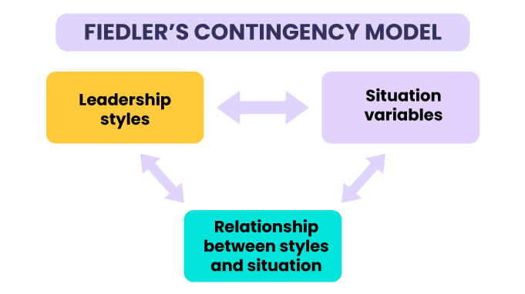
(Figure 1: Fiedler’s contingency model to support business)
(Source: influenced by (Shala, Prebreza, & Ramosaj, 2021)

Startup stage
Contingence approach | Implications
In this phase, the startup company faces different uncertainty in terms of business markets, product demands in the competitive business markets (Xia & & Gan, 2020). | - The company should implement effective management style such as implicate customer pivot-based business model to handle its business operations as well as evaluates new customer segment.  - The company should focus on lean management practices to achieve economic growth (Clift B. , 2019).
Growth stage
Contingence approach | Implications
Core Competencies:  Reduce Delivery  Time  Meet Specified  Delivery Dates  Improve Sales  Services  Improve Processes  Core Competencies:  Reduce Delivery  Time  Meet Specified  Delivery Dates  Improve Sales  Services  Improve Processes  Core Competencies:  Reduce Delivery  Time  Meet Specified  Delivery Dates  Improve Sales  Services  Improve Processes  In this phase, the firm uses developmental growth models to enhance both internal and external environment (Fürst, Gabrielsson, & Gabrielsson, 2023). It is also essential to collaborate with other competitive business partners for getting more capital which is needed for growth phase. | - The firm focus on different strategies and patterns to make of decisions in repaying debt as well as maintaining cash flow in a positive manner  - The firm also need to follows hybrid business models such as franchising, direct sales, advertising-based, and “brick-and-mortar stores” for achieving better profit margin (Piteli, Kafouros, & & Pitelis, 2021).  - The products or services of the company provides sale value and sale volume in the competitive marketplace.  - The company designs effective business proposals for attracting shareholders and new investors as more funds required in this phase to achieve positive results in their business growth.
Maturity stage
Contingence approach | Implications
In this phase, the company focuses on the sales of products or services per customer to retain competitive in business market (Clift, 2019). In order to decline the risks of repaying debt, the firm try to exhibit positive image in the market and successful business position for showing their abilities to repaying of their debt financing. | - The company implements different categories business models such as B2B and B2C model to shake out their sales and marketing segments to achieve steep growth in the business market.  - The company also considers “social media marketing” campaigns to increase their sales (Bianchi, 2021)  - For declining the business challenges, the firm integrates value-based selling approach.
Post-maturity stage
Contingence approach | Implications
Core Competencies:  Reduce Delivery  Time  Meet Specified  Delivery Dates  Improve Sales  Services  Improve Processes  Core Competencies:  Reduce Delivery  Time  Meet Specified  Delivery Dates  Improve Sales  Services  Improve Processes  Core Competencies:  Reduce Delivery  Time  Meet Specified  Delivery Dates  Improve Sales  Services  Improve Processes  In order to decline the debt capital, the corporation makes effective portfolio to portray its economic growth and development as well as adapt the changing working environment in their business cycle (Zhu, Xiao, & Dong, 2019). | - The company need to develop commercial skills and capabilities to utilize slake resources and achieve the criterion of better business performance.  - The company establishes efficient marketing planning strategies to maximize their growth (Audoly, 2023)  - The firm aims to expand their branches for remaining competitive and holding higher business position due to their reliability, flexibility, and customer value.  - The company also uses dynamic business models instead of using static model to maximize profitability and achieve operational efficiency.  - The company suggests variability in their slack resources to find out new market opportunities (Azmat, Hassan, & Ghaffar, 2021)  - The firm diversifies their market share model for getting repeated investments which in turn helps to overcome the risks of financial debt as well as optimize operational control

(Table 1: model of contingency business approach to support each stage of business cycle)
(Source: self-developed)

In this scenario, the cogenetic approach of different phases of the business life cycle helps to understand the key aspects of the firm that need to implement in their business for creating value in their business performance and achieve success in economic growth. In order to identifying the requirements criteria, the firm ought to focus on specific business practices such as improve value-added selling services to ensure customer satisfaction. It helps to increase revenue growth due to the improvement of product or service quality (Cefis & & Marsili, 2019). The contingent perspective in business practices helps the firm to implement effective strategic decision in their business model. However, the impact of the contingency approach helps the company to integrate “new product development” plan as well as increase the speed of their operational management systems. It creates positive impact on maintaining sustainability in their business practices.
On the other hand, incorporating advanced technology such as artificial intelligence, data analytics tools, and machine learning systems in measuring the sale volumes and sales value, helps the company to survive to the last stages of the business cycle due to their innovative approach and performance. However, availability of insufficient resources and lower level of accessibility to both internal and external business market slowly decline the company’s revenue growth over the passing time (Guerreiro, 2022). Therefore, it is essential to focus on various cost-effective resources to drive the performance of the company by following the contingent factors.

Provide an organisation example for each stage and critically discuss how the organisation implemented performance management
Implement performance management strategies in the Startup stage of a business life cycle
The business leaders and managers of the startup company follows key steps of the performance management process which includes designing of an action plans and goal setting framework to achieve success by implementing those goals. the second step is to create a bucket list for different categories goal settings which includes personal and professional goals. the third step of performance management is to monitor the assured goals on a regular basis through feedback systems and adjust the goals according to requirements (Cho, Bonn, & & Han, 2020). The HR managers of the company reviews the fulfilled goals and give ratings on the basis of employee’s effectiveness.
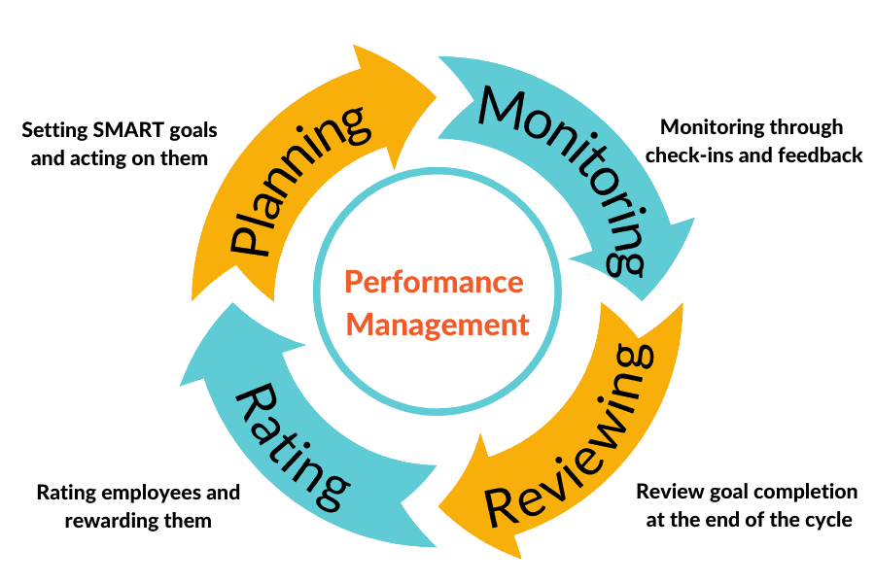
(Figure 2: Performance management model of startup company)
(Source: influenced by (Marcon & & Ribeiro, 2021 )
For example, the organization comes under the startup stage is “Rumin8” in Australia (Rumin8, 2023). The company focuses on delivering single services and goods such as advanced agricultural technology due to lack of adequate capital for moving to the next stage along with not create strong brand image in the marketplace. The company develops effective business plans for its scalability and maturity, it also provides digital solutions in their performance management process for successfully run the business.
Rumin8 integrates data analytics and HR analytics systems to manage the workforce, its business operations, financial process. The firm develops strategic plans in their informed decisions making process by using agile methodology to drive their business forward. Along with this, the company creates workforce planning by designing action plans with the help of “cloud-based SAP analytics” systems. Besides that, the Rumin8 forecasts their strategic planning by determining the demands of their products as well as maintaining the supply chains to cover the workforce gaps (Pham, 2020). The company implements skills-based management programs by collaborating with individual team members which helps to create effective action plans in business practices.
In order to achieve financial goals, Rumin8 sets different management tasks by integrating workforce tools. The company also take initiatives for mapping the competency which are measured by KPI indicators. The firm incorporates various strategies for its marketing segments by focusing on its “social media marketing” and email marketing. However, for tracking the business performance of the Rumin8, it implements “360 Degree Review” systems in their websites. In order to increase the engagement of employee, the managers of the company provide rewards to their employees such as bonuses and incentives (Nicholls-Nixon, Valliere, Gedeon, & & Wise, 2021). The vision of the Rumin8 is to lower methane emissions by developing better food supplement along with creates effective progress in agricultural technology for the next five years.
Rumin8 determines their business objectives to improve performance by aligning company's goals to contribute to successful business sets up. To be on startup phase, Rumin8 focuses on the slack resources to overcome the cost savings impacts. The company also follows agile techniques in performance management steps by determining the business objectives. In this scenario, the company uses time-based “SMART” goals framework to measure specific business objectives. Besides that, for better communication with each and every staff member, the HR manager implemented feedback systems on a regular basis to maintain healthy relationship with them.

Implement performance management strategies in the Growth stage of a business life cycle
For example, the organization like “George Weston Foods” in Australia (GWF, 2023), comes up with growth phase, implements strategic approaches in their performance management systems. The company provides services related to food science industries and develops food processing engineering in the manufacturing of the food products. However, in order to develop professional skills, the directors, board members, managers, and senior executives, focus on the key functions and activities of this team as well as team members are to facilitate training and proper education to provide a guide to food industry professionals. The goals and objectives of this firm is to maintain the sustainability of their selling food items in respects to packaging of materials and transition to retain the maximum value of the materials.
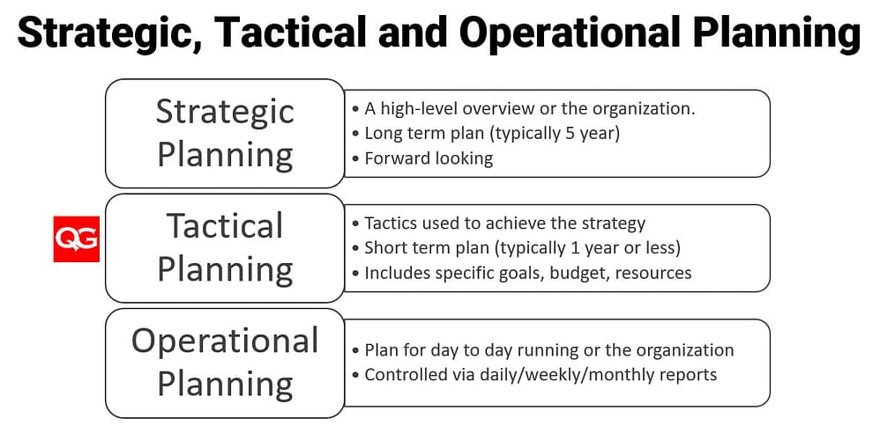
(Figure 3: model of strategic, tactical and operational planning process of the company)
(Source: influenced by (Pereira & Oliveira, 2020)
In order to increase the business performance in the marketplace, the food Quality analysing managers more significantly check the quality of food to ensure consistency in their performance. Besides that, the food processing engineers develop new and innovative technologies for the manufacturing of baking products along with to increase the operational efficiency. It helps to improve the safety, and the shelf life of baking food products (GWF, 2023). The regulatory and marketing professionals develop strategies to manage the portfolio of food policies and regulations which lead to facilitating changes in the food items.
However, the company execute a targeting plan for developing 50% of their products are packed in recycled plastic packaging. The “George Weston Food” company continuously work on the consumer affairs and quality issues to achieve success in economic development.
In order to solve these problems regarding quality issues, the company try to develop proper food safety plans and policy. The company also maintain healthy communication with consumers and their team members through feedback and emails. The performance outcomes of the company related to the strategic planning in food processing ensure that they provide high-quality food products by maintaining the guidelines of food safety as well as achieved high sale values and volume on yearly basis. Besides that, the company also provides training programs for improvement of professional performance (Yang, Jiang, & Jia, 2023). By practising in this training, individual could assess their performance through reflective learning to understand different perspectives that need to develop during communicating with other team members.
Along with this, in order to address the organizational goals for both personal and professional development, the company develops strategic framework which includes coaching and mentoring of staff members as well as arranging meeting conferences for active participation by the staff members in their training programs. With the help of professional development, the employees can grow their knowledge in the competitive environment and obtain new skills to perform better in their current workplace (Lim & Zheng, 2020). It ultimately helps the company to go to the next phases with the achievement of successful outcomes in managing business performance.

Implement performance management strategies in the Maturity stage of a business life cycle
For example, the organization like “Reliance” comes up with the maturity phase in their business cycle. The company uses “key performance indicators (KPIs)” and data analytics tools such as Ms-excels and BIM to measure the financial statements of the company. The company also implements performance reviews systems to monitor the performance of employees as well as the organization (Al-Delawi & & Ramo, 2020). Along with this, Reliance incorporates effective feedback model like “360-degree reviews” model to assess both employee’s and business performance by providing more comprehensive view on their performance. The company also uses agile framework and pivot table to measure the adaptive performance by setting-up business priorities and strategic planning.
The Reliance company uses advanced technologies like “Industry 4.0” to improve the business performance. Nowadays different components of Industry 4.0 tool help to manage the logistics and supply chains data of the company (Ghobakhloo, 2020). Along with this, the company also uses other technological tools to improve performance which includes “Internet of Things (IOTs)”, “machine-to-machine (M2M)”, and cloud computing systems for big data management. Using these technical tools help the company to increase value in its operational management to come in to the maturity stages.
Besides that, Reliance also promotes different professional skills and business ethics to support the organizational goals as well as increase the ability of going to the next steps of business cycle (Bastari, Eliyana, & & Wijayanti, 2020). However, the various management practices help the company to achieve success in the maturity stage. In this modern era, using of digital technology, helps the company to improve their business performance. Therefore, these success factor of Reliance, helps the firm to overcome challenges related to digital changes due to the establishment of advanced technical systems in the business environment.
Along with this, the different perspectives of transformational leadership which includes idealized influence, intellectual stimulation, inspirational motivation, and individualized consideration, influence the performance of the firm by inspiring professional goals of business leaders (Atan & & Mahmood, 2019). It stimulates different professionals’ behaviours of the leaders such as critical thinking ability, innovative, make strategic decisions in critical situations, and creative.
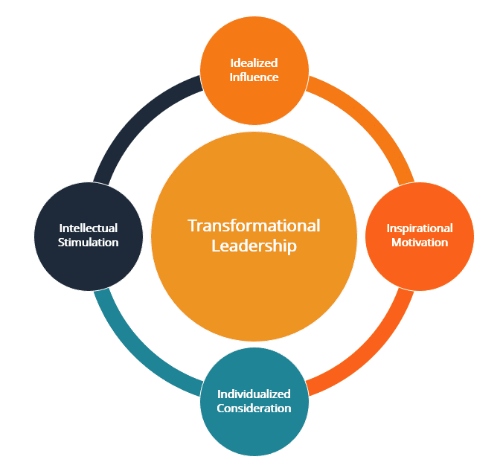
(Figure: transformational leadership styles for promoting performance management strategies)
(Source: influenced by (Legutko, 2020)
Besides that, the company also focus on the leadership styles for improving the performance of the professional leaders in the firm. It ultimately provides opportunities to Reliance for maintaining various managemental aspects which includes conflict management in workplace, stress management, and project management. The company incorporates transformational leadership styles in their business environment for maintaining healthy relationship with the team members. This type of leadership conversation helps to provide both personal and professional development to better manage the team work facilities. It provides effective strategies for solving the problems related to the changing business environment. The transformational leadership styles promote business leaders for guiding their teams with pragmatic-based solutions
Implement performance management strategies in the post-maturity stage of a business life cycle
For example, the organization like “Tesla” comes up with the post maturity phase of the business cycle. In this phase, it is essential to focus on the profits and financial problems related to the cash flow to prevent the company for undergoing into the unprofitable stage. In this regard, Tesla, implements effective performance management strategies to overcome financial managemental issues (Qingren, 2023). The company uses human resource tool in its corporate management, which in turn helps the line managers to monitor as well as evaluate the financial activities of the firm as well as professional performance of the employees in Tesla.
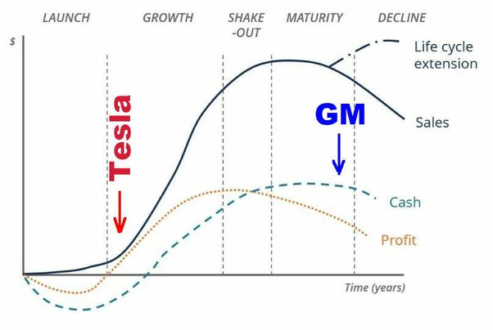
(Figure: model of business life cycle of Tesla)
(Source: influenced by (Lang, Reber, & & Aldori, 2021)

In the post maturity stages, Tesla need to improve their business performance by convenience as well as attract their customers by launching new electric vehicles along with providing better customer service facilities. In order to generate sales and profits margins in the post maturity stages, Tesla needs to implement new and advanced technologies such as AI-based sensors in their electric vehicles (EV). At this phase, the company also needs to focus on the EV sales as well as current marketing demands to retain competitive in the automobile business market. Tesla develops a conceptual framework to improve performance which incorporates sustainable ecosystem, implement various innovations, technologies, and modularity to their business model. These strategic key elements play a crucial role in the improvement of Tesla’s performance by shifting the automotive paradigm to the battery-based energy platforms like “electric vehicle (EV)” from fuel-based combustion engine. Along with this, another strategic approach of the firm to improve business performance is to use different performance management models and theories which includes “Goal-setting” theory and “Maslow's Hierarchy of Needs” theory.
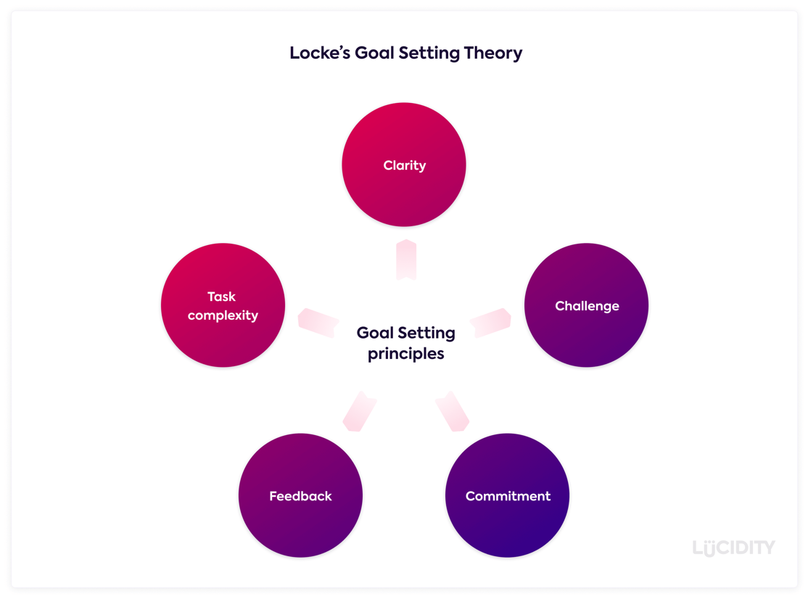
(Figure: strategic approach for improving performance using goals setting theory)
(Source: influenced by (Vig, Suta, & & Tóth, 2022)
The “goals setting theory” improves the task performance of the firm by involving employee engagement with the help of measurable and specific goals to achieve profits as well as improves productivity of the firm. By implementing strategic approach to the working environment, Tesla can improve the performance-based goals. however, different aspects of this theory propose basic principles of firm’s goals which include commitment, clarity, feedback, challenges, and complexity of operational management (Zhao, 2021). Using these strategic approaches, the company can overcome the challenges related to the declining of productivity and reduce of profits margin.
The realistic and clear goals help the firm to improve both employee performance as well as organizational development (Di Palma, 2022). The advantages of using strategic planning in the performance management as it helps the company to identify various developmental strategies of maturity stage.

Reflecting on the post-maturity stage, critically discuss relevant performance management activities for renewal, steady state, and decline.
The business life cycle curve of the organization describes the successful implementation of the performance management strategies by evaluating their progress in managing products and services. However, in the post maturity stages the company adopts strategic momentum for up taking the overall growth in various directions which includes renewal, decline, and steady phases of the post-maturity stage (Chipeta, 2022). At this saturation points, it leads to increase the curve upwards as high as possible to overcome the managemental issues.
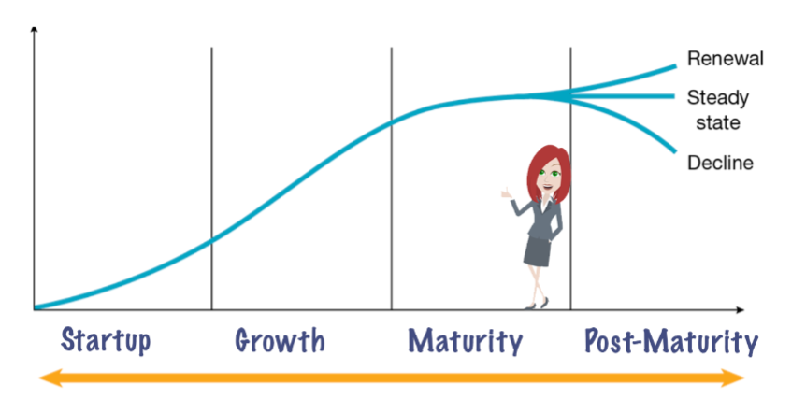
(Figure: dynamic model of different stages of a business life cycle)
(Source: influenced by (Cantner, Cunningham, Lehmann, & Menter, 2021)

Performance management activities and strategies for renewal at post-maturity stage
Emerging new and innovative ideas as well as convert those ideas into business purposes by the employee, the organization could improve its sustainable business growth at renewal stage of post-maturity phase. By adapting entrepreneurial decision-making strategies, the company could manage its business performance at the post-maturity phases of its business cycle (Al Aina & & Atan, 2020). Another business strategies the company should follow to manage the performance of individual employee, in order to balance the quality of the products and services offered by them are unique and attractive for customers, to manage economic growth of the company. The company also have clear vision and goals to successfully run the business. Besides that, another management activities that ought to incorporate related to making changes in their business operations according to industry trends and market transformations (Whysall, Owtram, & & Brittain, 2019). In this scenario, the employee needs to perform excellent in order to overcome the slow acquisition of customers towards their products. The employee should find out new products or modified the existing products for reducing the slow decline of the customer values and satisfaction of their existing products. It in turn helps to maintain lifetime value of the organization products or services due to the better performance and hard work of both the employees as well as the firm. The company also implement strategic approaches to their business model to cope up with its competitors by adopting customer acquisition strategies on the basis of current situations (Ngoc Su, Luc Tra, Thi Huynh, & Nguyen, 2021). Where, the company need to integrates new products or services by launching innovative products, which not have in the market as well as modify their existing products as per customer requirements. This type of customer acquisition strategy helps the company to remain competitive in the business market.
Performance management activities and strategies for steady state at post-maturity stage
In order to manage the performance of both the employees as well as organization, the firm should focus on the training and education of the individual staff members. The managers of the company offer rewards-based strategic framework to provides recognition for high performing employees to motivate them consistently (Meyers, van Woerkom, & Paauwe, 2020). The company also focus on the brand awareness in order to maintain competitiveness in market. Besides that, integrating appropriate feedback systems in their working environment, improves employee’s behaviour by providing support through identifying the lack of experience and skills in their performance on a regular basis.
The firm also enter into the new foreign market to retain its brand value and images in order to recover their startup survival by reaching at the peak position through effective market penetration strategies (Varma, Budhwar, & & DeNisi, 2023). In order to attract potential customers, the firm also focuses on the improvement of their product quality in order to increase their revenue segment. As the endpoint of this maturity phase the sales values and volume in respect to the product sales is declined instead of having effective product price. Therefore, it is essential to focus on the performance of both the employee as well as organization by making effective decisions in the product manufacturing, operations, and supply chain procedures in order to move for new types of business products in the market. With the help of using this business strategies, the firm can regain their customers values and satisfaction for the new types of products. In order to retain competitive advantages as well as maintain business position, the firm focuses on the environmental changes such as changes in the process of product manufacturing using advanced technologies and easily available resources materials.

Performance management activities and strategies for decline at post-maturity stage
Exploring new business opportunities to achieve economic growth, the company could manage its business challenges at the decline phase of the post-maturity stages. In order to retain product growth, the firm should implement effective key strategies, which includes market development, diversification of their products or services, and development as well as modification of the new and existing products respectively (Darmawan, et al., 2020). By encouraging and engaging individual staff members of the firm, the business leaders motivate employees for developing new or innovative ideas, with the help of these innovative strategies the firm can develop new or exciting products, which in turn attracted to the customers. By diversifying their business market with the development of new brand or the new products, the company can acquire new audience or consumers.
The firm also focuses on the different categories of customer segments plan to improve their existing product development (Andersen & & Nielsen, 2020). The firm also considering their pricing models in order to increase their recent market share for remain competitive at the prolonged phase of the post maturity stage. The firm also focus on the business ethics and legislation policies in order to manage their business values from privacy and safety concerns of both employees as well as the customers. It ultimately helps the company to save from a large number of fines or losses for breaking the rules of business ethics and compliance (Guinan, Parise, & & Langowitz, 2019). Apart from this, the company also focuses on the rapid scale development of their various infrastructure such as technical infrastructure besides the new product development at the post maturity stage.

Reflecting on this module, how would you improve your practice using what you learned? -
I will improve my performance and practice skills in my learning experiences by incorporating different perspectives of performance management such as improving problem solving and critical thinking abilities, creativity, empathy, more engagement and participation in various project work or activities. Along with this, it also required to develop strong communication skills, resilience, self-assessment and management, cooperation, and effective decision-making strategies. I will also improve my professional performance by developing different management skills such as literature skills, understanding skills, intellectual and cognitive skills, practical knowledge, and transferable skills.
In this context, I improve my transferable skills by developing my self-management abilities to recognize and handle my emotions, feelings, and impulsive behaviour. I will also develop self-resilience which help me to capable or to navigate my professional approaches successfully in any adverse situations. I will also implicate my learning strategies and practices in team-based work and time management. I will also adapt or develop transferable knowledge which play a crucial role in my performance development along with improving empathy throughout my life. The practical experiences that I achieved at the time of participating and learning skills and knowledge in various project work, which in turn will help me to develop effective communication skills at the time of working with my team members in a collaborative way. Identifying the transferable skills which will help to improve professional performance, I can develop practical knowledge as well as achieved a strong sense of responsibility in my professional practices.

I will develop my cognitive and intellectual skills by recognizing my emotional impact on the business practices to better understand the improvement in my professional performance. Nowadays I am able to deal with several problems related to project work. Along with improving my cognitive skills help me to critically think the workplace related problems, develop creative ideas and negotiable characteristics to solve business problems. However, assessing emotional intelligence level, I can improve my professional performance which in turn help me to manage work pressure in the internal business environment. It also helps me to maintain a healthy relationship with my coworkers as well as with team leaders.
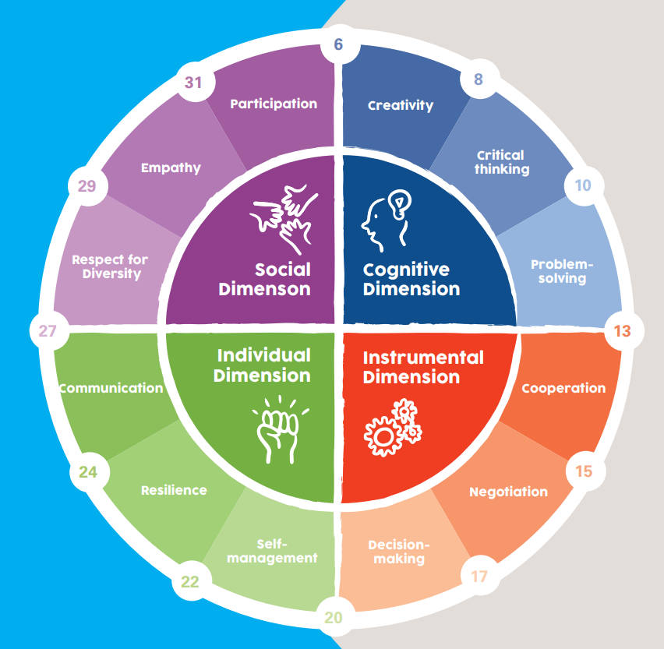
Figure: different types of performance skills in professional practices
(Source: influenced by (Pryor, Hale, & Hudson, 2019)
I have also observed that designing my personal development plan provide me the knowledge of using both cognitive as well as my intellectual skills in performance management practices. On the other hand, analysing my weakness in controlling emotion, helps me to develop better intellectual skills and knowledge as well as improve my cognitive skills. I will also improve my professional performance by managing time. My higher level of intelligence skills provides me opportunities to maintain transparent communication with all my team members. Developing emotional intelligence skills helps me to manage with my workplace problems in an effective way throughout my life.

Conclusion
In order to overview the contingence approach on the business life cycle, it has been stated that performance management is greatly influenced by various steps business life cycle. It also contributes to individual overall performance in professional practices. It also implicit the standards or quality of both personal and professional performance of an individual by improving various types of management skills and practice of learning. Furthermore, better understanding of the different types of skills which include literature skills, understanding skills, intellectual and cognitive skills, transferable and practical skills help individuals to improve the professional practices to fulfil business goals.

Recommendation
In this section, it is recommended that the learning objectives and experiences helped individual to better improve the performance management skills in professional practices. The recommended criteria are given below
- It is considered to implicate action plans for collaborative group work for better experiencing learning practices in developing different types of professional skills such as practical skills, transferable skills, cognitive and literature skills.
- It is also suggested to implement more technical tools such as AI based performance management software to better understand theoretical approaches and learning things
- It is also recommended to incorporate relevant and time- specific action plans so that individual can easily understand different stages of a business cycle and improve their business performance.

Bibliography
Al Aina, R., & & Atan, T. (2020). The impact of implementing talent management practices on sustainable organizational performance. Sustainability, 83-172, DOI: 10.3390/su12208372.
Al-Delawi, A. S., & & Ramo, W. M. (2020). The impact of accounting information system on performance management. Polish Journal of Management Studies,, 21(2), 36-48, DOI: 10.17512/pjms.2020.21.2.03.
Andersen, S. C., & & Nielsen, H. S. (2020). Learning from performance information. Journal of Public Administration Research and Theory,, 30(3), 415-431, DOI: 10.1093/jopart/muz036.
Atan, J. B., & & Mahmood, N. (2019). The role of transformational leadership style in enhancing employees’ competency for organization performance. Management Science Letters, 9(1), 2191-2200, DOI: 10.5267/j.msl.2019.7.033.
Audoly, R. (2023). Firm dynamics and random search over the business cycle. . FRB of New York Staff Report,, 10-69, DOI: 10.59576/sr.1069.
Azmat, S., Hassan, M. K., & Ghaffar, H. &. (2021). State contingent banking and asset price bubbles: The case of Islamic banking industry. Global Finance Journal,, 50(2), 100-531, DOI: 10.1016/j.gfj.2020.100531.
Bastari, A., Eliyana, A., & & Wijayanti, T. (2020). Effects of transformational leadership styles on job performance with job motivation as mediation: A study in a state-owned enterprise. Management Science Letters, 10(1), 2883-2888, DOI: 10.5267/j.msl.2020.4.019.
Bianchi, F. I. (2021). Diagnostic business cycles (No. w28604). . National Bureau of Economic Research., 34-67, DOI: 10.3386/w28604.
Cantner, U., Cunningham, J. A., Lehmann, E. E., & Menter, M. (2021). Entrepreneurial ecosystems: a dynamic lifecycle model. Small Business Economics, 407-423, DOI: 10.1007/s10845-019-01512-w.
Cefis, E., & & Marsili, O. (2019). Good times, bad times: innovation and survival over the business cycle. . Industrial and Corporate Change,, 28(3), 565-587, DOI: 10.1093/icc/dty072.
Chipeta, C. (2022). ANALYZING THE PERFORMANCE OF SOUTH AFRICA’S COMMODITY MARKET PRICES THROUGH BUSINESS CYCLE INDICATORS. Studia Universitatis Babes Bolyai-Negotia,, 45-70, DOI: 10.1111/joes.12364.
Cho, M., Bonn, M. A., & & Han, S. J. (2020). Innovation ambidexterity: balancing exploitation and exploration for startup and established restaurants and impacts upon performance. Industry and Innovation, 27(4), 340-362, DOI: 10.1080/13662716.2019.1633280.
Clift, B. (2019). Contingent Keynesianism: the IMF’s model answer to the post-crash fiscal policy efficacy question in advanced economies. Review of international political economy,, 26(6), 1211-1237, DOI: 10.1080/09692290.2019.1640126.
Clift, B. (2019). Contingent Keynesianism: the IMF’s model answer to the post-crash fiscal policy efficacy question in advanced economies. Review of international political economy, 26(6), 1211-1237, DOI: 10.1080/09692290.2019.1640126.
Darmawan, D., Mardikaningsih, R., Sinambela, E. A., Arifin, S., Putra, A. R., Hariani, M., & ... & Issalillah, F. (2020). The quality of human resources, job performance and employee loyalty. International Journal of Psychosocial Rehabilitation,, 24(3), 2580-2592,.
Di Palma, G. (2022). Servitization business model: the case of Tesla. 345-678, DOI: 10.25236/AJHSS.2023.061809.
Fürst, A., Gabrielsson, M., & Gabrielsson, P. &. (2023). The role of marketing in new ventures: How marketing activities should be organized in firms’ infancy. Journal of the Academy of Marketing Science,, 1-24, DOI: 10.1016/0883-9026(90)90028-R.
Ghobakhloo, M. (2020). Industry 4.0, digitization, and opportunities for sustainability. Journal of cleaner production,, 25(2), 119-869, DOI: 10.1016/j.jclepro.2019.119869.
Guerreiro, J. (2022). Belief disagreement and business cycles. . Job market paper, northwestern university., DOI: 10.59576/sr.1069.
Guinan, P. J., Parise, S., & & Langowitz, N. (2019). Creating an innovative digital project team: Levers to enable digital transformation. Business Horizons, , 717-727, DOI: 10.1016/j.bushor.2019.07.005.
GWF. (2023, September 28). George Weston Foods. Retrieved from https://www.gwf.com.au/
Lang, J. W., Reber, B., & & Aldori, H. (2021). How Tesla created advantages in the ev automotive paradigm, through an integrated business model of value capture and value creation. Business & Management Studies: An International Journal,, 385-404, DOI: 10.15295/bmij.v9i1.1790.
Legutko, B. J. (2020). An exploration of authentic, servant, transactional, and transformational leadership styles in Fortune 500 CEO letters.,. Journal of Leadership Studies, 14(2), 44-51, DOI: 10.1002/jls.21683.
Lim, K. Y., & Zheng, P. &. (2020). A state-of-the-art survey of Digital Twin: techniques, engineering product lifecycle management and business innovation perspectives. Journal of Intelligent Manufacturing , 1313-1337, DOI: 10.1007/s10845-019-01512-w.
Marcon, A., & & Ribeiro, J. L. (2021 ). How do startups manage external resources in innovation ecosystems? A resource perspective of startups’ lifecycle. . Technological Forecasting and Social Change, 17(1), 120-965, DOI: 10.1016/j.techfore.2021.120965.
Meyers, M. C., van Woerkom, M., & Paauwe, J. &. (2020). HR managers’ talent philosophies: prevalence and relationships with perceived talent management practices. The International Journal of Human Resource Management, , 562-588,.
Ngoc Su, D., Luc Tra, D., Thi Huynh, H. M., & Nguyen, H. H. (2021). Enhancing resilience in the Covid-19 crisis: lessons from human resource management practices in Vietnam. Current Issues in Tourism, 3189-3205, DOI: 10.1080/13683500.2020.1863930.
Nicholls-Nixon, C. L., Valliere, D., Gedeon, S. A., & & Wise, S. (2021). Entrepreneurial ecosystems and the lifecycle of university business incubators: An integrative case study. International entrepreneurship and management journal, 809-837, DOI: 10.1007/s11365-019-00622-4.
Pereira, D. F., & Oliveira, J. F. (2020). Tactical sales and operations planning: A holistic framework and a literature review of decision-making models. International Journal of Production Economics, 107-695, DOI: 10.1016/j.ijpe.2020.107695.
Pham, D. &. (2020). The impact of CEO duality on firm performance: Examining the life-cycle theory in Vietnam. . Accounting, 737-747, DOI: 10.5267/j.ac.2020.6.010.
Piteli, E. E., Kafouros, M., & & Pitelis, C. N. (2021). Follow the people and the money: Effects of inward FDI on migrant remittances and the contingent role of new firm creation and institutional infrastructure in emerging economies. Journal of World Business,, 56(2), 101-178, DOI: 10.1016/j.jwb.2020.101178.
Pryor, P., Hale, A., & Hudson, D. (2019). Development of a global framework for OHS professional practice. Safety science, 404-416 DOI: 10.1016/j.ssci.2019.04.033.
Qingren, W. (2023). Analysis of Tesla Company's Operations Based on Panel Data. Academic Journal of Humanities & Social Sciences, 50-58, DOI: 10.25236/AJHSS.2023.061809.
Rumin8. (2023, September 28). HR Analytics and Workforce Planning. Retrieved from https://rumin8.com/
Shala, B., Prebreza, A., & Ramosaj, B. (2021). The contingency theory of management as a factor of acknowledging the leaders-managers of our time study case: The practice of the contingency theory in the company Avrios. Open Access Library Journal, 1-20, DOI: 10.4236/oalib.1107850.
Sjödin, D., Parida, V., & Jovanovic, M. &. (2020). Value creation and value capture alignment in business model innovation: A process view on outcome‐based business models. . Journal of Product Innovation Management,, 37(2), 158-183, DOI: 10.1111/jpim.12516.
Varma, A., Budhwar, P. S., & & DeNisi, A. (2023). Performance management systems: A global perspective. Taylor & Francis.
Vig, S. G., Suta, A., & & Tóth, Á. (2022). Corporate Reporting of CO2 Emission Disclosures in Electric Vehicle Manufacturing: an Overview of Tesla Inc. . Chemical Engineering Transactions,, 391-396, DOI: 10.3303/CET2294065.
Whysall, Z., Owtram, M., & & Brittain, S. (2019). The new talent management challenges of Industry 4.0. Journal of management development,, 118-129, DOI: 10.1108/JMD-06-2018-0181.
Williams, G. (2022). The temporal stability of WTP estimates for the emissions reduction using the contingent valuation survey in Queensland, Australia. . Journal of Environmental Economics and Policy, , 1-15, DOI: 10.1080/21606544.2022.2149628.
Xia, X., & & Gan, L. (2020). SME financing with new credit guarantee contracts over the business cycle. International Review of Economics & Finance, 69(3), 515-538, DOI: 10.1016/j.iref.2020.04.015.
Yang, Y., Jiang, Y., & Jia, F. &. (2023). The impact of supplier instability on corporate social responsibility performance over the firm lifecycle: a social systems theory perspective. . British Journal of Management,, 34(3), 1259-1281, DOI: 10.1111/1467-8551.12651.
Zhao, L. (2021). Capital Structure of New Energy Automobile Industry: Analysis Based on Tesla and Nio. In Proceedings of the 4th International Conference on Economic Management and Green Development . Springer Singapore., 236-246, DOI: 10.54097/hbem.v6i.6325.
Zhu, X., Xiao, Z., & Dong, M. C. (2019). The fit between firms’ open innovation and business model for new product development speed: A contingent perspective. Technovation, 75-85, DOI: 10.1016/j.technovation.2019.05.005.

Appendix
https://www.eleken.co/blog-posts/maturity-stage-of-product-life-cycle#toc-0

https://mockitt.wondershare.com/product-management/product-lifecycle-management.html#:~:text=Growth%20Stage%20Product%20Life%20Cycle,will%20work%20and%20worth%20it.

