Analysis and Simulation of a Centrifugal Clutch
conducted by Kieran Cassidy

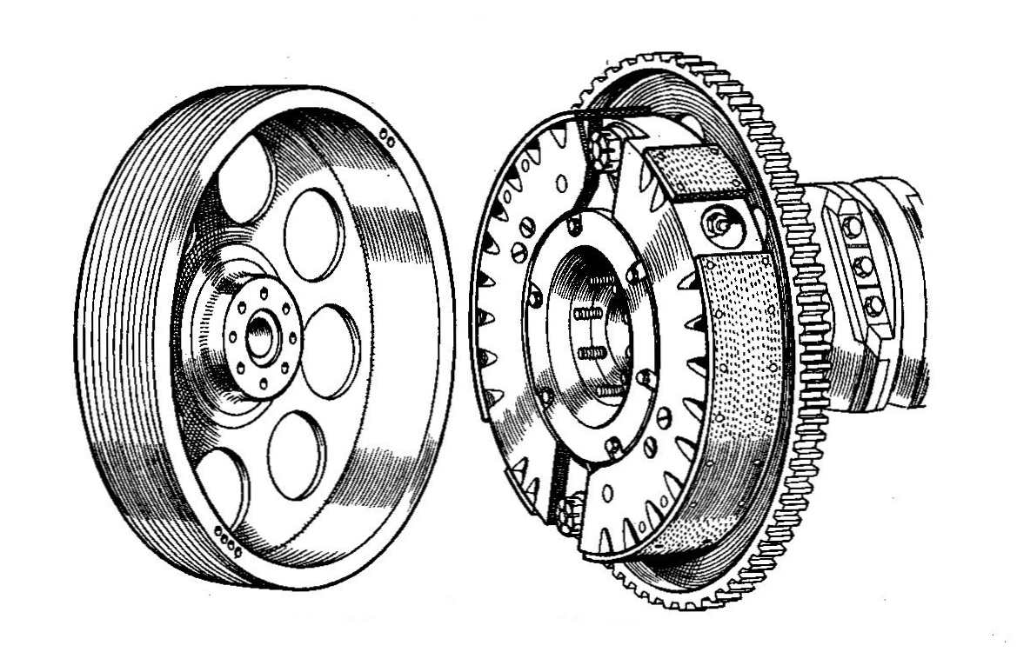

Contents

Table of Figures 3
Introduction 4
Development of the Centrifugal Friction Clutch 5
Challenges’ during the development of the friction centrifugal clutch 6
Material Choice 6
Advantages of the Centrifugal Clutch over other Types of Clutches 7
Electromagnetic Clutches 8
Task B 9
The diameter of the outer drum 9
Engagement speed of the centrifugal clutch 10
Radial force acting on the clutch face when the driving shaft is rotating at a speed of 550 RPM. 11
The value of torque transmitted to the driven shaft, when the driving shaft speed of 550 RPM 12
The transmitted torque at the driven shaft against driving shaft speed 12
The transmitted torque at the driven shaft against driving shaft speed when there is a coefficient of friction of 0.3 and 0.4. 14
The angular acceleration of the drum at the maximum possible torque taken from table 2. 15
Conclusion 16
Bibliography 17

Table of Figures

Table 1- Table to show Calculations of Transmitted Torque 13
Table 2 Graph to show the transmitted torque at the driven shaft Against Driving Shaft Speed 13
Table 3 Graph to show the transmitted torque at the driven shaft against driving shaft speed with a coefficient of friction of 0.3. 14
Table 4 Graph to show the transmitted torque at the driven shaft against driving shaft speed with a coefficient of friction of 0.4. 14

Introduction

The main components piecing together a Centrifugal Friction Clutch consist of the outer drum casting, shoes, springs, and the driving shaft. The analogy of a playground roundabout is often used to explain the concept of centrifugal force, the faster the roundabout spins the greater the operational force and sense of drag. This basic outlook can be applied when looking into the fundamental operations of a friction centrifugal clutch.

As the driving shaft rotates, the shoes begin to get pushed out towards the outer drum. Due to the high friction material, the contact engages the shoes and outer drum together as one. This gradual contact in relation to the clutch is considered by some as one of the smoothest, allowing small engines to be engaged at the correct rpm and disengaged as the engine decelerates. The centrifugal clutch therefore benefits small engines in many aspects (Pandit et al., 2017).

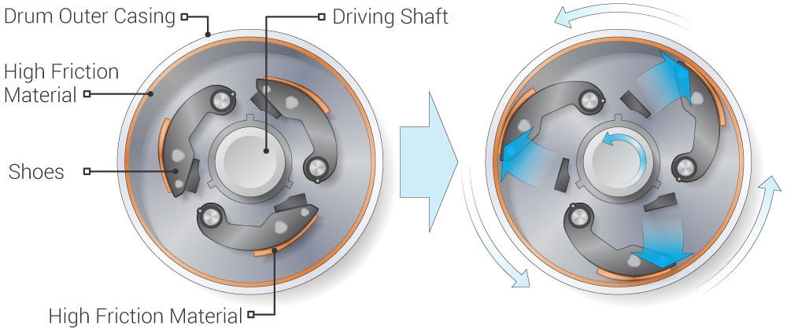

Development of the Centrifugal Friction Clutch

There have been many patents for the centrifugal clutch, according to United States Patent and Trademark office and the first Patent was issued in 1857. The patent specifically references the use of an automotive centrifugal clutch being used in an electrical Vehicle (Reynolds, 1857).

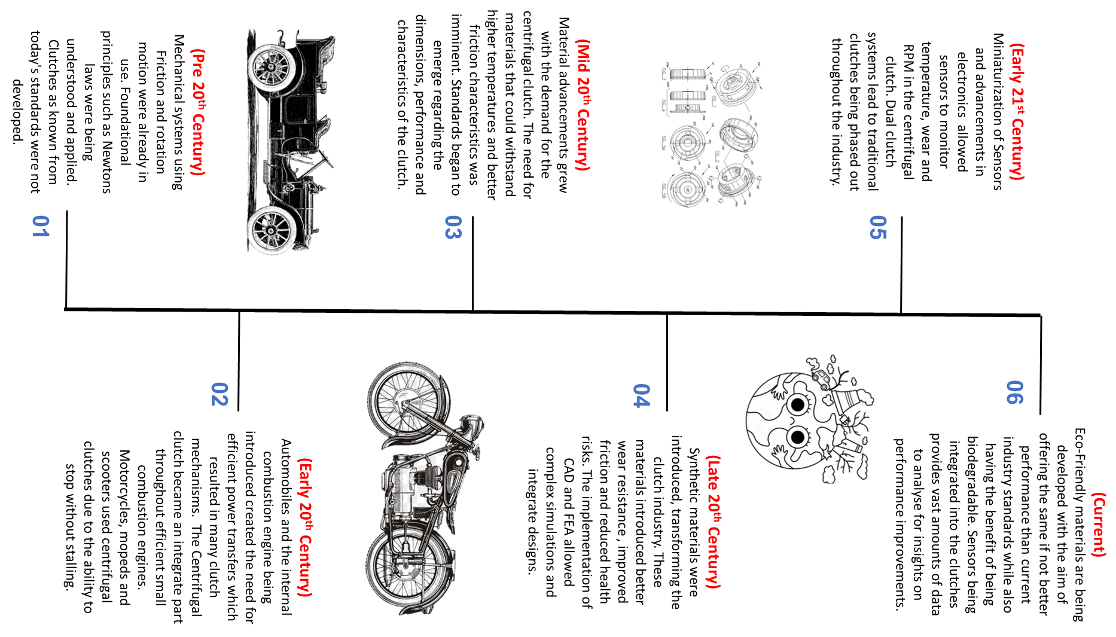
During the early 20th Century, the automobile industry grew massively, being escalated by innovations such as Henry Ford’s model T. These innovations were fundamental to the growth of the industry, achieving great advancements into mass production volumes (Williams et al.,1992). With these volumes came a need for the implementation of better performing mechanical parts. This need created great enhancement of technologies and accompanying principles for a variety of clutches.
The friction centrifugal clutch became more popular in smaller engines (Pandit et al., 2017), especially mopeds and scooters. Due to the affordability and ease of use, these mopeds and scooters were becoming more popular throughout this time-period (Alford and Ferriss, 2008) resulting in the centrifugal clutch becoming implemented worldwide. The main reason the clutch is used for smaller engines is because of the ability to stop without the need of manually disengaging the clutch, preventing the moped from stalling. It is not only small vehicles that benefit from centrifugal clutches, with garden equipment such as chainsaws using a centrifugal clutch. The clutch allows the engine to remain idle without damaging the chain, then when the engine speed is increased the clutch will engage, driving the chain.

Challenges’ during the development of the friction centrifugal clutch

During the early stages heat displacement was a huge concern during the development of the centrifugal clutch. This is due to the continuous friction and significant heat generated. The excessive heat effected the efficiency of the clutch leading to slipping and the power not being transferred efficiently. Many reviews attribute this to the leading cause of power loss (Jabbar et al., 2021). Not only was the heat displacement an impact on the performance but it also led to the material degrading. High temperatures caused permanent deformation in the structure and premature wear, over the lifetime of the clutch and this could lead to mechanical failure. Finite element analysis supports this (Abdullah and Schlattmann, 2014).

During the early stages of development many centrifugal clutches incorporated an enclosed design, that contributed to heat displacement (Crane et al., 2001). Due to the only cooling solution being passive air circulation, heat displacement played a huge factor. As the understanding of the overheating problems grew, designs began to be implemented with integrated air-cooling solutions, limiting the heat displacement defects that were causing a concern.

Throughout the early stages of the development, many inventors and companies explored various designs and ideas leading to many diverse concepts with a huge range of standards and designs. This led to a huge variability in performance, many designs having different types of springs, engagement ideas and weights specifically impacting on the performance. This could mean each clutch engaging at a different RPM or handing heat displacement at different rates. Due to this failure in standardisation (Abdullah and Schlattmann, 2013), it meant it was difficult to replace parts or provide mandatory maintenance.

Material Choice

Materials have developed vastly throughout the development period of the centrifugal friction clutch and modern-day examples vary greatly from initial ideas. The major advancements in materials have been made in the friction surfaces, increasing longevity, performance, and durability of the clutch. During the early designs of the centrifugal clutch asbestos was used as it offered great friction properties. Furthermore, the asbestos provided great performance under cycling temperature conditions. (Virmani, Madhogaria and Baskar, 2021). Asbestos was the preferred choice compared to the materials available at this time such as leather and fabric-based materials, due to their durability and superior performance.

Due to regulations and growing health concerns (Castleman and Berger, 2005), asbestos was phased out and non-asbestos organic materials became present throughout many mechanical applications including the centrifugal clutch. This shift to nanomaterials changed the perception of consumers and manufactures, influencing new design and manufacturing decisions Rajan et al. (2023). These materials consisted of fibres such as glass, carbon, fillers, and resins. However, one drawback was that the heat resistance and durability properties could not always be matched with that of asbestos materials during this period (Bijwe, 2004).
Ceramics have been used as a friction material in the centrifugal clutch particularly in high-performance and heavy-duty scenarios due to the excellent heat resistance and a better degradation rate compared to organic materials. Currently there is an emphasis on research that focusses on developing composites with friction and heat displacement to prevent common faults such as judder behaviour (Huang and Lin, 2016). Also, nanomaterials being incorporated can improve the materials’ properties enhancing the performance (Spear et al., 2015). The embodied carbon and impact that the material has on the environment is important as there is a need from a manufacturing standpoint to minimise the impact. (Mudie, 2020)

Advantages of the Centrifugal Clutch over other Types of Clutches

There are many types of clutches. Some major ones are Friction Clutch, Electromagnetic, Hydraulic, vacuum, and semi-centrifugal. All Clutches engage and disengage power transmission, and each has its own advantages and uses.

The centrifugal clutch automatically engages and disengages in a controlled and efficient way. This comes with many advantages over other types of clutches. The clutch is simple to use, and direct control isn’t necessary therefore easier for the operator. Eliminating the operator’s action also allows for consistency between the engagement and disengagement phases. This in turn results in smoother transition, enhancing the lifetime of the internal material and wear on the mechanical parts. Furthermore, due to the simplistic design of the centrifugal clutch there are fewer components, and this reduces the number of parts that can fail, reducing the amount of maintenance required and ensuring installation throughout (Borozan et al., 2012).

This in turn makes the centrifugal clutch more cost effective compared to other clutches. Nevertheless, it is essential to acknowledge the limitations of the centrifugal clutch, for example it would not be a suitable application if there was a need for manual control over the engagement and disengagement.

Electromagnetic Clutches

The electromagnetic clutch passes electrical current through a coil, generating a magnetic field, which in turn creates a mechanical force. This principle is called electromagnetic induction and can be used to engage and disengage the clutch. (Rikiya Kunii et al., 2005).

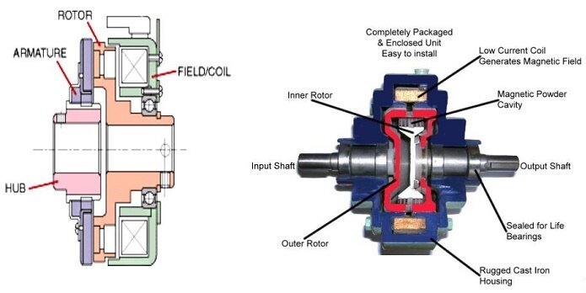

Electromagnetic clutches can be controlled by adjusting the current. This allows for smooth engagements which are also very quick, offering rapid response times (Shin, Kim and Kim, 2013). However, to achieve this the clutch must be operated via a continuous power source resulting in a lot of heat being generated from the coil when energised. This can be countered by cooling equipment adding to the complexity of the clutch but resulting in challenging maintenance and high-cost impacts.

The main use of electromagnetic clutches is in applications that require a high degree of control, rapid or remote response. An industry example would be air conditioning compressors in cars, conveyor systems and industrial machines. Electromagnetic clutches play a vital role in the manufacturing industry. The unique ability to engage and disengage power makes them irreplaceable when introduced into systems such as conveyers, machine tool drives, packing machinery and automated assembly lines. Automated manufacturing is the future (Esmaeilian, Behdad and Wang, 2016), with AI robots and conveyer systems being implemented. These systems will require the high degree of control and rapid response times the electromagnetic clutch can offer (Abhishek et al., 2020).

Task B
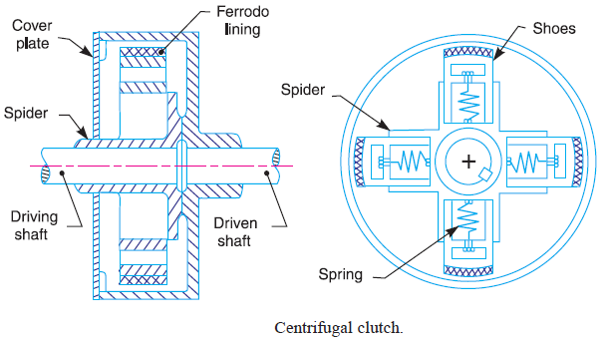
Consider the centrifugal clutch above that comprises of four ‘shoes’ symmetrically attached to the ‘spider’. Each shoe with its friction lining has a mass of 275 grams and is attached by means of a linear mechanical spring with a stiffness value of 7.5 kN/m. The coefficient of friction of the material attached to the shoes is 0.35. The centre of mass of each of the shoes is at a radius of 95 mm from the shaft centres in the rest position shown above and has a clearance distance of 9 mm to the outer drum. The outer drum has a wall thickness of 4 mm.

The diameter of the outer drum

Internal Radius = Centre radius + clearance radius
0.095 + 0.009 = 0.104m or 104mm
External Radius = Internal radius + wall thickness
0.104 + 0.004 = 0.108m or 108mm
Diameter of outer drum = 2 X external radius
2 X 0.108 = 0.216 or 216mm

Engagement speed of the centrifugal clutch
The engagement speed can be found when the centrifugal force is equal to the inward force of the springs. The centrifugal force will equal to the spring force and then the equation can be rearranged to solve for angular velocity at point of engagement or engagement speed. (w)

Centrifugal Force = $F_{c}=m⋅r⋅ω^{2}$
m = mass
r = radius
w = Angular velocity
Spring Force = $F_{s}=k⋅x$
K = stiffness of spring
X=deflection
Equation
$$m⋅r⋅ω^{2}= k⋅x$$
Rearranged for Angular Velocity
$$ω=\sqrt{\frac{k⋅x}{m⋅r}}$$
$$ω=\sqrt{\frac{7500⋅0.009}{0.275⋅0.95}}$$
$$ω=\sqrt{\frac{67.5}{0.026125}}$$
$$ω=\sqrt{2583.01}$$
$ω=$ 50.82 rad/s
Converted to RPM
RPM= $\frac{ω60}{2π}$
RPM= $\frac{50.82 X 60}{2π}$
RPM= $\frac{3049.2}{2π}$
RPM= 485.5 RPM

Radial force acting on the clutch face when the driving shaft is rotating at a speed of 550 RPM.

To calculate the radial force the first steps would be to calculate the centrifugal force however the 550 RPM needs to be converted into radians using the conversion formula below. After this step the frictional force can be calculated and then the radial force.

$$ω=\frac{RPM×2π}{60}$$

$$ω=\frac{550×2π}{60}$$

$$ω=57.59 rad/s$$

Centrifugal Force

Formula = $F_{c}=m⋅r⋅ω^{2}$

$$F_{c}=0.275 X 0.095 X {(57.59)}^{2}$$

$$F_{c}=0.275 X 0.095 X 3319.76$$

$$F_{c}=86.65N$$

Frictional Force

Formula = $F_{f}=μ⋅F_{C}$

$$F_{f}=0.35⋅86.65$$

$$F_{f}=30.33 N$$

This is per shoe, so it will now be multiplied by four.

Radial Force

F_{Total} = 4 X $F_{f}$

F_{Total} = 4 X 30.33 N

F_{Total} = 121.32 N

The value of torque transmitted to the driven shaft, when the driving shaft speed of 550 RPM
The torque transmitted by the outer drum is the total friction force (calculated earlier) multiplied by the effective radius. The assumption made is there is no lining thickness, this should have a miniscule effect.
Radius effective = 95mm or 0.095m
T = 121.32 * 0.095
T = 11.52 N

The transmitted torque at the driven shaft against driving shaft speed
The transmitted torque was calculated via five steps, these five individual steps were implemented into excel as formulas to achieve a figure at each RPM increment.
Step 1 – Convert RPM to rad/s
$$ω=\frac{RPM×2π}{60}$$
Formula in Excel = ‘=(C3*2*PI())/60’
*C3 being RPM figure
Step 2 – Centrifugal force for one shoe
F = 0.275 X 0.095 (rad/s)²
Formula in Excel = ‘=0.275*0.095*(C4)^2’
*C4 being rad/s
Step 3 – Calculation for all shoes
F = 4 X (Centrifugal force for one shoe)
Formula in Excel = ‘=4*C5’
*C5 being calculation for one shoe
Step 4 – Calculation for Frictional Force
F_{f} = 0.35 X Centrifugal force for all shoes
Formula in Excel = ‘=0.35*C6’
*C6 being Centrifugal force for all shoes
Step 5 – Torque
T = Frictional Force X 0.095
Formula in Excel = ‘=C7*0.095’
*C7 being Frictional Force

This was then applied to each RPM from 450 to 700 in increments of 25.
 | 450 | 475 | 500 | 525 | 550 | 575 | 600 | 625 | 650 | 675 | 700
Step 1 | 47.12 | 49.74 | 52.36 | 54.98 | 57.60 | 60.21 | 62.83 | 65.45 | 68.07 | 70.69 | 73.30
Step 2 | 58.01 | 64.64 | 71.62 | 78.96 | 86.66 | 94.72 | 103.14 | 111.91 | 121.04 | 130.53 | 140.38
Step 3 | 232.06 | 258.56 | 286.49 | 315.86 | 346.66 | 378.89 | 412.55 | 447.64 | 484.17 | 522.13 | 561.53
Step 4 | 81.22 | 90.50 | 100.27 | 110.55 | 121.33 | 132.61 | 144.39 | 156.68 | 169.46 | 182.75 | 196.53
Step 5 | 7.72 | 8.60 | 9.53 | 10.50 | 11.53 | 12.60 | 13.72 | 14.88 | 16.10 | 17.36 | 18.67
Table 1- Table to show Calculations of Transmitted Torque
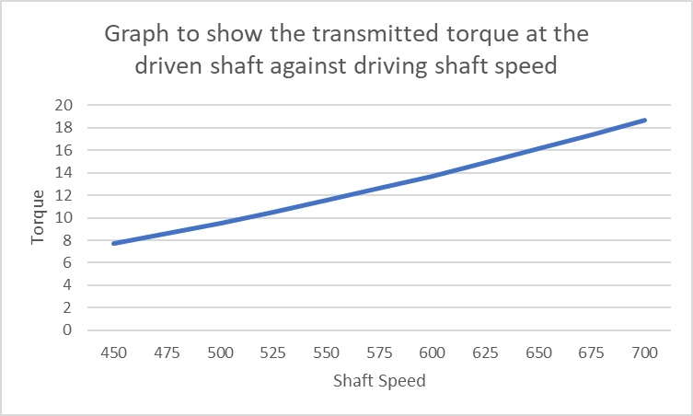
Table 2 Graph to show the transmitted torque at the driven shaft Against Driving Shaft Speed

The transmitted torque at the driven shaft against driving shaft speed when there is a coefficient of friction of 0.3 and 0.4.

Table 3 Graph to show the transmitted torque at the driven shaft against driving shaft speed with a coefficient of friction of 0.3.

Table 4 Graph to show the transmitted torque at the driven shaft against driving shaft speed with a coefficient of friction of 0.4.

There is a clear relationship between the coefficient of friction and the transmitted torque of the driven shaft. Table 3 shows the coefficient of friction at 0.3, at 700 RPM it shows a torque of 16N. Table 4 shows the coefficient of friction at 0.4, at 700 RPM it shows a torque of 21.3N. This shows that as the coefficient of friction increases so does the torque, this is resembled throughout all increments.

The angular acceleration of the drum at the maximum possible torque taken from table 2.
The maximum torque was taken from table 2, where the coefficient of friction is 0.35. The maximum torque is 18.67N.

$I=\frac{1}{2}⋅m⋅r^{2}$
r = External Radius
$$I=\frac{1}{2}⋅0.75⋅{0.108}^{2}$$
$$I=\frac{1}{2}⋅0.75⋅0.011664$$
$$I=0.375⋅0.011664$$
$I=$0.004374
$$α=\frac{T}{I}$$
$$α=\frac{18.67}{0.004374}$$
$$α=4268.31 rad/s^{2}$$

Conclusion
The implementation of the Centrifugal friction clutch has been and still is today an essential part to many small engine applications. The advancements of friction materials have had a huge impact on the performance, transforming the uses of the clutch. All the advancements have not come without its share of problems, health concerns and financial uncertainties. Standardisation, legislation, and environmental consideration have been paramount to the success of the centrifugal clutch mass production era. The move from enclosed designs to designs with heat dissipation in mind created great advancements of the performance. These designs and improvements in friction materials have combined multiplying the success of the intended application and will continue to do so. As Pandit says ‘As demand for time increases, people require something less time consuming as time is money, something more precise, something accurate, meaning something automatic which can serve the people comfortably.’ Pandit et al. (2017)

Bibliography

Abdullah, O.I. and Schlattmann, J. (2013). Contact Analysis of a Dry Friction Clutch System. ISRN Mechanical Engineering, 2013(DOI:10.1155/2013/495918), pp.1–9. doi:https://doi.org/10.1155/2013/495918.
Abdullah, O.I. and Schlattmann, J. (2014). An Investigation of Heat Generation Due To Friction Using Finite Element Method. SAE technical paper series, (ISSN: 0148-7191). doi:https://doi.org/10.4271/2014-01-0954.
Abhishek , C., Anupam, K. and Kumar Singh, S. (2020). Design and Analysis of an Electro-Magnetic Clutch. International Journal of Progressive Research in Science and Engineering, vol.1(Issue-3).
Alford, S.E. and Ferriss, S. (2008). Motorcycle. Reaktion Books.
Bijwe, J. (2004). Composites as friction materials: Recent developments in non-asbestos fiber reinforced friction materials?a review. Polymer Composites, 18(3), pp.378–396. doi:https://doi.org/10.1002/pc.10289.
Borozan, I., Maniu, I., Kulcsar, R.M. and Argesanu, V. (2012). The Automotive Friction Clutches Face Seal Axial Symmetric Modeling Problem. Applied Mechanics and Materials, 162(DOI:10.4028), pp.67–73. doi:https://doi.org/10.4028/www.scientific.net/amm.162.67.
Castleman, B.I. and Berger, S.L. (2005). Asbestos : medical and legal aspects. New York, Ny: Aspen Publishers.
Crane, N.B., Weight, B.L. and Howell, L.L. (2001). Investigation of Compliant Centrifugal Clutch Designs. Investigation of Compliant Centrifugal Clutch Designs. doi:https://doi.org/10.1115/detc2001/dac-21071.
Esmaeilian, B., Behdad, S. and Wang, B. (2016). The evolution and future of manufacturing: A review. Journal of Manufacturing Systems, [online] 39, pp.79–100. doi:https://doi.org/10.1016/j.jmsy.2016.03.001.
Jabbar, N.A., Hussain, I.Y. and Abdullah, O.I. (2021). Thermal and thermoelastic problems in dry friction clutch: A comprehensive review. Heat Transfer, 50(8), pp.7855–7878. doi:https://doi.org/10.1002/htj.22257.
Li, T.-C., Huang, Y.-W. and Lin, J.-F. (2016). Studies on centrifugal clutch judder behavior and the design of frictional lining materials. Mechanical Systems and Signal Processing, 66-67, pp.811–828. doi:https://doi.org/10.1016/j.ymssp.2015.06.010.
Mudie, R. (2020). Environmental sustainability in the automotive industry.
Pandit., Prof.S.V., Goud, C., Patil, M. and Patil, G. (2017). A Review on Centrifugal Clutch. doi:issn:22315063.
RAJAN, B.G., SAMBANDAM, P., HARIRAM, V. and VINODKUMAR, 2023. Influence of Nano Material Coating on the Automotive Brake Liner – An Investigational Approach. International Journal of Vehicle Structures & Systems, 15(1), pp. 110-115.
Reynolds, R. (1857). Friction Clucth.
Rikiya Kunii, Akihiro Iwazaki, Sekiya, S., Kanno, Y., Kitamura, K. and Yasuji Shibahata (2005). Development of Direct Electromagnetic Clutch System. SAE technical paper series, Vol.114. doi:https://doi.org/10.4271/2005-01-0551.
Shin, Y.H., Kim, S.C. and Kim, M.S. (2013). Use of electromagnetic clutch water pumps in vehicle engine cooling systems to reduce fuel consumption. Energy, 57, pp.624–631. doi:https://doi.org/10.1016/j.energy.2013.04.073.
Spear, J.C., Ewers, B.W. and Batteas, J.D. (2015). 2D-nanomaterials for controlling friction and wear at interfaces. Nano Today, 10(3), pp.301–314. doi:https://doi.org/10.1016/j.nantod.2015.04.003.
Virmani, K., Madhogaria, T. and Baskar, P. (2021). Design optimization of friction lining of a clutch plate. Materials Today: Proceedings, 46, pp.8009–8024. doi:https://doi.org/10.1016/j.matpr.2021.02.775.
Williams, K., Haslam, C. and Williams, J. (1992). Ford versus `Fordism’: The Beginning of Mass Production? Work, Employment and Society, 6(4), pp.517–555. doi:https://doi.org/10.1177/095001709264001.

