
Student name Augustine Daniel Ajayi
Student id 2321116
Internal Verifier: Dr Raheela Shaikh
Programme: BSc Health and Social Care
Module code: BMHP5015
Module Name: Changemakers: Building your Personal Brand for Sustainable Employment
Assignment Title: Component 2: Assignment (Report)

Executive Summary
To achieve a career as a Mental Health Nurse, this report outlines a customized step to follow to achieve both short-term and long-term goals. The short-term goals will include gaining practical experience, qualifying with certain certifications, and advancing his/her educational level. The long-term goals are about gaining superior qualifications, becoming leaders and specialize in such areas as paediatric and adolescent mental health. Also, the report touches on networking and personal branding measures meant to enhance employability of those in the mental health nursing field.
Table of Contents
Introduction 3
Job Role Analysis 3
Key Responsibilities 3
Needs Skills and Qualifications 3
Self-Assessment of Employability Skills 4
Testing of Current competencies. 4
Key Responsibilities 4
Identifying Gaps 4
Building a Personal Brand 5
Defining My Personal Brand 5
Action Plan and Timeline for Skill Development 5
Timeline 6
Professional Identity and Networking 7
Advocacy of My Professional Identity 7
Cover Letter 7
Online Presence 9
Networking 9
Conclusion 10
Reference 11

Introduction
The given report studies the procedure of creating an individual brand and enhancing employability skills that are relevant to the job of a Mental Health Nurse in the UK in terms of the healthcare industry. It will start with the analysis of the required and necessary employability competencies of my job, assess my individual strengths and developmental requirements and then set the plan of action based on both short-term and long-term goals. According to Cranage and Foster, (2022), the strategies to develop a professional identity, increase the visibility of personal brand, and perform networking activities to ensure prospective employment as a Mental Health Nurse are also expressed in the report.

Job Role Analysis
My job role as a Mental Health Nurse plays a critical role in providing care to victims of mental illnesses, where the ultimate point is to improve their quality of life and make them recover. This role works in various environments such as hospitals, community health centres and residential care facilities whereby they apply specialised nursing interventions to patients who are psychologically distressed (Marshman et al., 2022). This requirement requires that there should be close working together with patients, families, and multidisciplinary teams to assess, plan, and provide care that is specific to the needs of the patients (Saleh et al., 2022).

Key Responsibilities
As a Mental Health Nurse I have the responsibility of complete assessment of patients, formulation and establishment of individualized plans of care and tracking all-time improvement of patients. My role is to prescribe drugs, offer therapeutic care, and participate in activities that enhance their mental health. According to Turale and Nantsupawat, (2021) they address acute crisis management, emotional support and give counseling services to a patient and family. My role as Mental Health Nurses is instrumental in patient education, that determines the mechanisms of the disease process and the treatment choice to support the holistic approach to care.

Needs Skills and Qualifications
My job would need a combination of technical and interpersonal skills to succeed. Efficiency in clinical and medication-based interventions is a basic requirement. There cannot exist without strong communication skills because I have to establish trust among the patients and ensure co-existence with the health-care teams as well as deliver information intelligently to the family. Personal skills like empathy, patience and resilience would be vital in offering compassionate care in critical situations (Román-Sánchez et al., 2022). My professional practice requires a relevant nursing qualification, such as a degree in Mental Health Nursing as well as registration by the Nursing and Midwifery Council (NMC).

Self-Assessment of Employability Skills

Testing of Current competencies.
I have developed a list of transferable competencies relevant to the Mental Health Nurse career in an attempt to obtain the desired position. Sufficient background as a Healthcare Assistant has provided me with a strong background in patient care, specifically in helping people with non-homogeneous needs. I also show my ability to facilitate everyday life and work, pay attention to vital signs, and support over emotions, that are the essential elements of nursing practice. Additionally, I have excellent skills of interpersonal communication that allows me to establish rapport with the patients and work well with other individuals in multidisciplinary environments. The background in patient condition reporting and the experience in cooperation with case managers also confirm my ability to work in the professional health-care environment.
My other competencies are organisational sharpness and time-management skills that are crucial in a dynamic nursing type of setting. Knowledge of record keeping in relation to patients and retention of documentation in accordance with the health-care government standards is also apparent. Besides, flexibility in different environments, hospital, clinic, or at home emphasizes my flexibility and willingness to learn continuously.

Key Responsibilities
Switching to Mental Health Nurse is a necessary move that provides me the ability to cope with a set of basic tasks. These include the administration of extensive mental health examination, medication care, counselling and development of individual care plans jointly with patients (Subu et al., 2021). My responsibility will also be the management of the crisis, patient safety, and family education about mental illnesses and treatment. I should continuously develop certain specialised skills within psychiatric care and this practice as mental-health nursing in order to be a leader in these fields.

Identifying Gaps
According to García-Mayor , (2021) despite having the established experience in the area of dealing with patients, there are some knowledge gaps that are worth considering. The main shortcomings are the lack of exposure to psychiatric evaluation and diagnostic processes, that are the core elements of the Mental Health Nurse occupation (Anandan et al., 2024). I also need to improve the relationship in knowledge on therapeutic modalities such as “Cognitive Behavioural Therapy” (CBT) and other mental-health interventions. Furthermore, my comprehensive knowledge of psychotropic medications regimes and side-effects are areas that are yet to be developed.
In order to seal these gaps, I plan to undergo specialised training and accumulate practical experience in mental-health contexts. These ventures will support me in the development of necessary skills and qualifications in order to succeed as a Mental Health Nurse.

Building a Personal Brand
Developing a personal brand as a Mental Health Nurse is vital to stand out in a competitive employment field in the healthcare environment. This effort involves the display of individual skills, experiences and values in a bid to build a powerful and identifiable professional identity that appeals to prospective employers, peers as well as patients.

Defining My Personal Brand
To make the process go, I shall map out my brand based on my professional strengths and core values. The basis of my mental health nursing practice consists of compassion, empathy, and dedication to decreasing patient outcomes. I will use these principles in my online and offline presentation. I shall highlight my ability to withstand pressure, my strong communication abilities, and my commitment to providing patient-centre care, which will make me a reliable and qualified Mental Health Nurse.

Action Plan and Timeline for Skill Development
Steps | Actions | Timeframe
Complete a Mental Health Nursing Training Programme | Enroll in mental-health nursing courses, focusing on psychiatric care, assessment methods, and treatment procedures. | 6 months
Gain Practical Experience | Apply for placements or support roles in mental-health units or psychiatric hospitals to gain hands-on experience. | 6-12 months
Obtain Relevant Certifications | Register and complete Crisis Intervention Training (CIT) and Mental Health First Aid certification. | 6 months
Obtain Advanced Education | Apply for a master's degree or higher education in mental-health nursing to gain advanced clinical knowledge. | 2-3 years
Seek Leadership Opportunities | Attend leadership workshops, seek mentorship, and apply for nurse management or senior roles. | 3-5 years
Become a Specialist | Pursue specialized training in areas like child and adolescent mental health or forensic nursing. | 3-5 years
Table 1: Action Plan
(Source: Self-Developed)

Timeline
Over the 6-month time frame, I will take classes and acquire mental health nursing, crisis intervention, and mental health first aid credentials.
During the next 6 to 12 months, I will seek practicum placements in psychiatric environments which will focus on direct patient care and development of competencies needed in practice as a nurse.
In 1 to 2years, I will obtain other qualifications, gain more clinical practice, and gain basic education in clinical interventions.
In 2 to 5years, I am going to pursue a higher education of mental health nursing, pursue leadership opportunities and specialise in a selected aspect of mental health.
This gradual advancement will make possible a methodical acquisition of the skills and qualification, and experience, that will be needed to make up the well-rounded and capable Mental Health Nurse.

Professional Identity and Networking

Advocacy of My Professional Identity
Being a Mental Health Nurse, developing a certain professional identity is a matter of reputation building in the medical sphere and the possibility of getting career development opportunities. To market this identity, I shall create a strong online presence, build upon a professional network and make my qualifications and experiences easily viewed by future employers.
Among the initial steps that I will make is updating and optimising my profile on LinkedIn in order to reflect my pertinent experience and skills in the area of mental health nursing as well as the related certifications. I will share peer-reviewed materials on mental health care, participate in academic debates, and meet other representatives of the field. Such engagements will increase my publicity and ensure that I am updated on the latest trends and best practice in the industry.
I will also start my own web site where my professional path, education and professional experience in mental health care could be viewed. The site will include my resume vitae, my professional achievements and any articles, presentations or publications that I have written. This kind of web site is an effective tool to develop my brand identity as an informed and an interested mental health nursing practitioner.
I will also ensure on upholding a good ethical reputation. The ongoing involvement in professional development, as well as keeping abreast of the recent studies and standards in mental health care, will assist me to work ethically, express empathy, and provide the highest quality of care, which will give me a reputation of a compassionate and competent professional.

Cover Letter
Ajayi Augustine Daniel
71 Kingsway, Coventry, CV24EX
07388345124
Email: ajayi.daniel@icloud.com
22.11.2025
Organisation
My application to the advertised position of Healthcare Assistant at [Company Name] is presented hereby. With the experience I gained over the course of more than ten years of working in various healthcare settings, such as patient care, supportive capabilities, and leadership services, I can be a valuable addition to your team. My career experience in assisting patients with their daily tasks and providing them with the necessary support is in accord with the responsibilities of this position.
During my work in different organizations like Positive Mental Care and UK Caring Services, I developed high-level interpersonal skills, ability to develop and enact the patient care plan, and skills to work with medical documentation and record vital signs. Also, the commitment of your organization to patient-centred care, focus on caring, and compassion is particularly of interest to me as it is also comparable to my ethical features and professional philosophy. I believe that my restrained, compassionate nature and undying enthusiasm to ensure comfort of a patient will make a worthy contribution to your service.
I would be very pleased to have an opportunity to clarify how my experiences and qualifications will help to increase the high-quality care standards you maintain. I will be readily approachable to give you a formal interview and can be reached through telephone at 07388345124 or contact me through email at ajayi.daniel@icloud.com.
I hope you will give my application your attention. I look forward to the chance of facilitating further growth of the prosperity of [Company Name] as well as its vision of providing the highest level of patient care.
Yours sincerely,
Ajayi Augustine Daniel

Online Presence
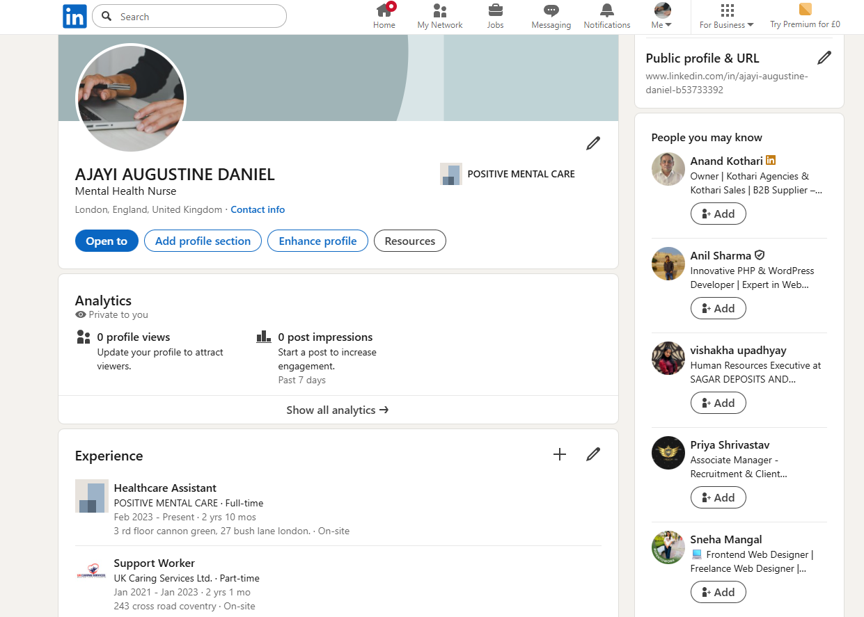
Figure 1: My Linkedin Profile
(Source: Linkedin)

Networking
According to Isabirye et al., 2024, networking is a vital career development tactic as well as a method of building relationships with other practitioners within the mental health sector. I will also be an active practitioner in the conferences, seminars, and workshops oriented towards mental health care. Such activities will give me a chance to connect with others, mentors and future employers and learn new methods and therapies. Such meetings will also give me an idea of the job availability, research, and other areas of possible partnership.
I will also ensure that I become a member of professional organisations like the “Royal College of Nursing (RCN)” and the “British Psychological Society (BPS)”. Such organisations provide great networking prospects, professional development programmes and access to special job listings. An active membership will enable me to interact with more experienced professionals who might become my mentor or source of career advice.

Conclusion
Lastly, I will participate in online groups and forums on the topic of mental health care where I will have an opportunity to connect with other nurses, therapists, as well as mental health experts. Through experience sharing, sharing ideas, and advice, I would be able to know more about the opportunities available in a new career and be in a position to build a relationship that would result in a potential future collaboration. Developing my career and applying successful networking practices will help me to overcome the unstable field of healthcare, new opportunities to reach new heights, and retain the top position in the practice of mental health nursing.

Reference
Anandan, R., Cross, W.M., Nguyen, H. and Olasoji, M., (2024). Mental health nurses' empathy towards consumers with dual diagnosis: A descriptive study. Journal of clinical nursing, 33(8), pp.3199-3211.
Cranage, K. and Foster, K., (2022). Mental health nurses' experience of challenging workplace situations: A qualitative descriptive study. International Journal of Mental Health Nursing, 31(3), pp.665-676.
García-Mayor, S., Quemada-González, C., León-Campos, Á., Kaknani-Uttumchandani, S., Gutiérrez-Rodríguez, L., del Mar Carmona-Segovia, A. and Martí-García, C., (2021). Nursing students' perceptions on the use of clinical simulation in psychiatric and mental health nursing by means of objective structured clinical examination (OSCE). Nurse Education Today, 100, p.104866.
Isabirye, A.K., Moloi, K.C. and Lebelo, R.S., (2024). Enhancing networking skills for professional success: Strategies and tactics. Mitteilungen Klosterneuburg Rebe und Wein, Obstbau und Früchteverwertung.
Marshman, C., Hansen, A. and Munro, I., (2022). Compassion fatigue in mental health nurses: A systematic review. Journal of psychiatric and mental health nursing, 29(4), pp.529-543.
Román-Sánchez, D., Paramio-Cuevas, J.C., Paloma-Castro, O., Palazón-Fernández, J.L., Lepiani-Diaz, I., de la Fuente Rodríguez, J.M. and Lopez-Millan, M.R., (2022). Empathy, burnout, and attitudes towards mental illness among Spanish mental health nurses. International Journal of Environmental Research and Public Health, 19(2), p.692.
Saleh, M.O., Eshah, N.F. and Rayan, A.H., (2022). Empowerment predicting nurses’ work motivation and occupational mental health. SAGE Open Nursing, 8, p.23779608221076811.
Subu, M.A., Wati, D.F., Netrida, N., Priscilla, V., Dias, J.M., Abraham, M.S., Slewa-Younan, S. and Al-Yateem, N., (2021). Types of stigma experienced by patients with mental illness and mental health nurses in Indonesia: a qualitative content analysis. International journal of mental health systems, 15(1), p.77.
Turale, S. and Nantsupawat, A., (2021). Clinician mental health, nursing shortages and the COVID‐19 pandemic: Crises within crises. International nursing review, 68(1), pp.12-14.

Appendices

Appendix A: CV
AJAYI AUGUSTINE DANIEL
Address 71 Kingsway
Cv24ex Coventry
HEALTH CARE ASSISTANCE
Profile: Dedicated, well-mannered Healthcare Assistant with strong compassion, patience and professionalism. Experienced in supporting patients from diverse backgrounds while upholding dignity, safety and wellbeing. Skilled in working under pressure and collaborating with multidisciplinary teams.
Key Responsibilities: Provides personal care including feeding, bathing and toileting; monitors vital signs; assists with mobility using equipment; maintains clean living spaces; updates case managers with patient condition reports to ensure continuity of care.
Experience: Healthcare Assistant and Support Worker across hospitals, residential settings and mental health centres (Caludon Centre, St Michael’s Hospital, Aspen Centre). Previous roles include team lead in warehouse operations achieving 70% annual productivity. Experience includes UK Caring Services, Work Place ENS, and Positive Mental Care.
Education & Training: BSc Business Administration (Second Class Upper), University of Benin. GCE O-Level. Healthcare certifications including CPI Blue Card, Safety & Intervention
Skills & Interests: Strong communication, reliability, teamwork. Enjoys football, basketball, cooking, cleaning, and travel.

