Student name: Aurelia Denicu, Student number: 2026240, Programme: Certificate of Higher Education Skills for the Workplace , Module: Psychology in Health and Social Care, Module code: BMHP4003_BIRMINGHAM, Lecturer: Muhammad Hossain.

Written Assignment Case Study – Mason Kabee

Table of Contents
1. Introduction 2
2. Tajfel’s and Turner Social Identity Theory 3
2.1 Social Categorisation 3
2.2 Social Identification 3
2.3 Social Comparison 4
3.Ajzen’s Theory of Planned Behaviour 4
3.1 Attitude 4
3.2 Subjecting Norms 5
3.3 Perceived Behavioural Control 5
4.Frustration-Aggression Hypothesis 6
4.1 Aggressive Cues Model 6
5.Conclusion 7
6.Reference list 8

Introduction
The aim of this report is to help the Youth Offending Team understand Mason Kabee’s behaviour by using psychological theories such as: Tajfel and Turner’s Social Identity Theory, Ajzen’s Theory of planned behaviour, and Frustration Aggression Hypothesis by Dollard and Berkowitz.
Mason Kabee, a 17-year-old that has been serving an 18-month custodial sentence for possession of drugs with intention of supplying, shows a sudden behavioural change, from being well presented, agreeing to go to college, to being rude, not attending college and being seen with wrong entourage. Identifying and explaining the factors that lead to Mason’s behaviour and attitude change towards the Youth Offending team is the goal of this report, with the help of the psychological theories mentioned above. Human beings are complex and complicate, and without psychology are hard to be understood, especially the behavioural changes that in most cases were caused by deeper factors then the ones that are shown.
As mentioned above, by using psychological theories, those problems can be found and explained.

Tajfel’s and Turner Social Identity Theory
According to Islam, G., (2014): “Social Identity Theory (SIT; Tajfel, 1978; Tajfel & Turner, 1979) begins with the premise that individuals define their own identities with regard to social groups and that such identifications work to protect and bolster self-identity.”
Society, comparison, discrimination are factors that define Social Identity Theory.
The way you see yourself, the way you are, and the way other people see you are totally different because people tend to judge.
In Mason’s case he was part of a group before his sentence and wanted to be integrated in that group he changed his self. After being sentenced and taken away from his group, his behaviour changed, he became better, accepting to do some changes such as going to college and having a more positive thinking.
When released and going back to what he was doing before the sentence he starts acting the same, stop going to college and start being aggressive with the Youth Offending Team.
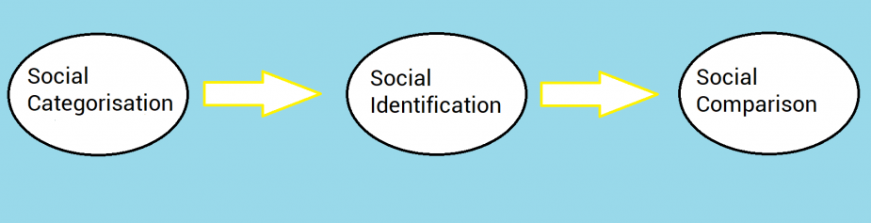(Shrestha,2017)

2.1 Social Categorisation
Social Categorisation refers to how we as humans use social categorise such as white, black, Christian, Muslim, bus driver, cleaner, student, British, Pakistani, Chinese etc.
Humans cannot function well if are not going to use this categorisation. If defying what group, we are part of, we can find out more things about ourselves. Our behaviour changes if our group members are identified. A person can be part of more then one group, and their behaviour changes according to the groups needs and members.

2.2 Social Identification
Social Identification refers to how we adopt the identity of the group we belong to. Emotional significance and self-esteem are the bonds that attach a person to that group.
When identify what that group does, the members act how they think should act as a group member. Mason was seen with a group of people that had problem with the police before, His behaviour changed because in order to be accepted by them and be part of their group Mason had to change his behaviour and act like the.

2.3 Social Comparison
Social Comparison refers to how a group compare with another group. Often groups consider themselves rivals and fight to maintain group members self-esteem.
Social Comparison occurs when group members categorise and identify themselves with a certain group. Social Identity Theory shows that they way a person is acting when part of a group is something real, something that is part of that person. Mason being already part of a group, was seeing the Youth Offending Team as a threat to him and his group, therefore he did not want to have any further interactions with them and stormed out from the meeting.

3.Ajzen’s Theory of Planned Behaviour
According to Ajzen, I., (1991) the Theory of Planned Behaviour identify as:” Intentions to perform behaviours of different kinds can be predicted with high accuracy from attitudes toward the behaviour, subjective norms, and perceived behavioural control; and these intentions, together with perceptions of behavioural control, account for considerable variance in actual behaviour. “
Attitude, subjective norms, and perceived behavioural control are factors that need to be taken into consideration when referring to the Theory of Planned Behaviour.

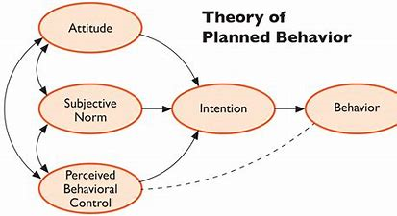 (Luzzi, Spencer,2008)

3.1 Attitude
The first factor that need to consider is the attitude held towards the behaviour.The way a person acts around others and the behaviour he/she has towards them is what defines attitude. In Mason’s case the attitude he shows towards the Young Offending Team is not a positive one. He is showing bad behaviour because as mentioned above he is already part of a group, and he considers the team as rivals to his group and to himself. Being away from his group, Mason’s behaviour changed, his attitude and behaviour changed. He was willing to improve himself, go to college, but once he is back to his group, he became verbally aggressive and did not want to interact with the Young Offending Team anymore.

3.2 Subjecting Norms
Beliefs of the people that matter to us such as our friends and family and if they have a favourable attitude towards the behaviour, are defining subjective norms.
“Self-determination theory suggests that better prediction of behaviour will be observed from intentions based on attitudes than intentions based on subjective norms.” (Sheeran, P., Norman, P. and Orbell, S., 1999)
An important factor to this case is the subjecting norms. Being around “bad” people and part of their group, Mason’s actions and attitude are a reflection of the group attitude and behaviour.
In the opinion of this report’s author, subjective norms are what made Mason Kabee’s behaviour and attitude change. In this case the subjective norms are represented by him friends, the group members that had a big influence on him.

3.3 Perceived Behavioural Control
This relates to whether the person believes they have the resources and opportunities to engage in the behaviour.
Perceived control and perceived difficulty combined are defining perceived behaviour control.
The performance of a person’s behaviour under voluntary control is known as perceived control. When a behaviour is easy or hard to perform by a person is what defines perceived difficulty.
The behaviour shown by Mason towards the team was a perceived behaviour control because he decided to act in a certain way, storming out from the meeting. His behaviour towards them was controlled behaviour, he intended to behave in that certain way.

4.Frustration-Aggression Hypothesis
“Frustrations can create aggressive inclinations even when they are not arbitrary or aimed at the subject personally.” (Berkowitz,1989)
Dollard et al., (1939) was one of the first to model and explain aggression in humans. When a person is frustrated, aggression occurs.

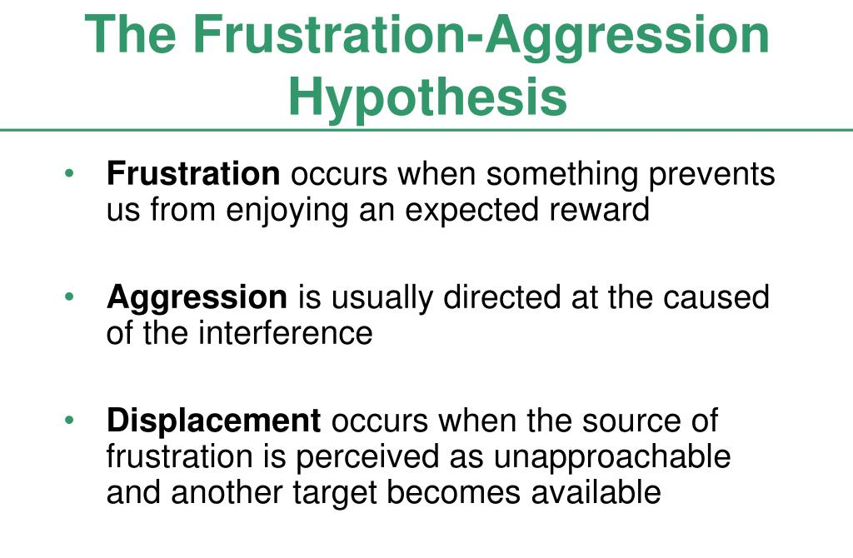(Filipe,2014)

The frustration of a person by encounter or an object will lead to response with aggressive behaviour if appropriate to do so. Displaced aggression occurs when a person is unable to express their frustration with aggressive behaviour.

4.1 Aggressive Cues Model
“Anger arousal creates a readiness to act aggressively but suitable cues—stimuli associated with the present or previous anger instigators—presumably are necessary if aggressive responses are actually to occur.” (Berkowitz,1989)
A series of events that lead to aggression are put forward in General Aggression Model.
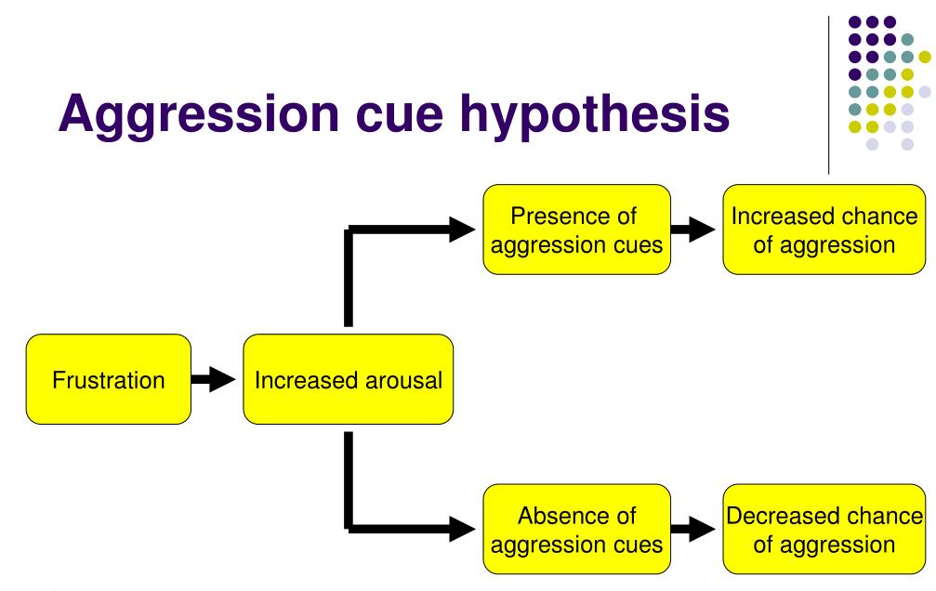

(Fuller,2014)

After research on Dollard and Berkowitz Frustration-Aggression Hypothesis, the report author’s opinion is that Mason Kabee showed frustration and verbal aggression during the meeting with the Youth Offending team meeting. The team were the factor that cause the frustration and verbal aggression on Mason.
Mason’s behaviour changed since being released and on the probation visit, he started to feel frustrated, which lead to verbal aggression and further to leaving the meeting.

5.Conclusion
A 17-year-old male, who was convicted for possession of drugs with the intention of supplying, named Mason Kabee, had a sudden behavioural change which cause problems in understanding for the Youth Offending Team on the parole visit. This report presented the factors that lead to Mason’s behaviour change from a person that agreed to attend college and do better, to a completely different person when released, displaying a rude attitude, and not attending college. This report concludes that by using the following psychological theories: Tajfel and Turner’s Social Identity Theory, Ajzen’s Theory of planned behaviour, and Frustration Aggression Hypothesis by Dollard and Berkowitz, the author was able to identify the cause of Mason’s behaviour changes. Defining their own identity, and how people behaviour changes so they can be a part of a group and also their actions to the other people that are not part of their group are the factors that were found and with the help of the psychological theories mentioned above the report’s author was able to relate them to Mason Kabee’s case and provide help for the Youth Offending team to understand his behaviour change better.

6.Reference list
1. Abrams, D. and Hogg, M.A., (1990). An introduction to the social identity approach. Social identity theory: Constructive and critical advances, pp.1-9.[online], Available at: An-Introduction-to-the-Social-Identity-Approach.pdf (researchgate.net) , (accessed: 31.03.2022).
2. Ajzen, I., (1991). The theory of planned behavior. Organizational behavior and human decision processes, 50(2), pp.179-211.[online], Available at: The theory of planned behavior - ScienceDirect , (accessed: 31.03.2022).
3. benkayandbrycesocial, (2018). Aggression Obsession: Why is Society so Angry? ,[online], Available at: Aggression Obsession: Why is Society so Angry? – Bay's Blogs (wordpress.com) ,(accessed: 01.04.2022).
4. Berkowitz, L., (1964). Aggressive cues in aggressive behaviour and hostility catharsis. Psychological Review, 71(2), 104–122. https://doi.org/10.1037/h0043520 , (accessed: 31.03.2022)
5. Berkowitz, L., (1989) ‘Frustration-Aggression Hypothesis: Examination and Reformulation’, Psychological bulletin, 106(1), pp. 59–73. doi:10.1037/0033-2909.106.1.59.[online], Available at: Frustration-Aggression Hypothesis: Examination and Reformulation - University of Wales Trinity Saint David (uwtsd.ac.uk) ,(accessed: 31.03.2022).
6. Felipe, J., (2014). Aggression.[online], Available at: PPT - Aggression PowerPoint Presentation, free download - ID:4813848 (slideserve.com) ,(accessed: 01.04.2022).
7. Lizzi, L., Spencer, A.J., (2022) Factors influencing the use of public dental services: An application of the Theory of Planned Behaviour.[online], Available at: Theory of Planned Behaviour (Ajzen, 1991). | Download Scientific Diagram (researchgate.net) ,(accessed: 31.03.2022).
8. Scott, J.P.,(1948). Dominance and the frustration-aggression hypothesis. Physiological zoology, 21(1), pp.31-39.[online], Available at : Dominance and the Frustration-Aggression Hypothesis | Physiological Zoology: Vol 21, No 1 (uchicago.edu) , (accessed: 31.03.2022).
9. Sheeran, P., Norman, P. and Orbell, S., ( 1999). Evidence that intentions based on attitudes better predict behaviour than intentions based on subjective norms. European journal of social psychology, 29(2‐3), pp.403-406.[online], Available at: Evidence that intentions based on attitudes better predict behaviour than intentions based on subjective norms - Sheeran - 1999 - European Journal of Social Psychology - Wiley Online Library , (accessed: 31.03.2022).
10. Shrestha, P., (2017). Social Identity Theory. [online], Available at: Social Identity Theory - Psychestudy , (accessed: 31.04.2022).
11. Tajfel, H., & Turner, J. C., (1979). An integrative theory of intergroup conflict. The social psychology of intergroup relations?, 33, 47.[online], Available at: Organizational Identity - Google Books ,(accessed: 31.03.2022).
12. Terry, D.J. and O'Leary, J.E., (1995). The theory of planned behaviour: The effects of perceived behavioural control and self‐efficacy. British journal of social psychology, 34(2), pp.199-220.[online], Available at: The theory of planned behaviour: The effects of perceived behavioural control and self‐efficacy - Terry - 1995 - British Journal of Social Psychology - Wiley Online Library ,(accessed: 31.03.2022).
13. Trafimow, D., Sheeran, P., Conner, M. and Finlay, K.A., (2002). Evidence that perceived behavioural control is a multidimensional construct: Perceived control and perceived difficulty. British journal of social psychology, 41(1), pp.101-121.[online], Available at: Evidence that perceived behavioural control is a multidimensional construct: Perceived control and perceived difficulty - Trafimow - 2002 - British Journal of Social Psychology - Wiley Online Library ,(accessed: 31.03.2022).

