INTERNATIONAL BUSINESS COMMUNICATIONS
Assignment 1

Student: Desislava Laleva
Student number: 2113192
Lecture: Charles Nwaogwugwu

Table of Contents
1. Introduction 2
2. A brief introduction to Barclays 2
3. Evaluation of two EU countries 2
3.1 Country facts to understand Cultural Differences 2
3.2 Communication Barriers 3
4. Recommendations 3
4.1 Recommended Nation with Justification 3
4.2 Strategies to Overcome Communication Challenges 3
5. Conclusion 3
Reference list 3

1. Introduction
The UK follows a different culture in business communication. It is a lone country in Europe which strongly looks over diplomacy before directness in communication. They tend to be very non-confrontational in every business situation (World Business Culture, 2019). This essay includes the difference between business communication with communication between the Czech Republic and Greece. British individuals also use language in a coded manner and they use more acceptable phrases for communication. In this essay, several cultural factors have been analysed based on two countries, Czech Republic and Greece. Communication barriers and differences have been also evaluated for these countries. This analysis has been done in the essay to identify the ideal country for Barclays to expand its operation.

2. A brief introduction to Barclays
Barclays is a Britain-based multinational bank which has its headquarters in London, England. This company operates in the case of two divisions, Barclays UK as well as Barclays International. Barclays believes that finance is the oxygen to Economy and this bank is acting to deploy finance responsibly for supporting people as well as business (Barclays, 2021). Barclays acts with empathy along integrity, this organisation prefers to become the global leader in the profession of Banking. For this reason, this bank wants to expand its operation by identifying the ideal country for expansion. Barclays bank is committed to maintaining diversity, equity as well as inclusion in its workforce. Barclays creates an inclusive and diverse workforce within their organisation in order to serve the community and customers appropriately. Being its root in the UK, all the officials follow the communication culture of the UK, thus countries close to the culture of the UK or better than the UK will be ideal for the organisation. Due to DEI culture in the organisation, they can retain the best talents from the banking sector (Barclays, 2018).

3. Evaluation of two EU countries

3.1 Country facts to understand Cultural Differences
Social context and profile
Barclays has a belief that students are the most important market segment in their sector for business. Students select a bank for the first time and Barclay’s tends to retain the customer for the long term. Thus, it can be concluded that the target customers for Barclay's can remain customers for a huge tenure. Greece has a high population of students which is 41%. Greek universities are quite popular as a huge number of people come for higher studies in this country (OECD, 2020). Thus, by expanding to this country, Barclays can target its preferred market segment. However, the amount of students is also high in the Czech Republic, especially in Prague, which suggests Barclays can get a suitable target market by expanding to both countries.
Greece is considered a collectivist society; the people of Greece show loyalty towards family and social groups. Personal relationships between individuals in Greece are important to people's day-to-day life (Evason, 2019). This type of social culture is appropriate for Barclay's expansion as targeting and convincing one individual from the family can get other customers of the family. As the loyalty of the individual is appropriate they will remain with the organisation for the long term. Greeks take pride in their hosting ability which is important for the business locomoting in their region. However, Individuals of Czechs remain to be straightforward in communication and they may remain reserved initially. People are attentive, they listen actively and prefer fostering clear communication (Prague Integration, 2023). Due to their social reservedness marketing communication can be tough with them, however, once they are convinced they remain with the brand for long term.
Language
Official spoken Language of Greece is Greek, this is a tough language to learn easily. However, people in Greece are familiar with English language communication and being a tourist hub in all the tourist spots people can communicate in English (Introducing Athens, 2022). Official language of Barclay's is English due to its origin and company; thus the company will not face any communication problems with locals while expanding to this country. The Czech Republic also has a common language of communication Czech, however, people in majority understand English and they also prefer communicating German and Russian (Czech University, 2022). Thus, due to the expansion of business in Czech, they will be able to communicate with the consumer segment due to the wide variety of language presence in the country.
Possible risks
As per the views of Koutsantoni (2015), the masculinity score of Greece is in the middle of 57, thus it can be concluded that society includes a female workforce however the society is slightly dominated by males. Thus, Barclay's will face possible risks in maintaining diversity and equality while operating in Greece. However, in the Czech Republic, 44% of the workforce includes women, still gender equality remains a major concern in the society. For this reason, the government of the Czech Republic has a Gender Equality strategy for 2021, thus it can be concluded Barclay's can get support from the government in the Czech Republic to maintain equality. Gender pay gap in Greece is 13% which is a major risk for Barclays to initiate business based on Gender equality in society.
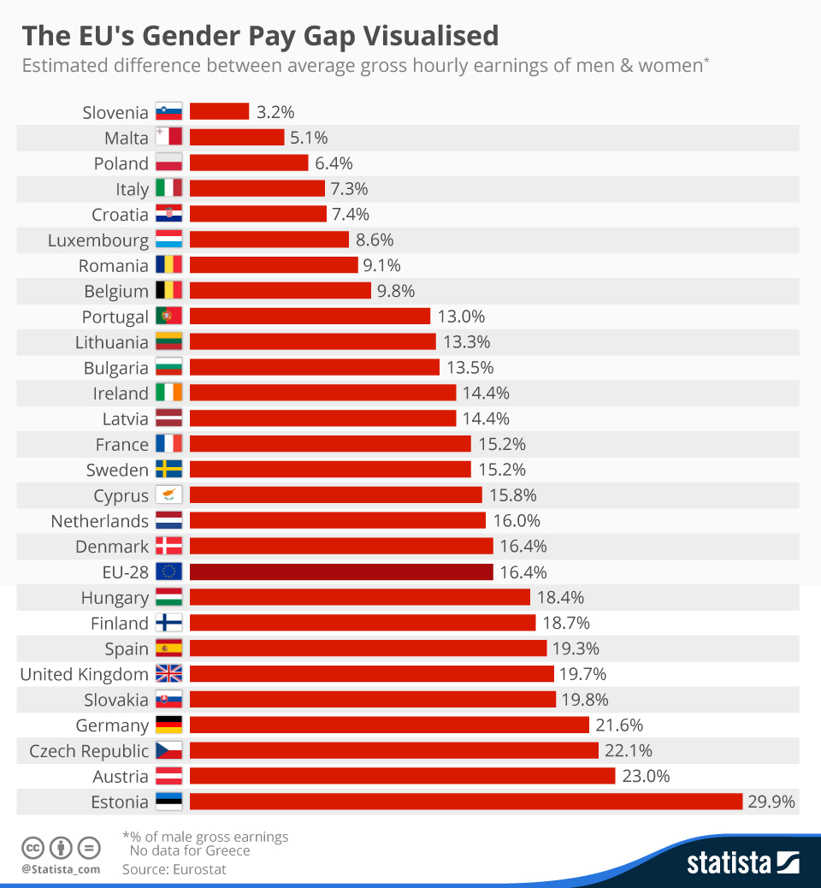
Figure 1: Gender pay gap in EU countries
(Source: Statista, 2022)
This figure indicates that the Gender pay gap in the Czech Republic is more than in Greece, which is 22.1% (Statista, 2022). However, with government support, paying equally for the same task can help a business grab talent from society.
Labour outlook
The Greek government is taking the initiative to include people from different cultural backgrounds and diversity in the workplace. In order to form an inclusive labour market Greece's government has implemented Generation 2.0 for rights, equality and diversity. For this reason, it will be easier for Barclay's to implement an inclusive workforce in Greece to bring productivity (Diversity in the Workplace, 2022).
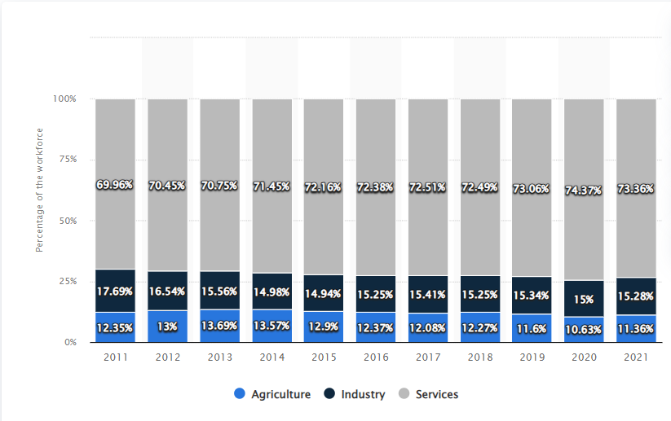
Figure 2: Workforce division in Greece
(Source: O’Neil, 2022)
This figure highlights workforce division in Greece, as per the data of 2021 there are 73.36 people involved in service, thus most of the people in Greece have a habit of getting into service (O'Neil, 2022). Thus, due to expansion of Barclays the banking sector will be able to find employees from the sector. However, people in Czech Republic are ethnically homogenous, it is difficult to find people from other racial backgrounds in the Czech Republic's rural areas, and some can be found in urban areas. Thus, it can be concluded Barclay’s will fail to include a diverse workforce by operating in this country.
Difference based on Hofstede
Hofstede cultural dimension model highlights the framework which has been developed by Geert Hofstede, this model includes six dimensions which are required to draw the differences across cultures in different countries (Wale, 2020). As per the views of Minkov (2018), accounting of the Geert Hofstede model by a business is useful if the brand is expanding to other countries.
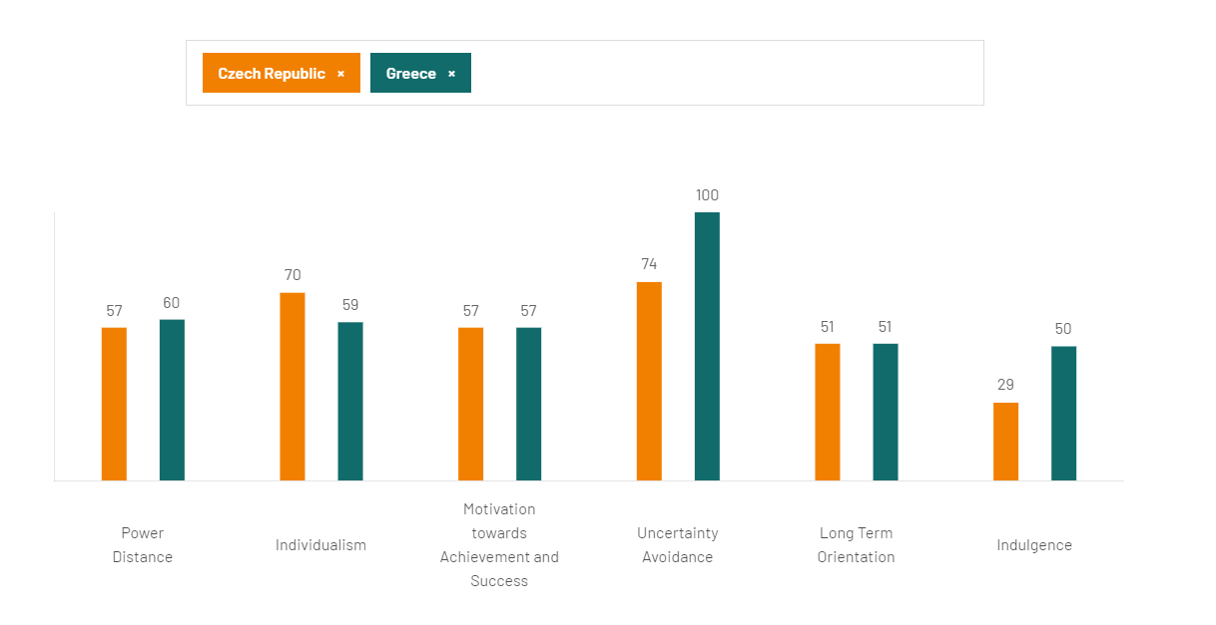
Figure 3: Hofstede model-based country comparison
(Source: Hofstede Insight, 2022)
This model highlights the six-factor difference between Greece and Czech Republic as per this model Power and distance factor score are similar for both countries. The hierarchy of the two countries shows average power to their employees. However, the individualism score of the Czech Republic is more than 70 which indicates that the company expanding to the Czech Republic will fail to implement teamwork within the organisation. This individualistic nature can also create communication problems within the organisation. Greek Score in Uncertainty avoidance is 100 which indicates that the people of Greece are not comfortable in ambiguous situations (Hofstede Insight, 2022). They prefer certainty and businesses that offer certainty in their modern operation tend to be selected by the people of Greece. People of Greece are passionate and emotion can be easily shown in their body language. Another negative identified in the Czech Republic marking is indulgence, a score of indulgence is 29, this indicates people are less indulged in the social norms and they think getting indulgence can create something wrong (Hofstede Insight, 2022). Expansion in this kind of society for a business is tough as people will be restrained from getting engaged with the organisation.

3.2 Communication Barriers
Communication Barriers in the Czech Republic
Individualistic nature in the workforce
The Czech Republic follows an individualistic society, they have a loosely knit social framework and people only think about their work (Hofstede Center, 2022). This is a complex situation in which employees do not prefer teamwork and focus on working all alone. Due to this kind of nature among the employees, the team working in the society is affected. Due to the individualistic nature, recruiting employees from this culture in a business can be tough as employees will not prefer communicating and sharing ideas which is effective for teamwork. Thus, Barclay's can face communication barriers while forming a team in their expansion to the Czech Republic. This company is focused on team working and they provide suitable service to the customers by forming a team. For this reason, expansion of this company will be ineffective if they move to the Czech Republic.
Restrained nature among people and emotional disconnect
As per the model, the Hofstede indulgence score of the Czech Republic is low, this indicates that people do not invest leisure time for gratification of their desires and individuals are restrained by social norms. Individuals are emotionally disconnected in nature and they do not have strong bonds with family or individuals in society. They don't even put time into communicating with individuals for this reason there is less chance of any business getting speeded by word of mouth in these kinds of countries. Barclays may face communication barriers to market their service in the Czech Republic as people do not feel like maintaining any relationship.
Reserved nature of people in society
People in the society are reserved by nature. Individuals of Czech remain straightforward in communication, thus there is a chance that people may not participate in any marketing activities of a business due to their reserved nature and may avoid it straightforwardly. People with straight straightforward nature are not fit for brand communication as they can simply reject the offers by not listening to the marketers. Thus, Barclays can face a barrier in communicating with potential customers because of its reserved nature and straightforward denial of marketing activities.
Communication Barriers in Greece
Language barrier
The majority of the individuals in Greece can understand and speak English, however, some groups in Greece and Athens do not understand English or face difficulties in speaking English (University of Delaware, 2022). However, as a business, it is important to target all types of customers from the society. However, people having problems with English communication cannot be targeted effectively by British organisation Barclays as their official language is English and all the employees are adequate in English language. Thus, a connection of people with origin language can be a significant communication barrier for Barclays in expansion to Greece.
Power and distance factors in the society
The UK has a low power and distance factor for this reason Barclays does not have strong forces between leaders and employees. Employees can work and innovate on their own and their working process is not restricted or derived by leaders. However, Greece follows such a culture where employees need to be forced by the leaders to work. This difference in working procedure can create cultural conflict among the employees and leaders after expansion. This chance of conflict can be a communication barrier for the organisation expanding to Greece.

4. Recommendations

4.1 Recommended Nation with Justification
As per the cultural comparison, it can be concluded that Greece offers a more suitable society for expansion as people hold the nature of collectivism. They are prone to making relationships and prefer communication with people present in society. However, Czech Republic's population pressures individualistic nature. They are straightforward and do not prefer communication with individuals in society. The people of Greece do not prefer any uncertainty in the case of a banking organisation. Thus, being a stable brand in EU origin Barclays has the experience in maintaining certainty. Thus, expansion of Barclay's can be effective in the country as due to their certainty in operation people will be more connected with this kind of organisation. As people are more connected to society thus word of mouth marketing can be effective for the organisation as people can spread the positives of the organisation in society.
Presence of workforce is another significant factor for an organisation to expand, approximately 70% of the population in society is engaged in the service sector and they prefer services other than opening their startup. Thus, Barclay's will be able to get employees from the society of Greece. Barclays prefers inclusion of a diverse team in the organisation so that they can deal with a wide variety of customers even from different cultural backgrounds. Greece promotes diversity in the workforce and individuals from diverse cultures are present in the workforce. This made the country fit for expansion.

4.2 Strategies to Overcome Communication Challenges
Despite all this positive angle Greece also faces cultural barriers of Language along with power and distance. Thus, it is recommended for Barclay to include more employees from Greek society so that the language barrier can be controlled by the organisation. People from Greece can communicate effectively in their local language thus hiring them can help the organisation target customers from the local market. It is also recommended that Barclay adopt the power and distance factor of Greece in order to avoid any kind of cultural conflict which can cause communication barriers. This two strategy inclusion can help Barclays to easily expand their organisation in Greece.

5. Conclusion
In corporate communication, the United Kingdom adheres to a different culture. It is the only country in Europe that prioritises diplomacy over directness in communication. Several cultural issues have been examined in this article using the Czech Republic and Greece as case studies. Communication difficulties and disparities in these nations have also been assessed. Barclays is a global British bank with headquarters in London, England. Greece is considered a collectivist nation, with individuals showing devotion to family and social groupings. Personal interactions between individuals are crucial in Greek daily life. Individuals of Czech origin are honest in communicating and may appear reticent at first. People are attentive, actively listen, and appreciate straightforward communication. The Czech Republic's individuality score is greater than 70, indicating that the firm expanding to the Czech Republic will fail to adopt collaboration inside the organisation. The people of Czech society are reserved by nature. Greece provides a more suited society for Barclays' development since its people value collectivism. The Greek language barrier can be overcome by hiring additional Greek personnel at Barclays.

Reference list
Barclays (2018). Barclays Diversity and Inclusion Programme | Barclays. [online] Home. Barclays. Available at: https://home.barclays/who-we-are/our-strategy/diversity-and-inclusion/ [Accessed 22 Dec. 2023].
Barclays (2021). Barclays core values and purpose | Barclays. [online] Home.barclays. Available at: https://home.barclays/who-we-are/our-strategy/purpose-and-values/ [Accessed 22 Dec. 2023].
Czech University (2022). Beginner’s guide to the Czech Language - Live & Study - Czech Universities. [online] www.czechuniversities.com. Available at: https://www.czechuniversities.com/article/beginners-guide-to-the-czech-language#:~:text=The%20official%20language%20of%20the [Accessed 22 Dec. 2023].
Diversity in the workplace (2022). Welcome! [online] Diversity In The Workplace. Available at: https://diversityintheworkplace.gr/ [Accessed 22 Dec. 2023].
European Institute for gender Equality (2023). Gender Equality Index | 2019 | Money | EL | European Institute for Gender Equality. [online] eige.europa.eu. Available at: https://eige.europa.eu/gender-equality-index/2019/domain/money/EL#:~:text=Inequalities%20in%20income%20distribution%20have [Accessed 22 Dec. 2023].
Evason, N. (2019). Greek Culture - Core Concepts. [online] Cultural Atlas. Available at: https://culturalatlas.sbs.com.au/greek-culture/greek-culture-core-concepts [Accessed 22 Dec. 2023].
Hofstede Center (2022). What about the Czech Republic? Power Distance / (Proximity). [online] Available at: https://is.muni.cz/do/cjv/impact/archiv/ka2/en/55950347/um/Geert_Hofstede_6D_C_ultural_Dimensions_Model_CR.pdf [Accessed 22 Dec. 2023].
Hofstede Insight (2022). Country comparison tool. [online] www.hofstede-insights.com. Available at: https://www.hofstede-insights.com/country-comparison-tool?countries=czech+republic%2Cgreece [Accessed 22 Dec. 2023].
Introducing Athens (2022). Greek Language - Useful phrases and expressions in Greek. [online] www.introducingathens.com. Available at: https://www.introducingathens.com/language#:~:text=Although%20the%20official%20language%20in [Accessed 22 Dec. 2023].
Koutsantoni, D. (2015). Greek Cultural Characteristics and Academic Writing. Journal of Modern Greek Studies, 23(1), pp.97–138. doi:https://doi.org/10.1353/mgs.2005.0007.
Minkov, M. (2018). A revision of Hofstede’s model of national culture: old evidence and new data from 56 countries. Cross Cultural & Strategic Management, [online] 25(2), pp.231–256. doi:https://doi.org/10.1108/ccsm-03-2017-0033.
O’Neil, A. (2022). Greece - Distribution of the workforce across economic sectors 2020. [online] Statista. Available at: https://www.statista.com/statistics/276400/distribution-of-the-workforce-across-economic-sectors-in-greece/ [Accessed 22 Dec. 2023].
OECD (2020). Education GPS - Greece - Overview of the education system (EAG 2020). [online] Oecd.org. Available at: https://gpseducation.oecd.org/CountryProfile?primaryCountry=GRC&treshold=10&topic=EO [Accessed 22 Dec. 2023].
Prague Integration (2023). Czech Culture and Etiquette: Tips for Expats. [online] Prague Integration. Available at: https://pragueintegration.cz/blog/czech-culture-and-etiquette-tips-for-expats/#:~:text=Be%20Mindful%20of%20Communication%20Styles [Accessed 22 Dec. 2023].
Statista (2022). Infographic: The EU’s Gender Pay Gap Visualised. [online] Statista Infographics. Available at: https://www.statista.com/chart/4159/the-eus-gender-pay-gap-visualised/ [Accessed 22 Dec. 2023].
University of Delaware (2022). Greece: Language Barrier | UD Abroad Blog. [online] Available at: https://sites.udel.edu/globalblog/2020/02/greece-language-barrier/#:~:text=Out%20of%20all%20these%20things [Accessed 22 Dec. 2023].
Wale, H. (2020). Hofstede’s Cultural Dimensions Theory. [online] Corporate Finance Institute. Available at: https://corporatefinanceinstitute.com/resources/management/hofstedes-cultural-dimensions-theory/ [Accessed 22 Dec. 2023].
World Business Culture (2019). British Communication Styles. [online] World Business Culture. Available at: https://www.worldbusinessculture.com/country-profiles/great-britain/business-communication-style/#:~:text=Almost%20alone%20in%20Europe%2C%20(with [Accessed 22 Dec. 2023].

