Learning in the Digital Era
ACCA4025
Component 1: E-portfolio

Submitted by:
UMAR KHITAB ABIDI

Student number:
2510352
Date: 9 March 2026

Table of contents
Contents
E-portfolio link 3
Screenshot of e-portfolio cover page/ welcome page 3
Screenshot of task 1 4
Screenshot of mind map 5
Link to mind map 5
Screenshot of the academic poster 6
Link to the academic poster 6
Screenshot of automatic referencing tool 7
Screenshot of each page of e-portfolio 8

E-portfolio link
Umar’s E-Portfolio - Essential Skills

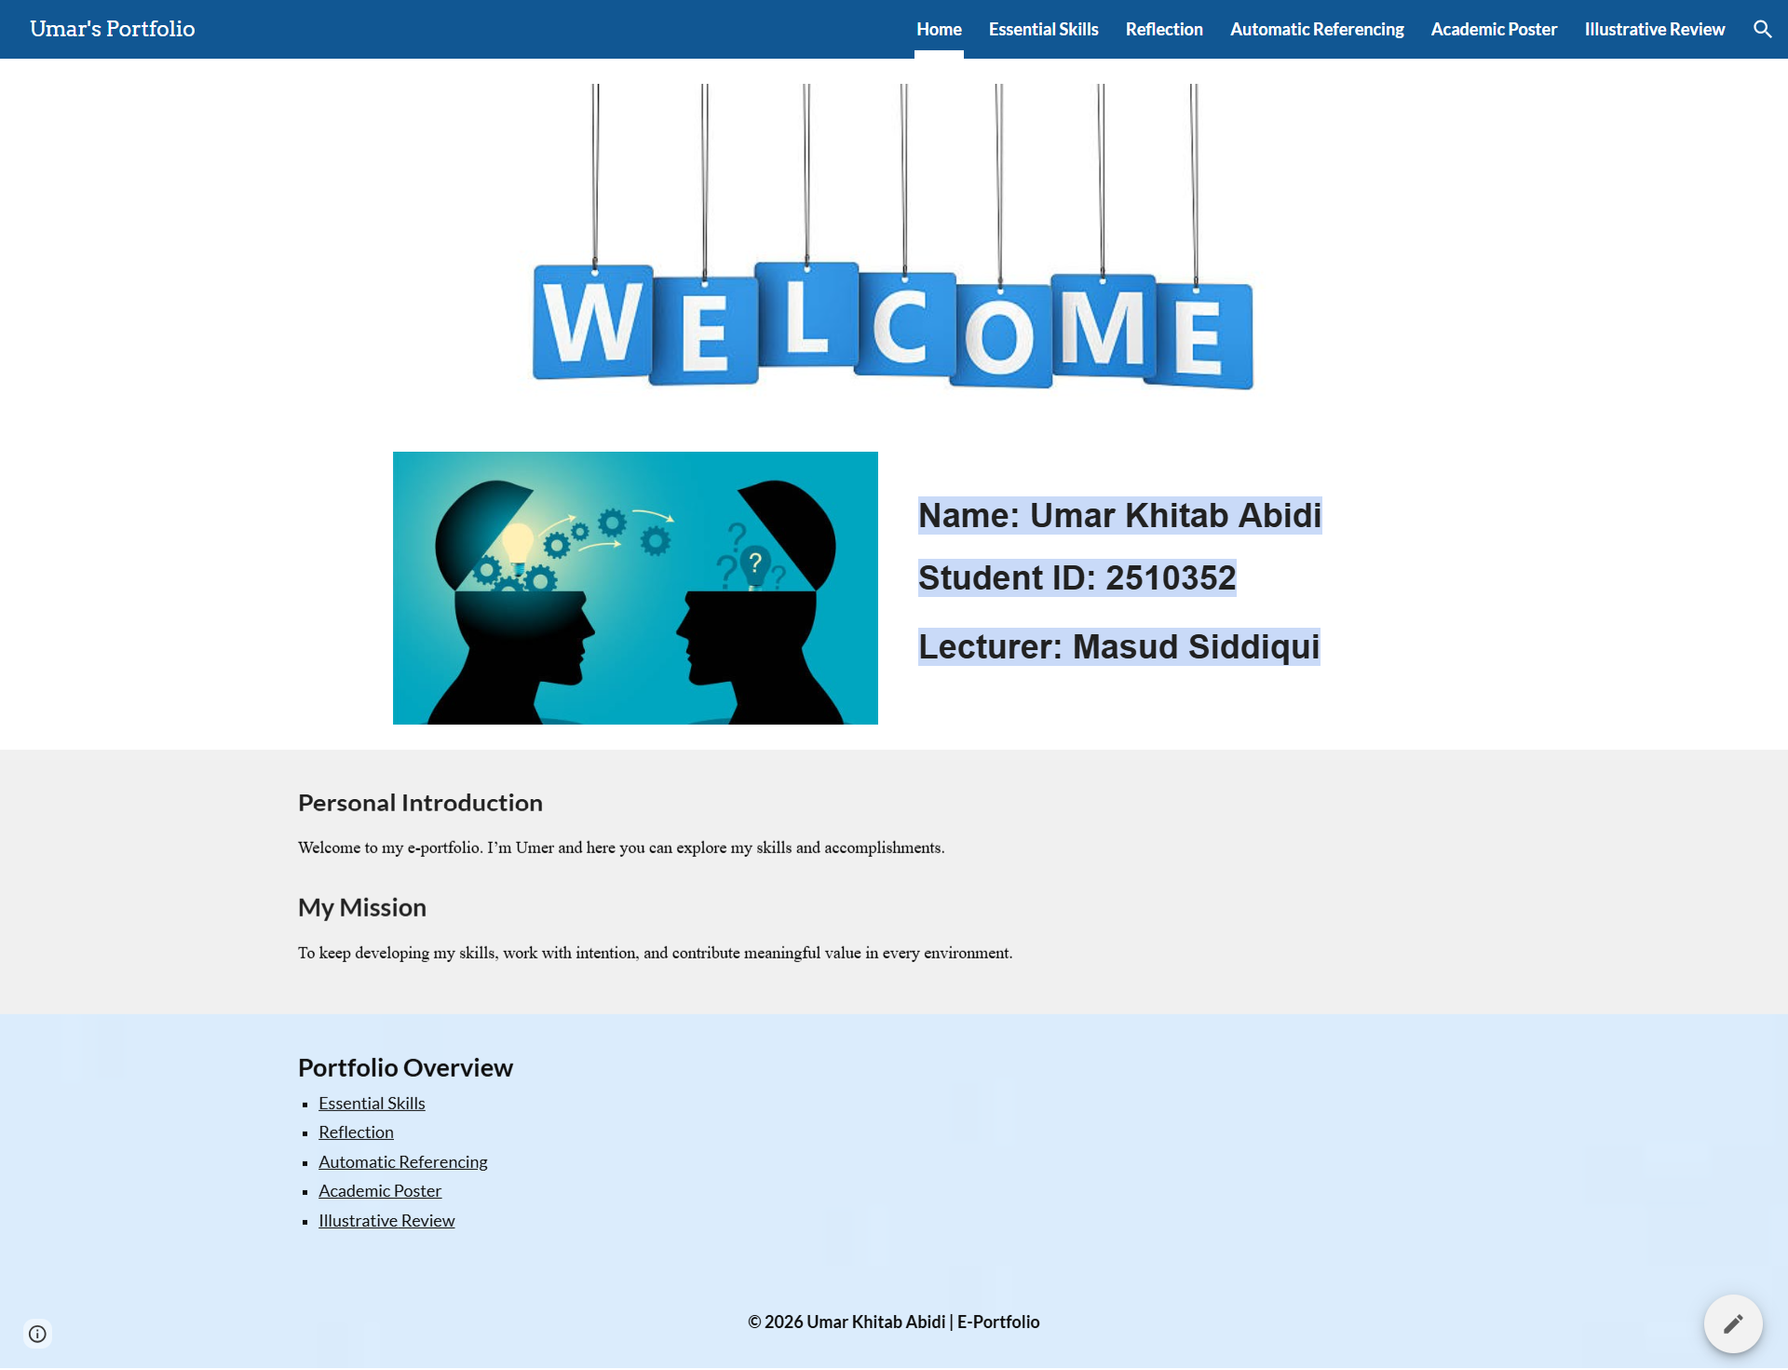

Essential Skills
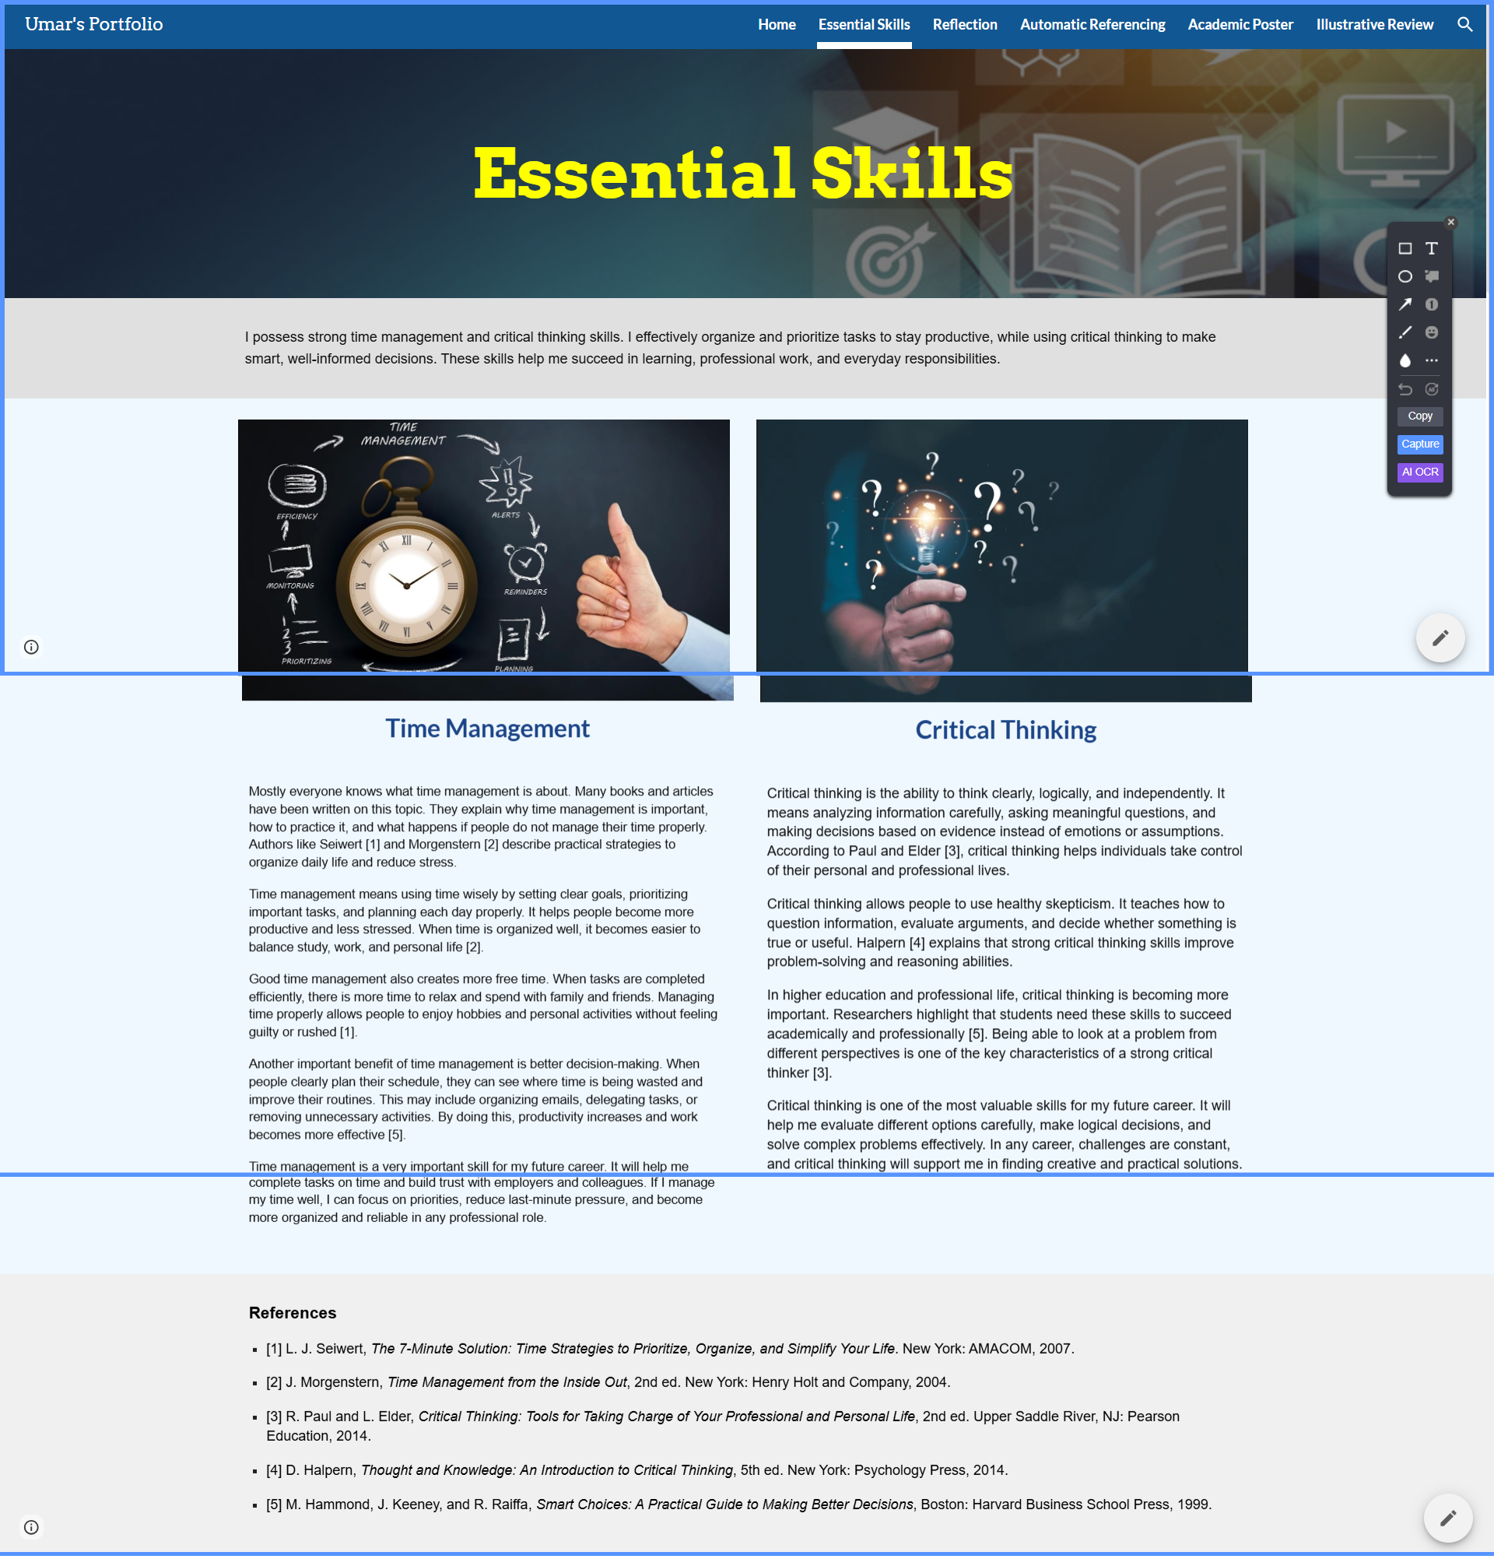

Reflection
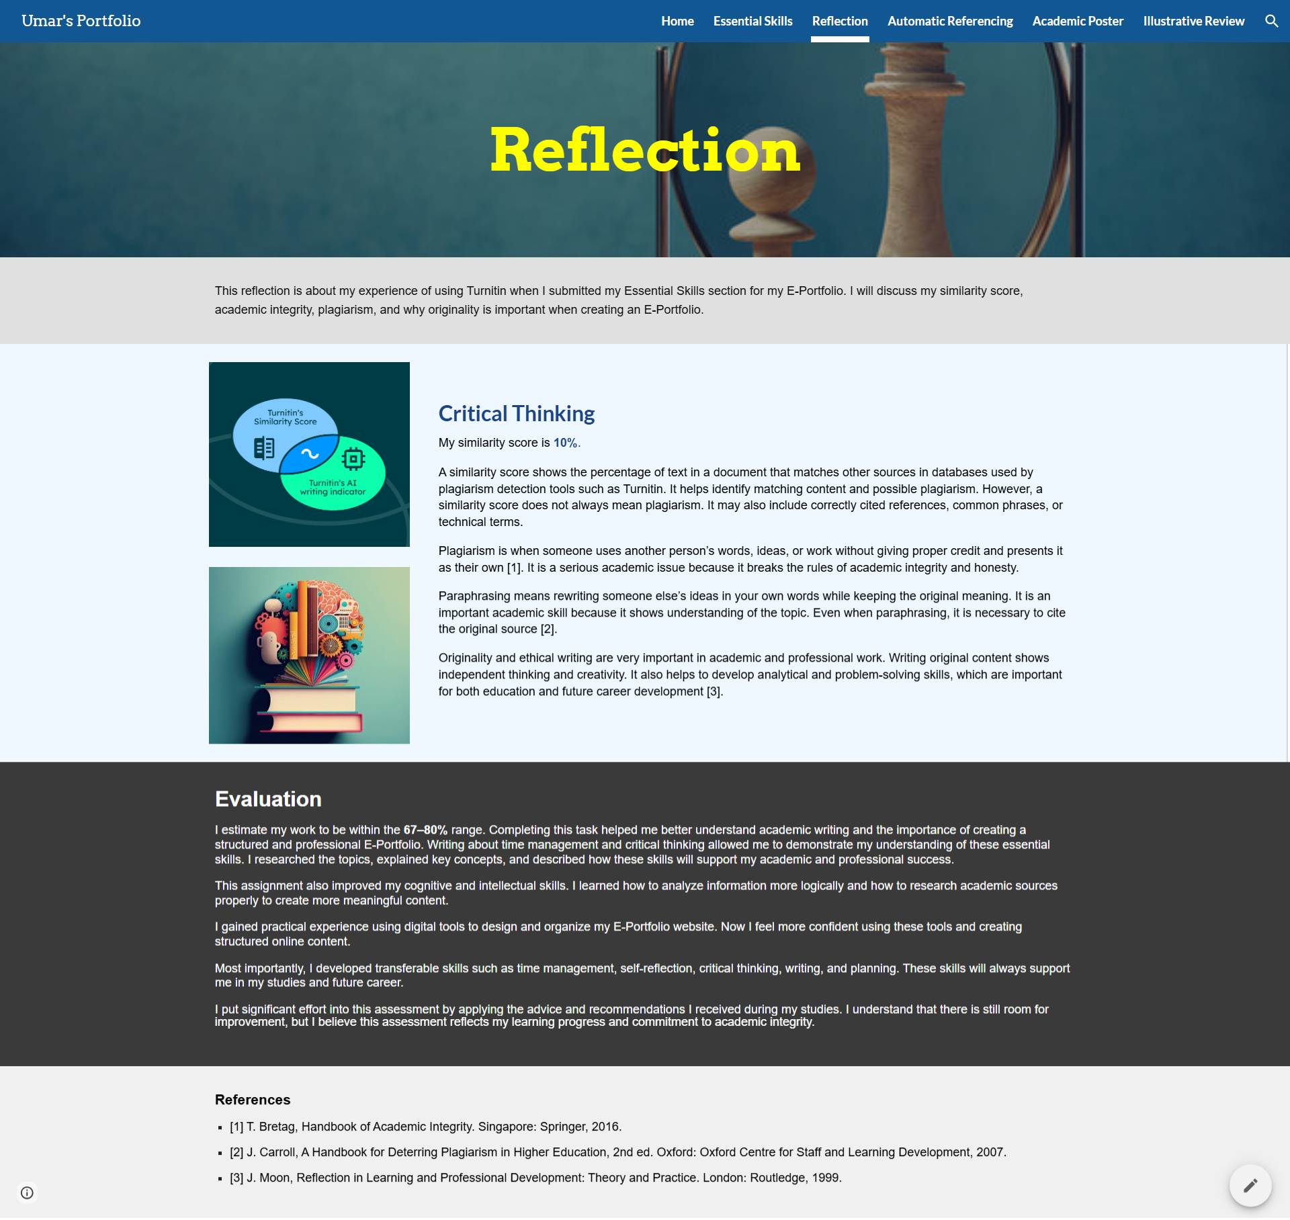

Automatic Referencing
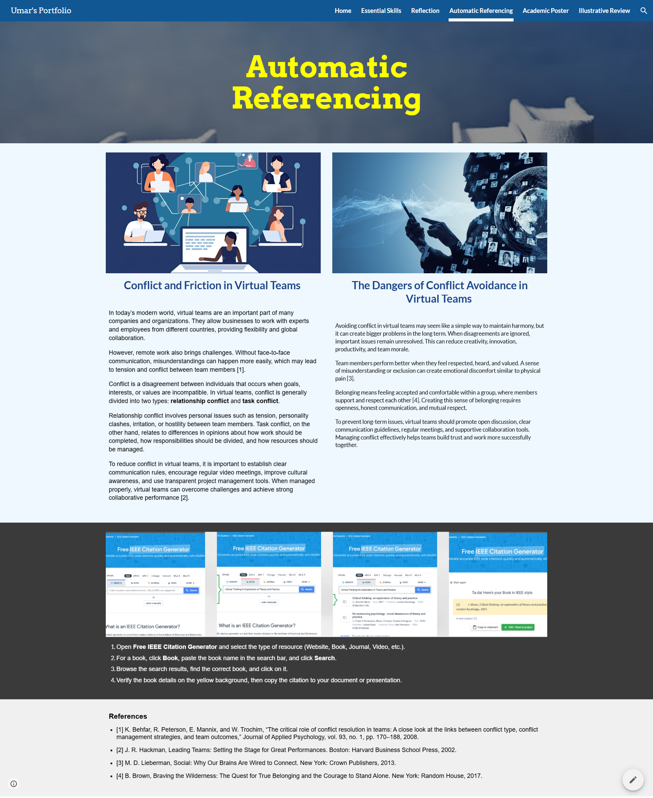

Academic Poster
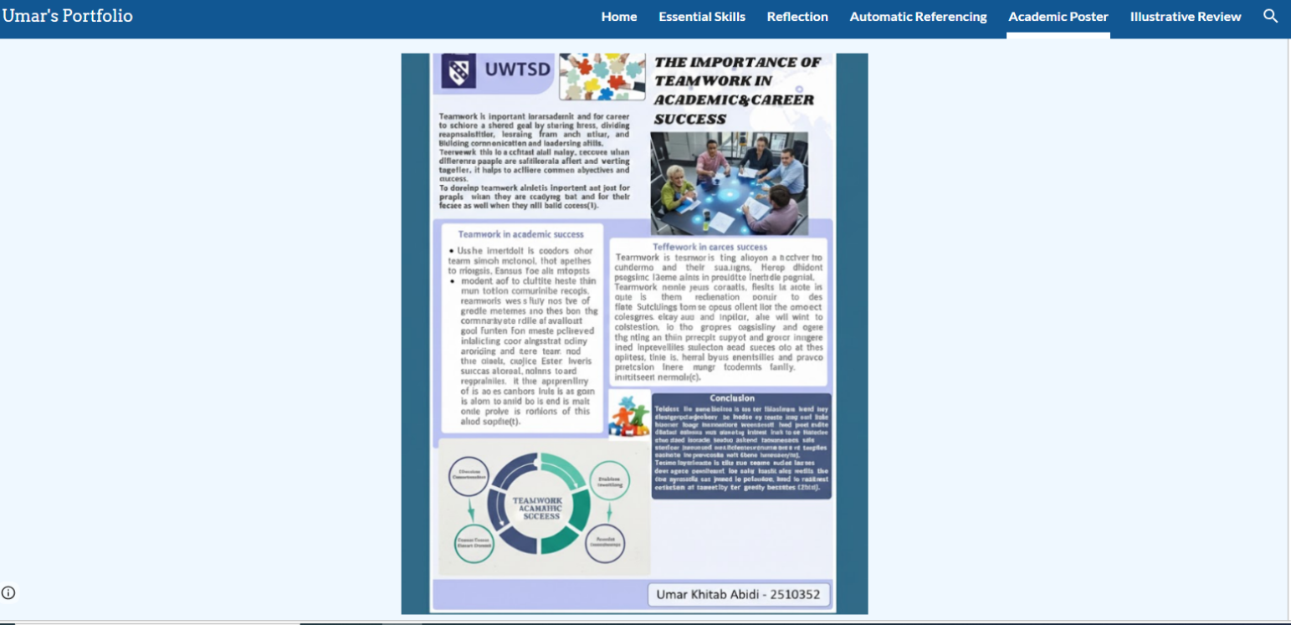

Illustrative Review


