
MASTER OF BUSINESS ADMINISTRATION

MARKETING MANAGEMENT
LCMB7024

MARKETING ENVIRONMENTAL ANALYSIS FOR PIONEERS AND FOLLOWERS

- Student Name: MAHIPALSINH RANVIRSINH GOHIL
- Module Name: MARKETING MANAGEMENT
- Module Code: LCMB7024
- Student ID:2510635
- Lecturer’s Name: DR. JAYALAKSHMI GOPALKRISHNAN
- Word Count: 2650
- Term 1.

Table of Contents
1.0 Introduction 3
2.0 Task 1: The macro marketing environment analysis (Technological and Economic) 3
2.1 Technological Factors 3
2.2 Economic Factors 8
3.0 Task 2: Strategic Responses 9
3.1 Retail sector: Sainsbury (innovator) vs Co-op (mimic) 9
3.2 Telecoms responses: BT Group (pioneer) vs Virgin Media (follower/challenger) 12
4.0 Conclusion 14
References 16

1.0 Introduction
The present report is a critical analysis of two external macro-environment actors, Technological and Economic and the opportunity and threat generated to pioneering and follower firms in the same industry by the changes in the external macro-environment actors. The comparison is between Sainsbury (a pioneer in digital retail/data-led retail media) and the Co-op (a follower with community/ethical differentiation and growing digital capability) in the UK grocery sector. It also shows a comparison between BT Group (a pioneer in network investment/ 5G/fibre rollout) and Virgin Media (a follower/challenger based on bundling/speed differentiation) in the UK telecommunication sector. The former discusses the effect of technological and economic changes on the opportunity/threat sets of pioneers and followers. The second part builds on the findings of Task 1 and literature regarding first-mover/follower appropriateness as an evaluation of strategic responses (marketing, product, pricing and channel strategies) that enable firms to remain competitive.

2.0 Task 1: The macro marketing environment analysis (Technological and Economic)
PESTLE is a category of macro-environment forces that change how the market is structured, customer behaviour and resource needs of firms (Makvandi, 2024). Both retail and telecom sectors are particularly transformational in terms of technology and economic conditions. Tuunanen et al. (2023) added that technology is redefining distribution, data utilisation and service design, and macroeconomic changes are changing demand elasticity and pricing power. The study concentrates on the different opportunities and threats that these two actors create to pioneers (early adopters/ large investors) and followers (later adopters/ niche or cost-focused challengers). Relevant theory emphasises the point that pioneers can attain lasting benefits in terms of asset pre-emption, network effects and data accumulation, whilst followers can enjoy the benefits of learning and reduced R&D expenses (first-mover/follower literature).

2.1 Technological Factors
2.1.1 Retail Sector: Sainsbury's vs Co-op
The grocery retail sector was overhauled by technology in 2019-2025. Online ordering development accelerated, faster delivery was desired, retail media increased in size, and AI was applied to personalisation and optimisation of supply chains. Sainsbury has specifically placed data and digital at the core of its plans for Next Level / Plan for Better and is ramping up Nectar360 retail-media, loyalty analytics and online capacity spending (Makvandi, 2024). The effects of these moves are threefold:
Opportunities of Sainsbury (pioneer): retail media monetisation (Nectar360) and data-driven personalisation are a way to gain new sources of revenue and insights into customers, bolstering customer lifetime value and targeted promotions. Online fulfilment and automated logistics boost access to services. The recent corporate reports of Sainsbury focus on the growth of the Nectar coalition and investment in order to scale digital retail media, which demonstrates a clear technology-based approach to the commercialisation of customer data (Sainsbury, 2025).
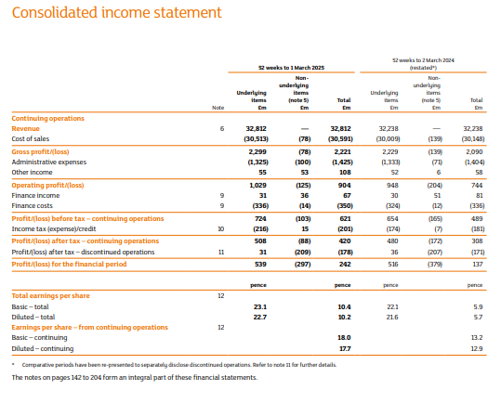
Figure 1: Consolidated Income Statement of Sainsbury
(Source: Sainsbury, 2025)
Threats of Sainsbury: high capital and operating expenses to fulfilment and data platforms, privacy/ regulatory risk associated with data monetisation, and due to its early mover position, it can risk sunk costs due to a rapid change in consumer preferences or technologies (Sainsbury, 2025). According to Shaik and Dhir (2021), early technological investment is worthwhile, but only has the risk of execution, and needs to accompany organisational change.
Opportunities of Co-op (follower): Co-op has an opportunity to be more selective in adopting proven platforms (e.g. dedicated online ordering, enhanced online UX, loyalty-oriented offers) and can use a partner platform to spread the risk of investment. The documented design system and experience library of Co-op Digital shows structured, repetitive digital development-appropriate to the benefit of followers by copying/adaptation of best practice at no pioneer scale R&D cost (Co-operative Group Digital, 2024).
Threats of Co-op: scale disadvantages in logistics and cost of same-day delivery will mean that the costs per order might increase. In addition, lower data pools diminish the performance of personalised retail media. In this way, the follower company, Co-op is at risk of being out-competed on the convenience of fulfilment and value-added services delivered through retail media networks. 2023 has marked a total comprehensive loss of €1,004 million as in 2024 (Co-operative Group Digital, 2024).
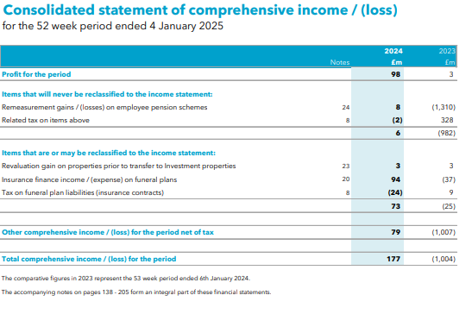
Figure 2: Consolidated Income Statement of Co-op
(Source: Co-operative Group Digital, 2024)
Net effect (retail): Technological change increases the value of data and the scale of fulfilment scale large pioneer advantages, monetisation, and scale in operation, but followers may still compete through the local service focus, membership/community credentials and selective digital adoption.
2.1.2 Telecommunications: BT Group vs Virgin Media
Telecoms is a heavy investment technology sector in which the leadership of a network is important. BT has spent heavily on full-fibre broadband and 5G (EE), and the joint venture (Virgin Media O2) has built a high-capacity fibre network and mobile following the 2021 joint venture. The official strategic reports point to the fact that BT has accomplished previous quarterly records of fibre builds and that converged offerings were strategic.
Pioneer opportunities in BT: The early adoption or first-mover of full-fibre and 5G network differentiation (speed, reliability) allows charging higher prices, B2B contracts and platform opportunities (edge services). The strategic disclosures of BT reflect high-scale rollout of fibre and 5G standalone experiments to support the new services (BT Group, 2025).
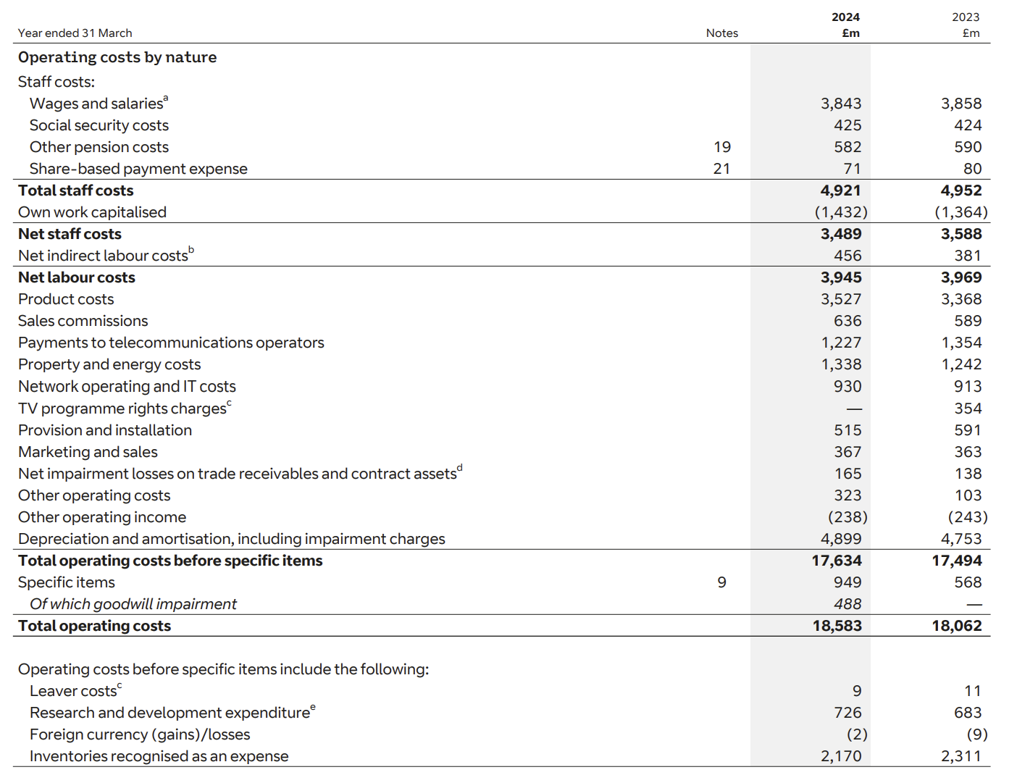
Figure 3: Consolidated Income Statement of BT Group
(Source: BT Group, 2024)
Threats for BT: The expense of CAPEX puts a firm in a risky position. It is because the economy slows down, early movers risk regulatory review and risks due to the speed of technological change, such as in the case of WiFi-7 (BT Group, 2024). Figure 3 revealed that total operating costs of BT has increased from €18,062 (2023) to €18,583 in 2024 (BT Group, 2024).
Virgin Media (follower) opportunities: There are scopes for Virgin Media to implement successful fibre and bundle strategies and vigorous market speed/value bundling. Being a challenger with a strong brand, Virgin Media can capture share with promotional pricing, differentiated customer experience, and partnerships (e.g. O2). In the joint-venture documentation, there is a focus on converged offers and the scale of customers (Virgin Media O2, 2022).
Threats to Virgin Media: Provided that challengers experience margin pressure, as well as profitability in a saturated subscription market, they can be undermined by intense price competition. In the case of BT can exploit network scale and regulatory advantages (Virgin Media O2, 2023).
Net effect (telecoms): There must be a tech investment to compete. There is also a need to first enjoy national network benefits. However, these first movers can still be outwitted by second movers using differentiated bundles, marketing and operating efficiency.

2.2 Economic Factors
Opportunities and Threats in the UK Retail Sector: Sainsbury’s vs Co-op
Between 2021-2024, the UK was under high inflation and a cost-of-living crisis. Food price inflation and real household incomes changed consumer behaviour to value and private label. In literature on economic issues and UK government/think-tank reports, record high demand substitution and trading down in grocery purchases in times of high inflation (NatCen Social Research, 2023).
Sainsbury (pioneer): A major retailer that has a multi-channel presence can use its own labels, leverage economies of scale buying to maintain profit margins, use loyalty data to implement targeted promotions, and divert customers to own-brand items with higher profit margins. The strategic statements that Sainsbury attributes to itself include the focus on value and application of Nectar understanding as a way of retaining customers in the face of economic strain. Nonetheless, macro weakness minimises total basket sizes that influence growth in the top line and necessitates revenue management in margins (Sainsbury, 2025).
Co-op (follower): Co-op community, convenience positioning. Co-op tends to be situated in the small format stores, which are more susceptible to the cost of inflation (increased per-unit logistic and operating costs). However, member model and ethical positioning can build loyalty during tough times at Co-op. Nevertheless, the consumers who are price-sensitive can switch to discounters, which will be a threat to the top line of Co-op (Co-operative Group Digital, 2023).
Net effect (retail): Economic stress raises price sensitivity. Under such circumstances, scale and data pioneers can rely on targeted pricing and private label strategies to protect share, whereas followers have to depend on loyalty, convenience and local differentiation to keep customers.
Opportunities and Threats in the UK Telecommunication Sector: BT vs Virgin Media
As understood from the findings of Akhoundova et al. (2025), the demand in the telecom industry is not that much price-sensitive with core connectivity, whereas the demand for discretionary services (premium pin, content packages) is budget-elastic in the household. The saturation of the market in terms of subscriptions puts an accent on the reduction of churn and management of ARPU (average revenue per user). According to industry and company reports, telecoms came under pressure yet stayed strong because of the necessity of services.
BT (pioneer): Capacity established in expansion phases can be utilised to fulfil demand, enabling it to upsell the more expensive services. However, the recession leads to an increased analysis of CAPEX and demand for network projects to clearly demonstrate a payback to the network. According to recent reports, BT focuses on disciplined investment and targets returns on fibre rollouts (BT Group, 2025).
Virgin Media (follower): Churners can be bought through pricing promotions and bundling (e.g. TV + broadband + mobile), in economic times of stress, but households with a tight budget could reduce premium add-ons, putting pressure on ARPU. The financial reports of the joint venture highlight the significance of bundling and convergence to reduce churn risk (Virgin Media O2, 2023).
Net effect (telecoms): Economic conditions moderate discretionary spend; connectivity is a core service - pioneers with scale can safeguard margins through service differentiation; followers are forced to compete by price, bundle and customer experience (Virgin Media O2, 2023).

3.0 Task 2: Strategic Responses

3.1 Retail sector: Sainsbury (innovator) vs Co-op (mimic)
Sainsbury-Pioneer strategic responses:
Data monetisation/personalised marketing: Sainsbury's is expanding Nectar360 retail media, and leveraging loyalty data to make targeted offers and advertise to third parties. This will enable customers to save £13-£80 on weekly shopping. Already customers have saved £2 billion in 2024/25 (Sainsbury, 2025). Such strategic exploitation of the first-party data is a textbook pioneer solution to transform the benefit of data in the form of new revenue and to funnel the customers in with improved personalisation.
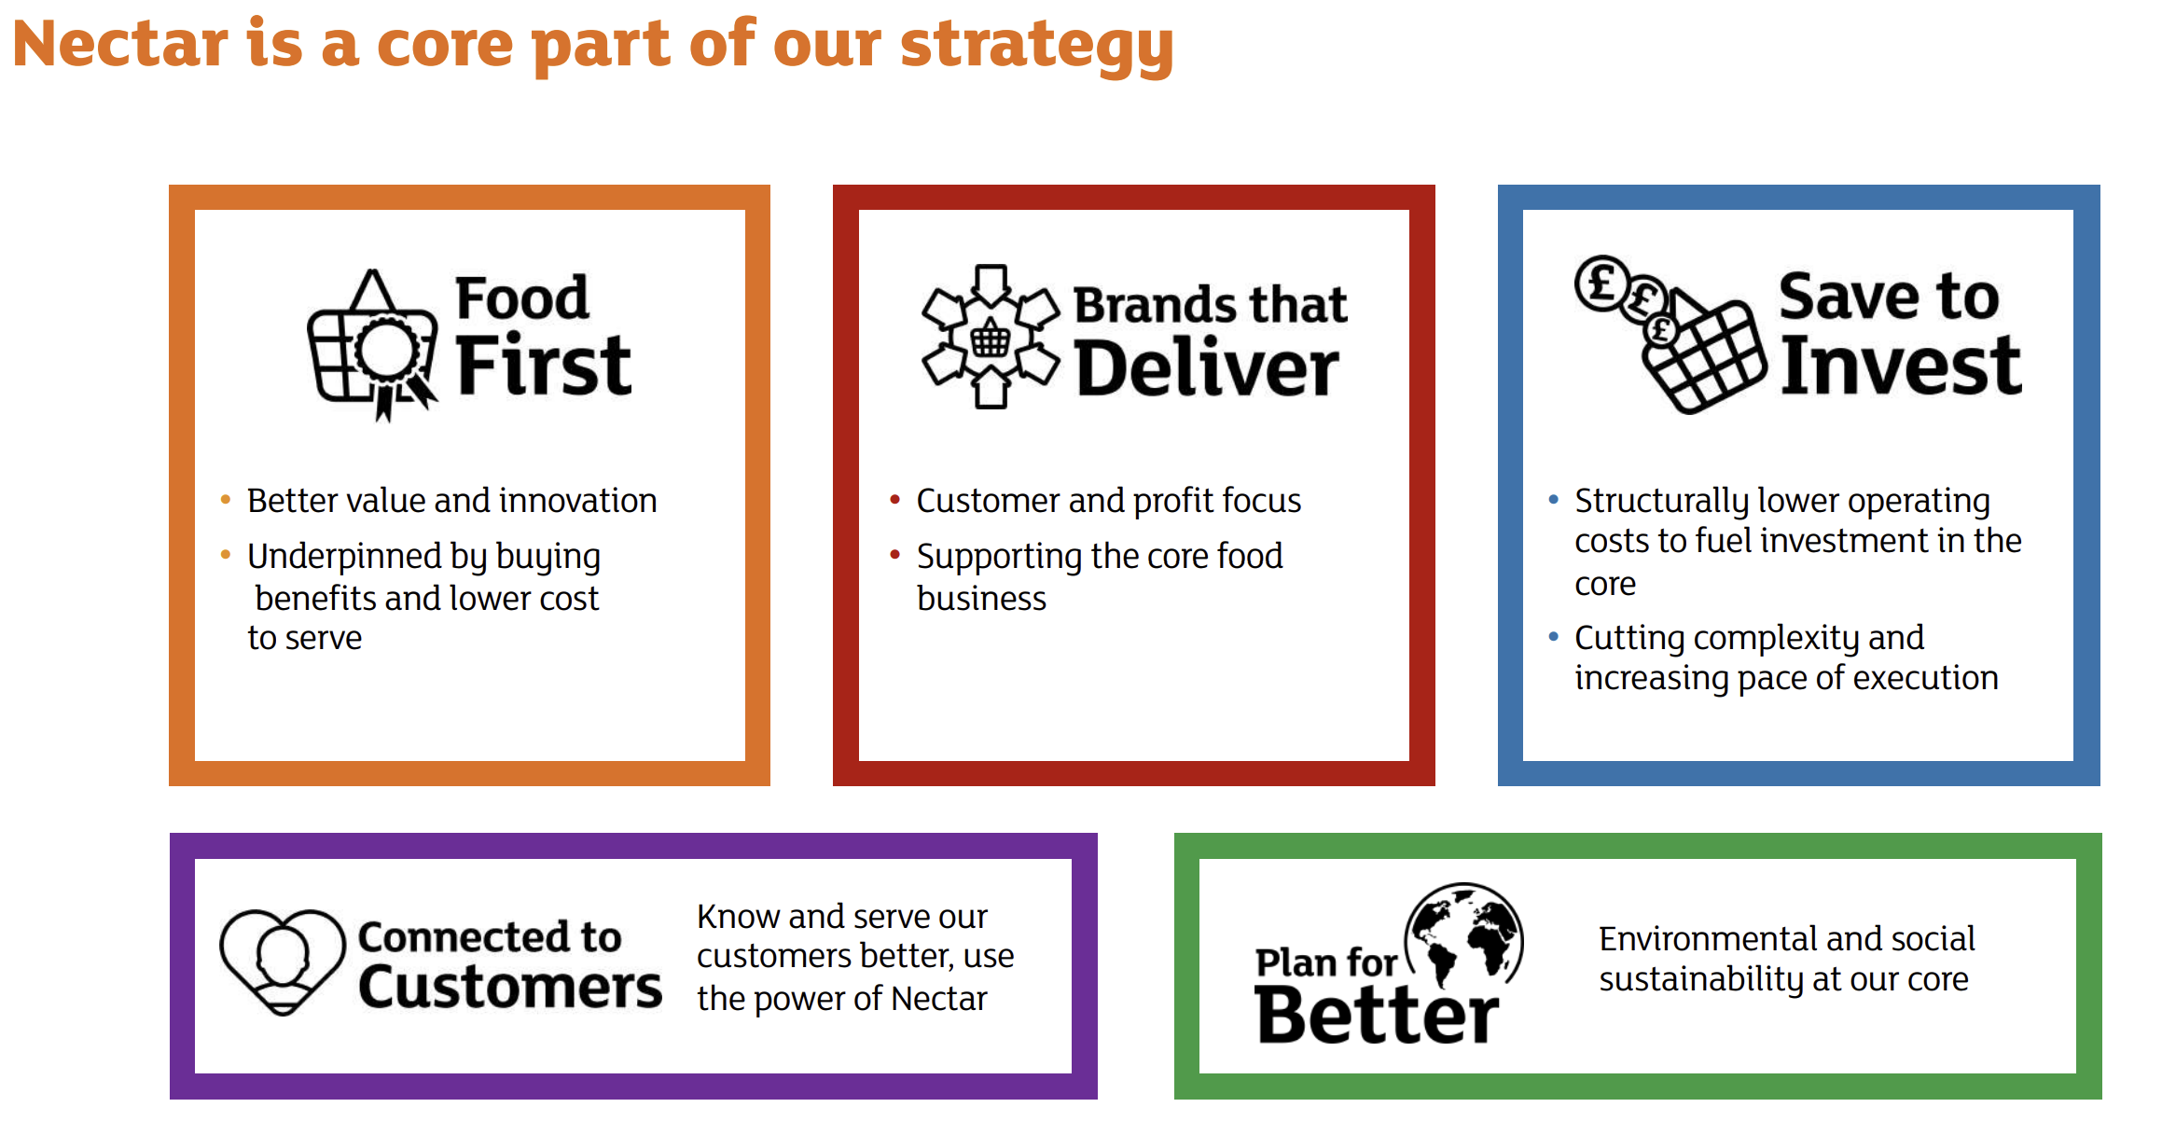
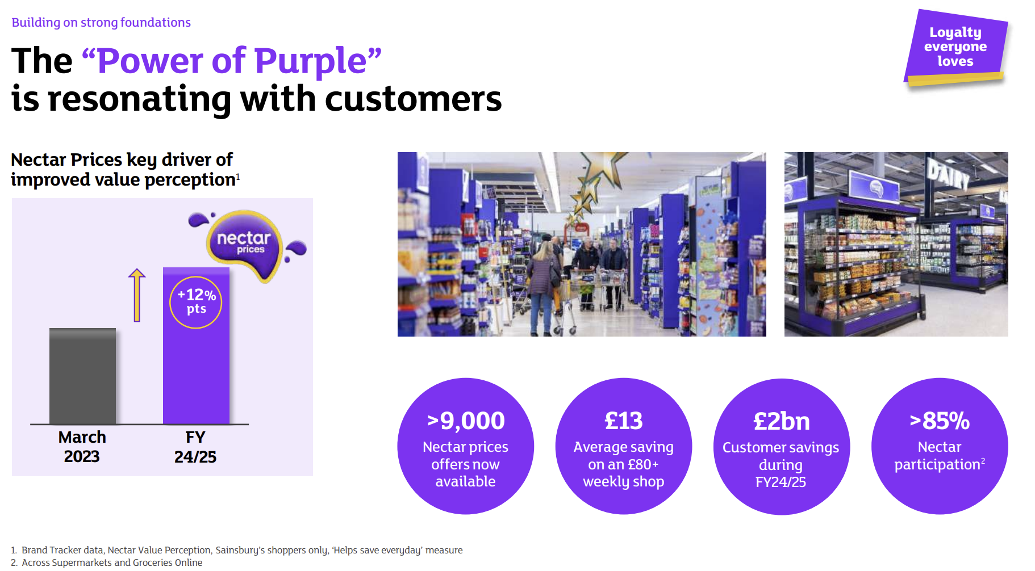
Figure 4: Nectar360 of Sainsbury
(Source: Sainsbury, 2025)
Omni-channel scale/fulfilment investment: Sainsbury has persistently invested in online fulfilment, click and collect, and supply chain automation to suit speed and convenience requirements, and it is using scale to cut per-order costs, thus protecting its margin as well as covering technological expectations. To implement this strategy, corporate filings focus on planned investment and change of operation to provide it (Sainsbury, 2025).
Value & own-label strategy: Sainsbury has a stronger own-brand offer during an inflation period that allows it to retain price-sensitive buyers without depleting the brand positioning as a part of the Ansoff/Porter categories of competitive scope and product strategy (Sainsbury, 2025).
The first-mover logic of the pioneer actions by Sainsbury is to ensure that assets (data, fulfilment networks) have been secured, and that these assets generate switching costs and are monetised. The risks include capital intensity and complexity of the executions (data integration, compliance with privacy). Halberstadt (2022) cautions that innovators need to couple the expenditure and organisational capacity so that they can achieve benefits.
Co-op Follower strategy responses:
Targeted digital adoption: Co-op has created modular design systems and experience libraries that allow it to make digital incremental improvements: improved web/app UX, local offers and membership capabilities that can create deeper loyalty without the size CAPEX of a nationwide fulfilment network (Co-operative Group Digital, 2023).
Membership/value-based marketing: Co-op uses member ownership and community programs as a differentiation strategy. In economic stress, community focus enables retention with perceived shared value and trust. It is a non-price strategy of differentiation among followers that has enabled it to serve more than 150 local co-operatives and 650+ communities, as shown in figure 5 (Co-op, 2025).
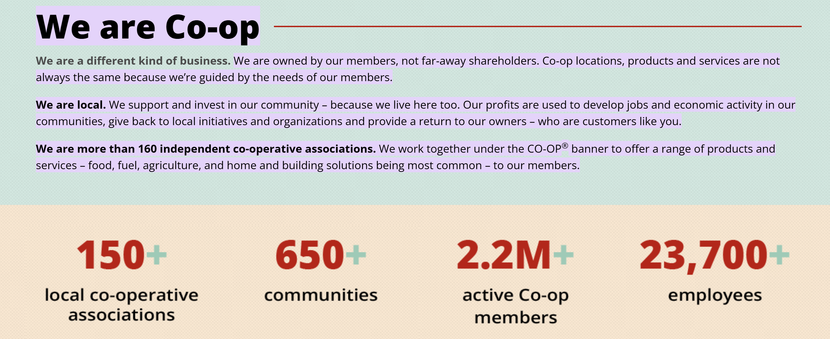
Figure 5: Strategic aspects of Co-op
(Source: Co-op, 2025)
Selective alliances: Co-op can partner on last-mile delivery instead of developing full-scale fulfilment or utilise third-party services to conduct ecommerce, lowering the amount of capital expenditure and time to market, which is a follower-type response that saves the risk (Co-operative Group Digital, 2023).
Co-op approach corresponds to follower benefits with reduced initial investment, adaptation of proven technology and emphasis on non-price differentiation (ethics, community). The negative is that it is prone to convenience competition as well as price competition, in which scale is an important factor.

3.2 Telecoms responses: BT Group (pioneer) vs Virgin Media (follower/challenger)
BT Group Pioneer strategic responses:
Network scale/ product uplifts: BT is offering a sustainable capability through its large-scale implementation of full fibre and 5G for 95% coverage (EE, 2024). As seen in Figure 6, BT has launched network upgrades (5G standalone, trials with WiFi-7) as networks. These services (enterprise edge computing, B2B connectivity) differentiate them in consumer markets where speed and reliability are valued at a premium. In annual strategic reporting, sustained fibre build goals and technology leadership remain focal points (BT Group, 2025).
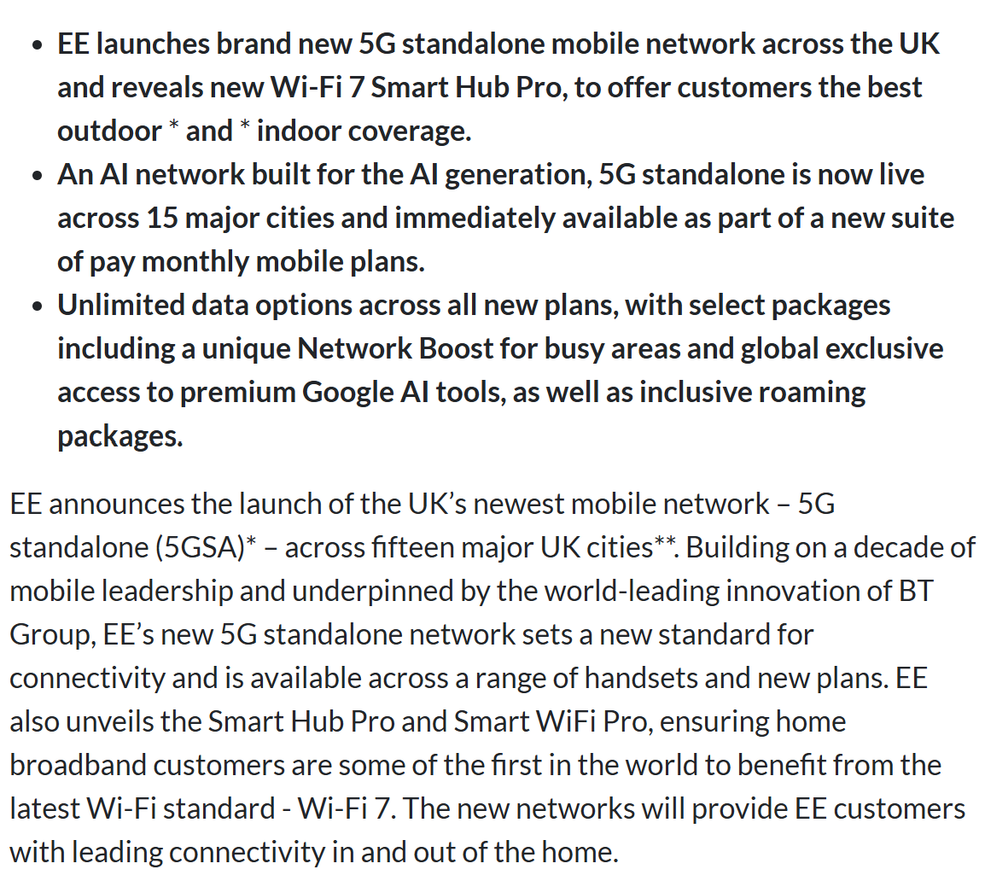
Figure 6: 5G standalone network and next-gen Wi-Fi 7 of BT
(Source: EE, 2024)
Monetisation through services and partnerships: BT uses network assets to offer value-added services (security, managed services, media rights in the past) (BT Group, 2024). It also negotiates with regulators and the government to enter contracts involving other parties. This aligns with early efforts to transform infrastructure into ongoing revenue-generating opportunities.
Focus on customer retention: Innovative investments are be accompanied by marketing that secures ARPU. BT focuses on offering bundles, loyalty schemes and service guarantee to retain share (BT Group, 2024).
The pioneer playbook that BT has developed is CAPEX-heavy, but able to provide scale economies and differentiated service levels. The long payback, however, implies macroeconomic sensitivity and regulatory risk.
Virgin Media- Follower/challenger strategy response:
Fierce bundling and positioning: Virgin Media O2 uses a combination of broadband and mobile resources to provide aggressive bundling and prices through promotion, by focusing on speed and convergence to gain market share. The joint-venture announcements highlight the business logic of convergence (Virgin Media O2, 2023).
Brand/customer as differentiator:
Virgin uses its brand and marketing to establish a sense of value; its followers tend to outcompete on marketing agility and customer experience, and not the owning pure infrastructure. Corporate governance and strategy documents indicate that they focus on customer centricity and brand-led propositions (Virgin Media O2, 2022).
Operational efficiency & focused investments: A follower does not have to waste money trying to match the pioneer on a nationwide fibre but can invest in segments with high yields (urban fibre, Wi-Fi mesh in customer premises) and extract higher ARPU using marketing (Virgin Media O2, 2022).
Virgin has a follower strategy bundle, brand, and targeted investment, which allows it to obtain market share without as much countrywide CAPEX as BT. However, profitability is conditional upon good control of churn and the prevention of devastating price wars.

4.0 Conclusion
The impact of technological and economic macro-forces on pioneers and followers is different. Technology magnifies scale and data benefits and favours innovators that can monetise first-party information and have access to nationwide infrastructure (Sainsbury, BT). The economic shocks make the prices more sensitive, straining the margins and boosting the significance of the targeted promotions and own labels (retail) and bundle management (telecoms).
The followers (Co-op, Virgin Media) can prosper by adopting the proven technologies selectively, capitalising on the brand/community differences, and employing focused operational models without incurring the heavy CAPEX of pioneers. Tactically, a first-mover in the context of technology needs to invest and marketing and have the capability to maintain the first-mover benefit; the followers need to use agility, targeted differentiation and alliances. Ongoing environmental scanning and alignment of marketing strategy to external changes are thus critical towards the maintenance of competitiveness.

References
Akhoundova, L., Colebrook, C., Crawford, A., Rincon Aznar, A., Schneebacher, J., Thakrar, A. and Walker, M., (2025). Recent Developments at the CMA: 2024–25. Review of Industrial Organization, pp.1-28. https://link.springer.com/article/10.1007/s11151-025-10037-x
BBC News (2023) ‘Cost of living: Households cut premium streaming and telecom bundles’, BBC News. Available at: https://www.bbc.co.uk/news/business-66578982 [Accessed on 10.11.2025]
BT Group (2024) Annual Report and Financial Statements 2024. London: BT Group plc. Available at: https://data.fca.org.uk/artefacts/NSM/Portal/NI-000098321/NI-000098321.pdf [Accessed on 10.11.2025]
BT Group (2025) Strategic Report: Full Fibre and 5G Expansion. London: BT Group plc. Available at: https://www.bt.com/bt-plc/assets/documents/investors/financial-reporting-and-news/annual-reports/2025/2025-bt-group-plc-strategic-report.pdf [Accessed on 15.11.2025]
Co-op. (2025). ABOUT. Available at: https://www.co-op.crs/about#:~:text=We%20are%20Co%2Dop&text=We%20are%20owned%20by%20our,most%20common%20%E2%80%93%20to%20our%20members. [Accessed on 15.11.2025]
Co-operative Group Digital (2024). Co-op Digital: Design System and Experience Library. Manchester: Co-operative Group. Available at: https://digitalblog.coop.co.uk/wp-content/uploads/2024/05/Co-op-Digital-Design-System-Experience-Library.pdf
Co-operative Group Limited (2023) Annual Report and Accounts 2023. Manchester: Co-operative Group Limited. Available at: https://www.coop.co.uk/media/3250/annual-report-and-accounts-2023.pdf [Accessed on 15.11.2025]
Dekimpe, M., Helsen, K. and Geyskens, I. (2023) ‘Retailing in times of soaring inflation: What we know and need to know’, Journal of Retailing, 99(3), pp. 435–455. https://doi.org/10.1016/j.jretai.2023.07.004
EE. (2024). BT's EE launches 5G standalone network and next-gen Wi-Fi 7 router. Available at: https://www.telecomtv.com/content/5g/bts-ee-launches-5g-standalone-network-and-next-gen-wi-fi-7-router-51204/#:~:text=Via%20EE,and%20out%20of%20the%20home. [Accessed on 18.11.2025]
Financial Times (2024) ‘UK grocers battle market inflation through loyalty pricing shifts’, Financial Times, 22 February. Available at: https://www.ft.com/content/3a12bd1e-4f09-4a35-bf17-9b09e3c1f0e4 [Accessed on 12.11.2025]
Halberstadt, J. (2022) ‘Revisiting first-mover advantages: A systematic review of pioneer and early follower strategies’, Journal of Business Research, 147, pp. 112–130. https://doi.org/10.1016/j.jbusres.2022.06.018
Makvandi, R. (2024). Analysis of the Impact of Macroeconomic Factors on the Development of Financial Products: Application of the PESTEL Model in Identifying Opportunities and Threats. Transactions on Quantitative Finance and Beyond, 1(2), pp.233-246. https://www.tqfb.reapress.com/journal/article/download/40/74
Mobile News (2023) ‘BT launches 5G Standalone with WiFi-7 trials’, Mobile News, 8 November. Available at: https://www.mobilenews.com/articles/bt-launches-5g-standalone-with-wifi-7-trials [Accessed on 12.11.2025]
NatCen Social Research (2023). The Price We Pay: The social impact of the cost-of-living crisis in the UK. London: NatCen. Available at: https://natcen.ac.uk/sites/default/files/2023-07/Society%20Watch%202023_The%20Price%20We%20Pay_the%20social%20impact%20of%20the%20cost%20of%20living%20crisis.pdf [Accessed on 18.11.2025]
Reuters (2023) ‘UK inflation and consumer demand pressures reshape retail spending’, Reuters. Available at: https://www.reuters.com/world/uk/food-retail-landscape-is-changing-good-says-britains-ocado-2021-02-09/ [Accessed on 15.11.2025]
Sainsbury (2024) Annual Report and Financial Statements 2024. London: J Sainsbury plc. Available at: https://corporate.sainsburys.co.uk/media/n3bdgevz/sainsbury-annual-report-and-financial-statements-2024.pdf [Accessed on 15.11.2025]
Sainsbury (2025) Nectar360 Retail Media and Data Transformation – Preliminary Results Presentation. London: J Sainsbury plc. Available at: https://corporate.sainsburys.co.uk/media/gwlnbo1p/j-sainsbury-plc-preliminary-results-2425-presentation.pdf [Accessed on 12.11.2025]
Sainsbury (2025) Plan for Better and Next Level Growth Strategy Update. London: J Sainsbury plc. Available at: https://corporate.sainsburys.co.uk/media/qe2cmbah/sainsbury-annual-report-and-financial-statements-2025-purpose-in-action.pdf [Accessed on 15.11.2025]
Shaik, A.S. and Dhir, S., (2021). What drives organisational performance: strategic thinking, technological change, strategic risks? A modified total interpretive structural modelling approach and MICMAC analysis. Journal of Indian Business Research, 13(4), pp.533-563. https://www.emerald.com/insight/content/doi/10.1108/JIBR-09-2020-0309/full/html
Stecuła, K. (2024) ‘Technology development in online grocery shopping: A systematic review’, Foods, 13(5), pp. 850–870. https://www.mdpi.com/2304-8158/13/5/850
The Guardian (2023) ‘Food inflation squeezes household spending as consumers trade down’, The Guardian. Available at: https://www.theguardian.com/business/2023/sep/10/food-inflation-household-spending-trade-down [Accessed on 12.11.2025]
Tuunanen, T., Salo, M. and Li, F., (2023). Modular service design of information technology-enabled services. Journal of Service Research, 26(2), pp.270-282. https://www.researchgate.net/profile/Tuure-Tuunanen/publication/360143904_Modular_Service_Design_of_Information_Technology-Enabled_Services/links/626b8d78d99ac24cc472be87/Modular-Service-Design-of-Information-Technology-Enabled-Services.pdf?origin=journalDetail&_tp=eyJwYWdlIjoiam91cm5hbERldGFpbCJ9
Virgin Media O2 (2022) Joint Venture Integration and Growth Strategy Update. London: Virgin Media O2. Available at: https://prod.ctassets.virginmedia.com/uploads/Virgin_Media_Limited_Corporate_Governance_Report_2022_2bcf6544df.pdf [Accessed on 15.11.2025]
Virgin Media O2 (2023) Annual Report and Financial Statements 2023. London: Virgin Media O2. Available at: https://prod.ctassets.virginmedia.com/uploads/VMED_O2_UK_Holdings_Limited_2021_Annual_Report_de8425b379.pdf

