Title Page: Business Plan
Programme of Study: Certificate in Higher Education Business Skills for the Workplace
Module Name and Code: Enterprise and Entrepreneurship LCLM4006
Assignment Title: Business Plan for Community Care
Lecturer’s Name: Dr Charles Oham
Business Name: Community Care
Location: London Borough of Newham
Executive Summary
Community Care Ltd will be a London-based domiciliary care agency operating in the London Borough of Newham. Its main objective is to support older people in their homes and nursing homes, to support people with disabilities, people who are recovering from the hospital and families who need care assistance in their homes. The service will include regulated personal care, medication assistance, meal preparation, companionship, domestic support, and respite care.
This business opportunity is supported by an ageing population and a growing preference for care at home. Community Care will position itself through continuity of personalised care plans, locally recruited employees, digital care records and free quarterly workshops for all carers. These workshops will address the challenges in communication, especially for people with dementia, preventing falls, and access to local support, giving the business a clear community-support element.
Marketing will focus on healthcare referrals, community partnerships, social media and search-engine visibility. The business requires £22,576 in start-up funding, comprising £7,000 owner investment, a £5,576 commercial bank loan, and a £10,000 Start Up Loan. First-year objectives are to obtain CQC registration, recruit and train 10 carers, support 15 clients and achieve at least 90% client satisfaction.
Table of Contents
- Overview of the Business Idea
- Organisational Structure
- Market Research
- Marketing Communications
- Financials
- Conclusion
References

1. Overview of the Business Idea
Community Care Ltd will be a London-based domiciliary care agency operating mainly in Newham. It will provide regulated personal care and home support for older people, people with disabilities, those recovering from illness and families needing reliable assistance. Personal care will include washing, dressing, toileting and safe mobility. Support will include companionship, light domestic tasks, meal preparation, shopping, welfare checks, appointments and travel escorts. The aim is to help clients remain independent at home while reassuring relatives that care is safe, dependable and recommendable, also responding to loneliness, carer stress and the desire for community connection.
Demand is supported by demographic and social change. The Office for National Statistics (2026) projects that the UK pensionable-age population will rise by about 1.8 million between mid-2024 and mid-2034, an increase of 14.6%.
Community Care’s mission is to provide compassionate, relationship-based care that enables people to live with dignity at home. Its vision is to become a trusted local agency in Newham, recognised for sustainable care, respectful relationships and clear family communication. First-year objectives are to obtain Care Quality Commission (CQC) registration before delivering regulated personal care, recruit and train 15 care employees, support 35 clients by year-end, achieve at least 90% client satisfaction, keep missed visits below 2%, and adopt mainly paperless care records within six months.
Community Care will operate as a private limited company because this separates the owner’s personal finances from company liabilities and may improve credibility with lenders, commissioners and suppliers. However, it must meet Companies House reporting, accounting and governance duties. The structure will include a Managing Director, Registered Care Manager, Administrator, Senior Care Workers and Care Assistants. CQC registration is required because personal care is regulated in England. The application must show the service will be safe, effective, caring, responsive and well-led (Care Quality Commission, 2026).

2. Organisational Structure
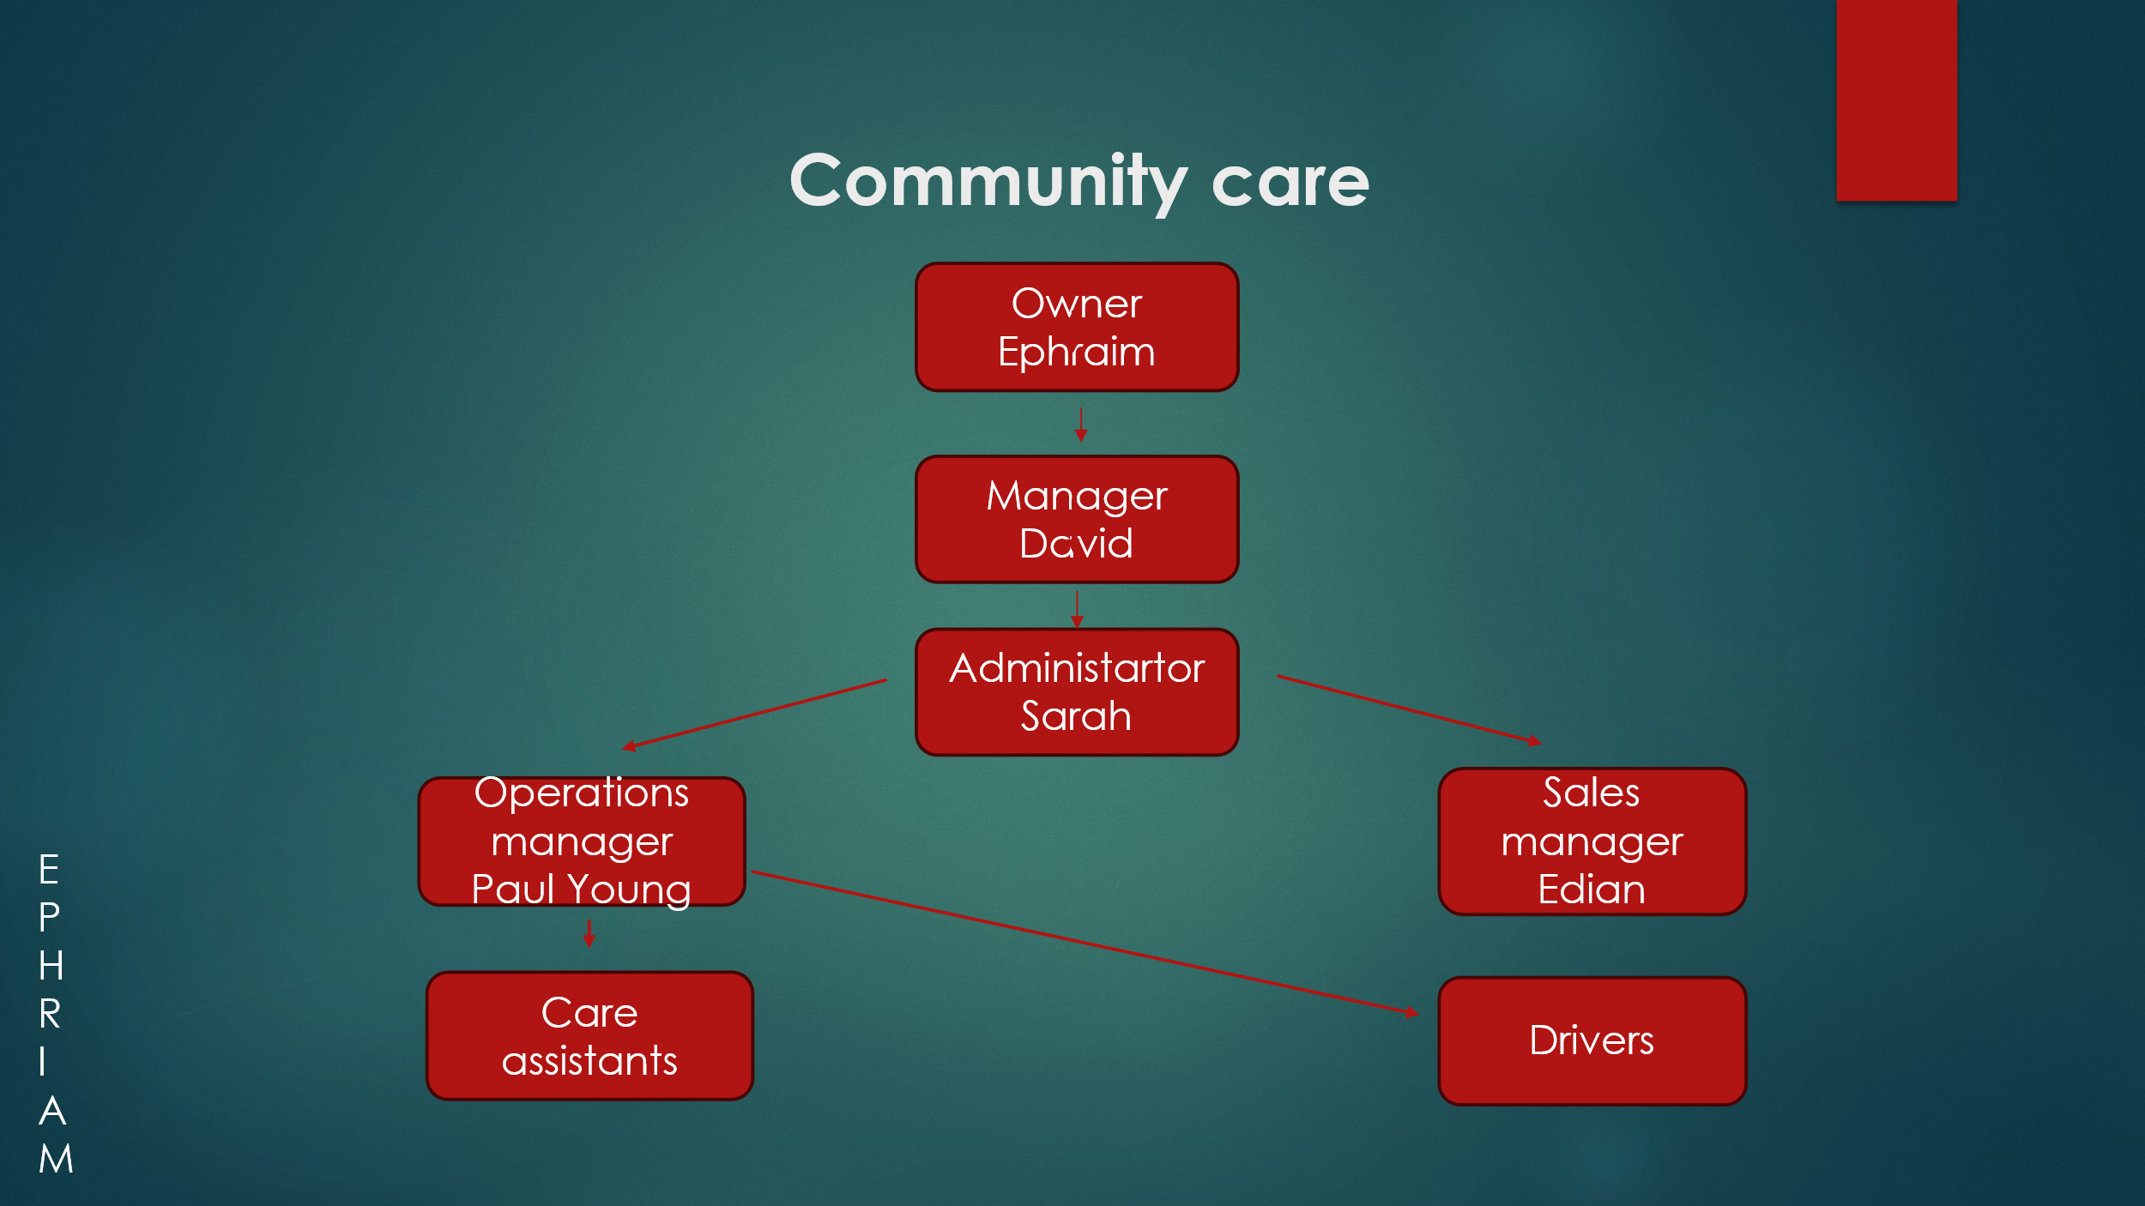

3. Market Research
A PESTEL analysis shows that Community Care is entering a demanding but viable market. Politically, adult social care remains under pressure despite increase in government funding to the NHS. Local authorities, NHS discharge teams and independent providers increasingly need to cooperate to support people at home. This creates opportunities for community-based agencies. However, underfunding may lead to low contract prices, so Community Care should avoid over-reliance on local authority work.
Economically, the main pressures will be wage inflation, employer costs, insurance, fuel, training, software and compliance. Recruitment is a major risk. Skills for Care (2025) reported that domiciliary care had a 9.7% vacancy rate in 2024/25, the highest among the main adult social care service types. Community Care should offer predictable hours, paid travel time, supervision, progression and respect, rather than competing only through basic pay.
Socially, ageing, disability, loneliness and family work increase demand for reliable home care. Clients and relatives will expect dignity, punctuality, sustainability, and understanding of individual routines. This is especially important in dementia care. Leverton et al. (2021) found that homecare workers supporting people living with dementia need training, relationship-building, consistent scheduling and managerial support. Community Care will therefore use small local teams and dementia training.
Technologically, the business will use electronic care plans, digital medication records, rota software and family updates. These systems can reduce duplicate paperwork and improve communication. Healey et al. (2024) show that digitalisation is important for UK homecare providers, although implementation must be practical. Community Care will retain telephone and printed options for digitally excluded clients.
Environmentally, the business will reduce waste through paperless records, route optimisation, recycling, suitable virtual training and gradual use of hybrid or electric supervisor vehicles. Local recruitment will reduce travel distances and support the community. Care packages will be accepted within a controlled radius.
Legally, Community Care must comply with the Health and Social Care Act 2008, CQC requirements, safeguarding duties, GDPR, health and safety, right-to-work checks, enhanced DBS checks and employment law to provide clear guidance protecting workers.
Benchmark competitors include Home Instead, Bluebird Care and Helping Hands. These providers are well-established with strong systems and marketing resources. However, even national brands differ between branches, so clients may still experience gaps in continuity, local relationships, flexibility or communication. Community Care’s weakness is its lack of track record. Still, it differentiates itself through dependable local carers, transparent communication, dementia and Alzheimer’s training, sustainable route planning, and free support for unpaid carers.
4. Marketing Communications
Community Care's marketing communications are guided by the 7Ps marketing mix. Kotler and Armstrong (2021) argue that effective marketing creates customer value and long-term relationships, important in domiciliary care where choice is influenced by trust and reputation.
The product includes regulated personal care and home support, medication assistance, meal preparation, companionship, domestic support, dementia care, respite care, recovery support and end-of-life care. Each client receives an initial and risk assessment then personalised care plan. Continuity of carers will be prioritised to encourage familiarity and consistency.
Pricing will be competitive and benchmarked against local providers. Charges for evenings, weekends, bank holidays or specialist services will be communicated before care begins, ensuring transparency for clients and support networks.
Place refers to care delivered in clients' homes across Newham within a controlled operating radius, improving punctuality, reducing unnecessary travel and supporting efficient scheduling.
Promotion will focus on healthcare referrals, community partnerships, social media and online presence. A website, Google Business Profile, Facebook page and local search advertising will improve visibility, while links with GP practices, pharmacies, hospital discharge teams, social workers and community organisations should generate trusted referrals.
Process will include enquiry handling, home and risk assessments, carer matching, electronic visit records, medication records where required, family updates and quality reviews.
Physical evidence will include uniforms, identity badges, branded documentation and published Care Quality Commission inspection reports once available.
People are central to the business. All carers will complete enhanced DBS checks, Care Certificate induction and training in safeguarding and dementia care, supported by supervision and performance reviews. Processes will include quality reviews, enquiry handling, home assessments, care planning, medication and electronic records where required.
Marketing effectiveness will be monitored through enquiries, referrals, conversion rates, client retention, satisfaction and missed visits.

5. Finances
Community Care requires £22,576 in start-up funding to establish the business and cover its first month of operations. Funding will comprise £7,000 owner investment, a £5,576 commercial bank loan and a £10,000 Start Up Loan.
The owner's investment shows commitment while reducing reliance on borrowing. The commercial bank loan will fund essential equipment, technology and working capital. The £10,000 Start Up Loan will support initial operating costs and spread financial risk. Combining personal and external finance provides sufficient capital while keeping borrowing manageable.
The estimated start-up costs for the first month of operations are shown in Table 1.
Table 1. Estimated First-Month Start-up Costs
Expense | Estimated Cost (£)
CQC registration and compliance preparation | 2,500
Office rent and deposit | 1,200
Insurance | 800
IT equipment and care management software | 2,500
Website development | 1,000
Initial marketing | 1,500
Recruitment, advertising and enhanced DBS checks | 3,000
Staff uniforms and care equipment | 2,000
Office furniture and equipment | 2,000
Working capital | 4,076
Total Start-up Funding Required | 22,576

Fixed Cost | M1 (£) | M2 (£) | M3 (£) | M4 (£) | M5 (£) | M6 (£)
Office Rent | 1,200 | 1,200 | 1,200 | 1,200 | 1,200 | 1,200
Care Management Software | 300 | 300 | 300 | 300 | 300 | 300
Telephone & Internet | 150 | 150 | 150 | 150 | 150 | 150
Utilities | 150 | 150 | 150 | 150 | 150 | 150
Insurance (Monthly Equivalent) | 67 | 67 | 67 | 67 | 67 | 67
Total Fixed Costs | 1,867 | 1,867 | 1,867 | 1,867 | 1,867 | 1,867

Variable Cost | M1 (£) | M2 (£) | M3 (£) | M4 (£) | M5 (£) | M6 (£)
Care Staff Wages | 3,500 | 5,500 | 8,000 | 10,500 | 12,500 | 14,500
Recruitment & Advertising | 800 | 600 | 400 | 300 | 300 | 300
Fuel & Travel | 500 | 700 | 900 | 1,100 | 1,300 | 1,500
Consumables/PPE | 250 | 350 | 450 | 550 | 650 | 750
Office & Cleaning Supplies | 150 | 175 | 200 | 225 | 250 | 275
Staff Training | 300 | 200 | 200 | 200 | 250 | 250
Total Variable Costs | 5,500 | 7,525 | 10,150 | 12,875 | 15,250 | 17,575

Financial Forecast/Projections
Item | M 1 (£) | M 2 (£) | M 3 (£) | M 4 (£) | M 5 (£) | M 6 (£)
Total Fixed Costs | 1,867 | 1,867 | 1,867 | 1,867 | 1,867 | 1,867
Total Variable Costs | 5,500 | 7,525 | 10,150 | 12,875 | 15,250 | 17575
Total Costs | 7,367 | 9,392 | 12,017 | 14,742 | 17,117 | 19,442
Projected Revenue | 5,000 | 8,200 | 11,500 | 14,900 | 18,700 | 21,400
Profit/(Loss) | -2,367 | -1,192 | -517 | 158 | 1,583 | 1958

Investment Capital: £18,500+£2,367+£1,192+£517= £22,576

Positive cash flow will be essential in year one. Burns (2022) argues that start-ups often underestimate operating costs and working capital needs, reducing viability. Community Care will therefore grow gradually, recruit according to client demand and review cash flow monthly.
This funding structure balances owner commitment with external finance. As client numbers increase, income from billable care hours is expected to cover operating costs, support loan repayments and provide a sustainable basis for growth.

6. Conclusion
Community Care is well-placed to meet the growing demand for high-quality domiciliary care within the London Borough of Newham. An ageing population, increasing pressure on health and social care services and a preference for home-based support create favourable market conditions. If supported by a clear marketing strategy, a realistic funding plan and commitment to person-centred care, the business has the potential to establish a trusted local reputation. Long-term success will depend on achieving CQC registration, maintaining high standards of care, retaining a skilled workforce and managing cash flow effectively.

References
Burns, P. (2022) Entrepreneurship and small business: start-up, growth and maturity. 5th edn. London: Bloomsbury Publishing.
Care Quality Commission (2026) Register as a provider. Available at: https://www.cqc.org.uk/guidance-providers/registration/register-provider (Accessed: 14 July 2026).
Healey, J., Davey, V., Liddle, J., O’Rourke, G., Hanratty, B. and Beresford, B. (2024) ‘UK homecare providers’ views about, and experiences of, digitalisation: A national survey’, Digital Health, 10.
Kotler, P. and Armstrong, G. (2021) Principles of marketing. 18th edn. Harlow: Pearson.
Leverton, M. et al. (2021) ‘“You can’t just put somebody in a situation with no armour”: An ethnographic exploration of the training and support needs of homecare workers caring for people living with dementia’, Dementia, 20(8), pp. 2982–3005.
Office for National Statistics (2026) National population projections: 2024-based. Available at: https://www.ons.gov.uk/peoplepopulationandcommunity/populationandmigration/populationprojections (Accessed: 14 July 2026).
Skills for Care (2025) The state of the adult social care sector and workforce in England 2025: executive summary. Leeds: Skills for Care.

