RESEARCH REPORT



  - INTRODUCTION
Creative and systematic activity undertaken to enhance the reservoir of knowledge" is what research is defined as. It entails gathering, organising, and analysing data in order to gain a better knowledge of a topic or issue. A research project could be a continuation of previous work in the topic. Research may repeat portions of previous projects or the entire project to assess the validity of instruments, processes, or experiments.
The tactics, processes, or techniques used in the collecting of data or evidence for analysis in order to uncover new knowledge or get a better understanding of a topic are known as research methods.
There are various sorts of research procedures that employ various data collection instruments.
The development of your research methodology is an important aspect of your study plan. There are two major decisions to be made while planning your tactics.
Decide how you'll collect data first. The type of data you require to answer your research topic will determine your methods:

Will your data be in the form of words or numbers? Qualitative vs. quantitative
Primary vs. secondary data: Will you acquire your own data or will you rely on data that has already been collected?
Descriptive vs. experimental: Will you measure something exactly as it is, or will you do an experiment?
Second, make a decision about how you'll examine the data.
To test correlations between variables with quantitative data, statistical analysis approaches can be used.
To interpret patterns and meanings in qualitative data, you can utilise approaches like thematic analysis.

Methods for collecting data

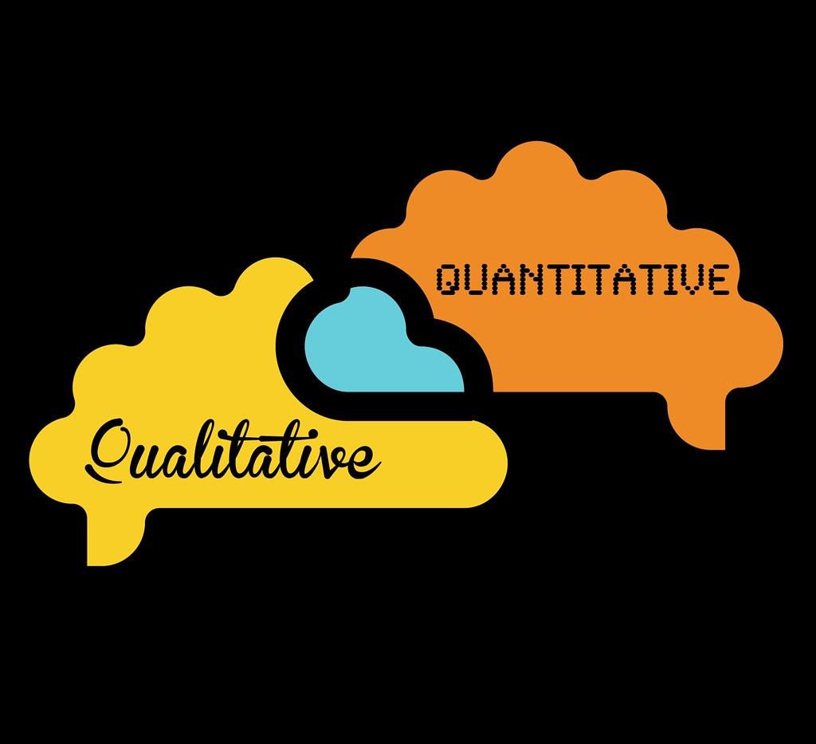

The information you collect to answer your research topic is referred to as data. The sort of data you require is determined by the objectives of your study.
  - Qualitative vs. quantitative data
The type of information you wish to develop will determine whether you collect qualitative or quantitative data.

Collect qualitative data to answer questions about ideas, experiences, and meanings, or to examine anything that can't be stated statistically.

Collect quantitative data if you wish to build a better mechanistic grasp of a topic or if your research involves hypothesis testing.

PROS CONS
Qualitative | 1)Flexible-You can adjust your methods periodically as you obtain new knowledge.  2) Can be conducted with small samples. | 1) Cannot be statistically studied or extrapolated to larger populations.  2) Standardization of research is difficult.
Quantitative | - It can be used to describe enormous collections of items in a methodical way.  - Generates repeatable information. | - Analysing data necessitates statistical training.  - Larger samples are required.

You can also utilise both qualitative and quantitative research approaches in a mixed methodologies approach.

  - Primary vs. secondary data
Any original information that you acquire for the purpose of addressing your research question is referred to as primary data Information that has already been gathered by other researchers is referred to as secondary data.
PROS CONS
Primary | - Can be gathered to answer a particular study issue.  - The sampling and measuring procedures are under your control. | 1) Collecting is more expensive and time-consuming.  2)Training in data gathering methodologies is required.
Secondary | 1) Accessible in a more convenient and timely manner.  2)You can collect data over longer timeframes and from a wider geographic area. | 1) There was no way to govern how the data was generated.  2)Extra processing is required to ensure that it is suitable for your analysis.

  - Descriptive vs. experimental data

You acquire data about your study subject without intervening in descriptive research. Your sample procedure will determine the validity of your study.
You methodically intervene in a process and measure the outcome in experimental research. Your experimental design will determine the validity of your findings.
You must be able to change your independent variable, properly measure your dependent variable, and adjust for confounding variables in order to conduct an experiment. This method is the greatest choice for answering issues regarding causation and effect if it is both realistic and ethically possible.

PROS CONS
Descriptive | 1) Allows you to describe your study topic without affecting it in any way.  2)Accessible - on a broader scale, you can collect more data. | 1) There is no way to control confounding variables.  2)Cause and effect correlations are impossible to establish.
Experimental | 1) Confounding variables are more under your control.  2)Possess the ability to construct cause-and-effect linkages. | 1) You might have an unanticipated impact on your research subject.  2)Data collection usually necessitates more knowledge and resources.

Before composing a study result section, double-check that you've used the correct data. It's all about following the appropriate steps when collecting data for study.
1st step: Interviews are a common method for gathering qualitative data. They can take place either in person or over the phone. These meetings might be official and structured, or they can be casual and unstructured. This will be determined by the topic and scope of your study. If you're conducting research through interviews, make sure your questions are clear. To ensure the success of your strategy, encourage others to speak their thoughts.
2nd step: Questionnaires are used to collect both qualitative and quantitative data. To make your findings easier to interpret, use a scale to assign a numerical value. Questionnaires can integrate the two sorts of data you collect while you work on your project. The outcomes are usually simple to comprehend and interpret.
3rd step: Using your personal observations is one of the ways to compose a research paper quickly. Qualitative data can be collected with the help of observations. They're frequently utilised to decipher and analyse a pattern or behaviour. Documenting observations is one of the most important things that any student should undertake. It's not feasible to rely on your recollection. To record your findings, you can utilise papers or films.
4thstep: Focus groups can aid in the analysis of various behavioural patterns. Focus groups might be utilised in science experiments or in psychology classes. A focus group is a collection of people who share a common interest in order to collect and categorise data. Make sure you preserve detailed records of your focus group's responses.
5th step: Case studies are investigations into a single problem or event. To compile meaningful qualitative and quantitative findings, you can employ surveys, questionnaires, and interviews. You can also help by reviewing existing case studies to demonstrate the validity of your hypothesis.
6th step: Ethnography is the study of cultural differences via observation and analysis, and it is frequently used in sociology projects. It all comes down to seeing people in their natural environments. Focus on being objective if you want to accomplish it correctly. You should be accepting of other people's differences.
7th step: Examining documents and previous records for relevant information for your assignment is an excellent approach to start. This is a low-cost method of gathering data, but you shouldn't put too much faith in the results. You must ensure that the information you utilise is current and useful.
  - CRAAP test
The abbreviation CRAAP stands for Context, Relevance, Authority, Accuracy, and Purpose. To analyse your sources, use the CRAAP Test.
It's tempting to include any source in your work that appears to support your argument, but keep in mind that not all information is useful, especially in an online world.
CURRENCY:
The timeliness of the information is referred to as currency.
When was the information released or made public?
Is the information correct and up to date?
Is the material relevant to your issue current or out-of-date?
Are the hyperlinks working?
RELEVANCE:
Relevance refers to how important the information is to your needs.
Is the information relevant to your topic or does it provide a solution to your question?
Who is the target market?
Is the content at an adequate level for your needs?
Have you looked at a number of different sources before deciding on this one?
Do you think you could use this source in a research paper?
AUTHORITY:
The source of the information is referred to as the authority.
What is the name of the author, publisher, source, or sponsor?
Are the author's credentials or affiliations with organisations listed?
What are the author's credentials or affiliations with organisations?
What qualifications does the author have to write on the subject?
Is there any contact information, such as an e-mail address or a publisher?
Is there any information about the author or source in the URL?
ACCURACY:
Accuracy refers to the content's dependability, veracity, and correctness.
What is the source of the information?
Is the information backed up by proof?
Has the data been peer-reviewed or vetted?
Can you corroborate any of the facts with another source or personal knowledge?
Does the language or tone appear to be skewed and emotionless?
Are there any typographical, grammatical, or spelling errors?
PURPOSE:
The reason for the information's existence is its purpose.
What is the information's purpose? to educate, market, entertain, or persuade?
Do the authors/sponsors make it clear what their ambitions or goals are?
Is the information true, false, or propaganda?
Is the point of view perceived to be neutral and impartial?
Are there any personal, political, ideological, cultural, religious, or institutional biases?

  - Boolean search
By using Boolean Search Operators or Modifiers, you can widen, limit, and define your search options. You'll be able to uncover profiles and candidates that are more closely aligned with your needs using Boolean Search Operators.
To find what you're looking for more accurately, use the Boolean operators and, or, and not between terms. And joins terms together, ensuring that each search result includes all of your terms. Or will check for any of your terms, ensuring that at least one of them appears in each search result. Before a search phrase you want to exclude from your results, type not.

  - How to write a research report
Finally, as I learned in a course on digital skills and research methodologies at the University of Wales Trinity St. David, I'd like to describe how to create a research report:
FIND A TOPIC | LOOK FOR SOURCES | ORGANIZE YOUR IDEAS | WRITE A FIRST DRAFT | PROOFREAD AND REVISE
Think of an interesting topic | Gather information (school library, google scholar) | Use a writing web to sort ideas | Create an interesting introduction | Check for spelling and grammar errors
Brainstorm question about the topic | Take notes | Use note card; organize by same ideas | Build paragraphs to support main ideas | Correct mistakes and rewrite
Group similar question together | Record your sources for the bibliography | Write an outline | Summarize with a conclusion
 | Avoid plagiarism |  | Reference sources in bibliography

  - Conclusion
Innovation means making a long-term commitment.
Almost every sector on the earth where we live has used innovation in their project to improve their outcome; the benefits of innovation are undeniably obvious.
There has been minimal improvement in the educational system, which explains why there has been little application of innovation in understudy learning.
The reason for the limited usage of innovation has been a lack of sufficient evidence to explain whether innovation, presuming it is used in understudy learning, has any effect.
There are distinguishing features associated with this investigation.
The various training partners have long pondered whether investing resources in innovation in learning establishments is the best thing to accomplish in the endeavour of further growing the learning framework.
This research has compiled data from various sources to demonstrate that the work of innovation in the learning framework has a significant impact on the students' learning process.

  - References list
Published since 2003
ISSN 1542-4448 (print), ISSN 2157-8893 (online)
The Journal of Business & Economics Research (JBER) welcomes articles in all areas of business and economics
Book Research Methods By David Crowther, Geoff Lancaster 2012

