
Skills for the Workplace
Module Assignment Submission
Student Name: | 2025488
Student Number: | Medi-Bethan Williams
Module No: | BMSK4008
Module Title: | Academic and Research Skills

Statement of Confirmation of Authenticity
By the act of making this submission, the student declares that this is the work of the student named above. The work has not, in whole or in part, been knowingly presented elsewhere for assessment, or where assessment has been built on a previous assessment, this has been identified. Where materials have been used from other sources it has been properly acknowledged. If this statement is untrue, the student acknowledges that an assessment offence has been committed.
Attention is drawn to the plagiarism and unfair practice policies of both the University and of ILM.
Permission for ILM to use this script
ILM uses learners’ submissions – on an anonymous basis – for assessment standardisation. By submitting, both the centre and the learner agree that ILM may use this script on condition that identifying information is removed. However, if you are unwilling to allow ILM use this script, please refuse by ticking the box: □

Table of Contents
Managing Remotely: Is it the Way Forward? 3
Part 1 3
1.1 Introduction 3
1.2 Research 3
1.3 Findings 5
1.4 Conclusion 6
Part 2 7
Personal Reflection on Managing Remotely 7
2.1 Description 7
2.2 Feelings 9
2.3 Evaluation 9
2.4 Analysis 10
2.5 Conclusion 11
References 12
Appendix A 14
Appendix B 15
Appendix C 17
Appendix D 18

Managing Remotely: Is it the Way Forward?

Part 1

Introduction

This report concentrates on agile working, managing remotely and the factors that impact upon it. The author will evaluate and analyse research undertaken, drawing their own conclusion from the information gathered. 2020 created a significant change to the way in which people deliver a service due to the global pandemic Covid 19 and how staff and teams are managed. Where once in a centralised location, in a department or building, it has now evolved to creating a possibility of global recruitment and management remotely.
Researching areas that impact on managing remotely and its potential for the future and transforming the working practice, the author undertook a comprehensive review taking into account the practicalities, infrastructure costs, wellbeing of staff, technology and the viability of it being possible for the way forward.

Research

De Lucas Ancillo, et.al (2020) stated how Covid 19 has brought adjustments to the way organisations within businesses must change, how they operate along with their settings and workplace environments and also how Covid 19 has brought unparalleled challenges. The article continues to indicate how Covid 19 exposes weaknesses and issues, specifically with roles that involve face to face interaction. It emphasises the geographical status of an employee and how they can work closer to family members whilst operating at home and therefore reducing travel.
Gill also identifies how this can often unstable employees’ identity and relationships with peers without being in a workplace setting. (Gill, 2019).
Furthermore, PricewaterhouseCoopers (PwC) concur that Covid 19 has changed people’s situations radically since March 2020, attributing to workplace change rationale. PwC (2020).
According to (Lowe, 1995). Companies need to base their business on evolving and being entrepreneurial. In several organisations prior to Covid 19, this would have been perceived as innovation and entrepreneurial behaviour. Additionally, 30% of real estate costs can be saved, for example, accommodation, rent and travel.
An evaluation of job specific roles, with 800 corporate executives was conducted by McKinsey & Company, based on how the potential of remote working varied, dependent on physical, spatial or interpersonal context. McKinsey & Company (2020). The practicality of daily activities was assessed and clearly identified through resources needed to carry out the function of their role. Whilst it was noted that manual, location-based machinery or equipment may hinder the ability to work remotely, there was a contrast where information gathering, and processing could be carried out.
Furthermore, it was identified that 20% of workforce could flexibly work remotely for a proportion of their working week. This equates to three quarters as many people working agilely than before the pandemic: impacting on economy, transport and spending.
As highlighted, a positive aspect of remote working is cost savings, in respect of travel and subsistence, equipment, lighting and heating of a permanent office.
The article states that following the pandemic only 39% expect their employees to work more than two or three days remotely. This is depicted in Appendix A, Figure 1, based on activity related work and also job roles, which can be performed remotely.
Forbes (2020) evaluates the impact on individuals working remotely and how the pandemic has increased stress and anxiety. Areas identified as contributory factors are:-
- 4/5 staff unable to switch off in the evenings
- 45% indicating they are mentally less healthy
- 50% say they are encountering interrupted sleep due to Covid 19
Within the survey carried out under this research almost all respondents highlighted the importance of companies prioritising employee’s mental health. The research quotes Marilyn Tyfting, Chief Corporate Officer at Telus, an organisation with 50,000 employees “We recognise that our responsibility as employers extends to modelling the healthy behaviours we want to inspire in our team members, such as taking days off to recharge and sharing our own feelings and the challenges we may be facing as fellow human beings so that they are comfortable approaching leadership for help”. (Tyfting, 2020).
Forbes (2020) alludes to two concerning factors whilst working remotely; isolation and burnout. The article indicates that a change for those who are used to social interaction and conventional settings, may see deterioration in mental health, which can be encountered from loneliness and burnout, due to people working longer hours. It concludes by offering simple steps to avoid the impact of these factors, for example, switching off emails before and after working hours.
CIPD.Co.UK (2020) outline key factors that can be implemented to ease the transition into remote working. It advises on setting up designated work-spaces to create an atmosphere that is a work setting within your own home, thus creating a focused environment to allow for less distraction. The article also recommends ensuring that satisfactory digital technology is in place, such as secure internet connectivity with applicable remote access to company networks. Vitally it also acknowledged the need to step away from the workspace, having clear set timetabling of hours. Clear communication lines should be created to ensure employees have clear and concise instruction as virtual meetings can impersonalise information that would otherwise come with face to face meetings.
According to (Forbes 2021), findings indicate a 34% drop in peer–to–peer recognition for those recruited during the period of lockdown, in comparison with that measured in 2019. The article refers to researcher Brook C. Holtom and his viewpoint that poor performance may prove more difficult to identify whilst working remotely, due to creditable observations being harder to detect via technology. Furthermore, a new employee may encounter anonymity during remote working and may feel detached from organisations values. He suggests ways that a manager may overcome these employee issues, by offering communication guidance and posing strategic questions to support the team member, which creates a personalised approach and assures the employee that they are a contributory and valued team member.
This is harmoniously reflected in an article in The Guardian (2020) where it is indicated not to be overconfident of the relayed apparent productivity gains from remote working. The article refers to a comment made by Satya Nadella, Microsoft's CEO, where she had recently told the New York times of how the personal and physicality of talking and meeting is something that they themselves personally miss.
The article refers to organisations learning from the pandemic and the need for organisations to adopt a work from home policy which can support the individuals need for flexibility and job satisfaction.
The author undertook a workplace questionnaire in order to evaluate the team in which she manages remotely. This was to establish the employees experience of agile working and being managed remotely. The results are discussed in section 1.3.

Findings

The author can empathise with the findings of their research, however, draws on several conflicting messages conveyed. Whilst generally the findings show that managing remotely can be done, there may be roles within organisations where this would not be an option, such as roles that require face to face delivery. The author feels that whilst there are areas of progression to working and managing remotely, it is disheartening to know that some organisations may never fully be remote or agile working, despite the evidence showing the cost savings that can be created through remote working.
The author understands why organisations choose to only work through an online methodology, as this means outlay would be minimum and greater return on profit. The author also understands the savings within her own self through reduction in costs travelling to and from the workplace.
Consciously the author recognises the research clearly identified times when employees may have increased mental health through anxiety and stress. This can be attributed to loneliness, isolation and stress where the employee needs to understand and maintain the boundaries of working hours to avoid such factors. Therefore, the author feels the article attributing key factors to implement, in managing remotely, is to ensure a workplace is distinguished within the household setting and clear guide on communication as well as the timetabling of set hours, will be practical and useful.
Whilst the research underpins the ability to enhance global recruitment and manage teams remotely from various locations, the author depicts this as not the route for their team. It has been found that it invariably leads to high trust in staff undertaking their tasks, managing deadlines and meeting the manager’s expectations of fulfilling their day to day activities. As indicated in one article researched, there can be leniency in the flexibility of working remotely, through a flexible working application, which the author feels can be implemented in her own workplace.
Reviewing the questionnaire results in Appendix B, which was undertaken to evaluate the authors own workforce and their experience of agile working and being managed remotely over the last twelve months. The data shows that only 50% feel more productive with 44% indicating a level of difficulty in working alongside their home environment. 72% acknowledge the correct resources had been implemented in order to complete their day to day tasks and a further 89% feel their manager was available to advise, guide and instruct.

1.4 Conclusion

In conclusion the author can relate and implement a number of the elements of the research into their day to day practices, embedding them as best practice to support and develop both themselves and her team to manage remote working.
After Covid 19, the author recognises that there may be conflict with those who have become accustomed to working from home, in returning to the workplace. However, the authors own survey sees 66.7% of her workforce wanting to return to a centralised location.
One consideration the author would undertake would be the development of a flexible working request form. This form is analysed and reviewed by the line manager and subsequently sent for approval to Human Resources.
It is necessary for the line manager to evaluate the request form to ascertain whether it is a viable option for both the employee and the company and whether the employees’ role justifies remote working with deadlines being achieved. This evaluation also fosters high levels of trust, actions and work ethos for both management and the employee under the context of remote working.
Strategically the new workplace is not known today, but a new variation has definitely emerged.

Part 2

Personal Reflection on Managing Remotely

The author utilised Gibbs(1988). reflective cycle model as a framework for reflective and critical thinking. Whilst not comprehensive it does allow for calibration of thoughts feelings and observations.

Gibbs, (1988) Learning by doing

2.1 Description

The author focuses on an educational setting and delivery of service within Gower Colleges External Funding Department and transformational changes undertaken by the External Funding Manager, necessary to continue to manage a large team effectively.
Presented with very little time to assess the departments’ requirements to work effectively and her own ability to manage remotely following the Government’s decision to enter into a period of lockdown. The Welsh Government gave advance notification to institutions two weeks prior to 20th March 2020 that they would be entering into a minimum of 3 months lockdown.
Reflecting on the review undertaken, the author understands the importance of ensuring that correct technology was made available to staff. Within the authors workplace, they undertook a gap analysis, see Appendix C, to establish the technological needs of the team to work remotely. The authors workplace made clear strict guidelines in respect of staff utilising their own equipment and it being prohibited due to confidential information and the General Data Protection Regulation (GDPR, 2018). The authors workplace undertook measures to ensure all staff had access to the colleges own equipment utilising funding that had been invested by Welsh Government. In particular, the Ed Tech funding which was announced for education by the Education Minister, Kirsty Williams (Gov.Wales 2019).
The author evaluated the team from perspectives of character, wellbeing, work ethic and home situations to determine management styles that would need to be implemented for effective productivity and staff wellbeing.
Douglas McGregor developed the authoritarian (Theory X) and participative (Theory Y) of leadership styles. According to McGregor “Most teams aren’t teams at all but merely collections of individual relationships with the boss. Each individual vying with the others for power, prestige and position”. McGregor (1960).
It was necessary for the author to utilise both styles in managing her teams and its staff to peer relationships. The author has capability to draw on each, depending on staff characters in order to achieve results. Whilst managing the Better Jobs Better Futures team, the use of a participative style of leadership was needed to support an inexperienced team, in contrast, the developed Skills for Industry team was managed in an authoritarian leadership style. Drawing the best out of each of the staff to ensure productive and timely meeting of deadlines and tasks was achieved.
The research items offered methodological ways in which to manage remotely with clear communication guidelines as an underlying key factor. Using software such as teams, the author can support staff with various queries and assistance. The software tool also offers a function to support team meetings through the calendar system which the author can access remotely. The author has embraced and embedded this within their own work practices to communicate with their teams by setting out clear meeting times which links to their team’s calendars. This gives the author’s team clear guidance on their expectation to attend. Setting out parameters of available contact hours and set meeting times created a focused and clear communication strategy, which was also populated into diary markers. The utilisation of the gap analysis had been implemented to safeguard the team’s ability to communicate through various digital technology such as Teams, Zoom etc by resourcing them with the relevant equipment to do so.
During the two week period the manager had instructed staff to scan all documentation they would need to process their work, making use of the digital technology available to them. This would mean functional day to day tasks could be carried out in preparation for project claims pending. All enrolment and eligibility documentation had been created in electronic format also for ease of working with participants and stakeholders remotely.
The implementation of tasks lists templates for the staff was implemented so that this could be monitored within their weekly meetings in order that the meetings stayed concise and to the point reassuring the manager that functions were being carried out as they would be in the normal day to day practice.
Considering staff wellbeing the Manager also factored in a “Get Together Thursday” meeting which was purely a wellbeing session which involved a quiz or game. Giving the staff time to enjoy the peer to peer conversations that would normally be undertaken within their workplace.

2.2 Feelings

The elements introduced to establish ease within managing remotely had created an environment which has augmented the author to have an ability to be reactive to the transformational change instilled upon them. With a greater lead time further structured plans could have broadened the depth of activity carried out throughout the first lockdown. However, key elements such as communication evidently worked well within that first lockdown but due to additional restrictions implemented by Welsh Government meant very few staff could return to the workplace at any one time therefore further measures would be needed to continue to deliver a seamless service provision.
The versatility of developing resources in an electronic format meant that the department was well prepared for what the challenge of lockdown may bring upon them and reassured the manager that any tasks outlines to the teams would be able to be carried out effectively.

2.3 Evaluation

Managing the team remotely had been an operational success. With 22 staff and 24 projects to oversee, the author was able to instruct, guide and advise staff in the manner that would be reflective of a central work based office environment. Team meetings were structured and concise, the creation of specific tasks list allowed for the author to manage staff in meetings concisely and effectively.
Tasks were reviewed weekly and adjusted according to priority which worked to support the team effectively and keep them updated on any strategic change in direction.
Establishing the correct managerial styles enabled the Manager to undertake her role of managing remotely with ease. However, invariably staff felt able to contact for meetings through Microsoft Teams and whilst this was out of the structured meetings set, it was important to undertake for reassurance to staff and show that they were valued and that even whilst working remotely that support with queries or advice was available. The Manager recognised some staff were struggling with the home working scenario and therefore knew that there was greater demand in some teams for additional support.

2.4 Analysis

Understanding the molecular structure of all components of the jigsaw to make the day to day functionality of the department fluid and complete to ensure work was being carried out and deadlines met, was predominantly of high importance to the Manager. Ensuring the correct tools, communication strategy was clear and conveyed, was the pivotal point in allowing remote managing to work.
There was great emphasis in this instance on levels of trust within her team that work was being carried out at both the professional level and administrative excellence expected of the staff. In some cases, this was invariably weaker with some staff who, as the Manager’s survey indicates, found remote working more difficult in the home environment. This can be attributed to a numerous factors within the team, such as home schooling and key worker responsibility for other members of the household, which meant that they would need to change their working pattern to compensate. This was seen with an employee whose spouse was contracted within the NHS and working nights at front line, resulting in them having to accommodate childcare, home schooling etc due to the sleeping pattern of the spouse. This was just one of the examples the manager had to allow compensation for.
Subsequently, the Manager, on numerous occasions had to undertake longer working hours to enable her own tasks to be completed.
Following the initial lockdown experience, the Manager undertook an action plan see Appendix D to creating a proactive and robust approach should the situation arise again implementing such action will overcome any challenges faced in accessing relevant documentation which are currently in paper format which may hinder departments function within its functionality amongst the college. The primary aims to process financial and participant data to establish financial claim and audits requirements to meet the funder’s specific criteria.

2.5 Conclusion

Though the Manager was catapulted into remote managing at short notice, the measures implemented through undertaking a gap analysis, resourcing the staff with the correct digital technology and ensuring all documentation was available in digital format contributed to the success.
On the whole as indicated in the staff survey, the overall remote managing delivery was evidenced as being undertaken successfully from the staff perspective, reassuring the Manager that she had been an effective leader in Managing Remotely.
Recognition must also go to that staff for their commitment and diligence in adapting to the new method of working.
Success was measured by the External Funding Unit successfully meeting claim submissions of over three million pound, the undertaking of five completed Welsh European Funding Office audits as well as two European Funding Audit Team checks.

References

Books
Gibbs, G. (1988) Learning by doing; A guide to teaching and learning methods. London: FEU
McGregor.D. (1960). The Human Side of Enterprise. McGraw-Hill

Journals
Gill, M. J. (2019). ‘The significance of suffering in organizations: Understanding variation in workers’ responses to multiple modes of control’. Academy of Management Review , Volume 44 (2), pp.377–404.
Lowe, A. (1995). ‘The basic social processes of entrepreneurial innovation. International Journal of Entrepreneurial Behavior & Research’, Volume 1 (2), pp.54–76.

Websites

CIPD.Co.UK (2020) Getting the most from remote working. Available at: Getting the most from remote working | Guides | CIPD (Accessed 24 March 2021)
De Lucas Ancillo. A., Del Val Núñez., M.T. & Gavrila. S.G. (2020) Workplace change within the COVID-19 context: a grounded theory approach. Available at: https://www.tandfonline.com/doi/full/10.1080/1331677X.2020.1862689 (Accessed: 24 March 2021).
Forbes (2020). Mental health and remote work. Available at: https://www.forbes.com/sites/chriswestfall/2020/10/08/mental-health-leadership-survey-reveals-80-of-remote-workers-would-quit-their-jobs-for-this (Accessed 24 March 2021)
Forbes (2020). When home becomes the workplace. Available at: https://www.forbes.com/sites/onemind/2020/03/17/when-home-becomes-the-workplace-mental-health-and-remote-work/ (Accessed 24 March 2021)
Forbes (2021) Employees hired remotely in 2020 say they are doing fine. The data says not really.
Available at: https://www.forbes.com/sites/markcperna/2021/02/16/employees-hired-remotely-in-2020-say-theyre-doing-fine-the-data-says-not-really (Accessed:10 March 2021)

GDPR (2018) General Data Protection Regulation. Available at: https://gdpr-info.eu (Accessed:5 March 2021)

Government Wales, (2019). New £50 million investment. Available at: https://gov.wales/computer-says-yes-new-ps50-million-investment. Accessed:5 March 2021)

McKinsey & Company (2020). Whats next for remote working. Available at: https://www.mckinsey.com/featured-insights/future-of-work/whats-next-for-remote-work-an-analysis-of-2000-tasks-800-jobs-and-nine-countries (Accessed 22 March 2021)
McKinsey & Company. (2020). Reimagining the Office and Work Life After COVID-19.. Available at: https://www.mckinsey.com/business-functions/organization/our-insights/reimagining-the-office-and-work-life-after-covid-19 (Accessed 22 March 2021)
PricewaterhouseCoopers . (2020a). COVID-19: Impacts on business. Available at: https://www.pwc.com/gx/en/issues/crisis-solutions/covid-19.html (Accessed: 24 March 2021).
The Guardian (2020). were-not-all-going-to-be-working-from-home-nor-should-we-heres-why
Available at: https://amp.theguardian.com/business/2020/jun/11/were-not-all-going-to-be-working-from-home-nor-should-we-heres-why
(Accessed:10 March 2021).

Appendix A

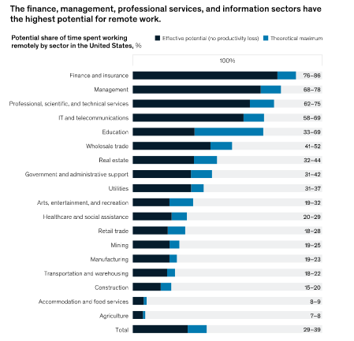
Figure 1 - Whats next for remote working

Appendix B
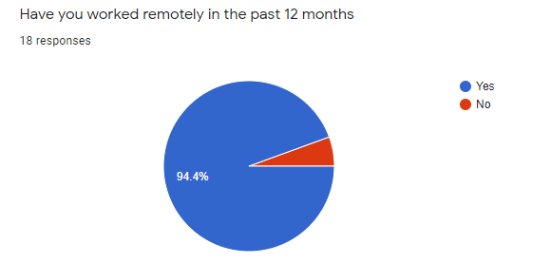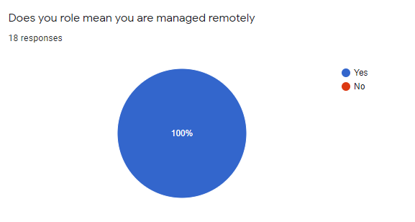

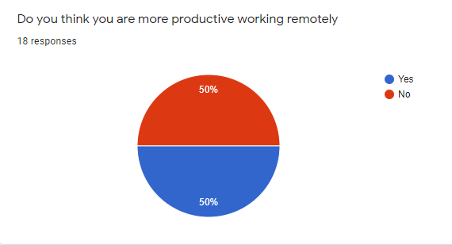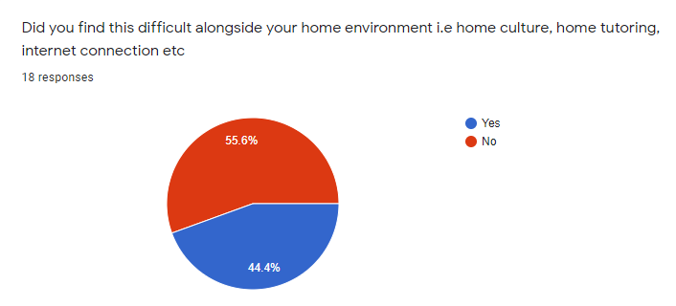

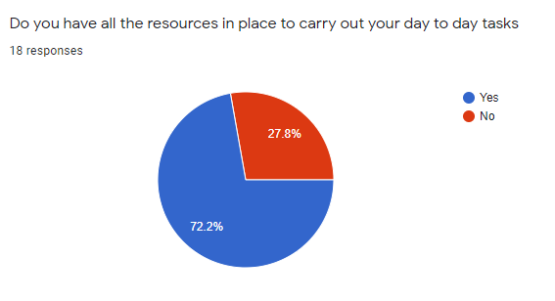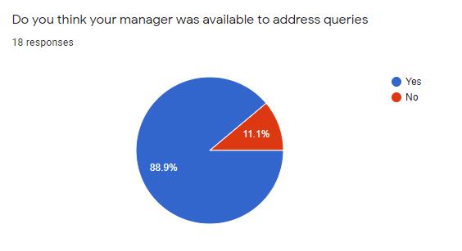

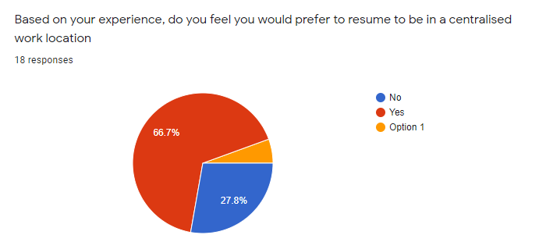

Appendix C
Gap analysis
Objective | Current Position | Deficiency | Action
What do I want to do | What can I already do | What am I lacking | How can I fix this?
Regular Team meetings | Face to Face fortnightly project team meetings | Greater contact to ensure wellbeing and address any issues arising | Set times for each project team meetings
Clear tasks and deadlines | Set out tasks and monitor throughout the day/week | Clear written task lists for each team | Develop a task list template setting clear deadline and when I need to have them returned to monitor completion
Make sure staff have access to relevant equipment | Staff have access to PC’s within the department | Evaluate staff equipment and need | Circulate a document that captures the digital devices staff have access to or need
Clear forms of communication | Use of shared documents | Software for all to communicate remotely | Report requirements to IT department so that software is accessible to all staff
Create a timetable of communication times | Set out times in the day/week | Knowing staff home environment and lifestyles | Speak to staff to establish working patterns
Ensure staff well being | Takeaway Thursday (where staff stop at lunch and take time to switch off from the work pressures) | Staff not in one location | Set a regular time and day for staff get together/social break and downtime from the busy work environment
Paper documentation is available | Access the office audit files | Computerised format of documentation | Scan relevant documents so staff can access and complete claim deadlines and tasks

Appendix D
Action Plan
Objectives | Tasks | Success Criteria | Time Frame | Resources
Goals | What does the department need to achieve this | Outcomes | Deadlines | Additional support/equipment etc
Electronic Versions of paperwork | Develop electronic versions of participant documentation | Full suite of documentation complete and translated for all projects | 1 month | IT department and reprographics
Central financial network file for collaborative access | Authorisation from both departments and a protected file | File Created | 2 weeks | IT department, finance director authorisation and External Funding Manager authorisation
Centralised Payroll information file | Authorisation from both departments and a protected file | File Created | 2 weeks | Payroll department  authorisation and External Funding Manager authorisation
Centralised HR information file | Authorisation from both departments and a protected file | File Created | 2 weeks | HR department  authorisation and External Funding Manager authorisation
Remote Network access for all staff | Work with IT for all PC’s to be allocated to relevant staff | Staff check access routes | 2 weeks | External Funding Manager permission and IT department to action
All software for Microsoft software to be available to all staff | Work with Head of IT to ensure staff have the most up to date version installed on their PC’s | Staff to check access and use | 3 weeks | External Funding Manager permission and IT department to action
Laptops for all staff | Utilise new funding allocation to purchase | Distribute to staff | 4 weeks | External Funding Manager requisition

