MANAGING PROJECTS IN THE ORGANISATION
(BMSW5104_LON)

Ivanovitch Bumba Girao Paiva (1916038)
2021

REXON NTING
Table of Contents
1- Introduction 2
1,2 - Project Lifecycle Short Brief of the project 3
2- Project Discussion and Company Background 4
2.1- Project Presentation 5
2.2- Why Project Management is important 6
2.3- Project Scope 6
2.4- Work Breakdown Structure of the Project 8
3- Project Management Software 9
3.1- Agile Software 9
3.2- Prince2 software 10
3.3- Scrum Software 10
3.4- Waterfall Software 11
4- Networking Planning Techniques 11
4.1- Critical Path Management 11
5- Budget Plan Management 12
5.1- Project Team Members Selection 13
5.2- Risk Management Plan 14
5.3- Communication plan 15
5.4- Swot Analysis 17
5.5- Personal Development Plan (PDP) 18
6- Conclusion 19
7- Reference 20
Bibliography 20

Introduction

In this report the main discussion will be about the general understanding of project management giving definition, phases, strategy, theories, and also about starting a new company presenting the phases with academic project management theories in light of the covid 19.
Project management is the process, skills, knowledge and experience to accomplish the project objective through the people. (Managment, 2019)
The plan is to build a kitchen to an coffee shop and with time expand all over England, the reason behind this idea is because since I arrived in London, I have been working in coffee shops, and being able to see this environment for 4 years I create a lot of experience and knowledge in this path, and I could see that even with the pandemic of covid 19 coffee shops could remain open included my, considering essential shops and that made me realise that I could prevent future problems and I got more safer about my plan, it gave me an extra motivation because I followed how my old company how they becalmed very successful I learned about their weakness and strongness and they took advantage of the situation to open more branch around London put more products and increasing the prices but none of them had the idea build a kitchen to increase the menu and to start to prepare fresh food and pastries and cakes.
I have been studying how I can build the kitchen In my coffee shop considering the space and how big I want the kitchen to be, our target population mission statement, timeline and I am using PESTEL and SWOT to help me understanding about the awareness and to develop my plan towards to the success, my shareholders are defined already holping to start on June 28^{th,}, applying the techniques of planning, scheduling and controlling and because of the size of this project I will use Agile project management software.
Regarding the covid 19 situation I will introduce my project explaining with project management tools, theories and methods all the management projects planning, scheduling and controlling, project organisation, project schedule techniques, projects reports and the work breakdown structure.
This project will start on 28th of June and will be finishing at 28th of July our internal stakeholders are management, team members, costumers, and the owner, our external stakeholders are competitors, community, council and suppliers.

1,2 - Project Lifecycle Short Brief of the project

The initiation phase of this project is to build a kitchen full equipped presenting the ideas with the kitchen blueprint the stakeholders internally are sponsors, owner, costumers, management, employees, and externally competitors, council, suppliers, government, with the purpose to increase the options in the company menu, improving the products quality providing fresh food and be ahead of the competitors. The purpose of this project being now is because of the pandemic situation for save the business the company needed to change the strategy. (Wrike, 2021)
The planning phase will be as well presented during the report with all map that the team needs to follow in order to achieve the goal with the project plan draft, goals and deliverables communication plan and schedule meeting. (Astron, 2021)
The execution phase will be provided in this report as well such as deliverables to ensure that the project is following the requirements with the project scope, project plan, communication plan, tools. (Astron, 2021)
The Controlling and monitoring phase is where I will be present in this report how is the project going if an issue occurs will be doing the adjustment, the awareness will be created here with monitoring the performance of the project, update of the project, and present the risk management. (Wrike, 2021)
The project closure this is the stage to evaluate the main sections and to reflect, presenting the success to the stakeholders. (Wrike, 2021)

Project Discussion and Company Background

The Bella Ciao LTD company is a coffee shop operating for 2 years now with more than 10 employees providing quality coffees and pastries, is located in London on lacy road with a costumer target between 20-60 years old. All started with the business owner Ivanovitch paiva that had the idea to open the coffee shop after working 3 years in 2 different coffee shop companies, with the experience and practical knowledge he decided to apply this knowledge and open his own company. Providing service for more than 400 costumers a day the company was doing £ 20.000 per month on profit. The coffee shop has capacity for 8 tables inside the shop and 4 outside that is 20 customers inside the shop and 8 outside. The open hours are Mon-Thursday 6am to 10pm and Friday-Sunday 7am to Midnight the sale strategy is to provide products that are ready to eat for the early workers and serve lunch for the local residents that want to stay.
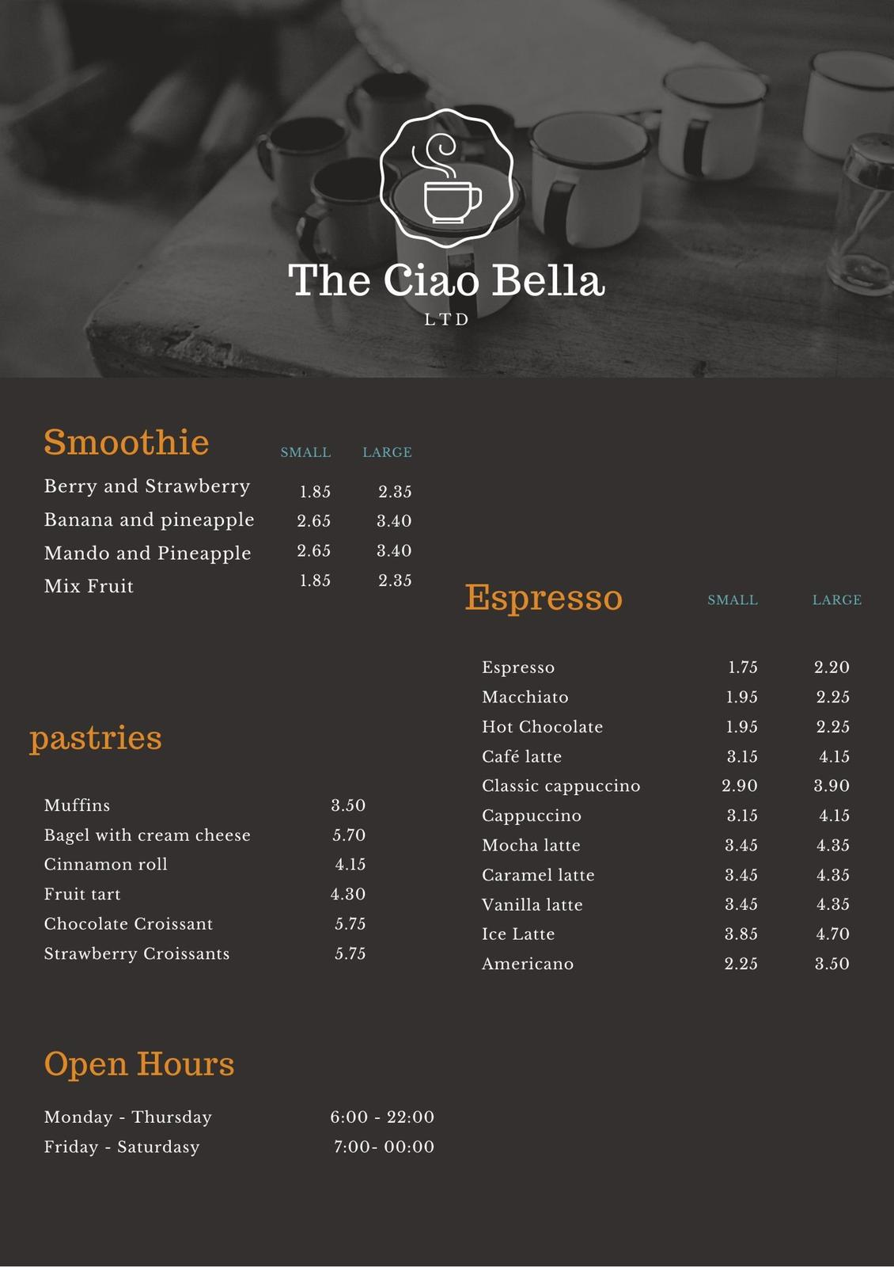
(by: ivanovitch
But everything changed in 2020 when the government decided to put the country in lockdown because of the covid-19 pandemic. All the strategies needed to change in the way to avoid big consequences, deciding to provide delivery services in south west side of the city we saw the need to have a kitchen in the shop to increase options in our menu and to increase our profit presenting the idea to my stakeholders we decide to start with this project.
Project is the time that you take to put the effort to create a unique product, service, or result.(TL, 2020)
Project management is when you apply the knowledge, skills, tools, techniques and experience to accomplish the project objectives and requirements. (Managment, 2019)

2.1- Project Presentation

The Ciao Bella is a coffee shop with more than 2 years in the market, well located providing a busy environment and a high demand of quality facing the pandemic of covid 19 the shop strategy needed to be changed for take-away only were the company felt the necessity to have a big kitchen to meet the demand, a big kitchen will increase the amount of products baked and the variety attracting more costumers increasing the option on our deliver service and the quality on our baked products.

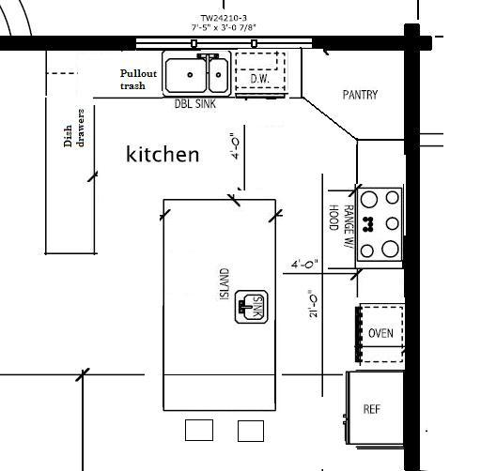
(Cookman, 2008)
Diverse of elements such project scope, work breakdown structure, communication plan and risk assessment will ensure that this project will be executed effectively and with the requirements.

2.2- Why Project Management is important

Project management is important because it ensure that when you start a project it will be finished on time and in the real value and the PM duties is also to ensure that the project will fit on the customers’ expectations and strategy framework of course that all project has a risk and issues and can make the project strategy change, but the project manager must ensure and be ready to readjust the project to conclude and meet the client expectations.(Astron, 2021)
Project management brings directions to the project that allows everyone to know what they supposed to do and when, is a guideline that motivates workers and gives the vision to develop a good work executing the strategic objectives. The position of a project manager is to ensure that all strategy and techniques are be following in the order to prevent situations that may interfere in the project and cause delays or ruin the entire project and is also important that the PM ensures that the client expectations are real and can be delivered when, and how much. (Astron, 2021)

2.3- Project Scope

The justification for this project me as owner and project manager is the need to build a kitchen to provide quality products and increase the range of option that is provided satisfying our loyal customers and the upcoming customers giving the opportunity to employ more and be ahead of my competitors will be a cornerstone for my business.
Product Scope is to build a kitchen for the coffee shop for attend the demand and quality, based in the customers emails and suggestions will be a kitchen full equipped with all requirements presented providing a safe place to the employees.
The acceptance criteria with the investors are that we agree to build the kitchen following the design provided and the requirement needed to execute the functionality needed.
Project Deliverables this project is to deliver a kitchen for my company to meet the demand that the business is needing that is baking fresh products and faster due the numbers of orders, the kitchen will be fully equipped with walking fridge, freezers, prover, oven with an area of 450sft that allows to have 2 chefs 1 kitchen porter and 2 kitchen members, sink, shelves to store inventory, small lift to send the products easily.

Timeline and Milestone the duration of this project are for 2 months all the phases are represented in a Gantt chart in the way that stakeholders can see the high-level timeline when each deliverable are ready and the project schedule duration.

(Gantt Chart By ivanovitch)

To achieve the objective finding out that each phase need time to start and end is crucial, all phases are well defined with a deadline so we can carry on with next phase and with this process we can make the objective tangible, so knowing that creating awareness is very important we decide to do PESTEL analyses to find out what can interfere in this process and create delays.

Political | Economic | Social | Technology | Environment | Legal
Will affect the project because of the world pandemic guidelines | Will affect this project because some of suppliers will increase the price | Will not affect but it will cause an impact, questioning about the safeness. | We will use technology in this project also to help us follow the guidelines | Will not affect. | Will affect the business because we need to follow the guidelines

With this PESTEL analyse we could see in which phase of this project will be affected and the impact of the delay that can cause, therefore we create awareness to prevent failures during this project.

2.4- Work Breakdown Structure of the Project

Work breakdown is a methodology in project management for completing project with multiple steps it helps to divide the task to get the project done more efficient and faster. The objective to have a work breakdown in a project is to make big projects manageable breaking it down in different stages with different teams divided by tasks so the project can run simultaneously, and the team can work with more accuracy and be more productive.(Wrike, 2021)
To execute this project a work breakdown structure is also required
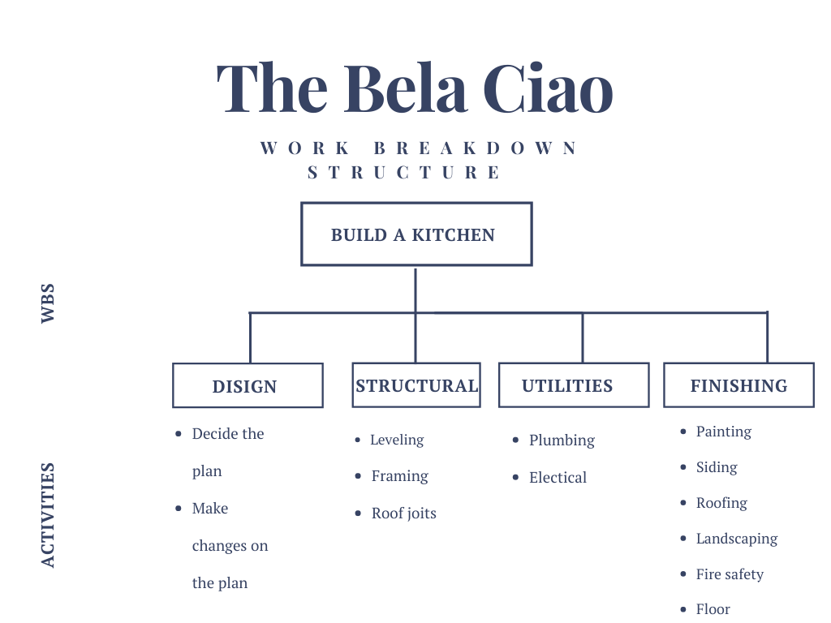
(By ivanovitch)

This work breakdown structure is divided by major tasks and subtasks everything is well structured to make the project manageable and achievable the Gantt chart is present as well with the start date and the end date everything well scheduled.

Project Management Software

Project management software is useful to run all types of projects and has a lot of benefits is important for communication in teal time for essential business to share tacit knowledge, and files with team. Managing a project without software still possible but the possibility to make a mistake is bigger and using the software is easy to have change in the project and share the updates with the team it has vantages and advantages such as allow the stakeholders tracking the progress of the project in real time. Project management software provides effective planning tracking delivering and much more methods to process projects. (cooke, 2006)

3.1- Agile Software

To execute this project, we will use the Agile Software, that were developed by engineers in 1990, to solve the problem that others software had with lateness, over budget and low quality. Agile is a methodology that show commitment with various feedback and have space foe improvement. The group of engineers knew it that they needed a better software to get the products in the market, the objectives was to create new methods to change the project without impact the cost or delay the production schedule.(Buehring, 2020)
The objective was to be able to divide the project in phases of interaction creating a faster development and testing to allow changes to be made without having to wait for the end of the project. (cooke, 2006)
Using Agile allow to answer the changes when the costumers request more faster without ruin the plan, that is the main reason that we choose this software, because we know that this project is small, and giving the costumer space to give feedback and be able to respond will be crucial to satisfy the customer. The collaboration with the costumer is very important because makes us able to give solution to customers problem. (Buehring, 2020)
Agile make us to do not have concern about the project if is worth it or which benefits will bring, the goal is to deliver the project with quality in the most efficient way, because the costumers are involved in this cycle of defining, prioritizing, developing, testing and give feedback. Agile principles are the value of teamwork, working together and collaboratively with the costumer, the cycle of interaction is developing, testing and give feedback, this software will allow the team to determine the tools and techniques to use it. Agile enable to share frequent progress of the project to the client without causing any delay in the project it also regulates the involvement of the client reviews of the progress, and Agile has 12 principles. (Buehring, 2020)
The main reason to use this software is the priority to satisfy the costumers being able to share ideas and feedback with the stakeholders and make changes during the process, because is suitable for project with a small scale and short timeline requires a good communication, the effective and efficient share of files and updates and the freedom of collaboration and innovation.

3.2- Prince2 software

Prince2 is the costumer project management methodology created in 1996 by the UK Government and have the ability to allow the organization manager to justify the project.(cooke, 2006)
Prince2 project management method is specifying the roles and responsibilities of the management team, and enable the costumers paying attention on the original project combining controlled project progress with regular progress making easy to take decisions and have an organized structure. Prince2 means project in controlled environment and has four elements and seven principles, each phase is controllable to make sure that the process is accessed at the end of each phase in the way that adjustments can be made on time it is necessary. (TL, 2020)
The reason why I am not using prince2 is because this project has a short timeline and I want to be focus on the low-level terms and have an adaptive approach and share all the progress with my stakeholders and be able to make changes without worrying about of the price changes or delays. (TL, 2020)

3.3- Scrum Software

Scrum is a framework in software development created in 1986, that can be used in project management that consist in teamwork accountability progress to achieve a well-structured goal scrum has three principles transparency, inspection, and adaption. Scrum consist in analyse what is Working and what is not working, and communication plays a big part of this framework that they call event such as daily scrum, sprint planning meeting, sprint review, sprint retrospective. (Contributor, 2017)

3.4- Waterfall Software

Waterfall is a regular approach to project management with a linear project flow that define timelines and deliverables from the outset, is the best option to understand the project constrain and the most straightforward way to manage a project. The strategy of waterfall is very inflexible any change will require a revision of the entire blueprint, is less effective in computer programming and is also divided in stages starting with requirements, system design, implementation, testing, deployment, maintenance. (Wrike, 2021)

Networking Planning Techniques

This is a useful process for planning, scheduling and controlling this technique provides an efficient management to know when the project is ending with more accuracy and identify the activities during the project that are important to complete different stages and help to analyse the scheduling for taking an advance action, it allows the management taking time to make the best decisions for controlling and monitoring during the project execution. The reason why this technique will be used is to give the advantages to deeply planning and taking logical decisions, identify the main activities so we can put our focus on and know with accuracy how long is going to be the project and avoid delays. (Nikhila, 2010)

4.1- Critical Path Management

The critical path in this project is to analyse the essential tasks to our project success, is here where we identify the task duration, the relation with the tasks and tasks that can cause delay in the project end date. The benefit to use the critical path is to identify and understand if a delay will have some impact in the project and take a quick action, and also when to prioritize the essential tasks. (Nikhila, 2010)

Budget Plan Management

Understand how to calculate the potential return on a project is essential and for this project we will use ROI formula that stand for Return on Investment, for a project manager is important to have the knowledge about this formula, in that way will allow to identify which project is worth it to work on and which project should be passed over, by understanding the basics of financial evaluation will allow us to evaluate the value of companies, project, anything that produce cash flow. (Stobierski, 2020)
Return on Investment (ROI) is a formula to find out how much profit we will get from an investment and we can calculate in two ways depending on when it was calculated Anticipated ROI and Actual ROI. For this project we will use the actual ROI that is only calculated when the project is concluded to find out the final cost and revenues to find out how much the project did compare with the expectations. (Stobierski, 2020)
For this project we first find out if would be profitable or not, so we started by calculating the total expenses and the expected revenue.

Expected revenue = 10,000 x £3000 = £30.000.000

Total Expenses = (10,000 x £2000) + £4000= £20,004,000

Once we got the total expenses and the expected revenue, we were able to find the net profit to find out if the project is worth it or not and to know how much the return on investment (ROI) is.

Net profit will be the total expenses subtracted by expected revenue

Net profit= 30,000,000 – 20,004,000 = £9,996,000

With the net profit calculated we are able to find out how much is going to be the return on investment

ROI= (£9,996,000/20,004,000) x 100=49.9% (Stobierski, 2020)

5.1- Project Team Members Selection

The success of a project depends a lot of the people that are working on it, most of PM select their team based on experience knowledge, degrees but is not necessary the best way to do it. This project our Human resource team is working on the selection criteria for the success of the project the first step is the information collection that will be provided by the candidates, by interviewing and talking with the candidates and recommendation from the people who have worked with everyone will be treated in a comparable way without discrimination and favouritism. (Jones, 2017)
The information provided should match the skills that we are looking for
- Good communicator
- Project management basic knowledge
- Organization skills
- Self-assured

With task-oriented personality because we need people that are self-motivated to do the work as the work itself and transmit this energy to the work environment and to ensure that we will use P-CMM Model that stand for people capability maturity model.
Job is about task, and role about people therefore our HR will provide training for coaches, training to correct performance problem, and organization development support.
Based on this term we will select the team members for this project and offer a compensative salary to maintain the quality and the good environment in the workplace. (Jones, 2017)

5.2- Risk Management Plan

When managing a project, we have the opportunity to get it right but is not always like that, because a project is never without risks and assuming that makes us ready to cope with the risk arise and trying to prevent analysing the risk of the project. Therefore, risk management is important because it ensures us that the risk can be managed in the way to avoid becoming a big issue. (D van Well Stam, 2003)
Risk management is defined as all activities and guidelines that we predict to deal with risk order to ensure the control over the project.
Risk management helps us to avoid interruptions on the project by dealing with the appropriate measure, ensure safety in the third parties and in the project, helps on the communication and to make decisions about the progress of the project. But to ensure the effectiveness of risk management it must be repeated during the project process and in this project, we will ensure that this cycle is repeating over and over again during the project. (D van Well Stam, 2003)

Risk management plan
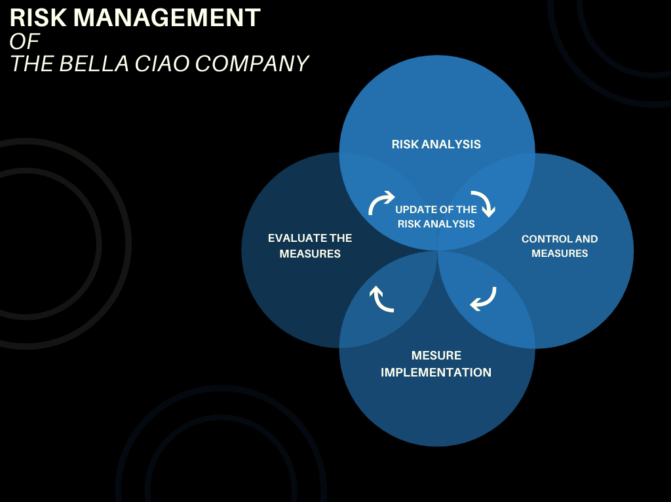
(by ivanovitch)

Because this project is been executed in time of world pandemic covid19 we will develop a coronavirus risk management.

Coronavirus Risk Assessment
Task/Activity |  | Project Management
Date of the risk assessment |  | 28.05.21
Name of the assessor |  | PM Ivanovitch paiva
Hazard |  | Illness (virus)
Who is at risk |  | Team members, contractors
Symptoms |  | Fever, loss of smell and taste
What is the risk. | Controls existing and further required |  | sign
Staff safety and  Contractors | Only fit staff to work those with symptoms need to follow the isolation guidelines |  | ivanovitch
Risk management can be applied in any type of project long or short term, however the
nature of the project is the people that are in the project and the objectives. (D van Well Stam, 2003)

5.3- Communication plan

Communication plan is to create a strategy to know how the information will be shared to stakeholders during the project, and it also identify who can receive the communication and how it will be received, and how often they should and will receive.(Team, 2020)
Management communication plan is important because the base of the success of a project is the communication more you communicate with your staff stakeholders more effective will be your project, communication plan will help your project being on track with
- Write documents that your team can reference
- Know when stakeholders will receive updates about the project
- Stakeholders will have a clear vision about the project and will increase the opportunity for them to give feedback. (Team, 2020)

This project will provide effective communication because we want to complete this project successfully and for that we created a communication plan, but due the world pandemic we will follow the guidelines of personal distance when is possible.

The Bella Ciao Company
Communication plan

Stakeholders |  | Deliverables | Frequency | Priority | Communication system
Management |  | Weekly update | Monday 9am | High priority most provide weekly report | Conference video call
Investors |  | Status update | Weekly | Low priority would be like to be update weekly, but the request is flexible | In person meeting but due the covid19 pandemic, video conference call will be the option
Project Team |  | Timeline update and review | Daily by EOD | High priority | Email
Project Staff |  | List of blockers | When needed | Medium priority | Team meeting
(Team, 2020)

5.4- Swot Analysis

Swot analysis is a strategy that the project manager can use to auto-analyse himself and use to help analyse their project finding the strengths, weakness, opportunities, threats of the project, with swot analysis you will be able to improve your confidence your project planning and reduce the risks of your project. (Wrike, 2021)

Swot Analyse of the project
Strengths | Weakness | Opportunities | Threats
- Project’s requirements  - Communication plan  - Implementation plan  - Work breakdown structure  - Risk management  - Project controlling  - Budget management | - Overallocated resource  - Team working together for the first time  - World pandemic  - Government guidelines  - Team meeting  - Project Delays  - Products delay | - Because of the covid the employment demand is high  - Suppliers doing discount  - More time to manage the project | - Bad weather  - Covid 19  - Suppliers and contractors leaving  - Employees miss the work  - Importation and exportations delay because of the covid

5.5- Personal Development Plan (PDP)

This personal development plan is to assess myself in the way to have the knowledge of how I can improve myself and what I can improve in my skills towards the project managing.
 | Personal Development Plan
Target |  | How? | Resources | Target Date
Improving my communication plan |  | Practicing, reading more about it and try different strategy | University Library  Internet videos and examples | March 2022
Be efficient using ROI formula |  | Calculating more, know when to use the formula.  Practicing in real projects or organizations. | University library  Online Resource  Reading real projects.  Be voluntary in one organization to deal in the real life | November 2023
Project management software |  | Learning more about with, know the difference between them and when to use each of them | Online resource  Library  Investigations about it | November 2022

Conclusion

With this report I completed my aim I presented my project in the way that the reader will understand my ideas and how I planned to execute this project using the project management theories, methods, and software I explained in a practical way using my project as example step by step showing how each step is important and why we need to use in the way to ensure that the project will be completed successfully.
I provided some pictures to make clearer about the structure and stages about my project I related the theories with my practical experiences and knowledge that I have got during this process, I learned a lot with my resources and investigations, and I felt that some aspects I needed to improve that is why I provided my personal development plan.

Reference

Bibliography
Astron, B., 2021. Digital Project Management. [Online]
Available at: https://thedigitalprojectmanager.com/why-is-project-management-important/
[Accessed 27 April 2021].
Buehring, S., 2020. Knowledge Train. [Online]
Available at: https://www.knowledgetrain.co.uk/project-management/prince2-agile/prince2-agile-comparison
[Accessed 25 April 2021].
Contributor, T., 2017. TechTarget. [Online]
Available at: https://searchsoftwarequality.techtarget.com/definition/Scrum
[Accessed 27 April 2021].
cooke, J. L., 2006. Prince 2 Agile An Implementation Pocked Guide. First Edition ed. Cambrigeshire: IT Governance Publishing .
Cookman, 2008. Kitchen Layout Planning & Designing. [Online]
Available at: http://www.cookmanequipments.com/services.php
[Accessed 24 April 2021].
D van Well Stam, F. L. S. V. K. B. v. d. B., 2003. Project Risk Management an Essential tool for managing and controling Project. 2nd Edition ed. Netherlands: Kogan Page Limited.
Jones, T., 2017. Bright Work. [Online]
Available at: https://www.brightwork.com/blog/6-tips-choosing-effective-project-team-members
[Accessed 28 April 2021].
Managment, A. f. P., 2019. What is project management?. [Online]
Available at: https://www.apm.org.uk/resources/what-is-project-management/
[Accessed 25 March 2021].
Nikhila, 2010. Business Management Ideas. [Online]
Available at: https://www.businessmanagementideas.com/project-management/network-technique-meaning-objectives-and-advantages/6541
[Accessed 28 April 2021].
Stobierski, T., 2020. Havard Business School. [Online]
Available at: https://online.hbs.edu/blog/post/how-to-calculate-roi-for-a-project
[Accessed 28 April 2021].
Team, L. C., 2020. Lucidchart. [Online]
Available at: https://www.lucidchart.com/blog/project-management-communication-plan
[Accessed 28 April 2021].
TL, P., 2020. Project Management. 2nd Edition ed. London: Nestfame Criations Pvt, Ltd.
Wrike, 2021. Project Management Guide. [Online]
Available at: https://www.wrike.com/project-management-guide/faq/what-is-work-breakdown-structure-in-project-management/
[Accessed 27 April 2021].

