Date: 24th June 2024

Managing Enterprise in 21stCentury – BMSW4011
Student Name: Sandra Gorolova Student ID number: 2311229

Table of Contents
TASK 1 3
1. Company concept 3
2. Company name 3
3. Mission Statement 4
4. Business Aims 4
5. Business Objectives 4
6. Legal identity 5
7. Marketing and PR Plan 5
8. Pricing Strategy 6
9. 7 P’s 7
10. Marketing samples 8
11. Physical Location 9
12. Human Resource Strategy 10
13. Sources of Finance 11
14. 12-Month Cash Flow Forecast: 11
15. SWOT Analysis 12
TASK 2 13
Reflecting on Luxury Nails' Strategic Vision to Transform Luxury Nail Care in the City 13
References 14

TASK 1

1. Company concept
This luxurious nail spa is located within the city. This ensures that one can experience first-class nail care services like manicures and pedicures, acrylic and gel nail extensions, and customized nail art using only branded products.
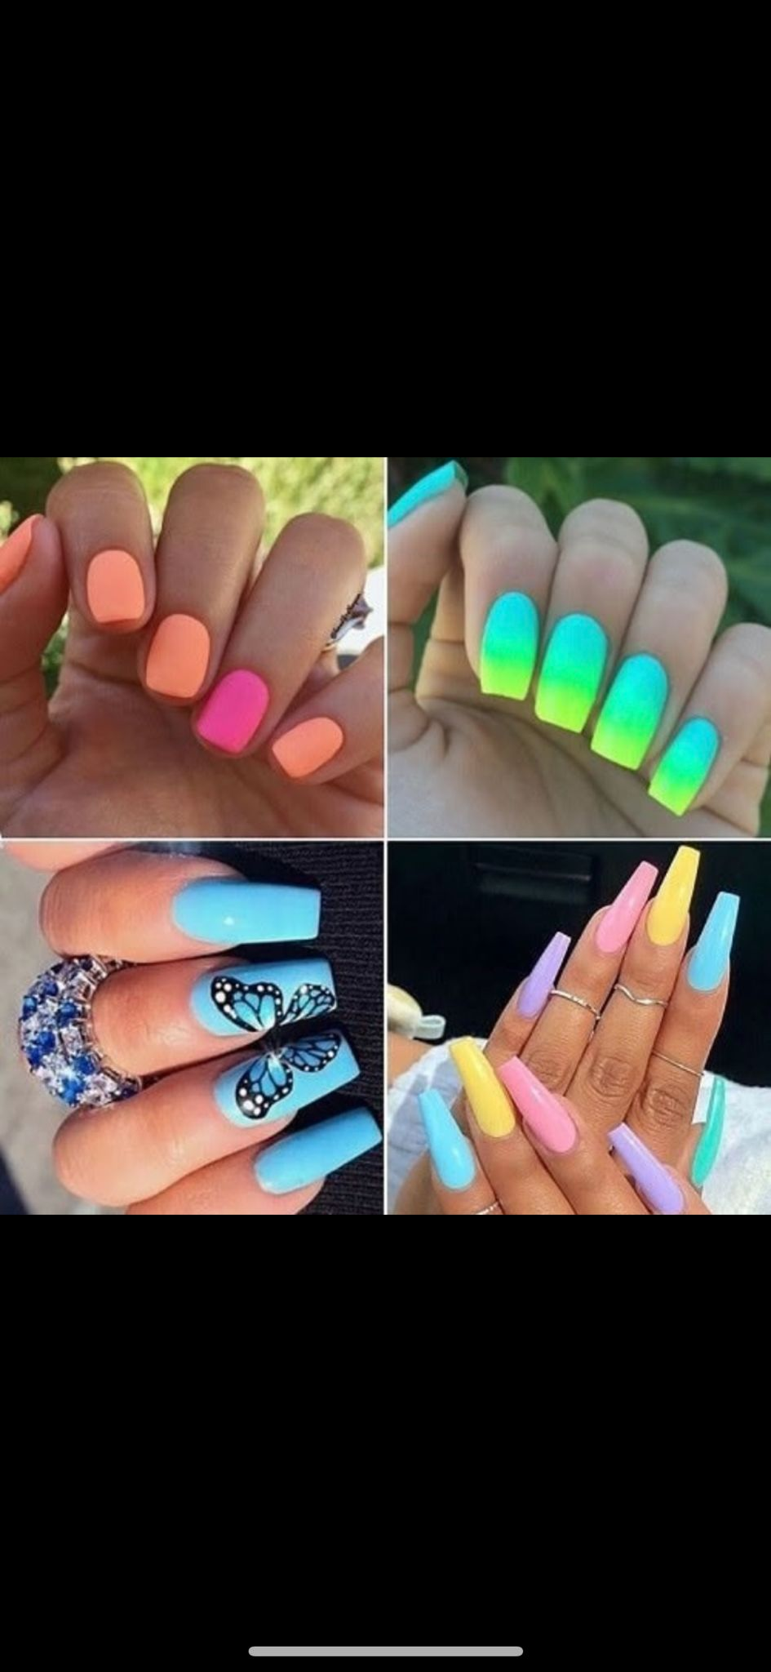
Figure 1: "Vibrant Elegance: Discover Luxe Nails' Exquisite Nail Art Creations"
This believes in focusing on hygiene and precision, with quality experienced by the customers from an indulgent journey (Saleh, 2023). They specialize in one-of-a-kind, tailor-made nail art, VIP exclusive party packages, and a serene high-end environment at a standard that will be hard to beat. Luxury Nails brings the highest level of technology but with a personal touch for the patrons' pampering and contentment (Dick, 2024).

2. Company name
Name: Luxury Nails

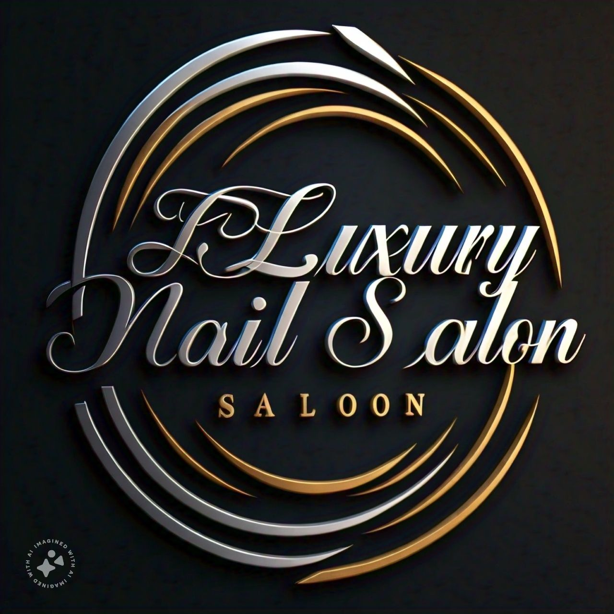
Figure 2: Luxury Nails logo

3. Mission Statement
This delivers unsurpassed, exclusive, ultra-luxury nail care services that surpass customers' expectations, enriching beauty, elevating self-esteem, and further elevating overall well-being.

4. Business Aims
The goal is to be the city's number one luxury nail center, hugely celebrated for high service standards and innovation in nail art, with an unyielding commitment to customer satisfaction.
Recruitment Plans and Dates:
- Objective: By the end of Q1 2025 - The recruitment of key staff has been completed.
Action Plan:
- January 2025: Advertise in local job fairs, beauty schools, and online job portals.
- February 2025: Interview Nail Technician, Receptionist, and Salon Manager and conduct Candidate Assessment.
- March 2025: Begin outfitting the location with necessary equipment and decor to match the luxury brand image.

5. Business Objectives
Year 1: Establish a strong client base and achieve a monthly revenue of £20,000.
Year 2: Expand service offerings and introduce a loyalty program.
Year 3: Open a second location in a neighboring affluent area.

6. Legal identity
Luxury Nails will function as an alliance. Although partners divide up the work and keep half of the profits, this business model is popular because it facilitates knowledge sharing, capitalization, and joint decision-making (Lee et al., 2022).

7. Marketing and PR Plan
This will increase comprehensive marketing and maximize digital platforms for exposure and coverage (Peter and Dalla, 2021). Instagram and Facebook are wonderful for nail art promotion. A few more targeted adverts will be convinced. Online bookings, customer reviews, and user-friendly websites make firms more credible. It has to connect with local beauty influencers for greater exposure and promotional incentives during the grand opening and other seasons to enhance visitors (Morgan, 2016).

Examples of Marketing Initiatives:
Influencer-led Instagram giveaways boost brand visibility and followers (brand Wales, 2021). Monthly emails with exclusive deals and updates will engage subscribers (Samantaray and Pradhan, 2020). Existing customers can get discounts for recommending friends and family. These techniques boost brand awareness and customer loyalty, ensuring Luxury Nails' long-term success (Smit, 2023).
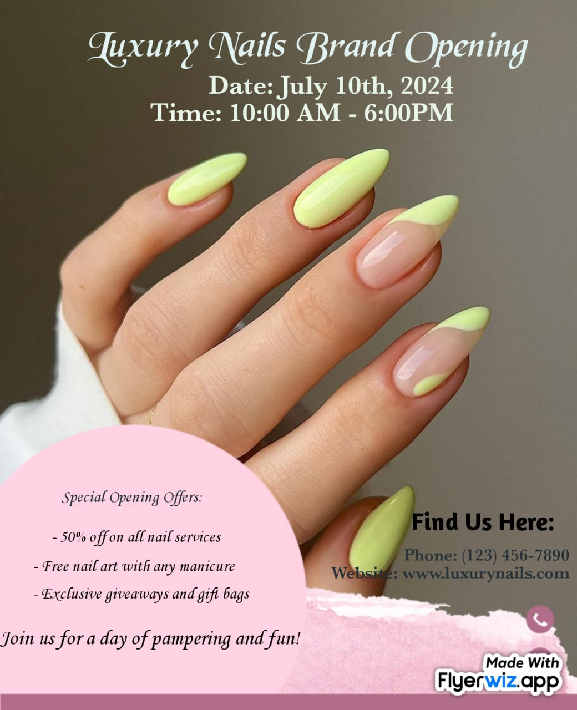
Figure 3:Flyer for Luxury Nails Grand Opening

8. Pricing Strategy
Luxury Nails will differentiate itself by offering premium, personalized nail care at competitive prices. This method provides high-quality service and limited availability, justifying the increased price. The plan aims to attract wealthy clients seeking unique nail art experiences to build a strong market position.
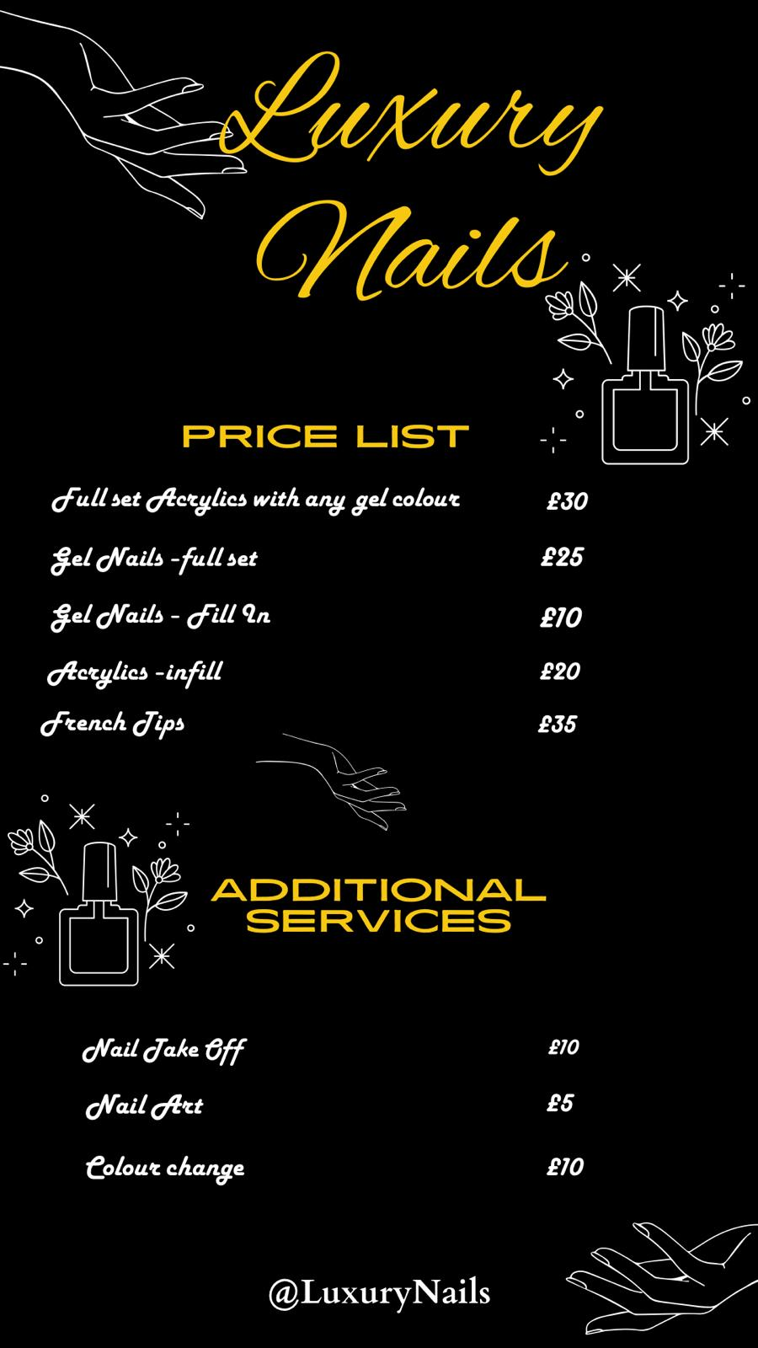
Figure 4: Premium Services price list

9. 7 P’s
- Luxury and personalized manicures, pedicures, gel and acrylic extensions, and handmade nail art are available.
- Premium prices indicate exclusive, high-quality services.
- Highly visible and accessible city center location.
- Email marketing, referrals, influencer collaborations, and social media.
- A salon manager, receptionist, and expert nail technicians work together to deliver outstanding service.
- A clean, efficient booking system with personalized assistance.
- This resort includes upscale furnishings, equipment, branded goods, and a peaceful ambiance.

10. Marketing samples
Research Methods
This involved online and street surveys of potential clients' interests and spending, which helped coordinate quantitative data releases. The competitor study included other nail salons to identify gaps and opportunities for this service (Dang et al., 2021). Focus group interviews helped us improve the service and experience.
Service | Preference (%)
Basic Manicure | 15
Basic Pedicure | 10
Nail Art | 30
Gel Nails | 25
Acrylic Nails | 10
Wellness Treatments | 10
Table 1: Survey Results on Preferred Nail Services
Findings and Application
The research showed considerable interest in the city center, which is linked with customized and luxurious nail services, and it helped us develop a competitive pricing plan. Among other things, it created a competitive pricing strategy for premium add-ons to serve a wider market niche (Ndlovu, 2024). Another area of very high interest was that of customized nail arts and treatments offered for general well-being.
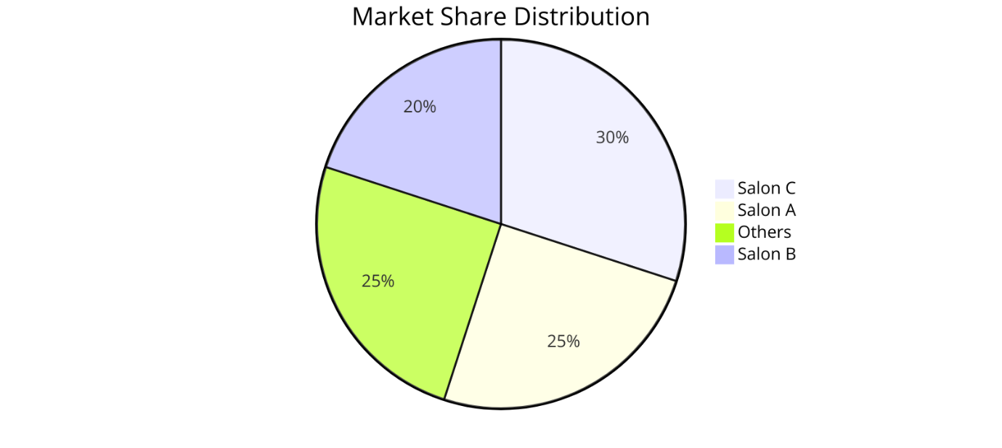
Figure 5: Market Share Distribution Among Competitors

11. Physical Location
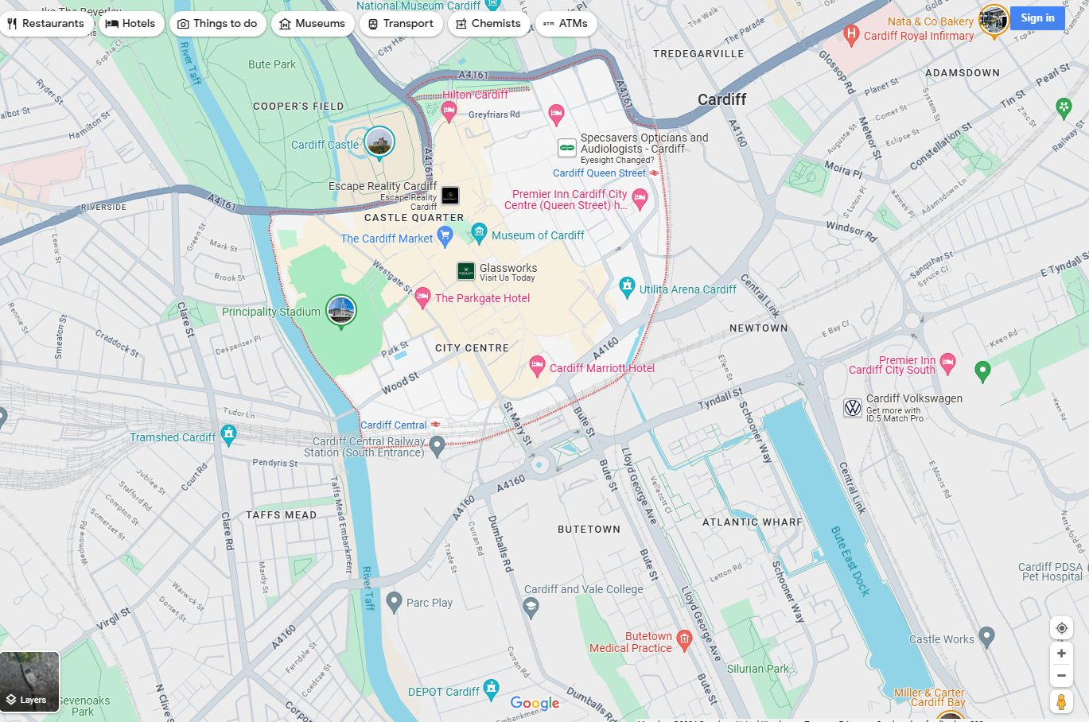
Location:
Luxury Nails will be in a prime city center location, ensuring high visibility and accessibility for the target market of professionals and affluent residents.

Figure 6: City Centre Location
Acquiring the First Location:
Objective: Obtain this lease in a central city location by the end of February 2025.
Action Plan:
- Select the final place of the city center, which is optimal when it comes to visibility and access.
- Finalize the conditions of the lease and sign the lease.
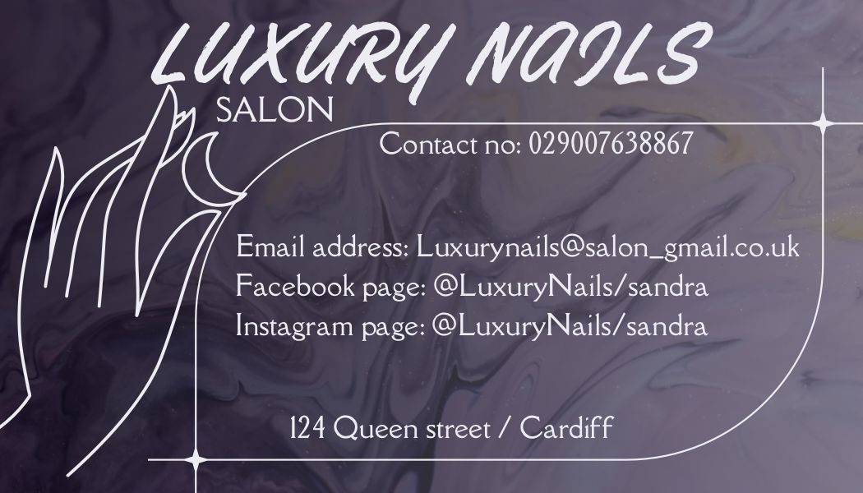
Figure 7: Prime Location
Equipment Required:
- Manicure and pedicure stations
- High-quality nail care tools and products
- Comfortable seating and luxurious decor
- Sterilization equipment for maintaining hygiene
- Point of Sale (POS) system for efficient transactions
- Security system for ensuring safety
The prime city center location and top-tier equipment will create a luxurious, relaxing environment, attracting professionals and affluent residents while ensuring exceptional service quality and client satisfaction (de Olim, 2021).

12. Human Resource Strategy
The staffing plan includes five qualified nail technicians to provide various types of nail services and customized nail art, a receptionist to handle appointments, client inquiries, and administrative tasks, and a salon manager to oversee daily operations, inventory, and staff performance. Recruitment will be conducted through local job fairs, beauty schools, and online job portals, with a preference for licensed nail technicians experienced in high-end salons (Chacko, 2020). A good orientation program will ensure that new employees align with service standards and provide exemplary service to clientele (Hotha, 2023).
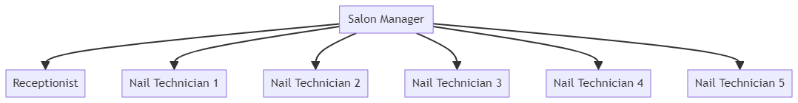
Figure 8:Organization Chart

13. Sources of Finance
To expand the business, it intends to secure a £10,000 bank loan, and the first funding will come from savings. To finance growth, it will also approach local investors in luxury cosmetics (Johnson et al., 2018). Personal savings demonstrate initial commitment and reduce the interest burden. The bank loan offers reasonable interest rates with a structured repayment plan (Hu, 2023).

14. 12-Month Cash Flow Forecast:
The financial plan includes a detailed table showing monthly income, expenses, and net cash flow.
Table 2: 12-Month Cash Flow
Description | Starting Point | Month 1 | Month 2 | Month 3 | Month 4 | Month 5 | Month 6 | Month 7 | Month 8 | Month 9 | Month 10 | Month 11 | Month 12
Cash In-Flows
Anticipated Sales | 15,000 | 15,000 | 16,000 | 17,000 | 18,000 | 19,000 | 20,000 | 21,000 | 22,000 | 23,000 | 24,000 | 25,000 | 240,000
Start-Up Loan | 50,000 | 0 | 0 | 0 | 0 | 0 | 0 | 0 | 0 | 0 | 0 | 0 | 50,000
Other Sources of Cash | 0 | 0 | 0 | 0 | 0 | 0 | 0 | 0 | 0 | 0 | 0 | 0 | 0
Total Cash In-Flows (A) | 65,000 | 15,000 | 16,000 | 17,000 | 18,000 | 19,000 | 20,000 | 21,000 | 22,000 | 23,000 | 24,000 | 25,000 | 285,000
Cash Out-Flows
Cost of Sales | 5,000 | 5,000 | 5,200 | 5,400 | 5,600 | 5,800 | 6,000 | 6,200 | 6,400 | 6,600 | 6,800 | 7,000 | 70,000
Rent or Premises Costs | 2,000 | 2,000 | 2,000 | 2,000 | 2,000 | 2,000 | 2,000 | 2,000 | 2,000 | 2,000 | 2,000 | 2,000 | 24,000
Utilities (gas, electricity, water) | 500 | 500 | 500 | 500 | 500 | 500 | 500 | 500 | 500 | 500 | 500 | 500 | 6,000
Insurance | 200 | 200 | 200 | 200 | 200 | 200 | 200 | 200 | 200 | 200 | 200 | 200 | 2,400
Telephone and Internet | 100 | 100 | 100 | 100 | 100 | 100 | 100 | 100 | 100 | 100 | 100 | 100 | 1,200
Marketing and Advertising Expenses | 1,000 | 1,000 | 1,000 | 1,000 | 1,000 | 1,000 | 1,000 | 1,000 | 1,000 | 1,000 | 1,000 | 1,000 | 12,000
Professional Fees (legal, accounting) | 300 | 300 | 300 | 300 | 300 | 300 | 300 | 300 | 300 | 300 | 300 | 300 | 3,600
Staff Costs | 5,000 | 5,000 | 5,000 | 5,000 | 5,000 | 5,000 | 5,000 | 5,000 | 5,000 | 5,000 | 5,000 | 5,000 | 60,000
Total Cash Out-Flows (B) | 14,100 | 14,100 | 14,300 | 14,500 | 14,700 | 14,900 | 15,100 | 15,300 | 15,500 | 15,700 | 15,900 | 16,100 | 185,200
Net Cash Flow (A - B) | 50,900 | 900 | 1,700 | 2,500 | 3,300 | 4,100 | 4,900 | 5,700 | 6,500 | 7,300 | 8,100 | 8,900 | 99,800

This financial plan projects positive cash flow starting from the first month, reaching a net positive of £8,900 by the end of the year. This ensures the sustainability and growth of Luxury Nails, positioning the business for long-term success (Sarkar et al., 2024).

15. SWOT Analysis
Strengths: A fantastic city center location, premium customized services, a talented team, and a detailed marketing strategy that incorporates social media and influential people (Atherton, 2023).
Weaknesses: Profit sharing, joint accountability, hefty startup expenses, and reliance on rich clients are drawbacks.
Opportunities: Opportunities include service diversity, expansion, loyalty programs, and powerful partnerships.
Threats: Threats include economic downturns, competition, innovation, and pricing changes.

TASK 2

Reflecting on Luxury Nails' Strategic Vision to Transform Luxury Nail Care in the City
One of the first steps was defining the product/service proposition. In order to define what products and services luxury nails offer, the trends of the market, customer preferences, and competitors need to be understood. This was a powerful lesson in the value of market research and differentiating characteristics from competitors. The trend of offering high-quality services such as tailored nail art and VIP private suites also matched the increasingly personalized luxury experience that consumers were demanding from the market. This transition showcased my analytical acumen of understanding market demands and trends.
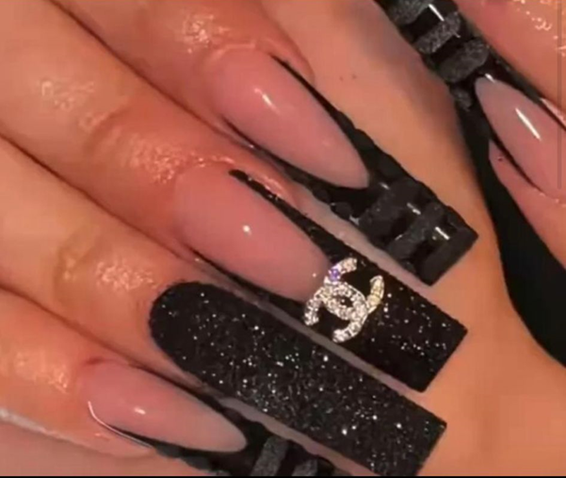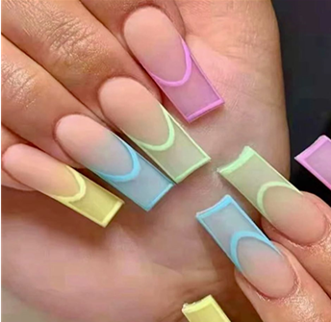
Figures 5 and 6: Discovered the Art of Nail Perfection at Luxe Nails
A key milestone was choosing the business name and entity type. Going as a partnership helped in the pooling of resources and shared expertise and is highly necessary for a high-end service business. An illustration that I am able to look at things strategically and decide what risks are worth taking to get the most financial benefit was in the decision of how I decided to own the rental properties. Creating the mission, purpose, and objectives was simply the act of defining the objectives and goals. Creating a mission statement around the most superior and unique luxury services helped get everyone on the same page and convey our brand to the consumers. To achieve this, comprehensive planning of physical and human resources was an important prerequisite for operational efficiency and service quality. My strategically positioned city center location, along with the best-in-class amenities and high-quality services, aims to make it welcoming and luxurious. Aiming to source professionals with good experience, the staffing plan highlighted the need to deliver good quality services through a skilled workforce. This stage showed how well my organizational and resource management skills.
Extensive market research via surveys and competitive positioning enabled us to identify customer preferences and missing gaps in the market. My services were data-driven to ensure the offerings of Luxury Nails were targeted to the customer demand, showcasing my skills in research and analytics. The viability and sustainability of Luxury Nails depended on financial planning. In order to go through the details of cash projection or figure out where funding will come from, one needs to have financial literacy in order to launch a business of its own. Demonstrated financial acumen, securing the first round of funding through personal savings, bank loans, and investments from investors. This means acknowledging the largest downfall- a slower economy, and then putting strategies in place to counteract it - again, another reminder is that resilience, or rather adaptability, is needed. I showed the story that I can think strategically, mitigate specific risks by diversifying our offerings, and have excellent customer service skills.

References
Atherton, J., 2023. Social media strategy: A practical guide to social media marketing and customer engagement. Kogan Page Publishers.
Business Wales.(2021), Business Advice in Wales, [online] available at: http://businesswales.gov.wales/
Chacko, S., 2020. " Shaping Beauty, Claiming Authenticity:” Gender, Work, and Immigration Experiences of Low-Wage South Asian Immigrant Women Workers (Doctoral dissertation, Loyola University Chicago).
Dang, J.V., Rosemberg, M.A.S. and Le, A.B., 2021. Perceived work exposures and expressed intervention needs among Michigan nail salon workers. International Archives of Occupational and Environmental Health, 94(8), pp.2001-2013.
de Olim, R.M., 2021. Business Plan: Madeira Heritage Boutique Hotel (Doctoral dissertation, ISCTE-Instituto Universitario de Lisboa (Portugal)).
Dick, E., 2024. Bhutanese women and the performance of globalization. In Threads of globalization (pp. 92-112). Manchester University Press.
Eze, F.J., James, E.E., Inyang, I.B. and Abe, G.N., 2024. Entry-Level Export Strategies in Developing African Countries: Evidence from Nigeria. African Journal of Humanities and Contemporary Education Research, 14(1), pp.173-192.
Hotha, K.K., 2023. Unleashing the Power of Innovation in CDMOs through Customer-Centricity and Culture of Service. American Journal of Industrial and Business Management, 13(4), pp.234-246.
Hu, Y., 2023. Interest-driven and legal supervision innovation of the capital pool model in Chinese banking financial products. Heliyon, 9(5).
Johnson, G., Scholes, K., Johnson, P.G. and Scholes, P.K. (2018) Exploring corporate strategy: Text and cases. 6th edn. Harlow, England: Financial Times Prentice Hall.
Lee, K., Romzi, P., Hanaysha, J., Alzoubi, H. and Alshurideh, M., 2022. Investigating the impact of benefits and challenges of IOT adoption on supply chain performance and organizational performance: An empirical study in Malaysia. Uncertain Supply Chain Management, 10(2), pp.537-550.
Morgan, P. (2016). The Business Student’s Guide to Study and Employability. Sage Publications
Ndlovu, S.G., 2024. Private label brands vs national brands: new battle fronts and future competition. Cogent Business & Management, 11(1), p.2321877.
Peter, M.K. and Dalla Vecchia, M., 2021. The digital marketing toolkit: a literature review for the identification of digital marketing channels and platforms. New trends in business information systems and technology: Digital innovation and digital business transformation, pp.251-265.
Saleh, M.I., 2023. Advantaging Tourism Through Influencers: Applying Transaction Cost Theory to Recognize Top Hero, Hub, and Hygiene Content Tactics for Tourism Marketing. Journal of Travel Research, p.00472875231214727.
Samantaray, A. and Pradhan, B.B., 2020. Importance of e-mail marketing. PalArch's Journal of Archaeology of Egypt/Egyptology, 17(6), pp.5219-5227.
Sarkar, T., Namboodiri, S. and Pandey, N., 2024. Nykaa: Repositioning for Growth. SAGE Publications: SAGE Business Cases Originals.
Smit, L.M., 2023. A managerial framework to increase sustainable competitive advantage within the beauty industry through Customer Relationship Management (Doctoral dissertation, North-West University (South Africa)).

