
Understand Haidilao training system and study customer satisfaction
Name: Qu Jiangying
Student ID: 2001788
Course code: BMBM6020
School: UWTSD Swansea

Acknowledgments
In the process of writing the paper, I met the difficulties and obstacles, which I spent with the help of my classmates and teachers. I would like to thank my thesis instructor, Ms. Caroline. Without her guidance and help, there would be no final completion of my thesis. Here I would like to express my heartfelt thanks to my teachers and classmates for their guidance and help. At the same time, I would like to thank the references in this paper. Without the inspiration and help of the research results of these scholars, I cannot complete the last chapter of this paper.
Due to the limited theoretical level of this study, some of the views in the paper, as well as the induction and elaboration of enterprise strength, inevitably have omissions and shortcomings. Welcome teachers and experts to correct.

Abstract
This study explores the service system of undersea fishing and customer satisfaction with undersea fishing. Since China is less affected by covid-19 in 2021, qualitative and quantitative data collection methods are adopted in this study. In the future research, more qualitative and quantitative methods will be used to improve the whole research. It is hoped that this research can help Haidilao improve its own training system and increase customer satisfaction with Haidilao.

Contents
1.0 Chapter one introduction 3
1.1 Introduction 3
1.2 Founder background 3
1.3 Haidilao Background 4
1.3 Aim and Objectives 5
1.3.1 Aim 5
1.4 Research structure 6
1.5 Conclusion 6
2.0 Charper2 Literature Review 7
2.1 Introduction 7
2.2 Enterprises need training 7
2.3 Main methods of training 8
2.4 Current training situation in China 8
2.5 Western training system 11
2.6 Submarine Haidilao training system 14
2.6.1 Haidilao University 14
2.4.2 Practice method 15
2.4.3 Regular etiquette training 15
2.4.4 Regular business training 15
2.5 Conclusion 16
3.0 Chapter Three: Research Method 16
3.1 Introduction 16
3.2 Research methods 16
3.2.1 Observation method 16
3.2.2 Face to face interview 17
3.2.3 Questionnaire survey method 18
3.2.4 Choice 22
3.3 Conclusion 22
4.0 Chapter Four: Data Analysis 22
4.1 Introduction 22
4.2 Data obtained by observation 23
4.3 Data obtained by face to face interview 24
4.4 Analysis of questionnaire data 25
4.5 Criticizing the service of Haidilao 32
4.6 Conclusion 32
5.0 Chapter Five: Recommendations and Conclusions 33
5.1 Introduction 33
5.2 Recommendations 33
5.2.1 Change the mode of service 33
5.2.2 Appointment function added to the service 34
5.2.3 Change the mode of tutorial system 34
5.3 summary 34
5.4 Further Research 35
5.5 Conclusion 35
6.0 References 36
7. Appendices 40

1.0 Chapter one introduction

1.1 Introduction
This chapter is mainly to provide the background for the research, as well as to explain the purpose of this study, to provide the research structure and the conclusion of this chapter. And This chapter mainly discusses the implementation of the training program for the employees of Haidilao enterprises.
Some studies have shown that in the early 1990s, service has become an important means and strategy of market competition and marketing in the catering industry. As an independent marketing system, with the development of the times and the in-depth study of service marketing theory, the service marketing of catering industry has gradually become the key factor to obtain customer recognition, loyalty and market advantage. Therefore, the training system of Haidilao hotpot shop is studied. Therefore, this study is to explore the success brought by the training system of Haidilao. This study is helpful for Haidilao to improve its own service and the overall optimization of Haidilao hot pot shop.
Background and Brand concept

1.2 Founder background
Zhang Yong, chairman of Sichuan Haidilao catering Co., Ltd., set up his own life goal in the early 1980s when he was in middle school. During this period of study, he read extensively to increase his knowledge, laying a solid foundation for his later unique thinking and business mind. (Qidai,2021) After that, after in-depth and careful market research and analysis, the first "Haidilao hot pot" was officially opened in 1994. At the beginning of its opening, its goal was not in Sichuan, but in the whole country. After seven years of hard work, in April 2001, Jianyang city, Sichuan province Haidilao catering Co., Ltd. was officially established. (Zhang yong,2010)

1.3 Haidilao Background
Haidilao is a famous hotpot chain store in China and all over the world. It originated in Sichuan and became famous in Beijing, Xi'an and other places. South Korea and Japan all believe that the catering service level of Haidilao has reached the international advanced level. (Qie,2013) At the same time, it also has a group of experts and professional technicians in catering, nutrition, storage and management. Now it has 91 direct restaurants in 21 cities in China, and has overseas direct stores in Singapore and the United States, with nearly 20000 employees. With the continuous development of Haidilao hotpot store, the number of employees is also increasing. (Sheng,2019) Moreover, Haidilao has four large-scale modern logistics distribution bases and a base material production base. Four large-scale logistics distribution bases are set up in Beijing, Shanghai, Xi'an and Zhengzhou respectively. With the concept of large-scale procurement, mechanization of production, standardization of warehousing and modernization of distribution, a large-scale logistics supply system integrating procurement, processing, warehousing and distribution has been formed. The company has won more than ten titles and honors in Sichuan, Shaanxi, Henan and other provinces, such as "advanced enterprise", "consumer satisfaction unit" and "famous hot pot". Its innovative characteristic service has won the reputation of "five-star" hot pot shop. From 2008 to 2010, it won the "top 10 most popular hot pot stores" of dianping.com for three consecutive years; At the same time, it has won the honorary title of "top 100 Chinese catering enterprises" for three consecutive years. (sou gou,2021)
Haidilao has been tested by the market and customers for many years, and has successfully built a high-quality hot pot brand with high reputation and integrating local hot pot characteristics. As a large-scale chain catering enterprise with global business, Haidilao adheres to the belief of good faith management, and improves the stability and safety of food quality as the prerequisite, providing consumers with healthier, safer, more nutritious and more assured food, as well as more intimate services. (Haidilao,2021)
Haidilao has always held high the banner of "green, healthy, nutritious and characteristic", and is committed to the development and research of hot pot technology. On the basis of inheriting the original characteristics of Sichuan and Chongqing catering culture, such as "hemp, spicy, fresh, fragrant, tender and crisp", Haidilao has constantly innovated to provide unique, pure, delicious taste and nutritious and healthy dishes, it has won the praise of customers and left a good reputation of customers coming without publicity. (Entrepreneurship College,2013) Haidilao always adheres to the brand concept of "service first, customer first", takes innovation as the core, changes the traditional standardized and single service of catering industry, advocates personalized characteristic service, takes service with heart as the basic concept, provides customers with intimate, comfortable and warm service, and advocates the excellent values of changing fate with both hands in management, Build a fair and just working environment for employees, implement humanized and family friendly management mode, and enhance the value and significance of employees.(YIge,2020)

1.3 Aim and Objectives

1.3.1 Aim
To study the training mechanism of Haidilao hot pot for service personnel, and research on customer satisfaction
1.3.2 Objectives
1. Discuss the importance of staff training and the training mechanism of Haidilao
2. Select appropriate research methods to analyze the service and customer satisfaction of Haidilao
3. This paper analyzes the collected data, makes a critical analysis of Haidilao, and discusses customers' views on the service level of Haidilao hotpot.
4. In the first three parts, we understand the practical significance of the research and put forward practical suggestions.
5. Combined with the limitations of this study, this paper discusses the possible research approaches and directions in the future, improves the research, and increases the research results.

1.4 Research structure
In order to achieve the research goal, this study is divided into five parts for analysis, the first chapter is the introduction, the second chapter is the literature review, the third chapter is the research methods, the fourth chapter is the data collection and analysis of the collected data, and the fifth chapter is the conclusion and suggestions for this study.
In the first chapter, it introduces the background information of the founder of this study, as well as the background information of this study, so as to carry out the basis of this study, as well as the goal and purpose of this chapter. This study will use the methods of interview, observation and questionnaire, using first-hand data and second-hand data for research and analysis.
In the second chapter is about the literature review of the training activities for the employees of Haidilao. Literature review can help to understand the existing fields in the topic selection, the existing problems and research gaps in this field. In the third chapter, we choose the appropriate research methods to solve the problems and research gaps.
The content of the third chapter is the method demonstration part. Firstly, the most suitable research method and blank are determined to make up for the vacancy in this field. According to the research methods, the theme is analyzed.
The fourth chapter is to analyze the method of analysis, collect the original data, analyze, draw the conclusion of the investigation, and then discuss.
In Chapter 5, the conclusion and the goal of this study are reviewed, and the findings and suggestions are discussed. The limitations of this study can contribute to the future research.

1.5 Conclusion
The first chapter is the introduction of this study, so as to clearly develop the purpose and goal of this study, and establish that the staff training of Haidilao hotpot can provide help. In the second chapter, the literature review will be carried out, so that the problems discussed in the first chapter can be more deeply understood and thought.

2.0 Charper2 Literature Review

2.1 Introduction
The purpose of this chapter is to review the importance of current training and the training methods of undersea fishing, so this chapter will complete the first objective: Discuss the importance of staff training and the training mechanism of Haidilao.
The following literature review comes from the data of CNKI and Baidu, which are all important academic contents of this study. Search key, the importance of training, Chinese training system, Western training system.

2.2 Enterprises need training
Training is an important part of human resource development. The term "human resource development" was put forward by George Washington University Professor Leonard Nadler in 1967, and it was generally accepted in the 1980s. At that time, the design of human resource development included training, education and development. (Xiao Mingzheng,2014)
Employee training usually refers to a series of planned and targeted activities carried out by enterprises to enable employees to acquire some work skills. Employees' skills include theoretical knowledge, professional technology, and knowledge and skills acquired by certain achievements in work, and these skills are used in real life. It can not only improve the work efficiency, but also enhance the work enthusiasm of employees, enhance their sense of belonging to the enterprise and recognition of the enterprise. The training system of enterprise staff itself refers to the training management and management system in accordance with the ideal development goal and direction of the enterprise, so that the quality and vocational skills of employees can be improved and improved. （Zhang Xiayi,2014）If enterprises want to achieve certain success, they must pay attention to staff training. Nowadays, staff training has gradually developed into a global strategy.

2.3 Main methods of training
Teaching method is a very traditional way of training. Through the trainer's language description and expression of trainees, trainees can systematically understand the knowledge they have learned. Through the trainer's description, trainees can understand the important concepts in the enterprise and the specific knowledge they need to use in the enterprise. (Sougou,2018) Job rotation method is a kind of on-the-job training, which allows trainees to change their positions in a predetermined period, so that trainees can obtain different job experience in the job change. It is generally used in the training of new employees. Many enterprises carry out job rotation method to cultivate young managers or quality employees with management potential. (Sougou,2018) Internship is a kind of training method for trainees through experienced employees or supervisors. It is a kind of "apprenticeship" training which is very commonly used in enterprises. Trainers need to tell the trainees how to complete their work in the job, and provide some suggestions to the trainees after the work, so as to ensure that the trainees can make better performance in the same situation next time, and they also need to express affirmation and encouragement to the trainees. (Sougou,2018)

2.4 Current training situation in China
Chinese enterprises and academic circles began to study enterprise training around 1996. On the basis of Western management experience and theory, gradually began to explore the theory of human resource development and human resource training, these theories were quickly accepted by Chinese researchers. Many scholars begin to focus on the effect of training on human resource development of enterprises, and study the training mode, training methods and training system effect evaluation in training management. (Zhang Xiayi,2014)
In the research of enterprise management training in China, it basically applies and follows the foreign training theory, which is not related to the actual situation of our country. The training system and training methods can-not be studied and evaluated according to the national conditions of our country and the characteristics of our enterprises. However, many scholars have designed the training management system of modern employees from the practical aspect. （Ma Jianjun,2011）According to Z theory, Professor Shi Jintao of Shanghai Jiaotong University puts forward the division of training management system. His view is that the enterprise training system includes three subsystems: training management system, training curriculum system and training implementation system. There are many aspects in the training management system, such as rules and regulations, training information collection and feedback, training actual effect and job promotion, training responsibilities of managers, cost management, training evaluation, training and performance appraisal, training and salary, etc. (Shi Jintao,2007) Qiu Zhao liang's (2002) "organizational learning fish" model shows that the training model consists of the following four parts: action, concept, organizational learning mechanism and organizational promotion and guarantee mechanism. These models not only clarify the basic structure of learning organization, but also explain the relationship between the components. Nowadays, enterprises not only pay attention to the development of human resource training for employees, but also pay more attention to the effect after training. The academic circle is discussing how to grasp and measure the input and output of human resource training. Meng Fan ping's view is that in the process of personal training, benefit evaluation should be carried out through an evaluation cycle, not through the natural year. By calculating the difference in human capital before and after employees enter the enterprise, the calculation table of personal training input and output can be obtained. This is the introduction of accounting in the process of studying the effectiveness of training the content of. (Liu Sanlin ,2000) According to ISO10015, Han Dewei (2003) divided training management into five steps: analysis and confirmation of training needs, design and planning of training contents, provision of training and supporting services, evaluation of training results, and supervision and improvement of training process. Huang Jian (1997) of the Institute of adult education of Shanghai Second Institute of education holds that in the process of developing enterprise training courses, there should be the following seven links: the first is to evaluate and test the training needs; the second is to set certain learning objectives; the third is to create training courses; the fourth is to choose appropriate training strategies; and the fifth is to choose certain training strategies Teaching resources, the sixth is the implementation of training, the seventh is the timely feedback of adverse problems in training. The starting point of enterprises should be to standardize training courses, so as to greatly increase the effectiveness and pertinence of training courses, so as to ensure the efficiency and quality of enterprise education.
Although the training management system is developing rapidly, it has not been applied in most enterprises. Generally, it is used by some large training institutions. There are few unified training management systems in Chinese enterprises, which are generally the same in this way, the training management system suitable for the enterprise does not mean that it can be used in the training management of other enterprises. The differences of enterprise training methods are closely related to the differences of employees' learning methods. Most of the work skills of employees in manufacturing enterprises can be cultivated in internal training institutions, while the skills of communication with customers required by employees in service enterprises depend more on the accumulation in actual work. In some catering industries in China, the "recommendation system" is an important way to recruit ordinary employees. When the recruitment needs of ordinary employees appear, Haidilao will mobilize employees to recommend. The recommended people are usually relatives, friends or fellow villagers of the employees. Because employees are very familiar with the working condition of the enterprise and the recommended person, they will take the initiative to match the person and position in the process of recommendation. And when training employees, they are more familiar with the training process than strangers. This is conducive to reducing the turnover rate of new employees, so that the catering industry has a stable workforce. (Chen Shengjun,2008)
According to the survey, the training of some small and medium-sized enterprises in China is out of touch with the employees in many aspects, ignoring the employees' training needs, ignoring the employees' feedback on the training effect, and failing to publicize the enterprise's training system and training purpose to the employees, which may make the employees lack confidence in the training, and the employees are not just the labor force of the enterprise, It's a kind of investment product and additive. The training of employees is not only limited to one or two vocational skills training, more importantly, it is necessary to let every employee combine with the development of the enterprise to form a win-win situation. And the problems in the training of small and medium-sized enterprises are exactly the core of the talent strategy development of small and medium-sized enterprises, that is, how to do a good job in talent investment. As an enterprise, the author thinks that the investment of the enterprise should face two aspects, one is the investment in products, the other is the investment in talents. Product investment forms output value, while talent investment forms production capacity. Therefore, as the cultivation of talents should be continuous, it needs enterprises to form a series of institutional programs to complete, that is, what we call career planning. Career planning is a deeper interaction between enterprises and employees, and training is one of the important means. Most small and medium-sized enterprises ignore the main body of training, so it is impossible for them to bear more important responsibilities, employees can't really grow, and enterprises can't get qualitative change.
2.5 Western training system.
Foreign countries began to study enterprise training around 1901. The earliest book about training theory (Taylor, 1911) published "The principles of scientific management" mentioned training theory, which studied the standardized technology and workflow of workers. Since then, the training theory has gradually emerged in practice, and constantly improved and promoted, once again acting in the training process. And achieved important results, such as training needs assessment, training effect assessment, and training system operation mode.
In the theory of human resource development, the most representative basic theory is human capital theory. Becker and Schultz are the founders of modern human capital theory. The starting point of these theories is economics, which thinks that human resource management is an investment, so it focuses on output rather than input. (Lizhongsheng,2012) The earliest training mode widely used in the United Kingdom and the United States is Boydell system mode（MBA，2020）, or Percival system mode (Taodoucs,2014). Its systematic and operational, according to logical steps, planned implementation of training, and then evaluate the plan, as well as audit, after constant revision, is still in use today. Harry Taylor created a transitional training model, which is a systematic training model. Taylor's transitional training model, which not only retains the system model as the basis of training guide, but also puts training in a broader enterprise background. At the same time, it points out that the organization as a whole should adapt to its development. (Zhou Jian,2013)
After studying Solomon model, Martin, an American economist, added "behavior evaluation" and the function of strategic promoter into the training. This is not only the reform of training needs, but also one of the signs of introducing evaluation into training. Later, in the training mode, the concept mode of "internal customers" and personal goals are added, which not only makes the training mode system more perfect, but also makes the training more scientific and feasible. （LBDJ,2021）And in the establishment of the theoretical basis of training evaluation system, American human resource management experts have made corresponding research, especially the four level evaluation model proposed by Donald in 1959, also known as Kirkpatrick Model. This is a well-known and applied model. He believes that the evaluation of the training effect should start from four aspects, namely, observing the reactions of the trainees, checking the learning achievements of the trainees, measuring the work performance before and after the training, and the changes of the company's business performance. It can also be called the result obtained from the reaction layer, the learning layer, the behavior layer, and the result layer. (sougou,2021) Pressman (2011) further proposed five levels of return-on-investment model on the basis of Kirkpatrick Model. He believed that although the fourth level of return-on-investment model has included certain impact on the business. And training has a great cost, but the cost of training is higher than the income, which leads to the failure to achieve the expected income. After that, the comparison of money cost and profit is added to improve the whole evaluation process. Professor Raymond A. noy (2001), a famous American Management Master, once used the standardized process to control the training, which has been effectively improved. There are 28 specific contents and seven construction steps in the process, in which there are a lot of emphasis on the method and purpose of each step.
In human resource management published by (Robert L. Mathis and John H. Jackson,2004), the following three theories have reached consensus in academic circles: the same factor theory, the incentive promotion theory, and the cognitive theory. According to the same factor theory, the environment and conditions for the transformation of training results only occur when the employees perform tasks in the same state as the working environment. The incentive promotion theory shows that only when the training project is clear can the training results be transformed into each other. Cognitive theory is a learning theory which studies the change caused by experience. It is a cognitive activity of memory, perception, etc. (SOGOU,2020) American human resource management expert Lester (1999) thinks that training is any activity that imparts knowledge and skills to employees, and is any form of education related to work. Her interpretation of training is based on the research of Bernard Taylor and Gordon Lippitt, which sublimates employee training to the perspective of education. Thus, the training form is no longer simple classroom teaching.
In the 1980s, IL Goldstein, E. P. Braverman and h. Goldstein, after long-term research, systematized the evaluation method of training needs and built a Goldstein three-level model. Goldstein three-level model is the basis of training needs analysis. It regards training needs analysis as a system, and classifies it. By integrating the needs of organization, task and personnel, it makes training needs more perfect and the analysis results more comprehensive. （Si Mu,2018）Goldstein regards training effectiveness evaluation as "systematically collecting the necessary descriptive and judgmental information to help make the decision of selecting, using and modifying training programs". Phillips believes that "evaluation is a systematic process used to determine the value or significance of an activity", which is used to predict the future situation of training projects. Bramley believes that in the field of training, evaluation refers to "a process of collecting information for the development of training activities, the purpose of which is to evaluate whether a training project is valuable and has achieved good results”. These researchers define the effectiveness of the training process.

2.6 Submarine Haidilao training system

2.6.1 Haidilao University
In June 2010, Haidilao founded Haidilao University, which focuses on the internal training at the grassroots level for internal staff training, and regularly organizes learning. Basic management knowledge, service etiquette, and academic education, this internal training method can make up for the shortage caused by many problems, such as quality problems and inadequate training, which need to recruit more employees. (Koubei,2021) In addition, Haidilao also holds regular golden platform activities, and each store sends three or four employees to carry out business teaching competitions. The trainers of "Haidilao" are basically the old cadres who have trained step by step from the front line of service, teaching their accumulated service experience to the staff without reservation. And in Haidilao University, Haidilao university only trains middle and senior talents, such as lobby manager or store manager. Generally speaking, the lobby manager needs to study for 5 to 7 days, and the store manager needs to train for two weeks at Haidilao University. All cadres of Haidilao stores are trained internally, and they will not find professional managers from outside. This is closely related to Haidilao's store opening strategy: first train reserve cadres, and then plan to open stores. Therefore, when making plans, Haidilao senior management will determine the next store opening plan according to the number of existing reserve cadres. This is also a way of the training system for The Haidilao hotpot store.: classroom training for new employees. The new employees will first participate in the 15-day collective training arranged by the personnel department. The training contents include common sense of life, such as how to look at the map, use ATM, identify traffic lights, etc., to help the new employees quickly adapt to the new Living environment; company system and performance standard; work rules, such as service rules such as no cell phone, no phone call, and cushion for pregnant women. (Souhu,2019)

2.4.2 Practice method
The training mechanism of "master with apprentice". After the training, each new employee will be assigned to the local branches, and the old employees will be assigned as "masters" to carry out the training, teach by words and deeds, and teach the detailed indicators in the work. During the training in the branch, the new staff union and the masterwork together: first, the master leads the work and the new staff study on one side. Later, the staff gradually let themselves be responsible for the service while the master supervises on the other side. The performance of "Apprentice" will affect the performance of "master". This kind of training method is direct and meticulous, with high fidelity. Haidilao University focuses on internal training at the grassroots level. (Wenwen,2014)

2.4.3 Regular etiquette training
The Haidilao hotpot store is a very service-oriented enterprise, so it is also very rigorous in the training of staff etiquette. Therefore, in order to consolidate the etiquette and politeness of employees. The Haidilao hotpot store will regularly train its employees. For example, when introducing dishes to customers, they must smile and point to each other with gestures. When walking, the walking posture must be upright, head up, eyes level, smile, etc. when greeting customers in the front hall, the left foot of the waiter needs to take a small step to the left, the distance between the two feet shall not exceed the shoulder width, the tips of the two feet shall be straight ahead, and the body shall be upright. The waitress's feet are roughly in the shape of "V", with the toe opening of about 50 degrees, and her hands are crossed in front of her abdomen. (Baidu,2020)

2.4.4 Regular business training
Haidilao's leaders are always at the side of every employee. They can pay attention to the trend of employees at any time, find out the deficiencies of employees, determine the training as soon as possible, and improve the deficiencies of employees. (Chen,2009) The leaders of Haidilao, no matter whether the employees have problems in life or work, will help them as long as the employees open their mouths, or even they haven't. They all know the situation and help the staff. The leaders of Haidilao often do not stay in the office. Most of the time, they are in the front line of the busiest and the most understaffed. It is convenient to cooperate with the employees to improve efficiency and help them in time. Haidilao's method of determining training needs will not make employees resent the training tasks issued by their superiors but make them accept them carefully and hope that their workability can rise to a higher level. Meanwhile, the working atmosphere and environment without class sense will make the training effect reach a higher level. (MBA,2020)

2.5 Conclusion
This chapter has achieved the first objective; Discuss the importance of staff training and the training mechanism of Haidilao hot pot and the next chapter Select appropriate research methods to analyze the service and customer satisfaction of Haidilao

3.0 Chapter Three: Research Method

3.1 Introduction
In the last chapter, the first goal has been achieved,
This chapter is to complete the second objective: Select appropriate research methods to analyze the service and customer satisfaction of Haidilao. The method of observation, face-to-face interview and questionnaire were used. In this study, we also need to consider the limitations, reliability, and moral issues.

3.2 Research methods

3.2.1 Observation method
Observation method is based on the researcher's research purpose, research outline, or observation table, using their own senses and auxiliary tools to directly observe the research object, so as to obtain the Research Institute and opinions. Scientific observation is purposeful, planned, systematic and repeatable. The common observation methods are narrative description and so on. The observer usually perceives the object by the eyes, ears and other sensory organs. But people's sense organs have a certain green camp, the observer can use modern tools to assist the observer to observe. For example, cameras, tape recorders, etc. (sougou,2017）Before the implementation of the observation method, the observer needs to develop the habit of observation, so that the observer can improve his observation sensitivity. During the observation period, the observer needs to focus on his own energy and observe from multiple angles. The observer must make a good observation outline. (MBA,2021) The observation method can obtain more in-depth and real data, which is suitable for any individual behavior and activity research. For some research objects that can-not use questionnaire and interview method, such as infants, the observer can directly obtain the required research data according to his behavior. (club,2020) Observation methods can collect emergencies, capture real-time phenomena, and collect some speechless materials. (Wenku,2011)

3.2.1.1 Methods adopted
The method is to experience the service of Haidilao waiters and observe the waiters' service behavior and attitude towards customers.

3.2.2 Face to face interview
Face to face interview, through the face-to-face communication between interviewers and interviewees, to understand the psychological basis of interviewees' psychology and behavior. Due to the different nature, purpose and object of the research question, the interview method has different forms. According to the standard degree of interview process, it can be divided into structured interview and unstructured interview. Interview method is widely used, which can simply and narrate to collect the work analysis data needed in many aspects, especially in the study of more complex problems, we need to understand different types of data from different types of people, which is loved by people. （Long,2020）During the interview, we can provide the interviewee with some questions, determine the interviewee, make the interview plan, and determine the content according to the problems that need to be studied. When conducting a formal interview, the interviewers must listen to the interviewees' answers carefully, and ask the interviewees when they think the interview questions are not clear. After that, they must record the interview content as soon as possible, sort out the interview data, analyze the interview results, and draw conclusions according to the interview. (Lin,2019)

3.2.2.1 Methods adopted
The method is to select two friends to evaluate the service quality of Haidilao hotpot.

3.2.3 Questionnaire survey method
According to the questionnaire, this study collected customers' opinions and satisfaction to get an accurate data. Ensure that the true attitude of customers can truly reflect the problem through this questionnaire. The results of quantitative research are not only attached to the qualitative research of historical facts and life experience, so as to avoid the inconsistency between the research results and authenticity.
The preliminary study was conducted by questionnaire survey. The questionnaire survey was conducted by formulating a detailed questionnaire and collecting the respondents' responses. Investigators can use this method to accurately and concretely measure social activities, obtain the required investigation data, make analysis and synthesis, and get a certain conclusion. （Baike,2020）
Its purpose is to fully grasp the current situation, can be to reveal a certain problem, can also be to make the data need to be clearer. It provides a more specific point of view and argument for further research and decision-making. （yebaike,2020）
This is a survey in the form of questionnaire. It is a form created in Chinese software called "questionnaire star". You can also send it to your relatives and friends through WeChat to voluntarily participate in the survey. The questionnaire must be confidential and anonymous. Through this link, participants can complete the questionnaire after providing information, and at the end, they can view the brief report after filling in all the content. As well as the basic principles of some studies (why to conduct the study and how to help the initiator), participants are provided with some contact information of the researchers, and participants can choose whether to leave their own contact information. If there are any questions they want to discuss, participants can contact the researchers themselves. Through the analysis of the data obtained from the questionnaire, the data analysis method of system reliability is comprehensively elaborated. The use of questionnaires is obvious, and effective data analysis methods. To avoid divulging the personal information of the interviewee and make the interviewee feel offended, the questionnaire must be collected anonymously.
The purpose of this study is to get the real inner thoughts of customers. Due to the restrictions of age, occupation and gender, there are probably some problems in some aspects. The investigators must track whether there is imbalance in the questionnaire in real time, so as to ensure that more questionnaires are sent to the unbalanced participants of the other party within the time limit that can be retained, so as to ensure that the survey can be completed more effectively and obtain a very stable research result. This is more conducive to the following research, as well as the final effective conclusion.

3.2.3.1 Limitations of the questionnaire
On the other hand, due to the wide range of the survey population, there is no restriction on the occupation of the respondents. It is possible that the employees of the enterprise participate in the questionnaire survey, and there are untrue answers. This leads to the distortion of the questionnaire, and affects the follow-up survey results, as well as the follow-up conclusions. Thus, the whole research results lost their authenticity. Therefore, when confirming the answers to the questionnaire, the investigators will also screen the occupations of the participants and listen to some suggestions and questions from these participants. However, if necessary, the questionnaires collected from these people may be eliminated to ensure the validity and authenticity of the questionnaire.

3.2.3.2 The moral standard of questionnaire survey
Ethical considerations must be taken into account when making evaluation plans. Ethical considerations during the evaluation include: informed consent, voluntary participation, harmlessness, confidentiality, anonymity, and only relevant components are evaluated. Informed consent means that those who participate in the evaluation should fully understand the current evaluation. Participants must know the purpose of the project and who sent out the questionnaire. When participants feel confused or painful during the evaluation, they should also provide supplementary information. Voluntary participation, participants must be free from coercion and threats to participate in the evaluation of this issue. Participants have the right to withdraw their participation at any time without any confirmation. No harm, no psychological or physical harm to the participants. Confidentiality: except for investigators, no one can disclose any information of past participants, and must keep it confidential to anyone except these participants. Anonymity: participants can evaluate the survey anonymously. Only the relevant components are evaluated and only the components of the ongoing programmed are evaluated.
This study was conducted in accordance with the relevant ethical standards of UWTSD, through the consideration of anonymity, confidentiality, harmlessness, and data security. The study was voluntary. The data was stored in a computer and protected by a password. The researchers had no potential psychological or physical harm to the participants.

3.2.3.4 Questionnaire design
There are 14 questions in this questionnaire. Can effectively make investigators get accurate and effective information, according to this questionnaire to expand the following content.
Q.1 what’s your gender?
Male; female
Q.2What is your age range?
18-25; 26-35; 35-45; over 45 years old
Q.3 what is your profession?
Student; worker
Q.4 where are you from?
Beijing, Shanghai, Guangzhou, Shenzhen; Provincial capital cities or municipalities directly under the central government, other special economic zones (except Shenzhen); Prefecture Level Cities; County level cities; Township / village / town
Q.5 Do you like Haidilao hotpot?
Like; dislike; normal
Q.6 have you ever had Haidilao hot pot?
Eat regularly; Seldom eat; Never
Q.7 Are you satisfied with the service of Haidilao hotpot?
Very satisfied; normal; unsatisfactory
Q.8 What personalized services do you think attract you?
Parking service; Child care services; Manicure service; Shoeshine service; Birthday surprise
Q.9 What do you think is the most distinctive and attractive aspect of Haidilao hot pot?
Dish taste; Dining environment; Personalized service ; take-out food; other
Q.10 Are you satisfied with the convenient transportation of Haidilao hot pot?
Very satisfied; normal; unsatisfactory
Q.11 What do you think of Haidilao hot pot takeout service?
very nice ; normal; indifferent
Q.12 Does anyone around you recommend Haidilao to you?
Yes; No
Q.13 Do you feel disgusted with some exaggerated Haidilao services on the Internet?
No aversion; Indifferent; That's exaggerating
Q.14 What do you think the service of Haidilao hot pot service needs to be improved?
Create more dishes; More waiting services; Launch more promotional activities; There is nothing to improve

3.2.4 Choice
The quantitative analysis method is more scientific than the qualitative analysis method. Although the qualitative analysis method is rough, researchers can use it when the data is insufficient. In this paper, both qualitative and quantitative methods can be used. When using qualitative analysis, get feedback by analyzing the performance of employees and customers. And quantitative analysis, collect data, better to complete this study. Qualitative analysis and quantitative analysis should be unified and complementary. When they are used together, we can get more extensive and in-depth conclusions.

3.3 Conclusion
This chapter successfully met the second objective: Select appropriate research methods to analyze the service and customer satisfaction of Haidilao.
This chapter determines the method of this study, which proves that researchers not only choose quantitative methods for analysis, but also use qualitative methods for analysis, and conduct research and analysis in the form of public behavior and questionnaire survey. The next chapter is to analyze and discuss the collected data.

4.0 Chapter Four: Data Analysis

4.1 Introduction
The former chapter has realized the research methods and ideas, and this chapter will achieve the third objective: This paper analyzes the collected data, makes a critical analysis of Haidilao, and discusses customers' views on the service level of Haidilao hotpot.
This chapter introduces the collected data and analysis, and 101 questionnaires are collected in the questionnaire.

4.2 Data obtained by observation
The observation method is a discovery made by investigating the service of the bottom fishing service personnel.
Through the survey, it is found that employees' smile to customers is not only a professional smile. After entering the store, Every employee shows the most real smile to customers, the Haidilao hotpot always takes the business philosophy of "customer first, service first" to release the creative potential of employees, and is committed to the personalized characteristics of customer weight, as well as the "five-star" like service. When people enjoy the service of the waiter, they will send free fruits, desserts, and drinks from time to time. After entering Haidilao, you can find that the Haidilao hotpot store has trained its employees perfectly. For example, help the guests to wash the pot and clean the dishes at any time. When the employee sees the customer wearing glasses, the waiter will offer glasses cloth for the customer to use. If the customer has a mobile phone, the waiter will offer a special plastic bag to prevent the customer from splashing the soup on the mobile phone, which is difficult to clean. The waiter will give the rubber band to the customer for use when the girl has long hair and does not have a rubber band. The old man who is inconvenient in legs and feet will go to the bathroom and be in the hall at any time Prepare a baby chair so that customers with children don't have to hold the baby or sit on the adult chair with customers to reduce the risk. Before eating the hot pot, Haidilao will issue an apron to customers, so that when eating the hot pot, it won't be splashed on the body, it's difficult to wash clothes, and it will send out a bad smell. And there are not only free hand cream and combs outside the bathroom. There will be special service personnel to hand over paper towels to customers after they wash their hands. And when customers have eaten, they can also stand in front of the taste machine to taste, and then they can be escorted by the service personnel to leave the Haidilao hotpot shop. Sometimes the number of people waiting for meals is as large as the number of people eating. Customers can eat snacks, play table cards, manicure nails and polish shoes while waiting. Occasionally, employees can have some interesting interactions in the waiting area. And when the interaction between customers and employees is successful, there will be many rich rewards, such as drinks and toys.

4.3 Data obtained by face to face interview
The face-to-face interview is aimed at two friends who had a meal in Haidilao hotpot. In order to protect their privacy, this time they use the way of pseudonym to describe.
The first person interviewed in this chapter is A. A think that the service staff of Haidilao are very dedicated and give her a very good service experience. Every time when they enter Haidilao, the staff of Haidilao will lead them to their own positions. All the service staff are smiling and on the way to their seats, the staff of Haidilao will say hello to the customers. Xiao a think that Haidilao's service is very humanized and customer-oriented. Xiao a is a person wearing glasses. After sitting down, the waiter will give her a cloth to wipe her glasses. As there are many ingredients in Haidilao's soup, they will be given plastic bags before ordering and put their mobile phones into plastic bags to reduce the possibility of spilling soup on their mobile phones. If they need to go to the bathroom midway, the attendant will also take them into the CI bathroom and wait in front of the door. Waiters always prepare hot towels for them in advance and hand them to them after they wash their hands. Every time after the meal, the waiter will prepare chewing gum for them to avoid the smell of hot pot in their mouth. Even if they walk out of the door, the waiter will not ignore the customers who have finished the meal in Haidilao, and will still show a smile to see them leave. A also thinks that she is very happy when she comes here for her birthday. Not only can she get free fruit and yogurt, but her employees also sing birthday songs to celebrate her birthday, and there is a big discount after the meal.
The second interviewee is B. B affirms Haidilao's service attitude, but she doesn't like to be influenced by others. She likes to eat and get along with her friends alone. She thinks that Haidilao's service personnel interfere too much with customers' actions. For example, when she finishes drinking, she doesn't want to add any more drinks, but the service staff will still add drinks to her. She thinks that such behavior not only does not respect the customers' ideas, but also forms a waste behavior. And, when he goes to the bathroom, he doesn't want to be led and followed by the waiters, but he still wants to be led and followed by the waiters. When she went to Haidilao hot pot for dinner on her birthday, she hoped to have dinner with her friends and family quietly, and did not want to have the celebration of waiters. She thought that there were too many customers and waiters in the restaurant, causing too much disturbance, which made her feel very embarrassed. She hopes Haidilao can improve her sense of service, otherwise she thinks she can't have a good meal in Haidilao hot pot.

4.4 Analysis of questionnaire data
Q.1 what’s your gender?
Male; female
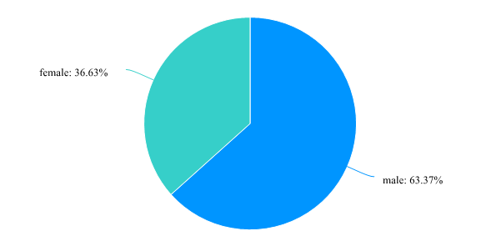
In question 1, the number of female students accounts for 36.63% and that of male students 63.37%. The total number of male students is almost twice that of female students. Because there is a lot of cooking oil in Haidilao hotpot, the number of girls choosing to go to Haidilao hotpot is less than that of boys.
Q.2What is your age range?
18-25; 26-35; 35-45; over 45 years old
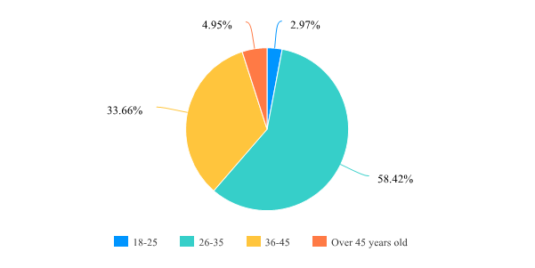
In question 2, 58.42% of the people aged 25-45 accounted for the largest proportion, while only 4.95% of the people aged over 45 accounted for the smallest proportion. Due to the high quality service of Haidilao and the large number of service personnel, as well as the high price of dishes. People aged 25-45 have more stable jobs and higher incomes, so more people enter Haidilao hot pot to eat, and Haidilao is a younger brand concept, so people over 45 do not adapt to the environment of Haidilao hot pot, and less people over 45 enter Haidilao hot pot to eat.
Q.3 what is your profession?
Student; worker
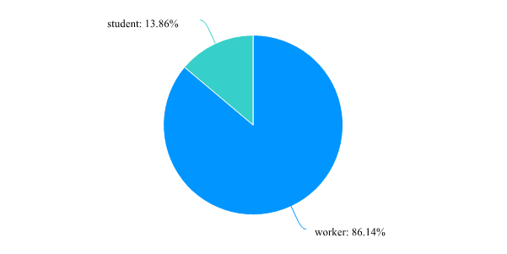
In question 3, the number of middle school students accounted for 13.86%, while the number of workers accounted for 86.14%, and the number of workers was six times that of students. Students usually choose to eat in the school market, while workers often have dinner together, so the proportion of students is obviously less than that of workers.
Q.4 where are you from?
Beijing, Shanghai, Guangzhou, Shenzhen; Provincial capital cities or municipalities directly under the central government, other special economic zones (except Shenzhen); Prefecture Level Cities; County level cities; Township / village / town
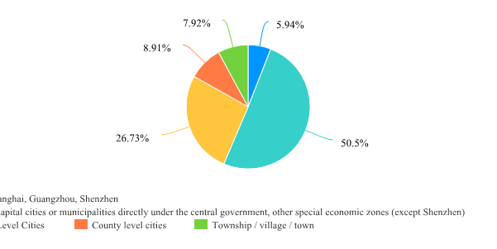
In question 5, people in the provincial capital account for 50.5%, while those in county-level cities and villages account for only 8.91% and 7.92%, indicating that Haidilao hotpot can not survive here because of the backwardness of county-level cities and villages.
Q.5 Do you like Haidilao hotpot?
Like; dislike; normal
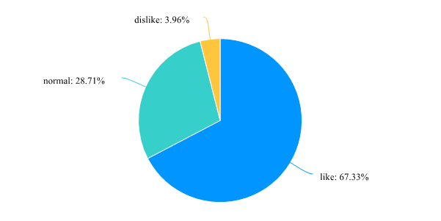
In question 5, 67.33% of people like it and only 3.96% don't like it. The number of people who like Haidilao is 17 times more than those who don't, so most people are satisfied with Haidilao.
Q.6 have you ever had Haidilao hot pot?
Eat regularly; Seldom eat; Never
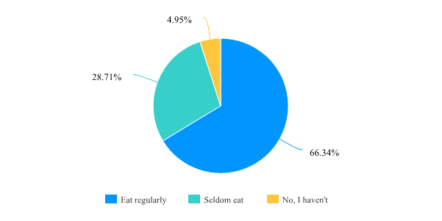
In question 6, 66.34% of people often go to Haidilao for dinner, and only 5.96% of people have never been to Haidilao for dinner, indicating that Haidilao is very attractive to customers and is a popular enterprise.
Q.7 Are you satisfied with the service of Haidilao hotpot?
Very satisfied; normal; unsatisfactory
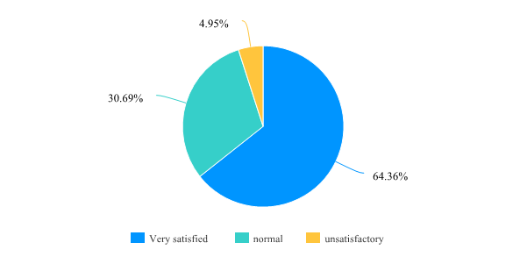
In question 7, 64.36% of the people were satisfied with Haidilao's service, while only 4.95% were dissatisfied with it. Generally speaking, people were satisfied with Haidilao's service, and the dissatisfied people might be due to its expensive dishes or too enthusiastic service staff.
Q.8 What personalized services do you think attract you?
Parking service; Child care services; Manicure service; Shoeshine service; Birthday surprise
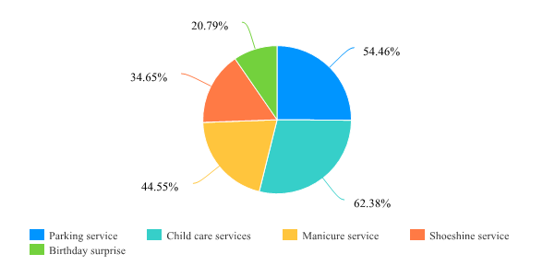
In question 8, there is a multiple-choice question. It is not difficult to see that customers are very urgent about parking services, child care services and manicure services, accounting for 54.46%, 62.38% and 44.55% respectively.
Q.9 What do you think is the most distinctive and attractive aspect of Haidilao hot pot?
Dish taste; Dining environment; Personalized service; take-out food; other
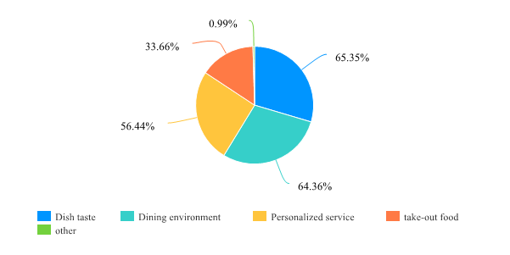
In question 9, the most important point to attract customers to eat at Haidilao is the taste of dishes, accounting for 64.36%. Secondly, its dining environment is also very prominent, accounting for 64.36%, and the proportion of personalized service is also very high, accounting for 54.44%. So, most customers eat in Haidilao hot pot for the taste of dishes, dining environment and personalized service.
Q.10 Are you satisfied with the convenient transportation of Haidilao hot pot?
Very satisfied; normal; unsatisfactory
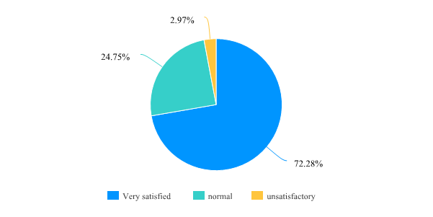
In question 10, 72.28% of the people think that it is very convenient to have a meal in Haidilao hot pot, mainly because Haidilao usually opens a shop near the subway station or the bus, and customers can choose more roads, so most people think that it is very convenient to have a meal in Haidilao.
Q.11 What do you think of Haidilao hot pot takeout service?
very nice ; normal; indifferent
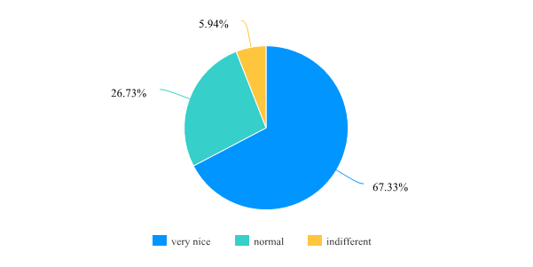
Q.12 Does anyone around you recommend Haidilao to you?
Yes; No
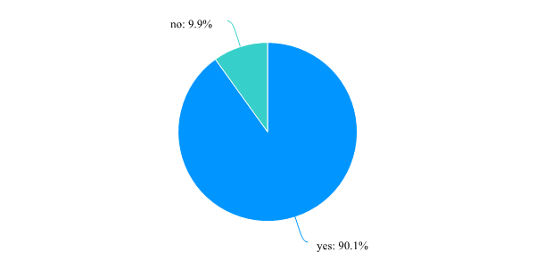
In question 12, 90.1% of the customers said they were introduced to Haidilao for dinner, while only 9.9% said they were not introduced to Haidilao. It shows that the customer retention rate of Haidilao hotpot is very high, and there are many potential customers, who are very satisfied with Haidilao.
Q.13 Do you feel disgusted with some exaggerated Haidilao services on the Internet?
No aversion; Indifferent; That's exaggerating

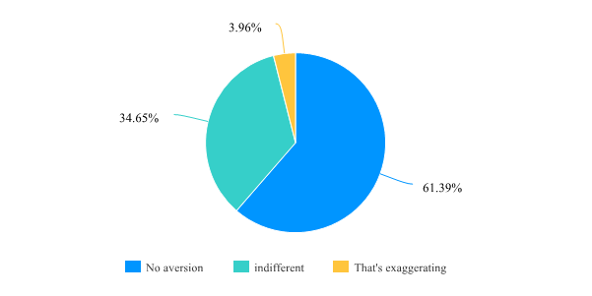
In question 13, 61.39% of the people didn't feel uncomfortable with the service of Haidilao, while 34.65% said they were worried about the service attitude of Haidilao. This kind of people didn't want to be disturbed, just wanted to eat quietly.
Q.14 What do you think the service of Haidilao hot pot service needs to be improved?
Create more dishes; More waiting services; Launch more promotional activities; There is nothing to improve
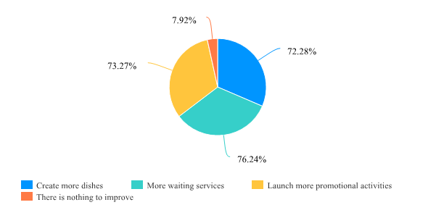
In question 14, this is still a multiple topic. Among the improvements that Haidilao is expected to make, 72.25% of dishes are added, 76.24% of waiting services are improved, and 73.27% of promotional activities are proposed. Due to the booming business of Haidilao, the waiting time for Haidilao is very long, up to two hours at most. Although Haidilao has provided a lot of waiting services, However, due to the long time, customers cannot help but feel bored when waiting.

4.5 Criticizing the service of Haidilao
Although Haidilao has a perfect training system and service attitude, it is not a good thing for a small number of people, because they hope to have a quiet meal and do not want too much interference from the service staff. Moreover, due to the high cost of Haidilao's service training, the price of dishes is stable at a high level. Even if there is a good service attitude, customers' satisfaction with Haidilao will be reduced in the long run. Haidilao should listen to customers' opinions more than just reform its training methods and service attitude.

4.6 Conclusion
This chapter achieves the third objective: This paper analyzes the collected data, makes a critical analysis of Haidilao, and discusses customers' views on the service level of Haidilao hotpot.
In this chapter, data analysis is carried out successfully, and customer satisfaction with the service is discussed. The last chapter achieves the final purpose of this study and puts forward suggestions.

5.0 Chapter Five: Recommendations and Conclusions

5.1 Introduction
The fourth chapter analyzes the data of this study, highlights the important information of this study, and achieves the third objective. This chapter will achieve the latter two objectives.
In the first three parts, understand the practical significance of the research and put forward practical suggestions. And Combined with the limitations of this study, this paper discusses the possible research approaches and directions in the future, improves the research, and increases the research results.

5.2 Recommendations

5.2.1 Change the mode of service
With the change of consumer market, consumer demand is also changing. For example, customers who like the taste of Haidilao don't like the over enthusiastic service features of Haidilao. Introverted customers, on the contrary, will feel annoyed and fidgety because of the service staff's walking back and forth, leading to this kind of consumers can't eat at ease. Haidilao's service attitude is customer-oriented, but it is too model oriented. Therefore, Haidilao should adjust its training mode and service mode according to customers' personality and identity. Service is for customers to have a good dining experience, not for customers to bring trouble.

5.2.2 Appointment function added to the service
Due to the booming business of Haidilao, it is difficult for too many customers to solve the problem of waiting too long for meals. Therefore, Haidilao should increase its own service function and increase the mode of appointment. Customers can use mobile phones, computers, or in store booking to reduce their queuing time. So that customers have a better service experience, but also reduce the time when customers wait for dinner, can also improve customer satisfaction with Haidilao enterprises, so as to increase customer trust in Haidilao.

5.2.3 Change the mode of tutorial system
As the service mode and training system of Haidilao has not been standardized, it relies more on tutorial system. However, due to the rapid development and scale expansion of undersea fishing, it should not be very good to inherit this service mode. How to keep the balance between the humanized tutorial system and the enterprise standard training system, Haidilao needs to change this tutorial system mode to make Haidilao's service more in place.

5.3 summary
Cultivating and bringing up a large number of international level talents and high-level and high-quality innovation teams is an indispensable and arduous task on the road of enterprise development. Employee training is not only an effective way to improve the overall quality of workers, but also a solid strategy to improve the pattern of modern social enterprises. Haidilao should improve its management strategy and staff training system on the basis of constantly absorbing new employees and talents. It is not only necessary to pay attention to the training system of new employees, to implement the innovation strategy and the formulation of employee training strategy, but also to recognize the importance of employee training. At the same time, undersea fishing needs to make enterprises have core competitiveness and realize healthy, stable and dynamic development. Only in this way can it help the development of Haidilao hotpot and the improvement of the staff training system and increase customer satisfaction with Haidilao

5.4 Further Research
This is conducive to the future research on the service system of Haidilao and the investigation of customer satisfaction. In the future, we can provide a richer and more detailed research plan. Further research can also further improve the service training system and enhance customer satisfaction,

5.5 Conclusion
This chapter achieves the fourth and fifth objective: In the first three parts, we understand the practical significance of the research and put forward practical suggestions. And combined with the limitations of this study, this paper discusses the possible research approaches and directions in the future, improves the research, and increases the research results. This study is to understand the training system of Haidilao and to study the customer satisfaction. The objective successfully achieved.

6.0 References
- Baidu, (2020) ‘Training method used in Haidilao’ [Online] Available at: https://wenku.baidu.com/view/04e975d3fac75fbfc77da26925c52cc58ad69063.html, [assessed 26 April 2021]
- Baike, (2020) ‘Questionnaire’ [Online] Available at: https://baike.so.com/doc/5623638-5836256.html, [assessed 5 March 2021]
- Chen，Zhixia; Eisenberger，Robert; Johnson，Kelly M.; Sucharski， Ivan L. and Aselage， Justin.， 2009，“Per⁃ ceived Organizational Support and Extra-Role Performance: Which Leads to Which”， Journal of Social Psychology， Vol.149，pp.119~124
- Chiba Chiba(2018), what are the free services of Haidilao? [Online]， available from: https://baijiahao.baidu.com/s?id=1608743944679884328&wfr=spider&for=pc, (accessed 11 march 2020)
- Club, (2020) ‘Advantages of observation’ [Online] Available at: https://mp.weixin.qq.com/s?src=11&timestamp=1620728639&ver=3062&signature=q5bjgWcpGS6D6wG3obXatdYha31FNt8ikt7i2PHBMzzzTScCKPxmbGkvI6grmNJIGVxNYh4h*ycW*d9*mfAeCYSWWMfkUjjMKbDJmxY5mD2Q0opocGKItl8OCxYPEbn5&new=1, [assessed 1 May 2021]
- Deere, T. and Kennedy, A., (2008), corporate culture: the customs and etiquette of corporate survival translated from Chinese by Li, Y., Beijing: Renmin university of China press
- Dubendorf.JM. Croly M H, Gross rand R H. (2005). ‘The dimensionality and antecedents of emotional labor strategies.’ Jamal of vocational Behavior, 66(2):339-357
- Entrepreneurship College, (2013) ‘Haidilao’ [Online] Available at: https://www.58cyjm.com/html/view/24774.shtml, [assessed 26 April 2021]
- Fan, XC. (2013), on the state - owned enterprise culture present situation and improvement countermeasure, Jinan: Shandong social science, p.30-31.
- Haidilao, (2021) ‘Haidilao’ [Online] Available at: https://www.haidilao.com/zh/gyhdl/ppgs/index.html, [assessed 26 April 2021]
- Jiang, Zike, Li, Xiaofeng, Jin, Weiwei, Yu, Xinsheng, & Zhou, Zhonghai. (2018). Planar optode observation method for the effect of raindrop on dissolved oxygen and pH diffusion of air–water interface. Experiments in Fluids, 59(11), 1-9.
- Koubei,(2021) ‘Haidilao unveracity’ [Online] Available at: https://xue.koubei.com/classroom/7/introduction, [assessed 26 April 2021]
- Lam, c F, and Gurland, s T. (2008) , ‘Self-determined work motivation predicts job outcomes, but what predicts self-determined work motivation’. Journal of Research in Personality, 42（4）:1109-1115
- Li, Z., (2012). Human resource development and economic development. Population and economy.
- Lin, (2019) ‘Face to face review’ [Online] Available at: https://zhuanlan.zhihu.com/p/84798169, [assessed 1 May 2021]
- Long, (2020) ‘Face to face review’ [Online] Available at: https://baike.sogou.com/v354264.htm?fromTitle=%E8%AE%BF%E8%B0%88%E6%B3%95, [assessed 1 May 2021]
- Lytle, R s, Timmerman, J E. (2006), ‘Service orientation and performance: An organizational perspective ‘. Journal of Services Marketing, 20(2): 136-147.
- MBA, （2020）‘Training method used in Haidilao’ [Online] Available at: https://doc.mbalib.com/view/a3514f9ada556e41fe05bc5a3130a2af.html, [assessed 1 May 2021]
- MBA, (2021) ‘Observation method’ [Online] Available at: https://wiki.mbalib.com/wiki/%E8%A7%82%E5%AF%9F%E6%B3%95, [assessed 1 May 2021]
- MBA，（2020），‘Systematic training mode’ [Online] Available at: https://wiki.mbalib.com/w/index.php?title=%E7%B3%BB%E7%BB%9F%E5%9E%8B%E5%9F%B9%E8%AE%AD%E6%A8%A1%E5%BC%8F&printable=yes, [assessed 6 February 2021]
- Qi dai, (2021) ‘Zhang yong’ [Online] Available at: https://baike.sogou.com/v64417934.htm?, [assessed 26 April 2021]
- Qie, (2013)‘Background of Haidilao’ [Online] Available at: http://blog.sina.com.cn/s/blog_72dd3d180101fgzv.html, [assessed 6 February 2021]
- Sheng, (2019) ‘Background of Haidilao’ [Online] Available at: https://wenku.baidu.com/view/98093d5b7e192279168884868762caaedd33bac4.html, [assessed 26 April 2021]
- Sougou, (2017）’ Observation method’ [Online] Available at: https://baike.sogou.com/v354252.htm?fromTitle=%E8%A7%82%E5%AF%9F%E6%B3%95, [assessed 1 May 2021]
- Sougou, (2018) ‘Training methods’ [Online] Available at: https://wenwen.sogou.com/z/q655154889.htm, [assessed 26 April 2021]
- Sougou, (2018) ‘Training methods’ [Online] Available at: https://wenwen.sogou.com/z/q655154889.htm, [assessed 26 April 2021]
- Sougou, (2018) ‘Training methods’ [Online] Available at: https://wenwen.sogou.com/z/q655154889.htm, [assessed 26 April 2021]
- Sougou, (2021) ‘Haidilao’ [Online] Available at: https://baike.sogou.com/v362580.htm?fromTitle=%E6%B5%B7%E5%BA%95%E6%8D%9E, [assessed 26 April 2021]
- Souhu, (2019) ‘Haidilao unveracity’ [Online] Available at: https://www.sohu.com/a/299775728_347412, [assessed 26 April 2021]
- Taodocs, (2014) , ‘Research on the maturity of enterprise training management based on systematic training mode’ [Online] Available at: https://www.taodocs.com/p-3783157.html, [assessed 6 February 2021]
- Taylor, F., (2007). The principles of scientific management. Beijing: China Machine Press.
- Wenku, (2010) Advantages of observation’ [Online] Available at: https://wenku.baidu.com/view/92ce37886529647d272852cd.html，[assessed 1 May 2021]
- Wenwen, (2014) ‘Training method used in Haidilao’ [Online] Available at: https://wenwen.sogou.com/z/q583889326.htm, [assessed 26 April 2021]
- Westbrook, Johanna I, & Ampt, Amanda. (2008). Design, application and testing of the Work Observation Method by Activity Timing (WOMBAT) to measure clinicians’ patterns of work and communication. International Journal of Medical Informatics (Shannon, Ireland), 78, S25–S33. https://doi.org/10.1016/j.ijmedinf.2008.09.003
- Westbrook, Johanna I, and Ampt, Amanda. "Design, Application and Testing of the Work Observation Method by Activity Timing (WOMBAT) to Measure Clinicians’ Patterns of Work and Communication." International Journal of Medical Informatics (Shannon, Ireland) 78 (2008): S25-33. Web.
- Xiao, M., (2014). Introduction to human resource development. BeiJing: Peking University Press.
- yebaike, (2020）’Questionnaire’ [Online] Available at :https://www.yebaike.com/22/716381.html, [assessed 5 March 2021]
- Yige, (2020) ‘Brand and culture of Haidilao’ [Online] Available at: https://mp.weixin.qq.com/s?src=11&timestamp=1620702982&ver=3061&signature=yTHRl8EUX5yFy*-4fLc5IPiXXebCVza5KgtPHxQbYY1D98BiMGFItPXDsanfhpPXOAOYCX1rjZ4Wa1xnnIR4CVt4HqCJYgZ6Qg0YOut0tg-pUtsGuYq*nwC*qF6NBOFn&new=1, [assessed 26 April 2021]
- Zhang yong (2010) ‘To create a catering brand recognized by the people all over the country’ [Online] Available at: https://www.docin.com/p-528981057.html, [assessed 26 April 2021]
- Zhang, X.,2014a. Design and Implementation of Personnel Training Management System. [Online] Available at: https://cnki001.zsafw.com:8011/kns/brief/Default_Result.aspx?txt_1_sel=FT%24%25%3D%7C, [assessed 6 February 2021]
- Zhou, J.,2013 Taylor's paradigm of scientific management and its ideological value. Scientific research.

7. Appendices
Q.1 what’s your gender?
Male; female
Q.2What is your age range?
18-25; 26-35; 35-45; over 45 years old
Q.3 what is your profession?
Student; worker
Q.4 where are you from?
Beijing, Shanghai, Guangzhou, Shenzhen; Provincial capital cities or municipalities directly under the central government, other special economic zones (except Shenzhen); Prefecture Level Cities; County level cities; Township / village / town
Q.5 Do you like Haidilao hotpot?
Like; dislike; normal
Q.6 have you ever had Haidilao hot pot?
Eat regularly; Seldom eat; Never
Q.7 Are you satisfied with the service of Haidilao hotpot?
Very satisfied; normal; unsatisfactory
Q.8 What personalized services do you think attract you?
Parking service; Child care services; Manicure service; Shoeshine service; Birthday surprise
Q.9 What do you think is the most distinctive and attractive aspect of Haidilao hot pot?
Dish taste; Dining environment; Personalized service ; take-out food; other
Q.10 Are you satisfied with the convenient transportation of Haidilao hot pot?
Very satisfied; normal; unsatisfactory
Q.11 What do you think of Haidilao hot pot takeout service?
very nice ; normal; indifferent
Q.12 Does anyone around you recommend Haidilao to you?
Yes; No
Q.13 Do you feel disgusted with some exaggerated Haidilao services on the Internet?
No aversion; Indifferent; That's exaggerating
Q.14 What do you think the service of Haidilao hot pot service needs to be improved?
Create more dishes; More waiting services; Launch more promotional activities; There is nothing to improve

