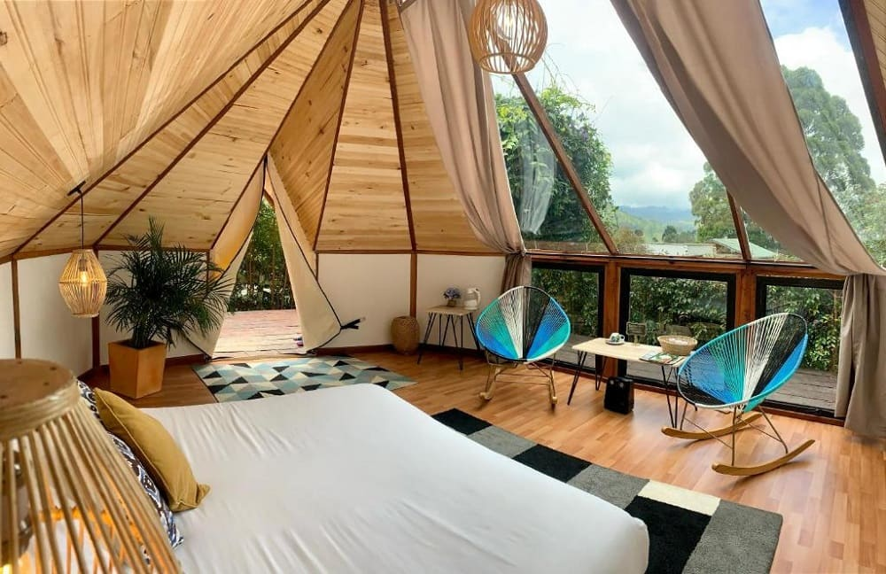
Eco Lux Glamping Retreat Ltd

Business Plan
Programme of Study: Business Management
Module: Enterprise & Entrepreneurship (LCLM4006)
Student Name: Kevin Fernando Useche Giron
Student Number: 2441569
Lecturer: Konstantina Mari

Table of Contents
1. Executive Summary
2. Overview of the Business Idea
3. Market Research (Environmental Analysis and Competition)
3.1. Pestle analysis
4. Marketing Communications
5. Financials
6. Swot analysis.
7. conclusion
8.List of references.

Executive Summary
EcoLux Glamping Retreat Ltd is a sustainable hospitality start-up offering affordable luxury glamping experiences in semi-rural UK locations. The concept capitalises on the growth of domestic tourism and ‘staycations’, where consumers seek nature-based escapes without the cost of international travel (VisitBritain, 2023). EcoLux positions itself between traditional camping and boutique countryside hotels, combining hotel-level comfort with immersive natural surroundings.
The business will operate as a Private Limited Company (Ltd), providing limited liability and an attractive structure for external investment. The start-up requires £85,000, funded through £15,000 founder capital, a £40,000 bank loan, and £30,000 angel investment for 20% equity, balancing control with financial stability and strategic support.
Financial projections are based on six luxury tents, an average nightly rate of £120, and 60% occupancy, generating estimated annual revenue of £155,520. With fixed costs of approximately £9,000 per month and a contribution margin of £80 per booking, break-even is expected within 16 months. EcoLux differentiates itself through sustainability-led operations, strong visual branding, and a digital-first marketing strategy to drive bookings efficiently (Kotler and Keller, 2016).

Overview of the Business Idea
EcoLux will offer a glamping experience that combines comfort, privacy and sustainability. The core product consists of six safari-style tents equipped with double beds, private bathrooms, heating, insulated flooring, solar-powered electricity and outdoor decking areas. Additional services such as romantic packages, breakfast hampers, late check-out and eco-activities will enhance customer experience and increase revenue.
The concept aligns with the experience economy, where consumers increasingly value unique and memorable experiences over functional services (Pine and Gilmore, 1999). EcoLux is designed to be visually appealing while maintaining sustainability, positioning itself as ‘Affordable Luxury in Nature’, offering higher comfort than campsites at a lower price than boutique hotels.
The business will be led by the Founder and Managing Director, Kevin Fernando Useche Giron, supported by two Hospitality Assistants and a part-time Marketing Manager responsible for digital campaigns and customer engagement.
EcoLux will operate as a Private Limited Company (Ltd), providing limited liability and a clear structure for investment. Key legal requirements include planning permission, public and employer liability insurance, fire safety certification, health and safety compliance, and environmental regulations.

Management Structure (Hierarchy Diagram)
Managing Director (Kevin Useche Giron)
↓
-----------------------------
↓ ↓
Hospitality Assistants Marketing Manager (Part-time)

3. Market Research
PESTEL Analysis:
Market research combines environmental analysis (PESTEL) with an assessment of competition and customer behaviour. The UK tourism market continues to support domestic and nature-based travel, with strong demand for short, experience-driven stays (VisitBritain, 2023). However, high customer choice and online price comparison increase competition, making differentiation and strong brand credibility essential.
Industry data also indicates that similar UK glamping businesses operate successfully within this pricing range, supporting the feasibility of the proposed revenue model (Statista, 2023; AirDNA, 2023).
Political: Domestic tourism remains strategically important for regional economic activity. Supportive local development initiatives can benefit rural hospitality, but planning permission and local council requirements may extend timelines. EcoLux will mitigate this by selecting land with compatible zoning and engaging early with planning authorities.
Economic: Inflation increases the costs of materials, utilities and labour. However, the relative affordability of UK staycations versus overseas travel helps maintain demand. EcoLux’s pricing will be positioned as accessible luxury, protecting demand during uncertainty by offering value compared with boutique hotels.
Social: Consumers increasingly prioritise wellbeing, nature connection and sustainable consumption. The experience economy trend supports premium ‘micro‑breaks’ and social‑media‑friendly stays (Pine and Gilmore, 1999).
Technological: Booking platforms (Airbnb, Booking.com) and digital advertising lower barriers to market entry but increase competitive pressure. EcoLux will use technology for booking automation, CRM email follow‑ups, and review management to build credibility and repeat purchases (Chaffey and Ellis‑Chadwick, 2019).
Environmental: Environmental awareness is both an opportunity and a responsibility. EcoLux’s solar power and waste‑reduction policies strengthen brand legitimacy. The business will implement recycling, responsible water usage, and supplier policies to minimise ecological impact.
Legal: Compliance is essential in hospitality. Fire safety, risk assessments, insurance, data protection and employment standards must be met to avoid operational disruption and reputational damage.
Competition analysis:
Similar glamping businesses in the UK report occupancy rates between 50%–70% (Statista, 2023). This supports the financial assumptions used in this plan.

4. Marketing Communications
Marketing Communications will focus on building awareness and trust through a digital‑first approach supported by partnerships and customer feedback. The target segments are: (1) urban professionals aged 25–40 seeking weekend resets, (2) couples seeking romantic getaways, and (3) eco‑conscious travellers who value sustainability alongside comfort.
4.2 tactics:
Website and SEO: a professional website will function as the primary channel, optimized for keywords such as ‘glamping near [city]’ and ‘eco glamping weekend’. SEO content (short blog posts and local guides) will support organic discovery over time.
Platform listings: Airbnb and Booking.com will be used to access demand quickly. Listings will highlight differentiators, clear policies, and professional photos.
Paid social advertising: Instagram and TikTok ads will target urban audiences within travel distance. Initial campaigns will use a launch offer (e.g., 20% off midweek stays) to build early occupancy and reviews.
Influencer and micro‑creator collaborations: carefully selected local creators will exchange a stay for content under clear deliverables. Micro‑influencers often deliver better engagement within niche travel communities.
Email and CRM: post‑booking emails will set expectations and upsell add‑ons (breakfast hamper, late checkout). Post‑stay emails will request reviews and offer a return‑guest discount.
Partnerships: partnerships with local activity providers will bundle experiences, increase perceived value and create cross‑promotion.

5. Financials
Funding requirement and sources: EcoLux requires £85,000. Funding will be sourced from £15,000 personal capital, £40,000 bank loan, and £30,000 angel investment. Personal capital demonstrates founder commitment and reduces external dependence. A bank loan preserves founder control while providing structured capital; repayments are included in cash flow. Angel investment provides growth capital and strategic guidance and supports faster brand development.
Main start‑up expenses expected in the first month of operations (budget):
Land lease deposit: £15,000
Six luxury safari tents: £30,000
Bathroom installation and plumbing connection: £10,000
Solar infrastructure and basic electrics: £8,000
Marketing launch budget (website, photography, ads): £5,000
Insurance and licences: £2,000
Working capital (utilities deposits, supplies, contingency): £15,000
Total: £85,000
Sales forecast assumptions: 6 tents; average nightly rate £120; 30 days per month; 60% occupancy. Monthly revenue = 6 × £120 × 30 × 0.60 = £12,960. Annual revenue = £12,960 × 12 = £155,520. The pricing and occupancy assumptions are based on industry benchmarks within the UK glamping and short-term rental market. According to Statista (2023), the UK glamping market has experienced consistent growth, with average occupancy rates ranging between 50% and 70% depending on location and seasonality. Similarly, AirDNA (2023) reports that short-term rental properties in rural and semi-rural UK areas achieve average nightly rates between £100 and £150, supporting the proposed pricing strategy of £120 per night.
These benchmarks indicate that the financial assumptions used in this business plan are realistic and aligned with current market conditions, reducing forecasting risk and increasing investment credibility.
Cash flow forecast: Operating costs are estimated at £9,000 per month (staffing, cleaning, utilities, supplies, platform fees). Loan repayment is estimated at £800 per month (illustrative). Other costs (marketing and maintenance) are estimated at £900 per month, giving total outflows of £10,700. Projected net cash flow = £12,960 − £10,700 = £2,260 per month. Positive net cash flow supports reinvestment in quality improvements and seasonal promotions.
Break‑even calculation: Fixed costs are approximately £9,000 per month. With an average contribution margin of £80 per booking, the break‑even volume is 9,000 ÷ 80 = 112.5 bookings, rounded to 113 bookings per month. With 6 tents, 60% occupancy equates to roughly 108 tent‑nights per month; therefore, break‑even is achievable through occupancy optimisation, higher weekend pricing, and add‑on sales. A realistic timeline to break‑even is approximately 16 months, allowing for seasonal variation and ramp‑up in review volume.
The contribution margin assumption is consistent with industry practices in the hospitality sector, where pricing strategies typically aim to balance affordability with premium experience positioning (Kotler and Keller, 2016).

5.1 Net cash flow.
Month | Revenue (£) | Cost(£) | Loan (£) | Other (£) | Net (£)
Jan | 12960 | 9000 | 800 | 900 | 2260
Feb | 12960 | 9000 | 800 | 900 | 2260
Mar | 12960 | 9000 | 800 | 900 | 2260
Apr | 12960 | 9000 | 800 | 900 | 2260
May | 12960 | 9000 | 800 | 900 | 2260
Jun | 12960 | 9000 | 800 | 900 | 2260
Jul | 12960 | 9000 | 800 | 900 | 2260
Aug | 12960 | 9000 | 800 | 900 | 2260
Sep | 12960 | 9000 | 800 | 900 | 2260
Oct | 12960 | 9000 | 800 | 900 | 2260
Nov | 12960 | 9000 | 800 | 900 | 2260
Dec | 12960 | 9000 | 800 | 900 | 2260

6. SWOT Analysis
Strengths: Affordable pricing, sustainability positioning.
Weaknesses: Seasonal demand, high startup costs.
Opportunities: Growing eco-tourism market.
Threats: Weather, economic downturn, competition.

7. Conclusion
EcoLux Glamping Retreat Ltd presents a viable and investable concept aligned with domestic tourism and sustainability trends. The business offers premium nature-based accommodation at an accessible price, targeting urban professionals and couples. Its focus on environmental responsibility strengthens brand credibility and customer trust. Strong market demand, combined with a clear financial structure and break-even strategy, supports its viability and scalability. Once established, the model can be expanded into additional locations.

8. Reference List
Chaffey, D. and Ellis-Chadwick, F. (2019) Digital Marketing. Harlow: Pearson.
Kotler, P. and Keller, K. (2016) Marketing Management. Harlow: Pearson.
Pine, B.J. and Gilmore, J.H. (1999) The Experience Economy. Boston: Harvard Business School Press.
Porter, M.E. (1980) Competitive Strategy. New York: Free Press.
Statista (2023) UK Glamping Market.
VisitBritain (2023) Domestic Tourism Trends Report.
Xiang, Z. and Gretzel, U. (2010) Tourism Management.

