Consultancy Report on Digital Transformation and Guest Personalization for Burj Al Arab, Dubai

Consultant Information:
Student Name: IULIANA MATEVICI
Student Number: 2211946
Consulting Firm: Inspire Luxe Consulting
Date: 30th October 2024.

I

Executive Summary
Burj Al Arab, Dubai’s case is analysed through this consultancy report to investigate the challenges and potential strategic benefits of incorporating into its luxury hospitality model for personalization powered by AI. Rodrigo Pellegrin and the Burj Al Arab team are under some pressure as an icon of luxury worldwide, to incorporate digital tools that allow for personalisation in line with modern guest expectations. The introduction of artificial intelligence (AI) and Internet of Things (IoT) technologies in a high touch and service-oriented environment such as Burj Al Arab, however, is not easy as it has its own complexity. As regards this, the hotel must find a balance between the advantages of these technologies—as which it shall enhance guest experience—but also between strict ties of data privacy and security as encapsulated by data protection laws, particularly as the hotel is a high-profile client and such in Dubai. The challenge of integrating AI without compromising the luxury, human centred service that characterizes Burj Al Arab is critical and this paper attempts to provide a prospective about how to do so effectively.
Most importantly, the analysis examines critical data privacy, service consistency and regulatory compliance as the biggest challenges for AI to be used for guest personalization. Private data protection is particularly important at Burj Al Arab, as the resort is used by high-net-worth guests, who are especially sensitive to privacy. Transitions to AI driven personalization could threaten the traditional service standards upon which Burj Al Arab's reputation is built, at the same time. This demands an open and hybrid approach interwoven between the human eye and the AI grasp. The UAE`s data security laws that necessitate specific disobedience and data coalescence get in the offing of data integration. There is no point to manage the elements in these areas, failure to do so can kill the hotel’s reputation, Guest loyalty. To unravel these complexities, the report uses PESTEL, SWOT, and TOWS to get a holistic sense of the external forces, internal strengths and weaknesses and the strategic opportunities.
Finally, with the PESTEL analysis it provides key external influences; namely government support of technological advancement alongside tough privacy laws; the economic significance of Dubai’s resilient luxury market; and a social trend toward more personalized but more private guest experiences. Given the hotel’s existing strengths, both in terms of brand reputation, its financial abilities, and its pre-existing dedication to excellence in service, it is well placed to go digital. But its current digital infrastructure is weak with a heavy reliance on manual personalization which could hold it back from scaling. There are opportunities to take advantage of growing demand for tech enhanced guest experiences as well as threats of privacy concerns, cyber risk, and high implementation costs that need to be cautiously planned for.
Bearing these finding in mind, the report recommends personalized AI innovations centred around Burj Al Arab’s specific context. They include AI guest preference tracking to predict and respond to guest needs, smart room technology that responds to guest preferences, and AI empowered communication to provide a more personalized experience from check in through to check out. Data minimisation, encryption and clearly defined access controls are advised, as is strict privacy compliance with UAE and international privacy regulations. Having a consent management system in place will mean your guests can view and manage their data preferences to increase transparency and build trust. Initially, Kotter’s 8 Step Change Model is recommended to facilitate implementation to set a mood of urgency and build a coalition of leaders in the hotel. To keep adoption rates high and to maintain that AI enhances and complements, rather than replaces, a prime location of staff training will be essential.
These initiatives are going to be measured in terms of success and performance monitoring will come in play with the Key Performance Indicators (KPIs) like guest satisfaction score, repeat guest rate, analysis of privacy handling, and efficiency of AI system. It will also indicate to us how well we have tracked employee engagement with the new tools as an indication of the effectiveness of the change management process. For this solution, estimated initial implementation costs of AI and IoT infrastructure, data security upgrades and training programs amount to $850,000 to $1,350,000, with annual maintenance costs of $150,000.
Overall, combining this AI driven personalization with this strategic integration of AI personalization provides Burj Al Arab a way to improve guest experiences while staying true to their luxury standards and data security. Implementing these guidelines will assist Burj Al Arab to release its service offerings to more sophisticated requirements of modern luxury traveller while maintaining guest’s trust. The proposed strategies are precisely in line with the hotel’s values, letting the hotel continue being a front runner in luxury hospitality and innovation.

Table of Contents
Executive Summary 2
Introduction 6
Hotel Background 6
Consultancy Background 7
Problem Context 7
Frameworks to Be Used 7
Analysis 9
Issue Identification 9
External Factors: PESTEL Analysis 10
Internal Assessment: SWOT Analysis 14
Strategic Insights: TOWS Analysis 16
Recommendations and Change Management 18
Personalization Strategies 18
Data Security 19
Change Management Frameworks 21
Performance Monitoring 22
Cost Analysis 25
Action Plan 28
Conclusion 30
Summary of Key Points 30
Closing Remarks 30
References 32

Table 1: External Factors: PESTEL Analysis for Burj Al Arab 11
Table 2: Internal Assessment: SWOT Analysis 15
Table 3: Strategic Insights: TOWS Analysis 16
Table 4: Cost Analysis Table for Implementing AI Driven Technology for personalized customer satisfaction 25
Table 5: Action Plan Table 28

Figure 1: Burj Al Arab 6
Figure 2: Number of Luxury Hotels in the Gulf Corporation Council (Source: Mordor Intelligence, 2024) 11
Figure 3: Global Spending on Luxury Leisure Hospitality (Source: Constantin et al., 2024) 14
Figure 4: Kotter’s 8-Step Change Model (Source: Bedard, 2023) 21

Introduction

Hotel Background
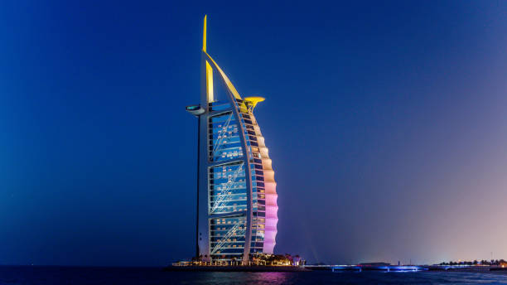
Figure 1: Burj Al Arab
Luxury hotel on an artificial island 280 meters off site — Burj Al Arab in Dubai, UAE. Completed in 1999, the 321 meters dhow inspired structure was designed by Tom Wright. Its 202 duplex suites are 170 to 780 square meters and are spread evenly between two buildings. With an atrium of 180 meters, it's one of the tallest in the world. At 210 meter (690 feet) above ground, the Burj Al Arab features a helipad and a 200 meter (650 feet) cantilevered restaurant above sea level. Situated in Dubai, it symbolises Dubai’s growth and futuristic vision (manged by Jumeirah group) (Davidson, 2019).

This is widely recognised as one of the world’s most luxury hotels, often referred to as ‘world’s only ‘seven stars’ property. The hotel is an iconic landmark design to represent a billowing sail, located within a man-made island and helps define the Dubai skyline and luxury tourism (Heyes, 2021). The Burj Al Arab is a symbol of opulence, a place for high-net-worth individuals, celebrities, and dignitaries to be private, exclusive, and personalized (Alp Sarper, 2022). For the hotel to have a superior position when a top example of digital transformation being in the luxury hospitality sector, the clientele anticipates a seamless transition from traditional luxury to modern innovation (Cavendish Maxwell, 2024). Comprising hotel’s mission statement, the commitment provides the delivery was bespoke experiences with no diminishment to the highest standards in the business.

Consultancy Background

Inspire Luxe Consulting is an established consultancy dedicated to the digital transformation strategies for the luxury hospitality industry, and this report is prepared by them. We have years of experience in arranging for a high-profile property, to integrate advanced digitals to improve the guests experience while maintaining the extreme high standard of privacy. We help with artificial intelligence (AI) for personalization, data driven insights into customers and strategic change management. Our focus is on a balance approach between innovative technology solutions that are as aligned as possible with our clients’ brand values and operational goals. It is a unique position to take on the challenging questions related to Burj Al Arab’s digital transformation and personalizing guests’ objectives.

Problem Context
Against the backdrop of digital personalization trends reshaping the hospitality landscape, Burj Al Arab (Mashfi, 2023) is being challenged to use and leverage AI and digital tools to deliver on delivering memorable, tailored guest experiences without sacrificing privacy and security. The hotel, however, must address complex data protection requirements in adherence to its ultra luxury clientele’s privacy concerns, and with implementation of AI driven personalization strategies (ENISA, 2024). If it doesn’t get fixed, then its liable to expose you to reputational risks and hurt guest loyalty. Digital transformation, if conducted properly, can help Burj Al Arab in its intent to personalize service, improve guest retention and stay competitive. While balancing personalization with privacy on data and integration of AI without hurting the human centric model that makes the brand, is a considerable challenge this report tries to address (Mann et al., 2024).

Frameworks to Be Used
To thoroughly analyse and provide actionable solutions for Burj Al Arab, several analytical frameworks will be employed:
- PESTEL Analysis: This tool will analyse external influences impacting Dubai’s efforts of digital transformation and personalization including technological developments, regulatory standards, and competitive pressures in Dubai’s high-end market.
- SWOT Analysis: This analysis will help identify internal strengths, weaknesses, opportunities, and threats so that insights about Burj Al Arab’s current capabilities and potential weak points in the process of implementing digital personalization strategies can be drawn.
- TOWS Analysis: The TOWS analysis based on SWOT takes current internal factors and contrasts them with external threats to come up with a series of strategic solutions for exploitation of new opportunities, improvement of efficiencies and the mitigation of threats.
- Change Management Theories: The implementation phase will be led by frameworks such as Kotter’s 8-step model aiming at encouraging stakeholder engagement, managing staff adapting to new digital tools and that changes are in sync with Burj Al Arab’s brand values and service standards (Burnes, 2014).

Analysis

Issue Identification

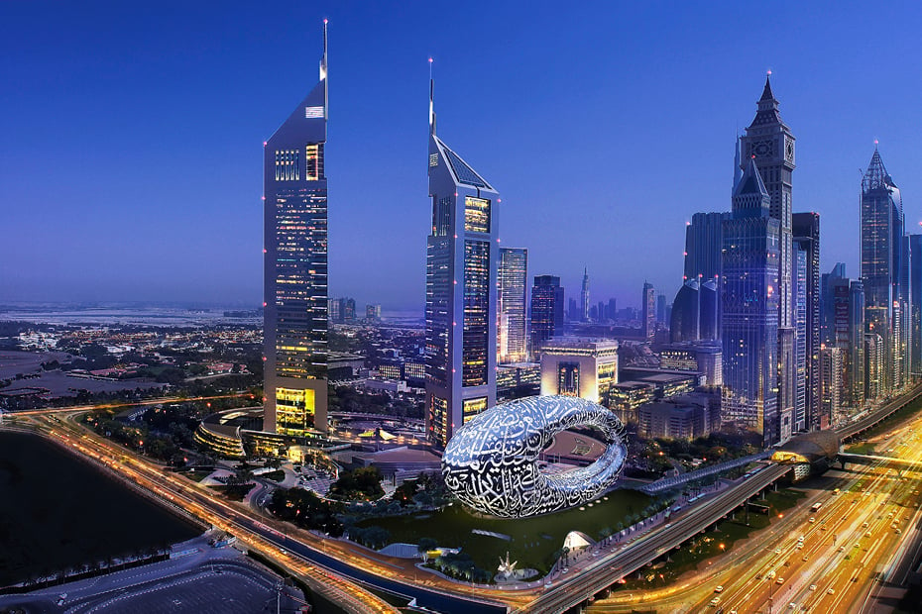
As one among the world's leading luxury hotels, Burj Al Arab has consistently fostered a reputation for opulent and personalized service to high-net-worth individuals, celebrities, and dignitaries. More recently digital transformation has led to more personalised and data rich experiences for guests that have been made possible by luxury hospitality (Sahota, 2024). reties, and dignitaries. In recent years, digital transformation has become a powerful tool in luxury hospitality, enabling hotels to offer more personalized, data-driven experiences to guests (Sahota, 2024). On the other hand, integration of AI and other digital tools for personalization will present some challenges with the integration of AI and digital tools, while at the same time maintaining the Burj Al Arab sterling service standard with the heat of maintaining privacy regulations (Jiwnani, 2024).
The main issue that Burj Al Arab is facing with regards to implementing AI driven personalization to improve customers’ experience, whilst retaining the luxury level of service, while protecting data privacy (Said, 2023). Personalization tools based on AI such as predictive analytics and real time preference tracking, help hotels to better predict and respond to guest needs (Zarezadeh, Rastegar and Xiang, 2022). But these tools could provide insight into what guests prefer, and in the case, it might allow Burj Al Arab to offer services that feel more bespoke, and tailor made for each person’s personal tastes. In fact, the clientele at Burj Al Arab is particularly sensitive on privacy and data security (Luxury Lifestyle Awards, 2023). Data collection practices may be off putting for events where high-profile guests are expected to take part, especially in a region such as the UAE, where data privacy laws are stiff. Burj Al Arab must respond to these challenges in a sensitive way to minimise any compromising of guest trust, so crucial to its brand reputation (Shin, et al 2022).
In addition, although AI increases personalisation, it may inadvertently cause the loss of the traditionally very high levels of human interaction and service consistency experienced by Burj Al Arab. To maintain the quality and exclusivity of a personalized experience while maintaining the human touch, an AI supportive approach is needed (hybrid), in which AI is there to complement, instead of replacing, the human service (Ordóñez-Martínez, Seguí-Pons and Ruiz-Pérez, 2023). Compounding all this complexity is the fast pace of tech change: Burj Al Arab must keep adjusting its digital strategy to stay relevant in a competitive luxury space and remain compliant with moving data privacy regulations.

External Factors: PESTEL Analysis
The PESTEL framework structurally analyses the macro-environment factors influencing the efforts of Burj Al Arab to integrate AI based guest personalization. The Table below represents each factor that has a straight impact on the challenges and opportunities that the hotel is facing in its digital transformation journey (Alrawadieh, et al., 2021).
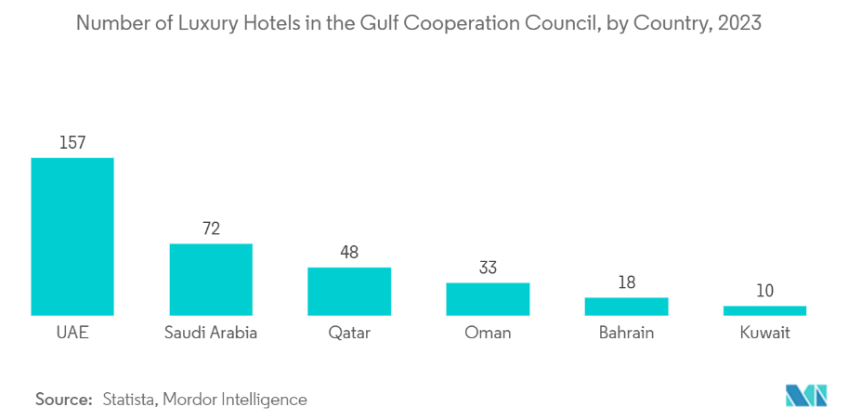
Figure 2: Number of Luxury Hotels in the Gulf Corporation Council (Source: Mordor Intelligence, 2024)

Table 1: External Factors: PESTEL Analysis for Burj Al Arab
Factor | Description
Political | The Luxury Institute (2024) points out that in Dubai’s government actively promote innovation and technological advancement in the most tourism relevant sectors, such as luxury hospitality. The UAE is a leading region in many ‘Smart Cities’ initiatives and supports for the AI. Yet, businesses face great regulatory demands for compliance with strict data privacy laws for data storage and transfer (Vij and Rizwan, 2022). Failure may cost a hotel like Burj Al Arab a fine or cause reputational damage (Noordzij, 2015), and so it must comply with local data laws and with international standards. On top of that, the purpose of the guest data in ourselves and with the hotel adds complexity in how we will implement a personalized AI-driven system, which the hotel will need to treat responsibly as they handle guest data and comply with privacy expectations as well as legal requirements.
Economic | Dubai luxury market is one of most resilient globally, attracting high net worth individuals that require a top tier service (COLIFE Dubai, 2024). Steady flow of tourists in the local economy: mainly from the Europe, Asia, and North America (Unwto.org, 2022). Yet in Dubai luxury hotels are growing increasingly competitive and incurring rising operational costs as they sell high technology or state of the art services (Garrison and Thompson, 2021). It is a manifestation of investing in technology and high skilled personnel to navigate and decipher AI generated insights (Morgan, Warren-Smith, and Kelly, 2020). Burj Al Arab has the financial resources to cover these investments, however, only if the return on investment fits the costs (Gajić, et al, 2024). Any economic downturn, or in fact, fluctuations in tourism or spending patterns amongst luxury travellers, could render long term investment in advanced technology unfeasible (Line, et al., 2020).
Social | With many travellers, particularly within the luxury segment, growing more interested in personalized interactions, there is a higher demand for the personalized guest experiences. More generally modern luxury clients expect hotels to meet their needs, to remember and anticipate previous preferences with the intention to provide personalised services felt exclusive to them (as D’Acunto, Volo and Filieri, 2021). While this demographic is also a privacy conscious demographic that does not want to be distributed with massive data collection that could seem intrusive (Ehl.edu, 2024). For Burj Al Arab, this presents a challenge as the ability to deliver this level of personalization requires guest data to be accessed and processed. This leaves the middle ground between personalisation and respect for privacy. Guests expect the hotel to provide them with the peace of mind that the data they provide gets taken care of securely, and only for the betterment of their experience. Along with this increasing social attitude towards sustainability towards an eco-conscious hotel, the use of technology that not only personalizes, but also helps with energy efficiency.
Technological | The hotel industry is benefiting from rapid advancement in AI & IoT to reach steady state operations and unprecedented levels of personalization (Karadayi-Usta, 2024). These technologies include smart room controls that sense what guests will like, smart analytics for future guest preferences, and even artificial intelligence (AI) based concierge service at Burj Al Arab. In addition, technology implementation is accompanied by cybersecurity risks (Elphick, 2024). Hotels of this kind, such as Burj Al Arab, can easily become targets for cyber-attacks in view of the sensitive personal information they are working with. To protect guest data and trust, the most important, is ensuring robust cybersecurity measures. Due to the fast pace of technology change, Burj Al Arab needs to keep up with the increasing rhythm record. A problem of managing regular updates and possible incompatibility of old and new technologies can be seen as disruptive (Fragnière and Yagci, 2021).
Environmental | With sustainability fast becoming a priority in luxury hospitality, guests prefer hotels that make little environmental impact (Pereira, Silva, and Dias, 2021). Following are energy saving solutions implemented in guest rooms to save the overall energy in Burj Al Arab (Vivek Sadh, 2024): It is in line with Dubai’s efforts to promote green tourism and strengthening Burj Al Arab’s swanky credentials among eco travellers. Using smart technology to optimize resource use allows the hotel brand to further brand as a responsible, environmentally conscious luxury provider appealing to a guest market that values sustainability as part of the luxury experience (EY, 2023).
Legal | In the case of the UAE, it has very specifically passed laws on data privacy, including explicit consent, data localization and transparency around personal data (pwc.com, 2023). What makes the legal landscape for data privacy so complicated is that a guest is national in nature and the laws differ from one country to another (buttrick 2009) meaning that data privacy can vary depending on a guest’s nationality. It also means that the hotel must cope with international regulations, like GDPR for guests from the EU. Substantial fines and reputation damage are threatened if any data governance practices at Burj Al Arab (Hotel Tech Report, 2020) are not robust. This means that all AI and personalization initiatives should absolutely adhere to these legal standards to not be exposed to potential legal consequences.

Internal Assessment: SWOT Analysis
Based on the internal perspective, the SWOT analysis of Burj Al Arab’s capabilities to establish the concept of AI powered personalization shows weaknesses that the hotel needs to overcome and areas in which it could exploit its strength to minimize risks.
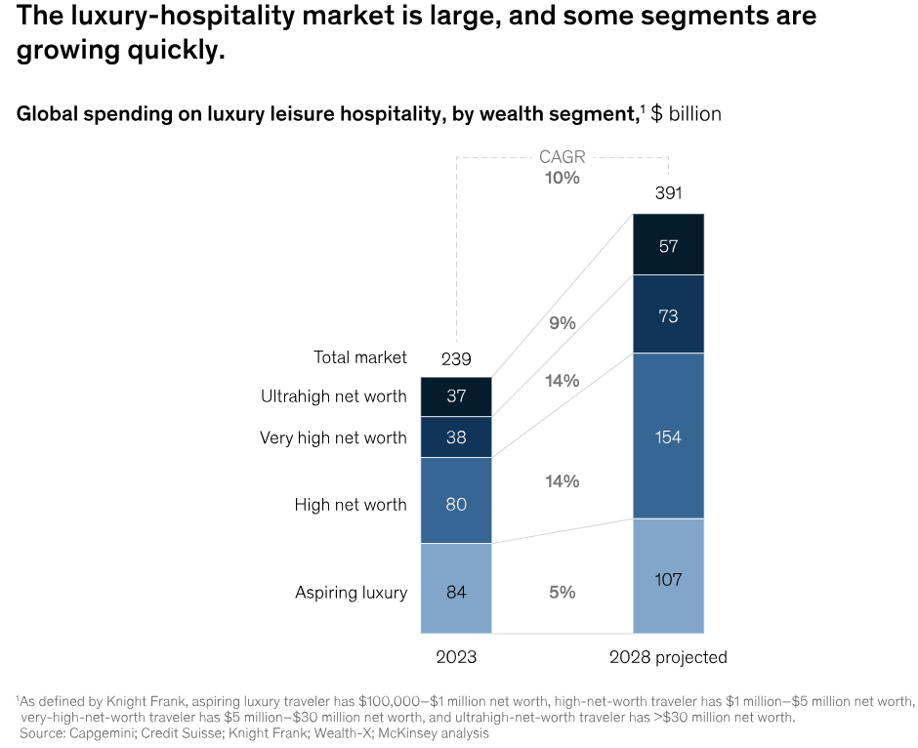
Figure 3: Global Spending on Luxury Leisure Hospitality (Source: Constantin et al., 2024)

Table 2: Internal Assessment: SWOT Analysis
Category | Description
Strengths | Exceptional Luxury Service Standards: This competitive advantage over Burj Al Arab exists because guests expect high standards and are willing to pay a price (Neesha Salian, 2024).
Strengths | Strong Brand Reputation: Burj Al Arab is one of the most known hotels in the world and this hotel has a solid brand, which reflects exclusivity, luxury, and prestige (admin, 2020).
Strengths | Financial Resources: With so many financial resources at its disposal, the cash starved hotel can invest in the latest hi tech technologies and structure to support its digital goal (Wynn and Jones, 2022).
Weaknesses | Over-reliance on Manual Personalization: Until now, the hotel has been highly personalized through human interaction, which has prevented functional scalability and consistency in all guest experiences. (Vinnakota, 2023)
Weaknesses | Limited Digital Infrastructure: The infrastructure that supports Burj Al Arab may in some respects need more support than would newer properties designed with digital integration in mind, which would require a lesser upgrade to facilitate AI driven systems. Implementation could be delayed, and costs would also rise (Default, 2021).
Opportunities | Growing Demand for Digital Experiences: Luxury travellers are placing increasing expectation on personalized digital experiences, paving the way for companies to differentiate in the space by providing personalized digital experiences at an advanced level (Constantin et al., 2024).
Opportunities | Availability of Advanced AI Tools: Real-time personalization has opened a plethora of AI solutions to the hotel industry to create more potent guest experiences than ever before (Schwarz, 2024).
Opportunities | Competitive Differentiation: The distinctive positioning of Burj Al Arab as a leader of digital innovation in the luxury market can raise its brand appeal and draw technology savvy, high net worth guests (admin, 2020).
Threats | Privacy Concerns: Reputational damage or loss of trust could be especially damaging for high profile guests and any mishandling of personal data could affect their trust in your organization (Guyer, 2024).
Threats | Cybersecurity Risks: An excess use of AI causes more exposure to potential cyber threats, therefore, stricter data security protocols (Polito and Pupillo, 2024).
Threats | Cost of Technology Upgrades: If they did not manage their strategic high costs involved in the current cutting edged digital infrastructure, it may impact profitability (Holland, 2016).

Strategic Insights: TOWS Analysis
Through TOWS analysis, we create strategies by aligning Burj Al Arab’s internal capabilities with external factors to respond to challenges and opportunities intended by AI in driving guest personalization.
Table 3: Strategic Insights: TOWS Analysis
 | Strength | Weakness
Opportunities | Invest in AI-driven guest services: Using Burj Al Arab’s financial strength and brand name to adopt the traditional tools of AI based personalization such as predictive analytics and smart room customization (Naumov, 2019). Lean into services that support the brand’s perceived luxury image and cater to tech savvy guests. | Upgrade digital infrastructure: Investing in scalable technology systems to address infrastructural limitations so that centred around AI driven personalization but maintain service consistency (Sigala et al., 2021). Phase these upgrades in to minimize disruption to guest experience, and better manage budget.
Threats | Implement strict data privacy and security protocols: Set up data governance policies based on resources, such as guest consent protocols and data encryption, to be in line with privacy laws to satisfy guest’s trust (Prabhakar, 2023). | Develop staff training and change management programs: Educate and empower staff members to effectively use new AI tools to add technological integration increasing luxuries of the hotel (Gupta, et al., 2022). There are strategies and lessons to focus on when managing the change, especially to create a culture on AI adoption to act as a tool rather than a replacement for key service offerings.

Despite this analysis, it provides a deep understanding of Burj Al Arab’s internal and externally environment about technology of personalization using AI. The PESTEL, SWOT and TOBS method suggests that there is a structured way of identifying important issues and coming up with actionable solutions which are consistent with the hotel’s dedication to luxury and exclusivity. Integration of these insights will assist Burj Al Arab in working strategically though digital transformation complexities, in line with personalization and still privacy to maintain its reputation as a luxury hospitality leader. This groundwork forms the basis of specific recommendations and change management strategies to come.

Recommendations and Change Management

Personalization Strategies
They say that following which luxury hospitality sector starts with implementing advanced AI driven personalization strategies as far as Burj Al Arab is to be considered. Furthermore, some of the most important personalization strategies follow the hotel’s high standard as well as its dedication to provide its guests with some personal experiences they won’t forget.
- AI-Driven Guest Preference Tracking
AI can further improve Burj Al Arab’s capacity to comprehend and foresee guest desires. Through AI enabled guest preference tracking, the hotel could study the guest behaviour, existing interaction with prior services, and feedbacks to serve each guest according to their own preference (Nam, et al., 2021). As a reminder, AI can track room temperature preferences, dining choices, and activity preferences and thus will allow hotel to decide earlier. Collecting this data ethically in a way that guests can give their consent to, and only to improve their experience, will help build on the feeling of exclusivity and attention to detail.
Burj Al Arab is suggested to store guest profiles with their respective preferences, so that these are maximized in effectivity with each guest come, owing to each guest’s stay. Thus, were a guest to like the smell of a particular room or the way one wants an evening finished off each time, then these items can be logged and reproduced during subsequent visits. Real time information that AI systems can provide staff with allows them to respond even more quickly to guests’ needs. However, this strategy not only boosts guest's satisfaction, but also encourages repeat guests to feel a unique sense of valued customer to enhance loyalty.
- Smart Room Features
By integrating IoT technology into guest rooms, an environment without seams is possible. Guests can adjust lighting, have curtains open and closed, adjust room temperature, and choose entertainment options, all depending on what smart room controls will adjust based on their preferences and behaviours. This personalization is achieved through automating these adjustments by the moment guests check into their rooms (Vinnakota, et al., 2022). Let’s take an example, arriving to the room, the room should automatically set to the guest’s preferred temperature and the television should display a welcome message.
The hotel can also embed voice activated assistants for a guest to use, either through word commands to summon services or adjust room settings. Adding convenience in a level modern luxury travel clients enjoy while reducing a need of physical interaction and delighting privacy conscious clients. Most importantly, smart room technology should provide guests the ability to turn off autonomous features, at their request, which cater to the needs of those who prefer the traditional service experience.
- Tailored Guest Communications
Personalized communication is very important when building a guest relationship. AI enabled tools can assist Burj Al Arab deliver individualised messages to guests before, through and after their stay. Take for example, pre arrival emails including personalised activity recommendations based on past stays, or preference at the time of booking. The hotel during the stay can send personalized notifications about events or dining options that guest’s interests are about, like having private tours or themed dining experiences.
Customization of post stay follow up such as thank you notes, or the invitations to special offers matching guests’ interests is possible. Burj Al Arab, especially, utilizes AI driven sentiment analysis to a way more accurate guest feedback and quicker resolution to concerns, creating a reactive and proactive communication strategy (Mavridopoulou and O’Mahoney, 2020). Not only does this create a better guest experience, but it also creates that strong emotional connection which makes people more likely to return.

Data Security
Since it is Burj Al Arab that will be extending its personalizing capabilities, then it’s highly essential to protect guest’s privacy and abide by the UAE data privacy regulations, which will be taken care of with robust data security policies. Recommendations that are actionable to ensure that data handling practices are in line with both legal standards as well as the guest expectations are shown below.
- Data Minimization and Purpose Limitation
To guarantee that only necessary guest data was collected, processed, and stored, it is necessary to implement a data minimization policy. Through limiting data collected only to information that is directly related to personalization workload, Burj Al Arab can minimize risks that arise from high data storage need. This, however, aligns with best practices and transparency, and establishes a clear purpose limitation policy, by which data is only used for the specific, declared purposes of increasing guest experience.
For example, hotel should apply anonymization and pseudonymization methods for roles in the data analytics processes that do not need personal identifiers. The techniques also minimize the chance of the identity of individual guests being exposed, and the extra level of security is particularly helpful with high profile, privacy sensitive guests.
- Encryption and Access Control
To implement end-to-end encryption for all guest data, which is stored in transit, Burj Al Arab must do exactly that. Data Encryption and Data Breach, it protects data from illegal access even in case of a breach (Tariq, 2024). Additionally, guest data ought to be available only to authorized personnel and role-based access control should be implemented to restrict the list of employee’s users who views the sensitive information.
All staff accessing guest data should be required to undergo multi factor authentication (MFA). These controls by the hotel minimize risk of unauthorized access to the guest data integrity and privacy.
- Compliance with UAE Data Privacy Laws and Global Standards
Since the data Burj Al Arab handles is extremely sensitive, the hotel must abide by the UAE data privacy regulations: Explicit guest consent for data collection, data transparency on how the data is used and the data localization. Additionally, it’s vital to comply with international standards like GDPR (to be compliant with European guests). To improve privacy for guests, Burj Al Arab should have a transparent consent management system which allows guest to easily view and manage their preferences about the data. This way is not only for compliance, but also induces trust as the guest sees that privacy is very important to them.
- Regular Data Security Audits
Regular auditing data handling and storage practices allows organization to continuously remain sure and boost security protocols. Vulnerability assessments and penetration testing should be performed by third party security firms to identify which potential risks may exist. Just as important are staff training with data protection practices on a regular basis, and continually staying abreast of the latest security threats.

Change Management Frameworks
These digital initiatives will only succeed if a structured change management approach is applied to ensure staff can learn new processes, and that guests feel comfortable with the changes. Bedard advocates using Kotter’s 8-Step Change Model to move proactively to facilitate this transition (Bedard, 2023).
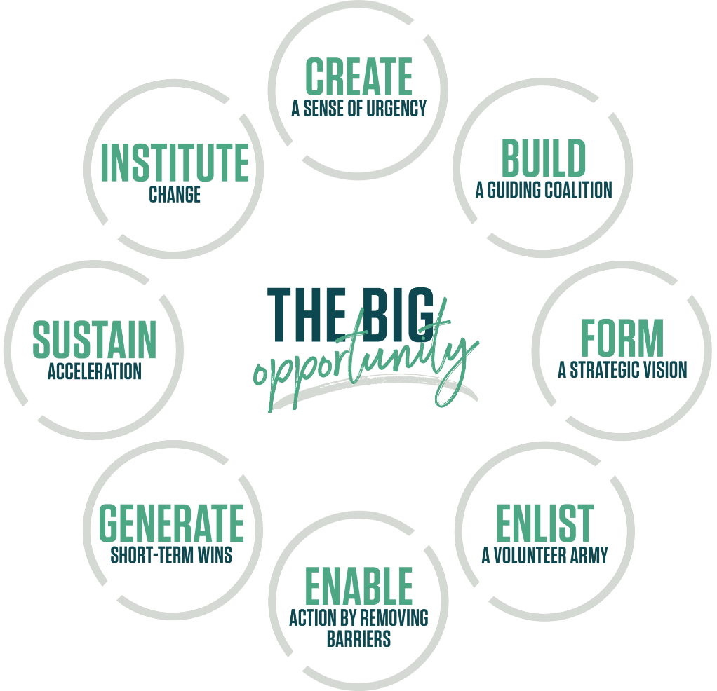
Figure 4: Kotter’s 8-Step Change Model (Source: Bedard, 2023)
- Create Urgency
A sense of urgency helps the staff to realise what they are doing now is important and so we need to move towards digital. This would allow management to tell guests how AI driven personalization will uplift guest satisfaction, meet the new industry norms, and enable Burj Al Arab to retain its competitive edge (Hadeel Sa’ad AL-HYARI, Hisham Mohammad AL-SMADI and WESHAH, 2023). That can be done by workshops and informational sessions which will force all employees to understand benefits of such changes themselves in initial buy in.
- Form a Guiding Coalition
To drive the change, you need to have a coalition of leaders within the hotel. All points of view should be represented -- management, IT, guest services and marketing -- in this coalition. They will be these leaders who are champions and provide support to their team, to make sure it happens.
- Create a Vision for Change
To achieve change efforts, they need a clear vision. For Burj Al Arab, this could be about 'bringing unparalleled, personalized luxury experiences by innovation and data integrity.' Staff across all levels should be made aware of this vision and told of how the new technology fits with the hotel’s values of luxury, exclusivity, and privacy.
- Communicate the Vision
From there communication is vital to the momentum and commitment of the team. Staff can stay updated related to progress and milestones with regular updates over meetings, newsletters, and other digital channels. First, the message must be sent that the transition is both beneficial and understandable which means that managers must face their concerns openly.
- Remove Obstacle
As it is important to identify and dispose of potential obstacles. For instance, there are some of the staff may not be comfortable with the use of AI tools. These concerns can be a little alleviated by offering targeted training sessions, mentoring, and hands on practice. Having potential compatibility issues for legacy systems is also important for a smooth transition because they require addressing technical challenges such as.
- Create Short-Term Wins
Early successes celebrate, and can help build the morale, and reinforce the benefits of changing. Initial wins might include positive guest feedback on smart room features, or successful integration of AI driven communications (Hussein Al-Shami, et al. 2022). It’s recognition for these achievements as much as anything else and a way of encouraging continued effort from most of the staff.
- Build on the Change
Constant improvement leads to sustained success. With AI, early outcomes can be managed, processes smoothed out with feedback, and capabilities of AI can be gradually increased. For example, if a hotel sets basic smart room features, then it might consider innovative features like AI based concierge services.
- Anchor the Changes in Corporate Culture
The changes are embedded in Burj Al Arab’s culture to make it part of day-to-day operations. You can easily accomplish that by always acknowledging and rewarding the staff who are using the latest technology to improve the service of the guest and promote the best of both technological innovation and personal service.

Performance Monitoring
Burj Al Arab must implement a set of Key Performance Indicators (KPIs), which would track the operational as well as the guest satisfaction of these personalization efforts. Below are recommended KPIs:
- Guest Satisfaction Scores
Post stay survey surveys can help to gauge the level of satisfaction guests had with the new personalization features; thus, offering an indication of how well they are received from guest’s perspective. Questions that focus on the ease of use of smart room features, perceived value of tailored communication and overall satisfaction with service consistency.
- Repeat Guest Rate
As an indication of satisfaction and loyalty a high repeat guest rate is a strong one. Tracking this metric enabled Burj Al Arab to note if their personalized services are increasing guest loyalty and raising repeat visits (Kalgi and Hire, 2024).
- Feedback on Privacy Handling
About data privacy, it is important to monitor guest feedback on privacy related issues. Surveys can measure whether guests feel comfortable with hotel’s data use practices and whether the hotel’s data transparency efforts are making an impact.
- AI System Efficiency
But for the AI’s performance to be evaluated, we must look at operational metrics such as system uptime, speed, and accuracy of personalization recommendations. Measuring these metrics allows for the technical issues to be detected early and a smooth guest experience.
- Employee Adoption Rates
The change management process is effective if we can track the percentage of staff actively using and engaging with AI tools. Successful training and buy in along with high adoption rates show we have high rates; low rates mean there is more to support.

Cost Analysis

Table 4: Cost Analysis Table for Implementing AI Driven Technology for personalized customer satisfaction.
Cost Category | Description | Initial Cost Estimate | Annual Maintenance Cost
AI and IoT Infrastructure | Includes sensors, IoT devices, and AI software to integrate with hotel management systems | $500,000 - $1,000,000 | N/A
Data Security Enhancements | Encryption software, cybersecurity audits, compliance solutions, and third-party assessments | $200,000 | N/A
Staff Training and Development | Training programs, workshops, hands-on sessions, and periodic refreshers to ensure effective AI tool use without service quality compromise | $50,000 | Additional refreshers as needed
Ongoing Maintenance and Upgrades | Covers software updates, system maintenance, and periodic assessments to keep systems current | N/A | $100,000
Total Estimated Costs | Total estimated investment for the first year with annual ongoing costs | $850,000 - $1,350,000 | $150,000
While implementing these AI driven personalization strategies will involve these significant investments, these costs should be proportionate to Burj Al Arab’s operational scale and revenue generation capability.
- AI and IoT Infrastructure
AI system and smart room technology needs are expected to run around $500,000 - $1,000,000 based on the scope and sophistication of the systems being used. Included in these costs are the prices of sensors and IoT devices, as well as AI software, which will seamlessly plug into a hotel’s current management systems (Whittington, 2020).
- Data Security Enhancements
Neither protects data nor eliminates data breaches and the consequent resulting legal, computational, security, and human costs. Both technology and third-party assessments are estimated at approximately $200,000 for an initial estimate.
- Staff Transformation and Development
Initial cost of comprehensive training programs, including seminars, hands on sessions plus ongoing support, are estimated at around $50,000 and additional costs will be incurred for periodic refreshers. This investment will provide us with the means to use AI tools to the best advantage without being compromised service wise.
- Maintenance and Upgrades Going On
An annual budget of $100,000 or more will be needed to keep us running. It has regular software updates, system maintenance, and measurement to make sure that technology remains in the front seat.
- Total Cost Estimate
First year projected total investment: $850,000 – $1,350,000; costs of around $150,000 per year. This is a big investment, but the anticipated guest satisfaction, loyalty, and operational efficiency returns should be a good financial investment over time.

Action Plan
An action plan for implementing an AI driven personalization at Burj Al Arab is listed below. It outlines the problem areas, the solutions recommended, outcomes desired, timelines and budget estimates in a clear table.
Table 5: Action Plan Table
Problem | Solution | Desired Outcome | Timeline | Budget
Limited personalization without AI | Implement AI-driven guest preference tracking | Enhanced guest satisfaction through tailored services | 3 months for setup, continuous improvement | $300,000
Manual control of room settings | Introduce smart room features and IoT technology | Improved comfort and convenience for guests | 6 months | $500,000
Inconsistent guest communications | Use AI for tailored guest communication pre-, during, and post-stay | Consistent and personalized communication, fostering loyalty | 4 months for integration | $150,000
Data privacy and security risks | Implement encryption, access controls, and UAE compliance measures | Secure data handling, maintaining guest trust | Initial setup in 3 months, ongoing audits | $200,000 for initial setup, $50,000 annually
Resistance to technology adoption among staff | Conduct comprehensive training and ongoing support programs | High staff adoption rate of new AI tools | 2 months for initial training, ongoing support | $50,000
This structured approach provides Burj Al Arab with a system that streamlines the implementation of AI and personalization tools within a clear and feasible financial planning and with set milestones that go in line with Burj Al Arab’s luxury service standards.

Conclusion

Summary of Key Points
This is a structured approach to adopt the AI-driven personalization in the luxury hospitality through the form of consultancy report for Burj Al Arab. Burj Al Arab has become a well-known brand internationally for its exceptional service standards and faces an important challenge in moving to incorporating AI driven personalization, whilst maintaining privacy and security for its very elite clientele. Advanced digital tools can help leverage the hotel to provide the modern luxury traveller an expectation of having tailormade and seamless service. The difficulty of data management and regulatory compliance does however lie in the complexity of the remaining data protection landscape in the UAE.
Solutions to tackle these challenges were proposed with the use of AI based guest preference tracking, smart room IoT features and personalized communication strategies to improve the guest journey. Robust encryption, access control measures, and regular data audits were advised as ways to meet both UAE and international standard for data security, to protect guest trust and provide compliance. In support of the new technology, the suggested change management framework is based on Kotter’s 8 step model such that the overall transition is made smooth through staff training and continued support to ensure the technology can be utilized by most staff. The COVID-19 pandemic is a good time for technological advancement, enabling scenarios such as the Burj Al Arab, which will allow KPIs like guest satisfaction scores, repeat guest rates, and feedback on privacy to give a reliable gauge of success of these initiatives together and to continue to maintain high service standards.

Closing Remarks
We are grateful for the chance to work with Burj Al Arab on this innovative project. Thanks to this collaboration, we’ve been able to apply our perspectives within the digital transformation and luxury hospitality consulting arena to one of the most prestigious hotels in the world. This strategy of implementation of these AI driven personalization and data security will help Burj Al Arab retain a market position as a world leader in the luxury hospitality industry, fulfilling the growing needs of modern travellers.
We are excited to see the recommendations contribute to driving improvements in guest satisfaction, loyalty, and operational efficiencies in Burj Al Arab. If there should be future opportunities for partnership, we look forward to supporting the hotel’s ongoing effort to be innovative and provide excellence in guest experience. Again, we thank you for believing in us to take on this project, as we remain steadfast in doing everything possible to make it a success.

References
‌‌admin (2020). Brand Appeal: The rise of luxury branded living. [online] Hotel & Catering. Available at: https://hotelandcatering.com/news/brand-appeal-the-rise-of-luxury-branded-living [Accessed 20 Oct. 2024].
‌admin (2020). Burj Al Arab awarded Luxury Travel Awards’ Best Hotel in the World. [online] Hotel & Catering. Available at: https://hotelandcatering.com/news/burj-al-arab-awarded-luxury-travel-awards-best-hotel-in-the-world [Accessed 20 Oct. 2024].
Alp Sarper (2022). Exclusive interview with ‘Inside Burj Al Arab’ GM. [online] Economy Middle East. Available at: https://economymiddleeast.com/news/visit-the-7-star-burj-al-arab-and-experience-the-pinnacle-of-luxury/ [Accessed 21 Oct. 2024].
Alrawadieh, Z., Alrawadieh, Z. and Cetin, G. (2021). Digital transformation and revenue management: Evidence from the hotel industry. Tourism Economics, 27(2), pp.328-345. https://www.academia.edu/download/63481400/Digital_transformation_and_revenue_management_20200531-69911-wt65u1.pdf
Bedard, A. (2023). The 8-Step Process for Leading Change | Dr. John Kotter. [online] Kotter International Inc. Available at: https://www.kotterinc.com/methodology/8-steps/ [Accessed 21 Oct. 2024].
Burnes, B. (2014) 4th Edition, Managing Change, Great Britain, Prentice Hall.
Buttrick, R. (2009) The Project Workout, London: Prentice Hall
‌Cavendish Maxwell. (2024). Luxury hospitality in the GCC | Insights | Cavendish Maxwell. [online] Available at: https://cavendishmaxwell.com/insights/blog/luxury-hospitality-in-the-gcc [Accessed 21 Oct. 2024].
COLIFE Dubai (2024). Why Dubai’s Luxury Market is More Popular Than Ever: A 2024 Snapshot. [online] Medium. Available at: https://medium.com/colife-dubai/why-dubais-luxury-market-is-more-popular-than-ever-a-2024-snapshot-c23ed2052e38 [Accessed 21 Oct. 2024].
D’Acunto, D., Volo, S. and Filieri, R. (2021). “Most Americans like their privacy.” Exploring privacy concerns through US guests’ reviews. International Journal of Contemporary Hospitality Management, 33(8), pp. 2988-3005. Available at: https://www.emerald.com/insight/content/doi/10.1108/IJCHM-11-2020-1329/full/html [Accessed 21 Oct. 2024].
‌Davidson, C. (2019). Dubai (city) | Geography, Map, & History. [online] Encyclopaedia Britannica. Available at: https://www.britannica.com/place/Dubai-United-Arab-Emirates [Accessed 22 Oct. 2024].
‌Default. (2021). Digital Dubai Approves Set of Measures Related to Implement the Strategic Vision for an AI-Powered Data Center Economy. [online] Available at: https://www.digitaldubai.ae/newsroom/news/digital-dubai-approves-set-of-measures-related-to-implement-the-strategic-vision-for-an-ai-powered-data-center-economy [Accessed 22 Oct. 2024].
Ehl.edu (2024). How AI in hospitality can enhance personalized customer experience. [online] Ehl.edu. Available at: https://hospitalityinsights.ehl.edu/ai-in-hospitality-personalized-customer-experience[Accessed 22 Oct. 2024].
Elphick, D. (2024). Cyber Security in the Hospitality Industry - SiteMinder. [online] SiteMinder. Available at: https://www.siteminder.com/r/cyber-security-hospitality-industry/#:~:text=What%20is%20cyber%20security%20in,resorts%20collect%20from%20their%20guests. [Accessed 22 Oct. 2024].
ENISA. (2024). Data Protection. [online] Available at: https://www.enisa.europa.eu/topics/cybersecurity-policy/data-protection [Accessed 24 Oct. 2024].
EY. (2023). Adapting AI and Digital Tools for Luxury Experiences: A Case Study on the Ritz-Carlton. Available at Ernst & Young Hospitality Insights www.ey.com
Fragnière, E. and Yagci, K. (2021). Network & cyber security in hospitality and tourism. Hospitality & tourism information technology. https://arodes.hes-so.ch/record/9164/files/Published%20version.pdf
Gajić, T., Petrović, M.D., Milanović Pešić, A., Conić, M. and Gligorijević, N. (2024). Innovative Approaches in Hotel Management: Integrating Artificial Intelligence (AI) and the Internet of Things (IoT) to Enhance Operational Efficiency and Sustainability. Sustainability, 16(17), 7279. Available at: https://www.mdpi.com/2071-1050/16/17/7279 [Accessed 24 Oct. 2024].
Garrison, J. and Thompson, Z., 2021. Burj Al Arab. https://scholarworks.boisestate.edu/cgi/viewcontent.cgi?article=1017&context=under_showcase_2021
Gupta, S., Modgil, S., Lee, C.K., Cho, M. and Park, Y. (2022). Artificial intelligence enabled robots for stay experience in the hospitality industry in a smart city. Industrial Management & Data Systems, 122(10), pp.2331-2350. https://www.researchgate.net/profile/Shivam_Gupta30/publication/362232881_Artificial_Intelligence_enabled_robots_for_stay_experience_in_the_hospitality_industry_in_a_smart_city/links/630766795eed5e4bd11b7e3f/Artificial-Intelligence-enabled-robots-for-stay-experience-in-the-hospitality-industry-in-a-smart-city.pdf
‌Guyer, N. (2024). Critical Considerations for Sensitive Information in a Data Breach. [online] Complete Discovery Source. Available at: https://cdslegal.com/insights/advisory-services/critical-considerations-for-sensitive-information-in-a-data-breach/#:~:text=Customers%20may%20lose%20trust%20in,and%20may%20impact%20business%20relationships. [Accessed 27 Oct. 2024].
Hadeel Sa’ad AL-HYARI, Hisham Mohammad AL-SMADI and WESHAH, S.R. (2023). THE IMPACT OF ARTIFICIAL INTELLIGENCE (AI) ON GUEST SATISFACTION IN HOTEL MANAGEMENT: AN EMPIRICAL STUDY OF LUXURY HOTELS. GeoJournal of Tourism and Geosites, [online] 48(2 supplement), pp.810–819. doi: https://doi.org/10.30892/gtg.482spl15-1081.
Heyes, A. (2021). What is luxury hospitality? A need to move towards a scientific understanding. Research in Hospitality Management, 11(2), pp. 67-69. Available at: https://doi.org/10.1080/22243534.2021.1917919 [Accessed 27 Oct. 2024].
Holland, G. (2016). Seven-star IT networks at the Burj Al Arab | TahawulTech.com. [online] TahawulTech.com. Available at: https://www.tahawultech.com/features/case-studies/guest-access/ [Accessed 28 Oct. 2024].
Hotel Tech Report. (2020). GDPR for Hotels: Here’s What You Should Know (2024). [online] Available at: https://hoteltechreport.com/news/data-protection-act [Accessed 28 Oct. 2024].
Hussein Al-shami, S.A., Mamun, A.A., Ahmed, E.M. and Rashid, N. (2022). Artificial intelligent towards hotels’ competitive advantage. An exploratory study from the UAE. foresight, 24(5), pp.625-636. https://www.researchgate.net/profile/Elsadig-Ahmed-3/publication/354819159_Artificial_intelligent_towards_hotels'_competitive_advantage_An_exploratory_study_from_the_UAE/links/6198d38107be5f31b79fa39b/Artificial-intelligent-towards-hotels-competitive-advantage-An-exploratory-study-from-the-UAE.pdf?origin=journalDetail&_tp=eyJwYWdlIjoiam91cm5hbERldGFpbCJ9
Jiwnani, L. (2024). AI’s transformative role in the hospitality industry | Deloitte UK. [online] Deloitte United Kingdom. Available at: https://www.deloitte.com/uk/en/Industries/consumer/blogs/embracing-the-future-ais-transformative-role-in-hospitality.html[Accessed 28 Oct. 2024].
Kalgi, D. and Hire, J. (2024). Loyalty Programs: The Important Factor of Success for Hospitality Industry. Current Scenario in Science and Technology, Environment, Agriculture, Health, Water Resources, Social Science, Literature & Industrial, p.84. https://www.researchgate.net/profile/Yuvika-Singh/publication/384562200_Beyond_Chalk_and_Talk_Transforming_Teacher_Training_For_the_Digital_Age/links/66fd48809e6e82486ffe6587/Beyond-Chalk-and-Talk-Transforming-Teacher-Training-For-the-Digital-Age.pdf#page=92
Karadayi-Usta, S. (2024). Cybersecurity Risks Analysis in the Hospitality Industry: A Stakeholder Perspective on Sustainable Service Systems. Systems, 12(10), 397. Available at: https://www.mdpi.com/2079-8954/12/10/397 [Accessed 28 Oct. 2024].
Line, N.D., Dogru, T., El-Manstrly, D., Buoye, A., Malthouse, E. and Kandampully, J. (2020). Control, use and ownership of big data: A reciprocal view of customer big data value in the hospitality and tourism industry. Tourism Management, 80, p.104106. https://thuvienso.hoasen.edu.vn/bitstream/handle/123456789/15238/Control%2C%20use%20and%20ownership%20of%20big%20data%20A%20reciprocal%20view%20of%20customer%20big%20data%20value%20in%20the%20hospitality%20and%20tourism%20industry.pdf?sequence=1&isAllowed=y
Luxury Lifestyle Awards. (2023). AI in Luxury Hospitality: Artificial Intelligence in High-End Hotels & Resorts. [online] Available at: https://luxurylifestyleawards.com/experience/ai-luxury-hospitality-artificial-intelligence-redefining-service-excellence[Accessed 29 Oct. 2024].
‌Magalhães, M.J., Tenreiro de Magalhães, S., Revett, K. and Jahankhani, H. (2017). A Review on Privacy Issues in Hotels: A Contribution to the Definition of Information Security Policies and Marketing Strategies. In: Global Security, Safety and Sustainability - The Security Challenges of the Connected World. Springer, pp. 205-217. Available at: https://link.springer.com/chapter/10.1007/978-3-319-51064-4_17 [Accessed 29 Oct. 2024].
Mann, R., Scully, E., Straus, M. and Holub, J.T. (2024). How the world’s best hotels deliver exceptional customer experience. [online] McKinsey & Company. Available at: https://www.mckinsey.com/industries/travel-logistics-and-infrastructure/our-insights/how-the-worlds-best-hotels-deliver-exceptional-customer-experience [Accessed 29 Oct. 2024].
Mashfi, G.D. (2023). The importance of digital transformation technology formulas in developing the performance of the hotel sector in Iraq. Czech Journal of Multidisciplinary Innovations, 20, pp.19-29. https://peerianjournal.com/index.php/czjmi/article/download/638/534
Mavridopoulou, and O’Mahoney, J. (2020). Elitism in Strategy Consulting: How Institutional Prestige Influences Recruitment. Management Consulting Journal, 3(1), 12–22. https://sciendo.com/pdf/10.2478/mcj-2020-0003
Morgan, G.A., Warren-Smith, C. and Kelly, R. (2020). the United Arab Emirates. Corporate Investigations, 2021, p.132. https://www.acc.com/sites/default/files/resources/upload/CORPINV21_E-edition%20Reduced.pdf#page=137
‌Nam, K., Dutt, C.S., Chathoth, P., Daghfous, A. and Khan, M.S. (2021). The adoption of artificial intelligence and robotics in the hotel industry: prospects and challenges. Electronic Markets, 31, pp.553-574. https://www.academia.edu/download/93508027/s12525-020-00442-320221102-1-a5but9.pdf
Naumov, N. (2019). The impact of robots, artificial intelligence, and service automation on service quality and service experience in hospitality. In Robots, artificial intelligence, and service automation in travel, tourism, and hospitality (pp. 123-133). emerald publishing limited. https://pure.northampton.ac.uk/files/6663755/Naumov_Nikola_EP_2019_The_impact_of_robots_artificial_intelligence_and_service_automation_on_service_quality_in_hospitality.pdf
Neesha Salian (2024). How Dubai is leveraging technology to enhance guest experiences. [online] Gulf Business. Available at: https://gulfbusiness.com/dubai-is-leveraging-tech-to-enhance-hospitality/ [Accessed 29 Oct. 2024].
Noordzij, G. (2015). Project Management of Hotel Opening Processes. [online] Available at: http://www.maxwideman.com/papers/hotel/hotel.pdf [Accessed 29 Oct. 2024].
Ordóñez-Martínez, D., Seguí-Pons, J.M. and Ruiz-Pérez, M. (2023). Conceptual Framework and Prospective Analysis of EU Tourism Data Spaces. Sustainability, 16(1), p.371. https://www.mdpi.com/2071-1050/16/1/371/pdf
Pereira, V., Silva, G.M. and Dias, Á. (2021). Sustainability Practices in Hospitality: Case Study of a Luxury Hotel in Arrábida Natural Park. Sustainability, 13(6), 3164. Available at: https://www.mdpi.com/2071-1050/13/6/3164 [Accessed 29 Oct. 2024].
Polito, C. and Pupillo, L. (2024). Artificial Intelligence and Cybersecurity. Intereconomics, [online] 2024(1), pp.10–13. Available at: https://www.intereconomics.eu/contents/year/2024/number/1/article/artificial-intelligence-and-cybersecurity.html [Accessed 30 Oct. 2024].
Prabhakar, R. (2023). Ethical Data Practices in Hospitality: Protecting Guest Privacy. [online] Xerago.com. Available at: https://www.xerago.com/Industries/Hospitality/guest-data-and-privacy [Accessed 30 Oct. 2024].
pwc.com, (2023). Data privacy handbook for the United Arab Emirates A guide to compliance with the UAE’s Data Protection Law. Available at: https://www.pwc.com/m1/en/services/consulting/documents/uae-data-privacy-handbook.pdf.
Sahota, N. (2024). AI In Hospitality: Elevating the Hotel Guest Experience Through Innovation. [online] Forbes. Available at: https://www.forbes.com/sites/neilsahota/2024/03/06/ai-in-hospitality-elevating-the-hotel-guest-experience-through-innovation/[Accessed 30 Oct. 2024].
Said, S. (2023). The Role of Artificial Intelligence (AI) and Data Analytics in Enhancing Guest Personalization in Hospitality. Journal of Modern Hospitality, [online] 2(1), pp.1–13. doi: https://doi.org/10.47941/jmh.1556.
‌Schwarz, L. (2024). AI in Hospitality: Advantages & Use Cases. [online] Oracle NetSuite. Available at: https://www.netsuite.com/portal/resource/articles/business-strategy/ai-hospitality.shtml [Accessed 30 Oct. 2024].
Shin, H.H., Jeong, M., So, K.K.F. and DiPietro, R. (2022). Consumers’ experience with hospitality and tourism technologies: Measurement development and validation. International Journal of Hospitality Management, 106, p.103297. https://www.researchgate.net/profile/Kevin-Kam-Fung-So/publication/362511885_Consumers'_experience_with_hospitality_and_tourism_technologies_Measurement_development_and_validation/links/64ff226af8931a4e29b57be6/Consumers-experience-with-hospitality-and-tourism-technologies-Measurement-development-and-validation.pdf
Sigala, M., Kumar, S., Donthu, N., Sureka, R. and Joshi, Y., 2021. A bibliometric overview of the Journal of Hospitality and Tourism Management: Research contributions and influence. Journal of Hospitality and Tourism Management, 47, pp.273-288. https://thuvienso.hoasen.edu.vn/bitstream/handle/123456789/15229/A%20bibliometric%20overview%20of%20the%20Journal%20of%20Hospitality%20and%20Tourism%20Management%20Research%20contributions%20and%20influence.pdf?sequence=1&isAllowed=y
Spence, J., Benckendorff, P. and Chien, P.M. (2022). Sustainable High Yield Luxury Tourism Experiences. In: Kotur, A.S. and Dixit, S.K. (Eds.), The Emerald Handbook of Luxury Management for Hospitality and Tourism. Emerald Publishing Limited, pp. 403-423. Available at: https://www.emerald.com/insight/content/doi/10.1108/978-1-83982-900-020211020/full/html [Accessed 30 Oct. 2024].
Tariq, M.U. (2024). Data breach incidents and prevention in the hospitality industry. In Corporate Cybersecurity in the Aviation, Tourism, and Hospitality Sector (pp. 181-199). IGI Global. https://www.researchgate.net/profile/Muhammad-Usman-Tariq-2/publication/382889043_Data_Breach_Incidents_and_Prevention_in_the_Hospitality_Industry/links/66b1f34b2361f42f23b58060/Data-Breach-Incidents-and-Prevention-in-the-Hospitality-Industry.pdf
‌The Luxury Institute (2024). The Luxury Institute. [online] The Luxury Institute. Available at: https://www.luxuryinstitute.com/ [Accessed 30 Oct. 2024].
‌Unwto.org. (2022). Impact assessment of the COVID-19 outbreak on international tourism | UN Tourism. [online] Available at: https://www.unwto.org/impact-assessment-of-the-covid-19-outbreak-on-international-tourism [Accessed 30 Oct. 2024].
‌Vij, M. and Rizwan, S.A. (2022). Emerging Technologies in Tourism for a Better Experience: The Case of Dubai. In: Technology Application in Tourism in Asia. Springer, pp. 97-107. Available at: https://link.springer.com/chapter/10.1007/978-981-16-5461-9_6 [Accessed 31 Oct. 2024].
‌Vinnakota, S. (2023). Leveraging Artificial Intelligence in the Hospitality Industry: Opportunities and Challenges. [online] ResearchGate. Available at: https://www.researchgate.net/publication/372783951_Leveraging_Artificial_Intelligence_in_the_Hospitality_Industry_Opportunities_and_Challenges.
Vinnakota, S., Mohan, M.D., Boda, J., Sekuini, J., Mustafa, M. and Madala, H. (2022). Leveraging artificial intelligence in the hospitality industry: opportunities and challenges. Asian Journal of Social Science and Management Technology, 5(3), pp.201-261. https://www.ajssmt.com/Papers/53201260.pdf
Vivek Sadh (2024). Artificial Intelligence in Hospitality: Top Benefits & Use Cases for Hotels. [online] Jellyfish Technologies. Available at: https://www.jellyfishtechnologies.com/artificial-intelligence-in-hospitality/ [Accessed 31 Oct. 2024].
Whittington, R. et al (2020) Exploring Strategy. Harlow: Pearson Education Limited.
‌Wynn, M. and Jones, P. (2022). IT Strategy in the Hotel Industry in the Digital Era. Sustainability, [online] 14(17), pp.10705–10705. doi: https://doi.org/10.3390/su141710705.
Zarezadeh, Z.Z., Rastegar, R. and Xiang, Z. (2022). Big data analytics and hotel guest experience: a critical analysis of the literature. International Journal of Contemporary Hospitality Management, 34(6), pp.2320-2336. https://vtechworks.lib.vt.edu/bitstreams/11b36eeb-c034-4c78-9e1a-e88f54713365/download

