
The impact of social media platforms on customer relationship management in the luxury fashion industry
STUDENT NAME: Rodica Georgiana Dinu
STUDENT ID: 1921784
SUBMISSION DATE: 06/01/2023
SUPERVISOR NAME: Tushara Balendran
DISSERTATION – PROPOSAL
MODULE CODE: LCBB6000

Contents

Introduction 2
Rationale of the study 2
Research aim 3
Objectives 3
Research Questions 3
Literature Review 4
Digital marketing strategies 4
The Honeycomb model 5
Research Methodology 7
Philosophy 8
Research approach 9
Research strategy 9
Type of investigation 9
Choices 10
Time Horizons 10
Data collection and analysis 10
Sampling 10
Data collection methods 11
Analysis of data 11
Research ethics 11
Planning 12
Reference list 13

Topic: The impact of social media platforms on customer relationship management in the luxury fashion industry

Introduction

The luxury fashion industry is a market that focuses on goods that are not essential but are enjoyable and fulfilling to own and whose possession is frequently connected with a specific amount of social prestige, with an emphasis on a high level of exclusivity (Sperber, 2016). In consumers' eyes, luxury is characterised by craftsmanship, quality, and originality. The industry's efforts to reach consumers digitally during the COVID-19 period did not significantly impact consumers who believe that luxury brands need to catch up to other industries in terms of digital customer experience. However, the luxury market has proved its endurance in the face of massive pandemic-related disruptions, with many top companies' sales statistics returning to pre-pandemic levels and, in some cases, exceeding them (Hazan et al., 2022). And furthermore, it is showing signs of resiliency, even though the macroeconomic conditions of 2022 may be detrimental to the sector's pace (Mckinsey&Company, 2022). Social media has revolutionised how customers and businesses communicate and exert influence over one another (Li, Larimo and Leonidou, 2021). Social media marketing can efficiently attract new clients and expand firms' brands by being relevant and effective because it enables firms to interact on a personal level with their target audience. Customers that perceive a personal connection with a brand are more likely to purchase from that company (Magids, Zorfas and Leemon, 2015). In order to ensure that customers feel secure and confident in the advantages that come from their relationship with a brand, customer relationship management in the luxury industry must take into account more than just marketing communications, product quality, and after-sale methods (Scussel and Demo, 2019).

Rationale of the study

The pandemic sped up the digital transformation across all industries, and social media platforms played a critical role in keeping the world connected. From the consumer's perspective, the luxury fashion industry lagged behind other industries in digital experience. Companies in the luxury fashion industry can benefit from this research by understanding more about social media platforms' impact in attracting and retaining customers to gain insights into how to retain customers. In addition, this research will contribute to determining what current customer relationship management and social media marketing strategies are effective to help companies in the luxury fashion industry in terms of the allocation of resources for further development of strategies.

Research aim

This research aims to analyse social media platforms' impact on customer relationship management in the luxury fashion industry.

Objectives

- To determine the current social media marketing strategies used in the luxury fashion industry.
- To investigate the customer relationship management strategies implemented in the luxury fashion industry
- To analyse the impact of social media platforms on customer relationship management in the luxury fashion industry.

Research Questions

- What social media marketing strategies have been used in the luxury fashion industry?
- What are the customer relationship management strategies in the luxury fashion industry?
- What is the impact of social media platforms on customer relationship management in the luxury fashion industry?

Literature Review

As a subset of marketing, social media marketing can be described as a new way to do business to achieve marketing goals by promoting goods, services, information, and ideas through social media platforms using their associated technologies and features (Dahnil et al., 2014). It is also defined as a communication tool based on the social interaction of Web 2.0 that departs from classical one-to-one communication and mass marketing, being more related to relationship marketing, where companies must transition from attempting to sell to building relationships with consumers (Schoja, 2016).
Customer relationship management (CRM) is a comprehensive process and strategy that aims to acquire, keep, and partner with specific customers to produce higher value for both the organisation and the customer (Parvatiyar and Sheth, 2001). Kotler et al. (2020) define CRM as a whole process of attracting and retaining customers and establishing and sustaining profitable customer relationships through delivering exceptional customer value and satisfaction by managing comprehensive information about individual customers and attentively managing every interaction between the customer and the business in order to enhance the loyalty of the customer.

Digital marketing strategies

Influencer marketing is a new type of digital marketing in which a firm collaborates with an online influencer to promote one of its products or services (Geyser, 2022). Luxury brands are well-known for selecting renowned faces for their advertising, but social media has altered the selection process, which explains why in 2017, Kendall Jenner, a famous fashion influencer with 50 million followers on Instagram, became the face of Estée Lauder (Sharma and Albus, 2017).
Search engine optimization (SEO) is the process of placing content on a website that has the potential to enhance its visibility to search engines and their users (GoogleAds, n.d.). In France, Louis Vuitton dominated Millennials' internet searches in the luxury market in 2020, with 700,000 Google queries (Luxus, 2020).
Brand storytelling integrates multiple types of communication and marketing methods to create persuasive selling points that in digital marketing is crucial for interacting with potential consumers, since people today desire advertisements that cut through the digital noise and touch on a human level (Bertram, 2021). Gucci is among the best in the luxury fashion sector for brand storytelling, which provides tremendous value (Langer, 2022).

The Honeycomb model

The model has been developed to evaluate the effectiveness of social media by analysing the factors that motivate users to engage in social media. The honeycomb model is based on the idea that businesses can select from the seven functional building blocks outlined by the model those that are more pertinent to their operations and concentrate on the key features to develop a consistent social media strategy (Kietzmann et al., 2011). Following, the seven functional building blocks of the model are illustrated and briefly mentioned.

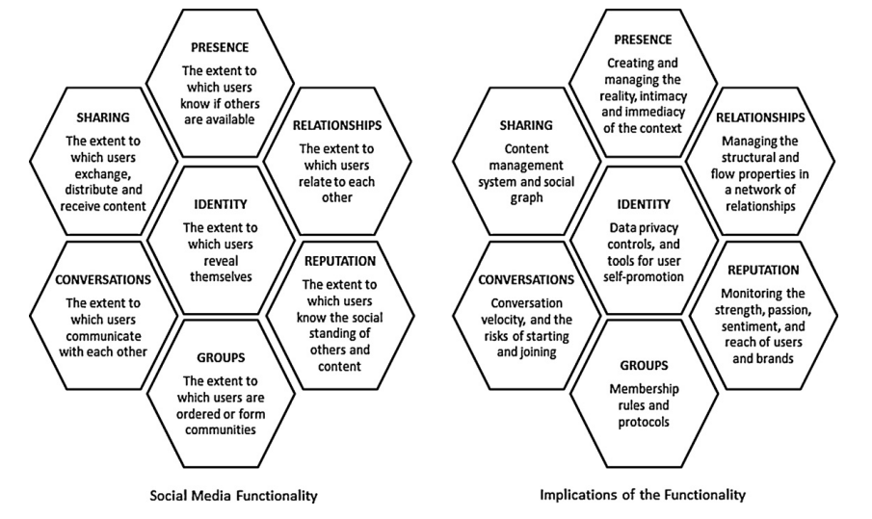
Figure 1. The Honeycomb of social media (Kietzmann et al., 2011)

Identity refers to users' personal disclosure regarding their identities on social media platforms (Kietzmann et al., 2011). Based on a customer's profile and purchasing history, Kering Group, which owns luxury brands such as Gucci, Bottega Veneta, Saint Laurent, Balenciaga, and others, has developed several experimental initiatives employing data science approaches to deliver customised messages and experiences (Kering, 2018).
Conversations block refers to the level of interaction between users when utilising social media platforms (Kietzmann et al., 2011). Due to its capacity to allow conversations not only between an individual and an organisation, but also between several individuals and various organisations, social media can be a potent relationship enhancer (Northumbria University Newcastle, 2019). Prada has integrated customer care that allows its sales agents to engage and assist customers on Instagram, Facebook, and live chat, and with conversational commerce capacity, to finalise deals in these same social platforms where they communicate with customers (Lang, 2022).
Sharing relates to the degree to which users of social media platforms receive, exchange and distribute content (Kietzmann et al., 2011). To engage with its followers during the pandemic, Versace launched the #VeryVersace challenge to engage and entertain the Versace community, inviting its followers on all social media platforms to photograph and share V shapes from their everyday lives (Eksousian-Cavadas, 2020).
Presence refers to the extent to which a user can determine whether or not another user is available (Kietzmann et al., 2011). Presence on social media for a luxury brand translates into a brand's exposure on social media platforms and the relationship it establishes with its community. As of 2021 , Chanel was, according to Sabanoglu (2022), the most popular luxury brand on social media globally, with 89.1 million users combined between Instagram, Facebook, Youtube and Twitter.
Relationships indicate the degree to which users can be connected to other users (Kietzmann et al., 2011). All Kering Houses have created or are developing WeChat (the Chinese social media platform) mini programmes to establish a close relationship with their Chinese clientele and offer social commerce. (Kering, 2018).
Reputation in a social media context can have different meanings and refers to the degree to which a user is able to discern the status of others, including himself (Kietzmann et al., 2011). A good reputation for a brand is invariably followed by increased consumer trust and loyalty, both of which contribute to higher sales and, consequently, profit (Blanchard, 2019). According to Creevey, Coughlan and O'Connor (2022), the democratisation of the development and delivery of business communication, spurred by the pervasiveness of social media, continues to pose substantial hurdles for luxury companies aiming to maintain an image and therefore a reputation based on originality, rarity and exclusivity.
Groups block refers to the capacity of social media platforms’ users to establish communities and subcommunities (Kietzmann et al., 2011). Louis Vuitton is the luxury brand with the greatest community on Facebook with a total of 24 million followers (Chevalier, 2022).
According to Senadheera, Warren and Leitch (2017), a vital advantage of the Honeycomb model lies in its ability to describe the strengths of the multiple functionalities related to the various social media technologies allowing businesses to use a variety of social media technologies and use the model to interactively distinguish and articulate the benefits or drawbacks of employing one or more social media technologies. In addition to discovering and measuring metrics linked with different functionalities, this approach provides strategies for monitoring, interpreting, and responding to different activities on social media (Senadheera, Warren and Leitch, 2017). Helms, Booij, and Spruit (2012) critiqued the Honeycomb model, arguing that it fails to account for significant content-related and time-related features of social media.

Research Methodology

Saunders (2019), defines research methodology as the theory of how research should be conducted, taking into account the philosophical and theoretical premises on which research is based as well as what these assumptions mean for the method(s) used.
The research ‘onion’ describes the steps a researcher must pass through in order to build an effective approach and contains six layers, and each of these must be peeled away prior to arriving at the core, which is data collection and analysis (Saunders, 2019).

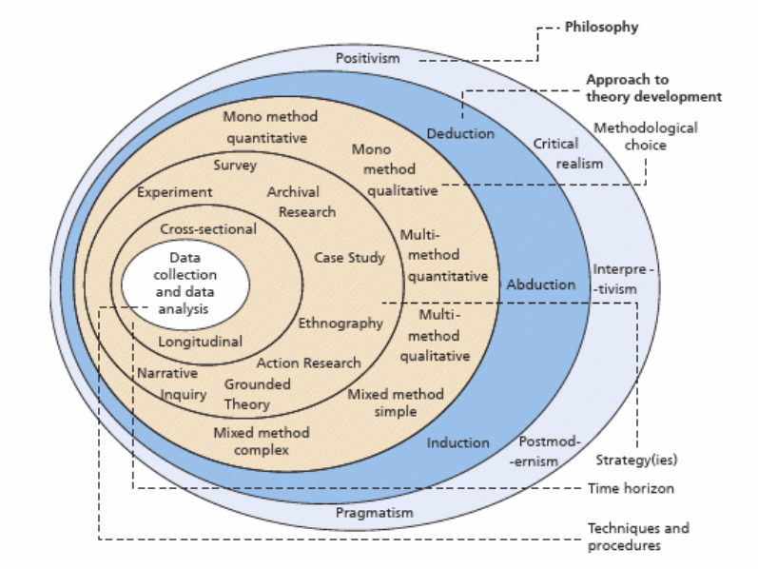
Figure 2 Research onion (Saunders, 2019)

Philosophy

Philosophy describes a set of beliefs and assumptions regarding the development and nature of knowledge in relation to research (Saunders, Thornhill and Lewis, 2015). Positivism is a natural scientist's philosophical approach that requires working with observable social reality to generate law-like generalisations (Saunders, 2019). For this research, positivism is the guiding philosophy to address the research questions that this paper seeks to answer which have been developed in the introduction. The use of positivism in this study will enable the researcher to find explanations based on the generally accepted worldview through acquiring scientific data and information and then analyse the information gathered in order to accept or reject the research hypothesis.

Research approach

The deductive approach can be defined as an approach to theory development including the testing of a theoretical assertion by employing a research strategy devised expressly for that goal (Saunders, 2019). In this study, the researcher will adopt a deductive approach to assess the influence of social media platforms on customer relationship management in the luxury industry. In this regard, a deductive approach will enable the researcher to verify the hypothesis that "social media platforms have a significant influence on customer relationship management in the luxury fashion industry" based on existing information regarding the current social media marketing and customer relationship management strategies in the luxury fashion industry. The hypothesis for this research paper will be tested considering past research models as initial framework such as the Honeycomb model and other theories.

Research strategy

A survey consists of a collection of questions and the process of collecting, aggregating and analysing the responses of a target population to those questions (Brace, 2008). As a research strategy in this study, the researcher will use a survey questionnaire to collect data from users of social media platforms. The purpose of employing a survey questionnaire is to collect rich, reliable and relatively easy to interpret quantitative responses to the study problem statement.

Type of investigation

This study will be investigated through primary and secondary research.
Primary research can be described as research that includes the collecting of original data specifically related to that determined study (Gratton and Jones, 2010). The primary research for this study will be conducted through the survey questionnaire.
Secondary research is the summarisation or synthesis of data and literature organised and published by other authors (Mertens, 2020). In this research paper, the secondary research will be conducted through the literature review.

Choices

Collecting and analysing non-numerical data in order to comprehend concepts, experiences, or opinions is defined as qualitative research, which can be used to get a deeper comprehension of a subject or to develop new research ideas (Merriam and Tisdell, 2016).
In the quantitative research, according to Creswell (2014 ) the researcher identifies a research problem based on trends in the field or the desire to explain why something arises and analyse it by setting specific assumptions and acquiring data to support or reject the hypotheses. For this study the chosen method is the mono-method quantitative research because there will be collected only quantitative data.

Time Horizons

The time horizon of the research is cross-sectional because of the short time period allocated to conduct the study which is ten weeks and is only done at a certain point in time.

Data collection and analysis

Sampling

Sample size
In this study, the sample will have a size of 100 respondents which are users of social media platforms. The access to the sample size will be done through various social platforms where the researcher has an account but mainly on Facebook, Instagram and Tiktok and also with the help of other friends and relatives that will share the survey on their accounts.

Sample type
The online survey will be conducted on users of social media platforms influenced by luxury brands from both gender male and female, and also intersex (or other), aged over 18 and belonging to various social statuses.

Sampling method
The non-probability convenience sampling is the sampling method chosen for this study. The convenience sampling is a quantitative sampling technique which relies on collecting data from participants selected by the researcher who are conveniently available to participate in the study (Creswell, 2014).

Data collection methods

Microsoft Forms will be used to create a multilingual online survey. The default language for the survey will be English and additional languages such as Italian and Romanian will be added. The survey will consist of eight to ten closed ended questions which will vary from 5 Point Likert Scale questions to multiple choice questions. The time frame given for the survey to be answered is ten minutes.

Analysis of data

The quantitative data of the study will be analysed through Microsoft Excel, which will be used to create tables and graphs.

Research ethics

Applying the basic ethical principles to research activities, such as how research is regulated, how is designed and carried out, how scientific misconduct is addressed and how resources and research results are utilised, define research ethics (Oliver, 2010). To guarantee that the study adheres to the ethical standards, the researcher will not disclose any information to third parties and all primary data obtained will remain private and confidential.

Planning

Reference list

Bertram, M. (2021) How To Use Storytelling In Digital Marketing To Transform Your Business. Available at: https://www.forbes.com/sites/theyec/2021/07/19/how-to-use-storytelling-in-digital-marketing-to-transform-your-business/?sh=7e0b7c2a67e0 (Accessed: 23 December 2022).
Brace, I. (2008) Questionnaire design how to plan, structure and write survey material for effective market research. 2nd edn. London: Kogan Page.
Chevalier, S. (2022) Leading luxury brands with the most followers on Facebook in 2020. Available at: https://www.statista.com/statistics/693747/luxury-brands-follower-facebook/ (Accessed: 8 December 2022).
Creevey, D., Coughlan, J. and O'Connor, C. (2022) 'Social media and luxury: A systematic literature review', International journal of management reviews : IJMR, 24(1), pp. 99-129. doi: 10.1111/ijmr.12271.
Creswell, J.W. (2014) Educational research : planning, conducting and evaluating quantitative and qualitative research. 4th edn. Harlow, Essex: Pearson.
Dahnil, M.I., Marzuki, K.M., Langgat, J. and Fabeil, N.F. (2014) 'Factors Influencing SMEs Adoption of Social Media Marketing', Procedia - Social and Behavioral Sciences, 148, pp. 119-126. doi: 10.1016/j.sbspro.2014.07.025.
Eksousian-Cavadas, A. (2020) Chanel has released a limited edition watch to celebrate 20 years of its J12 timepiece. Available at: https://www.vogue.com.au/fashion/news/chanel-has-released-a-limited-edition-watch-to-celebrate-20-years-of-its-j12-timepiece/news-story/12ce6297eef33b48187cb077cbca781a (Accessed: 8 December 2022).
Geyser, W. (2022) What is Influencer Marketing? – The Ultimate Guide for 2023. Available at: https://influencermarketinghub.com/influencer-marketing/#toc-0 (Accessed: 8 December 2022)
Gratton, C. and Jones, I. (2010) Research methods for sports studies. 2nd edn. London: Routledge.
GoogleAds (n.d.) SEO vs. PPC. Key PPC vs. SEO take-aways. Available at: https://ads.google.com/home/resources/seo-vs-ppc/ (Accessed: 8 December 2022).
Hazan, J., Willersdorf, S., Bianchi, F. and Fassenot, B. (2022) BCG x Comité Colbert. LUXURY OUTLOOK 2022. Available at: https://web-assets.bcg.com/e4/c4/5b3786d44055aa2b31749e98bd9e/bcg-and-comite-colbert-luxury-outlook-2022-final.pdf (Accessed: 27 November 2022).
Helms, R.W., Booij, E. and Spruit, M. R. (2012) ‘REACHING OUT: INVOLVING USERS IN INNOVATION TASKS THROUGH SOCIAL MEDIA.’ ECIS 2012 Proceedings. Paper 193. https://aisel.aisnet.org/ecis2012/193/.
Kering (2018) Kering announces new developments in its digital strategy . Available at: https://www.kering.com/en/news/announces-new-developments-in-its-digital-strategy (Accessed: 8 December 2022).
Kietzmann, J.H., Hermkens, K., McCarthy, I.P. and Silvestre, B.S. (2011) 'Social media? Get serious! Understanding the functional building blocks of social media', Business horizons, 54(3), pp. 241-251. doi: 10.1016/j.bushor.2011.01.005.
Kotler, P., Armstrong, G., Harris, L.C. and He, H. (2020) Principles of marketing Harlow, England: Pearson.
Lang, K. (2022) The Prada Story: Ensuring The Brand’s Future By Creating Unified Customer Experiences. Available at: https://www.forbes.com/sites/sprinklr/2022/01/21/the-prada-story-ensuring-the-brands-future-by-creating-unified-customer-experiences/?sh=24f40f3f2001 (Accessed: 23 December 2022).
Langer, D. (2022) What Can Luxury Brands Learn About Storytelling From Gucci? Available at: https://jingdaily.com/luxury-learn-gucci-brand-storytelling/ (Accessed: 23 December 2022).
Li, F., Larimo, J. and Leonidou, L.C. (2021) 'Social media marketing strategy: definition, conceptualization, taxonomy, validation, and future agenda', Journal of the Academy of Marketing Science, 49(1), pp. 51-70. doi: https://doi.org/10.1007/s11747-020-00733-3.
Luxus (2020) Louis Vuitton : The most sought-after luxury brand on Google among millennials, according to SEMrush. Available at: https://luxus-plus.com/en/louis-vuitton-the-most-sought-after-luxury-brand-on-google-among-millennials-according-to-semrush/ (Accessed: 20 December 2022).
Magids, S., Zorfas, A. and Leemon, D. (2015) The New Science of Customer Emotions. Available at: https://hbr.org/2015/11/the-new-science-of-customer-emotions (Accessed: 27 November 2022).
McKinsey&Company (2022) The State of Fashion 2023: Holding onto growth as global clouds gather. Available at: https://www.mckinsey.com/industries/retail/our-insights/state-of-fashion (Accessed: 27 November 2022).
Merriam, S.B. and Tisdell, E.J. (2016) Qualitative research : a guide to design and implementation. 4th edn. San Francisco, CA: Jossey-Bass.
Mertens, D. M. (2020) Research and evaluation in education and psychology: Integrating diversity with quantitative, qualitative, and mixed methods. 5th edn. Thousand Oaks, CA: Sage.
Northumbria University Newcastle (2019) Social Media in the SME Business to Business Environment and Toolkit. Marketing Trust. Available at: https://researchportal.northumbria.ac.uk/ws/portalfiles/portal/22726646/Social_Media_in_the_SME_Business_to_Business_Environment_and_Toolkit.pdf (Accessed: 8 December 2022).
Oliver, P. (2010) The student's guide to research ethics. 2nd edn. Maidenhead: McGraw-Hill/Open University Press.
Parvatiyar, A. and Sheth, J. N. (2001) ‘Conceptual framework of customer relationship management’, in Sheth, Parvatiyar and Shainesh (Eds.), Customer Relationship Management: Emerging Concepts, Tools and Applications, New Delhi: Tata McGraw Hill Education, pp. 3-25.
Sabanoglu, T. (2022) Most popular luxury brands on social media worldwide as of May 2022, by social media audience size. Available at: https://www.statista.com/statistics/1256796/luxury-brands-with-most-followers-on-social-media/ (Accessed: 23 December 2022) .
Saunders, M.N.K. (2019) Research methods for business students. 8th edn. Harlow: Pearson.
Saunders, M., Thornhill, A. and Lewis, P. (2015) Research methods for business students New York, New York State: Pearson Education.
Schoja, V. (2016) Why Should Companies Invest in Social Media Marketing? Parameters and Means for Performance Measurement Hamburg: Anchor Academic Publishing.
Scussel, F. and Demo, G. (2019) 'The relational aspects of luxury consumption in Brazil: the development of a Luxury Customer Relationship Perception Scale and the analysis of brand personality influence on relationship perception on luxury fashion brands', BBR Brazilian business review (Portuguese ed.); BBR, Braz.Bus.Rev, 16(2), pp. 174-190. doi: 10.15728/bbr.2019.16.2.5.
Senadheera, V., Warren, M. and Leitch, S. (2017) 'Social media as an information system: improving the technological agility', Enterprise information systems, 11(4), pp. 512-533. doi: 10.1080/17517575.2016.1245872.
Sharma, S. and Albus, T. (2017) 'Influencer Marketing Strategies for Indie, Mass and Luxury Brands', Global Cosmetic Industry, 185(7), pp. 30.
Sperber, S. (2016) 'The Luxury Market in the Fashion Industry: A Conceptual Segmentation', Handbook of Research on Global Fashion Management and Merchandising, , pp. 156-185. doi: 10.4018/978-1-5225-0110-7.CH007.

