Data Security and Governance Framework
[Student name: Isaac Francisco Feliz Vargas]
[Student ID: 2438248]
Programme: CertHE Computing Skills for Workplace
Module: ACCA4024 Networks and Cyber Security Essentials
University of Wales Trinity Saint David
Table of Contents
I. THE CRITICAL VALUE OF MEDICAL INFORMATION 2
II. IDENTIFICATION AND ANALYSIS OF THREATS 2
A. The Professionalisation of Ransomware 2
B. New Generation Social Engineering 2
C. Targeted Ransomware 2
III. A REAL GOVERNANCE FRAMEWORK 2
A. Access Control Policy 2
B. Encryption and Data Sovereignty 3
IV. MITIGATION MEASURES 3
A. Towards a Zero Trust model 3
B. Next Generation EDR and MFA 3
V. INCIDENT RESPONSE: THE 72-HOUR PROTOCOL 3
VI. THE AWARENESS PROGRAM 3
VII. CONCLUSION 3
VIII. Presentation 4
References 8

Abstract— Last year witnessed a dramatic shift in the threat landscape facing organisations managing healthcare data in the UK. HPA, having experienced firsthand the virulence of a ransomware attack, finds itself at an institutional crossroads. This report is not merely a technical response to a security breach; it represents a proposal for cultural and structural transformation. This document describes how HPA can transition from a reactive to a proactive model. Our operations align with the ISO 27001 pillars [1] and the NHS Data Security and Protection Toolkit (DSPT) [2]. The plan encompasses everything from hardening the technical infrastructure (Zero Trust, MFA, EDR) to redefining human policies, ensuring that the security triad (Confidentiality, Integrity, and Availability) is not just a operational reality that protects patient data and the company's reputation.

I. THE CRITICAL VALUE OF MEDICAL INFORMATION
To understand why we need this investment, we must be honest about what we're protecting. On the black market, a medical record is worth 10 times as much as credit card data. Why is that? Because health data is permanent, you can't "erase" a medical history the way you can close a bank account.
In the UK, HPA operates as a healthcare data processor and faces significant regulatory pressure. UK GDPR [3] and the National Cyber Security Centre (NCSC) guidelines [4] These are not suggestions, but legal requirements that, if not met, could result in fines of up to 4% of our annual turnover or even the withdrawal of our licenses to work with the NHS. Recent unauthorised access incidents have demonstrated that our traditional perimeter defences are no longer sufficient to contain an adversary using Artificial Intelligence to compromise our network.

II. IDENTIFICATION AND ANALYSIS OF THREATS
The attack we recently suffered was not an isolated event, but part of an increasingly professionalised criminal ecosystem.

A. The Professionalisation of Ransomware
We are no longer dealing with lone hackers, but with criminal organisations operating under the Ransomware-as-a-Service model. These groups buy access to our network through Initial Access Brokers and then deploy malware specifically designed to evade our current antivirus software. The goal isn't just to encrypt files, but to engage in double extortion: they threaten to publish sensitive patient data on the Dark Web if we don't pay. For HPA, this would be a breach of trust that could never be repaired.

B. New Generation Social Engineering
Humans remain the weakest link, but the attacks have become more sophisticated. Attackers can use mass language models to create phishing emails that perfectly replicate the style and tone of our managers. It's very easy for an employee, under pressure, to fall for an "urgent password change" request that is actually a backdoor to steal their credentials.

C. Targeted Ransomware
Remote work was a necessity, but it left its mark on our security. “Shadow IT” (the use of unauthorised applications such as Dropbox or WhatsApp to share medical reports for convenience) creates blind spots where the IT department lacks visibility and control. If an analyst connects to an HPA server from an unsecured public Wi-Fi network, our entire infrastructure is exposed.

III. A REAL GOVERNANCE FRAMEWORK
Governance is not about hindering work, but about providing safeguards to ensure safe work. We will use the NIST framework [5] to structure our policies.

A. Access Control Policy
We will implement a role-based access control (RBAC) model. Currently, for historical reasons, too many employees have "administrator" privileges. From now on, we will implement the Principle of Least Privilege: each user will have access only to what they need to perform their daily tasks, and nothing more. This restricts the "lateral movement" an attacker could make within our network.

B. Encryption and Data Sovereignty
For anyone without the key, the data should be irrelevant. We suggest encrypting all hard drives and databases at rest using AES-256. The use of TLS 1.3 protocols will be mandatory for data in transit (when a report is transferred from HPA to a hospital). This ensures that the information is unreadable, even if intercepted.

IV. MITIGATION MEASURES
This is where strategy becomes technical action. "Layered Defence" is our philosophy.

A. Towards a Zero Trust model
The old "secure internal network" model is obsolete. In a Zero Trust environment, we trust no one, even if they are in our office. Every connection attempt is checked, the device is verified, and the user is authenticated. The system automatically blocks access if, at 3:00 AM, an analyst is detected attempting to download 500 patient records from an uncommon IP address.

B. Next Generation EDR and MFA
Conventional antivirus software will be replaced by EDR (Endpoint Detection and Response) systems. These systems use behaviour, not just signatures, to detect malware. At the same time, multi-factor authentication (MFA) will no longer be optional. To eliminate the risk posed by stolen or weak passwords, we will use physical authentication applications or keys (FIDO2).

V. INCIDENT RESPONSE: THE 72-HOUR PROTOCOL
Speed is the deciding factor between tragedy and a setback when disaster strikes. Our response plan is implemented in four stages:
1) Detection and Categorisation: Using SIEM tools to detect irregularities in real time. 2) Critical Containment: Isolating compromised servers to prevent ransomware from spreading to the rest of the data farm. 3) Eradication and Rehabilitation: Cleaning systems and recovering data using our Immutable Backups. 4) Mandatory Notification: If a personal data breach is verified, we comply with the legal obligation to report it within 72 hours to the Information Commissioner's Office (ICO) and the NHS.

VI. THE AWARENESS PROGRAM
If an employee uses a USB drive they found in the parking lot or leaves their password on a sticky note, even the most expensive technology in the world is worthless. Our training program avoids tedious lectures. Employees who identify and report phishing emails will receive incentives, as we will implement realistic attack simulations. We want employees to feel like members of the security team, not victims of it.

VII. CONCLUSION
Investing in this cybersecurity framework isn't an expense; it's a lifeline for Health Plus Analytics. By aligning with international and NHS standards, we're not only ensuring the protection of our infrastructure, but also sending a clear message to the market: we are the most secure and trusted partner for managing healthcare data in the UK.

\

VIII. PRESENTATION
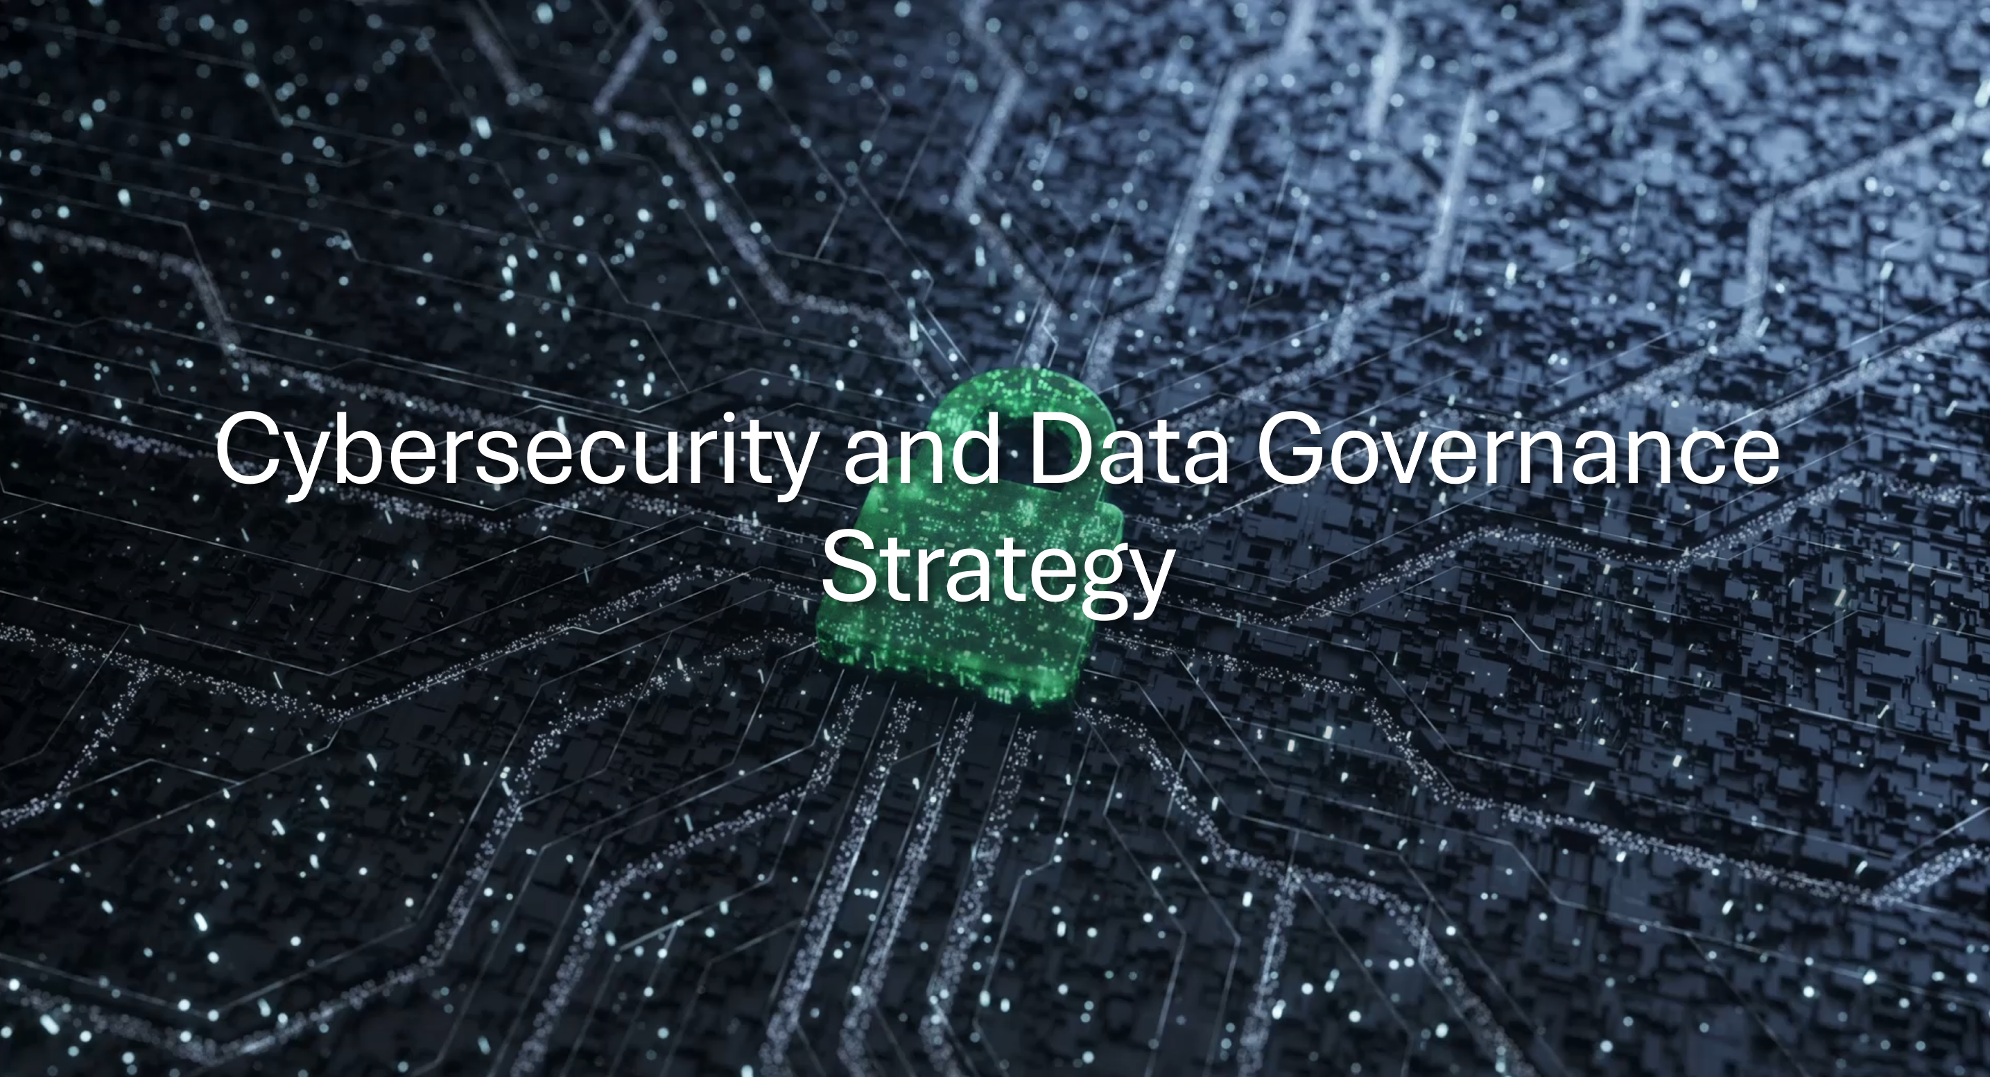
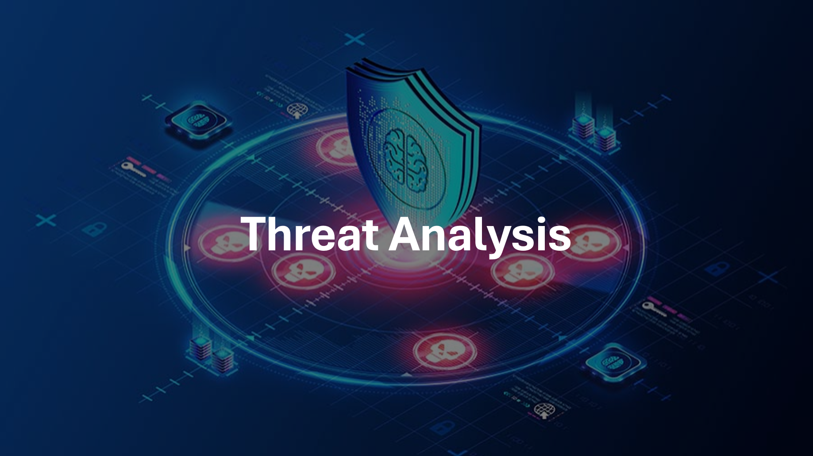
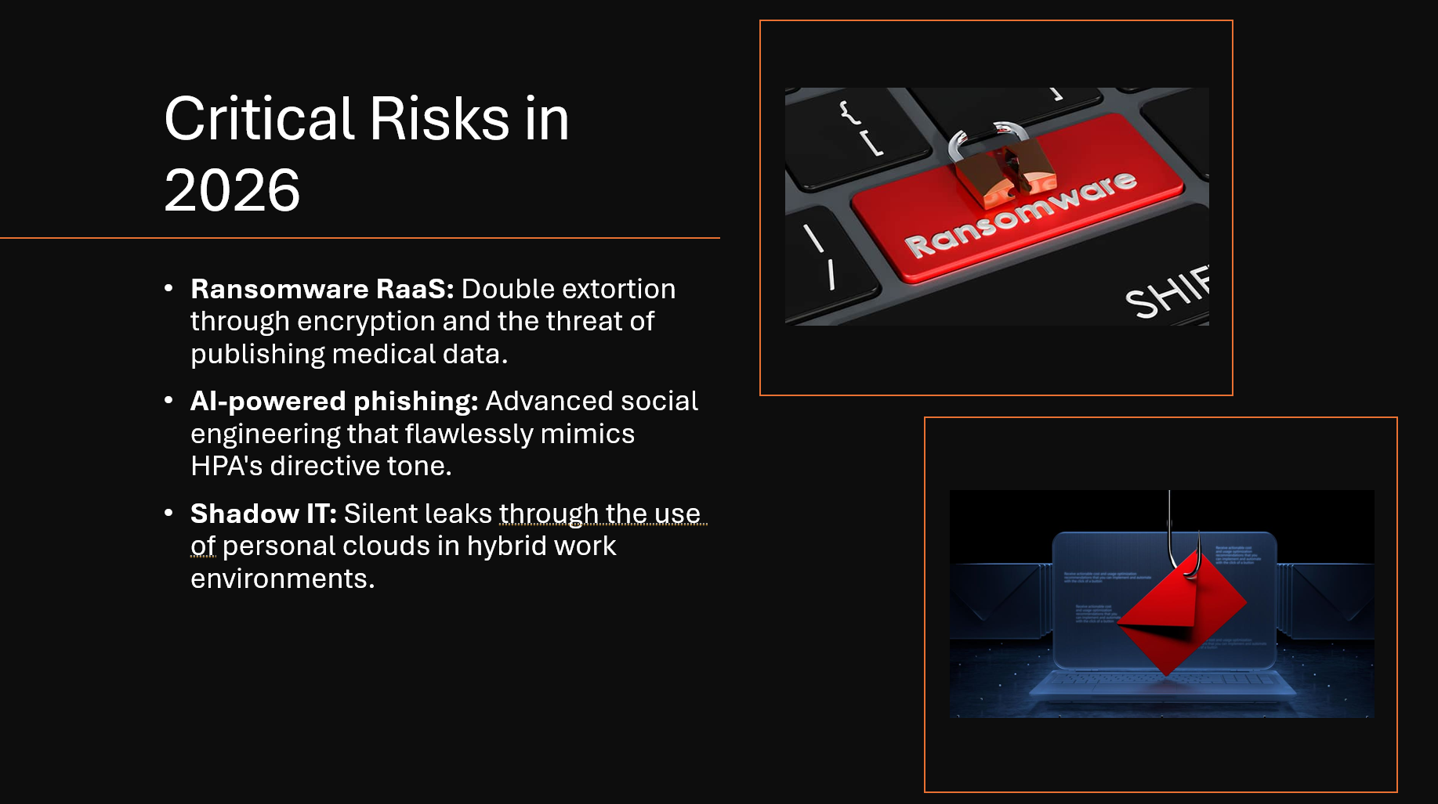
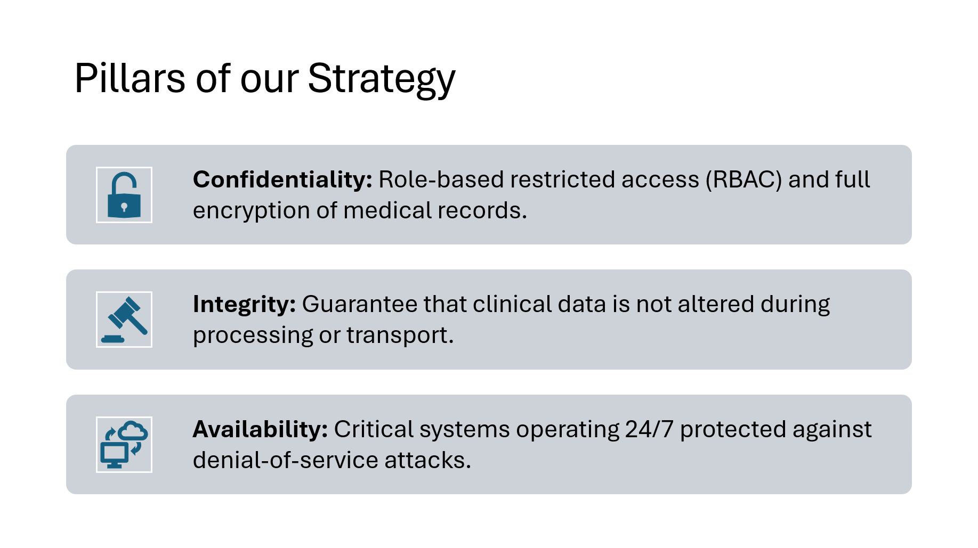
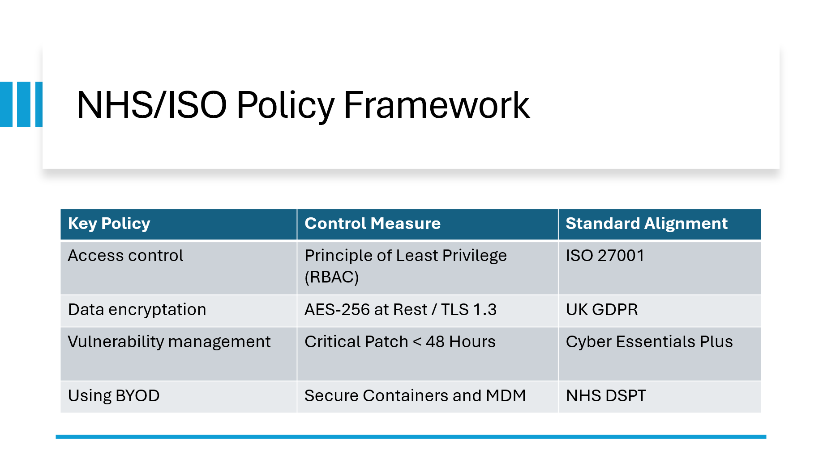
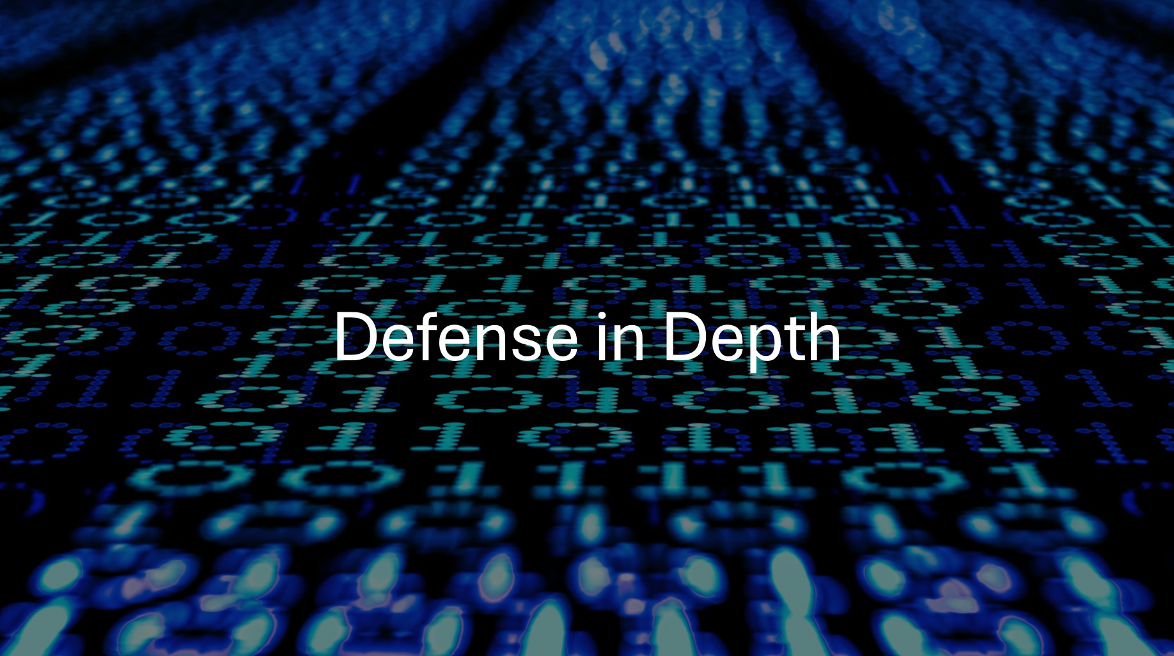
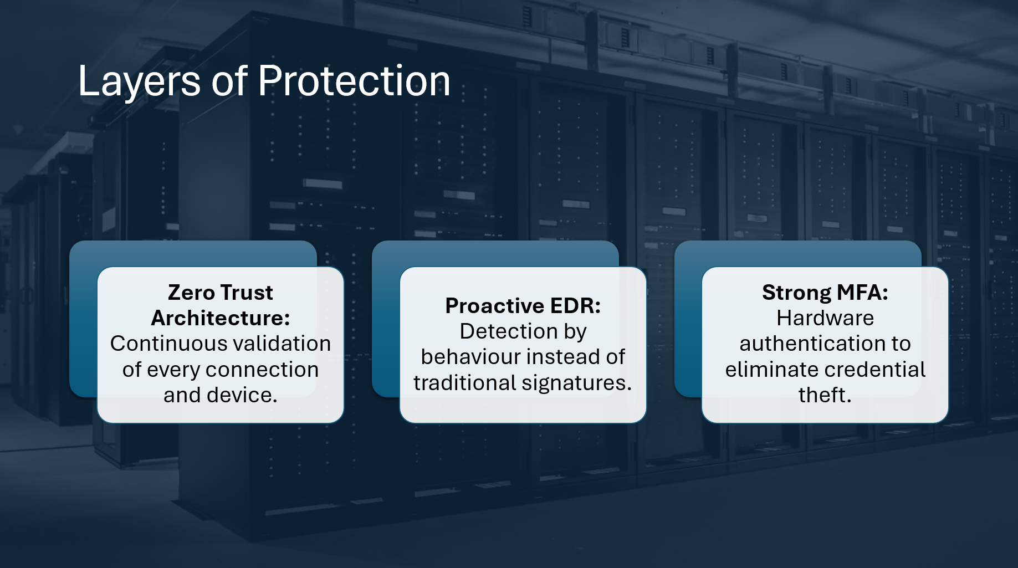
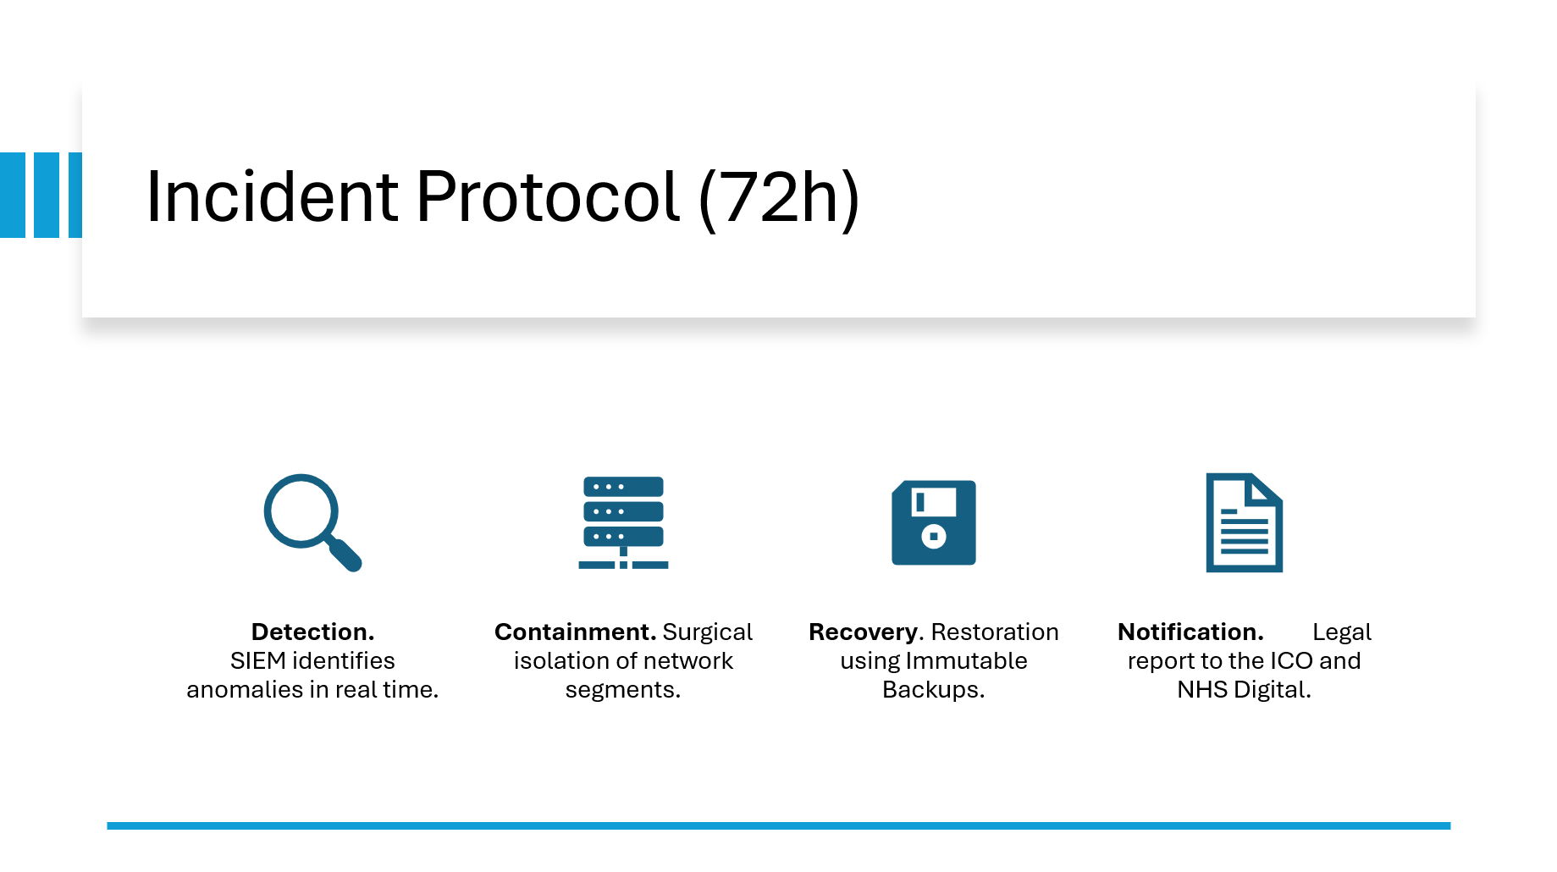
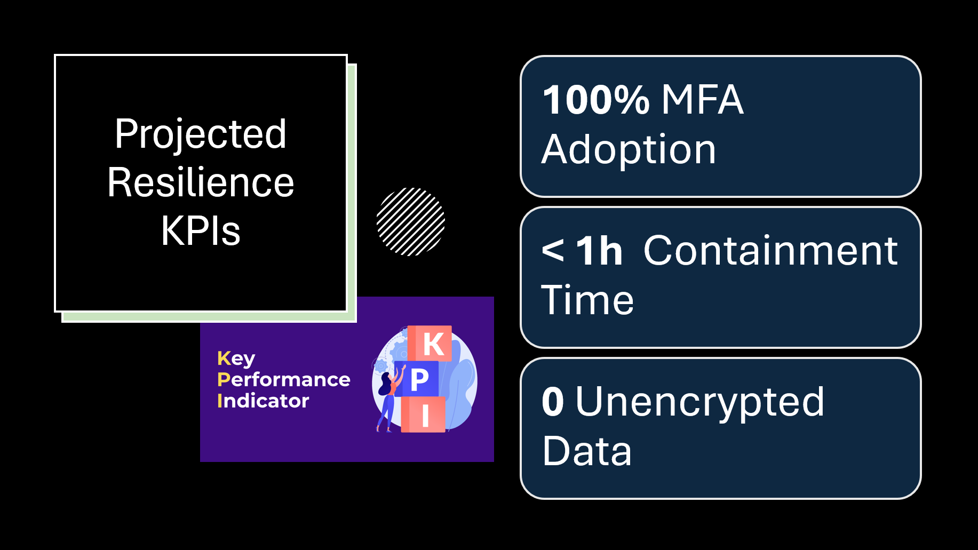
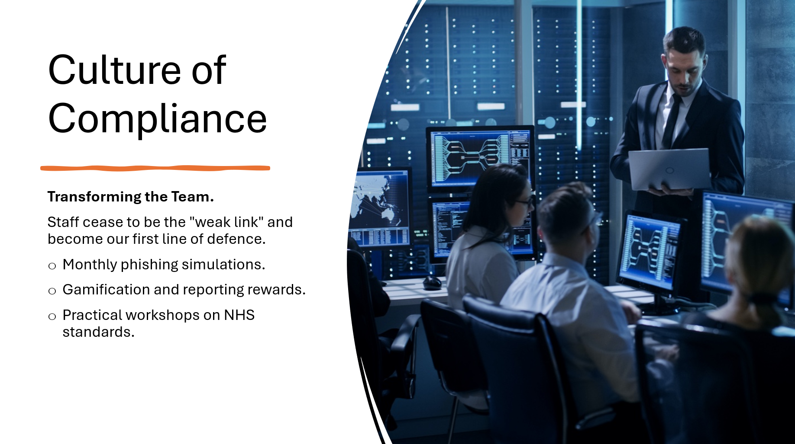
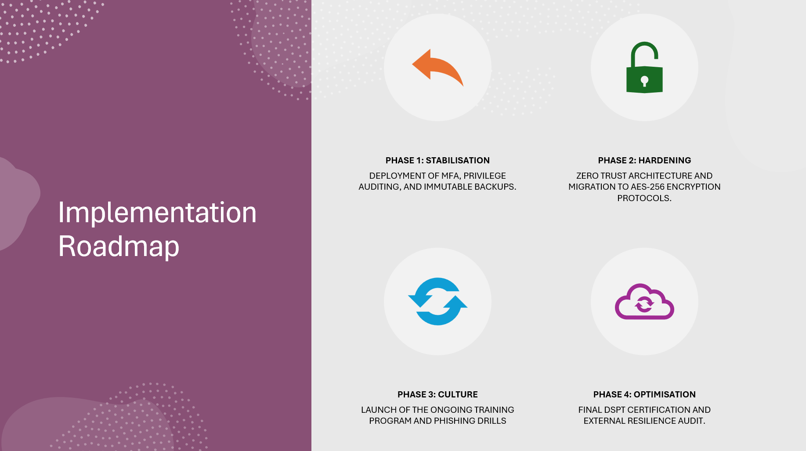
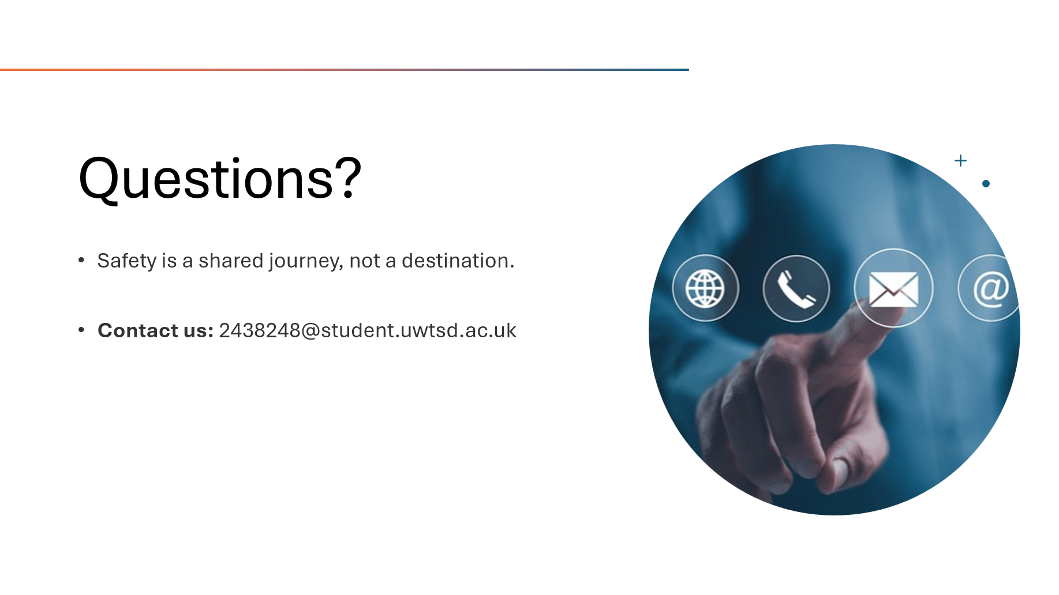

References

[1] | International Organization for Standardization, "ISO/IEC 27001:2022 Information security, cybersecurity and privacy protection — Information security management systems — Requirements," ISO, Ginebra, Switzerland, 2022. [Online]. https://www.iso.org/standard/27001
[2] | NHS England. (2023, June) Data Security and Protection Toolkit. [Online]. https://www.dspt.nhs.uk/
[3] | Information Commissioner's Office. (2021) Guide to the UK General Data Protection Regulation. [Online]. https://ico.org.uk/for-organisations/guide-to-data-protection/guide-to-the-general-data-protection-regulation-gdpr/
[4] | National Cyber Security Centre, "Ransomware: advice and guidance for organisations," NCSC, 2023. [Online]. https://www.ncsc.gov.uk/ransomware/overview
[5] | Nelson A., Rekhi S., Souppaya M., and Scarfone K., "Incident Response Recommendations and Considerations for Cybersecurity," NIST, 2025. [Online]. https://nvlpubs.nist.gov/nistpubs/SpecialPublications/NIST.SP.800-61r3.pdf

