

International financial management

Student name: Nikola Nikolov
Student ID 2014060
Date of submission 07/05/23

Introduction
The connection with foreign business affiliates, such as clients, suppliers, and financiers, is made possible through international financial activity. In addition, government agencies and charitable groups both use it. Therefore, this essay aims to look into and assess the advantages of global financial management at Tata Motors Limited.
This essay report will also examine the Company's difficulties in various international financial markets using theories of global financial management. It will also review and critically analyse the dividend distribution strategy of Tata Motors Limited. Additionally, the efficient market hypothesis theory will be critically examined in the context of the operations of Tata Motors Limited. Finally, this essay will review and critically analyse the project evaluation strategies used by Tata Motors Limited.
Tata Motors profile
The Tata Group includes the multinational Indian automaker Tata Motors Limited, headquartered in Mumbai. The Tata Motors Group is a well-known international automaker with a wide selection of business premises, passenger and electric vehicles. The Company revolves around engineering and technologically advanced automobile products to advance mobility. Tata Motors is a major international automaker manufacturing utility vehicles,cars, , buses, trucks, and defence vehicles with annual sales of US$37 billion (Tata Motors, 2023).

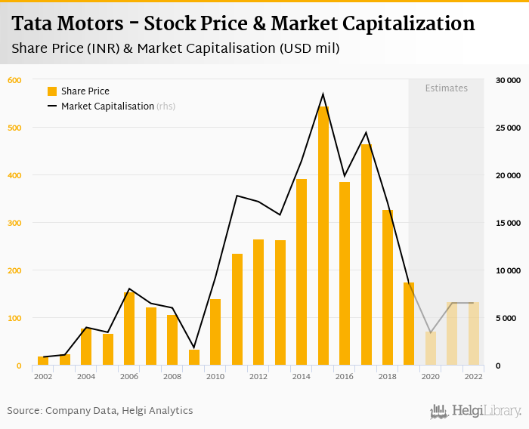
Source: Tata Motors (2023)
Benefit if international financial management
Madura and Fox (2019) note that by adhering to reporting norms that follow one accounting practice in international financial management, International Financial Reporting Standards contribute to cost savings. Concluding the calculation of various rates, international finance management aids in determining exchange rates between various currencies and the relative value of each nation. As a result, the management of Tata Motors Company can select the most advantageous pricing to optimise shareholder value. The ability to compare inflation rates also requires the use of international financial management. As a result, Tata Motors Company shareholders can determine whether to invest in global debt instruments, research other nations' economies, and evaluate the value of other currencies worldwide. Using current circumstances, Tata Motors Company can track the imports and exports they make per the pace of inflation (Shapiro and Hanouna, 2019).
Challenges faced in different financial markets
Electric challenge. Tata Motors has encountered severe difficulties developing more electric vehicles to decrease pollution. Tata Motor Company is one of many automakers not ready to produce enough electric vehicles. They need to redesign their company strategy to concentrate the cars more on the consumer base, which will cost money. For instance, global sales of battery-electric vehicles climbed to 1.3 million units in 2018 by 73% (Tata Motors, 2023). However, only a tiny portion of the 86 million automobiles sold represented this percentage.
Inconsistency in import tariffs. Some nations, like Nepal, impose taxes that can reach 250% (Tata Motors, 2023). Due to this, Tat automobiles are very costly compared to Indian costs. For instance, the Tata Safari Storme VX 4X4 costs INR 16 Lakhs in India but costs INR 40 Lakhs in Nepal. Occasionally, issues arise due to unpredictable and frequent changes in import duties.
Additionally, this hinders the development of PV-IB tactics. For instance, Sri Lanka's import tariff has changed seven times in the last four years. Garg (2019) points out that states started imposing taxes and other tariffs to deter consumers from using risky fuels after the Volkswagen combustion disaster rattled the European Union.
Exchange rate variations. When several different international currencies are exchanged for one another, exchange-rate fluctuations are subject to volatility. The present International Monetary Model is characterised by a mix of regulated and floating macroeconomic measures that every country implements following its goals. Therefore, even domestic items that depend on imported components and essential supplies will see price changes when the currencies fluctuate. As a result, several important currency pairs, including the US dollar, the British pound, the Japanese yen, and the Euro, are experiencing extremely variable exchange rates (Salam, 2013).
Dividend distribution policy
This Policy aims to establish a structure for the Company's dividend payments so that investors can share fairly in the business's success while preserving its sound financial position and ensuring long-term prosperity. The Tata Motors Company is an investment firm that specialises in long-term investments. As a result, the Company's profitability could change annually based on the state of the financial markets, which would also affect the dividend payment. Therefore, the Board will try to maintain an appropriate dividends payout for the firm, the dividends and interest income received by the firm and subject to profitability and other financial factors as per applicable legislative restrictions. However, this can entail considering previous dividend distribution trends, and the purchase and subsequent sale of new securities might need a review of the distribution of dividends (Nathe and Shukla, 2018).
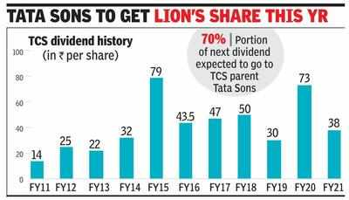
Source: Tata Motors (2023)
Dividend payments are entirely under a company's Board of Directors jurisdiction. There is no requirement under the law for the shareholders to approve the interim dividend, even though they must accept the dividend with the largest payout at the AGM. Because of this, one could argue that shareholders have little effect on dividend distribution. In domestic Indian commercial cars, their share price reached around 44% in 2017–2018 (Madura and Fox, 2019).
After properly considering the guidelines outlined in this Policy, the Board may keep its profits to use the money more effectively and ultimately raise the stakeholders' value. Therefore, the Company can declare dividends using either its current year's profits or those from any prior years. After carefully considering the guidelines outlined in this Policy, this is anticipated to be done in conformity with the provisions of the Companies Rules, 2014, as revised occasionally. In addition, all shareholders have the right to an equivalent dividend per share because Tata Motors Company only issued one class of equity shares with equal voting rights (Jain and Mehrotra, 2020).

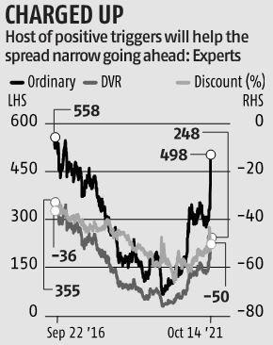
Source: Bloomberg (2021)

Based on the nature and rules of each new class of shares, the Policy shall be appropriately reviewed during issuance. The shareholders will ratify the interim dividend, which the Board has approved of directors, and the final dividend, following the terms of applicable legislation and this Policy. At the resulting Annual General Meeting of the business, the owners approve any resolutions the Board of Directors recommends (Jain, 2015).

Efficient market hypothesis theory
The EMH postulates that the instruments' prices accurately reflect every known detail regarding those stocks. As a result, it is thought that predicting good future behaviour may result in good current performance since market players will probably act quickly to trade on new data. Unpredictable new knowledge is a fact. If it could be foreseen, the forecast could become a part of the present knowledge (Fakhry, 2016). Furthermore, stock prices may fluctuate randomly and react to the latest information. Therefore, the movement of stock prices follows a Random Walk. According to the random walk hypothesis, fluctuations in stock prices have a uniform distribution and are unrelated to one another. Market participants frequently strive to join the proceedings before the price surges. Therefore a prediction of favourable future outcomes leads to positive current outcomes.
Weak-form. According to EMH, prices for stocks already account for every detail that can be learned from studying market trade information, like historical records of previous trading activity. The historical stock price information is easily accessible and practically free to obtain (Wahab et al., 2022)—Semi strong-form. According to EMH, a company's stock price should reflect every public detail about its future. This data covers previous rates and details about the Company's product line, management style, profits projection, and accounting procedures. Strong-form. According to EMH, stock prices represent all essential information about a company, even information only known to executives. This variation is extreme. Furthermore, it is always hard to define insider trading (Sharma and Jha, 2016).

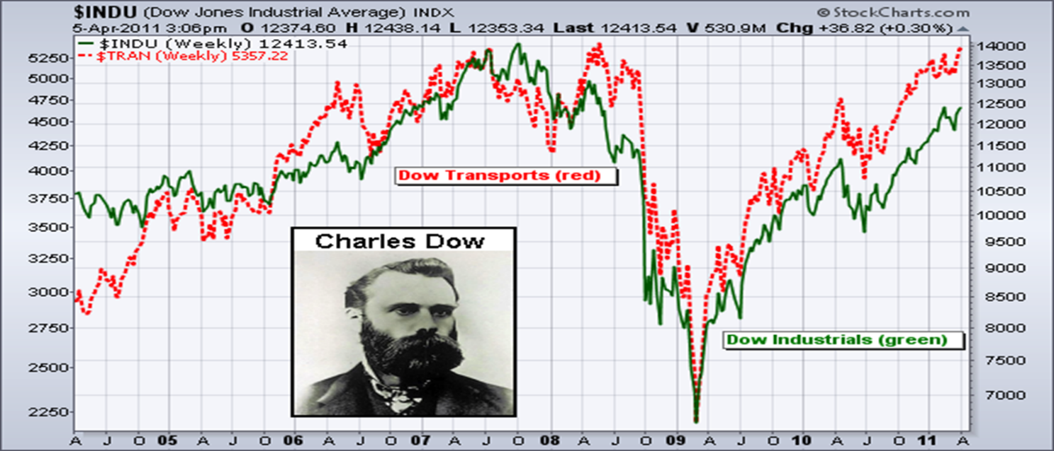
Source: Fakhry (2016)

Method of appraising projects
Net present value. The NPV is, theoretically, the most used capital budgeting approach for evaluating projects involving capital investments. An investment scheme is considered suitable whenever a positive NPV is a result using this methodology, which calculates the estimated value of future earnings and compares it to initial expenditures. Because it is convenient and straightforward, NPV is used more frequently at Tata Motors. Concerning a set of anticipated earnings and a discount rate, NPV displays the projected shift in shareholders' assets (Marchioni and Magni, 2018).
Conclusion
International financial management aims to provide the essential information and leadership abilities that modern finance directors will require to succeed globally. International financial management is centred on boosting the value of investors and improving their economic situation. Shareholders may buy and sell shares across borders worldwide thanks to relations, an essential component driving the global financial system. In addition, investors can evaluate the effect of a particular event on a company's stock price using quantitative financial analysis.

References
Becker-Ritterspach, F. and Bruche, G., (2012), Capability creation and internationalisation with business group embeddedness–the case of Tata Motors in passenger cars, European Management Journal, Vol.30 (3), pp.232-247.
Bloomberg, (2021). About Tata Motors Limited. {Online} Available at: https://www.bloomberg.com/quote/TTM:US (Accessed: 4.5.2023).
Fakhry, B. (2016). A literature review of the efficient market hypothesis. Turkish Economic Review, 3(3), pp.431-442.
Garg, S. (2019). Internationalisation of Tata Motors: strategic analysis using flowing stream strategy process. International Journal of Global Business and Competitiveness, 14(1), pp.54-70.
Jain, K (2015), Effect of declaration of dividend on the movement of share prices, Clear International Journal of Research in Commerce & Management, VOLUME NO. 6 (2015), ISSUE NO. 12 (DECEMBER) ISSN 0976-2183.
Jain, P. and Mehrotra, V. (2020). The Impact on Shareholder's Wealth due to Abolishment of Dividend Distribution Tax, International Research Journal on Advanced Science Hub, Volume 02 Issue 08 August 2020, pp.214-221.
Madura. J. and Fox. R, (2019). International Financial Management, Cengage, 5thed, pp2-22.
Marchioni, A. and Magni, C.A. (2018). Investment decisions and sensitivity analysis: NPV-consistency of rates of return. European Journal of Operational Research, 268(1), pp.361-372.
Nathe, Y. and Shukla, A. (2018). An analysis of dividend policy of companies listed in Sensex. {Online} Available at: https://www.researchgate.net/profile/Ajay-Shukla-14/publication/332344902_An_analysis_of_dividend_policy_of_companies_listed_in_Sensex/links/5caf1e46a6fdcc1d498c6ec4/An-analysis-of-dividend-policy-of-companies-listed-in-Sensex.pdf (Accessed: 4.5.2023).
Salam, M.T. (2013), Internationalisation of Tata motors: The case of JLR, Anglia Ruskin University. {Online} Available at: https://papers.ssrn.com/sol3/papers.cfm?abstract_id=2396897 (Accessed: 4.5.2023).
Shapiro, A.C. and Hanouna, P. (2019). Multinational financial management. New York: John Wiley & Sons.
Sharma, A. and Jha, S. (2016). Innovation from emerging market firms: what happens when market ambitions meet technology challenges? Journal of Business & Industrial Marketing, Santa Barbara Vol. 31, Iss. 4, (2016): 507-518.
Tata Motors, (2023). Tata Motors. {Online} Available at: https://www.tatamotors.com/about-us/ (Accessed: 4.5.2023).
Wahab, H.A., Bacha, O.I., Ibrahim, N., Abdullah, A.M. and Nasir, N.A.M. (2022). An Assessment of Currency Exposure of Non-Financial Firms in ASEAN-4: Insights using the Stock Returns and Cash Flow Methodologies. Asian Economic and Financial Review, 12(12), pp.1002-1026.

