HNC/HND Electrical and Electronic Engineering

Design of Electrical Installations

GOEE4001

Leighton Allen

Design an Electrical Installation

Contents page

Introduction - 3
Lights selected - 4
Lighting calculations - 5
Lighting diagrams - 19
Lighting cable calculations - 21
Single phase cable calculations - 24
Three phase cable calculations – 27
Socket cable calculations - 30
Maximum demand and diversity - 33
Forms of circuit Protection - 33
Circuit containment methods - 34
Containment Chosen - 35
References - 35
Appendix - 36

Task 1

Introduction
For this task I have been told to design an electrical circuit from scratch, this includes the sockets, the lights used and making sure that all the cable sizes are correct for what is needed, I’m tasked with doing this for both a factory and an office, this is my assignment.
This assignment will include single and 3 phase cable calculations and other things such as the maximum demand and diversity.

Part one:

Appropriate lighting systems for both the factory and office areas including wiring diagrams.

I firstly wanted to start off by doing the office areas as I have found this will be easier to start with rather than the factory floor.

Before we start, the reason I have used 500 lux for the offices and the conference room is because I’m assuming that the offices and conference room will have light coming in through the windows and from the computers which will increase the light intensity.

Lights selected.

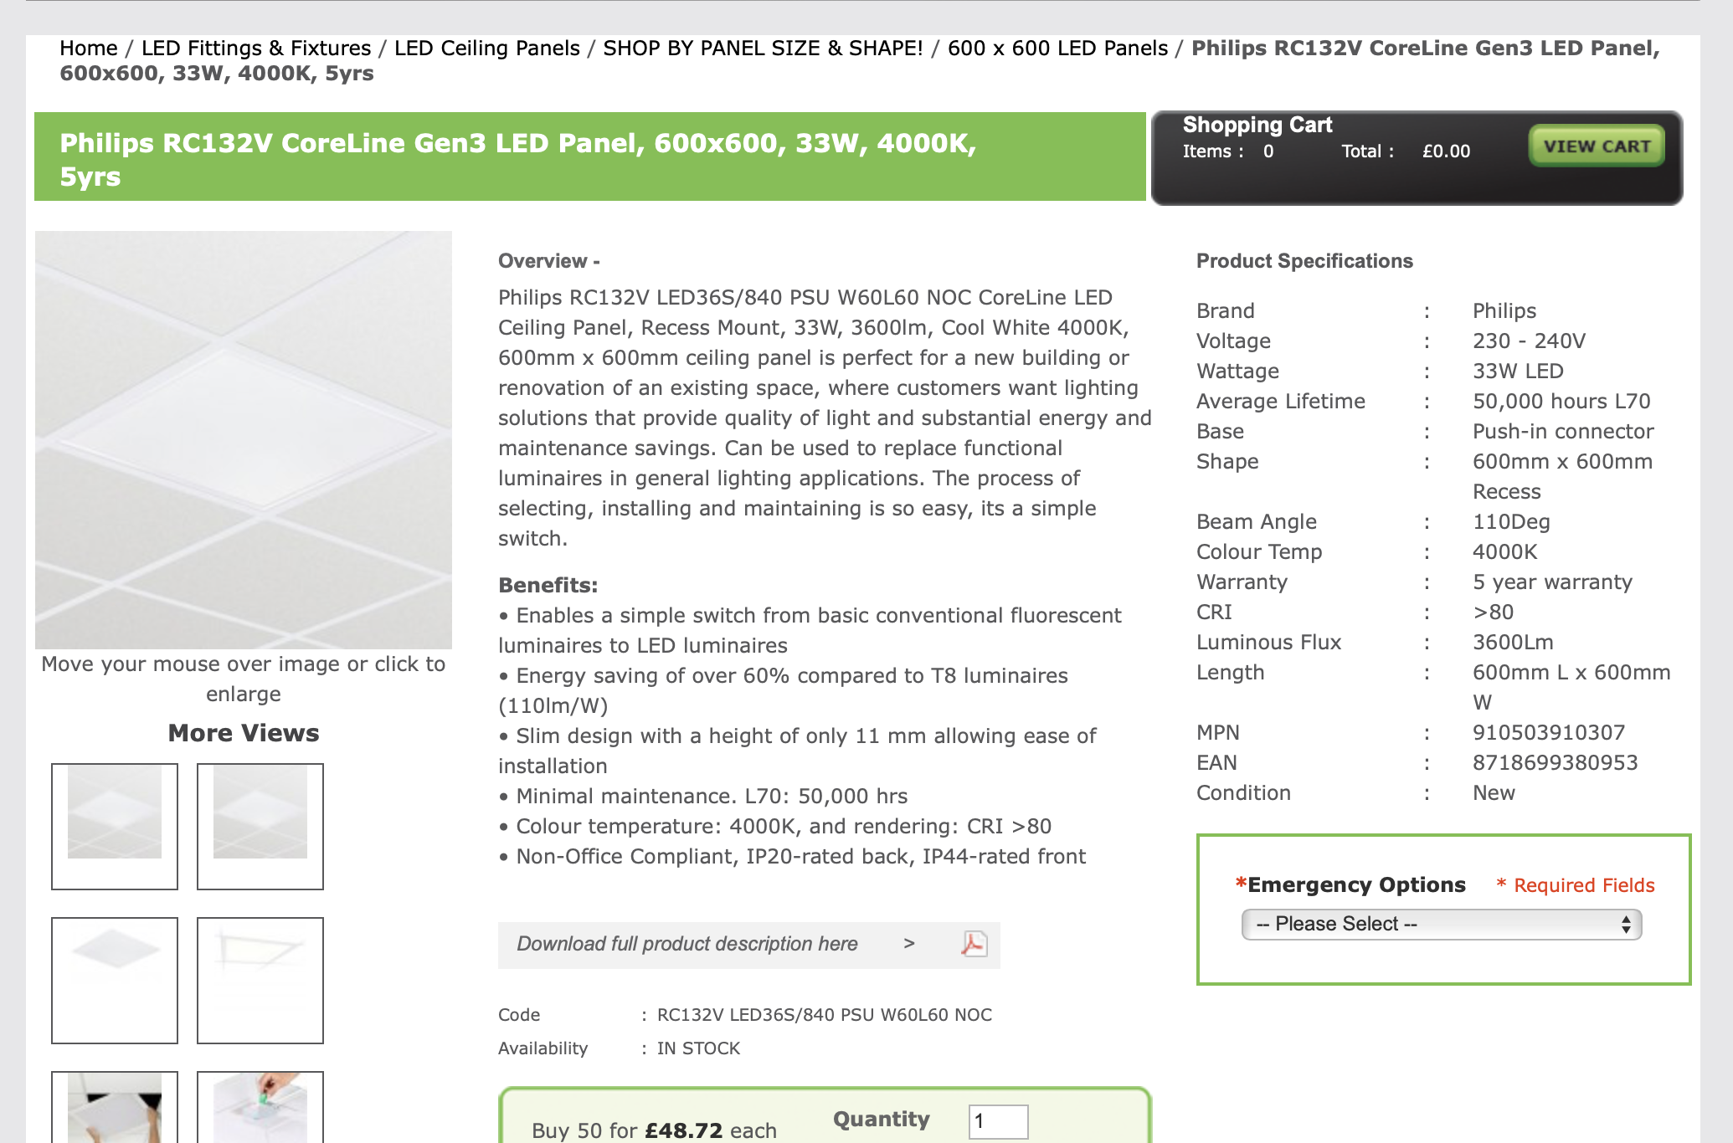
A square tile measuring 600 mm by 600 mm was selected for the offices because it blends nicely with the suspended ceiling. Because it is an LED panel, it requires a lot less energy to operate than a halogen one. It can operate between 230 and 240 volts and uses 33 watts of power.

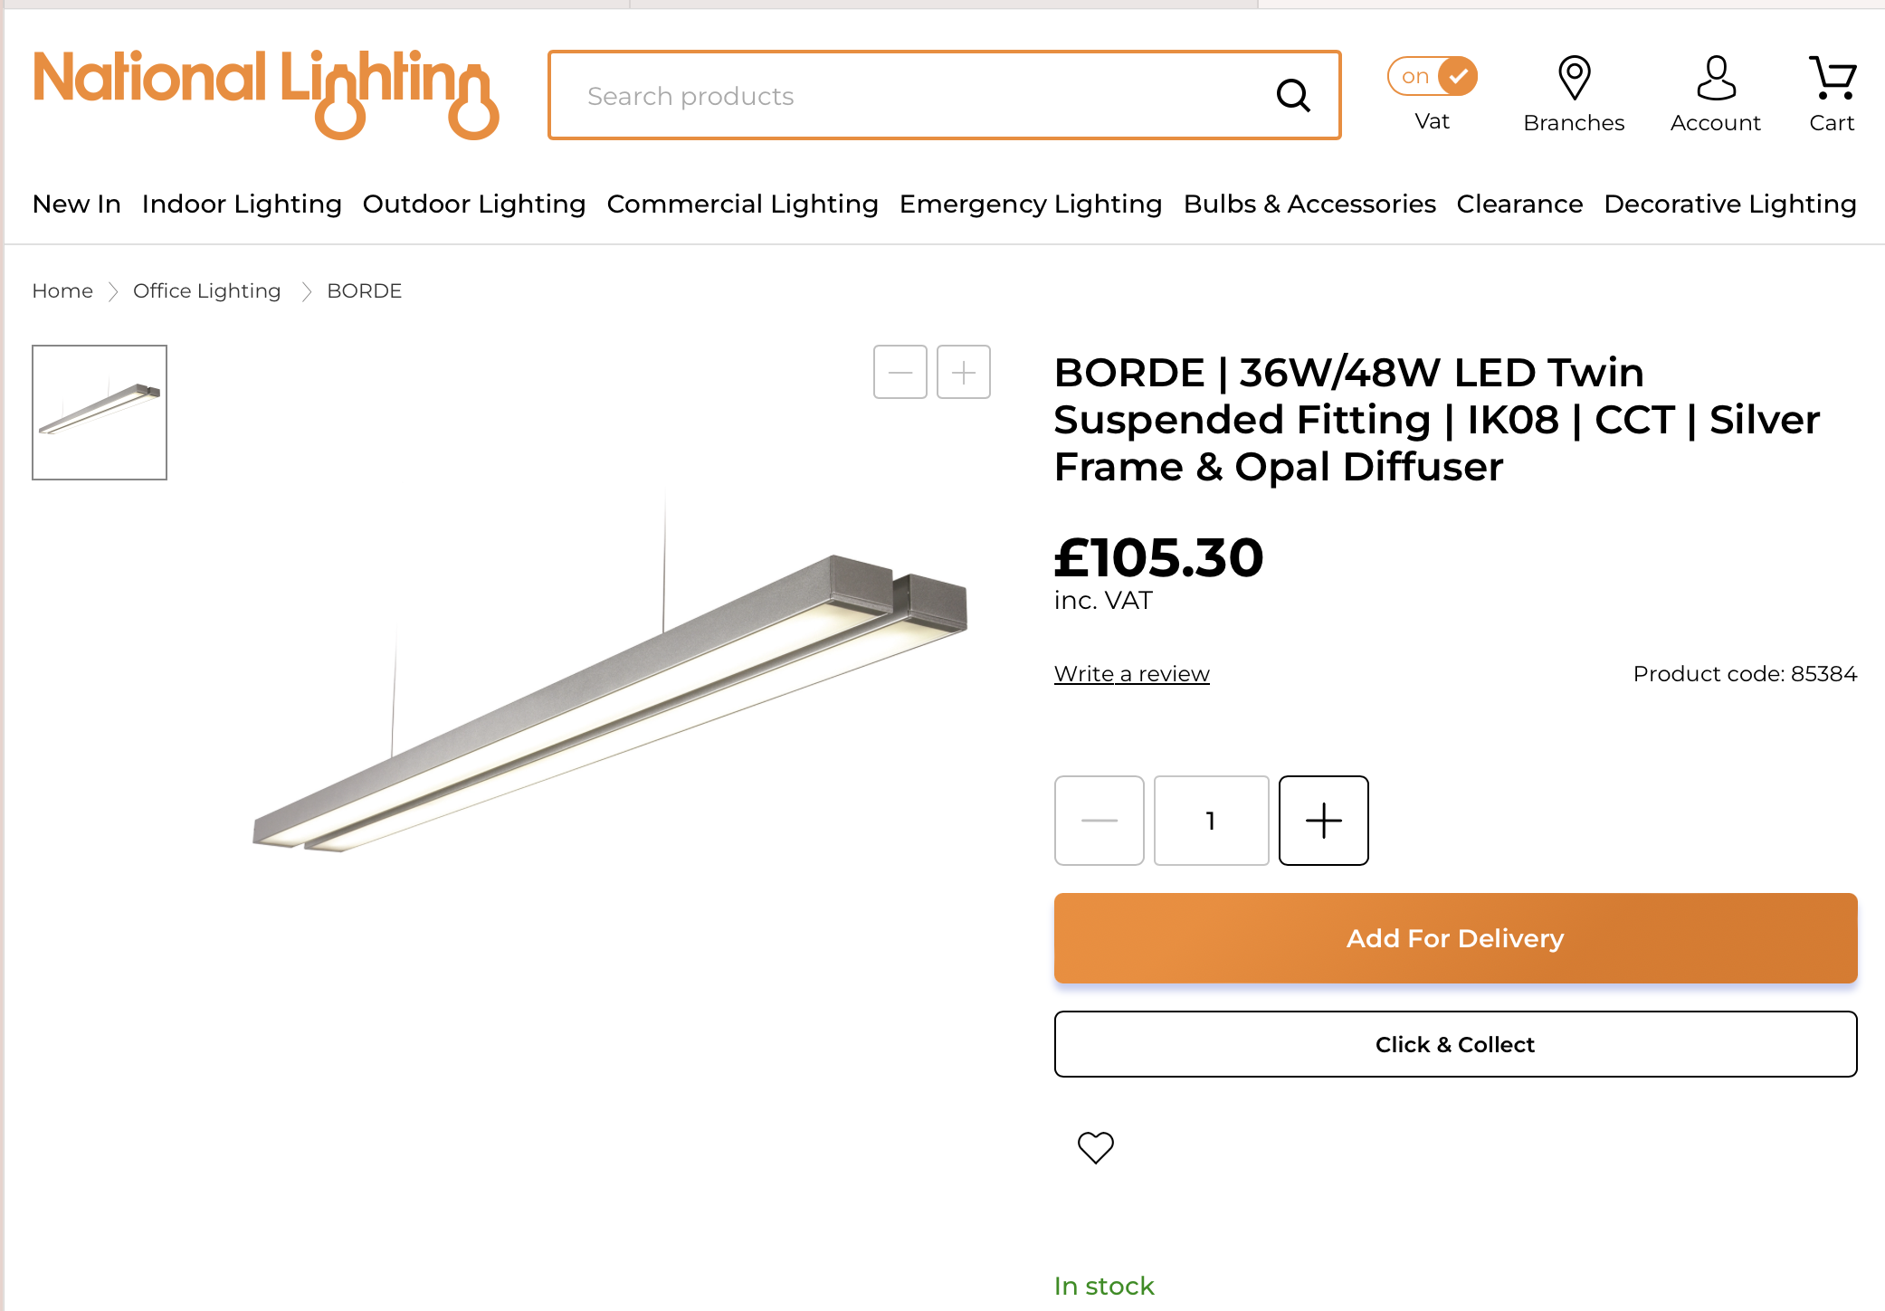
These are the lights I will be using in the factory area, they run off 36-48W of power, these also give off 4800 lumens of light.

Lighting Systems + calculations

Numerous lighting options are available for a variety of applications. However, they can differ significantly based on a variety of variables, including the lumen count, intensity, and area of the room they must fill. The selection of lights can also be influenced by the room's height.
There are several things to take into account when determining how many lights are needed in a given location.
These include the room's size, which must be considered, and the proper light intensity, which may be discovered online. The right lumen count is also crucial since it affects how many of that lights are required. the values for this can be found when looking at the lights that you are going to be fitting.
The equation to work out the total number of lights needed is $N=\frac{E*A}{F}$
E= Lux levels
A= Area of the room
F= Lumen count

Office floor
I will be using the same lights throughout, these lights are the PHILIPS RC132V CORELINE, GEN 3 LED PANEL, 600X600, 33W, 400K, 5YRS LIGHTS.

OFFICE 1:

First step for this is to find out the size of the room which will allow us to continue to work out the lights for this room, to do this we will need to multiply the width of the room by the length.

5000mm x 9000mm = 45,000,000 mm^2
As this number isn’t in metres squared it will be harder to use, therefore, to be able to get this number into metres squared I will divide this number by 1,000,000 to get to the answer I would like too.

45,000,000 / 1,000,000 = 45 squared meters of room that will need lighting up.

The next step will be to find out what lux will be needed to light up an office workplace, a quick google search found that offices would need a lux level of around 500 lux.

Now that I have my lux level, which is 500, I can now carry on by working out how many lumens I need, to do this I will need to use both the area of the room and what lux level I would like, I once again would need to multiply both these numbers together.

45 x 500 = 22,500 lumens

Now that I know how many lumens, I need we can leave this here for a minute and move on to the lights that I would like to use for the office areas.

After a bit of research, I have found the lights that I would like to use, the lights are as follows. PHILIPS RC132V CORELINE, GEN 3 LED PANEL, 600X600, 33W, 400K, 5YRS LIGHTS.

After finding what lights I would like to be using we can continue this by working out the required wattage, this is by using the total lumens and dividing that by the light’s efficacy, I have found that the lights I am using have a efficacy of 110 im/w.

22,500/110 = 204.55W
I will round this number up to 205w needed so its easier in the long run and rounding up will 100% give me enough light in the room to be 500 or above.

So what I have found out so far is that I need 205W of LED lighting to calculate a light intensity of 500 lux in my office which is 5000mm by 9000mm
Each light has a wattage of 33w, therefore, I would need to do 205 divided by 33 which comes out to around 6.21.
So I will need 7 lights to make sure the office is light enough to work in, however I would like to use 8 lights for this office so all the lights are even throughout the room and no single light would look out of place.

As I need 8 lights to light up this room I would like to work out the cost of all the lights for this room, each light costs a grand total of £52.43, so I would need to multiply this number by how many lights I am going to be using (8 lights).

£52.43 x 8 = £419.44
So for all the lights in this one office it would cost £419.44 to buy all the lights needed for this.

OFFICE 2

First step for this is to find out the size of the room which will allow us to continue to work out the lights for this room, to do this we will need to multiply the width of the room by the length.

4500mm x 9000mm = 40,500,000 mm^2
As this number isn’t in metres squared it will be harder to use, therefore, to be able to get this number into metres squared I will divide this number by 1,000,000 to get to the answer I would like too.

40,500,000 / 1,000,000 = 40.5 square meters.

Now that I have my lux level, which is 500, I can now carry on by working out how many lumens I need, to do this I will need to use both the area of the room and what lux level I would like, I once again would need to multiply both these numbers together.

40.5 x 500 = 22,250 lumens

Now that I know how many lumens, I need we can leave this here for a minute and move on to the lights that I would like to use for the office areas.

There is 110 im/w in each light.
After finding what lights I would like to be using we can continue this by working out the required wattage, this is by using the total lumens and dividing that by the light’s efficacy, I have found that the lights I am using have an efficacy of 110 im/w.

20,250 / 110 = 184.091W needed.
I will round 184.091 to 185 so it’s easier in the long run.
Same as before each light has 33W.

Again, I will do 185 divided by 33 to work out how many lights I will need for this office.
185 / 33 = 5.6 lights I will need.

I will round this up to 6 lights so that I can keep all the lights equal throughout the room.

The cost of the lights is still £53.43 per light.

6 (how many lights are needed) x £53.43 (cost of each light) = £314.58 (cost of all the lights in the second office).

OFFICE 3

First step for this is to find out the size of the room which will allow us to continue to work out the lights for this room, to do this we will need to multiply the width of the room by the length.

9500mm x 7000mm = 66,500,000 mm^2
As this number isn’t in metres squared it will be harder to use, therefore, to be able to get this number into metres squared I will divide this number by 1,000,000 to get to the answer I would like too.

66,500,000 / 1,000,000 = 66.5 square meters.

Now that I have my lux level, which is 500, I can now carry on by working out how many lumens I need, to do this I will need to use both the area of the room and what lux level I would like, I once again would need to multiply both these numbers together.

66.5 x 500 = 33,250 lumens

Now that I know how many lumens, I need we can leave this here for a minute and move on to the lights that I would like to use for the office areas.

There is 110 im/w in each light.
After finding what lights I would like to be using we can continue this by working out the required wattage, this is by using the total lumens and dividing that by the light’s efficacy, I have found that the lights I am using have an efficacy of 110 im/w.

33,250 / 110 = 302.27W needed.
I will round 302.27 to 303 so it’s easier in the long run.
Same as before each light has 33W.

Again, I will do 303 divided by 33 to work out how many lights I will need for this office.
303 / 33 = 9.1 lights I will need.

I will round this up to 10 lights so that I can keep all the lights equal throughout the room.

The cost of the lights is still £53.43 per light.

10 (how many lights are needed) x £53.43 (cost of each light) = £534.30 (cost of all the lights in the third office).

OFFICE 4

First step for this is to find out the size of the room which will allow us to continue to work out the lights for this room, to do this we will need to multiply the width of the room by the length.

6500mm x 4500mm = 29,250,000 mm^2
As this number isn’t in metres squared it will be harder to use, therefore, to be able to get this number into metres squared I will divide this number by 1,000,000 to get to the answer I would like too.

29,250,000 / 1,000,000 = 29.25 square meters.

Now that I have my lux level, which is 500, I can now carry on by working out how many lumens I need, to do this I will need to use both the area of the room and what lux level I would like, I once again would need to multiply both these numbers together.

29.25 x 500 = 14625 lumens

Now that I know how many lumens, I need we can leave this here for a minute and move on to the lights that I would like to use for the office areas.

There is 110 im/w in each light.
After finding what lights I would like to be using we can continue this by working out the required wattage, this is by using the total lumens and dividing that by the light’s efficacy, I have found that the lights I am using have an efficacy of 110 im/w.

14625 / 110 = 132.95W needed.
I will round 132.95 to 133 so it’s easier in the long run.
Same as before each light has 33W.

Again, I will do 133 divided by 33 to work out how many lights I will need for this office.
133/ 33 = 4.03 lights I will need.

As the difference is so small I will round down to 4 lights and I will assume that the light lost by rounding down will be made up by the light coming through the windows and the pc screens.

The cost of the lights is still £53.43 per light.

4 (how many lights are needed) x £53.43 (cost of each light) = £209.72 (cost of all the lights in the fourth office).

Now as all the offices lights have been calculated, we can now work out the total cost of all the lights for all the offices, this will be the cost of the lights added up. There are 8 lights in office 1, 6 lights in office 2, 10 lights in office 3 and 4 lights in office 4 which adds to a total of 28 lights in total.

£209.72 + £524.30 + £419.44 + £314.58 = £1468.04
This means it will cost £1468.04 to light all the offices correctly.

Reception

Next, I will be working out how many lights I will need for the reception, I will be doing this the same way that I did for all the offices.

First step for this is to find out the size of the room which will allow us to continue to work out the lights for this room, to do this we will need to multiply the width of the room by the length.

Lighting calculations for reception

6500mm x 4500mm = 29,250,000 mm^2
As this number isn’t in metres squared it will be harder to use, therefore, to be able to get this number into metres squared I will divide this number by 1,000,000 to get to the answer I would like too.

29,250,000 / 1,000,000 = 29.25 square meters.

After looking around on google I have found that for a conference room I will need between 500 and 1000 lux, so I will go in the middle and choose 750 lux for the conference room. After choosing this we can now carry on with the lighting calculations.

29.25 x 750 = 21,937.5 lumens, I will round this up to 21,938 lumens

Now that I know how many lumens, I need we can leave this here for a minute and move on to the lights that I would like to use for the reception.

I will be using the same lights in the reception as I did in all the offices as I want to keep the lights the same through the office building.

There is 110 im/w in each light.
After finding what lights I would like to be using we can continue this by working out the required wattage, this is by using the total lumens and dividing that by the light’s efficacy, I have found that the lights I am using have an efficacy of 110 im/w.

21,938 / 110 = 199.43W needed.
I will round 199.43 to 200 so it’s easier in the long run.
Same as before each light has 33W.

Again, I will do 200 divided by 33 to work out how many lights I will need for the reception. 200 / 33 = 6.06 lights I will need.

I will stick with 6 lights as the difference is so small and I can afford to do this as I used a higher lux value for the reception.

The cost of the lights is still £53.43 per light.

6 (how many lights are needed) x £53.43 (cost of each light) = £314.58 (cost of all the lights in reception).

Conference room

The way I will be working out the lighting for the conference room is by using the same method as I did for the offices and reception.

First step for this is to find out the size of the room which will allow us to continue to work out the lights for this room, to do this we will need to multiply the width of the room by the length.

10500mm x 5000mm = 52,500,000 mm^2
As this number isn’t in metres squared it will be harder to use, therefore, to be able to get this number into metres squared I will divide this number by 1,000,000 to get to the answer I would like too.

52,500,000 / 1,000,000 = 52.5 square meters.

After my research I have decided to use a lux of level of 500 again as a conference room and office are meant to have the same lux level.

Now that I have my lux level, which is 500, I can now carry on by working out how many lumens I need, to do this I will need to use both the area of the room and what lux level I would like, I once again would need to multiply both these numbers together.

52.5 x 500 = 26,250 lumens

Now that I know how many lumens, I need we can leave this here for a minute and move on to the lights that I would like to use for the office areas.

There is 110 im/w in each light.
After finding what lights I would like to be using we can continue this by working out the required wattage, this is by using the total lumens and dividing that by the light’s efficacy, I have found that the lights I am using have an efficacy of 110 im/w.

26,250 / 110 = 238.63W needed.
Same as before each light has 33W.
I will round 238.63 to 240 so it’s easier in the long run.

Again, I will do 240 divided by 33 to work out how many lights I will need for this office.
240 / 33 = 7.27 lights I will need.

I will round this up to 8 lights so that I can keep all the lights equal throughout the room.

The cost of the lights is still £53.43 per light.

8 (how many lights are needed) x £53.43 (cost of each light) = £419.44 (cost of all the lights in the conference room).

Toilets

As there are 3 toilets in the office area, 2 of the 3 are the exact same size and the third one is only 1 meter smaller, I have decided to use the same lighting calculations throughout all 3 of the toilets.

First step for this is to find out the size of the room which will allow us to continue to work out the lights for this room, to do this we will need to multiply the width of the room by the length.

3000mm x 3000mm = 9,000,000 mm^2
As this number isn’t in metres squared it will be harder to use, therefore, to be able to get this number into metres squared I will divide this number by 1,000,000 to get to the answer I would like too.

9,000,000 / 1,000,000 = 9 square meters.

When looking online for the recommended lux level for toilets I have decided to use the lux level of 800, this is due to the safety concerns and how whoever uses the toilets will need to see where and what they are doing and going to make sure that they don’t do anything stupid.

Now that I have my lux level, which is 800, I can now carry on by working out how many lumens I need, to do this I will need to use both the area of the room and what lux level I would like, I once again would need to multiply both these numbers together.

9 x 800 = 7200 lumens

Now that I know how many lumens, I need we can leave this here for a minute and move on to the lights that I would like to use for the office areas.

There is 110 im/w in each light.
After finding what lights I would like to be using we can continue this by working out the required wattage, this is by using the total lumens and dividing that by the light’s efficacy, I have found that the lights I am using have an efficacy of 110 im/w.

7200 / 110 = 65.45W needed.
I will round 65.45 to 66 so it’s easier in the long run.
Same as before each light has 33W.

Again, I will do 66 divided by 33 to work out how many lights I will need for this office.
66 / 33 = 2 lights I will need.

The cost of the lights is still £53.43 per light.

2 (how many lights are needed) x £53.43 (cost of each light) = £104.86 (cost of all the lights in one of the toilets).

As there are 3 toilets of all around equal size, each toilet will have 2 lights inside to make sure the lux level stays above 800.

As each toilet uses 2 lights and there is 3 toilets, 2 x 3 = 6 lights

6 x £52.43 = £314.58 this is the cost of all the lights for all 3 toilets in the office area.

Hallway – ground floor

So firstly as the hallway isn’t a room I will split the hallway into 2 separate rooms such to say so its easier to work everything out.

1st part of the hallway is the long sided one, this stretches out 16000mm I found this by adding 5000,4500 and 6500, these numbers came from the floor plan which was given to us when we started this assessment.

The width was also given to us, this was 4000mm

To work out the area we will need to do 4,000mm x 16,000mm
This works out at 64,000,000 square mm
Again I would like this value to be in meters squared so again we must divide this number by 1 million which leaves me 64 meter squared.

After looking online I found that hallways need to be above 100 lux level so I will use the 100 as my lux level.

64 x 100 = 6400 lumens needed

As before I will use the same lights for the hallways as I did for everything else, which means all the values will be the same.

Working out the wattage needed is as easy as doing the lumens needed divided by the wattage the lights give off.

6400 / 110 = 58.18W
I will round this up to 60 to make things easier as we move on and seeing as I used 100 lux rounding up will give me more than 100 lux which is perfect for the hallways.

Each light has 33w so now to work out how many lights are needed I will need to do the amount of wattage needed (58.18) divided by how much wattage each light gives off (33)

58.18 / 33 = around 1.9 lights
As its so close too 2 lights I will just use to, this allows me to be 100% sure that the hallways are light enough.

As I need 2 lights, to work out the cost of the lights to purchase, I need to do 2 (for the amount of lights) multiplied by how much they cost (£52.43) this equals to a cost of £104.86.

Now, moving on to the second part of the hallway.

I had to do some quick little calculations to get the size of the hallway.

6500-3000= 3000
13000-4500=8500

Now we can work out the area of this hallway too.

3000 x 8500 = 25,500,000
Again as that is in mm squared I will divide that number by 1 million to get my area in meters squared.

25,500,000 / 1,000,000 = 25.5 meters squared.

Again the lux level needed is 100 so I will multiply 100 by 25.5 to get the lumens that is needed.

100 x 25.5 = 2,550 lumens needed.
Same lights so same values are used which means I can do 2,550 divided by 110 to see the wattage I need for the hallway

2,550 / 110 = 19.318W

Seeing as this number is smaller than 33 I know that 1 light will be more than enough to light up the hallway.

So the cost of light here is just £52.43

As the hallway needs 3 lights I can just add £52.43 too £104.86 which gives me a total cost for the lights for the ground floor hallway is £157.29.

Hallway for first floor

Thankfully, this hallway is quite easy compare to the other one, the room isn’t completely a rectangle however as its just a little off being a rectangle I will just treat it as a rectangle.

Before we start, I will once again need to do some basic calculations to be able to continue with the lighting calculations.

13,000 – 4,500 = 8500

Now we can do length multiplied by width which is:

6500 x 8500 = 52,250,000 mm squared

Divide this number by 1 million again to make life easier for us all, this leaves us then with 52.25 meters squared room that needs to be lit up.

Once again I will use the lux of 100 for the hallway, this means I will have to multiply 52.25 by 100 to find out the amount of lumens needed to light up the room.

52.25 x 100 = 5225 lumens needed.

As we are using the same lights for the office area the lights still give off all the same values of before

So to work out how many lights I will need to use to light this hallway up I will need to divide 5225 by 110 to see what wattage I will need.

5225 / 110 = 47.5 wattage
I will not round this number up as its not needed for this bit as its not a long decimal.

To work out how many lights I need I will do 47.5 divide by 33, this gives me 1.439
I have chosen to round this number up to 2 lights, this allows me to have more than 100 lux which is better than having less than 100 lux.
As I need 2 lights for this hallway, the cost of the lights is as easy as £52.43 multiplied by 2 for the number of lights I will need, this gives me the total cost of the lights for the hallway for the first floor at £104.86.

Factory Area

Once again, I will be splitting the factory area into different areas so I can work out how many lights I will need per area.
All values of room size are in MM.

Room 1 is the power entry point; this room is 21500 by 10000, I have assumed that this is the correct width and length, we are given one of the values which was 21500 and the other one I have guessed its 10000 as the length of the whole factory is 20000 and this room looks like it takes up half of the factory so that is where the value of 10000 came from.

The storeroom was easy as the values are given to us as 5500 by 8000.

There are 2 toilets in the factory, one of them is 3000 by 4000 and the other one is 4500 by 4000.

The canteen is 5000 by 8000.

The actual factory then is the awkward one to calculate because of the shape of the room, So I have split this up into 2 sections, so all the calculations are easier to do, the first one is 10500 by 20000, and then the second one is 21500 by 10000.

With all these values, now we can start to work out how many lights each room will need, I will be doing this by using the same calculations as I did for the office area.

Power entry point room (assembly)

21500 x 10000 = 215,000,000
= 215m^2

300 lux is needed for heavy assembly.

215 x 300 = 64500 lumens.
For the factory area I will be using BORDE 36w/48w LED twin suspended fitting silver frame and opel diffuser lights.
Each light gives off 4800 lumens

So 64500 divided by 4800 = 13.4375 lights
I will use 14 of these lights to light up my assembly room.

Each light costs £105.30
105.30 x 14 = 1474.20
It will cost £1474.20 to buy all the lights to light up the assembly room.

Storeroom.

5500 x 8000 = 44,000,000
= 44 meters squared

100 lux is recommended for warehouse/bulk store and it is also the same for large item storage which is why I will use 100 lux.

44 x 100 = 4400

1 light will need to be used in the storeroom.

Cost to light up the storeroom is £105.30.

Toilets

3000 x 4000 = 12,000,000
= 12 metres squared
100 lux needed.
12 x 100 = 1200 lumens

I will use 1 light per toilet, but as the lumens needed are so small I will use one of the lighs that I had used in the office area for it.

4500 x 4000 = 18,000,000
= 18 meters squared
100 lux needed.
18 x 100 = 1800 lumens needed.
Again I will use 1 light and still use an office light to light this toilet up too.

Canteen

5000 x 8000 = 40,000,000
= 40 meters squared

300 lux is needed for a canteen.
40 x 300 = 12000 lumens needed.

I will use the factory lights again this time.

12000 divided by 4800 = 2.5
I will use 3 lights to light up the canteen.
3 x 105.30 = £315.90.

Welding bays
$$\frac{500*\left(4.5*9\right)}{7500}=2.7$$
I will round this too 3 lights to have 1 light per welding bay.

CNC/ Drill/ Small tools
$$\frac{500*\left(23.5*4\right)}{7500}=6.2$$
Rounded to 6 lights.

Painting/ Goods out
$$\frac{500*(9.5*4.5)}{7500}=2.55$$
Rounded to 3 lights.

Walkways
$$\frac{500*149}{7500}=9.9$$

Rounded to 10 lights.

Lighting diagrams
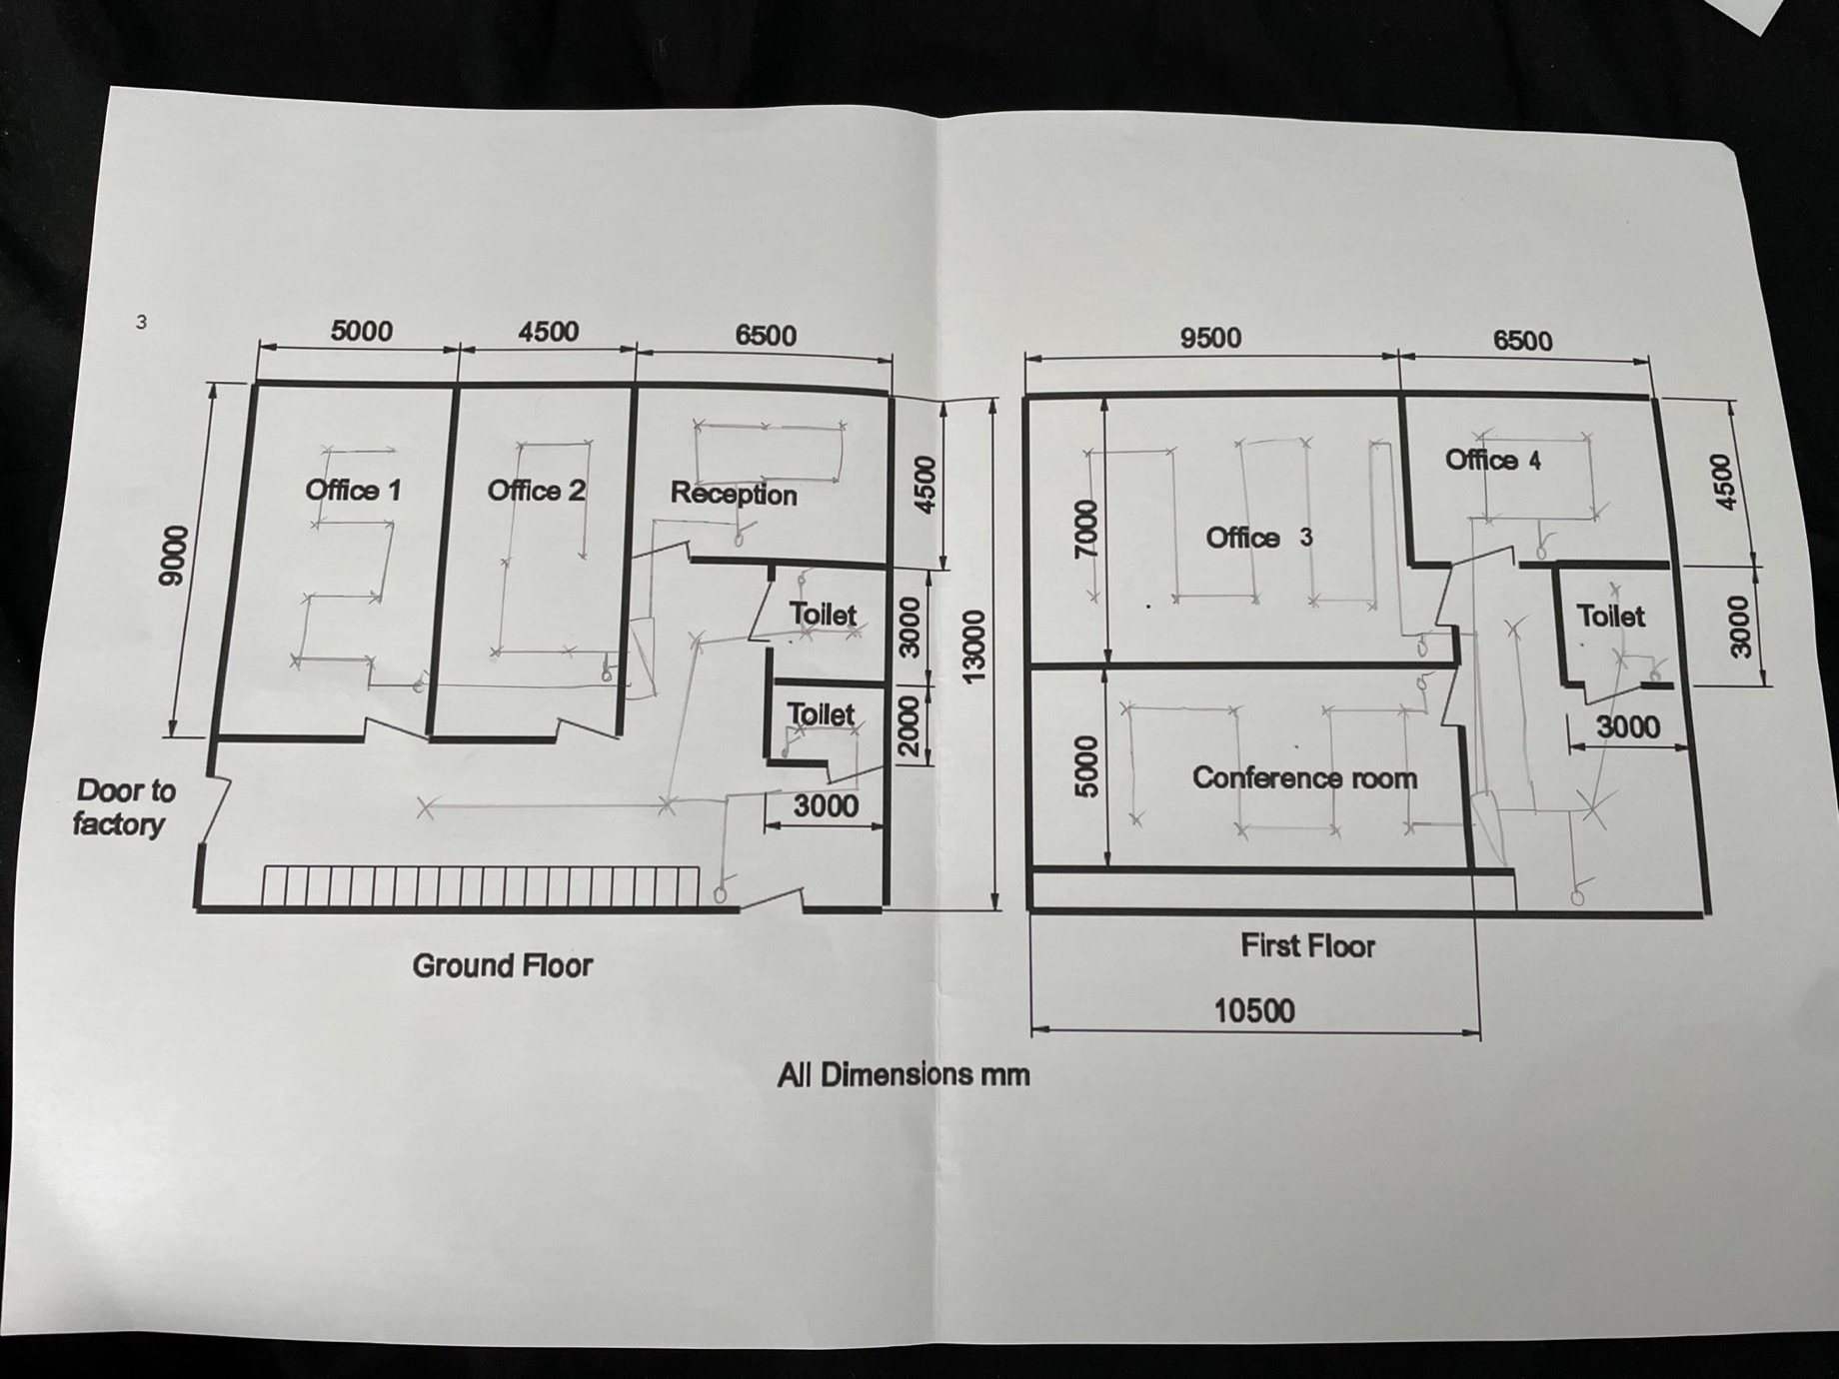
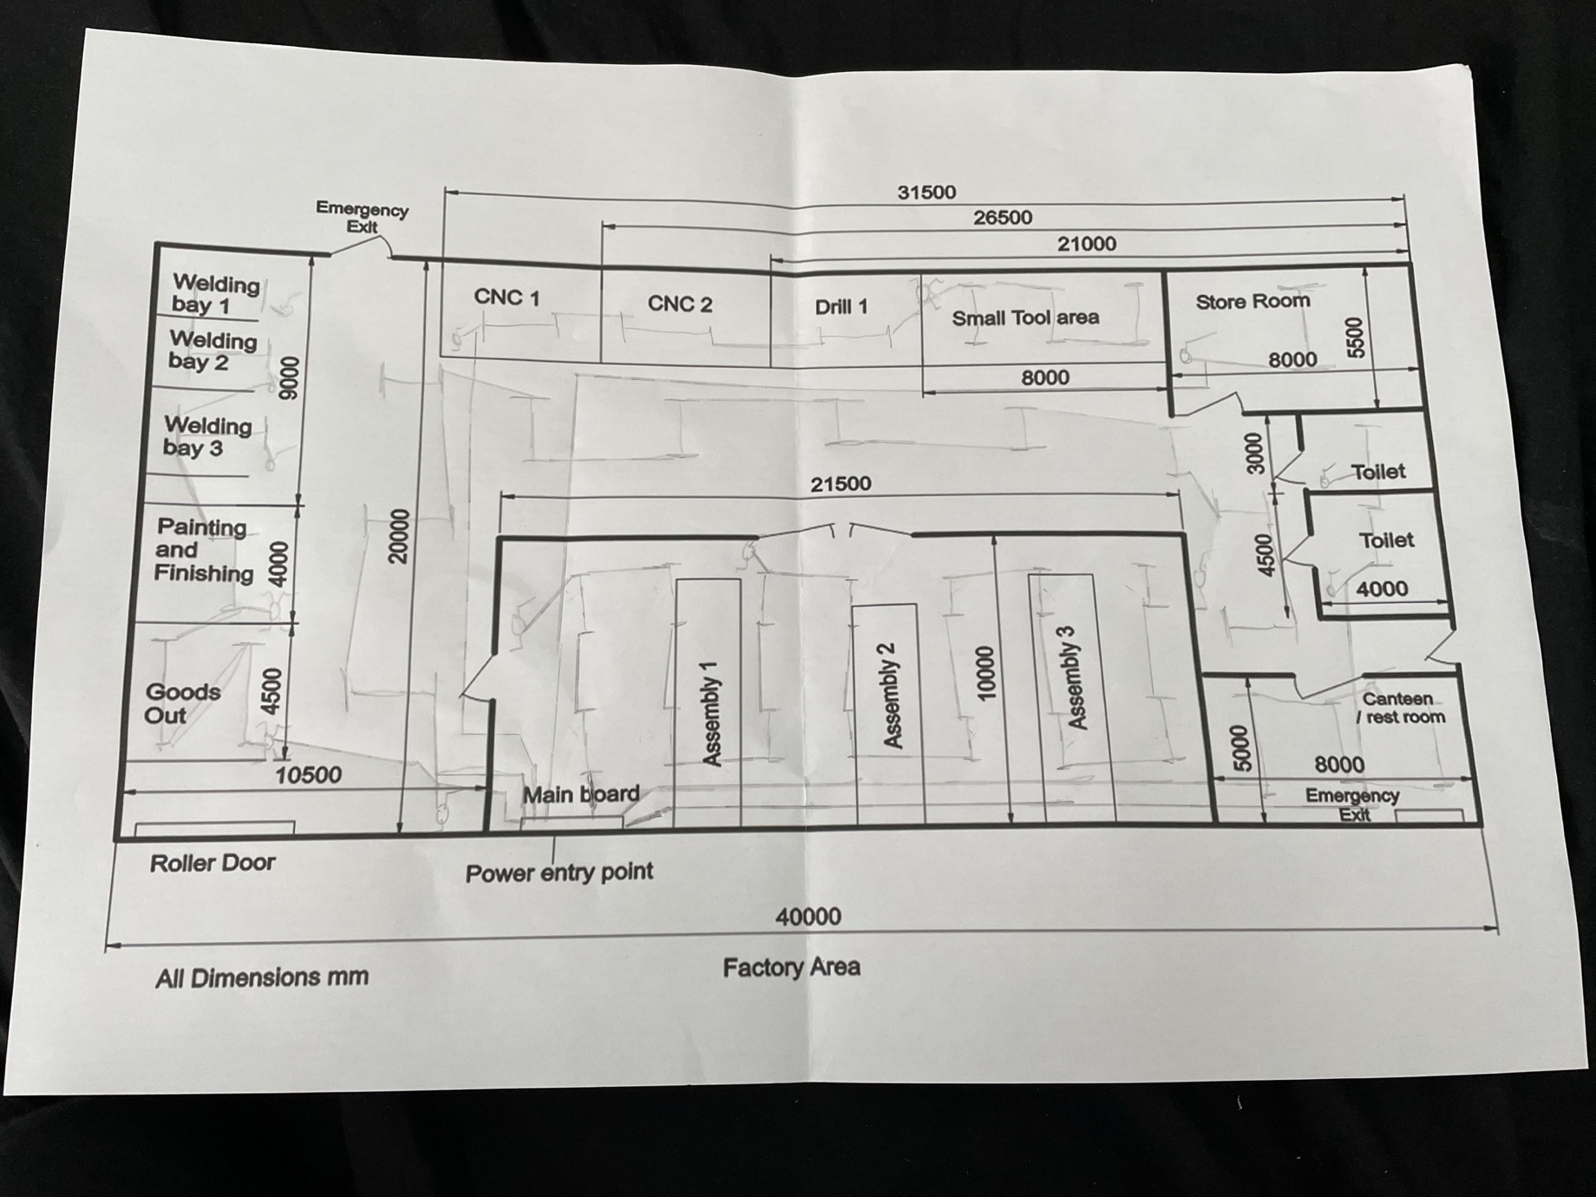

To bring the cables down to the board on the first story, it is assumed that there is a cavity gap in the wall for the second story of the office part.

Each floor has two lighting circuits because, in an emergency, a malfunction in one of the circuits would, in theory, only cause the power to trip to one of the lighting loops.

Lighting cable calculations.

The Lighting Cable Calculations are demonstrated below using Office 1 as an example,
All tables used for the values are located in the British standard for electrical installations, 18th edition.

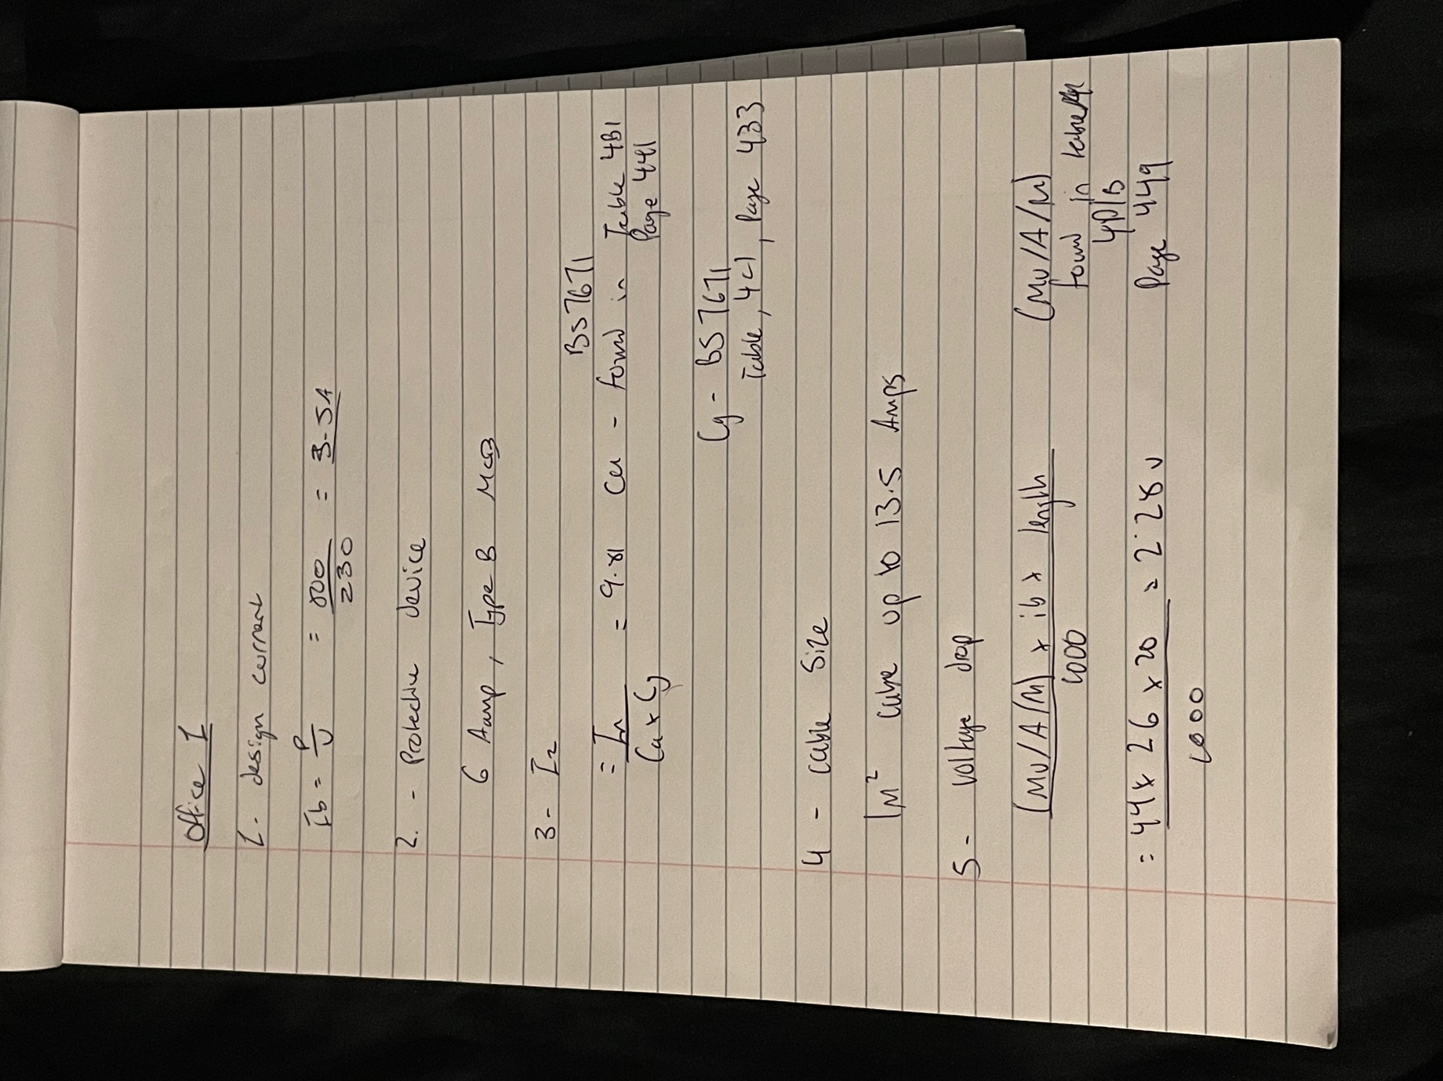

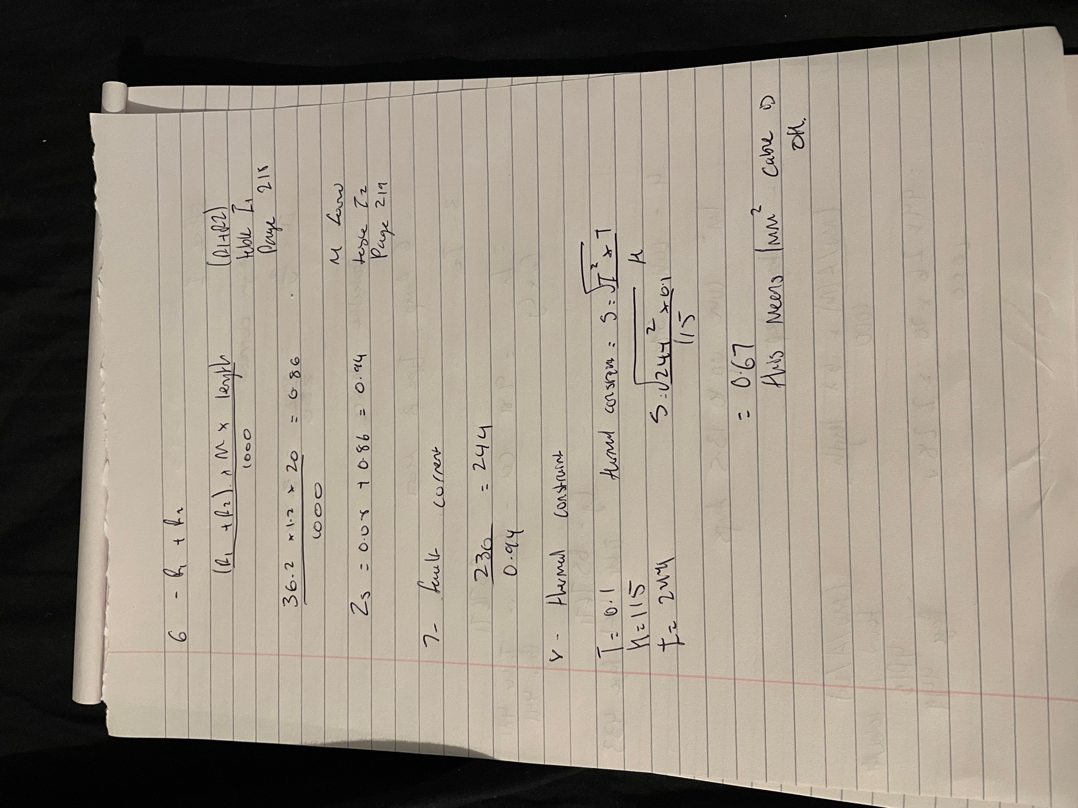

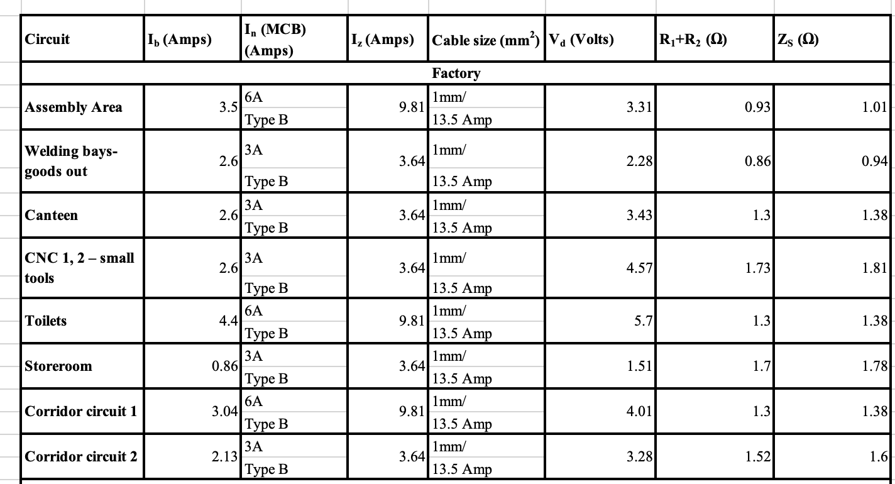
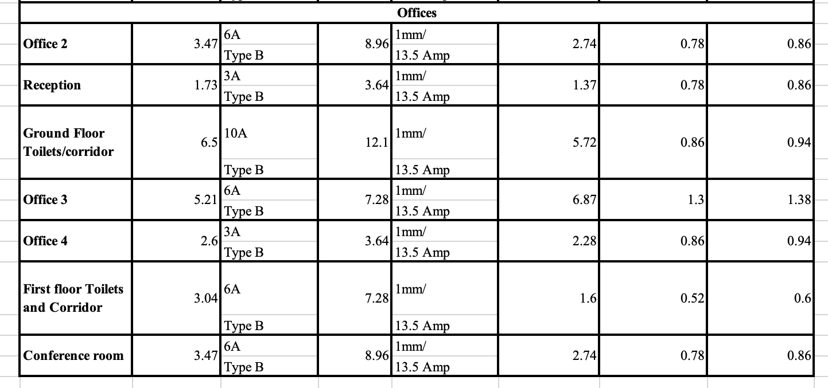

Single phase Cable Calculations

All tables used for the values are located in the British standard for electrical installations, 18th edition.
The single phase calculation for the Microwave ovens are shown below.

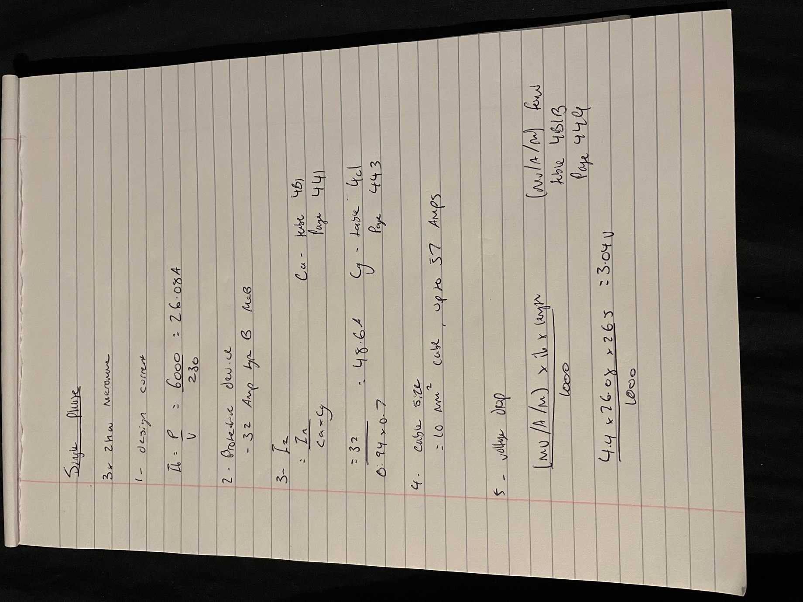

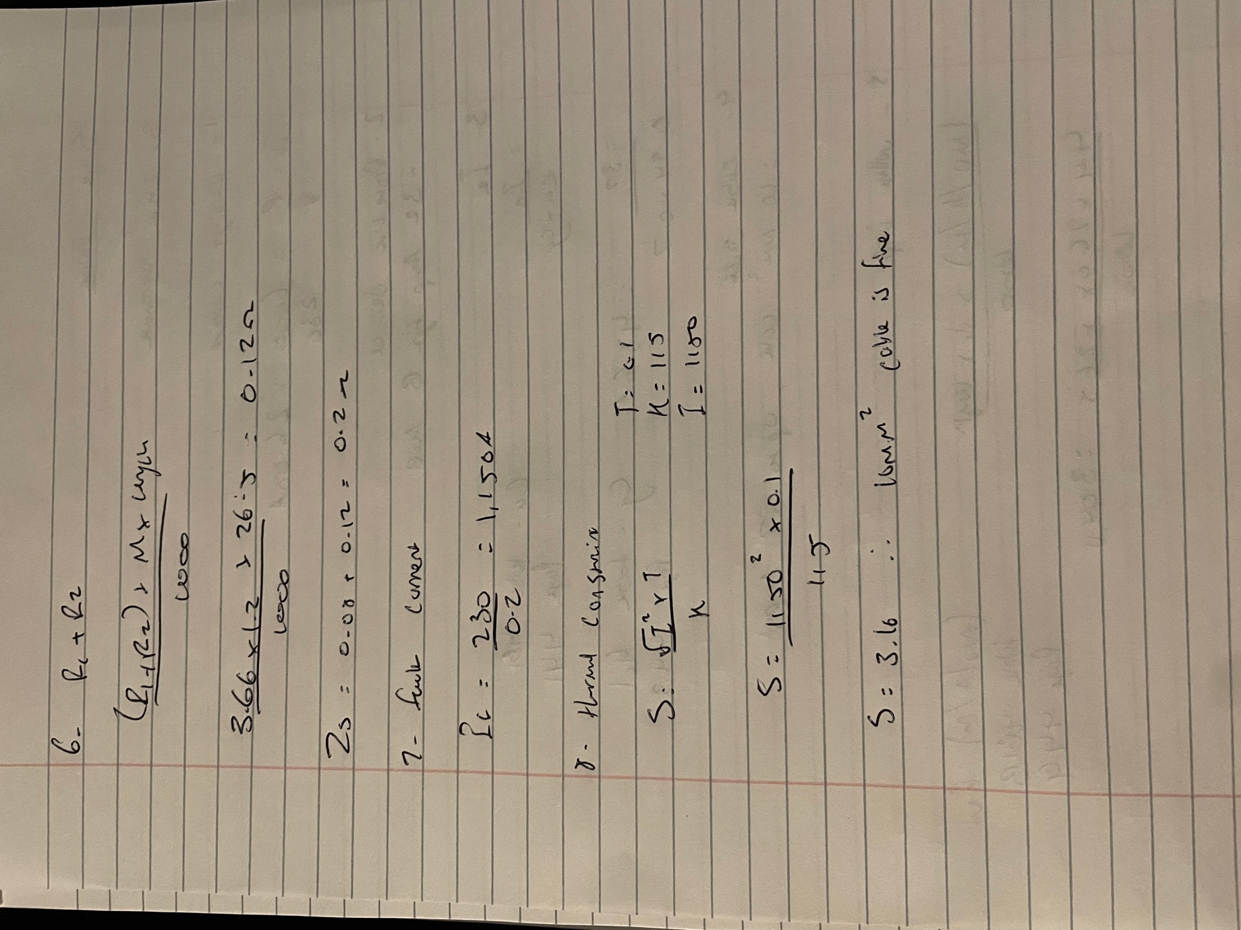
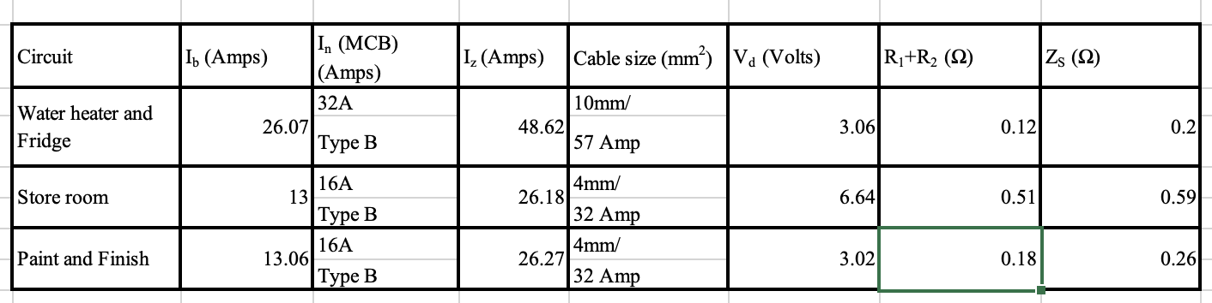

Three Phase Cable Calculations

Only the initial step of the three-phase calculation differs somewhat from the single stage. Rather than merely dividing the power (measured in Watts) by the voltage, the voltage is multiplied by the square root of three.
$$I_{b}\frac{P}{\sqrt{3}*V}$$
All tables used for the values are located in the British standard for electrical installations, 18th edition.

The example of the full cable calculation is the range oven from the canteen.

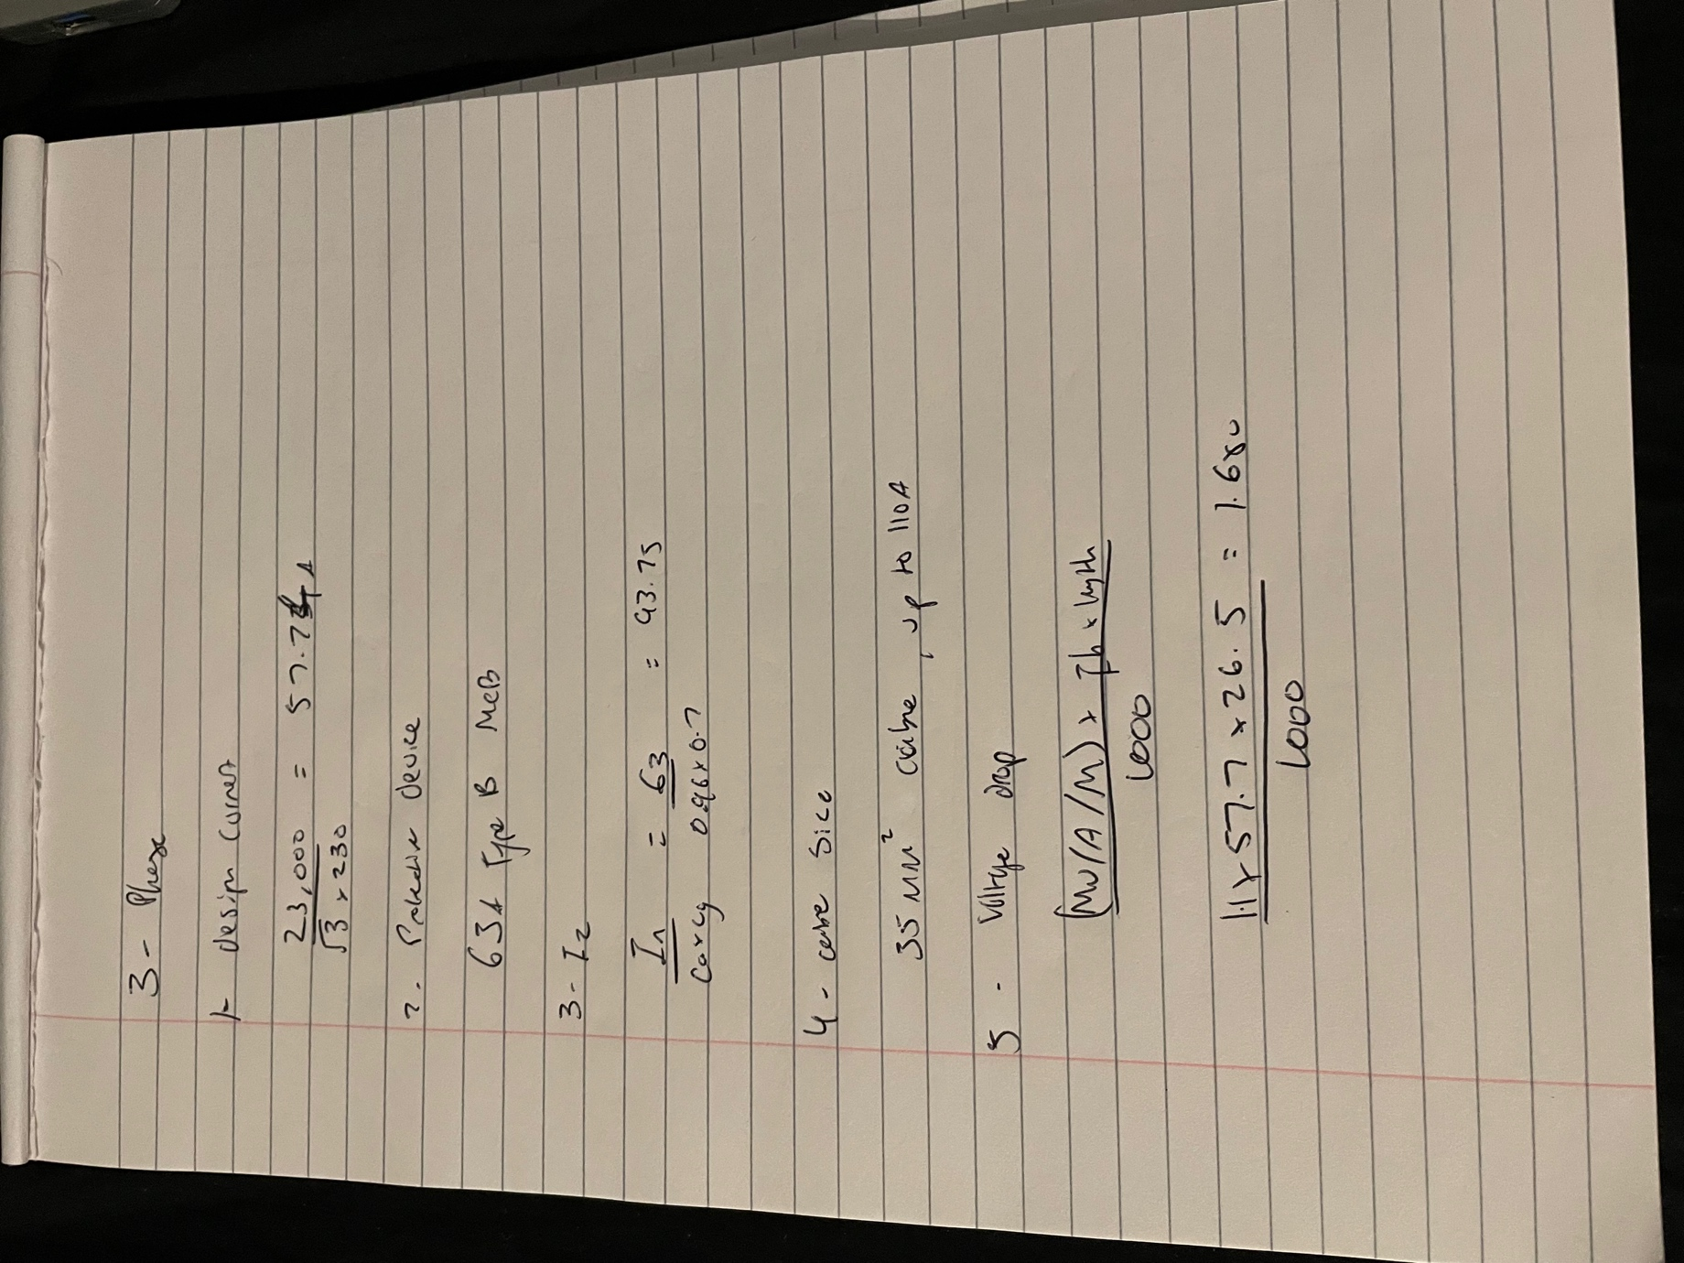
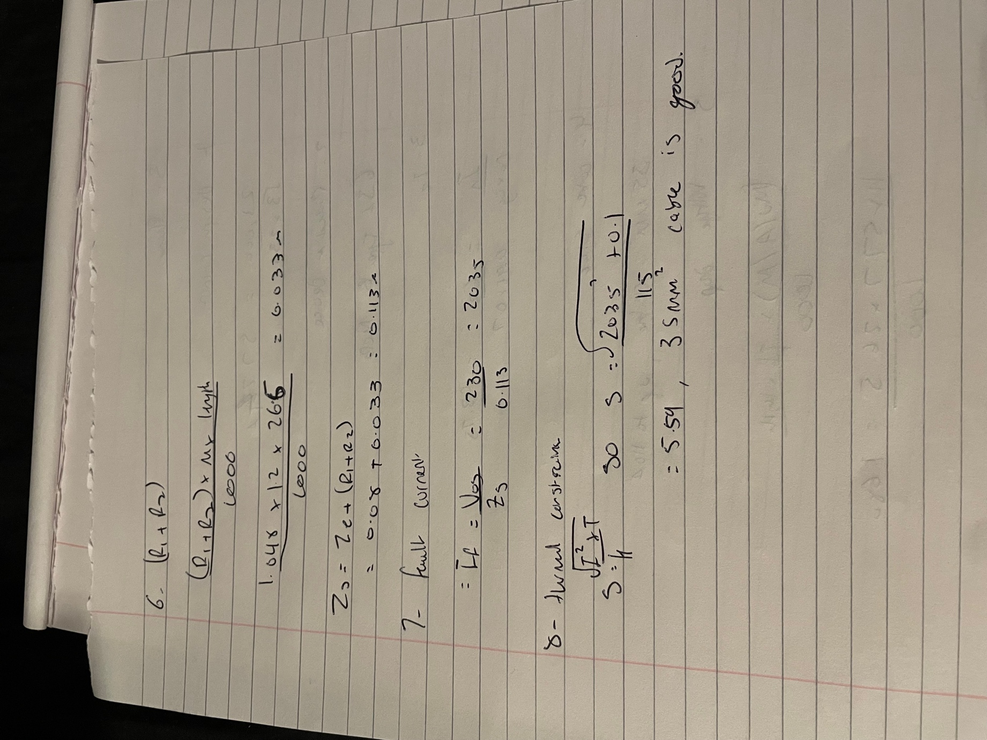

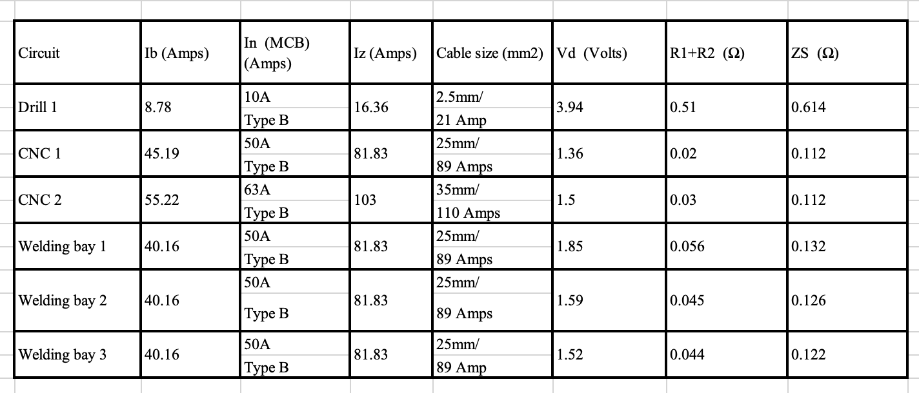

Socket Cable Calculations
The Socket Cable Calculations are shown in the example below for Office 1,
All tables used for the values are located in the British standard for electrical installations, 18th edition.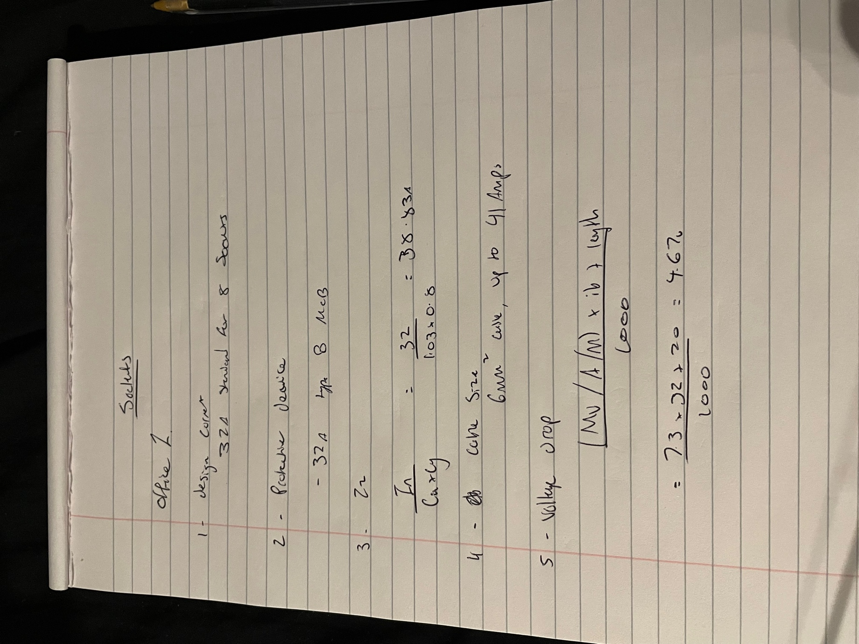
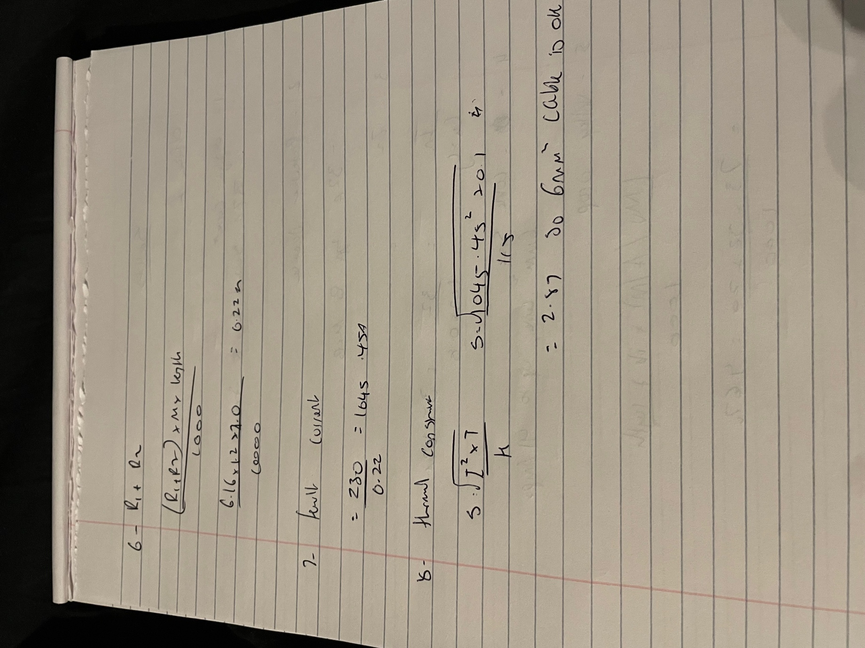

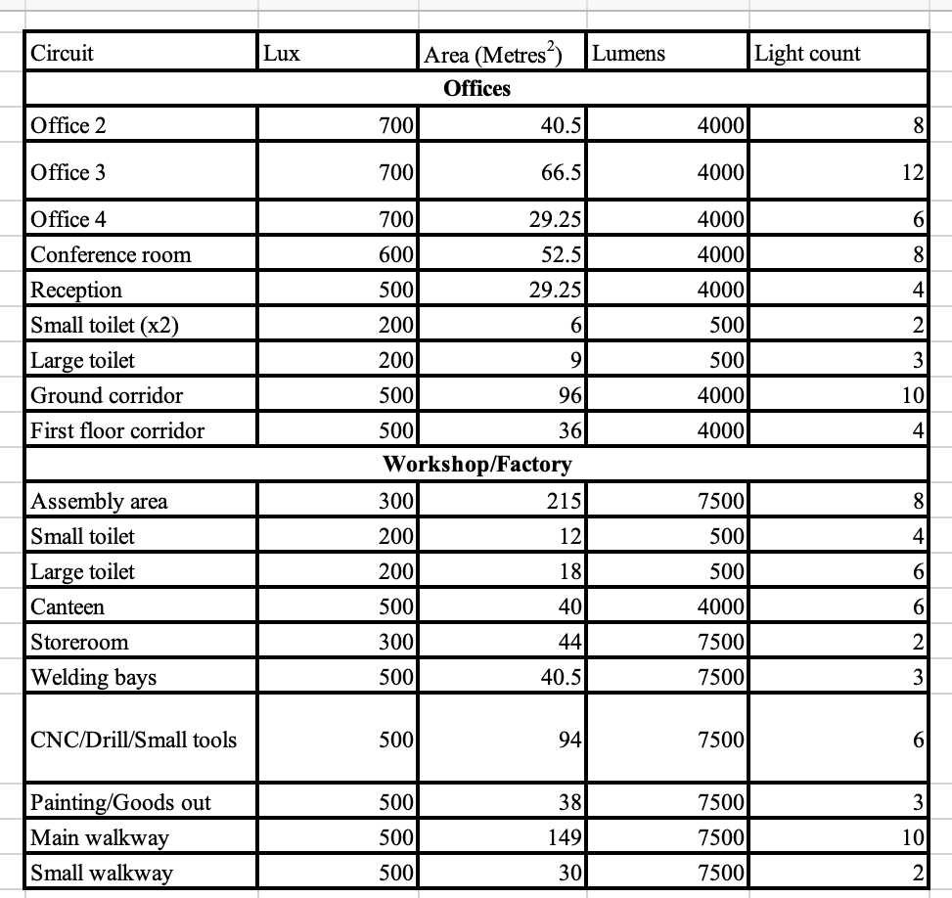

Maximum demand and diversity

Some circuits may use lesser protection devices (MCBs) to apply diversity. This is due to the presumption that not all the maximum current will be utilised at any given moment.

An example of a Type B MCB that can tolerate up to 63 Amps is found in the Range oven. A regular 10A fuse can be used to decrease the MCB and remove 30% of the residual current while still adhering to maximum demand and diversity regulations. In the end, a 25.9A MCB would be used; from there, a 32A MCB would be used, depending on the size.

Forms of circuit protection

MCB’s –
Although they are most employed in residential settings, type B MCBs can also be used in commercial and industrial settings in situations where the expected fault current is modest. It can be upgraded to a class C or D when the anticipated fault current is relatively significant. Since the current value for this installation wasn't too high, Type Bs were selected.

RCD’s –
The primary function of an RCD, or residual current device, in a circuit is to prevent any unintentional, lethal electric shocks.

RCBO’s –

Residual current devices, or residual current circuit breakers with overcurrent protection, are referred to as RCBOs. Its main goal is to keep earth fault or overload currents out of a circuit.

AFD’s –

Arc fault detectors, or AFDs for short, shield circuits from unusual electrical discharges that could cause overheating and even sparking.

Circuit Containment Methods

Trunking, which is mostly used for insulated cable, is a flexible technique to move various kinds of cable around a structure since it can be twisted and joined into many shapes. An Internal Protection (IP) rating is assigned to each trunking cable containment system, indicating the level of defence against external agents. Depending on the application, a variety of trunking types can be employed. Steel trunking, which is frequently utilised in commercial and industrial contexts, and PVC trunking are two examples of these types. For wires that are smaller, a micro version of PVC trunking is available. Compared to its steel equivalent, PVC trunking is lighter and requires less expertise to manufacture and fabricate.

Conduit, when sending wires to enclosures in a short and intricate manner, flexible conduits are utilised. They are offered in two varieties: fully plastic (polypropylene) or constructed of bare or plastic-coated galvanised metal. To ensure a safe mating connection with equipment enclosures, transit boxes, or trunking, glands are installed to cut lengths of flexible conduit. Conduit is available in a variety of configurations, such as heavy gauge and light gauge steel, and is available in PVC and steel varieties. They are then chosen along with the installation technique that works best for them. For corrosion resistance, PVC conduit may be superior to steel. One drawback of PVC conduit is that if the incorrect quantity of adhesive is applied, the joints cannot be completely waterproof.

Tray, A cable tray system is a unit or group of components that together create a strong framework for supporting and safeguarding electrical wires and raceways. It serves as the safe transportation of cables over open areas and is essentially the structural element, or skeleton, of an electrical system in a structure.

Basket, Basket systems and tray systems are comparable in that they both often use welded lattice structures to support and hold cables for various electrical circuits. Because of the spaces in them, cables can change direction based on where the circuits are located.

Containment Chosen

PVC trunking is what I've selected for this installation to store the wires that connect the office's outlets. Compared to the steel ones that were selected for the sockets in the workshop, this would have a more attractive appearance. Cable trays were selected to run the length of the building for the lighting in the offices and workshop, with conduit guiding the wires after they exit the trays.

References
Cable Management Warehouse, 2023. Cable Containment And Management Systems. [Online]
Available at: https://www.cmwltd.co.uk/blog/cable-management-containment/cable-containment-and-management-systems
[Accessed 7 April 2024].
Electrical Apprentice, 2024. An overview of cable management systems. [Online]
Available at: https://electricalapprentice.co.uk/an-overview-of-cable-management-systems/
[Accessed 7 April 2024].
Consumer Unit World, 2024. What is an MCB and how does it work?. [Online]
Available at: https://www.consumerunitworld.co.uk/what-is-an-mcb-and-how-does-it-work-328-c.asp
[Accessed 26 March 2024].
One Way group, 2022. Breaking Down Cable Containment Systems. [Online]
Available at: https://onewaygroup.co.uk/insights/breaking-down-cable-containment-systems/
[Accessed 7 April 2024].
Electrical Safety UK, 2022. Arc Fault Detection Devices (AFDDs). [Online]
Available at: https://elecsafety.co.uk/arc-fault-detection-devices-afdds/
[Accessed 30 March 2024].
The Insitution of Engineering and Technology, 2022. Table I1. In: On Site Guide. s.l.:The Insitution of Engineering and Technology, p. 218.
The Institution for Engineering and Technology, 2022. Table 4D1A. In: Requirements for Electrical Installation. s.l.:The Institution for Engineering and Technology, p. 448.
The Institution for Engineering and Technology, 2022. Table 54.3. In: Requirements for Electrical Installation. s.l.:The Institution for Engineering and Technology, p. 200.
The Institution of Engineering and Technology, 2022. Table 41.3. In: Requirements for Electrical Installation. 18 ed. s.l.:The Institution of Engineering and Technology, p. 68.
The Institution of Engineering and Technology, 2022. Table 4B1. In: Requirements for Electrical Installation. s.l.:The Institution of Engineering and Technology, p. 441.
The Institution of Engineering and Technology, 2022. Table 4C1. In: Requirements for Electrical Installation. s.l.:The Institution of Engineering and Technology, p. 443.
The Institution of Engineering and Technology, 2022. Table 4D1B. In: Requirements for Electrical Installation. s.l.:The Institution of Engineering and Technology, p. 449.
The Institution of Engineering and Technology, 2022. Table I3. In: On Site Guide. s.l.:The Institution of Engineering and Technology, p. 220.

Appendix

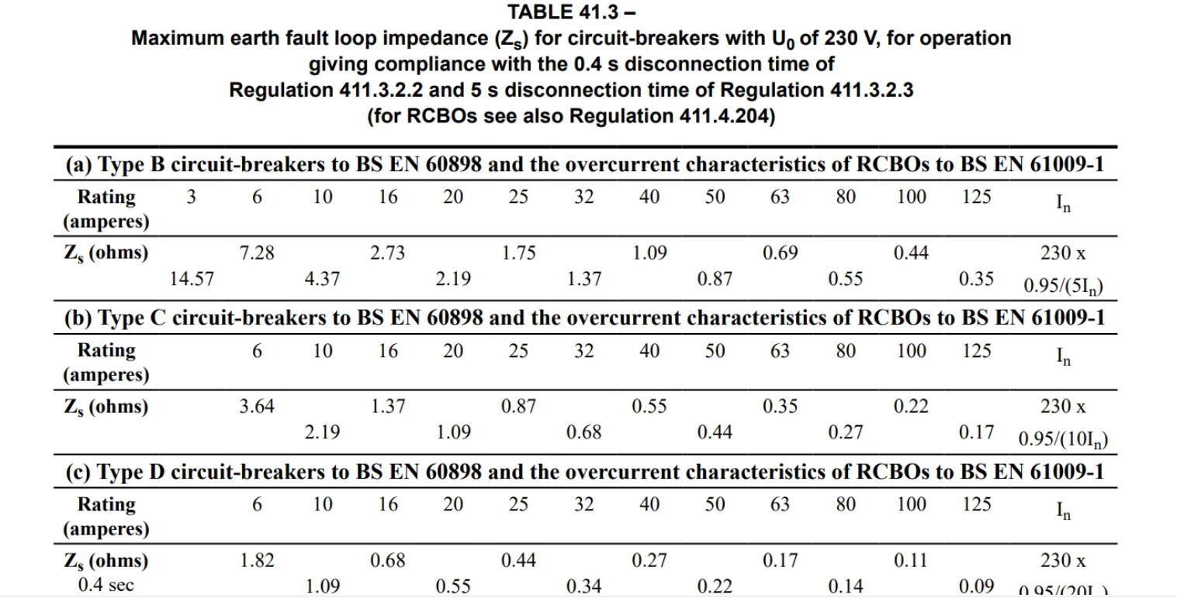 (The Institution of Engineering and Technology, 2022)

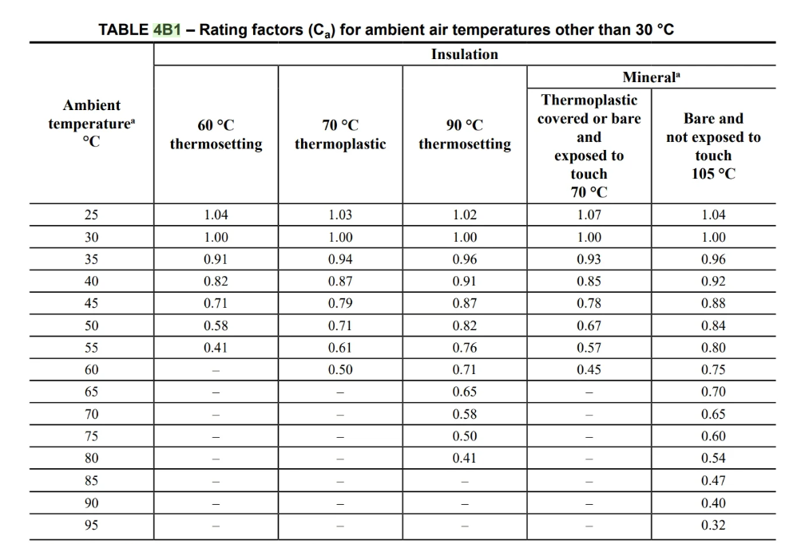 (The Institution of Engineering and Technology, 2022)
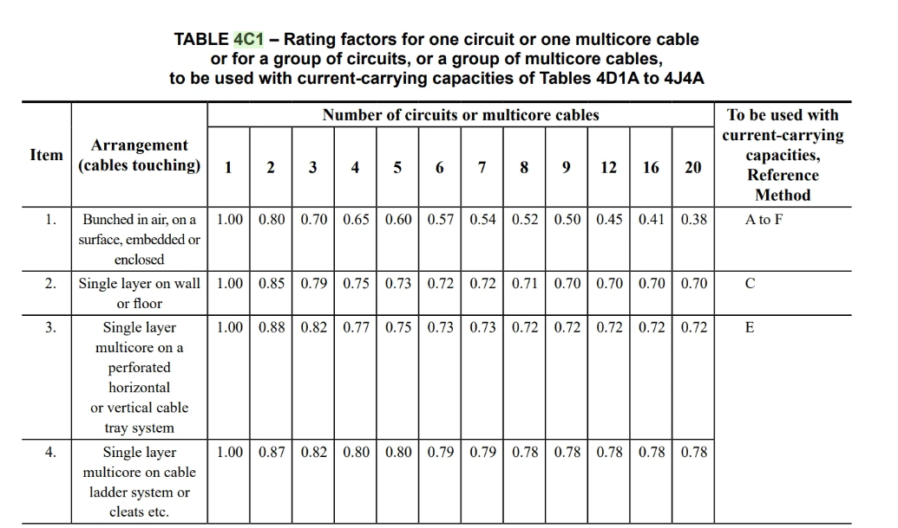 (The Institution of Engineering and Technology, 2022)
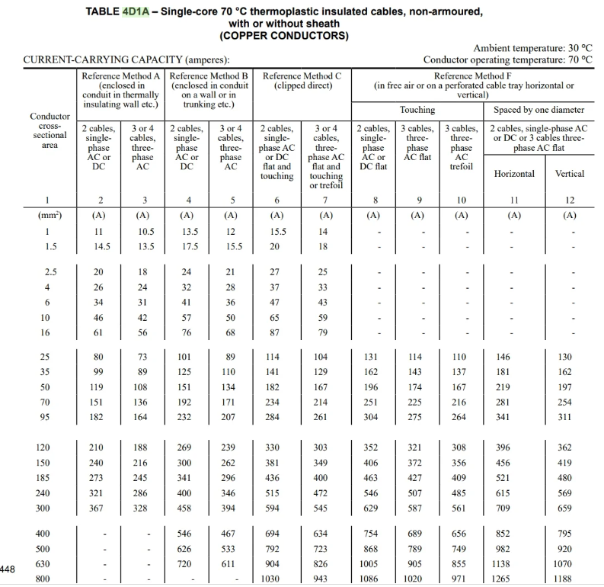 (The Institution for Engineering and Technology, 2022)
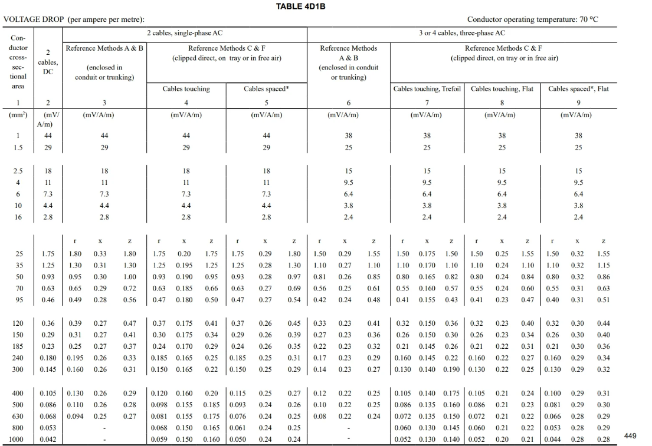 (The Institution of Engineering and Technology, 2022)

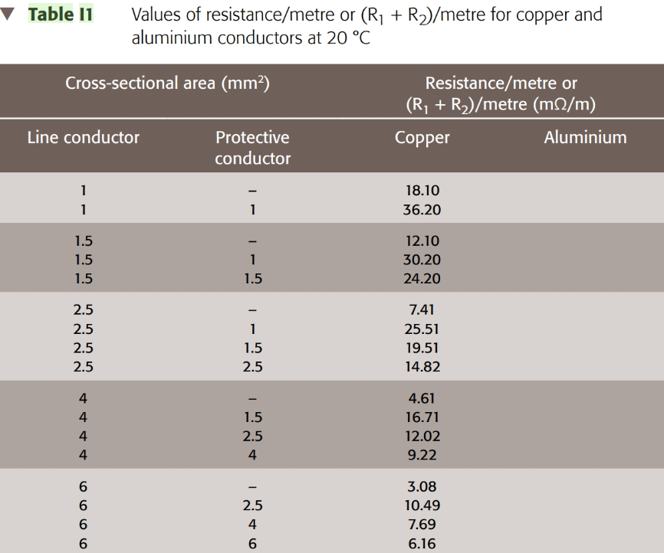
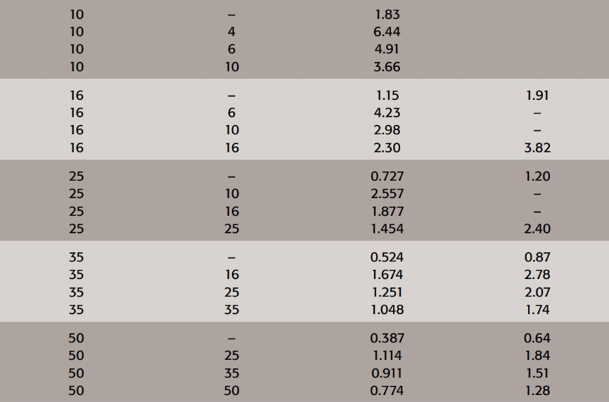 (The Insitution of Engineering and Technology, 2022)
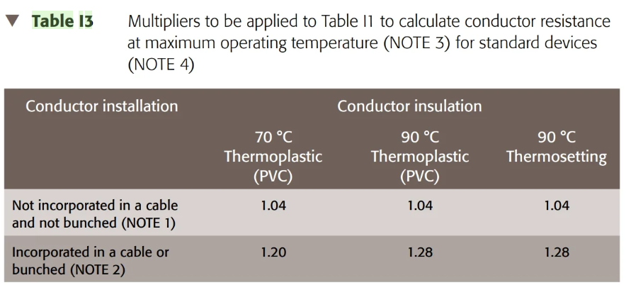 (The Institution of Engineering and Technology, 2022)

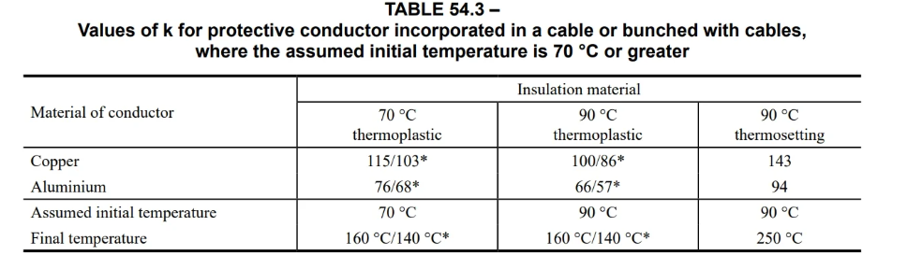 (The Institution for Engineering and Technology, 2022)

