
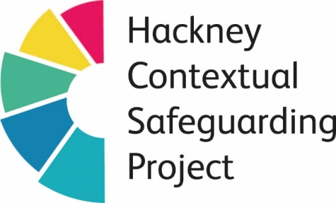

Youth Engagement Methods

May 2019

The University of Bedfordshire with the Hackney Contextual Safeguarding Team

Introduction
Participation refers to young people’s right to express opinions and to have a say in matters affecting their social, economic, religious, cultural and political life, enshrined in article 12 of the UN Convention on the Rights of the Child. Fundamentally, participatory engagement is about giving young people a say to inform the decisions made that concerns aspects of their lives or the communities in which they live – this applies both to individual young people, for decisions made about their personal lives, as well as to broader groups of young people at community level. In order to truly grasp and respond to young people’s experiences of harm, contextual approaches to safeguarding need to be informed and shaped by the realities of young people.
This document outline a range of participatory methods that were used by the Hackney Contextual Safeguarding team to engage with young people (including the Contextual Safeguarding team’s youth panel, Hackney Elite, school students and young people in the wider community) to inform contextual assessments and approaches.
Resources specifically developed by the Contextual Safeguarding team’s youth panel are available on Hackney’s Contextual Safeguarding Implementation Toolkit under the ‘Systems and structures’ section or via this link.
Youth Engagement Methods
Community mapping
Community mapping is an extension of the Safety Mapping tool and involves taking maps of a local area to group work session with young people or to community events to ask young people about their experiences of the local area. Maps can be printed on large paper and, using green, amber and red pins or colouring pens, young people can label the map with places they feel safe or unsafe. This activity can be adapted for use with younger children, asking them to draw/ stick items on the map of their community (e.g. baddies, places to play, police officers, etc.)
This can then be used to start conversations about what changes might need to be made. Before doing the exercise it is important to find out what services or agencies work in the area so that that during the exercise young people can be signposted to relevant services or opportunities – for example, a local youth or sports club. In order for community mapping to be effective it is important that the information is then developed into an action plan to prioritises the local communities experiences and needs.

School mapping (also known as ‘Shifting Boundaries’)
Safety mapping in schools works in the same way as community mapping. Students use maps of the school to mark areas they feel safe and unsafe. This can lead to school-level interventions such as revising school protocols, temporary exclusion zones, poster campaigns and responding to areas students identified as unsafe such as increasing supervision. This approach forms part of the Shifting Boundaries school curriculum and school-based intervention programme.

Group work to inform neighbourhood assessments
In Hackney, young people were engaged in several ways within the neighbourhood assessment through group work. One session was held in the local community centre, which was located within the assessment area and had been the location of an incident. Within this group session young people were engaged in a discussion about where they felt safe and unsafe and why this was. They were then asked to discuss what changes they would make and how they would like to be involved. An example session plan can be found in annex one of this document. For those young people that did not want to participate in the group, a smaller informal survey was designed including questions such as:
- Do you live in the area? How long have you lived in the area?
- Do you like the area? What do you like about it?
- Is there anything you don't like about this area?
- Do you feel safe in [area name]? If you do, what it is that makes you feel safe?
- What do you consider to be your area? Can you mark it on a map?
- How do you know when you're not in your area anymore? What does it feel like?
- If you could make any changes to this area, what would they be? E.g. more shops? Less mobile phone theft?
See annex 1 for a suggested template of a group work plan.
Problem Solving Booths
The idea of problem solving booths came from a young person shortly after they came out of prison. Problem Solving Booths are informal booths set up in public areas to encourage strangers to discuss any issues they would like to talk about with each other. It’s about connecting people and encouraging mutual support in local communities. They consist of two chairs facing each other – one for the “helper” and the other for the “helped”. Anyone can sit in the help or helper chair and individuals can swap roles if they wish to. In Hackney, the Contextual Safeguarding team set up a problem solving booth in a local park and found that people shared a broad range of concerns, including around managing children behaviour and safety. Young people also took part in this exercise and gave tips for making it more accessible to younger children, such as making the booths more visually attractive using pictures and glitter or holding them in schools.
Blackboard Comments
In Hackney, a large black board was taken to a community event and members of the community, including young people, were encouraged to write on it what they thought could make their community safer for young people. This exercise can also be used in group work sessions with young people. The Contextual Safeguarding team in Hackney found that the blackboard was a useful conversation facilitator and gave them an understanding of what was working well and what was missing locally.
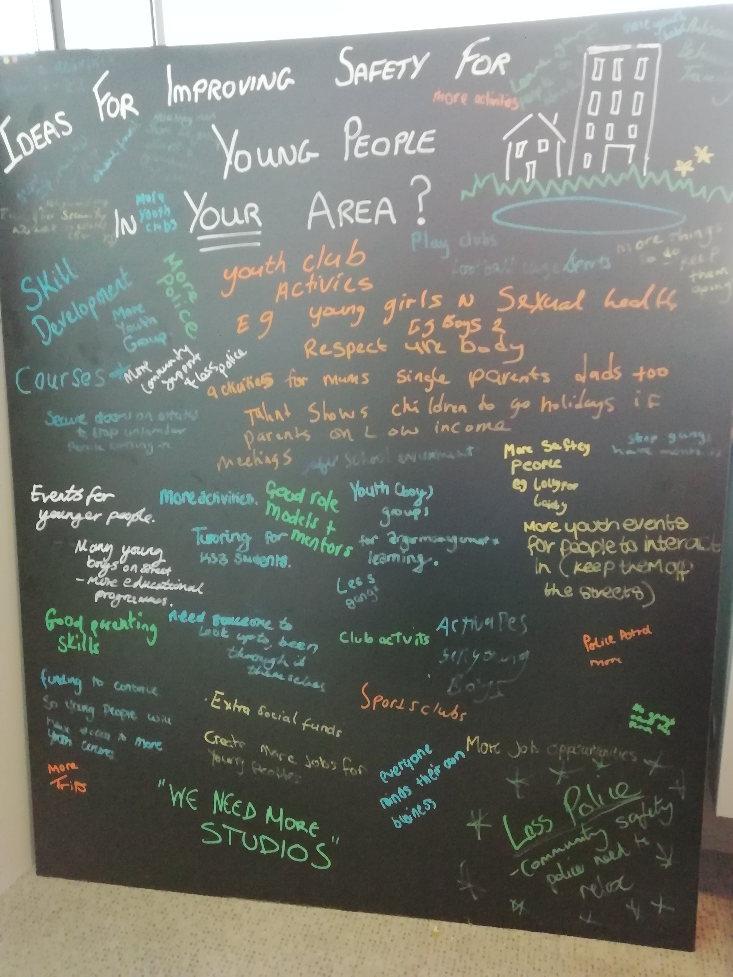
Image of the blackboard used in Hackney
Annex 1. Group work plan
1. Date |  | 2. Time(s)
3. Unit/Club
4. Project Title | Contextual Safeguarding pilot in– consultation with young people who attend the Youth Hub
5. Staffing
(Indicate FT/PT/Vol)
6. How was need identified? | The young people who attend the youth hub live or frequent the [area].  It will be important to include their views in the Contextual Assessment for the location pilot.
7. Method  (Please circle all appropriate) | - Group work at the Youth centre  - Where young people do not wish to join in group activity, one-to- one conversation/survey can take place instead  Group work will be based on the initial stages of the STAIRS model:  - Scoping: what are the problems, how have they come about?  - Targets: young people identify their goals or what they would like to change  - Activators: young people identify what is allowing these problems to occur (e.g. what are the reasons they do not feel safe walking through an unfamiliar area late at night?)  - Intervention: what needs to happen to change this?  - Review/Revise: has it worked? Does something else need to be done? - Sustainability – how can this be maintained? Who will maintain this?
8. Activity/session plan including young people’s involvement | Introduction:  - Brief explanation of Contextual Safeguarding and the location pilot, e.g. getting young people’s and residents views  - Explain what will happen with the information: it will be used, anonymously, in the Contextual Safeguarding location pilot. No names will be used, only ages and gender where necessary.  Mapping exercise:  - Young people point out areas they like/prefer a map of the area. This could include where they live, where they choose to socialise or shop. Explain why they’ve chosen these.  - Young people point out areas they dislike and why. Expand on this further by asking where they feel safe to meet friends or travel through, and places they would avoid.  - If they feel confident to share areas where they know incidents have happened, including assaults, drug dealing, stabbings, they can point these out. N.B. briefly clarify confidentiality policy before asking this and remind them they can talk to members of staff if they are worried about anything. (Also, have contact details of e.g. NSPCC, Childline or FAST).  - Any disclosures made should follow local safeguarding procedures  Finish - Refreshments:  Pizza will be ordered to arrive at the end of the session as a thank you to the young people.

9. What learning outcomes will the young people achieve? | The learning is mainly for the Contextual Safeguarding team but the session will also:  - Raise young people’s awareness of Contextual Safeguarding and importance of their involvement in development of new systems  - Remind young people of who they can contact if they have concerns about friends

