ACCA5036

Scripting and Programming Concepts

Coursework- Programming Assignment with Associated Documentation

Name:
Radu Cristian Boros

ID:
2319948

Module Tutor: Dr Mobolanle Bello

GITHUB CODE
Chrysdk2/raduasss
https:/ttps://github.com/Chrysdk2/raduasss/tree/main

Contents
1.0 INTRODUCTION 3
2.0 REQUIREMENT ANALYSIS 3
3.0 Software Design and Development 4
3.1 Design 5
3.1.1 Flowchart 5
3.1.2 Pseudocode Explanation 8
3.2 Implementation Decision 13
3.2.1 Data Structures 13
3.2.2 Programming Constructs 15
3.2.3 Python Modules and Libraries 19
4.0 Testing and Debugging 21
4.1 Role of Testing in Software Development 21
4.2 Types of Errors in Programming 21
4.3 Example of Test Cases 22
5.0 Evaluation 23
Challenges Faced 23
Future Improvements 23
Self-Reflections 24
References 25

1.0 INTRODUCTION
Bright Minds Academy is a small private tutoring centre that currently tracks classroom equipment bookings through a paper-based system. Tutors handwrite reservations for items such as laptops, projectors, and tablets. This method frequently leads to double bookings, lost or misplaced records, and uncertainty about whether equipment is available. As the centre grows and the number of tutors and students increases, these weaknesses become more noticeable, creating inefficiencies and sometimes disrupting lessons. For this reason, a straightforward and dependable computer-based system is needed to manage equipment bookings more effectively.
This project focuses on designing and developing a Python-based Student Equipment Booking System to replace the current manual process. The system will enable staff to register new equipment, log bookings for specific students and dates, view existing booking records, and carry out simple searches using either equipment names or student names. It will store information using suitable data structures such as lists or dictionaries, without relying on a database. By introducing this digital solution, Bright Minds Academy can improve record accuracy, minimise booking conflicts, and boost overall efficiency with an organised and user-friendly system.

2.0 REQUIREMENT ANALYSIS

The Student Equipment Booking System is being developed to replace Bright Minds Academy’s current paper-based booking method with a clear, organised, and computer-based solution. To be effective for day-to-day use, the system must satisfy both functional and non-functional requirements so staff can manage equipment confidently and efficiently.
Functional Requirements
When the program starts, it will load a set of pre-entered equipment items so the system is ready to use immediately without any setup. Staff must also be able to add new equipment whenever needed, ensuring the system can grow as the academy adds more resources.
One of the most important features is booking creation. Staff will enter the student’s name, choose the required equipment, and select a booking date. The system must check each request and prevent double bookings by ensuring the chosen equipment has not already been reserved for that date.
The system will also provide an equipment availability check by date. This allows staff to quickly see which items are free and which are already booked on a specific day, helping with planning and avoiding clashes. In addition, users must be able to view all booking records and search them by student name or equipment name to retrieve information quickly.

Non-Functional Requirements
The system should be simple to use, reliable, and easy to maintain. It must include input validation to avoid empty fields and incorrect entries. Since this is a prototype, booking data will be stored using Python data structures (such as lists and dictionaries) rather than a database. The interface should be straightforward to navigate, run efficiently, and reduce the chance of user errors during operation.

3.0 Software Design and Development

This section explains how the Student Equipment Booking System was designed and developed to meet the requirements identified earlier in the report. It focuses on the planning and implementation stages of the solution, including the use of flowcharts, pseudocode, data structures, programming constructs, Python modules, and the final source code. The purpose of this section is to show how the initial business problem was translated into a working Python program.
The design stage was important because it provided a clear structure for the system before coding began. Tools such as flowcharts and pseudocode were used to organise the logic of the program and reduce the risk of errors during development. After this, implementation decisions were made regarding the most suitable data structures, control structures, and validation methods needed to create a simple and reliable equipment booking system for Bright Minds Academy [7], [14].

3.1 Design

The design stage is an important part of software development because it helps transform requirements into a clear plan before coding begins. In this project, the design of the Student Equipment Booking System was created to show how the program would operate, how users would interact with it, and how the main features would be connected. This stage was useful because it reduced uncertainty before implementation and provided a structured guide for developing the final solution.
To support the design process, two main tools were used: a flowchart and pseudocode. The flowchart was used to represent the overall logic and movement of the program in a visual way, while the pseudocode was used to describe the core processes step by step in a simplified written form. Together, these design tools helped make the system easier to plan, understand, and implement correctly. [14]

3.1.1 Flowchart

The flowchart is an important design tool used to visually represent how the Student Equipment Booking System works step by step. Its main purpose is to provide a clear picture of the program’s overall structure before coding begins. Rather than immediately writing Python code, the flowchart allows the developer to plan the sequence of actions, decisions, inputs, and outputs in a structured way. This is useful because it makes the logic easier to understand, reduces confusion during implementation, and helps identify possible errors early in the design stage. In this project, the flowchart was used to map out how the system should respond to user actions, how data should be checked, and how the different features connect to each other within the menu-driven program [14].
One of the main advantages of using a flowchart is that it makes the design easier to follow for both the developer and the reader. Instead of describing the logic only in long paragraphs, the flowchart presents the system using standard symbols such as start/end points, processes, inputs, outputs, and decision diamonds. This creates a visual representation of the software design, making it easier to understand how users move through the booking system. In the context of this project, the flowchart helped translate the business requirements into an organised plan that could later be implemented in Python.[ 14].
The flowchart begins with the Start symbol, which represents the moment when the program is launched. Immediately after starting, the system performs an initial process by loading a set of pre-entered equipment items, such as laptops, projectors, and tablets. This step ensures that the software is ready to use straight away without requiring the user to create the first equipment records manually. Once this has been completed, the program moves to the main menu, where a list of options is displayed. These options allow the user to add equipment, record a booking, view booking records, search bookings, check availability by date, or exit the system.
The next stage in the flowchart shows the user entering a menu choice. This is an important input stage, because the rest of the system depends on what the user selects. After the input is entered, the program reaches a decision point where it checks whether the menu choice is valid. If the choice is invalid, the program generates an output message such as “Invalid choice. Please try again.” and returns the user to the main menu. This part of the flowchart is important because it shows how the system handles incorrect input safely without crashing or producing confusing results.
If the menu choice is valid, the flowchart branches to the selected function. For example, in the Add Equipment process, the user is asked to input a new equipment name. The program then checks whether the entry is empty or already exists in the equipment list. If the input is invalid, an error message is displayed. If the input is acceptable, the equipment is added successfully, and a confirmation message is generated. The system then returns to the main menu. This process demonstrates how user input is captured, validated, and converted into a useful system update.
Another key branch in the flowchart is the Record Booking function. In this part, the user enters a student name, an equipment name, and a booking date. These are the main pieces of data required to create a booking. The program then checks whether all fields have been entered, whether the equipment exists, and whether the date is valid. After this, the system checks for a booking conflict by comparing the selected equipment and date against existing records. If a clash is found, the output is an error message informing the user that the equipment is already booked. If no clash is found, the system saves the booking and displays a success message. This part of the flowchart clearly shows how the program processes multiple user inputs, performs validation, and generates either an error or a successful booking output.
The flowchart also includes the logic for View All Bookings, Search Bookings, and Check Availability by Date. In the viewing process, the system displays all stored booking records, or informs the user if no bookings exist. In the search process, the user enters a student name or equipment name, and the system outputs any matching records. In the availability process, the user enters a date, the system checks the bookings for that day, and the output shows both booked equipment and available equipment. These steps help demonstrate how the program transforms user input into useful information.
Finally, the flowchart ends with the End symbol when the user chooses the exit option. Overall, the flowchart plays a valuable role in the design of the Student Equipment Booking System because it provides a clear, logical, and visual representation of how the software operates, how user inputs are processed, and what outputs are generated at each stage.

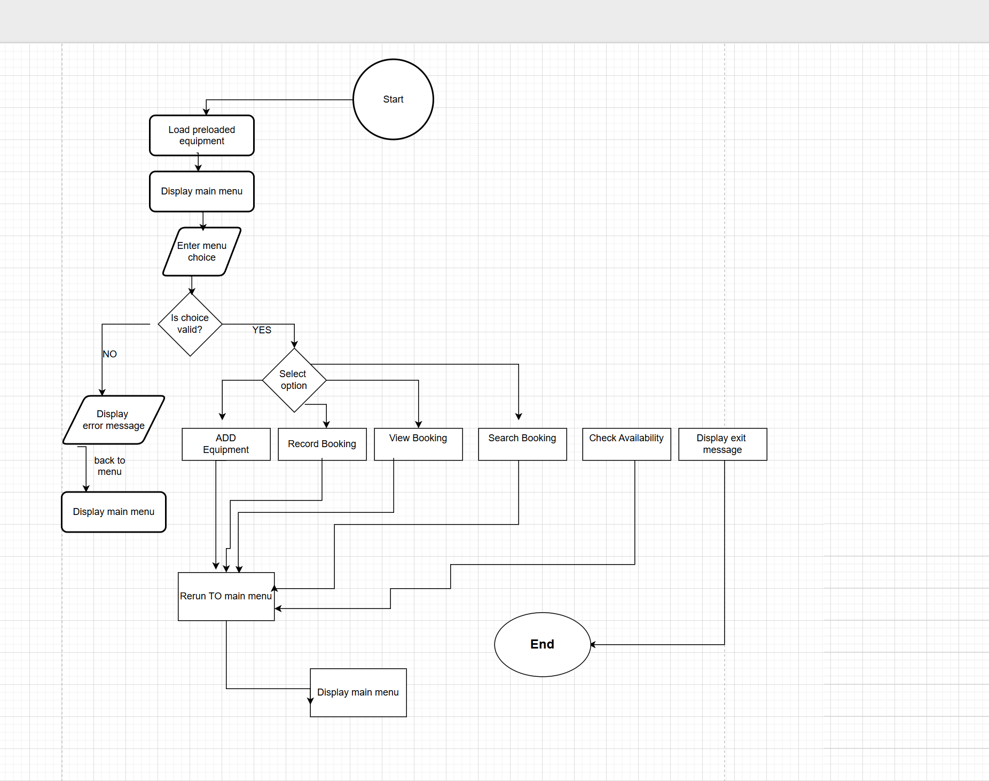
Flowchart of the Student Equipment Booking System

3.1.2 Pseudocode Explanation

// ---------- INITIALISATION ----------
SET equipment_list = ["Laptop 1", "Laptop 2", "Projector A", "Tablet 1", "Tablet 2"]
SET bookings_list = empty list
// Each booking will store: student_name, equipment_name, date
// ---------- MAIN LOOP ----------
REPEAT
DISPLAY "=== Equipment Booking System ==="
DISPLAY "1. Add Equipment"
DISPLAY "2. Record Booking"
DISPLAY "3. View All Bookings"
DISPLAY "4. Search Bookings"
DISPLAY "5. Check Availability by Date"
DISPLAY "6. Exit"
INPUT user_choice
// ---------- VALIDATION OF MENU CHOICE ----------
IF user_choice is NOT one of [1,2,3,4,5,6] THEN
DISPLAY "Invalid choice. Please try again."
CONTINUE to next loop iteration
END IF
// ---------- OPTION 1: ADD EQUIPMENT ----------
IF user_choice = 1 THEN
INPUT new_equipment_name
IF new_equipment_name is empty THEN
DISPLAY "Equipment name cannot be empty."
ELSE IF new_equipment_name already exists in equipment_list THEN
DISPLAY "Equipment already exists."
ELSE
ADD new_equipment_name to equipment_list
DISPLAY "Equipment added successfully."
END IF
END IF
// ---------- OPTION 2: RECORD BOOKING ----------
IF user_choice = 2 THEN
INPUT student_name
INPUT equipment_name
INPUT booking_date
IF student_name is empty OR equipment_name is empty OR booking_date is empty THEN
DISPLAY "All fields are required."
ELSE IF equipment_name NOT in equipment_list THEN
DISPLAY "Equipment not found."
ELSE
SET conflict_found = FALSE
FOR each booking in bookings_list DO
IF booking.equipment_name = equipment_name AND booking.date = booking_date THEN
conflict_found = TRUE
END IF
END FOR
IF conflict_found = TRUE THEN
DISPLAY "Booking conflict: equipment already booked for that date."
ELSE
CREATE new_booking = (student_name, equipment_name, booking_date)
ADD new_booking to bookings_list
DISPLAY "Booking recorded successfully."
END IF
END IF
END IF
// ---------- OPTION 3: VIEW ALL BOOKINGS ----------
IF user_choice = 3 THEN
IF bookings_list is empty THEN
DISPLAY "No bookings found."
ELSE
FOR each booking in bookings_list DO
DISPLAY booking.student_name, booking.equipment_name, booking.date
END FOR
END IF
END IF
// ---------- OPTION 4: SEARCH BOOKINGS ----------
IF user_choice = 4 THEN
INPUT search_term
IF search_term is empty THEN
DISPLAY "Search term cannot be empty."
ELSE
SET matches_found = FALSE
FOR each booking in bookings_list DO
IF search_term matches booking.student_name OR search_term matches booking.equipment_name THEN
DISPLAY booking.student_name, booking.equipment_name, booking.date
matches_found = TRUE
END IF
END FOR
IF matches_found = FALSE THEN
DISPLAY "No matching bookings found."
END IF
END IF
END IF
// ---------- OPTION 5: CHECK AVAILABILITY BY DATE ----------
IF user_choice = 5 THEN
INPUT check_date
IF check_date is empty THEN
DISPLAY "Date cannot be empty."
ELSE
DISPLAY "Booked equipment on ", check_date, ":"
SET booked_items = empty list
FOR each booking in bookings_list DO
IF booking.date = check_date THEN
DISPLAY booking.equipment_name, " booked by ", booking.student_name
ADD booking.equipment_name to booked_items
END IF
END FOR
DISPLAY "Available equipment on ", check_date, ":"
FOR each item in equipment_list DO
IF item NOT in booked_items THEN
DISPLAY item
END IF
END FOR
END IF
END IF
UNTIL user_choice = 6
DISPLAY "Exiting program..."
END PROGRA

Definition of Pseudocode
Pseudocode is a clear and organised way of writing down an algorithm using plain language mixed with common programming keywords. It explains what a program should do step by step, without following the exact syntax rules of a specific language like Python or Java. Instead, it uses familiar structures such as IF, ELSE, WHILE, and FOR to show decisions and actions in a format that is easy for people to read and understand. Because of this, pseudocode is often used as a bridge between analysing a problem and writing the real code, helping developers plan the logic in a structured way [14].
One of the main benefits of pseudocode is that it keeps the focus on the logic and flow of the solution rather than technical details. This makes it easier to spot mistakes early, adjust the steps if needed, and ensure the program’s structure makes sense before coding begins. In line with modern software development practice, using planning tools like pseudocode can improve the clarity, maintainability, and quality of the final program [7][14]. In this project, pseudocode is used to map out the logic of the Student Equipment Booking System before implementing it in Python.

Pseudocode is a practical planning tool used to describe how a program should work in a clear, organised way, without worrying about the exact rules of a specific programming language. Instead of writing real Python code straight away, the developer writes the logic using simple, readable statements and familiar structures such as IF, ELSE, WHILE, and FOR. This makes it easier to understand the program’s flow, even for someone who may not be a confident programmer. In other words, pseudocode focuses on what the program must do and in what order, rather than how to write it with perfect syntax. Because of this, pseudocode often sits between requirement analysis and coding, acting as a bridge that turns ideas into a workable plan.
In this project, pseudocode is used to map out exactly how the Student Equipment Booking System will run from beginning to end. The first part of the pseudocode handles initialisation. A set of equipment items is preloaded into the program, and an empty list is created to store bookings. This reflects a realistic situation at Bright Minds Academy: staff should be able to start using the system immediately without needing to enter basic equipment first. The booking list starts empty because bookings are added gradually as tutors and staff make reservations.
After setup, the pseudocode introduces a main loop, which is the core structure that keeps the program running. The menu is displayed repeatedly, allowing staff to choose different actions—such as adding equipment, recording a booking, viewing records, searching, or checking availability. This loop continues until the user selects the exit option. Using a loop is important because it lets users complete multiple tasks in one session rather than restarting the program each time.
A key part of the pseudocode is input validation, which helps the system stay reliable and prevents messy or incorrect records. For example, the program checks that the user’s menu choice is one of the listed options. If the choice is invalid, the system shows an error message and returns to the menu instead of crashing or behaving unpredictably. Similarly, when entering names or dates, the pseudocode checks for empty inputs so that the system does not store incomplete bookings.
Each menu option is represented as a clear branch in the pseudocode. Option 1 (Add Equipment) explains that new equipment can only be added if the name is not blank and does not already exist in the equipment list. This prevents duplicates and keeps the list tidy. Option 2 (Record Booking) is more detailed because it is the most important feature: the program collects the student’s name, the chosen equipment, and the booking date, then confirms the equipment exists. After that, it checks for conflicts by searching through existing bookings to ensure the same item has not already been booked for that date. If a conflict is found, the user is informed; if not, the booking is saved successfully.
The pseudocode also covers record handling. Option 3 displays all bookings, and if there are none, it tells the user so they are not left confused by a blank output. Option 4 allows searching by a keyword, such as a student name or equipment name, so staff can quickly find specific booking details.
Finally, the system includes an availability check by date, which helps staff plan ahead. The user enters a date, the program lists what is booked on that day, and then shows which items are still available. Overall, this pseudocode works as a step-by-step blueprint that can be translated into Python using loops, conditional statements, and simple data structures like lists and dictionaries. By designing the logic first, the developer can code more efficiently, reduce errors, and ensure the final program meets the academy’s needs.

3.2 Implementation Decision

This section explains the main technical decisions made during the development of the Student Equipment Booking System. After the design stage was completed, it was necessary to decide how the software would be built in practice. These decisions included selecting suitable data structures for storing equipment and booking records, choosing programming constructs to control the flow of the system, and identifying any Python modules required to support the solution.
The implementation decisions were guided by the need to keep the system simple, reliable, and easy to understand. Since the project is a small console-based prototype, the solution was developed using core Python features rather than complex tools or external libraries. This approach made it possible to create a functional booking system that meets the project requirements while remaining clear, lightweight, and suitable for academic assessment [7], [8]

3.2.1 Data Structures
Selecting suitable data structures is essential because it determines how a system stores information, how quickly it can find it, and how easy it is to maintain as it grows. For the Student Equipment Booking System, the main goal was to build a solution that is reliable and easy to understand, while still meeting all functional requirements. Since the project specification does not require a database, Python’s built-in data structures are more than enough for storing equipment and booking details in a clear and organised way [12]
The most important structure used in the system is the list. A list called equipment_list stores all equipment items that can be booked. This includes the preloaded resources (for example, laptops, projectors, and tablets) as well as new items added by staff while the program is running. A list is a sensible choice here because it can grow dynamically—new equipment can be added simply by appending it. Lists are also easy to loop through, which supports tasks such as displaying all available equipment, validating that the user entered an equipment name that actually exists, and checking availability for a chosen date [12] .For a small tutoring centre, where the number of items is manageable, list operations are fast enough and keep the program simple.
Bookings are stored in a second list called bookings_list. Each booking is recorded as a tuple with three values: (student name, equipment name, booking date). This design keeps every record consistent and neatly grouped. The use of tuples is helpful because a booking record should not change accidentally once it has been created; tuples are immutable, so they naturally encourage treating bookings as fixed records [12]. At the same time, the list itself remains flexible, allowing the program to add more bookings as needed. This structure supports core features such as conflict checking (searching for an existing booking with the same equipment and date), displaying all bookings, and searching by student name or equipment name.
The program also relies on supporting variables to temporarily store user input and guide program flow. For example, variables such as student, equipment, and date hold user-entered values before validation takes place. The choice variable stores the menu option selected by the user, which allows the system to run the correct function. The term variable stores the keyword entered during searches. Using clear variable names makes the logic easier to follow, reduces confusion during debugging, and improves maintainability.
Table 1: Description of Variables Used in the System

Variable Name | Data Type
equipment_list | List | Stores all available equipment items in the system.
bookings_list | List | Stores booking records as tuples (student, equipment, date).
student | String | Temporarily stores the student name during booking.
equipment | String | Stores the selected equipment name during booking.
date | String | Stores the booking date entered by the user.
choice | String | Stores the user’s menu selection.
term | String | Stores the search input used in the search function.

More complex structures such as dictionaries or databases were intentionally avoided. The purpose of this prototype is to demonstrate core programming concepts without adding unnecessary complexity. Lists and tuples offer a good balance of simplicity and functionality, keeping the system lightweight, readable, and easy to extend in future versions if required.

3.2.2 Programming Constructs

Programming constructs are the fundamental structures that control how a program works. They determine how instructions are carried out, how decisions are made, and how repeated tasks are handled. In the Student Equipment Booking System, a range of programming constructs were used to make the solution clear, organised, and reliable. These include selection statements, iteration, user-defined functions, and exception handling. Each of these constructs supports an important part of the system, such as responding to menu choices, processing equipment and booking records, and validating user input [11], [15].
One of the most important constructs used in this project is selection, which is implemented through if, elif, and else statements. These statements allow the program to make decisions depending on the value entered by the user. This is especially important in a menu-driven program, where each option must trigger a different action. In the main menu, the system checks whether the user selected the option to add equipment, record a booking, view bookings, search records, check availability, or exit the program. If the choice is not valid, the system displays an error message instead of continuing incorrectly. This improves usability and makes the program more dependable, as invalid options are handled safely rather than causing confusion or errors [11], [15].
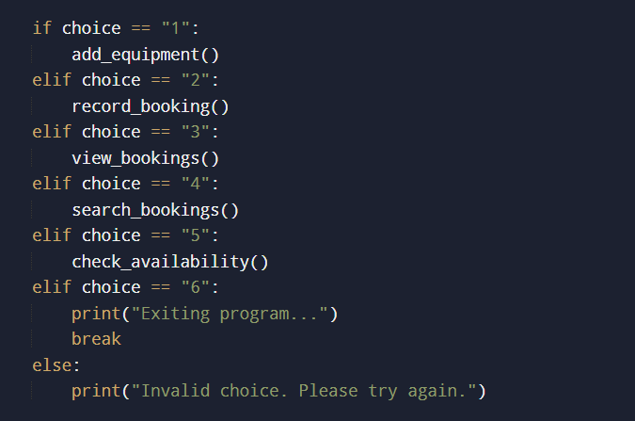
Figure 1: Selection statements used in the main menu
Selection statements are also used for validation. For example, when a user tries to add a new piece of equipment, the program checks whether the equipment name is empty, whether it already exists in the list, or whether it can be added successfully. Similar checks are used in the booking function to make sure the student name, equipment name, and date have all been entered. This means that conditional statements are not only used to control the main menu, but also to protect the quality of the data being entered into the system. Without these checks, the program could store incomplete or duplicate information, which would reduce its usefulness.

Another major programming construct used in the system is iteration. Iteration is needed when the same action has to be repeated. In this project, both while loops and for loops are used. The while loop appears in the main() function and keeps the booking system running until the user selects the exit option. This is important because the user may need to complete several tasks in one session, such as adding new equipment, checking bookings, and searching records. If the program ended after one action, it would be inconvenient and impractical for everyday use. The while loop therefore makes the system much more efficient and user-friendly [11], [15].
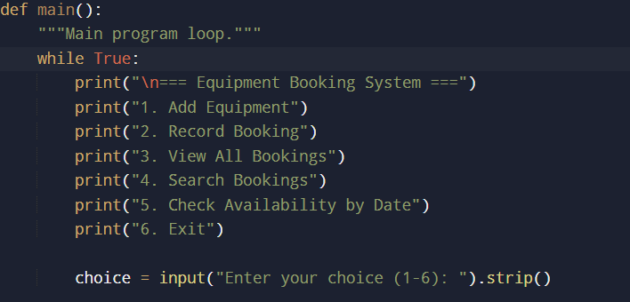
Figure 2: While loop used to keep the program running

The program also uses for loops, which are essential because the system stores information in lists. A for loop is used whenever the program needs to go through each item in a list one at a time. One important example is found in the booking function, where the program checks each record in bookings_list to make sure the same equipment has not already been booked for the same date. This process is one of the most important features in the entire program, because it prevents double bookings, which was identified as a major weakness in the academy’s current paper-based system. For loops are also used when displaying all bookings, searching for matches, and checking which items are already booked on a selected date [11], [12], [15]
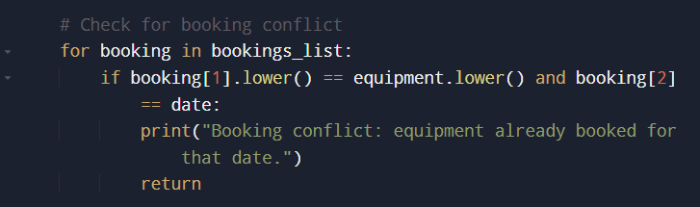
Figure 3: For loop used to detect booking conflicts

Another important construct used in the system is the use of user-defined functions. Functions make it possible to break a program into smaller and more manageable sections. Instead of writing all the instructions in one large block, the solution is divided into separate parts such as add_equipment(), record_booking(), view_bookings(), search_bookings(), check_availability(), validate_date(), and main(). This makes the program easier to read and understand because each function has a specific purpose. It also makes testing and debugging easier, since each feature can be checked separately. If an improvement needs to be made later, the developer can modify one function without changing the whole program. This modular structure is considered good programming practice because it increases readability, maintenance, and organisation [11]
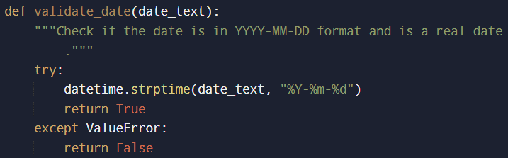

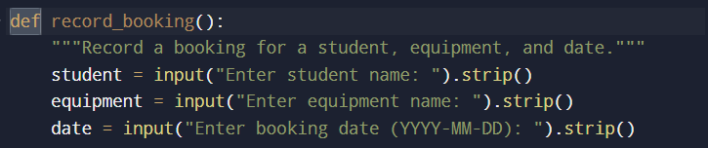
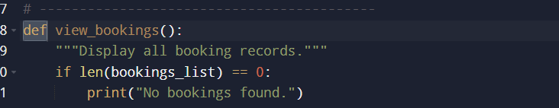
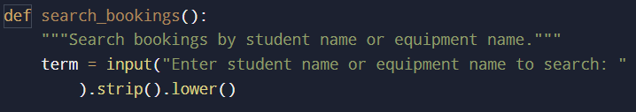
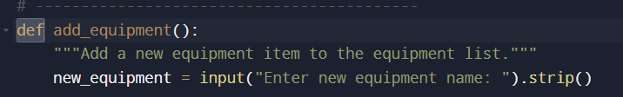
Figure 4: User-defined functions used in the system

The system also includes exception handling, which helps prevent the program from crashing when invalid input is entered. In this project, exception handling is used in the validate_date() function through the try and except statements. This function checks whether the date entered by the user follows the correct YYYY-MM-DD format and whether it is a real date. If the date is invalid, the exception is caught safely and the function returns False instead of stopping the entire program. This makes the system more robust and user-friendly because the user can correct the mistake and continue using the software without interruption [4], [16] .
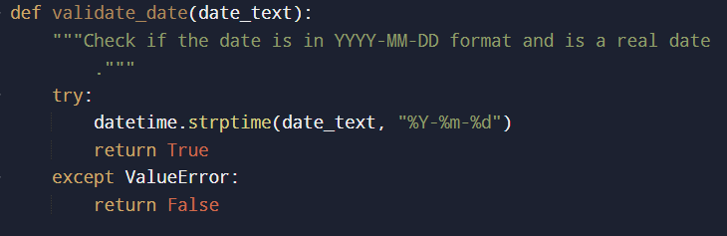
Figure 5: Exception handling used for date validation
Overall, the programming constructs used in the Student Equipment Booking System help ensure that the software is structured, reliable, and suitable for practical use. Selection statements allow the program to make decisions, loops allow it to process repeated tasks, functions improve code organisation, and exception handling protects the system from invalid input. Together, these constructs provide the logical foundation of the program and support the successful operation of the booking system.

3.2.3 Python Modules and Libraries

Python modules and libraries are collections of reusable code that help developers organise programs and perform common tasks more efficiently. In the official Python documentation, a module is defined as a file containing Python definitions and statements, and modules are used to organise related code into separate files that can be imported into a program when needed [1]. A library can be understood more broadly as a collection of modules that provide pre-written functionality for different types of tasks. Python’s Standard Library includes many built-in modules that are available by default, allowing developers to solve common problems without needing to install extra software[3]. This makes Python especially useful for educational projects, because students can create functional programs using simple built-in tools rather than relying on advanced external packages.
In the Student Equipment Booking System, the use of modules and libraries was intentionally kept to a minimum. This was a deliberate design decision rather than a limitation. The project was designed as a simple console-based prototype, with the main focus placed on core programming concepts such as data structures, functions, loops, conditional statements, validation, and logical program flow. Because of this, there was no need to use multiple libraries or any third-party packages. The system was successfully developed using basic Python features and only one built-in module from the Python Standard Library. This helped keep the code clear, lightweight, and easier to understand for both the developer and the person marking the coursework.
The only module used in this project is the datetime module, which was imported with the statement from datetime import datetime. According to the official documentation, the datetime module supplies classes for manipulating dates and times [2] This made it an appropriate choice for the booking system, because one of the most important pieces of information in each booking record is the booking date. Since staff members must enter a date whenever they create a booking, the system needs a reliable way to check whether that date is valid. If invalid dates were accepted, the records stored by the booking system would become inaccurate and less useful. For example, users might accidentally enter a date in the wrong format or type an impossible date such as 2026-02-30. By using the datetime module, the program can detect these errors before saving the booking.
It is important to note that in this system the booking date is still stored as a string, not as a datetime object. The user enters the value as text, and the program stores it in that form because a string is simple and fully suitable for a small console-based booking application. However, before the program accepts the value, it uses the datetime module to validate that the string follows the required YYYY-MM-DD format and also represents a real date. This means that the module is being used for validation, not for long-term date manipulation or advanced date calculations. This was sufficient for the needs of the project and avoided adding unnecessary complexity.
The datetime module is used inside the validate_date() function. In that function, the program applies datetime.strptime(date_text, "%Y-%m-%d") to the text entered by the user. The strptime() method attempts to interpret the string according to the specified date format. If the value matches the format and represents a valid calendar date, the function returns True. If the value is invalid, Python raises a ValueError, which is then handled safely by the except block, and the function returns False. This allows the booking system to reject incorrect dates without crashing. As a result, the program becomes more dependable and user-friendly, because users are informed that their input is invalid and can correct it immediately [2], [4]..
Using datetime was a sensible choice for several reasons. First, it is part of Python’s Standard Library, so no separate installation was required[3] .This made the program easier to run and more accessible, especially for a coursework project where simplicity is important. Second, it provided a more reliable solution than trying to validate dates manually using only string rules. A simple check could confirm the position of hyphens or the number of characters, but it would not always detect whether the date itself was real. The datetime module offers a more accurate and professional way to handle this problem. Third, using only one built-in module helped keep the solution aligned with the assignment brief, which emphasises basic programming concepts rather than advanced frameworks or external tools.
No other built-in modules or external libraries were needed for this project. This minimal approach was fully appropriate because the system does not require a database, graphical user interface, web framework, or file-handling package. All of the main functionality, including adding equipment, recording bookings, viewing records, searching, and checking availability, was achieved using core Python constructs such as lists, tuples, loops, functions, and conditional statements. Overall, the datetime module was the only additional support required, and it was enough to improve the quality and reliability of the Student Equipment Booking System while keeping the final solution simple, clear, and easy to maintain.

4.0 Testing and Debugging

This section explains the role of testing and debugging in the development of the Student Equipment Booking System. Testing was carried out to check whether the program works correctly under both normal and incorrect conditions, while debugging was used to identify and fix problems found during development. These activities were important because they helped improve the reliability, accuracy, and overall quality of the final program [5], [6], [12].
In this project, testing focused on checking the main features of the system, such as adding equipment, recording bookings, searching records, and validating user input. Different test cases were used to confirm that the software produces the expected output and handles invalid entries safely. Together, testing and debugging helped ensure that the system operates in a stable and user-friendly way [5], [6], [12].

4.1 Role of Testing in Software Development
Testing plays an important role in software development because it helps confirm whether a program works as expected. It allows the developer to check that the system performs the correct actions, produces the correct output, and handles invalid input safely. Without testing, a program may appear to work in simple situations but still fail when users enter unexpected values or follow a different path through the system. For this reason, testing is essential for improving software reliability and quality [5], [6], [12].
In the Student Equipment Booking System, testing is especially important because the program depends on user input. Features such as adding equipment, recording bookings, searching records, and checking availability all rely on the user entering correct information. Testing helps verify that these functions behave properly under both normal and incorrect conditions. It also helps reveal problems such as missing validation, incorrect logic, or unexpected outputs. Overall, testing supports the development of a more dependable, accurate, and user-friendly system [5], [6].

4.2 Types of Errors in Programming
Programming errors are problems in code that stop a program from working correctly or cause it to produce the wrong result. In general, the most common types of errors are syntax errors, runtime errors, and logical errors. Understanding these categories is important because each type affects a program differently and must be fixed in a different way [4], [6].
A syntax error happens when code breaks the rules of the programming language. This means the program cannot run properly because the interpreter or compiler cannot understand the instruction. Common examples include missing punctuation, incorrect indentation, misspelled keywords, or unmatched brackets. Syntax errors are usually easier to identify because the system often points to the line where the mistake occurs. They can be fixed by checking the structure of the code carefully and following the correct language rules [4], [6].
A runtime error happens while the program is running. In Python, errors detected during execution are called exceptions [4]. These errors may happen even if the code is written with correct syntax. Examples include dividing by zero, entering invalid input, or trying to access something that does not exist. Runtime errors are usually fixed by testing different inputs, adding validation, and using error handling techniques such as try and except so the program can respond safely instead of crashing [4], [6], [12].
A logical error occurs when the program runs without crashing, but the output is incorrect because the programmer’s logic is wrong. For example, a formula may be incorrect, a condition may be written the wrong way, or steps may be placed in the wrong order. These errors are often harder to detect because the program appears to work. Logical errors are usually fixed by tracing the program step by step, comparing expected and actual results, and using test cases to verify whether the solution behaves as intended [5], [6], [12].
Overall, programmers must be able to identify, test, and correct different types of errors in order to produce reliable software.

4.3 Example of Test Cases
Test cases were used to verify that the Student Equipment Booking System works correctly under both valid and invalid conditions. This was important because the program depends heavily on user input, which means it must respond properly not only when correct information is entered, but also when mistakes are made. The purpose of testing was to confirm that the main features of the system operate as expected, that validation rules are applied correctly, and that error messages are shown when inappropriate input is provided. The following test cases were selected to demonstrate a mixture of normal use and edge cases.
Table 2: Example Test Cases for the Student Equipment Booking System
Test ID | Test Description | Input | Expected Output | Actual Output | Result
TC1 | Add new equipment | Option 1, Laptop 3 | Equipment added successfully | Equipment added successfully | Pass
TC2 | Record valid booking | Option 2, Radu, Laptop 1, 2026-04-10 | Booking recorded successfully | Booking recorded successfully | Pass
TC3 | Prevent duplicate booking | Option 2, Maria, Laptop 1, 2026-04-10 | Booking conflict message displayed | Booking conflict message displayed | Pass
TC4 | Reject invalid date format | Option 2, Alex, Laptop 2, 10-04-2026 | Invalid date format message displayed | Invalid date format message displayed | Pass
TC5 | Search existing booking | Option 4, Radu | Matching booking displayed | Matching booking displayed | Pass

The first test case checked whether the program could successfully add a new item of equipment. This was important because one of the core system requirements is to allow staff to expand the list of available resources. The test passed because the system accepted the new item and displayed the correct success message.
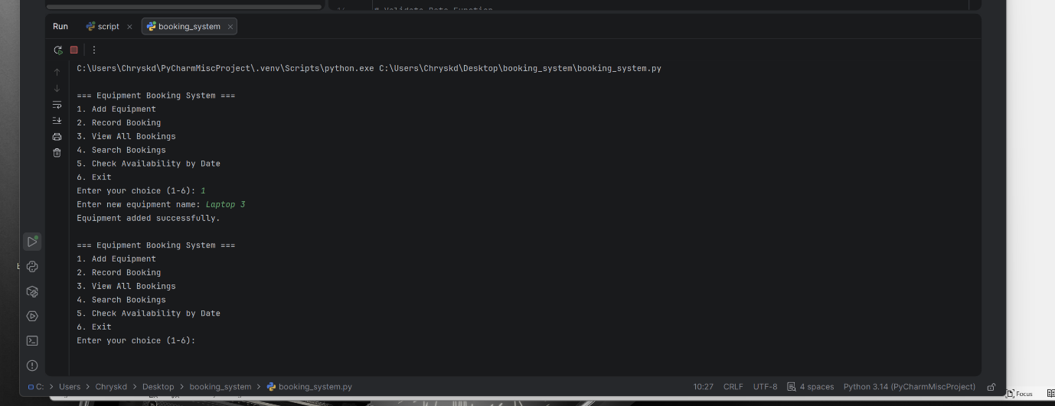
Fig 1
The second test case focused on recording a valid booking. In this case, all inputs were entered correctly, including a valid date format and existing equipment name. The booking was stored successfully, showing that the booking function works properly under normal conditions.
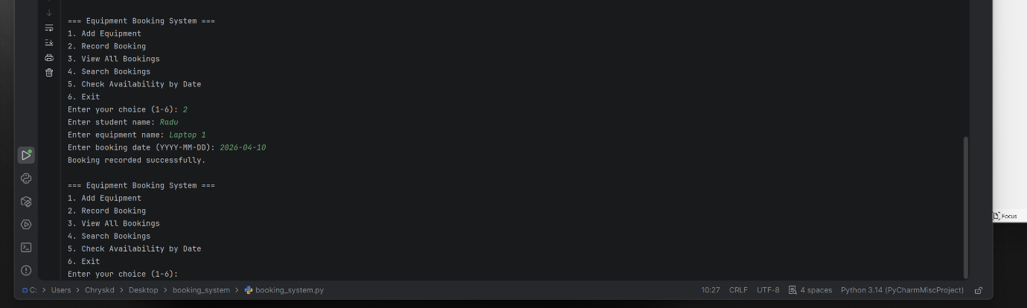
Fig2
The third test case was used to verify that the system prevents double bookings. This is one of the most important rules in the project, since avoiding clashes was one of the main reasons for replacing the paper-based system. The program correctly identified that the same equipment had already been booked for the same date and displayed a conflict message, so the test passed.
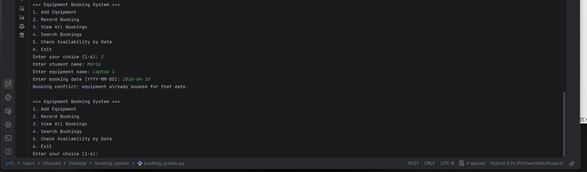
Fig-3
The fourth test case checked date validation by entering an invalid date format. This test was important because the system should reject incorrect date inputs rather than storing unreliable data. The program displayed the correct error message, confirming that validation and exception handling are functioning properly.
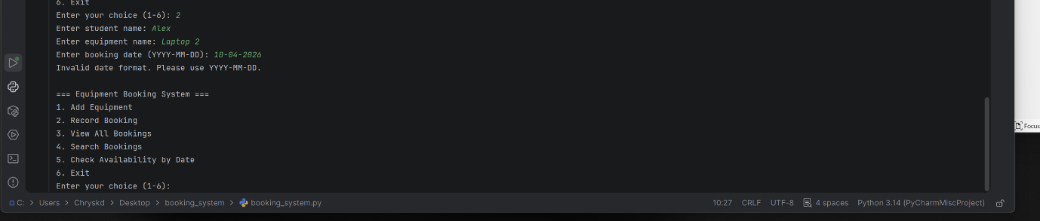
Fig4
The fifth test case tested the search feature by looking for an existing student booking. The correct record was displayed, showing that the search function works as intended. Finally, the sixth test case checked the availability feature. The system correctly displayed both booked equipment and remaining available items for the selected date. Together, these tests demonstrate that the main features of the program work correctly and that the system handles both normal and incorrect inputs in a reliable way.
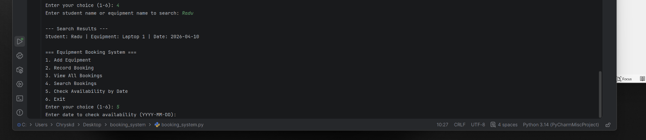
fig 5

5.0 Evaluation

Challenges Faced
One of the main challenges in this project was keeping the system simple while still making it useful and reliable. The assignment did not require a database or a graphical interface, so the solution had to be built using only core Python features such as lists, tuples, functions, loops, and validation. At first, this seemed straightforward, but in practice it required careful thinking. A booking system may look small, yet it still needs clear structure to avoid confusion. I had to decide how to store equipment and booking records in a way that matched the project requirements while also keeping the code easy to understand. Choosing lists and tuples worked well, but I needed to think carefully about how the data would be added, searched, and checked.
Another challenge was handling validation properly. A booking system is only useful if the information entered into it is accurate. This meant I had to prevent empty inputs, invalid menu options, duplicate equipment entries, and booking clashes. The most important challenge here was avoiding double bookings, because that problem was one of the main reasons why Bright Minds Academy needed the software in the first place. To solve this, I added checks that compare the equipment name and booking date against existing records before saving a new booking. Although the logic was not extremely advanced, it still required attention because even a small mistake in the condition could lead to incorrect results.
Designing the flow of the program was also more difficult than it first appeared. Because the system is menu-driven, the user must be able to complete multiple tasks in one session without the program becoming confusing or unstable. This meant I needed to make sure that after each action, the system returned to the main menu correctly. I also had to think about what messages the user would see after each input, especially in cases where something went wrong. During development, I addressed these challenges by breaking the program into small functions, testing each part separately, and making the logic more organised before finalising the code. This made the program easier to manage and improved the final structure of the solution.

Future Improvements

Although the Student Equipment Booking System meets the basic requirements of the project, there are many ways it could be improved in the future. One important improvement would be adding permanent data storage. In the current version, equipment and bookings only exist while the program is running. Once the system is closed, the data is lost. For a real organisation, this would not be practical. A future version could use a text file, CSV file, or database so that booking records are saved permanently and can be loaded again when the program starts. This would make the software much more realistic and useful in an everyday environment.
Another useful improvement would be creating a graphical user interface. At the moment, the program works through the console, which is suitable for demonstrating programming concepts but is not the most user-friendly format for staff in a real tutoring centre. A future version could be developed using a library such as Tkinter so that users can interact with buttons, forms, and clear screens instead of typing everything manually. This would improve accessibility and make the system easier to use for people with limited technical experience.
The search and booking features could also be expanded. For example, the system could allow staff to edit or cancel existing bookings, which would be very useful if plans change. At the moment, users can add and view bookings, but they cannot remove or update them. Another improvement would be to allow more advanced searching, such as searching by date only, viewing all bookings for one student, or filtering by equipment type. It could also be helpful to sort bookings in date order so that records are easier to read.
Security and user management could also be added in future versions. For example, staff accounts with usernames and passwords could be introduced so that only authorised users can make changes to the system. This would make the software more professional and suitable for use in larger organisations. Finally, the availability feature could be improved so that the system gives a more detailed daily summary of all equipment. Overall, while the current system works well as a prototype, it has clear potential to be expanded into a more advanced and practical software solution.

Self-Reflections

This project helped me understand that even a small program requires careful planning. Before starting, I assumed that a simple booking system would be easy to build quickly, but I learned that writing working code is only one part of the process. It is just as important to think about structure, validation, user interaction, and how the logic flows from one step to another. Creating the flowchart, pseudocode, and written explanations helped me see that software development is not only about code, but also about planning and clear communication.
I also developed a better understanding of how to use core Python constructs in a practical way. Through this project, I became more confident with functions, loops, conditional statements, and validation. I also learned the importance of testing different inputs and checking edge cases instead of assuming the program will always be used correctly. Most importantly, I feel that I grew as a developer by becoming more patient and methodical. Rather than trying to rush into writing code, I learned to break the problem into smaller parts and solve them step by step. This project showed me that good software comes from clear thinking, not just from writing more code.

References
[1] Python Software Foundation, “Modules,” Python 3 Documentation, 2026. [Online]. Available: Python tutorial, Modules section. Accessed: Mar. 27, 2026.
[2] Python Software Foundation, “datetime — Basic date and time types,” Python 3 Documentation, 2026. [Online]. Available: Python library reference, datetime. Accessed: Mar. 27, 2026.
[3] Python Software Foundation, “The Python Standard Library,” Python 3 Documentation, 2026. [Online]. Available: Python library index. Accessed: Mar. 27, 2026.
[4] Python Software Foundation, “Errors and Exceptions,” Python 3 Documentation, 2026. [Online]. Available: Python tutorial, Errors and Exceptions. Accessed: Mar. 27, 2026.
[5] International Software Testing Qualifications Board, Certified Tester Foundation Level Syllabus v4.0.1, 2024. [Online]. Available: ISTQB CTFL syllabus. Accessed: Mar. 27, 2026.
[6] A. Zeller, R. Just, G. Fraser, C. Holler, and T. Zimmermann, The Debugging Book, 2025. [Online]. Available: debuggingbook.org. Accessed: Mar. 27, 2026.
[7] R. Stephens, Beginning Software Engineering, 2nd ed. Hoboken, NJ, USA: Wiley, 2022.
[8] E. Matthes, Python Crash Course, 3rd ed. San Francisco, CA, USA: No Starch Press, 2023.
[9] M. Lutz, Learning Python: Powerful Object-Oriented Programming, 6th ed. Sebastopol, CA, USA: O’Reilly Media, 2025.
[10] R. J. Madachy, What Every Engineer Should Know About Python. Boca Raton, FL, USA: CRC Press, 2025.
[11] Python Software Foundation, “More Control Flow Tools,” Python 3 Documentation, 2026. [Online]. Available: Python tutorial, control flow. Accessed: Mar. 27, 2026.
[12] Python Software Foundation, “Data Structures,” Python 3 Documentation, 2026. [Online]. Available: Python tutorial, data structures. Accessed: Mar. 27, 2026.
[13] Python Software Foundation, “Built-in Functions,” Python 3 Documentation, 2026. [Online]. Available: Python library reference, built-in functions. Accessed: Mar. 27, 2026.
[14] I. Tarsini, N. U. S. Siregar, and J. Simarmata, “Explore flowchart and pseudocode concepts in algorithms and programming,” Indonesian Journal of Multidisciplinary Science, vol. 3, no. 4, 2024.
[15] Python Software Foundation, “Compound statements,” Python Language Reference, 2026. [Online]. Available: compound statements section. Accessed: Mar. 27, 2026.
[16] Python Software Foundation, “Built-in Exceptions,” Python 3 Documentation, 2026. [Online]. Available: exceptions library reference. Accessed: Mar. 27, 2026

