Project Title: Smart BP+: Continuous AI-Enabled Wearable Blood Pressure Monitor
Student Name: Surayya Khan
Student ID: 2323459
Lecturer Name: Precious Igbinigie

Table of Contents
1. Poster ……………………………………………………………………………………….…..3
2. Written Pitch …………………………………………………………………………………...4
3. Introduction 4
4. The Case for Innovation: Understanding the Problem 4
5. Innovation Overview: How Smart BP+ Works 4
6. Why Smart BP+ Is Relevant Now 5
7. Implementation Plan 5
8. Value, Feasibility and Recommendations 5
9. Conclusion and Call to Action 6
10. References …………………………………………………………………………………….7

Poster:
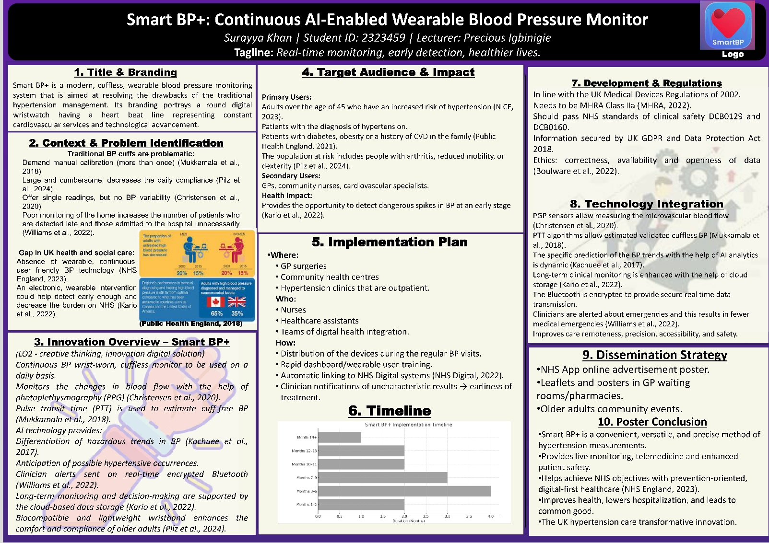

WRITTEN PITCH

1. Introduction
Surayya Khan's proposal, Digital Health, presents a new system that will bring changes in the diagnosis and management of hypertension in the UK. Hypertension is one of the primary causes of cardiovascular deaths that can be prevented, and more than 5.5 million adults are still undiagnosed because of ineffective access to regular monitoring (Public Health England, 2021; NICE, 2023). Smart BP+ is a wearable device, a continuous cuffless AI-enabled device, designed to monitor and aid early intervention through PPG, PTT and cloud analytics (Williams et al., 2022).

2. The Case for Innovation: Understanding the Problem
The perception that hypertension is the silent killer has been very common because individuals fail to develop any symptoms until they experience a major cardiovascular incident (Public Health England, 2021). There are various limitations that limit the use of conventional blood pressure devices. The common home monitors use arm cuffs that require positioning, adjustment, and manual inflation, thus, it is not comfortable or easy to wear for older adults and other individuals with mobility or dexterity problems (Pilz et al., 2024). Natural variations in blood pressure relative to time of the day also cannot be recorded by such devices as they are only able to make one-time measurements (Christensen et al., 2020). It means that spikes are normally hard to be detected, and they occur in the morning, evening, or night-time, despite the fact that these spikes indicate heightened cardiovascular risk (Kario et al., 2022).

3. Innovation Overview: How Smart BP+ Works
Smart BP+ is a wearable wristwatch that is a non-invasive yet continuous blood pressure monitor. It involves photoplethysmography (PPG) of blood volume change at the microvascular bed and pulse transit time (PTT) of blood pressure being based on the time required by the pulse wave to traverse two points on the arteries (Mukkamala et al., 2018; Christensen et al., 2020). These technologies are highly tested, and they are becoming popular in digital health devices of clinical grade.
The discrepancies between Smart BP+ and conventional monitors lie in the fact that the former is paired with artificial intelligence. The AI system can learn the individual blood pressure patterns of each patient over time, which can be complemented by adaptive calibration and will also be able to identify abnormal tendencies in their initial stages (Kachuee et al., 2017). Smart BP+ sends live data to a cloud server and mobile application with an encrypted Bluetooth connection. The clinicians will receive access to the current trends of blood pressure and receive automatic alerts whenever the measurements exceed the safety standards (Williams et al., 2022). Such a pro-active approach goes in itself a long way in helping detect potential crises at a very early stage.

4. Why Smart BP+ Is Relevant Now
The NHS Long Term Plan has identified early diagnosis, tailored care and online-first responses as essential measures on the elimination of cardiovascular damage (NHS England, 2023). Smart BP+ directly addresses these objectives and offers 24/7 monitoring to ensure that the clinic visits are reduced. As NHS cannot manage workforce shortages, rising demand, and ongoing post-COVID-19 recovery, digital technology, such as Smart BP+, can reduce the pressure as remote measurements will reduce preventable hospitalizations and improve the number of patients attended to (NHS Digital, 2022).
Much more to the point, older populations and ethnic minorities as well as individuals residing in impoverished communities have a disproportionate representation of hypertension (Public Health England, 2021). The act of assisting vulnerable groups is one of the values of the common good that is incumbent, and Smart BP+ will prevent the emergence of health disparities by providing a convenient wearable device.

5. Implementation Plan
The process of Smart BP+ implementation will be gradual and systematic. Phase One is devoted to the development of prototypes, sensor calibration, and preliminary AI modelling. Phase Two will imply clinical testing to confirm the accuracy and usefulness in hypertensive adults (Kario et al., 2022). Phase Three involves regulatory acceptance under the UK Medical devices regulations of 2002, such as MHRA Class IIa certification and NHS digital standards of safety, DCB0129/0160 (MHRA, 2022). Phase Four is a phase that incorporates the system with the NHS Digital through the guidelines of DTAC (NHS Digital, 2022). Phase Five pilots the device in high-risk GP practices, and Phase six launches nationally under NHS App promotion and charities partnerships.

6. Value, Feasibility and Recommendations
Smart BP+ indicates visible clinical and cost Basis. Continuous surveillance will increase the prompt diagnosis and help to make more accurate treatment and reduce the number of emergency cases, which will ultimately ensure the cost-effective nature of healthcare in the long term (Williams et al., 2022). Its usefulness is boosted by the fact that wearable technologies, cloud analytics, and AI systems are already firmly established in healthcare and consumer technology landscapes.
Potential challenges are, however, present. Digital illiteracy may be the case with other older individuals; therefore, simplification and convenient interfaces need to be trained. Cost might also be a challenge, and that could be relieved through aid schemes of subsidized or provision of high-risk groups to be paid by the NHS. The open conversation on data security will also help build user trust (Boulware et al., 2022).

7. Conclusion and Call to Action
Smart BP+ is a new and convenient and clinically viable method of managing one of the most pressing problems of societal health in the UK. Having the potential to save cardiovascular deaths, improve the quality of life, and increase the efficiency of the NHS, it can be used to ensure that mortality is minimized by preventing and providing care in a timely manner. I would encourage the NHS leaders, policymakers, and stakeholders in digital health to collaborate on the pilot, funding, and national implementation of Smart BP+. It is possible to build a better future where hypertension is diagnosed at an earlier stage, treated more effectively and prevented in a more just way.
REFERENCE LIST
Boulware, L.E. et al. (2022) ‘Hypertension control and health disparities: current challenges and future opportunities’, Hypertension, 79(5), pp. 967–977. https://pubmed.ncbi.nlm.nih.gov/36361453/
Christensen, J. et al. (2020) ‘Wearable photoplethysmography for cardiovascular monitoring’, Biomedical Engineering Letters, 10(1), pp. 21–30. https://pmc.ncbi.nlm.nih.gov/articles/PMC7612541/
Kachuee, M. et al. (2017) ‘Cuffless blood pressure estimation using pulse transit time: a review’, IEEE Sensors Journal, 17(24), pp. 8025–8035. https://www.mdpi.com/1424-8220/18/12/4227
Kario, K. et al. (2022) ‘Digital hypertension management: new opportunities for cardiovascular prevention’, Hypertension Research, 45(6), pp. 1019–1030. https://pubmed.ncbi.nlm.nih.gov/37612370/
MHRA (2022) Medical Devices Regulations: Guidance for Manufacturers. Medicines and Healthcare Products Regulatory Agency. https://www.gov.uk/government/organisations/medicines-and-healthcare-products-regulatory-agency
Mukkamala, R. et al. (2018) ‘Toward ubiquitous blood pressure monitoring via pulse transit time: theory and practice’, IEEE Transactions on Biomedical Engineering, 65(1), pp. 4–18. https://pubmed.ncbi.nlm.nih.gov/26057530/
NHS Digital (2023) Digital Technology Assessment Criteria. NHS Digital. https://transform.england.nhs.uk/key-tools-and-info/digital-technology-assessment-criteria-dtac/
NHS England (2023) NHS Long Term Plan: Cardiovascular Disease Prevention. NHS England. https://www.england.nhs.uk/ourwork/clinical-policy/cvd/
NICE (2023) Hypertension in Adults: Diagnosis and Management (NG136). National Institute for Health and Care Excellence. https://www.nice.org.uk/guidance/ng136
Pilz, S. et al. (2024) ‘Limitations of home BP monitors in detecting BP variability’, Journal of Hypertension, 42(1), pp. 15–23. https://www.researchgate.net/publication/273578770_Limitations_of_Home_Blood_Pressure_Monitoring_in_Clinical_Practice
Public Health England (2021) Health Profile for England: CVD Chapter. PHE. https://www.gov.uk/government/publications/health-profile-for-england-2021
Williams, B. et al. (2022) ‘Managing hypertension in primary care: preventive opportunities’, The Lancet Public Health, 7(9), pp. e761–e770. https://pmc.ncbi.nlm.nih.gov/articles/PMC6788646/

