Welsh Medieval Court Poetry
Session 2

This second session contains:

- Lecture 2, Arwyrain Owain Gwynedd by Cynddelw Brydydd Mawr, and the Hendregadredd Manuscript – Recorded lecture with Powerpoint
- Arwyrain Owain Gwynedd – text and translation in PDF file
- MP3 file – Short discussion with Dr Jenny Day regarding warfare and weapons in the poetry

Before launching the Powerpoint please could you ...
- have a printout of the text and translation to hand (from the PDF provided)
- have access to the University of Wales Dictionary (either online at gpc.cymru, or as an app on your smart device) and read the instructions in the PDF provided
- read the notes that Rhian M. Andrews has for this poem in her Welsh Court Poems (Cardiff, 2007), poem 2, notes on pp. 51-56. (I have included a pdf file of the notes on moodle, incase you don’t have a copy)
- Read the following biographical note on Owain Gwynedd: https://biography.wales/article/s-OWAI-GWY-1100

Following the session you may want to take a closer look at the Hendregadredd Manuscript: https://www.llyfrgell.cymru/darganfod/oriel-ddigidol/llawysgrifau/yr-oesoedd-canol/llawysgrif-hendregadredd/
(at the time of writing this, 30/9/2019, only the Welsh side of the website is working. Try clicking the “English” button at the top right – the problem may have been resolved by the time you read this!)

After completing the session, please email me the answers to the following questions (apo@cymru.ac.uk). This is not obligatory, but will help you get to know the poetry! One or two sentence answers, as appropriate:

When was the poem likely to have been composed, and where?

What is the meaning of the following words (consult the GPC app for assistance): meddfaeth (line 4), celain (line 30), eryfain (line 22), prain (l. 37), esillydd (line 14)?

In what manuscript has the poem survived? If the poem was composed in 1167, how many years between 1167 and the date it was copied into the manuscript?

Who was Owain Gwynedd’s father? What were Owain’s dates? Who was the mother of his two sons Dafydd and Rhodri?
https://biography.wales/article/s-OWAI-GWY-1100

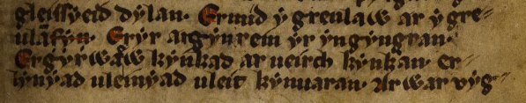

Starting with the third word in the first line, can you please transcribe these lines. When getting to know a medieval hand, it’s worth making a table of the letters for yourself – including capitals and lower case letters. Alpha is quite consisten in his letters, but others may have three or four different letter shapes for the same letter!

Ermid …

