University of Wales Trinity Saint David
School of Engineering

Plant Flow Diagrams and Pipe and Instrument Diagrams
Plant Operations and Performance
ACMA4002

Adam Dolloway
2312274
19/7/2024

Table of Contents
1 Introduction 4
1.1 Aims 4
1.2 Objectives 4
2 Pipe and Instrument Diagram 5
2.1 Diagram 5
2.2 Explanation of the Diagram 5
3 Analysis of Diagram 9
4 Health and Safety 10
5 Conclusions 11
6 References 12

1 – Image of a Pipe and Instrument Diagram made for this report. 5
2 – Cropped Image of the previous diagram. 7

Introduction
This report will identify and explore the different methods and components used within the pipe and instrument diagrams of FSG Tool and Die, this will give the vital information on the materials flowing through the pipes within the chosen section of the factory whilst also giving information the materials used for components and the possible reasoning behind it. Strengths, weaknesses, and possible improvement methods will also be studied to attempt to improve the function, layout or accessibility of the pipes and components within the working environment.

Aims
This report aims to convey information on the pipe and instrument diagrams within FSG Tool and Die, the information shown in this report will display and explain each component, pipe, or symbol. Whilst also explaining the importance of each component and the overall importance of the chosen section of the factories pipe and instrument diagram. The information displayed beneath will also give information on the materials which flow throughout the factory’s pipes, a health and safety perspective will also be explored, explaining the potential risks and how to mitigate these risks to nullify any danger within the working environment.

Objectives
- Identify and create a pipe and instrument diagram of the chosen section within FSG.
- Explain the pipe and instrument diagram in depth (this will include components and materials).
- Analyse the information pipe and instrument diagram, to identify flaws or potential issues involved with the current set up.
- Identify all safety issues that associate with the current layout, equipment, and transported materials. (This section will include COSHH).

Pipe and Instrument Diagram

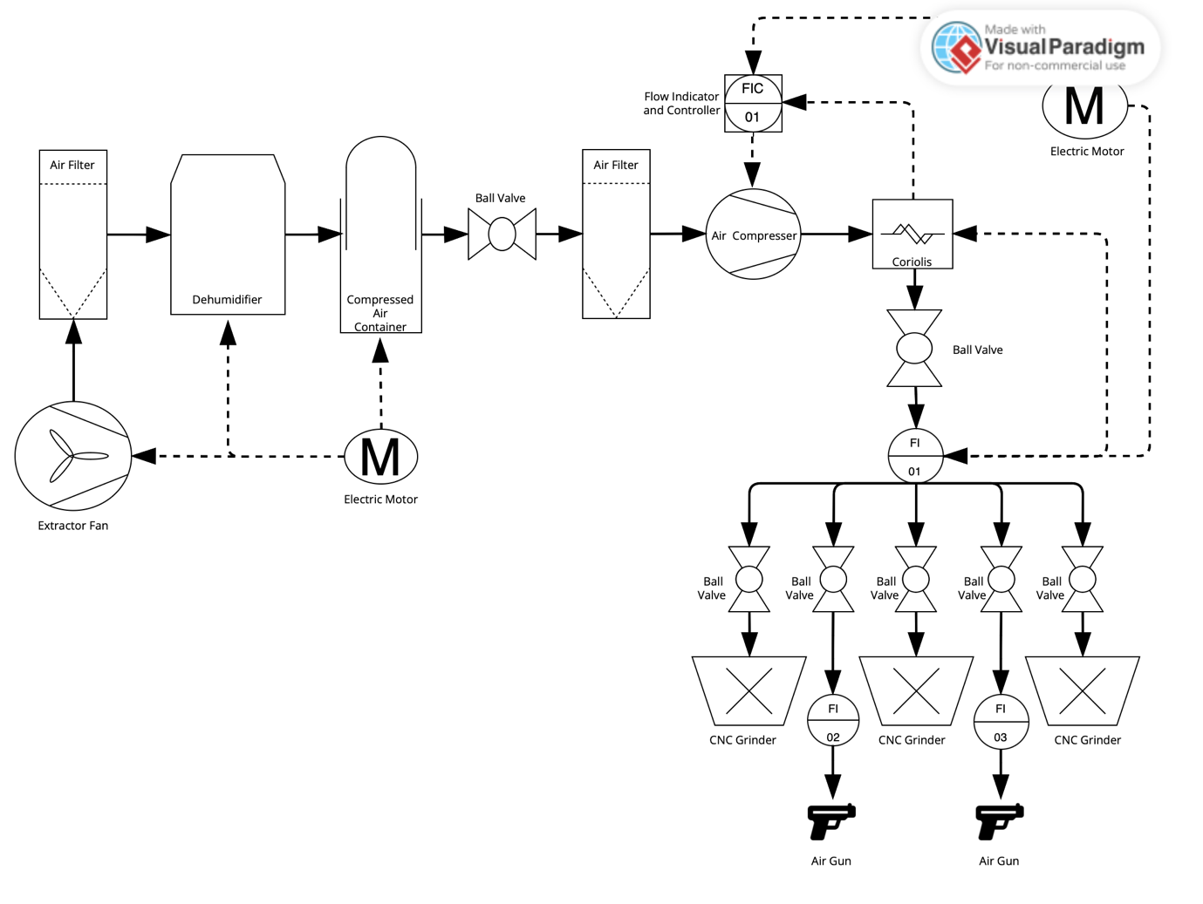
Diagram
1 – Image of a Pipe and Instrument Diagram made for this report.

Explanation of the Diagram
This pipe and instrument diagram was created to replicate the exact layout and components of the grinding section in FSG also known within FSG as SG4. This diagram depicts the movement of pressurised air from its origin, which in this case would be the extractor fan and storage containers all the way to the grinding machines and air guns. Although this diagram suggests that the only substance involved with this section of grinding is pressurised air, this statement would be false as throughout the diagram there is clear electronic connections between certain components. This is represented by the dashed connecting lines between components as stated by (Andrews, 2024) who states that “Users can identify how instruments connect to each other and what type of signal is being used.
For example, a solid line indicates piping, while a dashed line tells us that there is an electrical signal”.
The direction that the pressurised air flows through is also marked by the arrows shown on the diagram above, but to give a deeper understanding of the flow of the substance this report will now explain the order in which the air travels, each step and the reasoning behind the components presented above. At first the air enters the system as regular air which is sucked in by a large extractor fan located on the outside of a storage house, it is then pulled through into the air filter which ensures that the air is clean and has no debris which could be potentially damaging to upcoming components within the system. As the air moves from the air filter it is transported into the dehumidifier which extracts all moisture that is trapped in the air, this is essential due to the uses of the pressurised air such as, using an air gun to clean a component, if the air were to contain moisture components would rust and wear at an accelerated pace. Once the air has been completely sucked of its moisture it is then stored into a large, sealed container which as overflow valves attached, the reason for this is if there were too much air contained in one container the container could become damaged or even explode. Attached to the large storage container is a ball valve which can shut off the main supply of air to the factory, the location of this ball valve is to give the ability to control the flow of air which is flowing through the system at all times whilst also giving the ability to eliminate all air to the factory which is a large safety factor when dealing with high amount of air. When there is a demand for air the air leaves the air tank and travels through yet another air filter to ensure no contaminated air supply before flowing through the air compressor which compresses the air to six bars of atmosphere, this is a specific bar due to FSGs compliance to various health and safety regulations, it is also crucial for the air to be compressed to six bar due to all machines in the factory needing a minimum of six bar to operate at full capacity.

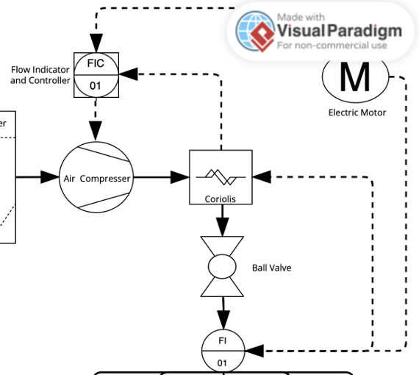
2 – Cropped Image of the previous diagram.

The Coriolis depicted on the diagram is a flow control and altering component which can change the flow rates therefore increasing or decreasing the pressure if needed, to support this (Omega, n.d.) states that Coriolis flow meters measure the rate of flow through inertia and vibrations, emitted by small actuators within the device. In this circumstance the Coriolis and the air compressor are both joined into a smaller subsection of connections by being wired to a FIC or flow indicator and controller, this allows users to gain information on the flow and pressures emitted by the system before the substance in question reaches the main supplies or pressurised air such as machines and air guns. This small subsection of the diagram also is self-correcting, for instance the Coriolis and air compressor are both linked and controlled by the flow indicator and controller, this grants the flow indicator and controller the ability to adjust the air pressure being output to the needs of the working environment. As seen in the diagram above the Coriolis leads directly into another ball valve, this is once again a matter of safety and ease of access to give the ability to close off the main supply of compressed air entering the working environment. The symbol presenting the FI letters below the ball valve is simply a flow indicator, this will act as a readout for users and employees which will give the flow rate of the compressed air whilst also giving the pressure levels of said compressed air. Each major component within this smaller sub assembly such as the Coriolis, flow indicator, air compressor, and the flow indicator and controller is each powered by one single electric motor, this is represented by the circular symbol with the letter M in the centre, this allows the components to function by generation electricity for the components to use. As seen within the original pipe and instrument diagram an electric motor is also used to power the extractor fan, dehumidifier, and the readouts on the compressed air tank.
From the previous ball valve discussed the compressed air is diverted and separated into five different streams of substance, each branch of the pipe is fitted with a ball valve as a safety precaution whilst also giving the ability to isolate the compressed air directly to each machine or air gun. The air is split to supply three large grinding machines, this controls all pnumatic functions on each machine. It is also distributed to two air guns which are equipped with their own flow indicators to assure the pressure being used meets health and safety regulations.

Analysis of Diagram
Whilst reviewing and analysing the pipe and instrument diagram in question, it seems to have areas where improvements could be applied such as, other suitable components may be more effective than the components currently fitted to the assembly. In this case this report feels that a variation of valves within different parts of the layout could be beneficial, this was the first improvement under investigation due to all valves within the factory being ball valves. In the opinion of the report a needle valve would be more suitable for the pressurised air due to its ability to control the natural flow of the substance more efficiently than a ball valve could, although in the case of FSG these needle valves would only be fitted to the machines and airguns due to the needle valves capabilities of only handling small flow rates. (CPV, n.d.) states that although the needle valve offers “precise control of flow” due to the nature of the sharp disc and custom seating inside, it does not deal with high flow rates proven by this quote “It’s worth noting that although needle valves can control flow with precision, they are usually capable of handling only relatively low flow rates.”. However other sources suggest that the ball valve is suitable for the use alongside with the wafer and butterfly valves such as (Foss, 1998) who suggest that wafer, ball, and butterfly valves are the most used and most efficient in terms of line shut offs within compressed air systems.
Within the compressed air system there does not seem to be any major flaws or concerns in the opinion of this report, the only other suggestion that will be made is that, instead of leaving the waste compressed air leak from blow off valves, the air should circulate back to the original sealed storage tank to be re-filtered and repurposed. Therefore, there is less of a strain on the extraction fan unit, since it will not be demanded of air as often, causing less overtime wear.
A possible investment of another extractor fan could also be extremely beneficial to the company, this allows more air to flow through the system.

Health and Safety
Whilst studying the pipe and instrumentation diagram of the grinding section within FSG Tool and Die, there seems to be no immediate risks or flaws within the framework of the diagrams that would be classed as dangerous. Although this does not imply there is no danger, the transportation of compressed air if not executed correctly could cause serious harm. FSG Tool and die comply to the regulations of the HSE (Health and Safety Executive). (HSE, 2016) informs that “These Regulations cover pressure equipment and assemblies with a maximum allowable pressure PS above 0.5 bar.” Which suggests that all components within this diagram are under HSE regulations. The regulations set by the (HSE, 2016) state that all pressure equipment this includes pipework, and vessels must be connected to safety features especially when used as supports, lifting equipment, nozzles, and flanges. Whilst conducting an in person viewing of the piping and instrumentations within the grinding section, all pipework is connected properly and maintained correctly therefore complying with the HSE regulation. All instruments were correctly installed, preserved, and maintained. It is also clear that all valves are in functioning order and are not causing any detrimental leaks of pressurised air within the system.

Conclusions
In conclusion the pipe and instrument diagram within the working environment of grinding within FSG Tool and Die shows to be very effective whilst transporting and distributing pressurised air to each machine and instrument and around the entire section. It is also apparent that although the diagram is of a smaller section within the company, based off the evidence shown by the pipe and instrument diagram FSG not only has an effective system, but they also operate and maintain a safe system.

References
Andrews, K., 2024. How to Read oil and Gas P&ID Symbols. [Online]
Available at: https://kimray.com/training/how-read-oil-and-gas-pid-symbols#:~:text=Users%20can%20identify%20how%20instruments,by%20downloading%20our%20reference%20chart.
[Accessed 19 July 2024].
CPV, n.d. 6 Types of Flow Control Valves & What You Need to Know About Them. [Online]
Available at: https://www.cpvmfg.com/news/6-types-of-flow-control-valves-what-you-need-to-know-about-them/#:~:text=Needle%20Valves,disc%20and%20a%20matching%20seat.
[Accessed 19 July 2024].
Foss, R. S., 1998. Imporving Compressed Air System Efficiency: Part 3. [Online]
Available at: https://www.powermotiontech.com/technologies/other-technologies/article/21883482/improving-compressed-air-system-efficiency-part-3
[Accessed 19 July 2024].
HSE, 2016. Pressure Equipment (Safety) Regulations 2016. [Online]
Available at: https://www.hse.gov.uk/pressure-systems/pesr.htm
[Accessed 19 july 2024].
Omega, n.d. What is a Coriolis Flow Meter and How Does it Work?. [Online]
Available at: https://www.omega.com/en-us/resources/what-is-a-coriolis-flow-meter#:~:text=Coriolis%20mass%20flow%20meters%20measure,resulting%20in%20a%20phase%20shift.
[Accessed 19 July 2024].

