Structure and Culture- Assignment 1
Student ID:1813660
Student Name: Mihaela Filimon
Professor Name:Kenny Tang

Contents
Introduction 3
1. Structure 4
2. Culture 6
3. People 7
4. Organizational Performance 8
Conclusion 11
References 12

Introduction
In a business organization, structure and culture are two basic elements to get the company’s goal achieved as well as being successful when it needs to operate inside or outside the national border (Schein, 2015). Culture shapes the structure while leadership brings about the ultimate expected performance of the firm. The paper portrays the structure and culture practiced in Wal-Mart, the leading super chain shop in the world, started its operation in 1962. The whole paper reveals the structure, culture, individuals and organizational performance which are linked with each other to bring Wal-Mart in this position. The company organized its structure with product divisional and functional basis while it practices employee-oriented culture as well as customer-driven positioning. Finally, organizational performance is analysed in relation to the structure, culture, and individuals of Wal-Mart.

Structure
According to Fatehi (1996), there are three models through which a basic structure of any organization can be determined. Due to globalization, some other organizational structures emerge which are sometimes classified as mixed structure. These three models are product structure, functional structure, and geographic structure.
1a) Product Structure:
Wal-Mart is one of the leading retail chained businesses which is the biggest revenue-generating firm in the world. It works with more than 2 million employees in 11,695 stores across 28 countries in the world. Since Wal-Mart is a large corporation, it operates its business activities with a mixed organizational structure that is the combination of product divisional structure and functional structure. To give the light of Wal-Mart, Sam Walton, founder of Wal-Mart, cherished the vision of keeping prices of commodities as low as possible in his organization. To have better communication within the organization, product divisional structure enhances the motive as well as facilitates to maintain good communication with the customers and individual stores worldwide (Fatehi, 1996). At the same time, functional structure in operational level creates the ease of line managers to monitor employee performance and disseminate command frequently with a shortest possible time. In the top executive body, four divisional executives hold the hierarchical positions.
1b) Geographic Structure:
At the operational level, Wal-Mart is divided into three phases- Above-store managers, In-store managers, and In-store hourly workers. Within these groups, managers and workers perform their functions in several departments such as information technology, human resource management, marketing, and other departments (Fatehi, 1996). The following figure states the basic functional hierarchy in operational level executives of Wal-Mart.
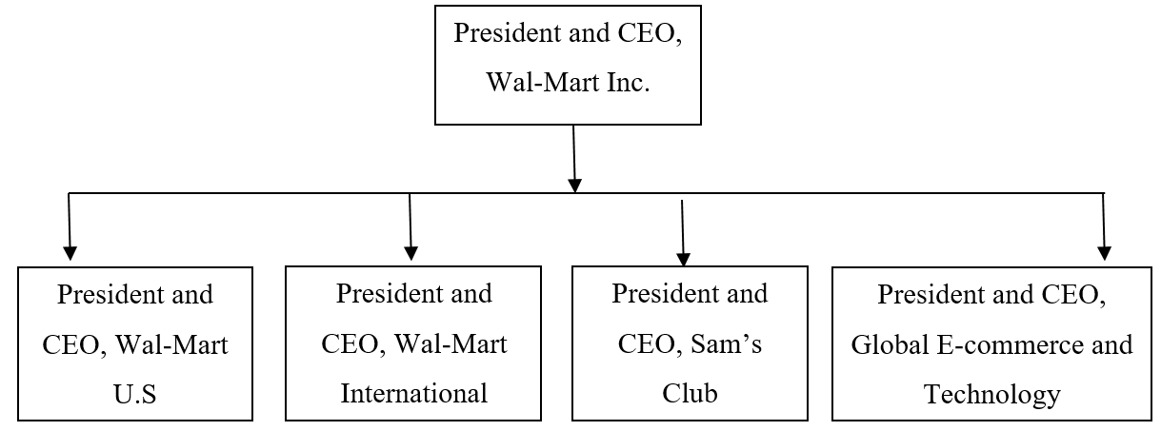
Figure 1: Divisional Structure of Wal-Mart (Stock.walmart.com, 2019)
1c) Functional Structure:
To integrate employees within the organization, structure plays one of the vital roles to increase productivity, loyalty, and satisfaction (Fatehi, 1996). Since the company maintains divisional hierarchical structure at the top level, new strategies come accordingly leading the organization within a good span of control and command.
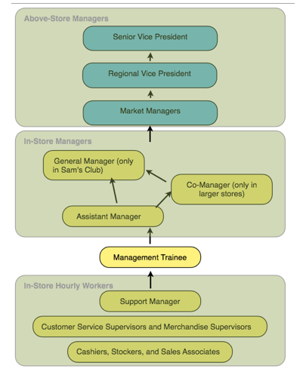
Figure 2: Functional level structure of Wal-Mart Inc. (Corporate - the US, 2019)
On the other hand, at the operational level, task and controls are disseminated to get the best outcome from the specialized employees in that particular function. These delegation process starts from the regional managers to store and assistant managers which ends up to the staff members of that particular function. Since the communication becomes frequent, sometimes it takes a long time to get feedback from the task for having a lot of phases in functional phases. Besides, the delegation structure in operational level gives flexibility to subordinates to think in their own way, use their potential to the best-suited position and get satisfaction from their core activity.

2. Culture
Wal-Mart possesses a good culture in its business environment. The organizational structure gets its appropriate shape when a proper culture for the organization is adopted (Hiriyappa, 2011). Generally, culture defines the common code of conduct, attitude, norms and inherent values in an organization through which the organizational structure and hierarchy are operated in a sound manner.

2a) Cultural factors in Wal-Mart:
Wal-Mart includes four core cultural aptitudes that are giving the best service to customers, showing respect for individuals, striving for the excellence of the company and taking action with the utmost integrity (McGee, 2018). Since the company maintains a delegated structure where employees can think and talk about their potential ideas, Wal-Marts culture gets the shape of being innovative, independent and more satisfactory for the employees. The explicit artifacts in the company include MSP (My Sustainability Plan) focusing on the green planet, sound life and making “My life plan” (developing skills, utilizing time and money, enjoying life) (Stock.walmart.com, 2019). Grassroot Employee-opinion survey in Wal-Mart is the MBO (Management by Objective) process of getting employee opinion about the line managers for ensuring the satisfaction of the workers that is another explicit culture in the organization.

2b) Challenges:
Wal-Mart has some challenges in maintaining the good culture within the organization when conflict arises between associates and management about the organizational goals. For example, when a store- manager achieves profit goal against the morale, he/she may get fired from the organization. To overcome this dilemma, management should give proper training to the employees to give a clear view of the goals and objectives of the company. Since the company possesses a culture of making a minimum profit with the best customer service and the market share, employees should focus on the implementation of policies rather than doing much for the economic front.
2c) Analysing the Hofstede’s cultural dimension factors

Culture – Hofstede – Comparison with the US
Dimensions | Wal-Mart | US | Explanations
- Power-distance | 35/100 | 40/100 | Wal-Mart practices a low power distance where managers listen to his subordinates being a resourceful democrat.
- Uncertainty avoidance (Risk-taking) | 40/100 | 46/100 | Wal-Mart has to undertake uncertain events because it needs to compete with global brands on a regular basis.
- Individual-Collective | 45/100 | 91/100 | Individualism is practiced in the organization since employees are given the best room to prove and develop themselves.
- Masculine-Feminine | 55/100 | 62/100 | Wal-Mart believes that the roles are overlapping. That means any kinds of job can be performed by both male and female.
- Short term vs Long term | 60/100 | 26/100 | From a long-term perspective, Wal-Mart emerged as an organization with the goal of being the leading super chain retail across the world.
Figure: Hofstede’s Cultural Dimensions (Hofstede, 1991)

3. People
The management has to deal with the people of the organization because they ultimately products the products and contribute to the organization by adding values. Here, the main responsibility of the management is to recruit the most skilled people in the organization and hold them in such a way that they work for the organization with true dedication and effort. If the culture of Wal-Mart is distinguished in the view of Hofstede’s cultural dimensions, it will be revealed that the organization uses polychronic-future oriented culture that is more people-focused and flexible in the control system thinking about the long term objectives. The company is more of co-operative rather than competitive since the company merely thinks about the differentiation rather emphasize on the cost reduction process. The culture inhibits responsiveness towards customer, society, and employees to get the organizational goal achieved.
The cultural dimension turned in the failure in Germany for different cross-cultural diversities. The smiling policy of employees imposed in the Wal-Mart culture became the hindrance to operate its business in Germany as the nation denies smiling with strangers. Besides, using poly bags in green countries like Germany created cultural difference and made difficulties to operate the business outside its origin arena (Clark, 2019).

3a) HR Function:
The main role of the Human Resource function is to engage the employees in the organization and provide the proper facilities and supports so that they perform their functions properly. In simple words, the organization is the coordination of the elements such as manpower, machine, capital, and land in a management process (Stock.walmart.com, 2019). The company managers practice participative value-based leadership strategy where subordinated are best treated with humane. For example, open-door policy in Wal-Mart indicates the humane atmosphere in the organization where any difficulties regarding organizational tasks, proper right issues, and others are handled with great concern and communication with the employees take place frequently.

4. Organizational Performance
The performance of the organization is dependent on implementing an appropriate strategy by considering its overall impacts. The organizational performance will ensure only when all other factors in the organization such as organizational culture, structure, and people are properly implemented. So, here the role of the management is to identify the most appropriate strategy so that it can increase the organizational performance and success. To implement the participative leadership strategy, organizational executives need to be prepared with five personality traits (Hofstede, 1991). Openness to learning new things, conscientiousness, and extraversion with the other people, agreeable being kind and trustworthy and neuroticism are the traits to implement a good participative leadership in the organization. With the help of a functional delegated structure and culture where employees can participate in their views and thoughts, decision making becomes fluent and appropriate in a supportive manner of employee satisfaction and loyalty in Wal-Mart. It serves the best output of employees, improves employee quality and skills. Moreover, overall organizational performance finds the stepping stone to touch its peak.
After analysing SWOT for Wal-Mart, it is revealed that worldwide brand name, the achievement of economies of scale and usage of an advanced technological information system to place order, tracking order and customer delivery point detection are the strengths for the organization. On the other hand, employee turnover and low-quality product deliver are two of the weaknesses of the organization. Wal-Mart has the opportunity to expand its operation in developing countries with western goods and can include more organic products to make life healthier. At the same time, it faces the threat of other competitive organizations such as ALDI, Amazon and many others. Rising commodity prices may hinder the ultimate value or goal of the organization with cost leadership strategy which is another threat for the entire firm.

3b) Rewards system:
Wal-Mart treats its manpower as the prime asset of the company while customer satisfaction is another choice to serve accordingly. Individuals within the organization are given motivation financially or implicitly (Kotter, 2014). The extrinsic rewards include discount cards of Wal-Mart provided to the employees where ten percent discount on the daily products are offered after three months’ probation period of new employees. It also gives employees a profit-sharing facility on the performance exceeding the expected range. The company announced $200 million of cash bonuses on performance in 2015 as part of the profit-sharing policy (Strategic Management Of Walmart, 2018). Employees also have the stock purchase option as part of the extrinsic motivation to the individuals of the company.
The intrinsic reward is achieved by the individuals since the company delegate its functional authority to individuals and they can realize themselves as part of the company. Individuals get satisfaction from their assigned work and the smooth environment with a participative leadership strategy makes them feel comfortable in the organization. But the unequal wages within the firm creates unsatisfactory situation while unpaid overtime and discriminated promotion lead the employee turnover excessive for several years. For more betterment of the firm, the hygiene factors stated in Frederick Herzberg’s theory should be maintained strictly so that the employees cannot face dissatisfaction. Customers are served with the motto of living a better life by saving money which integrates the whole performance of the firm in a good point. A functional structure in the operational level along with the smooth culture of employee and customer concentration gives the best positioning of the company while the value-based custom leads Wal-Mart to achieve its excellence worldwide. Thus the management strategy and leadership skills combined the whole company like a chain of success nationally and globally.

Conclusion
Organizational success mostly depends on the structure and culture which retains the manpower of the company or lose those assets for malpractice of the culture and leadership. Wal-Mart creates an environment with a good span of control which is decentralized in the operational level and optimizes the corporate structure with the application of cultural dimensions throughout the organization. Apart from all those facilities and considerations towards employees, the turnover rate increased due to the unfair promotion, unequal salaries and wages, unpaid overtime schedules and so on. Since the company maintains a cost leadership strategy, customers sometimes get dissatisfied with the low-quality product with less differentiation. At the same time, more retail chained business is intruding in the global market which is the prime threat unless the improvement in the quality and services of the organization take place to sustain in the same position. Wal-Mart management team needs to consider all these cultural and behavioural factors so that it holds the position of being the largest business and revenue-generating organization in the world.

References
Clark, A. (2019). Wal-Mart pulls out of Germany. [online] the Guardian. Available at: https://www.theguardian.com/business/2006/jul/28/retail.money [Accessed 21 Jul. 2019].
Corporate - US. (2019). Leadership. [online] Available at: https://corporate.walmart.com/our-story/leadership [Accessed 21 Jul. 2019].
Fatehi, K., 1996. International management: A cross-cultural and functional perspective. Prentice-Hall.
Hiriyappa, B. (2011). Organizational behavior. New Delhi: New Age International.
Hofstede, G., 1991. Cultural constraints in management theories. Academy of Management Perspectives, 7(1), pp.81-94.
Kotter, J. (2014). Corporate culture and performance. [Place of publication not identified]: Free Press.
McGee, R. (2018). How Large is Walmart? A Comparison of Walmart Sales to Nationss GDP. SSRN Electronic Journal.
Schein, E. (2015). Organizational culture and leadership.
Stock.walmart.com. (2019). Walmart Investor Relations - Investors - Business & Strategy. [online] Available at: https://stock.walmart.com/investors/our-strategy/ [Accessed 21 Jul. 2019].
Strategic Management Of Walmart. (2018). Research Journal of Social Sciences.

