

Programme: Master of Business Administration
Module name: Marketing Management
Module code: LCMB7024
Assignment Title:
Assessment component 1: Marketing Environment Analysis for Pioneers & Followers

Lecturer name:
Dr Tola Odugbsesan

Student name:
Pew Peakhom
Student ID:
2433833

Term 1
Submission date:
26-03-2026

Table of Contents
1. Introduction 3
2. Industry and Organisational Overview 4
2.1 EV Industry Overview 4
2.2 Pioneer: Tesla 5
2.3 Follower: Ford 6
2.4 Comparison table of Tesla and Ford 7
3. Task 1: Macro-Marketing Environmental Analysis 8
3.1 Macro Factor 1: Technological Environment 8
3.1.1 Nature of Technological Change 8
3.1.2 Political and Regulatory Environment 8
3.1.3 Economic Environment 9
3.1.4 Environmental Environment 9
3.1.5 Impact on Tesla 9
3.1.6 Impact on Ford 10
3.2 Competitive Position Synthesis 10
4. Task 2: Strategic Responses & Competitive Evaluation 10
4.1 Porter’s Generic Strategies Analysis 11
4.2.1 Tesla 11
4.2.2 Ford 12
4.3 Ansoff’s Growth Matrix Evaluation 13
4.3.1 Tesla 13
4.3.2 Ford 13
4.3.3 Risk and Growth Sustainability 14
5. Comparative Strategic Discussion 14
6. Conclusion 14
Reference list 15

1. Introduction
Strategic marketing management is all about helping the organization develop a unique identity in the market, grow its businesses geographically and serve the customers better than the competitors. However, the EV business is a new type of automotive manufacturing (Liu, Boothman and Graham, 2025).
Strategic marketing management consists of planning, executing, and controlling a companies' marketing strategies through determining how the company will achieve its business objectives and goals, while at the same time dealing with the external environment's influence on their business objectives (Akinsooto, Ogunnowo and Ezeanochie, 2025).
The theory of first-mover advantage suggests that a company who is among the first to enter a new or emerging market may gain a significant advantage over its competitors by building customer loyalty to its brand and creating costs for switching to another company from theirs. There is a dynamic between pioneering companies and those that come later into a market after they have established themselves as market leaders (such as Tesla). Companies that enter the same market after a pioneer may be taught by the experiences of the pioneers how to compete effectively against the pioneer (Akinsooto, Ogunnowo and Ezeanochie, 2025).
The report’s objectives align with the learning outcomes of this module regarding the ability to critically review the marketing activities occurring within the EV sector.

2. Industry and Organisational Overview

2.1 EV Industry Overview
Pelegov, Chanaron, and Chanaron (2022) reported that electric cars provide consumers with a cleaner option for getting around, and they are becoming increasingly popular. Nearly 6.6 million electric cars were sold worldwide in 2021, which equates to roughly 9% of total worldwide car sales.
Furthermore, electric vehicle (EV) sales growth has exploded globally from 2020 through 2025, ballooning from roughly 3 million transactions to a projected roughly 20.7 million between now and then. Additionally, according to the International Energy Agency, worldwide electric car sales are expected to be approximately 17 million for all of 2024, demonstrating a year-over-year growth of over 25%, with just the growth of an additional 3.5 million sales through one calendar year in 2024 alone exceeding the total number of electric cars sold throughout the entire Year 2020 (IEA, 2025). The question is whether this trend can continue due to declining consumer demand, interest rates rising, and government subsidies being decreased or removed (particularly in Germany and the U.K.).
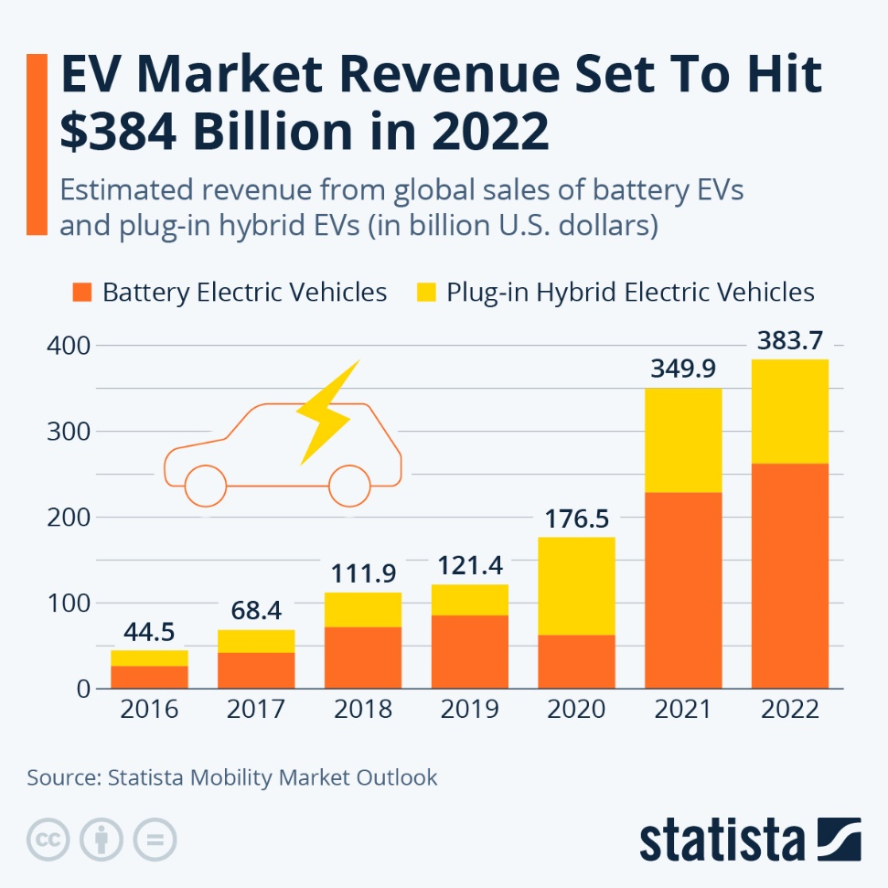
Figure 1: EV market revenue
(Source: Fleck, 2022)
Moreover, Fleck (2022) stated that global electric vehicle sales are projected to reach $384 billion in 2022. The growth of the electric vehicle (EV) market has been remarkable even during the COVID-19 pandemic and the resulting supply chain challenges. While raw material prices have moderated, geopolitical tensions and supply chain vulnerabilities continue threatening production costs, suggesting EV profitability may remain volatile rather than following predictable improvement curves.

2.2 Pioneer: Tesla
Tesla began in 2003, becoming the first company in the world to develop an EV-only business model and manufacture only electric vehicles (Tesla, 2025). Tesla has utilized vertical integration to improve its competitive advantage by controlling the manufacturing process of batteries; building its own software systems; and establishing a proprietary Supercharger network. Figure 2 represents that 2024 $94.82 Billion USD (Companies Market Cap, 2023).
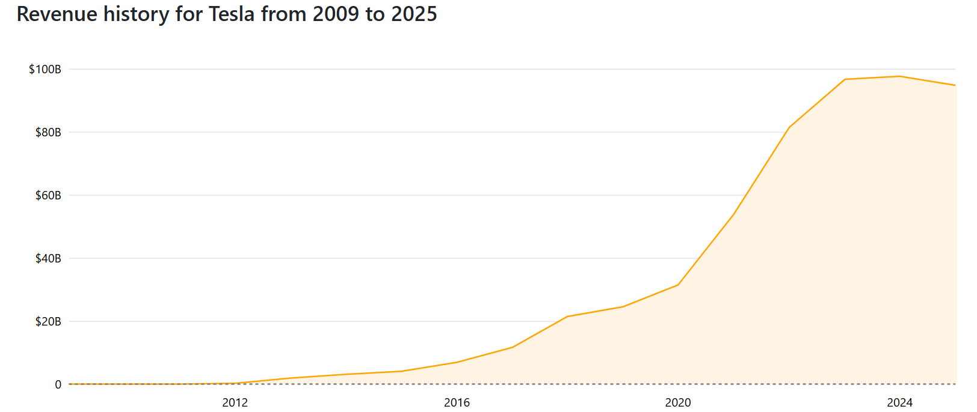
Figure 2: Revenue history of Tesla
(Source: Companies Market Cap, 2023)

2.3 Follower: Ford
Greenfield (2024) reported that founded 1903, Ford is a legacy ICE manufacturer entering EVs later than pioneers. The company pursues a hybrid strategy, bridging internal combustion and electric transition through electrification of existing models like the F-150 Lightning and Mustang Mach-E (News, 2025). The major tension is whether Ford can close the cost gap between its legacy manufacturing systems and those of the pure plays in the EV segment while managing the complexities involved in the production of a dual engine vehicle. Ford maintains traditional dealer-based distribution while adapting to new technology. Revenue of Ford in 2024 was $184.99 Billion USD (Companies Market Cap, 2024).

2.4 Comparison table of Tesla and Ford
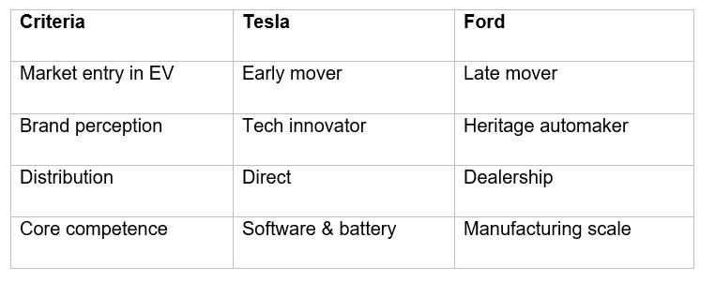
Figure 3: Comparison
(Source: Self-developed)
Figure 3 compares Ford and Tesla on the dimensions of market entry, brand perception, distribution and core competence indicates Tesla leverages its innovative focus to create differentiation, whereas Ford uses its size and scale to primarily pursue a cost leadership strategy, according to Porter’s theory. Figure 4 shows Tesla generates higher revenue per vehicle than Ford, indicating a differentiation-based pricing strategy (Stock dividend screener, 2025).
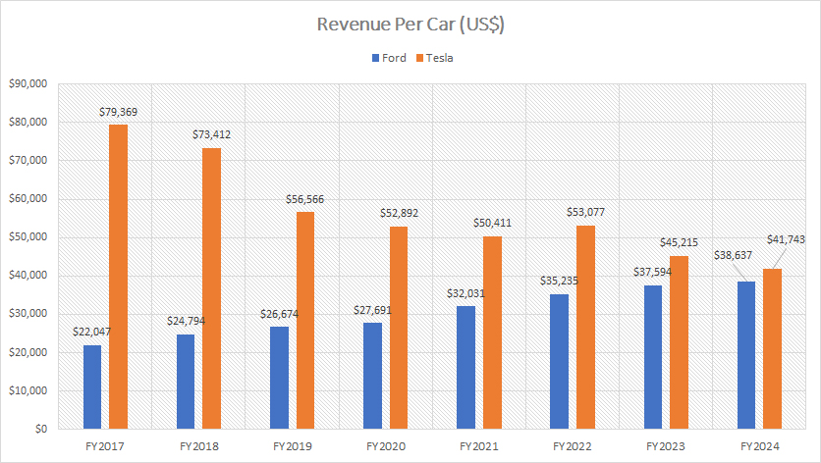
Figure 4: Revenue Per Car
(Source: Stock dividend screener, 2025)

3. Task 1: Macro-Marketing Environmental Analysis

3.1 Macro Factor 1: Technological Environment

3.1.1 Nature of Technological Change
The fast pace of development in EV technology is changing the competitive landscape. Innovations are rapidly evolving in battery technologies, and lithium iron phosphate (LFP) batteries now account for about 70% of the passenger EV market in China. Solid-state battery technologies are approaching commercialisation, with mass production planned for 2026 and a global shipment of approximately 50 GWh, including notable products such as CATL's 500 Wh/kg batteries and Toyota's applications of sulfide electrolyte technologies. The continued growth of investment in autonomous driving technology is supported by substantial investments such as Wayve’s recent $1.2 billion financing and Nicolet’s Alpamayo platform which is leveraging generative artificial intelligence to compete with Tesla’s Full Self-Driving platform for virtual training environments. Additionally, the use of over-the-air (OTA) software updates has now become commonplace with approximately 40% of all vehicles receiving OTA software updates at this time. There is also a significant change in the automotive sales channel model due to the rise of digital retailing and it is projected that the automotive digital dealership market will reach $6.43 billion by 2032.

3.1.2 Political and Regulatory Environment
Government action influences market conditions in many different ways. The Inflation Reduction Act of 2022 offers significant consumer tax rebates for qualified expenditures for electric vehicles up to $7,500 but imposes strict battery sourcing requirements to help support and foster domestic battery manufacturers. The Dual-Credits system in China is used to penalise the manufacturers who do not achieve their production quotas for electric vehicles while rewarding domestic manufacturers to innovate faster. European Union (EU) proposed Euro 7 standards as well as the planned phase-out of internal combustion engine vehicles by 2035, provides a level of long-term certainty for investments in electric vehicle development. However, geopolitical tensions have prompted tariff escalations: the US imposed 100% tariffs on Chinese EVs, whilst the EU introduced provisional tariffs up to 38% on Chinese imports.

3.1.3 Economic Environment
All macroeconomic factors produce high uncertainty related to EVs, as the cost of consumer financing and manufacturer capital expenditures will be affected by fluctuations in interest rates. The volatility of lithium prices from 2021 to present, which have varied from $15,000-$80,000 ton, have further complicated the forecasting of production costs and margin opportunities.

3.1.4 Environmental Environment
Globally, more regulations are being issued regarding becoming carbon neutral. Each regulation continues to mandate GHG emissions reductions. Countries are also establishing stricter CO2 targets, with 15 countries announcing all ICE vehicles will phase out by 2035.

3.1.5 Impact on Tesla
Tesla's technological positioning represents some unique opportunities. The company's significant advantage from being a first-mover in terms of its software ecosystem continues to be quite significant due to its FSD system becoming available only through subscription models. Additionally, monetization of the Supercharger network has expanded through third-party access and with the "Magic Dock" being installed at European stations, it can now be considered as one of the de facto standards across multiple brands. Furthermore, Tesla has evolved its brand from being purely about automotive products to developing a broader AI and robotics platform. With energy storage installs projected to be at 46.7GWh by 2025, this represents the highest growth segment within the company.
On the other, the threats to Tesla are increasing. Rapid competition is beginning to emerge over the next several years, with many competitors losing valuable time to develop their technologies and use Nvidia's Alpamayo platform, thus possibly commoditizing autonomous driving technologies in the foreseeable future. Increased scrutiny around software regulation makes the risk of regulations more pronounced along with the inability to complete delivery of products on time and providing post-delivery fixes which led to a completion of recalls for more than 11,000 vehicles. The high cost of innovation has become burdensome, with Tesla's operating margins projected to be at 5.8% by 2025, and the company will maintain a sizable investment in research and development.

3.1.6 Impact on Ford
The macro-environmental conditions provide Ford with both significant possibilities and obvious challenges. On the positive side, Ford is in a position to take advantage of established battery technologies because of the rapid growth of the globally installed capacity for EV batteries (an increase of more than 35% over the next several years) (E-mobility, 2025). The continued growth of EV batteries will require exponential growth in the amount of EV batteries manufactured and supplied to customers around the world. Additionally, strategic partnerships with battery manufacturers, such as the lessened size of Ford's partnership with CATL regarding LFP batteries, enable Ford to reduce its technological gap as well as mitigate supply chain risk (E-mobility, 2025).
Furthermore, Ford also has many of its own production-related issues associated with its software and EV technology, as well as competition, especially when compared to other companies focused on software solutions. In addition, Ford has also experienced a lot of organizational inertia that has hindered its ability to successfully transition to the EV market.

3.2 Competitive Position Synthesis
The macro environment helped to reinforce Tesla's market dominance through technology trends that favour a new class of electric vehicles called software-defined EVs. At the same time, Ford has been using a hybrid strategy based on its long history of internal combustion engine (ICE) vehicles to catch up with Tesla. Being the first mover in the software-defined EV market continues to give Tesla an advantage over its competitors.

4. Task 2: Strategic Responses & Competitive Evaluation
It mainly focuses on macro forces, then strategic response, implies competitive advantage.

4.1 Porter’s Generic Strategies Analysis

4.2.1 Tesla
Tesla has based its generic strategy on four pillars of differentiation. One major advantage is the software-based ecosystem created by 12 billion (7.5 billion miles) of driving data from Full Self-Driving (Supervised) globally. However, Porter warns that differentiation must be sustainable, competitors using synthetic data generation may neutralize Tesla's real-data advantage without matching its scale. Another major advantage is that Tesla has positioned itself as an innovator in the marketplace and continues to present a premium-based perception even with a simplified product line; the use of a minimalist SKU is a deliberate decision for the company, as new model launches are seen as "pseudo-demand" and distract from the development of innovation. As mentioned above, monetization of the Supercharger network is a third major differentiating element that will provide owners of Tesla vehicles a unique ownership experience.
From a pricing perspective, it appears that Tesla is moving towards becoming a cost leader. As an example, in 2023-2024 Tesla has reduced the cost of the Model 3 by as much as 15%, which is the most aggressive price reduction of all time for the Model 3 in its most significant markets, as Tesla will prioritize volume over quality. According to Elon Musk, “it does make sense to sacrifice a margin to create a greater number of vehicles” (Crownhart, 2026). A stark contrast with the profitability as net profit margin decreased from 11% in 2023's 3rd quarter to 5.8% in 2024's 3rd quarter-a 47% decline from 11%-while this depreciation still exceeds 3.9% designated for Volkswagen (Wedbush, 2026).
The hybrid strategies produced from the combination of premium-based differentiation and aggressive pricing have increased margin pressure significantly, which have grown to at least $20 billion per year related AI chips, dogo supercomputing, and robotics as necessary elements in order to enable business model differentiation (OECD, 2025). Tesla has now formally announced that they are an "AI, robots, energy-based technology company" rather than being classified solely as an electric vehicle manufacturer.

4.2.2 Ford
Ford adopts a hybrid strategy that combines scale-based cost efficiency with specialized differentiation, focusing on electric trucks as an area of specialization. By 2027, Fordaims to be exceptional from its competitors by developing mid-size electric pickups costing USD 30,000 through the use of structural lithium-iron-phosphate (LFP) batteries and giga casting technology. Porter would classify this as focused differentiation within the truck segment rather than true hybrid strategy, avoiding some "stuck in the middle" risks. Ford's ambition is to lead the market in terms of the cost of EV pickups, i.e., to "help rapidly increase the purchase of EV pickups in a manner not previously done." Additionally, because Ford's F-Series trucks have been the best-selling trucks in the U.S. for the past 40 years, Ford's competitive advantage as a result of its size continues to be significant due to its production scale and leverage with suppliers that newer entrants to this market lack (Central Desk, 2026).
Moreover, an important question arises about whether Ford’s traditional structure can compete against all electric vehicle (EV) manufacturers when evaluating Ford’s legacy. Ford has taken immediate and decisive measures by reorganizing into two separate business units: “Ford Model e” (for EVs) and “Ford Blue” (combustion engines). This structural separation should provide “start-up speed and unrestrained innovation.” Thus far, progress is being made in controlling costs—Ford anticipates that it can achieve approximately $1 billion in reductions for both material and warranty costs in 2026, which will offset the impacts of tariffs and rising input costs (Ding and Liu, 2023). However, EV impairment costs remain extremely high at $5.5 billion in 2026 and 2027, and transitioning into the energy storage business will have an expected cost of approximately $2 billion (Rezaei et al., 2025).
Ford has drastically cut back on entry-level models like the Fiesta, Focus, and Fusion in order to offer more higher-priced SUV or truck options; as a result, dealerships are now experiencing volatility in pricing due to loss of entry-level consumers who were looking for "a simple, dependable car to drive." The orders for the small Maverick pickups (at $20K-$30K) continue to exceed supply amounts because there is still strong demand for affordable Fords (Mangram, 2012).

4.3 Ansoff’s Growth Matrix Evaluation
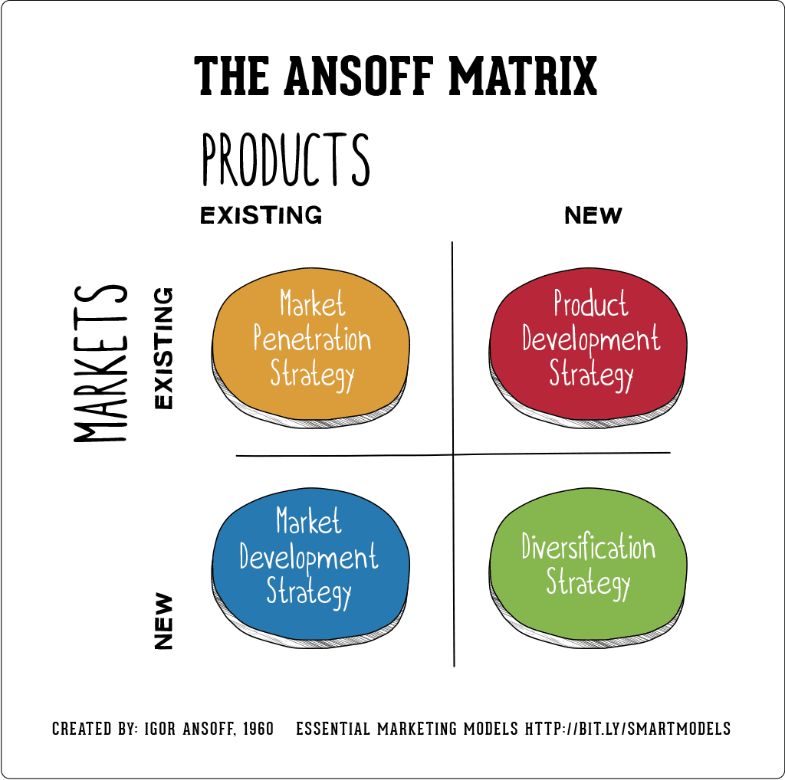
Figure 5: Ansoff matrix
(Source: Hanlon, 2021)

4.3.1 Tesla
Tesla has pursued an aggressive market penetration strategy (refer to Figure 4) using frequent price reductions to increase sales volume and hold onto their market shares in a highly competitive electric vehicle (EV) market. When looking at Tesla’s product development, it can be seen in the launch of the new Cybertruck and ongoing autonomous upgrades driven by artificial intelligence (AI), as well as an emphasis on technological differentiation (Garikapati and Shetiya, 2024). The critical question is whether Tesla over-diversifies into AI and robotics, stretching resources beyond core automotive competency. Also, through expanding into China and Europe (two high-growth regions for EVs), Tesla continues to pursue market development.

4.3.2 Ford
Ford uses a product development strategy by electrifying their legendary vehicles (Mustang and F-150) using their pre-existing brand equity to develop their vehicle line up. This low-risk approach assumes brand loyalty transfers to EVs, an assumption weakening as younger consumers prefer new EV-native brands. Ford's market penetration strategy is primarily based on trying to convert their existing large customer base to EVs (Balawardhana, 2020).

4.3.3 Risk and Growth Sustainability
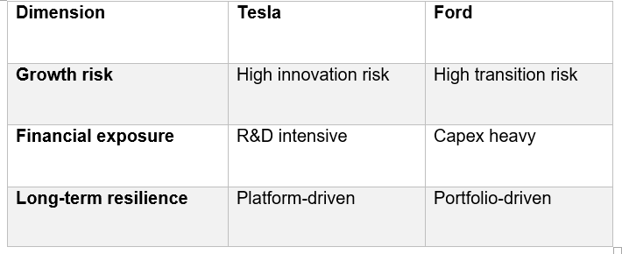
Figure 6: Risk and growth
(Source: Self-developed)

5. Comparative Strategic Discussion
As the EV market is undergoing a price war and battery commodity pricing begins to cannibalise innovation premium(s), it is clear that Tesla's software ecosystem represents the technological leadership of electric-battery vehicles, due to their history of considerable investments in artificial intelligence technology. However, this shift to a price leadership model (rather than differentiation) will put pressure on Tesla to continue reducing their margin(s) on their electric vehicles (Balawardhana, 2020). Conversely, Ford has taken a focused differentiation strategy to leverage its scale to produce cost-effective new lines of electric trucks that meet customers’ demands. However, due to Ford's legacy manufacturing costs and the dealer network, Ford's ability to compete with Tesla has been limited.

6. Conclusion
In conclusion, the hybrid strategy of Ford's brand and manufacturing size utilizes the historical importance of the Ford brand as well as using Ford's large manufacturing capabilities; however, Ford's lack of capability to address structural issues creates problems as well. Ultimately, Tesla's software ecosystem advantage pressures traditional manufacturers, who must transform fundamentally or face obsolescence as electric revolution accelerates.

Reference list
Akinsooto, O., Ogunnowo, E.O. and Ezeanochie, C.C. (2025). The Future of Electric Vehicles: Technological Innovations and Market Trends. Engineering and Technology Journal, 10(04). doi: https://doi.org/10.47191/etj/v10i04.04.
Balawardhana, M. (2020). Marketing and Digital Future - Ford Motor Company. [online] ResearchGate. Available at: https://www.researchgate.net/publication/345228131_Marketing_and_Digital_Future_-_Ford_Motor_Company [Accessed 28 Feb. 2026].
Central Desk (2026). How Ford F-Series Became the Most Dominant Vehicle Line. [online] Auto World Journal | Feel The Responsible Auto Industry News. Available at: https://autoworldjournal.com/how-ford-f-series-became-the-most-dominant/ [Accessed 28 Feb. 2026].
Companies Market Cap (2023). Tesla (TSLA) - Revenue. [online] companiesmarketcap.com. Available at: https://companiesmarketcap.com/tesla/revenue/ [Accessed 28 Feb. 2026].
Companies Market Cap (2024). Ford (F) - Revenue. [online] Companiesmarketcap.com. Available at: https://companiesmarketcap.com/ford/revenue/#google_vignette [Accessed 28 Feb. 2026].
Crownhart, C. (2026). What’s next for EV batteries in 2026. [online] MIT Technology Review. Available at: https://www.technologyreview.com/2026/02/02/1132042/whats-next-for-ev-batteries-in-2026/ [Accessed 28 Feb. 2026].
Ding, Y. and Liu, Y. (2023). The Impact of tariff increase on export and employment of Chinese firms. China Economic Quarterly International, [online] 3(3), pp.155–166. doi: https://doi.org/10.1016/j.ceqi.2023.08.002.
E-mobility (2025). EV Battery Installations Climb 35% as Market Shares Shift - Battery-Tech Network. [online] Battery-Tech Network. Available at: https://battery-tech.net/battery-markets-news/ev-battery-installations-climb-35-as-market-shares-shift/ [Accessed 28 Feb. 2026].
Fleck, A. (2022). Infographic: EV Market Revenue Set To Hit $384 Billion in 2022. [online] Statista Daily Data. Available at: https://www.statista.com/chart/28211/electric-vehicles-revenue-projections/?srsltid=AfmBOopUDStB1x082AEbfuQL7AmapOKYdtMca21-XQlT7x0IX56iM69o [Accessed 28 Feb. 2026].
Garikapati, D. and Shetiya, S.S. (2024). Autonomous Vehicles: Evolution of Artificial Intelligence and the Current Industry Landscape. Big Data and Cognitive Computing, 8(4), p.42.
Greenfield, S. (2024). Legacy automakers struggle with EV transition, hybrids offer profitability amid uncertainty. [online] CBT News. Available at: https://www.cbtnews.com/legacy-automakers-struggle-with-ev-transition-hybrids-offer-profitability-amid-uncertainty/ [Accessed 28 Feb. 2026].
Hanlon, A. (2021). The Ansoff Model. [online] Smart Insights. Available at: https://www.smartinsights.com/marketing-planning/create-a-marketing-plan/ansoff-model/ [Accessed 28 Feb. 2026].
Hayden, D. (2025). PESTLE analysis. [online] CIPD. Available at: https://www.cipd.org/en/knowledge/factsheets/pestle-analysis-factsheet/ [Accessed 28 Feb. 2026].
IEA (2025). Trends in electric car markets – Global EV Outlook 2025. [online] IEA. Available at: https://www.iea.org/reports/global-ev-outlook-2025/trends-in-electric-car-markets-2 [Accessed 28 Feb. 2026].
Liu, C.C., Boothman, S.G. and Graham, J.D. (2025). The Rise and Recent Decline of Tesla’s Share of the U.S. Electric Vehicle Market. World Electric Vehicle Journal, [online] 16(2), pp.90–90. doi: https://doi.org/10.3390/wevj16020090.
Mangram, M. (2012). The globalization of Tesla Motors: A strategic marketing plan analysis. [online] ResearchGate. Available at: https://www.researchgate.net/publication/254322834_The_globalization_of_Tesla_Motors_A_strategic_marketing_plan_analysis [Accessed 28 Feb. 2026].
News, C. (2025). Ford reports record revenue and increases focus on core operations. [online] CBT News. Available at: https://www.cbtnews.com/ford-reports-record-revenue-and-increases-focus-on-core-operations/ [Accessed 28 Feb. 2026].
OECD (2025). The Adoption of Artificial Intelligence in Firms New Evidence for Policymaking. [online] Available at: https://www.oecd.org/content/dam/oecd/en/publications/reports/2025/05/the-adoption-of-artificial-intelligence-in-firms_8fab986b/f9ef33c3-en.pdf [Accessed 28 Feb. 2026].
Pelegov, D.V. and Chanaron, J.-J. (2022). Electric Car Market Analysis Using Open Data: Sales, Volatility Assessment, and Forecasting. Sustainability, 15(1), p.399. doi: https://doi.org/10.3390/su15010399.
Rezaei, M., Nekahi, A., Feyzi, E., M R, A.K., Nanda, J. and Zaghib, K. (2025). Advancing the circular economy by driving sustainable urban mining of end-of-life batteries and technological advancements. Energy Storage Materials, [online] 75, p.104035. doi: https://doi.org/10.1016/j.ensm.2025.104035.
Stock dividend screener (2025). Ford Vs Tesla – Sales, Pricing, Cash, Debt And Margin | Fundamental Data And Statistics For Stocks. [online] stockdividendscreener.com. Available at: https://stockdividendscreener.com/auto-manufacturers/ford-vs-tesla-stock-in-margin-and-profitability/ [Accessed 28 Feb. 2026].
Tesla (2025). About Tesla. [online] Tesla.com. Available at: https://www.tesla.com/en_in/about [Accessed 28 Feb. 2026].
Wedbush (2026). The Musk Convergence: Tesla, the Creator Economy, and the High-Stakes Future of Autonomy. [online] Wedbush.com. Available at: https://investor.wedbush.com/wedbush/article/finterra-2026-1-28-the-musk-convergence-tesla-the-creator-economy-and-the-high-stakes-future-of-autonomy [Accessed 28 Feb. 2026].

