Lectures Name: Jinping Li
Module Name: Mandarin
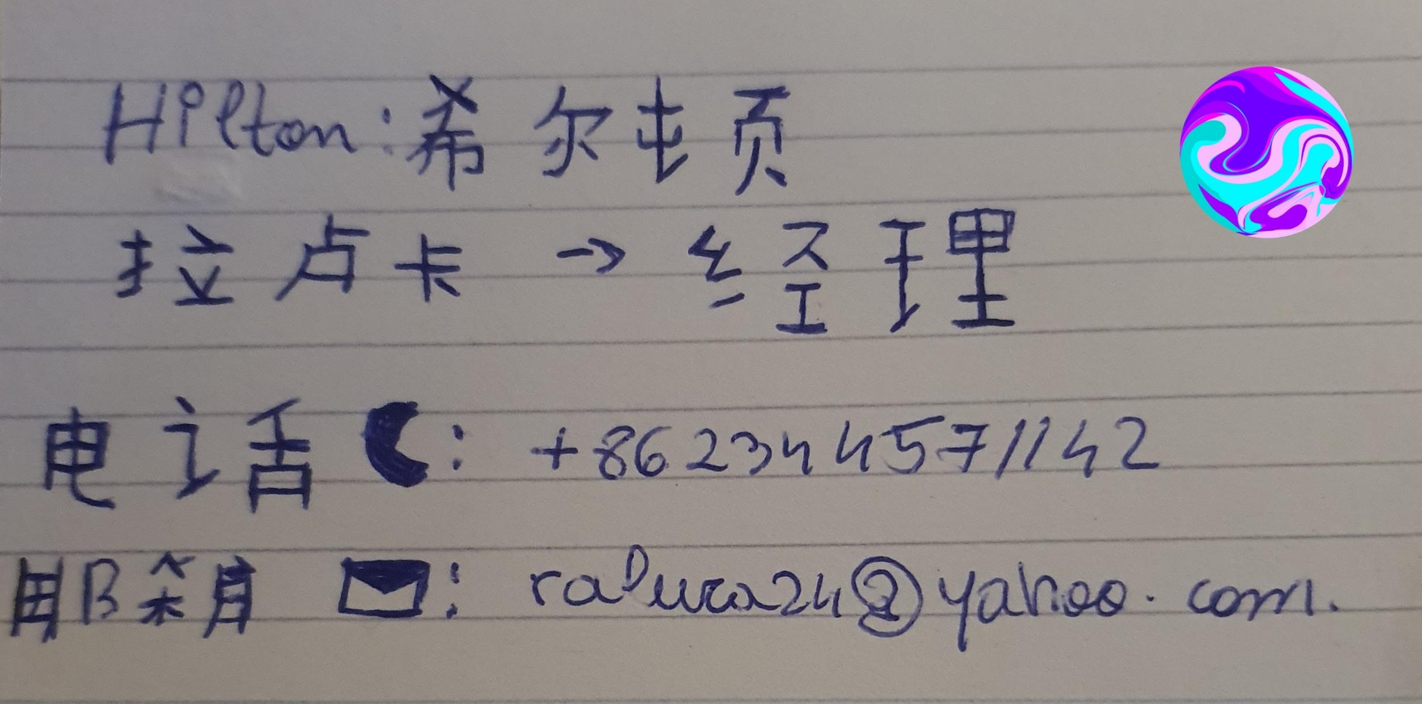
Student number: 2022597

My name is Raluca Suciu, I’m a student of International Hotel Management and I’m so excited because I have this opportunity to attend the Mandarin Class and I’m ready to learn more better at this. Today I submitting my first business card to Hong Kong Hilton Hotel.
Many Thanks Laluca!

