Reflective practice is a form of critical thinking which enables practitioners to provide children with a high standard of care, it allows you to look back at previous experiences and improve and develop them making them more beneficial for the children. Reflective thinking can develop your skills and understanding as a practitioner, to be a reflective practitioner you should always think about how you work and acknowledge your strengths and weaknesses (Early Years Careers, 2015). Reflective practice is seen as an important part as professional development, it also ensures that there is a high standard of provision at the setting (Bleach, J., No Date). Reflecting on work and experiences will help you to set targets and identify your personal and professional needs, this in turn creates improvements for your setting (Professional Association for Childcare and Early Years, 2016).
In this section I will be evaluating and comparing two different models of reflection considering the advantages and disadvantages of both and which is more effective in practice, Today I will be talking about the Gibbs Reflective Cycle and the Rolfe Model of reflection. The first comparison between both is that the Gibbs cycle appears to be much longer and more in depth that the Rolfe cycle, the Gibbs cycle consists of 6 parts while the Rolfe cycle only consists on 3, this could be difficult for teachers as there is already the added pressure of extra paperwork and observations a research report carried out by the department for education seen practitioners say that a continuing challenge in settings was time taken out for paperwork, they worried that this cut down in their interaction time with the children as there was no extra time to do it throughout the day meaning that it took time away from the children, teachers also said they found the extra paperwork very demanding (Brooker, L. Et.al, 2010). In comparison to the length of the Gibbs cycle Rolfe’s cycle is made up of three simple questions (University of Cumbria, 2016). Although the Gibbs cycle offers clear structure, which Rolfe does not, Gibbs has also been criticised for not enabling critical and reflective approaches in the format he provides meaning it does not offer the opportunity to move beyond practice restricting the ‘practice leads to change’ element of reflective thinking (Middleton, R., 2017). The Rolfe Model has not been under the same criticism. Gibbs also encourages practitioners to tale about their feelings in his model, Middleton, R., 2017 also suggests that talking about feelings in a reflective cycle could end up clouding the true learning that could possibly evolve from following a reflective process (Middleton, R., 2017). As a practitioner you also may not be confident talking about your feelings, this may encourage you to choose a different model to follow when thinking reflectively of your work. Simpler Cycles such as Rolfe’s have been criticised for not allowing a great depth of reflection due to the questions being very simple this can lead to little change in practice because you are not encouraged to reflect on your practice thoroughly enough for any changes to take place, The Gibbs cycle for example encourages you to think about your experience in a more in depth way enabling you to learn more from the reflective cycle as become a better practitioner and learn from previous experiences (Holistic HR, 2017). Some may say that Rolfe’s Cycle is to simple, but this may be a easier cycle to follow if you are new at reflective thinking or how trouble understanding other models. Due to Rolfe’s model being very simple, other people have also used the same questions as the base of their model, Borton’s reflective model came out in 1970 (Badell, J., 2020), The Driscoll adaptation od the model was then released in 1994 (Hampshire Online Learning, 2019), Meaning that Rolfe was the last person to adapt the model in 2001, In comparison to the Rofle model the Gibbs model is more original. The Gibbs model is more of a reactive approach rather that a proactive one, reactive means the cycle just encourages you to talk about what has happened but does not give you the tools to act proactively which is then doing something about a situation and not letting git rise again (Expert Program Management, 2020).

To summarise using reflective cycles in practice is very beneficial, they encourage you to do better and look at the way you work, leading to positive changes in early years settings. Not all reflective cycles suit one person, there are many model’s you can follow all with different ways of approaching reflection. Researching the different models is recommended in order to find the right model for you along with trial and error of what works and what does not work in your setting.

What is Reflective Practice?
In order to provide a high standard of care to children practitioners should be aware of the term Reflective Practice, it enables you to look back on previous activities and improve and develop them, making them more challenging for the children. To get the best results for children you should always think outside of the box, rather than just settling for what is easy, this will develop your understanding and skills as a practitioner (Early years careers, 2015). A reflective practitioner should always think about how they work, acknowledge their strengths and weaknesses, Consider the impact that your actions have on others, Identify and resolve problems, Review your methods to improve the quality of your practice and always be opening to listening and trying new things (Early years careers, 2015). To reflect on your work you could follow any reflective model, such as gibbs, this is what the Gibbs model looks like: 1. A description (What Happened?), 2. What are you thinking/Feeling?, 3. Evaluate (What was good and what was bad?), 4. Analyse (What sense can you make of the situation?), 5. Conclusion (What could you have done?). 6.Action Plan (if it arose again what could you do?). (University of Edinburgh, 2019).

History of Reflective Practice
Almost 100 years ago John Dewey formulated his idea of how we think in a book which used the same name, He speaks about many forms of thought which included imagination, belief and a stream of consciousness but the form he was the most interested in was reflection. He believed that reflection was a meaning making process which can move the learner from one experience to the next with a deeper understanding of its connections to other experiences, he believes his though makes continuity of learning possible, He believes it was a disciplined way of thinking which needed to happen with others and within communities he also believes that its required an attitude of someone who valued their personal and intellectual growth of oneself and others (Rodgers, 2002, p. 842-866).
Schon was a philosopher and professor who built on Dewey’s work and decided to link reflection more consistently to professional practice and professional development He believed that this theory was the knowledge that underpinned what practitioners do normally by instinct, this new understanding could help practitioners improve practice and become skilled at what they do. Donald Schon identified two different types of reflection these were reflection on action which is undertaken retrospectively, the second is reflection in action which is referred to as thinking on your feet, he believes that continually carrying out reflection on action can help practitioners to build upon previous experiences, The aim is for when an unexpected situation occurs in practice for the practitioner to respond quickly and with instinct in an appropriate manner (EdShare, 2020).
Why is it important?
Reflective practice alongside ongoing professional development for members of staff are deemed as crucial to ensuring high standards of provision in early years care (Bleach, J. No Date). Reflecting on your work will Support you to set targets, Help you focus on and take control of your practice, Enhance your skills whilst improving your motivation and confidence and help you identify your professional needs, This will in turn create improvements for your setting making you more resourceful, improving your reputation and encoring you to work in teams (Professional Association for Childcare and Early Years, 2016). Being reflective encourages us to become more self-aware of the nature and impact of our role, this awareness creates opportunity for professional and personal development (Play Wales, 2019). It is always helpful to remember that all children are different and learn at different paces, reflective practice can help you to look back and see where you can improve (Play Wales, 2018). Reflective practice can require us to be open-minded, responsible and considerate, these key values are identified by Dewey who is thought to be the founder of reflection, Reflective practice is not about criticising everything we do in a negative way or completely changing the way we do things but about seeking to provide the very best we can for the children in our care (Colwell, J. 2019). You can enhance your reflective practice and professional learning by collaboration and discussion with other colleagues, this way you can share knowledge, experience and expertise it can also help to solidify thoughts and develop new ideas (Colwell, j. 2019).

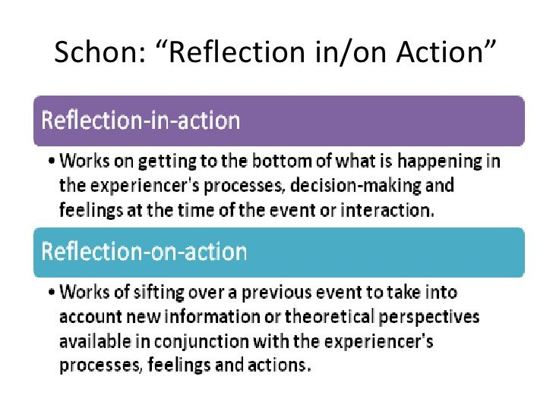
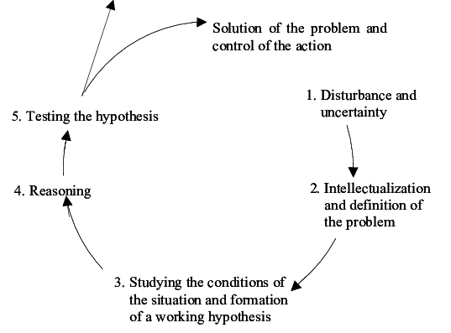
Reflective Models.
If you are considering using reflective models at your setting it is important that you find one that suits you. There are many to choose from all which have positives and negatives, here I will list a few with links available for you to use to conduct your own research.
- Gibbs Reflective Cycle - https://www.mmu.ac.uk/media/mmuacuk/content/documents/careers/Applying-the-Gibbs-Model-2018.pdf
- Rolph Reflective Cycle - https://my.cumbria.ac.uk/media/MyCumbria/Documents/ReflectiveModelRolfe.pdf
- Driscoll Reflective Cycle - https://www.nottingham.ac.uk/library/documents/academicskillstoolkit/reflective-writing-model-driscoll.pdf

Common Misconceptions
Along with some barriers there can often be some common misconceptions around reflective practice some people believe that thinking about what they have done will not directly affect their practice, this is incorrect as reflection is a cyclical process, you do, analyse, adapt and repeat, this will have a direct impact on the next activity you carry out, some people also believe that reflection takes to long and that they simply do not have the time, Schon believes in reflection-in-action, this is reflecting on things as they happen, and asking yourself the correct questions there and then. It can also be perceived that reflection is only focused on you, again this is not true as any reflection you do will encourage you to change and adapt your practice this will allow students to gain new skills and hopefully become stringer learners (Cambridge assessment International Education, 2020).
Barriers to Reflective Practice
The question can often be asked that is reflective practice is so beneficial why is it mot used more often?, well the answer would be that there can often be some barriers to reflective practice, this could include not having enough time or not being sure on where to start, making time to reflect on your work in important but it is equally important to have the right tools and know where to start (Professional Association for Childcare and early years, 2016). Reflective practice involves asking yourself some important questions, sometimes it can be hard to criticise yourself and admit things may need improving, this can deter people from using reflection in their practice, another barrier is just generally finding it hard, being critical of yourself can sometimes take practice and some time to get used to, not having the correct support can also be a barrier, for reflective practice to work effectively you need to be given the opportunity and support to help make improvements without this the whole process is pointless (Play Wales, 2018).

Schon Reflective Model.
Dewey’s Reflective Cycle. (ResearchGate, 2019).

Reflective Log.

Brief description of the activity (no more than 50 words) | The activity undertaken was a colour mixing activity using primary colour paints, the activity was undertaken outside in a tuff tray using paintbrushes and the children’s hands.  Age range for the activity is ages 3-4.
Aim/Objective of the activity | -The aim of the activity is to teach children their primary colours which are yellow, red and blue.  -This also taught the Children what the different primary colours can make when mixed together.  -I encouraged the children to explore the texture of the paint using their hands and to mix the colours with a paintbrush.  -I Encouraged the children to share during the activity.  -I encouraged the children to use key language for the activity such as naming the colours, saying please and thank you when sharing and encouraging conversation between children.
Your role | My role was to Supervise the activity, encourage children to ask questions and be inquisitive.  I provided all the equipment needed for the activity to be successful, help the children where needed and encourage them to clean up the activity area and wash their hands once finished.
Positive aspects – why? How could these be developed further? | The positive aspects of the activity were how much the children enjoyed learning about colours they were smiling and laughing while mixing the colours together, the children also enjoyed getting messy. The children would often link the colours to things they had at home, for example one child told me that her mummy’s coat was red. The children enjoyed being able to mix these colours freely and use their hands to understand the texture better, the children also learned lots of new key words such as mix, light and dark. To develop this further you could move on to mixing secondary colours instead of primary, you could mix more than two colours, or add white or black to make colours lighter or darker. and introduce more complex colour names such as violet and indigo you could also introduce the words primary and secondary.
Challenging aspects – why? Link to your own practice. | Some challenging aspects of this activity were encouraging the children to share the paints and take it in turns with their friends.  I feel I may have also taken to much control of the setting up of the activity I feel I could have encouraged the children to help me rather that doing it on my own then calling the children out. Another challenge for myself was trying to supervise the activity while making observations of my key children for their Foundation Phase Profiles.
What knowledge did you demonstrate? | During this activity I demonstrated my knowledge of primary and secondary colours by passing on accurate information to the children to help them develop their skills I also demonstrated good language skills by encoring the children to use words which were appropriate for their age.  I also demonstrated appropriate knowledge of the foundation phase profile allowing me to make suitable observations related to the activity and the children’s age.
What skills did you demonstrate? | I demonstrated good reasoning skills by encouraging the children to share and take turns. I demonstrated patience and positivity which rubs off onto the children encouraging them to act the same. I also demonstrated organisation skills when planning and setting out the activity. I showed good time management skills rotating the groups of children around various activities in accordance with their attention span for their age, I did not want the children to get bored and not enjoy the activity.
Which values did you demonstrate? | In this activity I demonstrated values such as Kindness by encouraging the children to share with others, patience with the children that struggled to share the paint, being enthusiastic and encouraging the children to have fun. i was also very positive during the activity, praising the children’s work and behaviour.
What could be done differently in future? Why? | Next time I would let the children squirt the paint themselves rather than me doing it, this makes them feel more involved and in control of the activity, rather than doing the activity in a tuff spot I would provide pieces of paper to the children, this makes the activity more personal as they get to keep the paintings. I would also ask the children what colours they would like to mix so they get to choose what colours are used in the activity, I would also add some natural recourses for the children to paint with such as outdoor recourses, frit/vegetables, sponges or feet.

Personal Development Plan
Area for further development (provide further details) | Why? | How? | Who/Where? | When?
Take part in a sign / Mackaton course | I feel this will better my opportunity and be beneficial for children I may work with in the future | Research local BSL courses and sign up to one.  Find out weather this is something I can do through my job. | After research I have discovered you can do these locally in Swansea collages they cost £350 or online for a little cost of £25. | As soon a class I can attend becomes available if this is a long wait I will enroll online ASAP.
Updating my First aid course. | To ensure I can do my part if first aid is ever needed at my setting or elsewhere, this will also help to improve my continues professional development. | My place of work provides these free for us. | These courses are arranged by my place of work and I will have the details shortly. | Within the next few months. My course runs out in August.
Updating my food hygiene. | To ensure I can prepare all snack and meals safely at the nursery. | My Place of work provides these courses to us, | These courses are provided to me free of charge from my workplace, I will be passed on details shortly. | Within next few months m certificate runs out September.
Research volunteer opportunities at children’s hospital wards. | If I change my mind about become a teacher the next job I am interested in becoming a play worker on a children’s ward. | Contact the hospital and ask about volunteer opportunity. | Morriston or singleton hospital. | As soon as possible as this is something I am very interested in.
Healthcare play worker. | This is something I may be interested in after I finish my degree, I do not need a degree for this job only a kevel 3 childcare which I have | I would apply for this job on the NHS website. If this is something that I enjoy I can then move forward and train to become a health care play specialist, these courses are available through the hospital | Children Ward. | Summer 2021.
Graduate from my current degree | To give myself more opportunity in the long run and prove to myself that all the hard work was worth it, even with all the barriers I face daily with dyslexia. | Work hard and continue to attend lectures, Try and use all recourses available to me, and continue to push myself to be better. Complete assignments on time and to the best of my ability. Attend my 1:1 support session’s and make use of software made available to me on my laptop. | Continue to study at UWTSD. | Summer 2021.
Attend a Welsh course | To Give my opportunity in the future, as I live in Wales, I believe it is important to speak basic Welsh to the children. | The Welsh course is being provided by UWTSD for free to my workplace to help encourage the setting to use more welsh. | At my workplace, in the evenings one night a week | To be rearranged as soon as possible as it was postponed due to Covid-19 Pandemic.

Brooker et al. (2010). Practitioners Experiences of Early Year’s Foundation Stage. Department of Education.
Cambridge Assessment International Education (2020). Getting started with reflective practice. Available at: https://www.cambridge-community.org.uk/professional-development/gswrp/index.html (Accessed 11.6.20).
Colwell,J. (2019) Reflective Practice: What is Reflection? Why should it inform our practice and what does it involve? Available at:https://eyfs.info/articles.html/teaching-and-learning/reflective-practice-what-is-reflection-why-should-it-inform-our-practice-and-what-does-it-involve-r256/ (Accessed 7.6.20).
Darbell, J. (2020) Every day is a school day. Available at: https://johndabell.com/2018/08/05/models-of-reflection/ (Accessed 13.6.20).
Early Years Careers (2015) Reflective Practice. Available at: http://www.earlyyearscareers.com/eyc/latest-news/reflective-practice/ (Accessed 9.6.20).
EdShare (2020) Reflection and professional development. Available at: http://edshare.soton.ac.uk/11124/1/index.htm (Accessed 11.6.20).
Expert Program management (2020) Gibb’s Reflective Cycle. Available at: https://expertprogrammanagement.com/2019/05/gibbs-reflective-cycle/ (Accessed 12.6.20).
Hampshire Online Learning, (2020) Driscoll Model of Reflection. Available at: https://www.hampshireonlinelearning.co.uk/pluginfile.php/4368/mod_resource/content/6/What%2C%20So%20What%2C%20Now%20What.pdf (Accessed 12.6.20).
Holistic HR (2017). Reflective and Reflexive Theory Practice. Available at: https://lewisgallon.wordpress.com/2017/04/12/reflective-and-reflexive-theory-and-practice/ (Accessed 12.6.20).
https://web-b-ebscohost-com.ezproxy.uwtsd.ac.uk/ehost/detail/detail?vid=0&sid=0c1cb6b3-046c-4b0c-9608-8e8e70e8ecb9%40pdc-v-sessmgr06&bdata=JnNpdGU9ZWhvc3QtbGl2ZQ%3d%3d#AN=95610023&db=eue
Issuu (2018) Reflective Practice. Available at https://issuu.com/playwales/docs/reflective_practice (10.6.20).
Middleton, R. (2017). ‘Critical Reflection: The struggle of a practice developer’, International Practice Development Journal, 7(1).
Professional Association for Childcare and Early Years (2016) Reflection. available at: https://www.pacey.org.uk/Pacey/media/Website-files/PACEY%20member%20practice%20guides%20(PDFs)/PG04-self-reflective-practice.pdf (Accessed 10.6.20).
Research Gate (2019) Reflective Cycle. Available at: https://www.researchgate.net/figure/Model-of-reflective-thought-and-action-Dewey_fig1_255622722 (Accessed 11.6.20).
Rodgers, C. (2002) ‘Defining Reflection: Another look at John Dewey and Reflective Thinking’. Teachers College Record, 104(4), pp.842-866.
University of Edinburgh (2019) Gibbs reflective cycle. Available at: https://www.ed.ac.uk/reflection/reflectors-toolkit/reflecting-on-experience/gibbs-reflective-cycle (Accessed 9.6.20).

