Slide 1
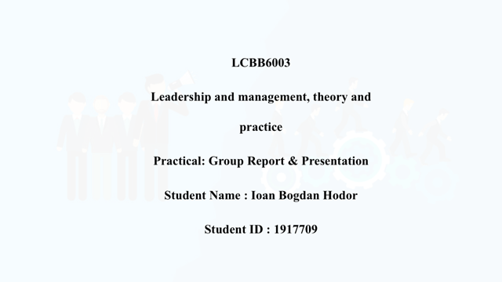

Slide 2
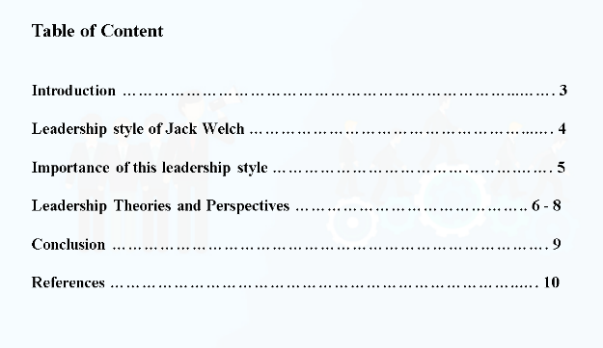
Slide 3
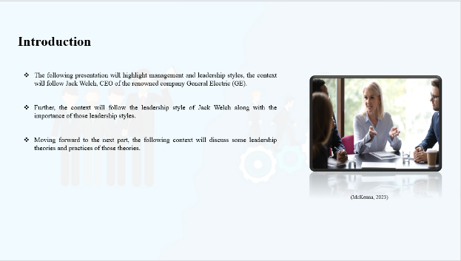
Notes

Introduction
The following presentation will highlight management and leadership styles, the context will follow Jack Welch, CEO of the renowned company General Electric (GE). Further, the context will follow the leadership style of Jack Welch along with the importance of those leadership styles. Moving forward to the next part, the following context will discuss some leadership theories and practices of those theories.

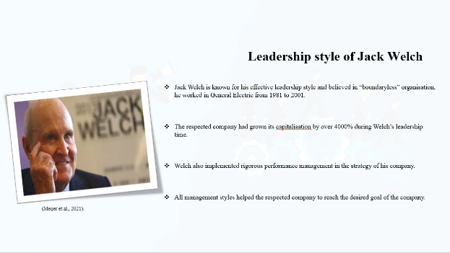

Leadership style of Jack Welch
Jack Welch is known for his effective leadership style and believed in “boundaryless” organisation, he worked in General Electric from 1981 to 2001. The respected company had grown its capitalisation by over 4000% during Welch’s leadership time. Welch always encouraged his employees to reach their company goals. The leadership style which had been followed by Jack Welch believed that traditional hierarchical structure along with the bureaucratic structure of management could help their employee to hinder innovation as well as creativity. Welch also implemented rigorous performance management in the strategy of his company. Moreover, to get more success Welch implemented “Rank and Yank” or “vitality curve” to his management style. All management styles helped the respected company to reach the desired goal of the company
Slide 5
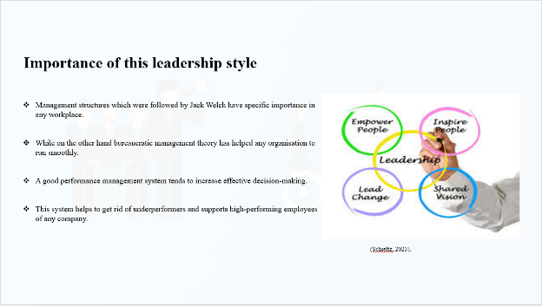

Note

Importance of this leadership style
Management structures which were followed by Jack Welch have specific importance in any workplace. Traditional hierarchical structure creates authority as well as unity in any workplace. Additionally, it can map out career paths and ensure accountability. While on the other hand bureaucratic management theory has helped any organisation to run smoothly. Additionally, management becomes easier and processes are less chaotic (Meijer et al., 2021). A good performance management system tends to increase effective decision-making and boost employee performance of the respected company. On the other hand “Rank and Yank” system which is known as the “vitality curve” as well as a controversial system. Managers need to rank their employees according to their performance and those employees who got less than 10% need to leave the company. This system helps to get rid of underperformers and supports high-performing employees of any company (McKenna, 2023).

Slide 6
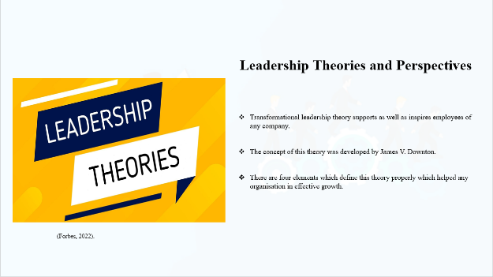
Note

Leadership Theories and Perspectives
Jack Welch followed transformational leadership theory during his time for the strategic development of his company.
Transformational leadership theory
Transformational leadership theory supports as well as inspires employees of any company additionally it can foster the company’s culture along with accountability. The concept of this theory was developed by James V. Downton. There are four elements which define this theory properly which helped any organisation in effective growth. Transformational theory helps to transform the members of any company along with the moral development of the individual (Schieltz, 2023).
Perspective
Jack Welch noticed this kind of theory is useful for the development of his company as well as self-actualisation and self-interest increased by implementing this theory so he implied this to his strategy.

Slide 7
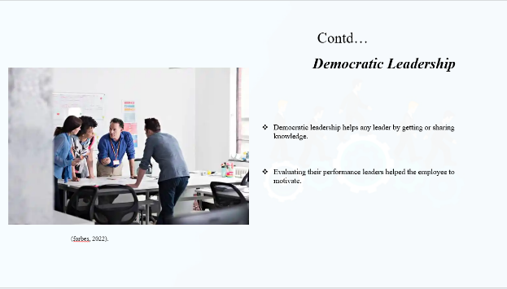
Notes
Democratic Leadership
Democratic leadership helps any leader by getting or sharing knowledge from peers and co-workers and helps their employees to reach expected goals. Moreover, evaluating their performance leaders helped the employee to motivate on their own and increases performance (forbes, 2022).

Slide 8
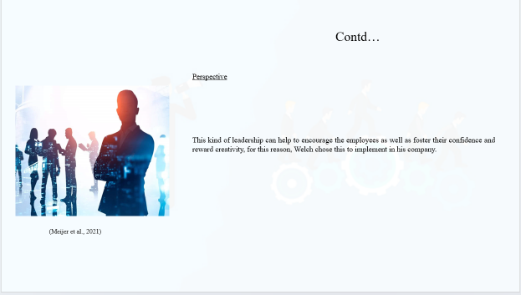
Note
Perspective
This kind of leadership can help to encourage the employees as well as foster their confidence and reward creativity, for this reason, Welch chose this to implement in his company.

Slide 9
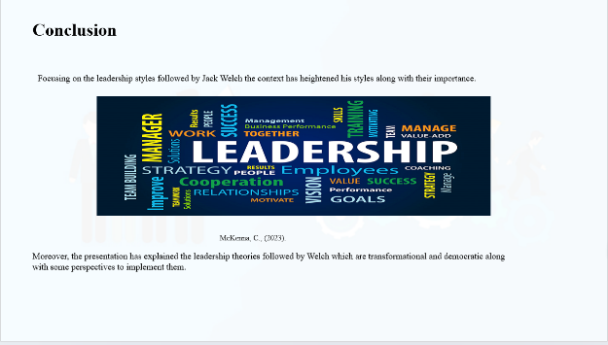
Notes

Conclusion
Focusing on the leadership styles followed by Jack Welch the context has heightened his styles along with their importance. Moreover, the presentation has explained the leadership theories followed by Welch which are transformational and democratic along with some perspectives to implement them.
Slide 10
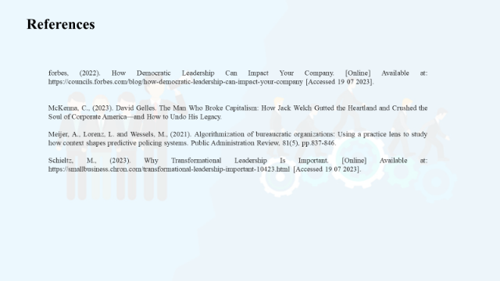
Notes

References
forbes, (2022). How Democratic Leadership Can Impact Your Company. [Online] Available at: https://councils.forbes.com/blog/how-democratic-leadership-can-impact-your-company [Accessed 19 07 2023].
McKenna, C., 2023. David Gelles. The Man Who Broke Capitalism: How Jack Welch Gutted the Heartland and Crushed the Soul of Corporate America—and How to Undo His Legacy.
Meijer, A., Lorenz, L. and Wessels, M., 2021. Algorithmization of bureaucratic organizations: Using a practice lens to study how context shapes predictive policing systems. Public Administration Review, 81(5), pp.837-846.
Schieltz, M., (2023). Why Transformational Leadership Is Important. [Online] Available at: https://smallbusiness.chron.com/transformational-leadership-important-10423.html [Accessed 19 07 2023].

