

Level 5 Assignment – BSc (Hons) / BEng (Hons) - Ordnance, Munitions and Explosives
Principles of OME – ACDA 5010

Assignment: Chemistry
Boswell, John S
December 2020

Student Number 1906963

Abstract
Understanding the chemical properties of an energetic material gives an insight into how the material will react during a deflagration or detonation. Within the molecules, the breaking of bonds and the forming of new bonds can absorb or release energy, the amount of which can be calculated. This report provides an overview of a simple explosive device that is suitable for use as a blasting charge for mining and quarrying. The components in the explosive train are separated into primary explosive, booster charge and secondary explosive (main charge). A lead azide and lead styphnate mixture is proposed as a primary explosive and a booster charge of pentaerythritol tetranitrate (PETN) provides the additional energy to initiate the main charge (secondary explosive) of nitroglycerine. The chemical and physical properties for each material are explained, and there is an overview of how to calculate the heats of formation figure (ΔH). The report concludes with a brief description of manufacturing factors and why understanding the chemical details is important.

Table of Contents
List of figures
- Introduction 5
  - - Problem addressed 5

- Method 6
  - – Description of the device 6
  - – Physical and chemical properties of the proposed materials and 7 compounds

- Results 8
  - – Primary explosive 9
  - – Secondary explosive 10

- Discussion 10
5. Conclusions 10
6. References 11

List of Figures
Figure 1. The Explosive Train 6

- Introduction

Explosives have been used in the mining industry for hundreds of years. The earliest records of using black powder to blast rock date back to 1627, when a blasting demonstration was carried out in Hungary [1]. It was in the late 19th century that nitroglycerine based explosives began to dominate the industry after Alfred Nobel made significant advances in the development of dynamite [2].

Although coal production in the UK declined drastically in the 1990’s, and volumes have consistently fallen over the last three decades, coal mining still continues, and the mining of industrial minerals such as gypsum and potash, and construction minerals such as aggregates and brick clay is carried out commercially and exported internationally [3].

The civilian use of explosives in the United Kingdom is governed by the Explosives Regulations 2014 (SI2014/1638) [4].

Understanding the chemical composition of an explosive material is important when assessing its use for a particular task. There are many different energetic compounds that all react in different ways. Studying the detail of the chemical reactions that occur gives an insight into both the products created during the reaction and the amount of energy that is released.

  - Problem addressed
There is a need to understand the chemistry of a simple explosive device that is used in the civilian mining and quarrying industry as a blasting charge. This report proposes some materials that could be used for all parts of the explosive train, their physical and chemical properties and describes the reactions that occur at each stage. The mechanisms for energy release for each of the reactions, along with an explanation of the calculations for a heats of formation figure are included in the results section. It concludes with an overview of the processes involved during manufacturing of the energetic compounds described.

- Method

2.1 Description of the device

The device proposed for use as a blasting charge follows the simple explosive train design used in many explosive articles. The explosive train can be described as

“…an arrangement of explosive components by which the initial force from the primer is transmitted and intensified until it reaches and sets off the main explosive composition.” [2]

The detonation shock wave is created by the initiation of a highly sensitive primary explosive which transfers its energy into a less sensitive but higher output booster charge, which in turn initiates a low sensitivity main charge. The main charge then produces the desired output.

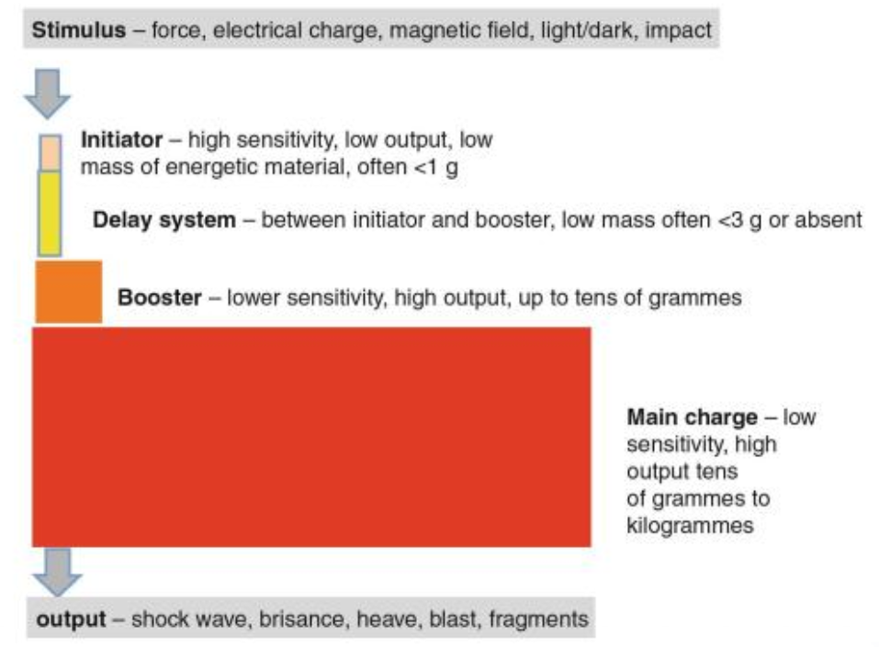

Fig 1. The Explosive Train (Image taken from Blast Injury Science and Engineering, Chapter 1, ‘The Fundamentals of Blast Physics’ by William G. Proud)

The explosive proposed for use as an initiator is a detonator containing a primary explosive mixture of lead azide, lead styphnate and aluminium. This would be initiated by an electric charge and would pass its energy to a small amount of pentaerythiritol tetranitrate (PETN), being used as a booster explosive. This booster energy will initiate a secondary explosive main charge consisting of nitroglycerine.

  - Physical and chemical properties of the proposed materials and compounds

Lead Azide (PbN6)
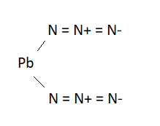

Lead azide is a colourless or white crystalline solid which is stable in dry conditions but becomes unstable in the presence of moisture. A molecule is made up of lead and nitrogen atoms. It can exist in two allotropic forms which have slightly different properties. Lead azide is commonly used in detonators as it is very effective at initiating secondary explosives. It is relatively insensitive to initiation by impact and is often mixed with lead styphnate to increase its impact sensitivity. As can be seen in the diagram above, lead azide does not contain oxygen atoms unlike most explosive compounds, which also contain nitrogen, oxygen and a fuel such as carbon or hydrogen.

Lead Styphnate (C6 H3 N3 O8 · Pb)
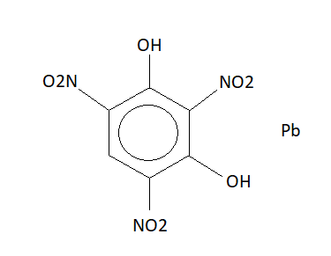
Lead styphnate is an orange/yellow or dark brown crystalline solid which unlike the azides, contains oxygen atoms within the molecule. It is very sensitive to electrical stimulus but is weak as a primary explosive and is commonly mixed with aluminium and lead azide for use in detonators.

Pentaerythritol Tetranitrate (PETN) (C5 H8 N4 O12)
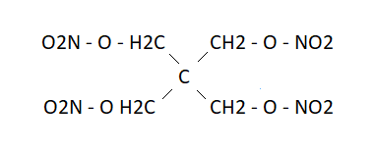
PETN is a colourless crystalline solid that is the most stable of the nitric esters. A molecule is made up of oxygen, hydrogen, carbon and nitrogen atoms. It is a powerful secondary explosive often used in detonation cords. PETN is not used in its pure form as it is extremely sensitive to friction. It is commonly mixed with a phlegmatizer to reduce its sensitivity. PETN is very sensitive to initiation by primary explosives which makes it an effective booster charge.

Nitroglycerine (C3 H5 N3 O9)
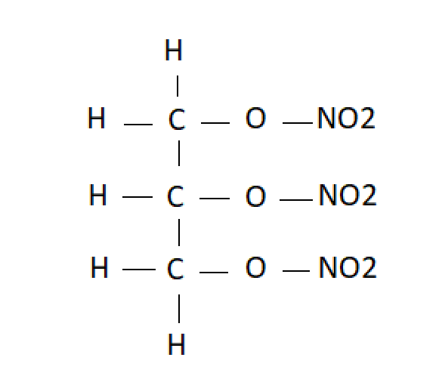
Nitroglycerine is a yellow liquid (oil) that is a powerful secondary explosive. A molecule is made up of carbon, hydrogen, oxygen and nitrogen atoms. It is frequently used in commercial blasting explosives as it has a high brisance (shattering effect) which makes it suitable for quarrying and mining. It can also be used as an ingredient in rocket propellant mixtures and explosive powders.

- Results
Thermochemistry plays an important part in understanding the details of the reactions that occur during a detonation.
During an explosive reaction, the molecules of the material involved split apart into the individual atoms and then rearrange to form new, smaller molecules such as water and carbon dioxide. Energy is required to break the atomic bonds and during the forming of new bonds, energy is released. Exothermic reactions will produce energy, the majority of which is heat, and endothermic reactions will absorb energy.
Using formulas and scientific techniques, the exothermicity, or heat release (ΔH), can be calculated. The heat of formation figure can be negative, indicating an exothermic reaction, or positive, indicating an endothermic reaction.

3.1 Primary explosives

Lead Azide

To calculate the energy released during the detonation of the lead azide, the energy from the reactants (the lead azide molecules) needs to be calculated. This figure can then be subtracted from the energy produced by the products (the newly formed molecules).

ΔHf = ΔH (products) – ΔH (reactants)

After completing the calculations, the figure of the heats of formation for lead azide is +468.61 KJ mol -1. [2]
As this figure is a positive number, it indicates that the reaction is endothermic, meaning that it absorbs heat. This energy is required to form the new bonds.

Lead Styphnate

To calculate the heats of formation figure for lead styphnate, the same formula can be used.

The chemical formula of lead styphnate molecules, C6 H3 N3 O8 · Pb, needs to be broken down into its constituent atoms and then the individual energies calculated. This will give the figure for the reactants This figure can then be subtracted from the figure for the atoms of the products.

After completing these calculations, the figure for the heats of formation for lead styphnate is -836.80 KJ mol-1. [2]

As the figure is a negative number, it indicates that the reaction is exothermic, meaning that heat is given out during the reaction. It can also be noted that twice as much heat is given out during this reaction than is absorbed during the lead azide reaction.

  - Secondary explosive

Pentaerythritol Tetranitrate (PETN)
To calculate the heats of formation figure for PETN, an additional set of rules are required due to the oxygen balance within the molecules. The Kistiakowsky-Wilson rules are used to work out the decomposition products.
The heats of formation figure for PETN is -530.53 KJ mol-1. [2]
As the figure is a negative number, it indicates that the reaction is exothermic, meaning that heat is given out during the reaction.
Nitroglycerine
Like calculating the energy released for PETN, the Kistiakowsky-Wilson rules are used to work out the decomposition products for nitroglycerine.
The heats of formation figure is -370.70 KJ mol-1. [2]

The formula given above, ΔHf = ΔH (products) – ΔH (reactants), can be used to calculate the heats of formation for many different types of explosives, giving valuable information which can be applied in many ways.

- Discussion

The manufacturing processes involved in making explosive substances can influence how the material behaves during a detonation. For example, the size of the crystals in lead azide and lead styphnate can affect the reactions on initiation. Processes of heating and cooling the crystals, how they are formed, and their shape alter their structure. This is the same for any crystalline solid explosive material.

Introducing additives during the manufacturing process can make the substance more sensitive or less sensitive to initiation or behave in a more controllable way. Additives can also effect the explosion, increasing or decreasing the fireball and the heat output.

- Conclusions

The explosive train and how the individual components within in the system interact are key to achieving a controlled outcome. Sensitive primary explosives, booster charges that provide additional energy, and secondary explosives that deliver the main effect all interact as a complete system. It is important that the detail is studied to fully understand how these components react and initiate, so that the system can function as intended.

- References

[1] | G. I. Brown, The Big Bang: A History of Explosives, Stroud, Gloucestershire: Sutton Publishing Ltd., 1998.
[2] | J. Akhavan, The Chemistry of Explosives (3rd Edition), Cambridge: Royal Society of Chemistry, 2011.
[3] | Unknown, “Mining and Quarrying in the UK,” 20 December 2019. [Online]. Available: www.gov.uk/government/publications. [Accessed 5 December 2020].
[4] | S. I. -. U. Parliament, The Explosives Regulations 2014, London: UK Parliament, 2014.

