Title: Academic And Employability Skills
Module Code: BMS4001
Student Name: Adnan Hussain
Student Number: 2132390
Lecturer Name: Doreen Nyaa Amundam

- Introduction
- Effective Motivation ways
- 4 different ways motivation can help staff (split across)
- Trust and loyalty to workers
- staff involvement
- Recognition of work
- Skill match
- Conclusion
- Reference list

Introduction

What is Motivation?
Motivation is a natural reaction that is instilled within us that makes us react or work in a certain way that will help us achieve certain life goals or target. If you were to observe your surroundings and see other people, we can ask a question to ourselves what actually motivates them and if the answer seems right, we can actually go ahead with that certain skill of motivation and apply it and get the person to work whilst under that Motivation upscale which was not there before. It is important that all members are motivated in a certain way that suits there needs as everyone is different and the same approach may or may not work on another person.

Effective Motivation ways
There are many Effective ways of motivation that suits each individual persons needs as everyone comes from different backgrounds temperaments and working styles so its only fair that the approach is catered to individuals rather than a group of people.
One of the effective motivation ways is to show trust loyalty and be open to whom you are motivating as certain employees are Motivated to work hard and take use of their initiative When they feel trusted by their leader/s. To add to that give, them the freedom to work things out for themselves as we can only learn from our mistakes and become better from those lessons learnt which will only motivate people to do better.
Different people have different needs to motivate them one of the examples is Money as living in a world where without money you will struggle to in-still money is needed to live a better life then that motivation will ignite.
Another being recognition as you want to be recognised for your hard work so to do that you need to work extremely hard but smart to be the attention of management and once the appraisal is upon you that image will be created i.e., he or she is a hard worker and once known that motivation will remain for you to do better than what you have done already.

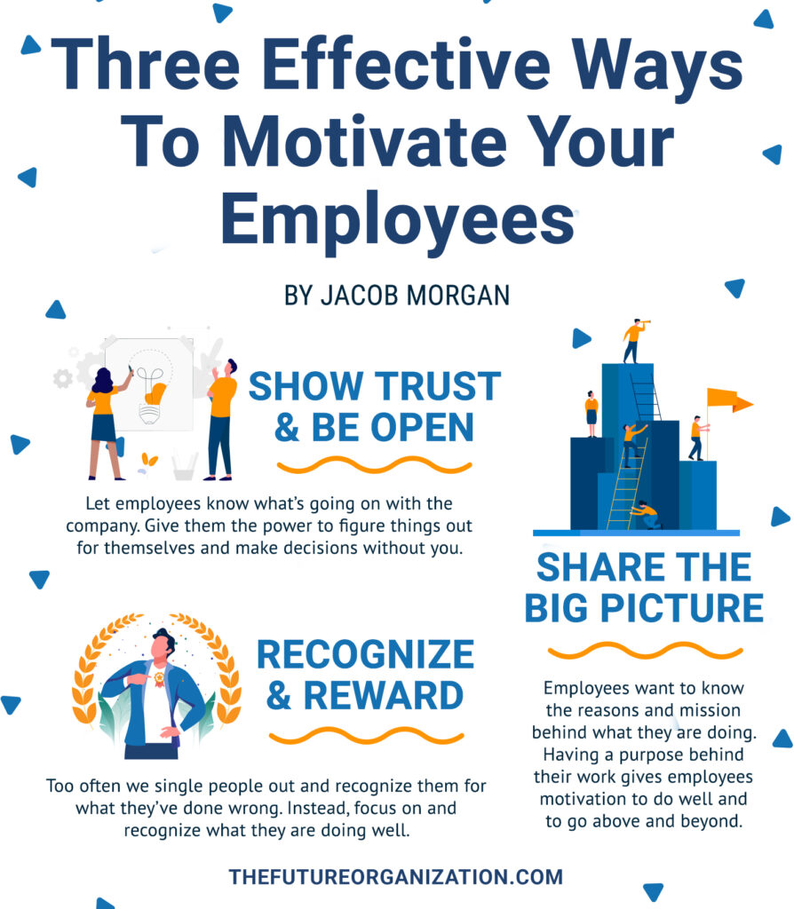

Motivation can be shared and felt, and this is to welcome everyone into the team share the big picture, so staff know what they are doing and the purpose behind their job and role.
When an employee only has a percentage of an insight to what they are doing it may demotivate them so If they know that what they are doing has a purpose and a goal at the end of it again it will only motivate them to do better next time.
Also include them in team projects make them feel apart of the team let them know that you are the reason we will achieve this result.
Not only will this boost their morale it will give them the motivation to do even better knowing that something positive will come out of what they have done individually and then as a team effort.

Another keyway is to recognises the good work employees put in and as a result of that good work reward them with an incentive or even a verbal appraisal to say well done.
Too many employers single out the mistakes and what they have done wrong and why its bad and wrong instead single out the achievements the employee has done and what positive impact this has had on the business.
Give some paid time off to the staff members or increase the pay of the members this automatically will be recognised by the staff who will say we have worked very well, and this is the reason why we have been give a pay rise or paid time off for a holiday or break
The positive from this factor is the workers will be even more motivated to better next time as they know the better they become of themselves and the work they do the higher the reward will become for them so its very important to have a balanced factor on this reward system as some workers may become demotivated due to knowing they have the increase in pay and drop in performance so a performance based system in place to ensure those who are motivated to work hard will earn the right of a pay rise or a extended break off work to enjoy with their family and friends.

Matching people to their skill is a very huge factor and important role as a employer to recognise. Why?
People who are confident in there ability to do there jobs which they have experience in will already have a heads up of what they need to do so automatically the motivation is there as they have been there and done that Example : a warehouse worker who has a forklift truck licence will automatically be comfortable using a forklift in a new company as the experience to use one is there from previous jobs and he or she can straight away understand how to operate the machine and what health and safety observation and precautions need to be carried out in order to work safely. Now to put someone in a position where they have not worked before and to expect an end result to be a positive one will be a difficulty as they have no knowledge, they won’t have the motivation to do well as the experience or understanding is not there and automatically the morale boost of this individual will drop and put them off doing the required task

Conclusion

I have on the above topic concluded that there are multiple ways to motivate staff and the best way in my opinion is to reward.

The reason I have concluded this as the key aspect as everyone who works has come to earn money to provide for there families and future and savings.
Now to have an increase in income automatically will increase your motivation to earn and achieve more than what you already have which leads to better work better attendance self esteem will be increased as the person is confident in the work that they are doing the business itself has a content happy worker and that relationship is built and a profile between whom it may has been created.
The understanding will be clear on an individual basis which will work for many that if you work and perform in the way we want you to not only better yourself you will have an increase to your rate of pay and other perks depending on business structure.

Reference list
https://thefutureorganization.com/three-effective-ways-to-motivate-your-employees-2/
J.M 2021

Pearce (2007) .pdf Chris Pearce MSc, BA, RGN, DipN, RNT, CertHSM is a life coach and freelance trainer with Life Goal Specialists

