Elitsa Ivanova
Student ID: 2123375
The Global Business Environment-Environmental Analysis of an industry

Module code: LCBB4005
Lecturer: Alfred Mensah and Nadeem Mirza

Table of Contents

1. Pandemic effect 1
1.1Negative effect on the BMW group 2
1.2 Positive effect on the BMW group 3
2. Conclusion 4

- Introduction
This report would continue to discuss the global automobile sector by exploring in detail the effect the global pandemic had on the organization. The analysis would be critical, which means it would also recognize some of the positive effects of the pandemic. As part of the report, there would be analysis of the strategies the BMW group development to improve their future success.

The global pandemic effects
BMW is one of the biggest and most popular automobile companies in the world. The BMW Group production network comprises 31 production and assembly facilities in 15 countries; the company has a global sales network in more than 140 countries. The success of the BMW has been based on a long-term thinking and responsible action. The company has established ecological and social sustainability thought the value chain, product responsibility and clear commitment to conserving resources an integral part of its strategy (PRESSCLUB GLOBAL · ARTICLE,2020).

  - Negative effect
The coronavirus pandemic heavily impacted the automobile industry. According to the performance analysis across different countries, the highest declines took place in Europe, North America and Asia – regions which imposed the strictest restrictions in order to cope with the virus threat (Knoema, 2021)
The BMW group had a good start in the beginning of 2020, and it was reporting sales growth. However, they started to report changes which led to a significant decrease in sales due to the impact of the global pandemic. Almost 80% of all retail outlets across Europe and 70% of those in the US were closed. In several countries, including Germany, stationary retailers are legally prohibited from selling cars. According to the performance data, in the beginning of 2020, the BMW sells were down by 20.6% globally, including an 18% decline in Europe. There was also a

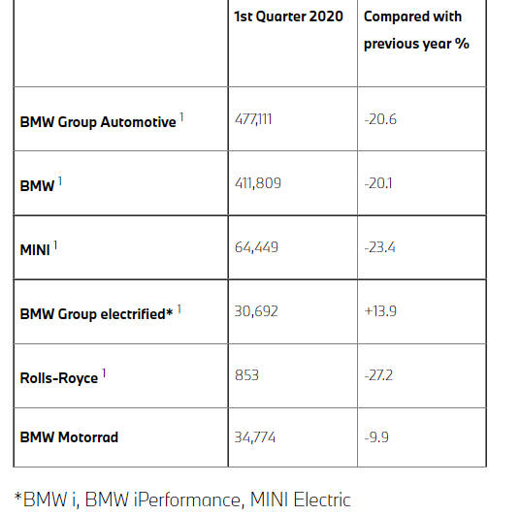

BMW GROUP SALES, MARCH 2020

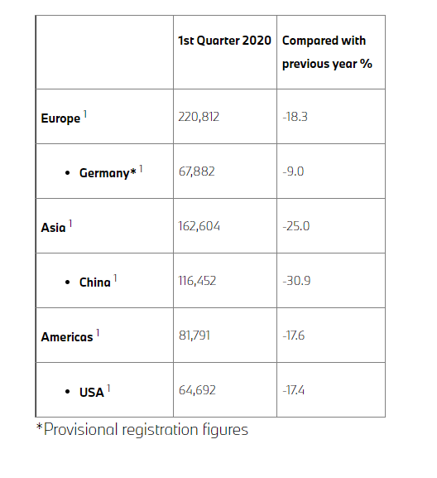

BMW GROUP 2020 sells across the globe

Also, due to the negative effect of the pandemic, BMW is also seeking to cut more than 5,000 employment positions. According to Statista, 55 % of the UK customer preferred to shop online and the most popular item to buy were clothes and sports goods. Services and products least popular with consumer were bicycles, mopeds, and cars, where less than 10% purchase them online. This could be supported by the statement issued by BMW that their margin fell to 2.7 percent for the year as well as the vehicle deliveries, fell 8.4 percent to 2.33 million. It has been also reported that the company pre-tax profit for the year 2020 was 5.2 billion euros, down nearly by 27% from 7.2 billion euros in the prior year.
Another challenge, which had a negative impact on the organization was the supply chain problems. There was a continuous delay in production, many of the workers had to isolate themselves due to being sick, working from home, adjusting to the “new normal”, as well as partial ports lockdowns and transportation delays. The automobile industry relies heavily on computer chips to control everything from air condition to electric car batteries, which they were not able to obtain due to a global shortage in chips. Jolly, J. (2021), online article
The pandemic has led to unpredicted economical changes. As reported by the World Bank (2022), the global decline in incomes, as measured by the changes in GDP (gross domestic product), surpassed 3%, which is worse than the performance during the global crisis in 2008-09. The uncertainty in the income and the consumers play an important part in the decreasing demand in the automobile sector. Despite being a very difficult period for the automobile industry, that there was a significant recovery in the production levels in 2021.

  - Positive effect
The global pandemic was directly related to the changes in consumer preferences. A survey created by Schroders (2021) shows that there has been changed in terms of increased preferences for environmental protection and sustainability. The surveys shows that the more than half of the consumers consider sustainable development more than the pre-pandemic period. Sustainable, fair-trade, cruelty-free, and environmentally friendly products are becoming a base standard for customer’s’ expectations and some customers are even willing to pay more for these types of products. Being environemntly0friendly could be a company, as it reduces the carbon footprint but also give positive association for the brand among its customers. This could be even the sole reason a customer has chosen a specific brand over the others.
The effects of the pandemic made the companies to re-think their business models and strategies. The BMW Group has placed sustainability and resources conservation at the center of its strategy. Therefore, the BMW has stuck to its strategy of building cars with hybrid, battery-only or combustion engine models. According to Oliver Zipse, the chief executive there was increased demand increased demand for electric and plug-in hybrid cars with sales doubling between January and September. However, the fully electric cars which do not produce carbon dioxide exhaust account only for 60,000 sales. The company is also preparing to introduce a new vehicle architecture by 2025, which will be based mainly on electric and digitally connected vehicles. In 2021, there has been investments in electrification and self-driving technologies. The costs for development and research remained high at 5.7 billion euros, which is more than 4% below the nearly 6 billion euros the company spent in 2019. The BMW group is also developing towards creating new production technologies as well as suitable sustainable material substitutes.
Although, BMW group faced several challenges in the beginning of the year, the group reported a better-than-expected second half profit after a loss earlier in the year. The sales were down by 20.6% globally in the first three months of 2020. But despite the significant decline in the first few months, the group’s profit was £686m, which was 4.7% higher than the previous year. Sales jumped nearly by 45% and sales in China which drove the manufacturer back to profitability were nearly up by 12%.

- Conclusion
In summary, the result of the pandemic has made significant changes in the consumer preferences, which have evolved towards more environmentally products and services. According to the findings, the BMW Group is well-prepared for the changes and successfully moving toward their focus to sustainable products. To have a future success, the organisation must continue to apply this strategy and continue to invest into research and new innovations. The BMW group has established ecological and social sustainability thought a product responsibility and a clear commit to conservating resources as part of its strategy. In addition, it is very likely that the competitors would replicate many of the strategies and practices and it is vital for the BMW group to continue to remain in a leadership position in technological innovation and customer satisfaction.

References
- Knoema (2021) Global Automotive Industry Overview | Data and Analysis, [online] Available: https://knoema.com/infographics/gdwntfe/global-automotive-industry-overview-data-and-analysis
- Abbas, S. (2021) Statistics on E-commerce in the United Kingdom in 2021, [online] Available: https://osome.com/uk/blog/2021-ecommerce-trends/
- www.press.bmwgroup.com. (n.d.). BMW Group focuses on flexibility and solidarity in dealing with Coronavirus Pandemic. [online] Available at: https://www.press.bmwgroup.com/global/article/detail/T0307368EN/bmw-group-focuses-on-flexibility-and-solidarity-in-dealing-with-coronavirus-pandemic?language%3Den
- Jolly, J. (2021). BMW profits rise to €3.4bn as focus turns to more expensive cars. [online] the Guardian. Available: https://www.rms-recruitment.co.uk/2021/11/bmw-profits-rise-to-e3-4bn-as-focus-turns-to-more-expensive-cars/

