University of Wales Trinity Saint David

School of Engineering

Study Into the Optimisation of Drying Methods for Aggregate and Suitable Application of Renewable Energy: Quantitative Study

(ACMA 6013)

Nathan Scott Morgan

1902731

28th April 2022

Declaration
This work has not previously been accepted in substance for any degree and is not being concurrently submitted in candidature for any degree.
Signed……………………….
Date…………….28/04/2023
STATEMENT 1
This thesis is the result of my own investigations, except where otherwise stated. Where correction services have been used the extent and nature of the correction is clearly marked in a footnote(s). Other sources are acknowledged by footnotes giving explicit references. A bibliography is appended.
Signed……………………….
Date…………….28/04/2023

Acknowledgements

I would like to thank the Art of Eco team on assisting with requests for endless amounts of aggregate, and information regarding material compositions and financial detail. It’s has been an amazing experience and I hope this report will help you make the correct decision, not just to scale up but to benefit the future generations.
Additionally, I would like to thank all the lecturers and supervisors that helped me with gathering information on experimental equipment, and process methodology.
I would like to thank Dr. Mike Goodfellow-Smith for directing me on this path and for his enthusiasm and passion towards the environment for the future generations.

Abstract
This report focuses on finding and analysing the total moisture content in aggregate used in Art of Eco products. The study involves conducting experiments based on using different time and temperature parameters to determine the most efficient way to dry the aggregate and reach desired moisture content. The aims of the study are to find and analyse the total moisture content in the aggregate, find and analyse at what point the desired moisture content has been reached, and to identify a cost effective, clean, and efficient renewable energy technology for drying aggregate used in Art of Eco products based on the experiments and research conducted.
The laboratory procedure for experimenting on aggregate involves weighing scales and an oven which utilises a standard methodology. The aggregate sample is initially weighed, and then heated at a given temperature for an extended period. This is repeated on the same sample through repeated intervals until it has dried. The weight loss is then used to calculate the moisture loss, and further used to calculate the value of the desired moisture content.
The study also investigates the power needed to heat the aggregate samples to recommend renewable technologies for drying aggregate, taking into consideration their efficiency, cost-effectiveness, and environmental impact. The study concludes with a recommendation of the most suitable renewable technology for drying Art of Eco's aggregate based on the results of the experiments and research conducted. The findings of this study have significant implications for Art of Eco who want to achieve the optimal moisture content of aggregates to gain the desired physical properties whilst doing so in the most sustainable process.
Specifically, the report investigates the effect of temperature and drying time on the moisture content of aggregate used by Art of Eco. Results show that higher temperatures result in an accelerated rate of moisture removal, while lower temperatures lead to a reduced rate of moisture extraction from the aggregate's interior. Finally, the report recommends the most appropriate renewable technology for drying Art of Eco's aggregate based on the results of the experiments and research conducted.

Table of Contents
1 Abstract iv
2 Introduction 1
2.1 Aims 2
2.2 Objectives 2
3 Timing Plan 3
4 Literature Review 5
4.1 Drying Process 5
4.2 Aggregate 5
4.2.1 Sand 6
4.3 Renewable Energy 7
4.3.1 Solar Energy 7
4.3.2 Air and Ground Sourced Heat Pumps 9
4.4 Energy Consumption 10
5 Methodology 11
5.1 Concept 11
5.2 Materials 11
5.3 Procedure 12
6 Work Carried Out 17
7 Results 18
7.1 At 200°C 18
7.1.1 30 Minute Intervals 19
7.1.2 60 Minute Intervals 20
7.1.3 90 Minute Intervals 21
7.1.4 120 Minute Intervals 22
7.2 At 150°C 23
7.2.1 30 Minute Intervals 24
7.2.2 60 Minute Intervals 25
7.2.3 90 Minute Intervals 26
7.2.4 120 Minute Intervals 27
7.3 At 100°C 27
7.3.1 30 Minute Intervals 29
7.3.2 60 Minute Intervals 29
7.3.3 90 Minute Intervals 30
7.3.4 120 Minute Intervals 31
7.4 At 50°C 32
7.4.1 30 Minute Intervals 33
7.4.2 60 Minute Intervals 34
7.4.3 90 Minute Intervals 35
7.4.4 120 Minute Intervals 36
7.5 Averages of Moisture Loss 36
8 Discussion 40
8.1 Oven 40
8.1.1 Phase 1 – Heating Up 40
8.2 Wattage to Dry One Tonne 47
8.3 Cost Analysis 48
8.3.1 Russel Roof Tiles – Case Study 48
8.4 Renewable Energy Recommendation 48
8.5 Amount of Solar Panels 49
9 Analysis 51
10 Conclusion 53
11 Recommended Further Work 54
12 References 55

Figure 1 - Expected Timeline of Project 3
Figure 2 - Actual Timeline of Project 4
Figure 3 - Sales of Sand, Gravel, and Crushed Rock for Primary Aggregates, 2019 (J M Mankelow, 2021) 5
Figure 4 - World Estimated Population Growth in Urban Cities (United Nations, Department of Economic and Social Affairs, Population Division, 2018) 6
Figure 5 - Ideal Aggregate Life Cycle (Behera, et al., 2014) 6
Figure 6 - Total Solar Radiation on a 1m² Horizontal Area (kWh) by (Renewable Developments Wales, 2023) 7
Figure 7 - Summer Solar at Present and Into the Future (50 Years) by (Burnett & Barbour, 2014) 8
Figure 8 - Deployment of Photovoltaic System in Wales by (Welsh Parliament - Senedd Research, 2021) 8
Figure 9 - Average Monthly Clear Sky UK by (Burnett & Barbour, 2014) 9
Figure 10 - Hours of Solar Energy Annually 9
Figure 11 - Average Business Energy Rates 2023 by Love Energy Savings (British Electricity Prices, 2023) 10
Figure 12 - Fine and Coarse Aggregate 12
Figure 13 - Oven (Left), Oven Temperature Dial (Right) 12
Figure 14 - Dish Weight 13
Figure 15 - Weight of Aggregate 14
Figure 16 - Oven Dish 14
Figure 17 - Dish with Dried Aggregate 15
Figure 18 – Dry Aggregate Weighed After Oven Processing 16
Figure 19 - Weight Difference Calculation 16
Figure 20 - First Interval at 200°C 18
Figure 21 - Second Interval at 200°C 18
Figure 22 - Third Interval at 200°C 19
Figure 23 - 30 Minute Intervals at 200°C 20
Figure 24 - 60 Minute Intervals at 200°C 21
Figure 25 - 90 Minute Intervals at 200°C 22
Figure 26 - 120 Minute Intervals at 200°C 23
Figure 27 - First Interval at 150°C 23
Figure 28 - Second Interval at 150°C 24
Figure 29 - Third Interval at 150°C 24
Figure 30 - 30 Minute Intervals at 150°C 25
Figure 31 - 60 Minute Intervals at 150°C 26
Figure 32 - 90 Minute Intervals at 150°C 26
Figure 33 - 120 Minute Intervals at 150°C 27
Figure 34 - First Interval at 100°C 28
Figure 35 - Second Interval at 100°C 28
Figure 36 - Third Interval at 100°C 28
Figure 37 - 30 Minute Intervals at 100°C 29
Figure 38 - 60 Minute Intervals at 100°C 30
Figure 39 - 90 Minute Intervals at 100°C 31
Figure 40 - 120 Minute Intervals at 100°C 32
Figure 41 - First Interval at 50°C 32
Figure 42 - Second Intervals at 50°C 33
Figure 43 - Third Intervals at 50°C 33
Figure 44 - 30 Minute Intervals at 50°C 34
Figure 45 - 60 Minute Intervals at 50°C 35
Figure 46 - 90 Minute Intervals at 50°C 35
Figure 47 - 120 Minute Intervals at 50°C 36
Figure 48 - Weight Loss Averages Across All Temperatures During 30-minute Intervals 37
Figure 49 - Weight Loss Averages Across All Temperatures During 60-minute Intervals 38
Figure 50 - Weight Loss Averages Across All Temperatures During 90-minute Intervals 38
Figure 51 - Weight Loss Averages Across All Temperatures During 120-minute Intervals 39
Figure 52 - Phases of Energy Used in an Oven 40
Figure 53 - Density of Air at 1 Atmosphere Pressure at Different Temperatures (°C) by (The Engineering ToolBox, 2003) 42
Figure 54 - Specific Heat Capacity of Air at Constant Pressure 43

Equation 1 - Power Equation 41
Equation 2 - Heat Equation 41
Equation 3 - Change in Temperature for 100°C 42
Equation 4 - Air Mass Calculation at 20°C 42
Equation 5 - Heat Equation for Air 43
Equation 6 - Power Equation for Air 43
Equation 7 - Heat Equation for Water 44
Equation 8 - Power Equation for Water 44
Equation 9 - Heat Equation for Grit 45
Equation 10 - Power Equation for Grit 45
Equation 11 - Heat Equation for Slate 45
Equation 12 - Power Equation for Slate 45
Equation 13 - Heat Equation for Cement 46
Equation 14 - Power Equation for Cement 46
Equation 15 - Heat Equation for Polyurethane Binder 46
Equation 16 - Power Equation for Polyurethane Binder 46
Equation 17 - Heat Equation for Graphene 47
Equation 18 - Power Equation for Graphene 47
Equation 19 - Minimum kWh Produced Per Day 50
Equation 20 - Minimum kWh Produced Annually 50

Introduction
Drying aggregate through the “Oven-Dry” or “Air Dry” processes, is a tedious and expensive operation. A new method of drying aggregate is needed, one that avoids these disadvantages. Additionally, Art of Eco requires a method that is both environmentally and sustainably practical for the future, while producing at a higher volume. Currently, the summer season is used as the best method to dry aggregate through an “air drying” technique on a drying bed. However, the aggregate cannot be stored through the winter months as the current location is limited in available space and the aggregate would absorb moisture from the increase in relative humidity leading to poor product quality.
The oven drying process plays a role in the preparation of mixed aggregates, which must meet specific requirements. The mixture is comprised of recycled sand and grit that has been collected and repurposed. Additionally, to enhance the strength and durability of the final product, small amounts of slate, cement, and a polyurethane-based binder that has been emulsified before mixing are added. Graphene is incorporated into the mixture to improve its mechanical properties, making it ideal for use in applications such as paving slabs.
High moisture content in the mixture can create early defects and decrease the reliability of the product as the binder will not solidify. Therefore, removing any moisture content present in the mixture is essential to ensure that the product is suitable for use. The oven drying process effectively eliminates any moisture present in the mixture and results in a high-quality product that meets the required specifications.
Art of Eco have informed that they would like 10% moisture in the aggregate to be processed. To achieve this, one essential requirement is knowing the moisture content of the aggregate, which needs to be accurately measured and monitored. To do this, the “wet” aggregate will first be dried in an oven until all the moisture is removed to determine the amount of moisture it currently contains. Then, by taking 10% of the moisture loss and adding it to the lowest weight value, the desired moisture content can be calculated. With this information, appropriate parameters, such as time and temperature, can be set to achieve desired results. One of the advantages from monitoring is once the desired moisture content has been reached, drying can be stopped. Thus, improve the optimal processing efficiency, and time.
Additionally, it is important to regularly monitor and maintain the moisture content after oven drying to ensure that the aggregate isn’t absorbing moisture due to humidity or evaporating moisture due to high environmental temperatures.
Renewable energy technology has emerged as a significant area of innovation, offering alternative clean and efficient supply of energy to conventional methods such as gas for drying aggregate. One promising technology that has experienced rapid growth over the past decade is solar energy. However, deployment of this technology in the United Kingdom (UK) has been slow, due to cloud coverage during winter months and lack of government incentives. Despite this, the UK's suitability for solar energy is often underestimated, particularly in South Wales and South England. Germany, located on the same latitude as the Mid and South of the UK, has seen a 10% annual increase in its solar energy output and aims to extract 80% of its annual energy consumption from solar by 2030. This report seeks to analyse the potential of solar energy in the UK for aggregate drying purposes, with a focus on South Wales.
In addition to solar energy, other renewable technologies are also being explored for their compatibility with the aggregate drying process, as well as their suitability for the location of the facility. These alternative technologies include wind energy, air-sourced heat pumps, and ground-sourced heat pumps. The selection of a suitable renewable technology is a factor in achieving efficient and sustainable aggregate drying. Therefore, an extensive assessment of these alternative technologies is necessary to determine their compatibility with the drying process and location of the facility.

Aims
This report sets out the following overall outcomes to be achieved as follows:
- To find and analyse the total moisture content in the aggregate.
- To find and analyse at what point the desired moisture content has been reached.
- To identify a cost effective, clean, and efficient renewable energy technology for drying aggregate used in Art of Eco products.

Objectives
- To conduct experiments using varied time and temperature parameters to determine the most efficient way to dry Art of Eco's aggregate.
- To compare the moisture content of the wet aggregate samples to the desired moisture content specified by Art of Eco.
- To research and evaluate different renewable technologies for drying aggregate, taking into consideration their efficiency, cost-effectiveness, and environmental impact.
- To recommend the most suitable renewable technology for drying Art of Eco's aggregate based on the results of the experiments and research conducted.

Timing Plan

Figure 1 - Expected Timeline of Project
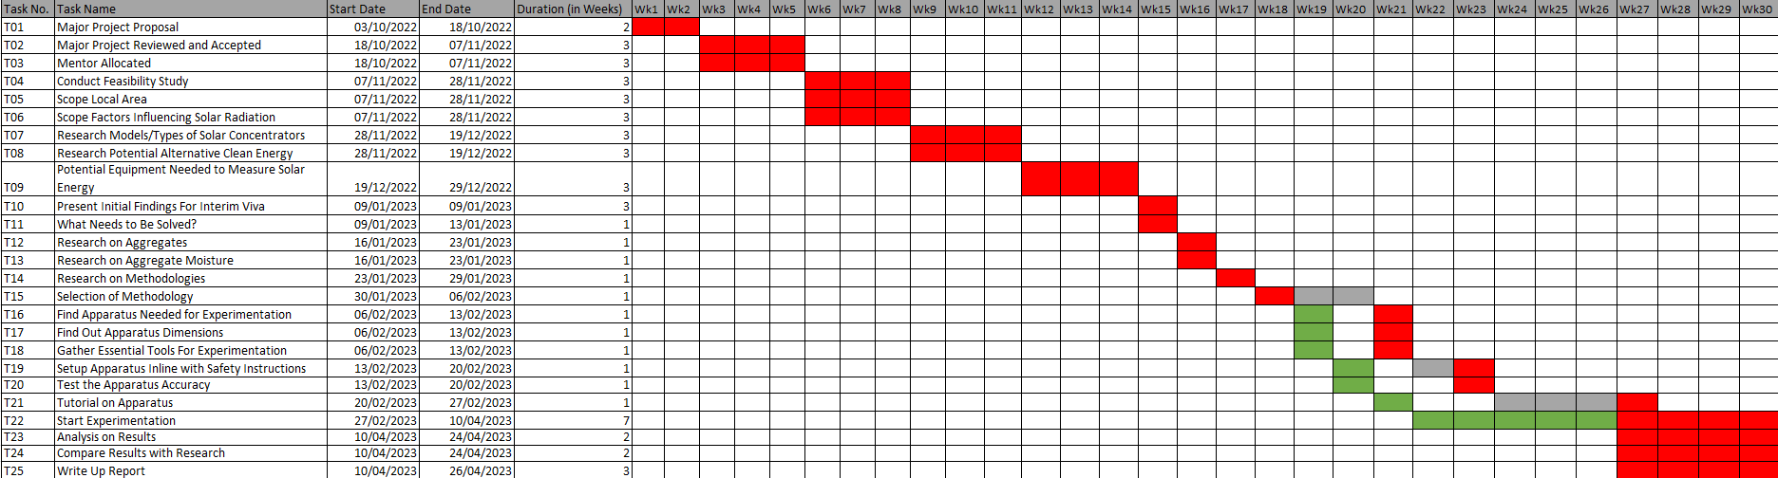
Figure 2 - Actual Timeline of Project

Literature Review

Drying Process
Drying is a process that involves the removal of moisture or water content from a material or substance. The drying process is affected by various factors, such as the “absorption and the moisture content of the aggregates as well as the drying temperature and time” (Mallick, et al., 2011).
The Moisture content of the aggregate can significantly affect the drying process. Aggregates with high moisture content will require more time and energy to dry compared to aggregates with lower moisture content. The drying temperature also plays a critical role in the drying process. Higher temperatures can help accelerate the drying process, but excessive heat can also cause damage to the aggregates. Additionally, the drying time needs to be controlled carefully to ensure that the aggregates are thoroughly dried without being overheated or damaged. Aggregate with higher moisture content can decrease the “bonding due to moisture intrusion” (Cong & Guo, 2021).

Aggregate
“In the UK, at present, the majority of aggregate materials, for all construction applications, are obtained from primary resources such as crushed rock and sand and gravel” (Hill & Dawson, 2001). In 2019, “total sales of primary aggregates produced in England and Wales, including marine-dredged sand and gravel, but not imports of aggregates from outside England and Wales, were 148.1 Mt in 2019 of which 90% was produced in England” (J M Mankelow, 2021) as shown below by region (Figure 3).
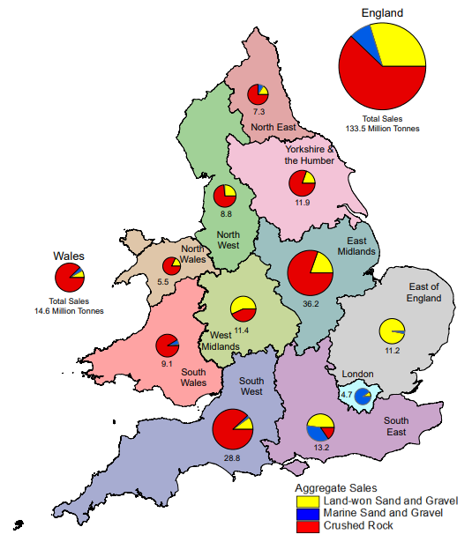
Figure 3 - Sales of Sand, Gravel, and Crushed Rock for Primary Aggregates, 2019 (J M Mankelow, 2021)
Due to current trends, the amount of aggregates sales and consumption will likely increase as the population increases leading to urbanisation and pedestrianisation expansion (Government Office for Science, 2021).
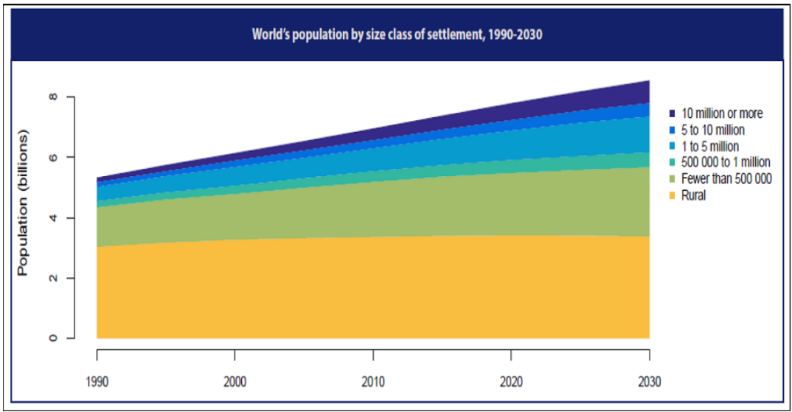
Figure 4 - World Estimated Population Growth in Urban Cities (United Nations, Department of Economic and Social Affairs, Population Division, 2018)
Thus, highlighting the need to recycle materials and utilise quarry waste aggregate (Mehta & Monteiro, 2014) (Behera, et al., 2014).
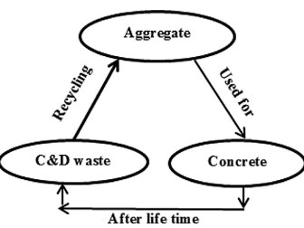
Figure 5 - Ideal Aggregate Life Cycle (Behera, et al., 2014)

Sand
Sand constitutes an important component in the production process at Art of Eco, accounting for 40% of the total composition alongside grit. In the United Kingdom, sand is primarily sourced from the sea rather than riverbeds, due to the potential environmental hazards of urban flooding and habitat destruction. However, the employment of sea-sand or seawater as raw materials for concrete has not gained widespread acceptance due to their elevated chloride content, which significantly increases the susceptibility of reinforcing steel to corrosion (Xiao, et al., 2017). This factor has contributed to an 18% decline in sand sales within the UK between 2014 and 2019. As the demand for sand escalates and regulations regarding the preservation of freshwater ecosystems intensify, it becomes imperative to investigate the feasibility of adopting sea-sand as a viable alternative.
The issue is being addressed through ongoing research and development, with a focus on alternative Fibre Reinforced Polymer (FRP) composites. These composites are being considered as replacements for traditional steel rebars, as they demonstrate improved performance in the resistance to corrosion by chloride and alkali (Ceroni, et al., 2006). Specifically, studies have shown that FRP composites are less susceptible to corrosion and degradation in the presence of seawater or sea-sand. These findings suggest that FRP composites provide the potential to offer a more sustainable approach to sand production.

Renewable Energy

Solar Energy
“The average solar power for the UK is about 100 W/m² for flat ground, 110 W/m² for south-facing roof space” (Roper, 2016). In South Wales, 1100kWh of total solar radiation falls per 1m² (Figure 6). This shows that solar in the UK is perfectly viable in the present and into the future as solar becomes more efficient due to innovation and investment.
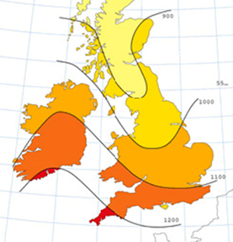
Figure 6 - Total Solar Radiation on a 1m² Horizontal Area (kWh) by (Renewable Developments Wales, 2023)
“The current solar energy resource in the UK offers a huge un-tapped potential, especially in the south of England and Wales where the average daily solar irradiance is often in excess of 130 Wm2” (Burnett & Barbour, 2014). This data correctly correlates to the fact that the average in the UK is 100W/m² and Figure 6 where South Wales receives more than the rest of the UK, hence higher than the average.
An assumption could be made that “in the places where the current resource is largest (in the south and south-west), the resource will on average see a sizeable increase due to climate change” (Burnett & Barbour, 2014). Although this isn’t great for the climate, it does put South Wales in an interesting position, at least for the foreseeable future (Figure 7) that solar will be a great investment working alongside the negative impact of climate change but using it to fuel business, and decarbonisation.
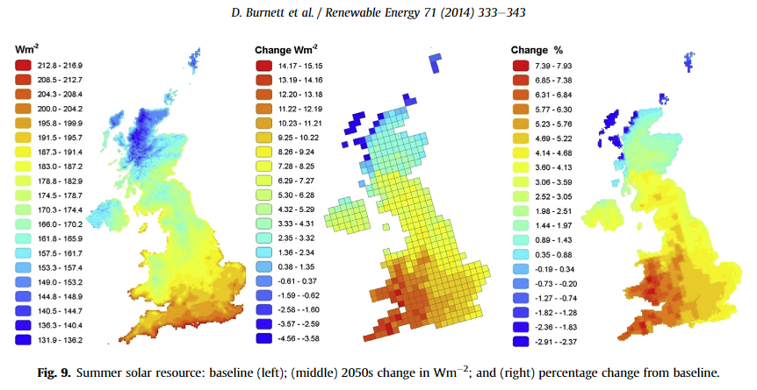
Figure 7 - Summer Solar at Present and Into the Future (50 Years) by (Burnett & Barbour, 2014)
Due to this, investment in photovoltaic system is accelerating (Figure 8) in Wales, especially as Governments offer incentives for businesses to decarbonise and the public look for new ways to reduce their annual energy bills.
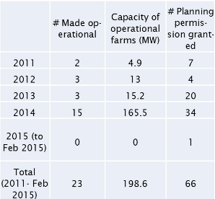
Figure 8 - Deployment of Photovoltaic System in Wales by (Welsh Parliament - Senedd Research, 2021)
Solar energy can also be received even there are clouds, and it is raining. However, it does heavily depend on the “type of panel used, with cheaper models losing out by a factor of ten to twenty on really cloudy days” (Roper, 2016). Figure 9 below, shows the percentage of clear sky ($\overline{K}clear$) across the UK. Weather monitors across the UK, can measure the direct solar irradiance across the year to calculate the average. Highlighted in red on Figure 9, is the average percentage of each month for the monitoring station for South Wales. This shows that South Wales is above average compared to the rest of the UK monitoring stations throughout the year, especially during the summer.
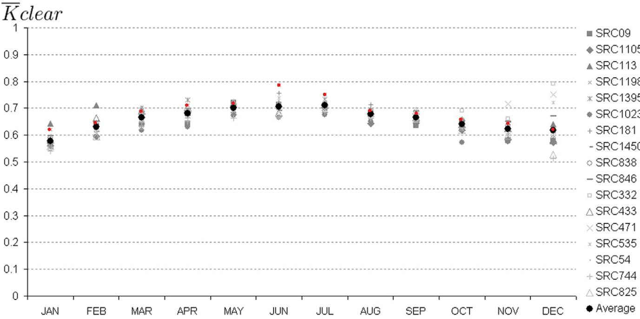
Figure 9 - Average Monthly Clear Sky UK by (Burnett & Barbour, 2014)
Both photovoltaic and solar thermal systems could provide efficient and clean energy or hot water/air to dry out aggregate at high temperatures all year round, but particularly in the summer.
Figure 10 below, demonstrates hours of day length each day. Between the March Equinox and September Equinox, there is an average of 14.76 hours of sun light, with the highest in June at 16 hours. During the winter the lowest is at 8 hours, so during the winter months the average is approximately 9.26 hours.
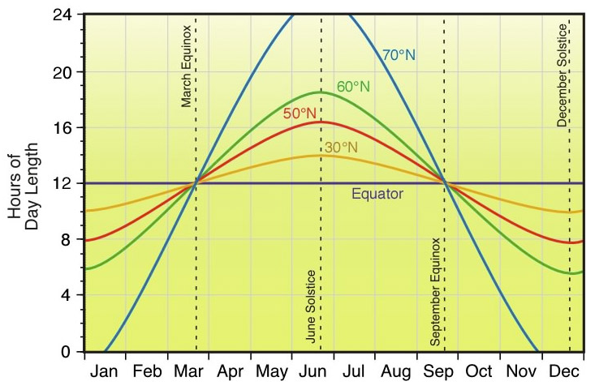
Figure 10 - Hours of Solar Energy Annually

Air and Ground Sourced Heat Pumps
Air source and ground source heat pumps only use electricity so in combination with a green grid would offer a low-carbon alternative from gas boilers. The average lifespan of an air and ground sourced heat pump is 20 years which is significantly longer than the average gas boiler. The UK government also offer a £5,000 grant towards air and ground sourced heat pumps in the Wales (British Gas, 2023). However, air source and ground source heat pumps rely on the good thermal insulation of a building and installations can involve things like excavation for ground sourced heat pumps.
Both types of heat sourced pumps generally produce up to 55°C for hot water. With an insulated cylinder temperatures can reach 60°C (Energy Saving Trust, 2023).

Energy Consumption
The monthly cost of electricity at Art of Eco is equal to £500. Based on Figure 11, which outlines the average business rates for electricity during 2023 in the UK, it is estimated that Art of Eco will spend an annual electricity cost of £6,000, equivalent to 20,000kWh. Considering the implementation of new drying equipment for aggregate, it is reasonable to assume that additional electricity will be needed. This will bring up the annual costs unless an investment is considered with renewable technology options so energy generation can be brought locally. This investment would protect the company from rising energy prices and lower the monthly costs as well as reduce their carbon footprint.
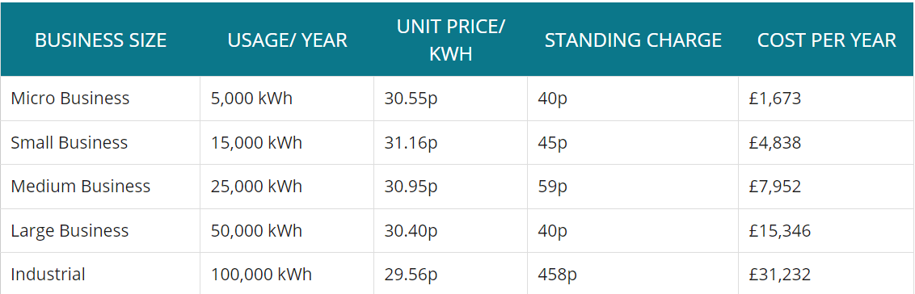
Figure 11 - Average Business Energy Rates 2023 by Love Energy Savings (British Electricity Prices, 2023)

Methodology

Concept
The conventional oven method is traditionally used to measure the loss of moisture after applied heat over a period. The initial moisture weight is then subtracted from the secondary moisture weight. Thus, giving a moisture weight loss. To validate results, the test will include two additional samples with the same weight, heat and time applied.
After the third sample has been tested, the experiment will be repeated with the same samples and subjected to the same conditions to further reduce moisture content within the aggregate. This will be repeated on all samples for three intervals in total. For retesting, each sample will undergo a cooling process that lasts for two times the duration of its oven drying time. This will allow the other aggregate samples to be tested.
The experiment will increase and decrease the time and temperature intervals for several samples. Providing a thorough observation into a suitable parameter setting for choosing a suitable renewable energy source.
Due to uncontrollable factors, it is essential to note that the oven dish utilised in this study is limited to a maximum temperature of 230°C. This restriction may be attributed to potential oven glove safety failure or material degradation at higher temperatures. To maintain safety and reliability, the experiments were conducted at temperatures below 200°C. Additionally, it should be acknowledged that the quantity of material tested is reliant upon the container's volume, and as such, tests involving larger amounts of aggregate may exhibit different weight loss characteristics. This report does not investigate these variations.

Materials
This study will conduct experimentation on various aggregate sizes and materials. The aggregate consists of:
- Sand (Recycled)
- Grit (Recycled)
- Slate
- Cement
- Binder
- Graphene
The sizes vary from fine (0.165mm) to coarse (0.52mm).
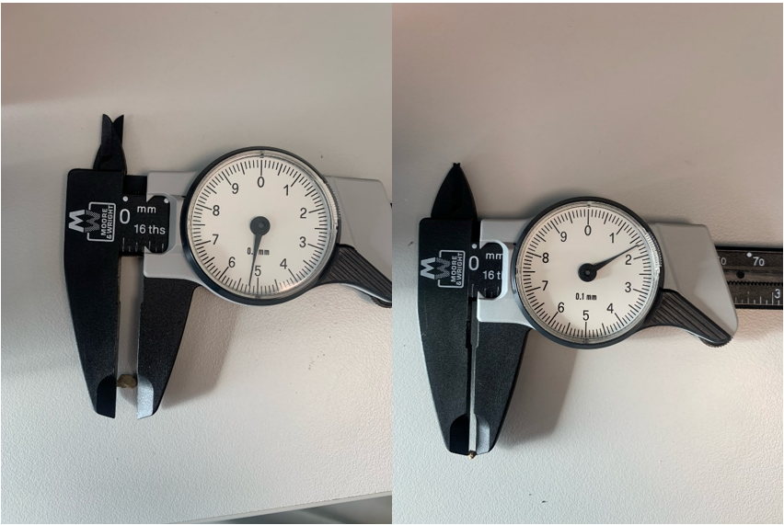
Figure 12 - Fine and Coarse Aggregate

Procedure
The laboratory procedure for preparing aggregate samples involves the following steps:
- The oven is preheated to the desired temperature.
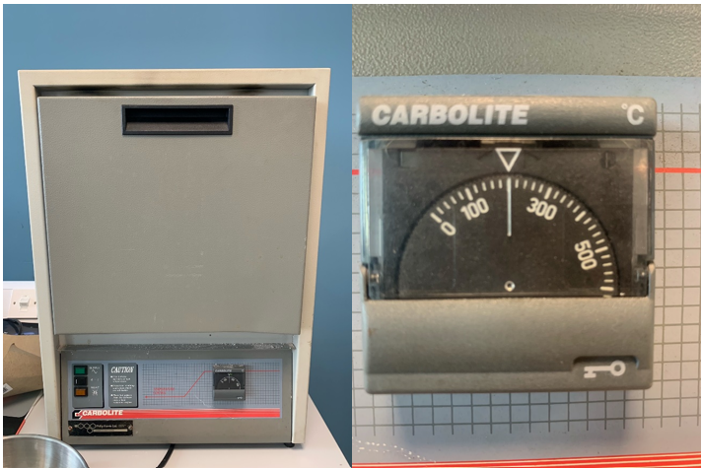
Figure 13 - Oven (Left), Oven Temperature Dial (Right)
- The empty dish is weighed using traditional weighing scales, and its weight in grams is recorded.
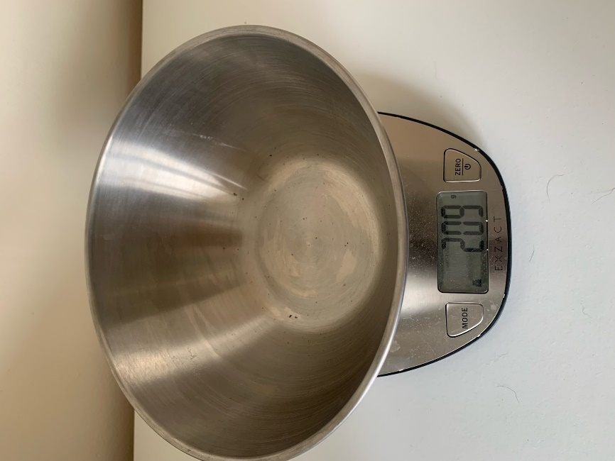
Figure 14 - Dish Weight
- 389g of mixed aggregate (or the maximum weight allowed for the dish volume) is placed into the dish.
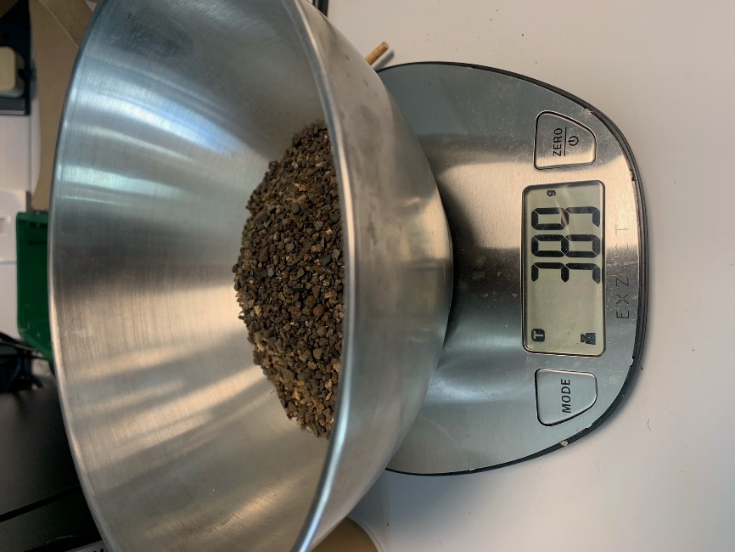
Figure 15 - Weight of Aggregate
- The aggregate is then poured into an oven dish with the mixed aggregate, then placed into the oven, and the timer is started for the desired time.
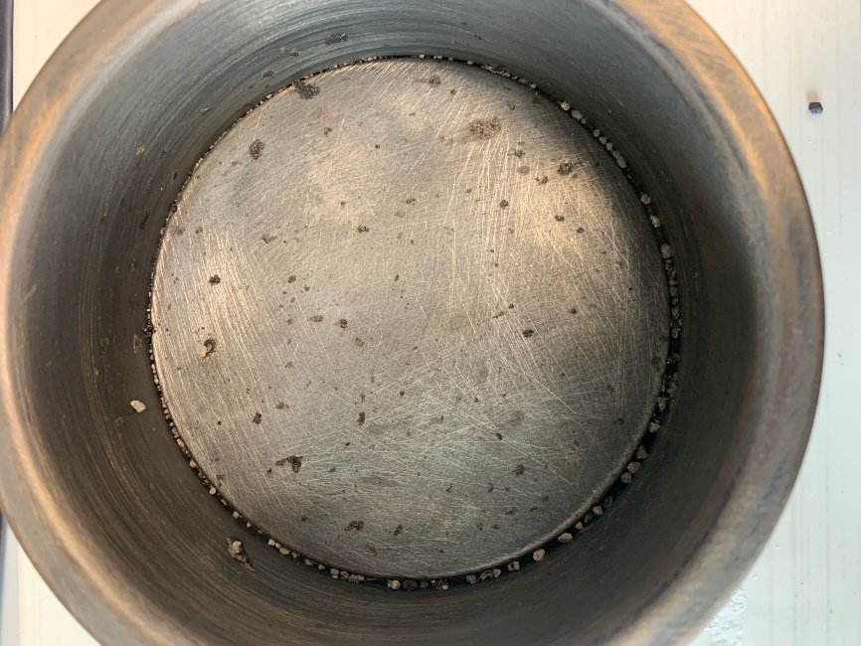
Figure 16 - Oven Dish
- After the timer goes off, the oven dish with the dried aggregate is taken out from the oven using safety gloves and goggles and placed on a heat-proof mat (ceramic tile) to cool down for five minutes. It is then placed back into the dish to be placed onto the weighing scales.
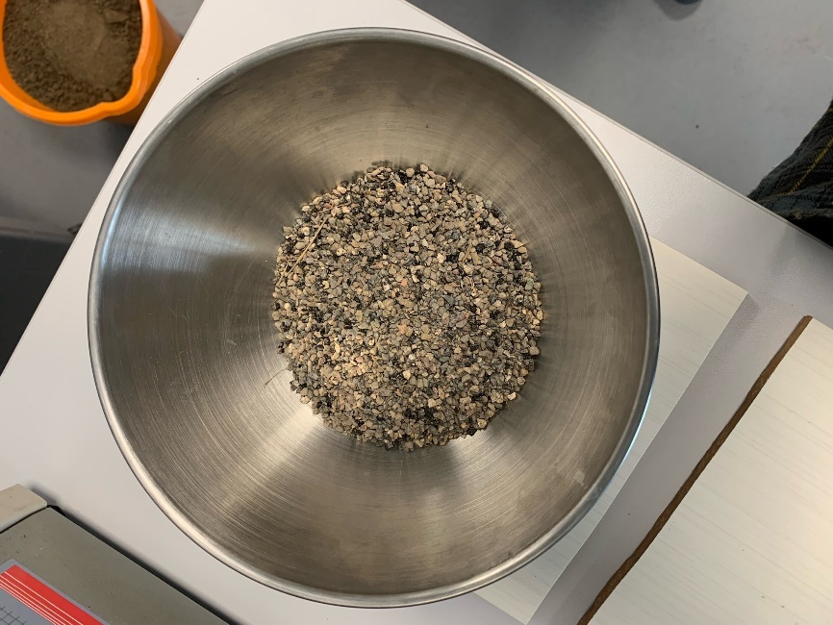
Figure 17 - Dish with Dried Aggregate
- Once the aggregate has cooled down for five minutes, the dish with the dried aggregate is placed onto electronic weighing scales, and the weight in grams is recorded.
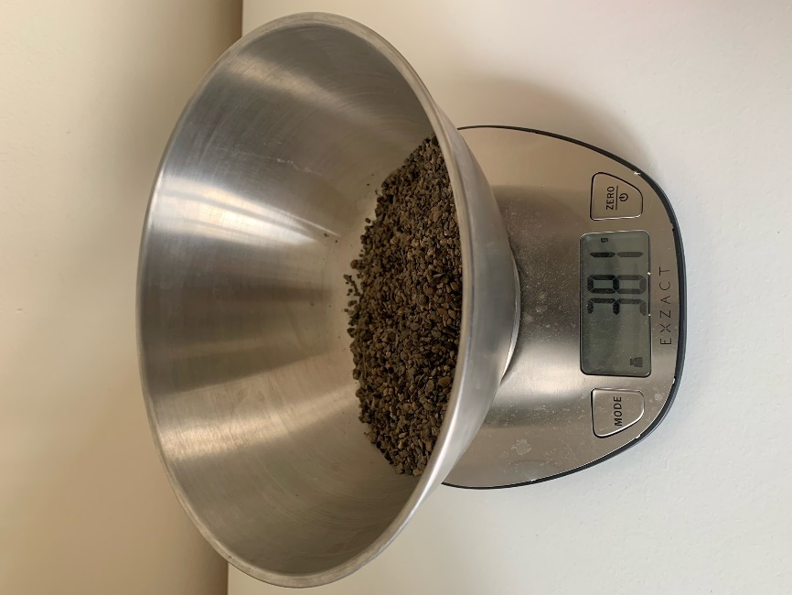
Figure 18 – Dry Aggregate Weighed After Oven Processing
- The weight of the empty oven dish is subtracted from the total weight to determine the weight of the dried aggregate, thus giving the difference which is equal to the moisture extracted in grams.
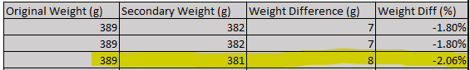
Figure 19 - Weight Difference Calculation
This laboratory procedure ensures that the aggregate samples are consistently and accurately prepared for testing. Additionally, it includes safety precautions to prevent injuries and equipment damage.

Work Carried Out
An initial feasibility study was conducted to observe whether renewable technologies could be a viable option for Art of Eco in the process of drying aggregate. After documenting the surrounding environment, which includes the latitude, forage, sun direction, height above sea level and direction of the roof. It was concluded that the site would be suitable for many forms of renewable technology.
The next step was to work out how to dry aggregate and withdraw moisture. Different methodologies were researched, and the selection was based on controlled factors and reliability. Experimentation then started on various samples over a range of different temperatures and drying time parameters. This enabled a comprehensive understanding of the effects.
Then, once the data was collected and analysed. The energy consumption of the oven was calculated to find out what the estimated energy usage would be if Art of Eco went forward with this process. From these results, the amount of energy needed to be provided by solar panels could be calculated and recommendation could be made to the company based on the findings.

Results

At 200°C
Samples were weighed at 389g each and subjected to heat at 200°C across different variations of time (Figure 23, Figure 24, Figure 25, Figure 26). Once the samples have been initially tested, they were placed back into the oven for an additional interval at the same time. This process was repeated an additional time with three intervals in total. This process (Figure 20, Figure 21, Figure 22) was introduced to monitor how much moisture was being extracted at different points in time, to accurately examine the rate of change.
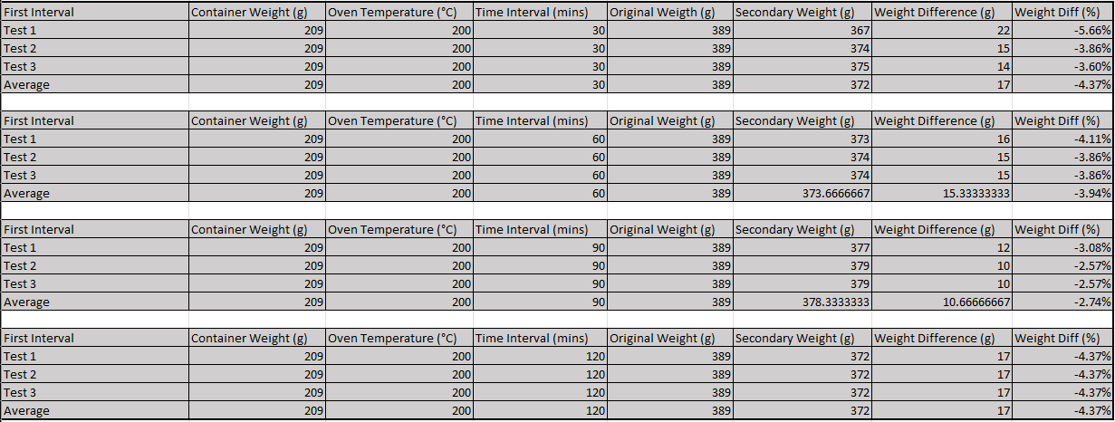
Figure 20 - First Interval at 200°C
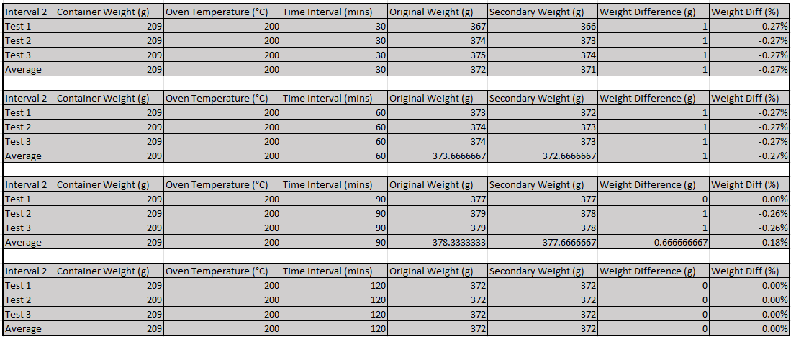
Figure 21 - Second Interval at 200°C
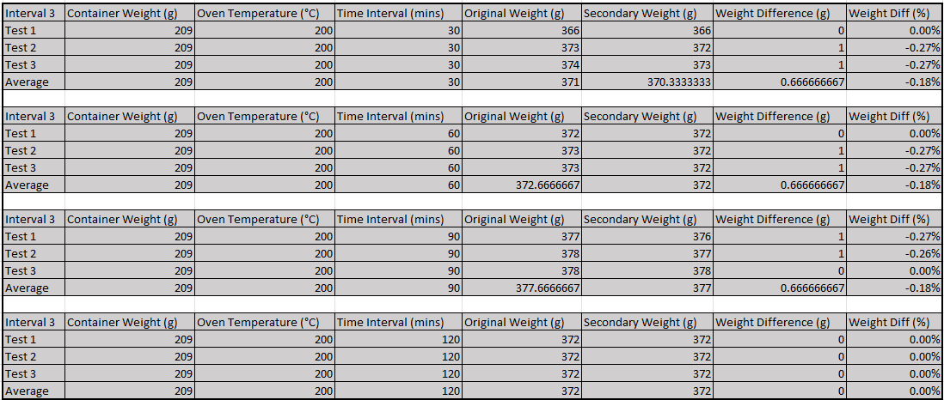
Figure 22 - Third Interval at 200°C

30 Minute Intervals
Figure 23 presented below, illustrates the variation in each sample's weight over the duration of the experiment. A substantial decrease in weight is observed during the initial 30-minute interval of 4.37%, which can be attributed to the removal of moisture accumulated on the aggregate's exterior. The rate of change is considerably large compared to the rate of change during the 60-minute intervals below (Figure 24).
As the experiment progresses through each interval, a continued loss of moisture is observed at a slower rate of 0.27%. This phenomenon is likely a result of moisture trapped within the aggregate being released as steam, leading to the fracturing of the aggregate.
An anomaly is observed in the first sample (represented in orange), which exhibits a significantly lower weight compared to the other two samples. This discrepancy developed from a mistake in recording the initial weight, which was assumed to be 389g. However, a more accurate estimation of the initial weight is approximately 382g.

Figure 23 - 30 Minute Intervals at 200°C.

60 Minute Intervals
Figure 24, displayed below, demonstrates the variation in the weight of each sample throughout the experiment. A significant decline in weight is evident during the initial 60-minute interval of 3.94%, which can be credited to the elimination of moisture present on the aggregate's surface. The significant decrease, followed by a levelling off in subsequent intervals, suggests that moisture within the aggregate is also likely to have been removed.

Figure 24 - 60 Minute Intervals at 200°C.

90 Minute Intervals
Figure 25, depicted below, highlights the changes in each sample's weight throughout the experiment. A significant reduction in weight is observed during the initial 90-minute interval of 2.74%, which can be attributed to the elimination of moisture present on the aggregate's surface. The rate of moisture is decreased compared to prior temperature intervals (Figure 24, Figure 23) due to moisture loss outside of experimentation which is further described below. The considerable drop and subsequent levelling from the further intervals suggest that the moisture within the aggregate has likely been removed as well.
When comparing Figure 25 to Figure 23 and Figure 24, it is evident that the weight loss is considerably less, despite being subjected to higher temperatures for a longer duration. This anomaly transpired following a four-day break over the Easter holidays, when the aggregate container likely evaporated within the laboratory due to high ambient temperatures and unregulated university room conditions. Consequently, a new supply of aggregate was obtained from the same batch and utilized for the remainder of the experiments. To improve further accuracy of the tests, the container will be sealed using cling film.

Figure 25 - 90 Minute Intervals at 200°C.

120 Minute Intervals
Figure 26, depicted below, highlights the changes in each sample's weight throughout the experiment. A significant reduction in weight is observed during the initial 120-minute interval of 4.37%, which can be attributed to the elimination of moisture present on the aggregate's surface. The considerable drop and subsequent levelling from the further intervals of 0% suggest that the moisture within the aggregate has likely been removed as well leaving the aggregate completely dry. This has been observed on Figure 23,Figure 24 and Figure 25.

Figure 26 - 120 Minute Intervals at 200°C.

At 150°C
Samples were weighed at 389g each and subjected to heat at 150°C across different variations of time (Figure 30, Figure 31, Figure 32, Figure 33). The samples then went through a series of intervals to further decrease the moisture content and monitor the rate of moisture loss (Figure 27, Figure 28, Figure 29).
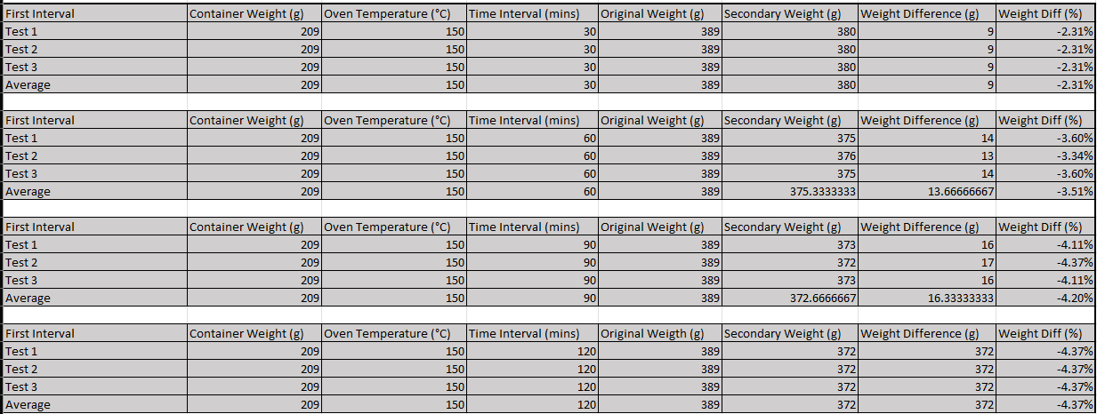
Figure 27 - First Interval at 150°C
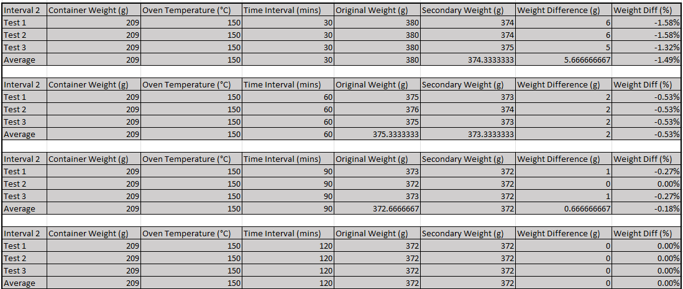
Figure 28 - Second Interval at 150°C
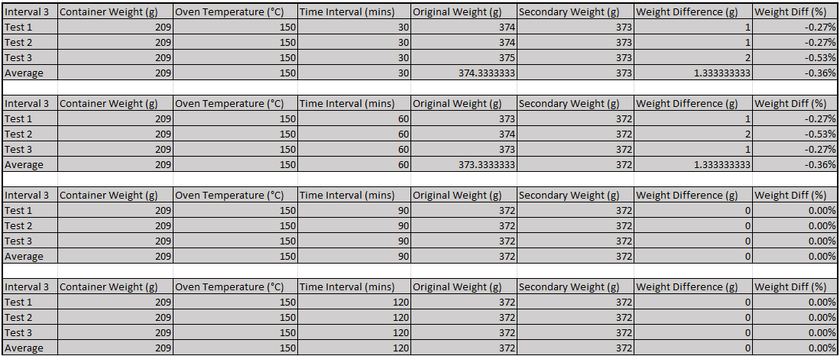
Figure 29 - Third Interval at 150°C

30 Minute Intervals
Figure 30,presented below, illustrates the variation in each sample's weight over the duration of the experiment. A moderate decrease in weight is observed during the initial 30-minute interval of 2.31%, which can be attributed to the removal of moisture accumulated on the aggregate's exterior. As the experiment progresses through each interval, a continued loss of moisture is observed at a slower rate. The second interval observed a 1.49% decrease in moisture, followed by 0.36% in the third interval. This phenomenon is likely a result of moisture trapped within the aggregate being released as a steam, leading to the fracturing of the aggregate. In contrast to Figure 23, the quantity of moisture extracted is comparatively lower. This observation can be attributed to the reduction in temperature as well as corrected weight measurements.

Figure 30 - 30 Minute Intervals at 150°C.

60 Minute Intervals
Figure 31, displayed below, demonstrates the variation in the weight of each sample throughout the experiment. A significant decline in weight is evident during the initial 60-minute interval of 3.51%, which can be credited to the elimination of moisture present on the aggregate's surface. The significant decrease, followed by a levelling off in subsequent intervals, 0.53% in the second interval and 0.36% in the third interval, suggests that moisture within the aggregate is also likely to have been removed.

Figure 31 - 60 Minute Intervals at 150°C.

90 Minute Intervals
Figure 32, depicted below, highlights the changes in each sample's weight throughout the experiment. A significant reduction in weight is observed during the initial 90-minute interval of 4.20%, which can be attributed to the elimination of moisture present on the aggregate's surface. The considerable drop and subsequent levelling from the further intervals of 0.18% in the second interval and 0% in the third, suggest that the moisture within the aggregate has likely been removed as well.

Figure 32 - 90 Minute Intervals at 150°C.

120 Minute Intervals
Figure 33, depicted below, highlights the changes in each sample's weight throughout the experiment. A significant reduction in weight is observed during the initial 120-minute interval of 4.37%, which can be attributed to the elimination of moisture present on the aggregate's surface. The considerable drop and subsequent levelling from the further intervals, 0% in the second and third interval, suggest that the moisture within the aggregate has likely been removed as well. This has been observed on Figure 32 and Figure 31.

Figure 33 - 120 Minute Intervals at 150°C.

At 100°C
Samples were weighed at 389g each and subjected to heat at 100°C across different variations of time (Figure 37, Figure 38, Figure 39, Figure 40). The samples then went through a series of intervals to further decrease the moisture content and monitor the rate of moisture loss (Figure 34, Figure 35, Figure 36).
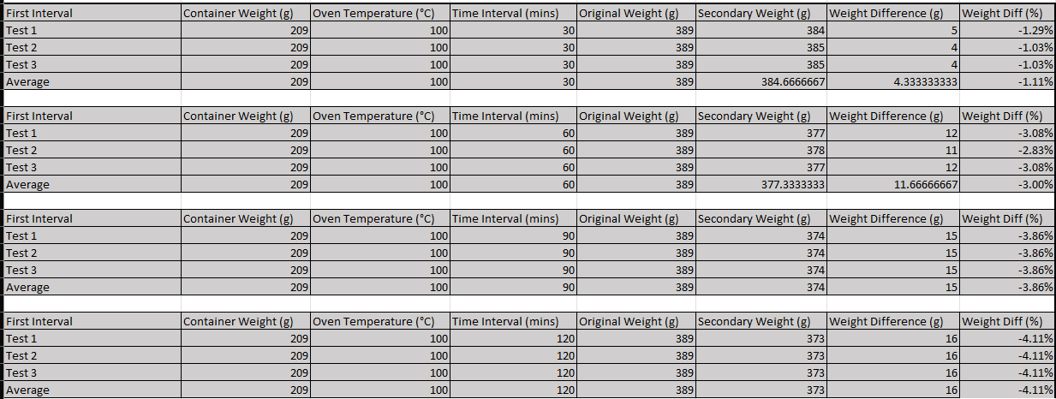
Figure 34 - First Interval at 100°C
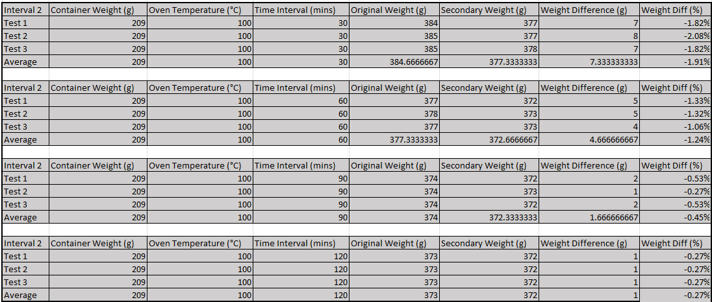
Figure 35 - Second Interval at 100°C
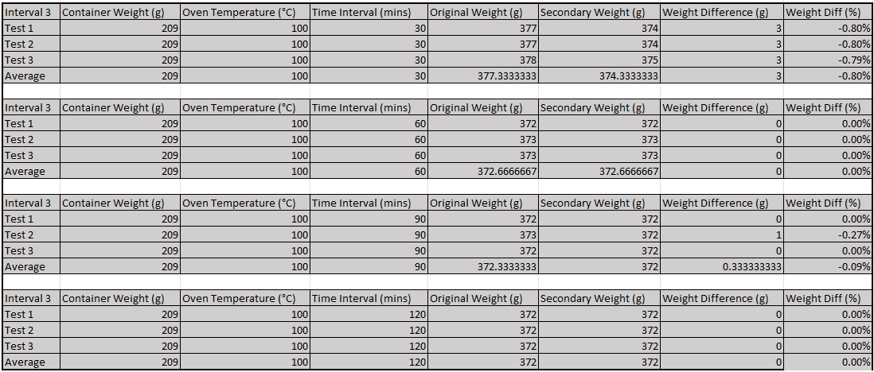
Figure 36 - Third Interval at 100°C

30 Minute Intervals
Figure 37, presented below, illustrates the variation in each sample's weight over the duration of the experiment. A mild decrease in weight is observed during the initial 30-minute interval of 1.11%, which can be attributed to the removal of moisture accumulated on the aggregate's exterior. As the experiment progresses through each interval, a continued loss of moisture is observed at an accelerated rate during the second interval at 1.91% and a decrease at 0.80% in the third interval. This acceleration is likely due to the heat retention within the container material between intervals or the aggregate has reached 100°C in the second interval which has further increase moisture loss from interior moisture.

Figure 37 - 30 Minute Intervals at 100°C.

60 Minute Intervals
Figure 38, displayed below, demonstrates the variation in the weight of each sample throughout the experiment. A significant decline in weight is evident during the initial 60-minute interval of 3%, which can be credited to the elimination of moisture present on the aggregate's surface. The significant decrease, followed by a levelling off in subsequent intervals, at 1.24% in the second interval and 0% in the third interval, suggests that moisture within the aggregate is also likely to have been removed.

Figure 38 - 60 Minute Intervals at 100°C.

90 Minute Intervals
Figure 39, depicted below, highlights the changes in each sample's weight throughout the experiment. A significant reduction in weight is observed during the initial 90-minute interval of 3.86%, which can be attributed to the elimination of moisture present on the aggregate's surface. The considerable drop and subsequent levelling from the further intervals, 0.45% in the second interval and 0.09% in the third, suggest that the moisture within the aggregate has likely been removed as well.

Figure 39 - 90 Minute Intervals at 100°C.

120 Minute Intervals
Figure 40, depicted below, highlights the changes in each sample's weight throughout the experiment. A significant reduction in weight is observed during the initial 120-minute interval of 4.11%, which can be attributed to the elimination of moisture present on the aggregate's surface. The considerable drop and subsequent levelling from the further intervals, at 0.27% in the second interval and 0% interval, suggest that the moisture within the aggregate has likely been removed as well. This has been observed on Figure 38 and Figure 39.

Figure 40 - 120 Minute Intervals at 100°C.

At 50°C
Samples were weighed at 389g each and subjected to heat at 50°C across different variations of time (Figure 44, Figure 45, Figure 46, Figure 47). The samples then went through a series of intervals to further decrease the moisture content and monitor the rate of moisture loss (Figure 41, Figure 42, Figure 43).
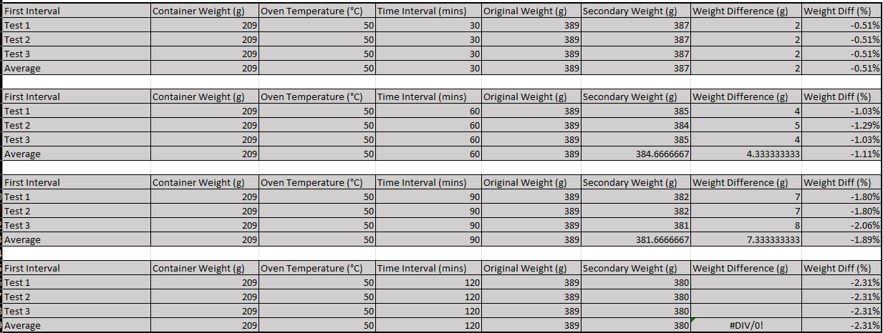
Figure 41 - First Interval at 50°C
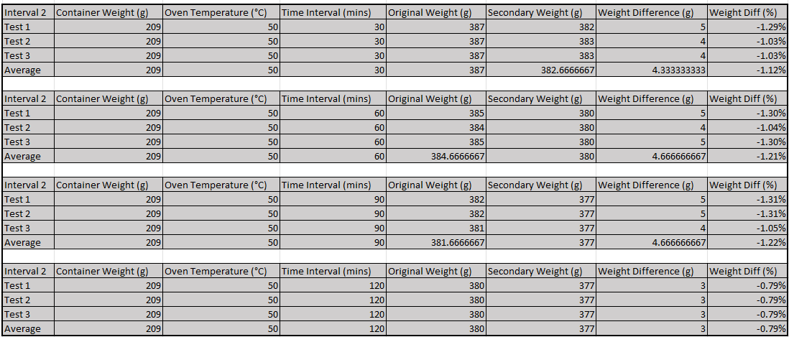
Figure 42 - Second Intervals at 50°C
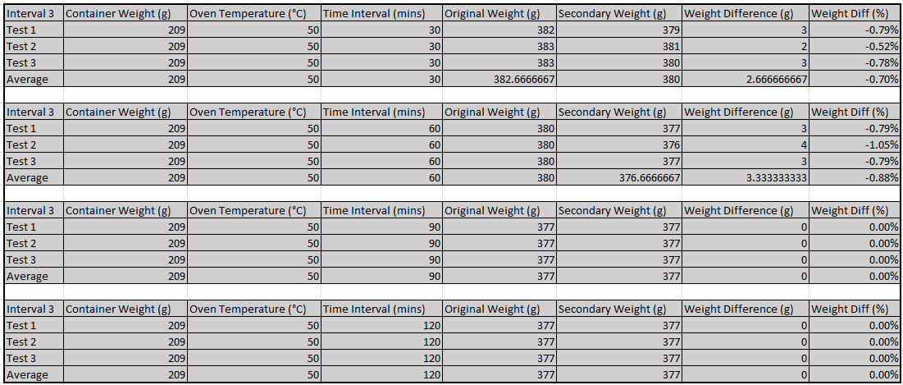
Figure 43 - Third Intervals at 50°C

30 Minute Intervals
Figure 37, presented below, illustrates the variation in each sample's weight over the duration of the experiment. A minor decrease in weight is observed during the initial 30-minute interval of 0.51%, which can be attributed to the removal of moisture accumulated on the aggregate's exterior. As the experiment advances through successive intervals, at 1.12% in the second interval and 0.70% in the third interval, there is a noticeable accelerating decrease in moisture content followed by a drop in the moisture loss rate. This phenomenon can be attributed to the aggregate's retention of heat from preceding test intervals, coupled with the heat maintained within the container itself. It is important to note that, in instances of elevated temperatures (Figure 26), a point is reached where no additional moisture can be extracted. Nevertheless, the absence of a levelling-off effect in the present case suggests that moisture extraction has not yet reached its limit and might be due to the 50-degree temperature being below the water boiling point. Consequently, moisture within the interior of the aggregate is potentially heated to warmer temperatures rather than being converted to steam, which could then fracture the aggregate and escape.

Figure 44 - 30 Minute Intervals at 50°C.

60 Minute Intervals
Figure 45, displayed below, demonstrates the variation in the weight of each sample throughout the experiment. A minor decline in weight is evident during the initial 60-minute interval of 1.11%, which can be credited to the elimination of moisture present on the aggregate's surface. Due to little evidence of weight loss levelling off, the significant decrease, followed by a levelling off in subsequent intervals, 1.21% in the second interval and 0% in the third interval, suggests that moisture within the aggregate is also likely to have been removed.

Figure 45 - 60 Minute Intervals at 50°C.

90 Minute Intervals
Figure 46, displayed below, demonstrates the variation in the weight of each sample throughout the experiment. A moderate decline in weight is evident during the initial 90-minute interval of 1.89%, which can be credited to the elimination of moisture present on the aggregate's surface. Significant decrease, followed by a levelling off in subsequent intervals, 1.22% in the second interval and 0% in the third interval, suggests that moisture within the aggregate is also likely to have been removed.

Figure 46 - 90 Minute Intervals at 50°C.

120 Minute Intervals
Figure 47, displayed below, demonstrates the variation in the weight of each sample throughout the experiment. A significant decline in weight is evident during the initial 90-minute interval of 2.31%, which can be credited to the elimination of moisture present on the aggregate's surface. Significant decrease, followed by a levelling off in subsequent intervals, 0.79% in the second interval and 0% in the third interval, suggests that moisture within the aggregate is also likely to have been removed.

Figure 47 - 120 Minute Intervals at 50°C.

Averages of Moisture Loss
Based on the results presented, specifically Figure 26 and Figure 33, it is observed that the aggregate's weight stabilizes at 372g when completely dry. By subtracting this weight from the initial measurement, the amount of moisture removed can be determined. The difference multiplied by 0.1 provides 10% of the moisture loss. Adding this value to the weight of the dried aggregate allows for the calculation of the desired moisture content. Utilising this indicator, the average weight across each time interval can be used to calculate the optimal time at which the aggregate should be removed from the experiment.
Figure 48, as presented below, illustrates the influence of varying temperature conditions on the rate of moisture extraction from the exterior and interior of the aggregate material. As observed, lower temperatures lead to a reduced rate of moisture removal and are inadequate in effectively extracting moisture from the aggregate's interior. This outcome is likely due to insufficient exposure to heat for an extended duration and the inability to boil moisture out from the interior.
In contrast, higher temperatures result in an accelerated rate of moisture removal and successfully extract moisture from the aggregate's interior, as demonstrated by the orange line (200°C). This line indicates that the aggregate surpasses the 10% moisture level after approximately 26 minutes. Due to the inaccurate measurements discussed previously (7.1.1)
As demonstrated by the grey line (150°C), the average sample reached 10% moisture content after approximately 65 minutes.

Figure 48 - Weight Loss Averages Across All Temperatures During 30-minute Intervals
Figure 49 below, displays the effect of sustained exposure to high temperatures. The initial temperature interval of 60 minutes across the temperatures exhibits a rapid decrease in moisture content, which subsequently stabilizes during the second and third intervals during temperatures exceeding 100°C.
As demonstrated by the grey line (150°C), the average sample reached 10% moisture content after approximately 65 minutes.

Figure 49 - Weight Loss Averages Across All Temperatures During 60-minute Intervals
Figure 50 below, displays the effect of sustained exposure to high temperatures, surpassing the optimal moisture content for different temperature inputs (200, 150, and 100). The initial temperature interval of 90 minutes across the temperatures mentioned above exhibits a rapid decrease in moisture content, which subsequently stabilizes during the second and third intervals during temperatures exceeding 100°C. This shows that the moisture has been completely extracted from the aggregate.

Figure 50 - Weight Loss Averages Across All Temperatures During 90-minute Intervals
Figure 51, as depicted below, further demonstrates a decline in moisture loss over an extended duration at a diminished rate after 90 minutes. Subsequent intervals exhibit no considerable alterations, lending further support to the assertion that moisture has been extracted.

Figure 51 - Weight Loss Averages Across All Temperatures During 120-minute Intervals

Discussion

Oven
As shown below (Figure 52), the oven initially heats up the air in the chamber during Phase 1 to the desired temperature. Once the desired temperature has been reached, the internal temperature is maintained shown by Phase 2 which is directly related to the heat loss to the outside environment. Once the oven has been turned off or the heat is reduced, energy is depleted shown by Phase 3.
2
3
1
Figure 52 - Phases of Energy Used in an Oven
The first phase requires a considerable amount of power to raise the temperature within the chamber. Once the temperature has been reached, less energy is required during Phase 2 to maintain the temperature. “In physics, the second law of thermodynamics says that heat flows naturally from an object at a higher temperature to an object at a lower temperature” (Holzner, 2016). Therefore, it is correct to assume even with efficient insolation, heat is still released. It is also appropriate to assume that the machine has points of leakage, even though no damage was observed during the experiment. It was observed that heat was released during the withdrawal of sample but due to the swiftness of the process, heat wasn’t significantly released and could quickly heat back to the controlled temperature.

Phase 1 – Heating Up
Phase 1 can be calculated, providing the following factors are known:
- Room Temperature (Typically 15-20°C)
- Time to heat up to desired temperature (20s at 200°C)
- Air mass (at 15°C=1.225kg/m³, at 20°C=1.204kg/m³)
- Oven Chamber Volume (Figure 54)
- Heat Capacity of Each Material
Given this, the following equation (Equation 1) can be used to calculate how many watts are needed to produce heat and reach the desired temperature.
Equation 1 - Power Equation
$\dot{W}=\frac{Q}{∆t}$
Where $\dot{W}$ represents power (watts, W), Q represents heat added (joules, J) and $∆$t represents the time interval (seconds, s)
To work out Q, the following equation (Equation 2) is used:
Equation 2 - Heat Equation
$$Q=c\text{ x }m \text{x }∆T$$
Where c represents the specific heat capacity of the material, m represents the mass of the material, and $∆T$ represents the temperature change.
Using the equations, we can solve the watts required to heat the materials and the air within the chamber at different temperature intervals.

Watts Needed at 100°C.
Firstly, it is essential to estimate the percentage composition of each material in the aggregate samples. Art of Eco has provided the known percentage values for certain materials in the aggregate, including sand, grit, binder, and graphene. However, the percentages for slate and cement were not given. Therefore, an assumption was made, and the remaining percentage was divided between these two materials. The percentage breakdown of known and assumed values is as follows as well as approximate heat capacity for each material:
- Grit – 40% (Known)
- Slate – 22.715% (Assumed)
- Cement – 22.715% (Assumed)
- Binder – 10% (Known)
- Graphene – 0.20% (Known)
- Water – 4.37% (Known from Experiments)
It is important to note that sand was not included in the composition of aggregate used during experimentation so will be excluded on further calculations.

Heating Up Air
The time required for the oven to reach 100°C without any sample material inside, heating only the air, must be determined. Additionally, it is assumed that the laboratory's ambient temperature is maintained at 20°C. Given this information, the oven chamber is already 10% prepared for heating. Thus, the change in temperature is as follows (Equation 3):
Equation 3 - Change in Temperature for 100°C
$$Change in Temperature=100-20=80°C$$
The time for the oven to reach 100°C is approximately 10 seconds which was recorded during experimentation.
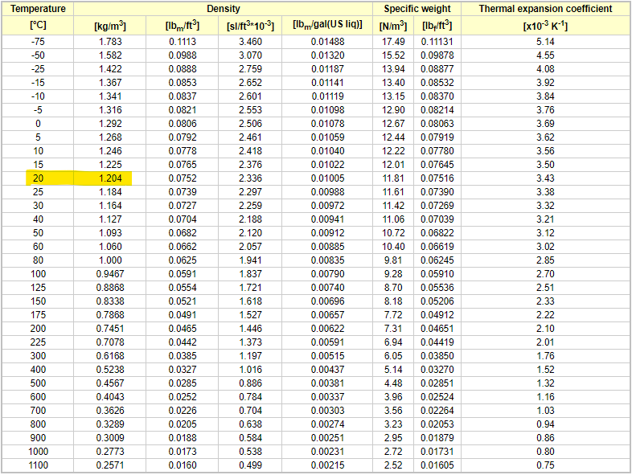
Figure 53 - Density of Air at 1 Atmosphere Pressure at Different Temperatures (°C) by (The Engineering ToolBox, 2003)
Now knowing the value of air density at 20°C is 1.204 kg/m³, the mass of the air can be calculated using the volume of the chamber (Figure 54) and the density, as demonstrated below (Equation 4):
Equation 4 - Air Mass Calculation at 20°C
$$m=\left(0.16 \text{x }0.18 \text{x }0.205\right)\text{ x 1.204 = 0.0071kg}$$
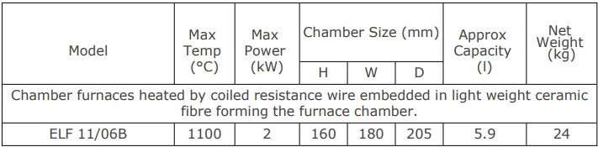
Figure 54 - Oven Specifications by (Carbolite Gero, 2021)
The remaining variable to determine is the specific heat capacity of air at constant pressure. The reasoning for using specific heat capacity at constant pressure is that the air is at atmospheric pressure. In contrast, constant volume would be used in situations where the oven is sealed and contains minimal air or zero air such as a vacuum oven. The specific heat capacity of air at constant pressure is given as 1.005 kJ/kg.K as shown below:
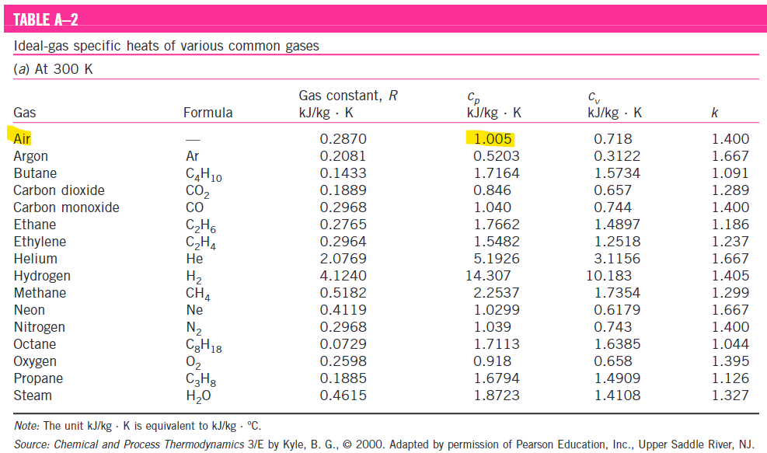
Figure 55 - Specific Heat Capacity of Air at Constant Pressure
With this information, the heat equation (Equation 2) can be applied:
Equation 6 - Heat Equation for Air
$$Q=1.005 \text{x }0.0071 \text{x 80 = 0.571}$$
Subsequently, the power equation (Equation 1) can be used with the previous calculation above which is equal to Q:
Equation 7 - Power Equation for Air
$$\dot{W}=\frac{0.571}{10}=0.0571kW=57.1W$$
This demonstrates that 57.1W is needed to heat the air inside the oven chamber to 100°C.

Heating Up Water
As the water in the aggregate is at room temperature it will be heated up to 100°C. By using the change of temperature equation (Equation 3), the heat being added is known. The mass of the water is also known through experiments (7.1) which gives the mass at 17g. This is 4.37% of the material composition from the 389g sample.
The time for the water to reach 100°C is unknown, however between the 30 minutes of the first and second interval. It can be observed that the second interval sees a significant decrease in moisture compared to the first interval. This is likely due to the aggregate reaching 100°C, which allows the moisture to boil out of the aggregate interior. The exact time cannot be measured due to limitations of not having instrumentation to measure the aggregate heat over the course of the experiment. An assumption that the aggregate reaches 100°C after approximately 45 minutes will be used to assume the water reaching 100°C.
Using the heat equation (Equation 2) with the known values as follows:
Equation 8 - Heat Equation for Water
$$Q=4.18 \text{x }0.017 \text{x 80 = 5.685}$$
Subsequently, the power equation (Equation 1) can be used with the previous calculation above which is equal to Q:
Equation 9 - Power Equation for Water
$$\dot{W}=\frac{5.685}{2700}=0.0021kW=2.11W$$

Heating up Aggregate - Grit
As the grit is at room temperature it will be heated up to 100°C. By using the change of temperature equation (Equation 3), the heat being added is known. The mass of the grit is unknown, but an assumption will be made based on the percentage of material in the aggregate which gives the mass at 155.6g. This is 40% of the material composition from the 389g sample.
The time for the aggregate to reach 100°C is unknown, however between the 30 minutes of the first and second interval. It can be observed that the second interval sees a significant decrease in moisture compared to the first interval. This is likely due to the aggregate reaching 100°C, which allows the moisture to boil out of the aggregate interior. Although the exact time cannot be measured due to limitations of not having instrumentation to measure the aggregate heat over the course of the experiment. An assumption that the aggregate reaches 100°C after approximately 45 minutes will be used to calculate wattage needed.
Using the heat equation (Equation 2) with the known values as follows:
Equation 10 - Heat Equation for Grit
$$Q=1 \text{x }0.1556 \text{x 80 = 12.448}$$
Equation 11 - Power Equation for Grit
$$\dot{W}=\frac{12.448}{2700}=0.0046kW=4.61W$$

Heating Up Aggregate – Slate
As the slate is at room temperature it will be heated up to 100°C. By using the change of temperature equation (Equation 3), the heat being added is known. The mass of the slate is unknown, but an assumption will be made based on the percentage of material in the aggregate which gives the mass at 88.34g. This is 22.715% of the material composition from the 389g sample.
The time for the aggregate to reach 100°C is unknown, however between the 30 minutes of the first and second interval. It can be observed that the second interval sees a significant decrease in moisture compared to the first interval. This is likely due to the aggregate reaching 100°C, which allows the moisture to boil out of the aggregate interior. Although the exact time cannot be measured due to limitations of not having instrumentation to measure the aggregate heat over the course of the experiment. An assumption that the aggregate reaches 100°C after approximately 45 minutes will be used to calculate wattage needed.
Using the heat equation (Equation 2) with the known values as follows:
Equation 12 - Heat Equation for Slate
$$Q=0.84 \text{x }0.08834 \text{x 80 = 5.94}$$
Equation 13 - Power Equation for Slate
$$\dot{W}=\frac{5.94}{2700}=0.00219kW=2.19W$$

Heating Up Aggregate – Cement
As the cement is at room temperature it will be heated up to 100°C. By using the change of temperature equation (Equation 3), the heat being added is known. The mass of the cement is unknown, but an assumption will be made based on the percentage of material in the aggregate which gives the mass at 88.34g. This is 22.715% of the material composition from the 389g sample.
The time for the aggregate to reach 100°C is unknown, however between the 30 minutes of the first and second interval. It can be observed that the second interval sees a significant decrease in moisture compared to the first interval. This is likely due to the aggregate reaching 100°C, which allows the moisture to boil out of the aggregate interior. Although the exact time cannot be measured due to limitations of not having instrumentation to measure the aggregate heat over the course of the experiment. An assumption that the aggregate reaches 100°C after approximately 45 minutes will be used to calculate wattage needed.
Using the heat equation (Equation 2) with the known values as follows:
Equation 14 - Heat Equation for Cement
$$Q=0.75 \text{x }0.08834 \text{x 80 = 5.3}$$
Equation 15 - Power Equation for Cement
$$\dot{W}=\frac{5.3}{2700}=0.0019kW=1.96W$$

Heating Up Binder
As the polyurethane binder is at room temperature it will be heated up to 100°C. By using the change of temperature equation (Equation 3), the heat being added is known. The mass of the binder is unknown, but an assumption will be made based on the percentage of material in the aggregate which gives the mass at 38.9g. This is 10% of the material composition from the 389g sample.
The time for the aggregate to reach 100°C is unknown, however between the 30 minutes of the first and second interval. It can be observed that the second interval sees a significant decrease in moisture compared to the first interval. This is likely due to the aggregate reaching 100°C, which allows the moisture to boil out of the aggregate interior. Although the exact time cannot be measured due to limitations of not having instrumentation to measure the aggregate heat over the course of the experiment. An assumption that the aggregate reaches 100°C after approximately 45 minutes will be used to calculate wattage needed.
Using the heat equation (Equation 2) with the known values as follows:
Equation 16 - Heat Equation for Polyurethane Binder
$$Q=1.5 \text{x }0.0389 \text{x 80 = 4.668}$$
Equation 17 - Power Equation for Polyurethane Binder
$$\dot{W}=\frac{4.668}{2700}=0.001728W=1.73W$$

Heating Up – Graphene
As the graphene is at room temperature it will be heated up to 100°C. By using the change of temperature equation (Equation 3), the heat being added is known. The mass of the graphene is unknown, but an assumption will be made based on the percentage of material in the aggregate which gives the mass at 0.778g. This is 0.2% of the material composition from the 389g sample.
The time for the aggregate to reach 100°C is unknown, however between the 30 minutes of the first and second interval. It can be observed that the second interval sees a significant decrease in moisture compared to the first interval. This is likely due to the aggregate reaching 100°C, which allows the moisture to boil out of the aggregate interior. Although the exact time cannot be measured due to limitations of not having instrumentation to measure the aggregate heat over the course of the experiment. An assumption that the aggregate reaches 100°C after approximately 45 minutes will be used to calculate wattage needed.
Using the heat equation (Equation 2) with the known values as follows:
Equation 18 - Heat Equation for Graphene
$$Q=5.1 \text{x }0.000778 \text{x 80 = 0.317}$$
Equation 19 - Power Equation for Graphene
$$\dot{W}=\frac{4.668}{2700}=0.000117W=0.12W$$

Total Watts Needed for 100°C Summary
- Air = 64.67W After 10 seconds
- Water = 2.11W After 2700 seconds
- Grit = 2.88W after 2700 seconds
- Slate = 2.19W after 2700 seconds
- Cement = 1.96W after 2700 seconds
- Polyurethane Binder = 1.73W after 2700 seconds
- Graphene = 0.12W after 2700 seconds
In total the energy requirements are an estimated 75.66W

Wattage to Dry One Tonne
Art of Eco receives one metric ton of aggregate, which is subsequently dried over time, with air drying being the current method during the summer months. Given that the energy consumption for heating 389g of aggregate at 100°C in the oven is 75.66W, that would make one metric ton of aggregate approximately 2,568 times larger. Therefore, the energy required to dry one metric ton of aggregate is approximately 194.29kW, assuming the same oven and 45-minute time interval is used. If Art of Eco were to invest in a larger oven with improved insulation, it could accommodate greater volumes of aggregate.

Cost Analysis
As it takes 194.29kW to dry one tonne of aggregate within 45 minutes. This would consume electricity at approximately 145.72kWh, as 45 minutes is three quarters of one hour. As depicted in Figure 11, this amount of kWh, places the company within the micro business electricity rates at 30.55p per kWh. So, the cost for drying one tonne of aggregate is equal to £0.3055 multiplied by 145.72kWh which is equal to £44.51.
Art of Eco have said that they use eight tonnes of aggregate annually at this current moment but would like to scale to 86 tonnes. To work out the current cost to dry eight tonnes of aggregate, then multiplying 145.72 by 8 which is equal to 1165.76kWh. This puts the company within the micro business rates at 30.55p per kWh. The cost for drying eight tonnes of aggregate is equal to £0.3055 multiplied by 1165.76kWh which is equal to £356.14 annually.
Due to Art of Eco wanting to scale up and not having the drying capabilities that an oven would bring. The above gives a good indication on what the costs of operating costs of a drying oven would approximately be. Firstly, multiply 145.72 by eighty-six which is equal to 12531.92kWh. This puts the company above the micro business rate and into the small business rates of 31.16p per kWh. So, the cost for drying eighty-six tonnes of aggregate is equal to £0.3116 multiplied by 12531.92kWh which is equal to £3,904.95 annually.
It would also be beneficial for the company to explore the option of storing energy in battery storage. This would allow the company to store energy for days when there isn’t much solar power.

Russel Roof Tiles – Case Study
Russel Roof Tiles, a large British supplier of concrete tiles saved £72,000 during the first year of combined heat and power solutions provided by e.on which covered 100% thermal demands and 70% of the electrical demands.
These are massive energy cost savings which puts the company back into control over their energy.

Renewable Energy Recommendation
Considering all information gathered during this report. The recommendation would be to use a solar photovoltaic system in conjunction with an oven. The reasoning for this, is that the solar panel system would not just provide electricity for the companies drying operations but also for other utility costs such as lights, electrical sockets, and electrical cars. This could mean that the entire company could reduce its carbon output in several ways.
If the company was to scale up, they would need a fast-processing equipment which can be controlled and is reliable. The oven can be controlled and is very reliable at giving the desired results (moisture content) and can be easily monitored or can change the desired results within a short period. With enough space, an industrial electric oven could be installed to accurately acquire the desired results, which would accelerate the company’s product output. Other methods of drying aggregate would simply take much longer or take a large amount of space.

Amount of Solar Panels
The amount of electricity produced by solar panels varies based on several factors. These include, location, panel orientation, shading, and local weather on average.
During the initial site visit, a feasibility study was conducted to see if solar panels could be installed on the roof of the building where Art of Eco is based. The roof angles down towards the Southeast, and during the winter, the forage was low compared to the summer where the forage will increase. The building is moderately elevated above the tree line, and on a hill (110m above sea level) providing open access for direct solar.
These factors can be used to calculate the number of solar panels needed to provide enough energy.
In the UK, at a latitude of 51°46’53” N, the Art of Eco facility is subject to 9.26 hours of day light during the winter months and 14.76 hours in the summer (Figure 10). There is approximately 3-4 peak sunlight hours per day, and with the roof facing south-east, the generation will not be as efficient however, it isn’t significant.
The following equation can be used to calculate how much a 5kW solar panel can produce considering the peak sunlight hours per day (Equation 20) and annually (Equation 21).
Equation 20 - Minimum kWh Produced Per Day
$$Minimum Per 5kW Panel Per Day=5 \text{x 3 = 15kWh}$$
Equation 21 - Minimum kWh Produced Annually
$$Minimum Per 5kW Panel Annually=15 \text{x 365 = 5475kWh}$$
Now that the annual kWh production from the 5kW solar panel has been worked out, the number of solar panels can be calculated using the following equations:
$$Amount of 5kW Solar Panels Needed=\frac{12531.92}{5475}=2.29$$
However, it isn’t possible to get a fraction of a solar panel so to reach 100% of the electricity needs to power the oven for drying the aggregate, three 5kW solar panels will be needed or the company could opt for less just to offset the electricity by a little and still use electricity from the grid.

Analysis
In the provided experimental data a consistent pattern of substantial weight reduction during the initial intervals (30-min, 60-min, 90-min, and 120-min) was observed across multiple figures during high temperatures (200°C,150°C,100°C), which can be attributed to the removal of moisture accumulated on the aggregate's exterior. As the experiments progressed, a slower rate of moisture loss was observed, likely due to moisture trapped within the aggregate being released as steam and causing the aggregate to fracture. Evidence of fracturing during experimentation was observed by the sound of “popping” after taking the samples out of the oven.
An anomaly was identified in Figure 23, where the first sample (orange) displayed a significantly lower weight compared to the other samples. This discrepancy was found to have resulted from an error in recording the initial weight. The mistake was rectified, with the corrected initial weight of approximately 382g, instead of the assumed 389g.
A comparison of Figure 23, 24, and 25 revealed a considerably lower weight loss in Figure 25. This discrepancy was attributed to a four-day break over the Easter holidays when the aggregate container likely evaporated within the laboratory due to high ambient temperatures and unregulated university room conditions. To enhance the accuracy of future tests, the container was sealed with cling film.
Figure 37 displayed a noticeable acceleration in the decrease of moisture content as the experiment advanced through successive intervals. This phenomenon can be attributed to the aggregate's retention of heat from preceding test intervals and the heat maintained within the container itself.
In experiments with elevated temperatures, such as Figure 26, a point was reached where no additional moisture could be extracted. However, in certain instances (Figure 47, Figure 46), the levelling-off effect occurred earlier on, suggesting that moisture extraction might not have reached its limit due to the temperature being below the water boiling point. Therefore, it was proposed that moisture within the interior of the aggregate might be heated to warmer temperatures rather than being converted to steam, which could then fracture the aggregate and escape. This provided interesting results, not seen with other temperatures and may suggest that temperatures below 100°C will not be effective at reaching desirable moisture content results.

Conclusion
In conclusion, temperatures above 100°C offer reliable results for reaching the desired moisture content of 10%. Whereas lower temperatures (50°C), insufficiently extracted enough moisture. However, higher temperatures are far below the target moisture content during longer time periods. For this reason, it would be recommended that aggregate is heated either at high temperatures but withdrawn earlier at a suitable time much less than this experiment showed or choose lower temperatures not less than 100°C but dry for longer durations.
It is important to note, that higher temperatures (150°C, 200°C) observed aggregate damage while withdrawing the samples from the oven. Suggesting the heat is causing too much stress on the aggregate. Therefore, a suitable option to reduce this would be to select a lower temperature for a longer duration.
Due to moisture extraction, the binders within the aggregate absorbed the moisture due to the humidity which then coalesced aggregate together. This was observed on all temperatures.
The main energy consumption during the experimentation was just the first phase where 75.66W were used at 100°C. The wattage to maintain the temperature is significantly low due to the insulation of the oven. Therefore, if Art of Eco were to make an investment into renewable technologies, it would be beneficial to dry the aggregate annually at a higher, reliable, and controllable volume.
The energy consumption requirements to scale up is relatively inexpensive and with solar panel generation, the energy cost would be offset or completely removed based on whether Art of Eco decide to invest in 5kW solar panels and an electrically powered oven.

Recommended Further Work
- Further work on the effects of high temperatures on aggregate needs to be considered as an aspect for product quality. Although high temperatures resulted in fast drying speed, there is unknown amounts of damage caused to not just the aggregate but also the binders. During experimentation, it was observed that the aggregate would “popcorn” and “crackle”. This is likely due to the aggregate fracturing due to gases escaping from the interior.
- Additional damage was observed at higher temperatures such as possibly the binder coalescing aggregate during the oven drying process. This is likely due to the binders absorbing the evaporating moisture.
- Further improvements should be made to the experimentation such as heating the oven and the aggregate at the same time. Then measure the aggregate temperature after every 5 minutes to check how long it takes to reach the controlled temperature. This would allow further accuracy in working out the wattage needed to process aggregate.
- Further work would include, finding suitable oven drying machinery for Art of Eco to use as they scale up the company. Concern around whether 86 tonnes is feasible without an oven drying process is questionable especially with limited space and employees to operate and maintain equipment.
- Work out the potential solar energy of the site to optimize and accurately calculate the power generation.

References
Behera, M., Bhattacharyya, S., Minocha, A. & Deoliya, R. a. M., 2014. Recycled aggregate from C&D waste & its use in concrete – A breakthrough towards sustainability in construction sector: A review. Construction & building materials, Volume 68, pp. 501-516.
British Electricity Prices, 2023. What are the average business electricity prices per kWh in 2023?. [Online]
Available at: https://www.businesselectricityprices.org.uk/cost-per-kwh/#:~:text=In%202023%2C%20the%20average%20unit%20price%20for%20business,Non-profits%20and%20charities%20can%20apply%20for%20discounted%20rates.
[Accessed 25 04 2023].
British Gas, 2023. Go greener with an air source heat pump. [Online]
Available at: https://www.britishgas.co.uk/home-services/boilers-and-heating/air-source-heat-pumps.html?source=HomeImprovement-Google-PPC&cid=PPC.cid_cname=ASHP_Generics&gclid=226c4493a71a119aa82220d8280e0191&gclsrc=3p.ds&msclkid=226c4493a71a119aa82220d8280e0191
[Accessed 2023 04 28].
Burnett, D. & Barbour, E. a. H. P., 2014. The UK solar energy resource and the impact of climate change. Renewable Energy, Volume 71, pp. 333-343.
Carbolite Gero, 2021. Installation, Operation and Maintenance Instructions. [Online]
Available at: https://www.carbolite-gero.com/downloads/operating-manuals/
[Accessed 27 04 2023].
Ceroni, F., Cosenza, E. & Gaetano, M. a. P., 2006. Durability issues of FRP rebars in reinforced concrete members. Cement & Concrete Composites, 28(10), pp. 857-868.
Cong, P. & Guo, X. a. G., 2021. Effects of moisture on the bonding performance of asphalt-aggregate system. Construction & building materials, Volume 295, p. 123667.
Energy Saving Trust, 2023. In-depth Guide to Heat Pumps. [Online]
Available at: https://energysavingtrust.org.uk/advice/in-depth-guide-to-heat-pumps/
[Accessed 28 04 2023].
Government Office for Science, 2021. Trend Deck 2021: Urbanisation. [Online]
Available at: https://www.gov.uk/government/publications/trend-deck-2021-urbanisation/trend-deck-2021-urbanisation
[Accessed 18 04 2023].
Hill, A. R. & Dawson, A. R. a. M., 2001. Utilisation of aggregate materials in road construction and bulk fill. Resources, Conservation and Recycling, 32(3), pp. 305-320.
Holzner, S., 2016. Flowing from Hot to Cold: The Second Law of Thermodynamics. [Online]
Available at: https://www.dummies.com/article/academics-the-arts/science/physics/flowing-from-hot-to-cold-the-second-law-of-thermodynamics-174307/
[Accessed 27 04 2023].
J M Mankelow, C. E. W. T. J. B. M. A. S. D. G. C., 2021. Collation of the results of the , London: Queen’s Printer and Controller of Her Majesty’s Stationery Office.
Mallick, R. B., Tao, M., Chen, B.-L. & O'Sullivan, K. a. C., 2011. Practical Method to Understand the Effect of Aggregate Drying on the Moisture Content of Hot-Mix Asphalt. Transportation Research Record, 2208(1), pp. 90-96.
Mehta, P. K. & Monteiro, P. J., 2014. Concrete: microstructure, properties, and materials. Fourth Edition ed. s.l.:McGraw-Hill Education.
Renewable Developments Wales, 2023. Why Welsh Solar?. [Online]
Available at: http://rdwales.co.uk/why-welsh-solar.htm#:~:text=South%20west%20Wales%20is%20one%20of%20the%20best,be%20produced%20on%20approximately%202%20hectares%20%285%20acres%29.
[Accessed 28 04 2023].
Roper, C., 2016. Learn Solar #1: How much solar power do we receive?. [Online]
Available at: https://octopus.energy/blog/learn-solar-1-how-much-solar-power-do-we-receive/
[Accessed 27 04 2023].
The Engineering ToolBox, 2003. Air - Density, Specific Weight and Thermal Expansion Coefficient vs. Temperature and Pressure. [Online]
Available at: https://www.engineeringtoolbox.com/air-density-specific-weight-d_600.html?vA=15&units=C#
[Accessed 2023 04 27].
Welsh Parliament - Senedd Research, 2021. Solar farm development in Wales- the latest figures.. [Online]
Available at: https://research.senedd.wales/research-articles/solar-farm-development-in-wales-the-latest-figures/
[Accessed 28 04 2023].
Xiao, J., Qiang, C. & Nanni, A. a. Z., 2017. Use of sea-sand and seawater in concrete construction: Current status and future opportunities. Construction & building materials, Volume 155, pp. 1101-1111.

