Control Theory Assignment

Table of Contents
Control Theory Assignment 1
Introduction 3
Task 1: PID Control in a PLC System 3
PID Controller Circuit Diagram ( 5
Closed-Loop (Ultimate Gain) Method 6
Critical Evaluation of Ziegler–Nichols Methods 6
Task 2: System Representation 7
Signal Flow Graph to block diagram (Lucidchart, 2026) 7
Signal Flow Diagram 8
Mason’s Gain Formula 9
Task 3(a): State-Space Modelling 9
Task 3 (b) Development of the State-Space Model 10
Task 3 (c) Determination of the Transfer Function from the State-Space Model 12
Task 4 (a) Principles and Applications of Root Locus Analysis 13
Task 4 (b) Root Locus Construction and Stability Analysis 14
Task 5: Frequency Domain Analysis 15
Bode Diagram 16
Nichol’s chart 17
Comparison and Evaluation 18
Conclusion 18
References 19

Introduction
Control systems are fundamental to modern engineering, enabling the regulation and automation of processes across industries such as manufacturing, robotics, and energy systems. A control system manages the behaviour of dynamic systems by using feedback to achieve desired outputs, ensuring stability, accuracy, and efficiency (Electrical4U, 2012).
One of the most widely used technologies in industrial control is PLC-based control, where programmable logic controllers (PLCs) are employed to monitor inputs, execute control algorithms, and control outputs in real time. PLCs are essential in automation due to their reliability, flexibility, and ability to operate in harsh industrial environments.
This assignment explores several key concepts in control systems. It begins with PID control, a widely used feedback mechanism that combines proportional, integral, and derivative actions to improve system performance. The discussion then moves to system representation, which provides mathematical models of dynamic systems, followed by state-space modelling, a modern approach that represents systems using sets of first-order differential equations.
Further analysis techniques are also examined, including the root locus method, which illustrates how system stability changes with varying parameters, and frequency response methods such as Bode and Nichols plots, which are used to analyse system behaviour in the frequency domain.
The purpose of this assignment is to develop a comprehensive understanding of control system analysis and design techniques, and to demonstrate how these methods can be applied to real-world engineering systems, particularly those involving PLC-based control.

Task 1: PID Control in a PLC System
A PID controller is one of the most widely used control strategies in industrial automation and is commonly implemented within Programmable Logic Controller (PLC) systems. Its purpose is to maintain a process variable, such as temperature, pressure, flow rate, or speed, at a desired setpoint by continuously calculating and correcting the error between the measured value and the target value.
In a PLC system, the PID controller operates as part of a closed-loop control system. The process begins when a sensor measures the current value of the controlled variable and sends this feedback signal to the PLC. The PLC then compares the measured value with the required setpoint. The difference between these two values is known as the error. The PID algorithm processes this error and generates an output signal, which is sent to an actuator such as a control valve, motor drive, or heater. This corrective action influences the process so that the error is reduced over time (National Instruments, 2023).
PLD control equation:
$$u\left(t\right)=K_{p}e\left(t\right)+K_{i}\int{e}\left(t\right)dt+K_{d}\frac{de(t)}{dt}$$

The term PID refers to the three control actions used in the algorithm: Proportional, Integral, and Derivative. Each of these terms contributes differently to the overall control response.
The proportional component produces an output that is directly proportional to the present error. This means that the larger the error, the greater the controller response. Proportional control improves responsiveness and reduces the immediate magnitude of the error. However, on its own, it is often unable to remove steady-state error completely.
The integral component responds to the accumulation of past errors over time. Its main purpose is to eliminate steady-state error by increasing the controller output until the process variable reaches the setpoint exactly. Although integral control improves accuracy, excessive integral action may lead to overshoot and a slower settling time (Bolton, 2015a).
The derivative component predicts future behaviour by considering the rate of change of the error. It acts as a damping term and helps the controller respond more smoothly by reducing overshoot and improving stability. Derivative control is especially useful in systems where the process variable changes rapidly. However, it can be sensitive to noise in the measurement signal (Wikipedia Contributors, 2023).
The main advantage of PID control within a PLC system is that it provides a balanced and flexible method of control. The proportional term gives fast reaction, the integral term removes residual error, and the derivative term improves stability and dynamic performance. As a result, PID controllers are suitable for a wide range of industrial applications and can achieve good accuracy, robustness, and efficiency when properly tuned (Bolton, 2015a).
In practice, PLC-based PID controllers are popular because they can be configured easily in software, integrated with sensors and actuators, and adjusted to suit different process requirements. Their effectiveness, however, depends greatly on correct tuning of the controller parameters.

PID Controller Circuit Diagram (Vyas, 2022)
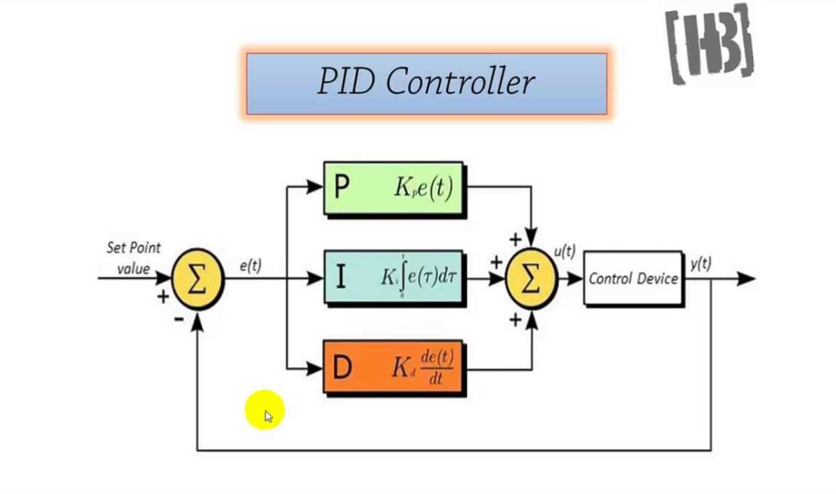

Ziegler–Nichols PID Tuning Methods
The Ziegler–Nichols tuning methods are widely used empirical techniques for determining suitable PID controller parameters. Developed to simplify controller design, these methods provide initial estimates for proportional, integral, and derivative gains based on observed system behaviour rather than detailed mathematical modelling (Lee, 2025).
Two principal methods are commonly applied: the open-loop (process reaction curve) method and the closed-loop (ultimate gain) method.

Open-Loop (Process Reaction Curve) Method
This method involves applying a step input to the process in open-loop conditions and observing the output response. The resulting curve is analysed to determine key parameters, specifically the process dead time (L) and time constant (T). These parameters are then substituted into standard Ziegler–Nichol’s formulas to estimate controller settings.
This approach is particularly suitable for systems that are inherently stable and can be tested without feedback control. It is commonly applied in process industries such as thermal or chemical systems.
However, the method has several limitations. It requires the system to be taken out of normal operation, which may not always be practical. In addition, the accuracy of the tuning depends heavily on correctly identifying the parameters from the response curve, which may be difficult in noisy or complex systems (Krunoslav Cvetko, 2026).

Closed-Loop (Ultimate Gain) Method
The closed-loop method involves operating the system under feedback control while adjusting the proportional gain. The controller is initially set to proportional-only mode, and the gain is gradually increased until the system exhibits sustained oscillations (Bolton, 2015). At this point, the gain is defined as the ultimate gain (Ku), and the oscillation period is recorded as the ultimate period (Pu).
These values are then used to calculate PID parameters using standard tuning relationships.
This method is advantageous because it can be applied directly to systems in operation and does not require detailed system modelling. It is widely used in industrial practice due to its relative simplicity.
Nevertheless, it introduces significant drawbacks. The process must be driven to the verge of instability, which may pose safety risks, particularly in critical systems. Furthermore, the resulting tuning parameters often produce an aggressive response, characterised by overshoot and oscillations, meaning further refinement is typically required (Staff, 2018).

Critical Evaluation of Ziegler–Nichols Methods
While both methods provide a practical starting point for PID tuning, they are not without limitations. A key drawback is that they are based on simplified assumptions about system dynamics and may not perform well for highly nonlinear or time-varying systems.
Additionally, the tuning rules often prioritise responsiveness over stability, leading to excessive overshoot and oscillatory behaviour. This can be undesirable in systems requiring high precision or smooth operation.
The open-loop method is generally safer but less flexible, whereas the closed-loop method is more widely applicable but carries a higher risk during implementation. In modern control engineering, these methods are often supplemented with optimisation techniques or software-based tuning to achieve improved performance.

Task 2: System Representation
A signal flow graph is a graphical representation of a control system that shows the relationships between system variables. Unlike block diagrams, which represent systems using functional blocks, signal flow graphs represent the system as a set of nodes connected by directed branches.
Each node represents a system variable, and each branch represents a transfer function or gain. The direction of the branch indicates the direction of signal flow.
Signal flow graphs are particularly useful for analysing complex systems because they allow the use of Mason’s Gain Formula to determine the overall transfer function in a systematic and efficient manner.

Signal Flow Graph to block diagram (Lucidchart, 2026)
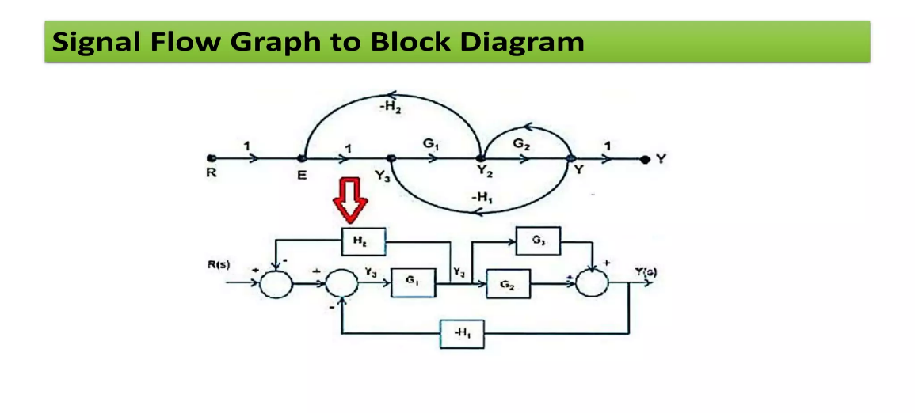

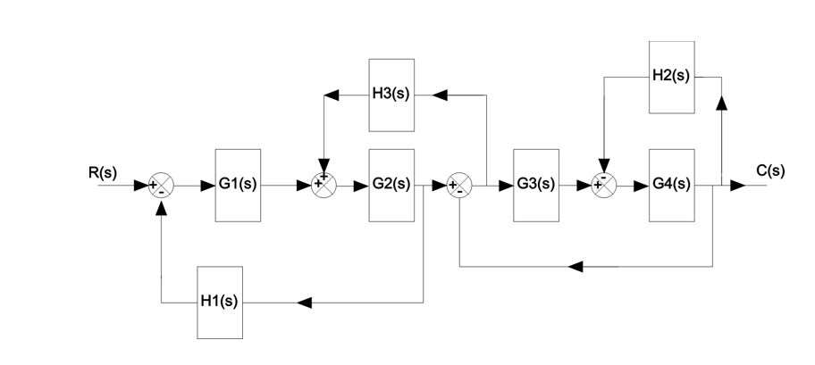

Signal Flow Diagram

H3(s) -H2(s)

1 G1(s) G2(s) G3(s) G4(s) 1

X1 X2 X3 X4 X5

-H1(s) -1

H3(s) -H2(s)

1 G1(s) G2(s) G3(s) G4(s) 1

X1 X2 X3 X4 X5

-H1(s)

Mason’s Gain Formula
$T\left(s\right)=\frac{Y(s)}{R(s)}=\frac{1}{∆}\sum_{k=1}^{p}{T}k∆k$

$$P_{1}=G1G2G3G4$$
$$∆=1-\sum{(loop gains)}$$
$$∆_{k}=1$$
$$\frac{C(s)}{R(s)}=\frac{P1}{∆}$$
$$\frac{C(s)}{R(s)}=\frac{G1 G2 G3 G4}{1+G4 H2+G3 G4+G1 G2 H1-G2H3-G2 G4 H2 H3+G1 G2 G4 H1 H2+G1 G2 G3 G4 H1}$$

Task 3(a): State-Space Modelling
State-space modelling is a mathematical technique used to represent dynamic systems using a set of first-order differential equations. It provides a structured way of describing how a system evolves over time in response to inputs and initial conditions (Huang, Miao and Li, 2024).
A key concept in state-space modelling is the state variable. A state variable represents the current condition of the system and contains enough information to determine the future behaviour of the system. These variables typically correspond to physical quantities such as displacement, velocity, current, or voltage.
A collection of state variables is known as the state vector. The state vector provides a complete description of the system at any given time. By using this vector, complex higher-order systems can be broken down into a set of simpler first-order equations.
The state equation describes how the state variables change over time. It relates the rate of change of the state variables to the current state and the system input (GeeksforGeeks, 2023).
$$\dot{x}\left(t\right)=Ax\left(t\right)+Bu\left(t\right)$$
$$y\left(t\right)=Cx\left(t\right)+Du\left(t\right)$$
X(t) = state vector
U(t) = input vector
Y(t) = output vector
A = system matrix (physics of system)
B = input matrix (actuators)
C = output matrix (sensors)
D = maps input to output
State-space modelling is particularly useful because it allows engineers to analyse systems with multiple inputs and outputs and to study the internal behaviour of the system, not just the relationship between input and output. It also forms the basis of modern control techniques such as state feedback and optimal control (Wikipedia Contributors, 2019).

Task 3 (b) Development of the State-Space Model
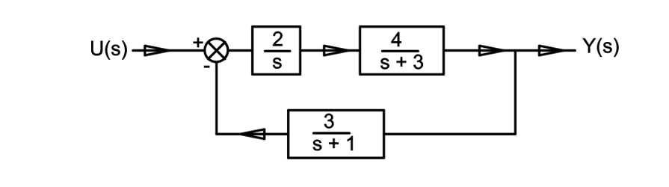
$$x_{1}=y→\dot{x}1=\dot{y}$$
$$x_{2}=\dot{y}→\dot{x}2=\ddot{y}$$
$$x_{3}=\ddot{y}→\dot{x}3=\overset{⃛}{y}$$

$$x_{1}=output of\frac{2}{s}$$
$$x_{2}=output of\frac{4}{s+3}$$
$$x_{3}=output of feedback block \frac{3}{s+1}$$
$$\dot{x1}=input x2$$
$$input=e=u-x_{3}$$
$$\dot{x1}=2(u-x_{3})$$
$$\dot{x1}=2u-2x_{3}$$

$$\dot{x1}=2u-2x_{3}$$
$$\dot{x2}=4x_{1}-3x_{2}$$
$$\dot{x}3=3x_{2}-x_{3}$$
$$y=x_{2}$$
$\left[\begin{aligned}\dot{x}1 \\ \dot{x}2 \\ \dot{x}3\end{aligned}\right]$=$\left[\begin{aligned}\begin{matrix}0 & 0 -2 \\ 4 & -3 0\end{matrix} \\ 0 3 -1\end{aligned}\right]\left[\begin{aligned}x1 \\ x2 \\ x3\end{aligned}\right]+\left[\begin{aligned}2 \\ 0 \\ 0\end{aligned}\right]$u
$$y=x_{2}$$

$y=\left[0 1 0\right]$ $\left[\begin{aligned}x1 \\ x2 \\ x3\end{aligned}\right]$ =$\left[0\right]$u

Task 3 (c) Determination of the Transfer Function from the State-Space Model

X= $\left[\begin{aligned}\dot{x}1 \\ \dot{x}2\end{aligned}\right]$=$\left[\begin{aligned}-2 2 \\ 1 3\end{aligned}\right]\left[\begin{aligned}x1 \\ x2\end{aligned}\right]+\left[\begin{aligned}0 \\ 1\end{aligned}\right]\left[u\right]$

$$y=\left[0 1\right]\left[\begin{aligned}x1 \\ x2 \end{aligned}\right]$$
$$D=\left[0\right]$$
Formula
$$G\left(s\right)=C(sI-A)^{-1}B+D$$

A=$\left[\begin{aligned}-2 2 \\ 1 3\end{aligned}\right],$
$$B=\left[\begin{aligned}0 \\ 1\end{aligned}\right]$$
$$C=\left[0 1\right]$$
$$D=0$$
$$sI=\left[\begin{matrix}s & 0 \\ 0 & s\end{matrix}\right]$$
$$sI-A=\left[\begin{matrix}s+2 & -2 \\ -1 & s-3\end{matrix}\right]$$
$$=\left(s+2\right)\left(s-3\right)-\left(-2\right)\left(-1\right)$$
$$=\left(s+2\right)\left(s-3\right)-2$$
$$=s^{2}-s-6-2$$
$$s^{2}-s-8$$
$$(sI-A)^{-1}B=\frac{1}{s^{2}-s-8}\left[\begin{aligned}2 \\ s+2\end{aligned}\right]$$
$$G\left(s\right)=\left[0 1\right] . \frac{1}{s^{2}-s-8}\left[\begin{aligned}2 \\ s+2\end{aligned}\right]$$
$$G\left(s\right)=\frac{s+2}{s^{2}-s-8}$$

Task 4 (a) Principles and Applications of Root Locus Analysis
Root locus analysis is a graphical technique used in control engineering to examine how the locations of the closed-loop poles of a system change in the complex $s$-plane as a system parameter, typically the gain $K$, is varied. It is based on the open-loop transfer function and provides a visual representation of how the system dynamics evolve as the gain is adjusted (https://www.facebook.com/electrical4u, 2012).
In a feedback control system, the position of the closed-loop poles determines the stability and dynamic behaviour of the system. As the gain $K$increases, the poles move along specific paths known as root loci. These paths begin at the open-loop poles and terminate at the open-loop zeros (or extend to infinity if there are more poles than zeros). By observing these trajectories, it is possible to predict how the system will respond to different gain values.
Root locus analysis provides important insight into system stability. A system is considered stable when all closed-loop poles lie in the left-hand side of the complex plane. If any pole crosses into the right-hand side, the system becomes unstable. Therefore, the root locus allows engineers to determine the range of gain values that maintain stability.
In addition to stability, root locus also gives information about the transient response of the system. The position of the poles influences characteristics such as rise time, settling time, overshoot, and damping. For example, poles located further to the left typically result in faster responses, while complex conjugate poles closer to the imaginary axis produce oscillatory behaviour with greater overshoot.
Furthermore, root locus is valuable in assessing overall system performance. By selecting an appropriate gain $K$, designers can achieve a balance between speed of response and stability. This makes root locus a practical tool for controller design and tuning.
The importance of root locus lies in its ability to provide a clear and intuitive graphical method for predicting system behaviour without requiring repeated algebraic calculations. It enables engineers to design and analyse control systems efficiently by linking the open-loop transfer function to the closed-loop performance (GeeksforGeeks, 2023a).

Task 4 (b) Root Locus Construction and Stability Analysis

System (a)
$$G\left(s\right)=\frac{K}{(s+2)(s+3)(s+4)}$$
Transfer function
$$TF=\frac{\frac{K}{(s+2)(s+3)(s+4)}}{1+\frac{K}{\left(s+2\right)\left(s+3\right)\left(s+4\right)}}$$

$$TF=\frac{K}{\left(s+2\right)\left(s+3\right)\left(s+4\right)+k}$$

Characteristic equation
$$\left(s+2\right)\left(s+3\right)\left(s+4\right)+K=0$$
$$\left(s+2\right)\left(s+3\right)=s^{2}+5s+6$$
($s^{2}+5s+6)(s+4)$
$$=s^{2}+9s^{2}+26s+24$$
$$s^{2}+9s^{2}+26s+24+K=0$$

start and end points
$$\left(s+2\right)\left(s+3\right)\left(s+4\right)=0$$
$$s=-2, s=-3, s=-4$$
$$3 poles 0 zeros$$

System (b)
$$G\left(s\right)=\frac{K}{(s+1+2j)(s+1-2j)(s+2)}$$

transfer function
$$TF=\frac{K}{\left(s+1+2j\right)\left(s+1-2j\right)\left(s+2\right)+k}$$

Characteristic equation
$$\left(s+1+2j\right)\left(s+1-2j\right)\left(s+2\right)+K=0$$
$$\left(s+1+2j\right)\left(s+1-2j\right)=(s+1)^{2}+(2)^{2}$$
$$s^{2}+2s+1+4)$$
$$=s^{2}+2s+5$$
$$(s^{2}+2s+5)(s+2)$$
$$=s^{3}+4s^{2}+9s+10$$
$$s^{3}+4s^{2}+9s+(10+K)=0$$
Start and end points
$$K=0$$
$$\left(s+1+2j\right)\left(s+1-2j\right)\left(s+2\right)=0$$
$$s=-1-2j$$
$$s=-1+2j$$
$$s=-2$$
$$3 poles 0 zeros$$

Task 5: Frequency Domain Analysis
Frequency domain analysis is a method used to study how control systems respond to inputs of varying frequency. Instead of analysing how a system behaves over time, this approach examines how the system reacts to sinusoidal inputs at different frequencies. This is important because many real-world systems are subjected to disturbances and signals that vary in frequency, such as vibrations, noise, and oscillatory inputs (uk.mathworks.com, n.d.). By analysing a system in the frequency domain, engineers can better understand its stability, robustness, and dynamic performance without needing to solve complex time-domain equations.

Bode Diagram
A Bode diagram is a graphical representation of a system’s frequency response. It consists of two separate plots:
- Magnitude plot (gain vs frequency)
- Phase plot (phase angle vs frequency)
Both plots are drawn against frequency on a logarithmic scale, which allows a wide range of frequencies to be analysed efficiently.

Bode diagram (Wikimedia.org, 2022)
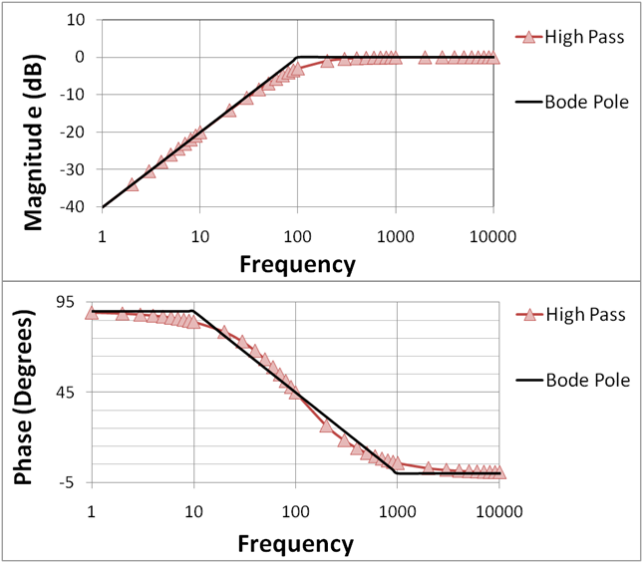

Bode diagrams are important because they provide a simple way to assess system stability using gain and phase margins, which indicate how far a system is from instability by showing how much gain can increase and how much additional phase lag can be tolerated.
Bode diagrams provide insight into system behaviour by showing bandwidth (which determines response speed), resonance (which indicates potential oscillations), and noise sensitivity (where high-frequency gain reveals noise amplification, meaning wider bandwidth gives faster response but high high-frequency gain increases noise).

Nichol’s chart
A Nichols chart is a frequency-domain tool that combines magnitude and phase into a single plot, with phase (in degrees) on the horizontal axis and magnitude (in dB) on the vertical axis.

Nichol’s chart (Mathworks.com, 2024)
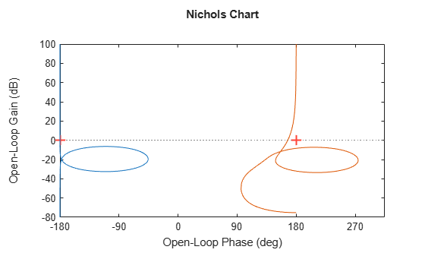

How it works
Instead of using separate plots like the Bode diagram. It is often used together with closed-loop contours, which allow engineers to predict how the closed-loop system will behave.
Nichols charts are important because they provide a compact and powerful way to analyse system behaviour, allowing engineers to assess stability and performance simultaneously, evaluate robustness more effectively, and design controllers using graphical techniques.

Comparison and Evaluation
Both Bode diagrams and Nichols charts are essential tools in frequency domain analysis, but they serve slightly different purposes.
Bode diagrams are generally easier to understand and are widely used for basic stability analysis. They provide clear insight into gain and phase margins and are suitable for initial system design and tuning.
In contrast, Nichols charts provide a more advanced method by combining magnitude and phase into a single plot. This makes them particularly useful for analysing system robustness and for designing controllers in more complex systems.
However, Nichols charts are less intuitive and require greater experience to interpret effectively. As a result, bode diagrams are often preferred for teaching and basic analysis, while Nichols charts are used in more advanced engineering applications.

Conclusion
This assignment has explored several fundamental concepts and analysis techniques used in control engineering and PLC-based control systems. The study began with PID control, examining how proportional, integral, and derivative actions work together within a PLC system to improve stability, accuracy, and dynamic performance. The importance of PID tuning was also discussed through the Ziegler–Nichol’s methods, highlighting both their practical applications and limitations.
The assignment also examined system representation techniques using signal flow graphs and Mason’s Gain Formula. These methods provide a systematic approach for analysing complex systems with multiple feedback paths and determining the overall transfer function efficiently.
State-space modelling was then investigated as a modern method of representing dynamic systems using first-order differential equations and matrix notation. This approach was shown to be particularly useful for analysing multi-variable systems and understanding internal system behaviour.
In addition, root locus analysis was explored as a graphical technique for studying how the closed-loop poles of a system move as the gain varies. This demonstrated the relationship between pole locations, system stability, and transient response characteristics.
Finally, frequency domain analysis was discussed through the use of Bode diagrams and Nichols charts. These techniques provide valuable insight into system stability, robustness, and frequency response behaviour, making them essential tools in practical control system design.
Overall, the assignment has demonstrated how different control engineering methods can be used together to analyse, model, and improve the performance of dynamic systems. These techniques form an important foundation for the design and operation of modern industrial automation and control systems.

References
Bolton, W. (2015a). Instrumentation and control systems. second edition ed. Amsterdam: Newnes.
Bolton, W. (2015b). Programmable Logic Controllers. Cambridge: Elsevier Science.
Electrical4U (2012). Control System | Closed Loop Open Loop Control System | Electrical4U. [online] Electrical4U. Available at: https://www.electrical4u.com/control-system-closed-loop-open-loop-control-system/.
GeeksforGeeks (2023a). Control Systems Root Locus. [online] GeeksforGeeks. Available at: https://www.geeksforgeeks.org/electronics-engineering/control-systems-root-locus/ [Accessed 30 Apr. 2026].
GeeksforGeeks (2023b). What is State Space Analysis ? [online] GeeksforGeeks. Available at: https://www.geeksforgeeks.org/electronics-engineering/what-is-state-space-analysis/ [Accessed 30 Apr. 2026].
https://www.facebook.com/electrical4u (2012). Root Locus Technique in Control System | Root Locus Plot | Electrical4U. [online] Electrical4U. Available at: https://www.electrical4u.com/root-locus-technique-in-control-system-root-locus-plot/#google_vignette [Accessed 30 Apr. 2026].
https://www.facebook.com/electricneutron (2025). PID Control in PLCs - Electrical Engineering Center. [online] Electrical Engineering Centre. Available at: https://www.electricneutron.com/pid-control-in-plcs/ [Accessed 21 Apr. 2026].
Huang, Y., Miao, S. and Li, P. (2024). What Can We Learn from State Space Models for Machine Learning on Graphs? [online] arXiv.org. Available at: https://arxiv.org/abs/2406.05815 [Accessed 29 Apr. 2026].
Krunoslav Cvetko (2026). Zn Open Loop Method. [online] Scribd. Available at: https://www.scribd.com/document/38051002/Zn-Open-Loop-Method [Accessed 27 Apr. 2026].
Lee, S. (2025). Ziegler-Nichols Tuning: Theory and Practice. [online] Numberanalytics.com. Available at: https://www.numberanalytics.com/blog/ziegler-nichols-tuning-theory-practice [Accessed 27 Apr. 2026].
Lucidchart. (2026). Visualize your ideas. [online] Available at: https://www.lucidchart.com/pages/landing/visualize-your-ideas?utm_source=bing&utm_medium=cpc&utm_campaign=_chart_en_tier1_mixed_pmax_strategic_&km_CPC_CampaignId=687628945&km_CPC_AdGroupID=1235852078116986&km_CPC_Keyword=www.lucidchart.com&km_CPC_MatchType=b&km_CPC_ExtensionID= [Accessed 2 May 2026].
Mathworks.com. (2024). Nichols Response with Nichols Grid Lines. [online] Available at: https://uk.mathworks.com/help/control/ref/dynamicsystem.nichols.html [Accessed 1 May 2026].
National Instruments (2023). The PID Controller & Theory Explained. [online] www.ni.com. Available at: https://www.ni.com/en/shop/labview/pid-theory-explained.html.
Staff, E. (2018). Ziegler-Nichols Closed-Loop Method (Ultimate Gain). [online] Inst Tools. Available at: https://instrumentationtools.com/ziegler-nichols-closed-loop-method-ultimate-gain/ [Accessed 27 Apr. 2026].
uk.mathworks.com. (n.d.). Practical Introduction to Frequency-Domain Analysis - MATLAB & Simulink Example - MathWorks United Kingdom. [online] Available at: https://uk.mathworks.com/help/signal/ug/practical-introduction-to-frequency-domain-analysis.html [Accessed 30 Apr. 2026].
Vyas, S. (2022). What is PID Controller? [online] Electrical Volt. Available at: https://www.electricalvolt.com/what-is-pid-controller/ [Accessed 2 May 2026].
Wikimedia.org. (2022). Category:Bode plots - Wikimedia Commons. [online] Available at: https://commons.wikimedia.org/wiki/Category:Bode_plots [Accessed 30 Apr. 2026].
Wikipedia Contributors (2019). State-space representation. [online] Wikipedia. Available at: https://en.wikipedia.org/wiki/State-space_representation [Accessed 29 Apr. 2026].
Wikipedia Contributors (2023). Proportional–integral–derivative controller. [online] Wikipedia. Available at: https://en.wikipedia.org/wiki/Proportional%E2%80%93integral%E2%80%93derivative_controller.



