
[Document title]
Assessment 2 Environmental Analysis of an industry (Rolls Royce)

Gabriela Borislavova Tosheva Student ID2116099
University of Wales Trinity Saint David

Summary

I will start my report with a brief introduction of the environmental analysis and how it is an essential factor that assists organisation with drawing effective understanding of factors associated with internal and external environment. I will talk about Porter`s diamond model also referred as “theory of national competitive advantage of industries”. Post COVID-19 pandemic, there have been several challenges that have arisen and impacted industries globally in a negative way. There are several methods that can be adopted by Rolls Royce to mitigate political challenges post pandemic.

Table of Contents

- Introduction
- Introduction
- Identification of Forces Associated with Global Business Environment
- Application of business Models
- Involvement of organisation in International Trade
- Assessment of factors associated with market
- Conclusion

1. Introduction
Environmental analysis is important tool that is necessary for any organisation to be assessed. It is an essential factor that assist organisations with drawing effective understanding of factors connected to the external and internal environments (Weersink et al., 2018, p.19). It is a necessity for organisations to understand and ensure environmental analysis as it helps with ensuring increased probability implementation of organisational changes and its appropriate reflection within the organisation. In this report I tried to highlight forces that are associated with global business environment and suggested appropriate business models in context of Rolls Royce. Moreover, necessity for organisations to be involved with international trade and that has been highlighted in this report.

2. Identification of Forces Associated with Global Business Environment
There have been potential changes post introduction of “industrialisation 4.0” and it has further helped in effectively revolutionising global networking approach. There have been major changes in global business environment in aspects of values, attributes, demographics, political uncertainty and several other aspects (Martínez-Ferrero and García-Sánchez, 2017, p.102). There are several forces that are responsible for shaping and influencing global business environment in context respective industries. First and foremost, force can be highlighted as “technological advancements.” Technological advancements have initiated ease of connectivity, application of artificial intelligence, and incorporated business with the influence of global platforms. It has impacted progressively on operational expenses (Leonidou et al., 2017, p.585). Moreover, this has also enabled providing efficient security towards storage of sensitive information. In addition, this has also allowed aspects with respect to improved communication approaches.
There have been major impacts of capital investments and evolution of money within several nations around the globe.
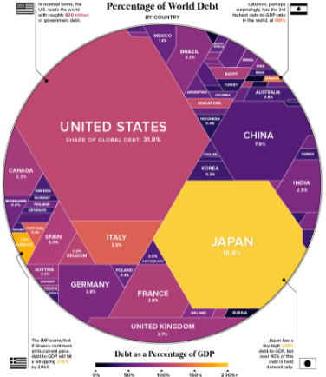
Figure 1: Portrays percentage of world debt by nations globally
(Source: Brannen et al., 2017)
Currency fluctuations can be regarded as a potential natural outcome of “floating exchange rates.” These aspects lead to impact upon functional aspects of merchandise trades and further a potentially weak currency contributes to trade deficits. Similarly, a strong currency might lead to an impact on trade surplus in a defined amount of time (Brannen et al., 2017, p. 139). Another major financial aspect that is regarded as a factor influencing global business environments are the capital flows that are being carried out within a nation, along with concerned inflation rates and interest rates.
Additionally, another major factor that is responsible for ensuring healthy global business activity can be highlighted as the “competitive environment” of businesses. Each global nation depicts a different competitive market or environment that has its own defined impact on a business. Moreover, when an organisation is entering a new target market it is required to identify its potential competitors for ensuring appropriate business activities (Clayton et al., 2016, p.199). There are several other factors or challenges that can be pointed out in context of global business environment such as; concern’s nation’s rules and legislations, lack of appropriate information exchange, and many more.

3. Application of Business Models

3.1 Porter’s Diamond Model
Porter’s diamond model is also referred to as “theory of national competitive advantage of industries.” This can be further expanded as a strategic tool that is used by organisations towards establishment of effective determination and development of a strategic approach towards international expansion and growth (Deng et al., 2018, p.1).
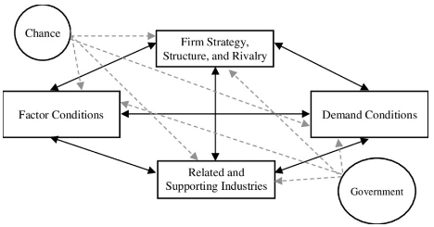
Figure 2: Portrays elements of Porter’s diamond model
(Source: Yang et al., 2020)
Above figure shows elements that can be progressively utilised by Rolls Royce for effective international business expansion. These elements can be described as ; “firm strategy, structure rivalry, related and supporting industries, factor conditions, demand conditions, chance and government” (Yang et al., 2020, p.7).

3.1.1 Factor Conditions
Resources with respect to Capitals
These can be addressed as financial resources that are potentially available for usage by Rolls Royce. The company can effectively extract these resources from debt finances and equity capital associates. Capitals based on equity are at large generated by Rolls Royce by effective application of channels and internal resources (Lee et al., 2018, p.383). Resources that are gained or debts that are acquired by Rolls Royce from external sources can be highlighted as debt-based capital.
Natural Resources
There are several natural resources that are available to Rolls Royce and are actively being utilised for running its firms. These can be highlighted as “water channels,” “glass,” “rubber,” “petroleum products,” and many more (Luna et al., 2018, p.26). These are potentially available for Rolls Royce due to their locations and further budget-oriented accessibility.

Human Resources
Human resources are a combination of skills and performance of individuals that are employed at Rolls Royce. Concerned organisation also consider providing training programs and associated investment programs with respect to human resources and global employee based (Awad and Amro, 2017, p.88).
Technological Innovation
Presence of appropriate skills effectively accounts for scientific knowledge within Rolls Royce, thus, this ensures technological innovations within its manufacturing aspects. Technological innovations are a key aspect of increasing economic outcomes and reduction of production costs and relevant operation costs (Rolls-royce.com, 2022).

3.1.2 Relevant Industries and Supporting Organisations
Presence of relevant and supporting industries are an essential aspect for international business expansion as it ensures effective acquisition of target markets (Rolls-royce.com, 2022).
Presence of Related and Supportive Industries
Presence of related industries in both domestic and global markets is a key aspect of growth and development for an organisation. This will help Rolls Royce in conducting effective business operations by provision of support materials that are a necessity for operational and functional approaches (Yeger and Shenhar, 2019, p.73). The presence of supporting industries will act as a facilitator for Rolls Royce and further will help with expansion of business.
Presence of Rivalry and Global Competitors
Presence of rivalry and global competition plays a key role in expansion and growth of a business as it ensures that there are probable advancements being adapted in concerned industry (Rolls-royce.com, 2022). Thus, rivalry and competitors will act as a catalyst for change, growth and development, and further innovation for Rolls Royce.

3.1.3 Business Strategy and Structure
This can be expanded as an organisation's approach towards management of strategic focus and organisational structure management (Yeger and Shenhar, 2019, p.73). These are quintessential points that are crucial for ensuring growth and functioning of an organisation in target market.
Organisational Strategy and Structure
The strategy that is adopted by Rolls Royce is prioritising consumers and provision of quality products. The company ensures valued products and services for consumer’s expenses and maintains a strategic focus upon needs of consumers (Batmunkh et al., 2017, p.98). Moreover, Rolls Royce functions based on a democratic leadership approach and further ensures active participation of employees at all levels.
Managerial System
The existing managerial system adapted by Rolls Royce is supportive as it ensures interest of all levels of employees and work towards their growth and development (Rolls-royce.com, 2022).

3.1.4 Government
Government Policies and Industry Legislations
There has been extensive support provided by concerned government of nations and further has helped Rolls Royce ensure financial and productive growth in the market. Moreover, this has also ensured effective access towards import and export norms (Taeihagh and Lim, 2019, p.103). Additionally, industrial regulations have also proved to be supportive for Rolls Royce and further ensure effective growth prior to presence of competitors.

3.1.5 Demand Conditions
Domestic Market Size and Consumer Needs
The size of the domestic market plays a key role in aspects of Rolls Royce in its internationalisation processes and relevant expansion measures. This helps with dynamic considerations of consumer needs in target market and helps to categorise the strengths and weaknesses (Rolls-royce.com, 2022). Consumer patterns are also responsible for anticipating behaviour and predicting demands in concerned target market.

4. Involvement of Organisations in International Trade
There are several reasons for the organisations to get actively involved in international trade. One of those reasons can be the “increased revenue gains.” This can be expanded as; international trade ensures that there is a potential gain in client base that is crucial for generating revenue (Taeihagh and Lim, 2019, p.103).
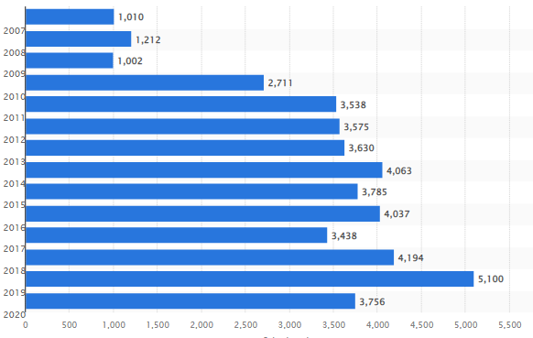
Figure 3: Portrays increased revenue by Rolls Royce
(Source: Statista.com, 2022)
The figure above shows the increased revenue gain that has been experienced with respect to internationalisation of their business. It can be concluded from the figure that there has been extensive gain in revenues by Rolls Royce from 2007 to 2020 (Statista.com, 2022). Thus, we can conclude that international trade is a key source of generating revenue.
Furthermore, another major benefit of international trade are the benefits from effective “currency exchange.” This will also act as a catalyst for increased revenue when currency exchanges are considered.
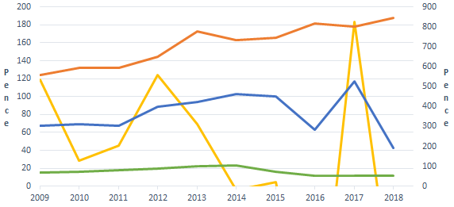
Figure 4: Beneficial outcomes from currency exchange for Rolls Royce
(Source: Rolls-royce.com, 2022)
The figure above shows the financial gains that have been acquired by Rolls Royce within a time span of 9 years. The orange-coloured market indicates revenue that has been gained by Rolls Royce with foreign currency management. It can be highlighted that it is the least affected in all its financial activities (Rolls-royce.com, 2022). Thus, we can conclude that the organisations can potentially benefit from currency exchange while considering international trade.

5. Assessment of Factors associated with Market
Post COVID-19 pandemic, there have been several challenges that have arisen and impacted industries globally in a negative way. There are several methods that can be adopted by Rolls Royce to mitigate political challenges post pandemic. There is a necessity for consideration with respect to involvement of external stakeholders that will help with effective political risk mitigation and further frame appropriate approaches for contingency plans (Clayton et al., 2016, p.199). Furthermore, there are several economic risks that are being borne by Rolls Royce. These risks can be mitigated with incorporation of “deployment timescales.” This can be expanded as a defined approach or framework that is structured and consistent in nature and further effectively aligns with business objectives and initiatives.
Major approach to management of economic risks are considerations of “international fiscal crisis.” This can be explained as effective maintenance of increased international government debt and decreased amounts of fiscal simulations in specific areas that are crucial to impose challenges. There are several measures that can be utilised with respect to mitigation of strategic issues-ensuring active engagement of consumer bases. Adapting to appropriate leadership and communication strategy along with framing of potential vision will also ensure mitigation of social issues (Batmunkh et al., 2017, p.98). In order to mitigate legal issues, Rolls Royce is required to adapt to an appropriate risk management plan, endorse organisational commitment and further ensure active identification and analysis of the risks. There is a necessity for considerations of adaptation of frameworks that are responsible for ensuring mitigation of environmental challenge. These frameworks can be adapting to models of energy efficiency, installations of renewables, adapting measures with respect to conservation of water, and further considering shipment of goods in frequent time periods.

6. Conclusion
It can be concluded from my report that internal business expansion is a crucial aspect for any business that is operating in any given part of the world. Rolls Royce has effectively considered its international expansion and gained a large amount of revenue. However, there are certain challenges that are being experienced by Rolls Royce post COVID-19 pandemic. These are associated with employment opportunities, revenue generation and many more aspects. This assessment with the help of Porter’s diamond model point out several measures that have been adopted and further are required to be adopted by Rolls Royce in order to ensure effective revenue generation and potential market growth.

Reference List
Awad, I.M. and Amro, A.A., 2017. The effect of clustering on competitiveness improvement in Hebron: A structural equation modeling analysis. Journal of Manufacturing Technology Management.
Batmunkh, U., Barnes, R., Barbosa, E., Kaya, Z.D. and Samuda, C., 2017. The Future of the UK Midlands Automotive Cluster.
Brannen, M.Y., Piekkari, R. and Tietze, S., 2017. The multifaceted role of language in international business: Unpacking the forms, functions and features of a critical challenge to MNC theory and performance. In Language in international business (pp. 139-162). Palgrave Macmillan, Cham.
Clayton, S., Devine-Wright, P., Swim, J., Bonnes, M., Steg, L., Whitmarsh, L. and Carrico, A., 2016. Expanding the role for psychology in addressing environmental challenges. American Psychologist, 71(3), p.199.
Deng, A., Yeo, A. and Du, L., 2018. A Study on Gwadar Port International Competitiveness using Porter’s Diamond Model. World Journal of Innovative Research, 4(1), pp.1-7.
Lee, Y.K., Porter, C., Diamond, S.L., Crocker, J.C. and Sinno, T., 2018. Deposition of sticky spheres in channel flow: Modeling of surface coverage evolution requires accurate sphere-sphere collision hydrodynamics. Journal of colloid and interface science, 530, pp.383-393.
Leonidou, L.C., Christodoulides, P., Kyrgidou, L.P. and Palihawadana, D., 2017. Internal drivers and performance consequences of small firm green business strategy: The moderating role of external forces. Journal of business ethics, 140(3), pp.585-606.
Luna, J., Addepalli, S., Salonitis, K. and Makatsoris, H., 2018. Assessment of an emerging aerospace manufacturing cluster and its dependence on the mature global clusters. Procedia Manufacturing, 19, pp.26-33.
Martínez-Ferrero, J. and García-Sánchez, I.M., 2017. Coercive, normative and mimetic isomorphism as determinants of the voluntary assurance of sustainability reports. International Business Review, 26(1), pp.102-118.
Taeihagh, A. and Lim, H.S.M., 2019. Governing autonomous vehicles: emerging responses for safety, liability, privacy, cybersecurity, and industry risks. Transport reviews, 39(1), pp.103-128.
Weersink, A., Fraser, E., Pannell, D., Duncan, E. and Rotz, S., 2018. Opportunities and challenges for big data in agricultural and environmental analysis. Annual Review of Resource Economics, 10, pp.19-37.
Yang, Y., Fabus, M., Bae, K.H. and Zhang, M., 2020. A diamond model based analysis for improving the sustainable competitiveness in educational exports by Chinese colleges and universities. Entrep. Sustain, (2020), p.7.
Yeger, D. and Shenhar, A.J., 2019. A Unified Framework for Classification of Business Model Transformations of Established Firms. Journal of Business Models, 7(4), pp.73-78.
Rolls-royce.com, 2022, Annual Report 2020, viewed on: 23/08/2021, viewed from: https://www.rolls-royce.com/~/media/Files/R/Rolls-Royce/documents/annual-report/2020/2020-full-annual-report.pdf
Statista.com, 2022, Worldwide Sales Volume Of Rolls-Royce Automobiles From 2007 To 2020, viewed on: 23/08/2021, viewed from: https://www.statista.com/statistics/267243/worldwide-sales-volume-of-rolls-royce-automobiles/

