

Assignment Title: Component 1: Individual Presentation (Academic Poster)

Student Name: Albert Malula
Student ID: 2310030

Table of Contents
Introduction to OCD 3
Historical and Contemporary Understanding of the Disorder 3
Evolution of Attitudes, Practices and Policies 5
Recommendations for Future Policy and Practice 6
Conclusion 7

Title: Obsessive Compulsive and Related Disorders
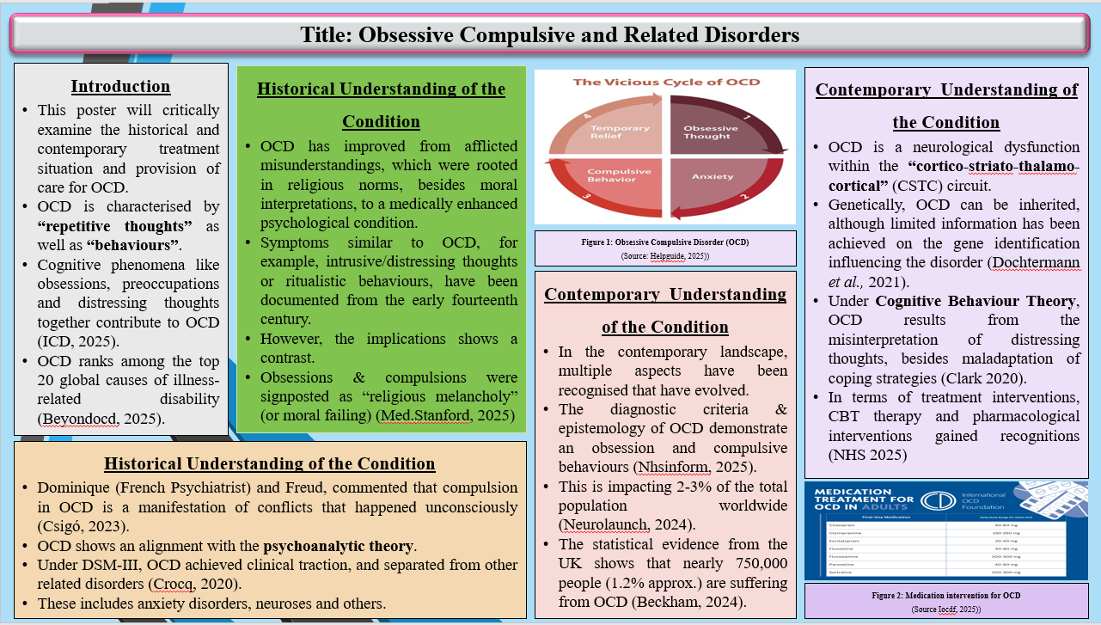
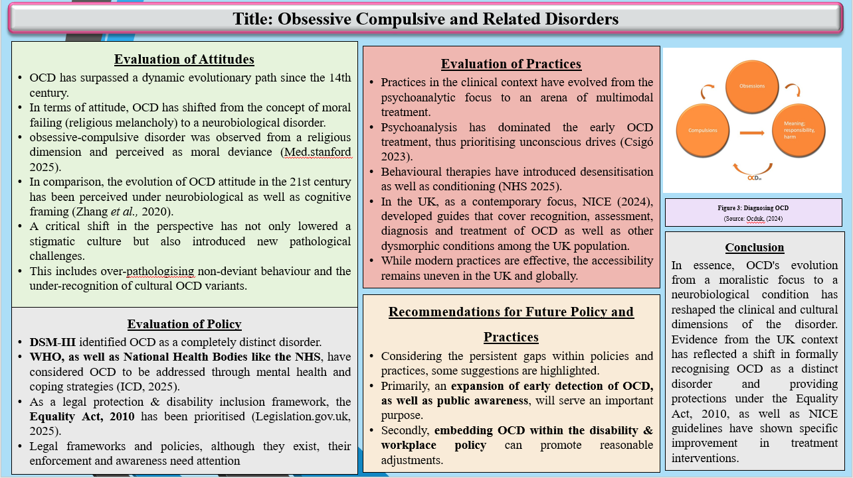

Introduction to OCD
Obsessive Compulsive & related Disorders (OCD) are multiple conditions, which are characterised by “repetitive thoughts” as well as “behaviours”. These thoughts are assumed to share a similar etiology, besides diagnostic validators. Evidence states that cognitive phenomena like obsessions, preoccupations and distressing thoughts together contribute to OCD (ICD, 2025). Based on the estimation by the World Health Organisation, OCD ranks among the top 20 global causes of illness-related disability (Beyondocd, 2025). Herein, the disorder is mostly prevalent among individuals aged 15-44 years.
Understandably, this poster will critically examine the historical and contemporary treatment situation and provision of care for OCD. Further, recommendations will be provided upon assessing the improvement needed in future policy and practices.

Historical and Contemporary Understanding of the Disorder
Over the years, an understanding of OCD has improved from afflicted misunderstandings, which were rooted in religious norms, besides moral interpretations, to a medically enhanced psychological condition. Notably, the evolution of knowledge has highlighted a different spectrum of treatment modalities available for the disorder (Mayoclinic, 2025). Historically, as explained by Ocduk (2025), symptoms similar to OCD, for example, intrusive/distressing thoughts or ritualistic behaviours, have been documented from the early fourteenth century, although the implications were different. Gradually, in the seventeenth century, as evidenced by Med.stanford (2025), obsessions & compulsions were signposted as “religious melancholy” (or moral failing). This has been demonstrated in the book “Anatomy of Melancholy” by Robert Burton in 1621 (Gowland, 2020). It has been stated that individuals were emotionally tormented for indecent behaviour under public discourse.
Between the nineteenth and early twentieth centuries, OCD was classified as a neurosis. This has been scientifically termed obsessive neurosis (Araujo et al., 2020). From multiple demonstrations as presented by Dominique (French Psychiatrist) and Freud, compulsion in OCD is a manifestation of conflicts that happened unconsciously (Csigó, 2023). Hence, OCD shows an alignment with the psychoanalytic theory. Gradually, between the mid and late twentieth century, obsession and compulsions were scientifically termed as “Obsessive Compulsive Disorder” (OCD), thus gaining medical recognition (1960-1970). Under the “Diagnostic and Statistical Manual of Mental Disorders” (DSM-III) in 1980, OCD achieved clinical traction, and separated from other related disorders, including anxiety disorders, neuroses and others (Crocq, 2020).
In the contemporary landscape, multiple aspects have been recognised that have evolved, including disease identification, development of policies and regulations, as well as improved treatment plans and provision of care. Notably, the diagnostic criteria & epistemology of OCD demonstrate an obsession and compulsive behaviours (Nhsinform, 2025). This is impacting 2-3% of the total population worldwide (Neurolaunch, 2024). The symptoms are typically recognised from the adolescent to the early adulthood period. The statistical evidence from the UK shows that nearly 750,000 people (1.2% approx.) are suffering from OCD (Beckham, 2024). At the same time, it has been identified that the lifetime prevalence rate has been estimated to be 2.3%, which shows an equal percentage of affected males and females (Ocduk, 2024).
From the neurological context, modern research explains that OCD is a neurological dysfunction within the “cortico-striato-thalamo-cortical” (CSTC) circuit. Zhang et al., (2020) explained that people with OCD show abnormal yet spontaneous activities of the cerebellum, with weakened motor functioning. On the other hand, from the genetic context, Dochtermann et al., (2021) explained that OCD can be inherited, although limited information has been achieved on the gene identification influencing the disorder. With the transition of knowledge on OCD, various theories have come into focus that have demonstrated OCD with psychological insights. Drawing attention to the “Cognitive Behavioural Theory” (CBT), Clark (2020) explained that OCD results from the misinterpretation of distressing thoughts, besides maladaptation of coping strategies. Correspondingly, Metacognitive Models emphasised beliefs regarding thinking itself.
Amidst understanding the vibrant focus on exploring the evolutionary concept of OCD, treatment approaches are explored. “Cognitive Behavioural Therapy” (CBT), as informed by the NHS (2025), is a communication therapy with exposure to nearly 8-20 sessions, followed by response prevention. This has been marked as a gold standard treatment intervention. Apart from this, pharmacological treatments, for example, SSRIs such as fluoxetine and sertraline, have been proven to be effective as a first-line contemporary treatment (Iocdf, 2025). From a cultural dimension, OCD in recent times has been manifested differently, with an emphasis on stigmatisation. On the other hand, Glazier et al., (2022) misdiagnosis remains a critical challenge, particularly in low-resource settings.

Evolution of Attitudes, Practices and Policies
Attitude
Upon exploring the literature review, it has been identified that OCD has surpassed a dynamic evolutionary path since the 14th century. In terms of attitude, OCD has shifted from the concept of moral failing (religious melancholy) to a neurobiological disorder. In the early 20th century, obsessive-compulsive disorder was observed from a religious dimension and perceived as moral deviance (Med.stanford 2025). This implies that affected individuals were stigmatised and even treated spiritually. In comparison, the evolution of OCD attitude in the 21st century has been perceived under neurobiological as well as cognitive framing (Zhang et al., 2020). This identification has evidence that OCD is a brain-based dysfunction, thus de-stigmatising the disorder with the growth of advocacy.
A critical shift in the perspective has not only lowered a stigmatic culture but also introduced new pathological challenges, for example, over-pathologising non-deviant behaviour and the under-recognition of cultural OCD variants.
Clinical Practices
Similar to the attitude toward OCD, practices in the clinical context have evolved from the psychoanalytic focus to an arena of multimodal treatment. Historically, as explained by Csigó (2023), psychoanalysis has dominated the early OCD treatment, thus prioritising unconscious drives. Contrastingly, behavioural therapies have introduced desensitisation as well as conditioning (NHS 2025). In the UK, as a contemporary focus, NICE (2024), developed guides that cover recognition, assessment, diagnosis and treatment of OCD as well as other dysmorphic conditions among the UK population. This guideline is critical for appropriate healthcare practices, thus scoring information on the responsibilities of individual mental health professionals. Additionally, pharmacological interventions like SSRIs and clomipramine are identified as widely used medications for treating OCD (Iocdf, 2025).
From a critical perspective of this information, it can be stated that while modern practices are effective, the accessibility remains uneven in the UK and globally. Moreover, the ERP treatment intensity highlights an irregular pattern of adherence. Hence, a call to more personalised and culturally-enhanced approaches is suggested.
Policy
Over the years, mental health policies have emerged as a progressive solution to balance the diagnostic process and treatment interventions of OCD, besides cultural instigation. As explained by Crocq (2020), DSM-III identified OCD as a completely distinct disorder. On the other hand, the WHO, as well as National Health Bodies like the NHS, have considered OCD to be addressed through mental health and coping strategies (ICD, 2025). As a legal protection & disability inclusion framework, the Equality Act, 2010 has been prioritised (Legislation.gov.uk, 2025). Relevant to OCD, the disorder has been identified as a “disability” under UK law, thus protecting individuals from discrimination across employment, academics, as well as public services.
From a critical focus, legal frameworks and policies, although they exist, their enforcement as well as awareness need attention, due to the persistence of stigma in the UK.

Recommendations for Future Policy and Practice
Indeed, the evolutionary landscape of OCD interventions has shown a significant improvement for many decades. However, considering the persistent gaps within policies and practices, some suggestions are highlighted. Primarily, an expansion of early detection of OCD, as well as public awareness, will serve an important purpose. Evidence shows that integrating an OCD screening process within routine practices can improve the mental health assessment. Additionally, training the frontline staff can help in recognising OCD symptoms with referrals. This early intervention is effective in reducing severity & long-term medical costs. Secondly, embedding OCD within the disability & workplace policy can promote reasonable adjustments. For instance, the updation of the NHS & NICE guidelines by including OCD-related examples can promote improvement in clinical practices.

Conclusion
In essence, OCD's evolution from a moralistic focus to a neurobiological condition has reshaped the clinical and cultural dimensions of the disorder. Evidence from the UK context has reflected a shift in formally recognising OCD as a distinct disorder and providing protections under the Equality Act, 2010, as well as NICE guidelines have shown specific improvement in treatment interventions. Nevertheless, critical perspectives show significant gaps in clinical access to OCD treatments and legal shortcomings. Notably, suggestions on future-proof policies and practices are provided.

Reference list
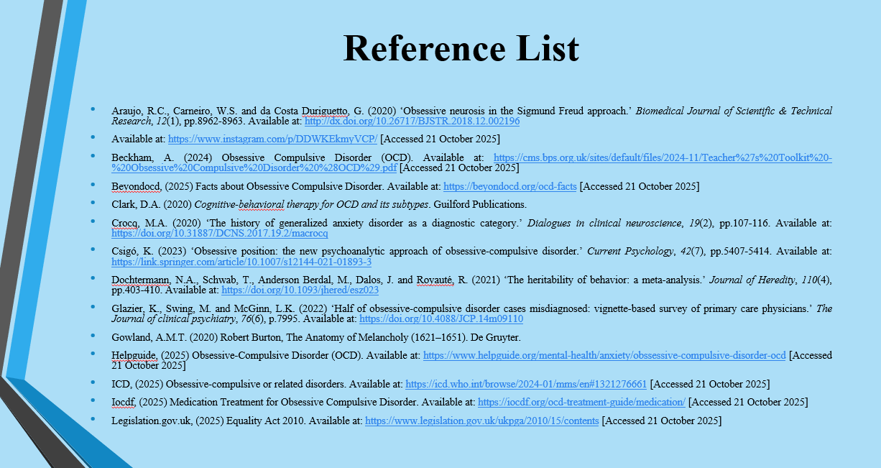
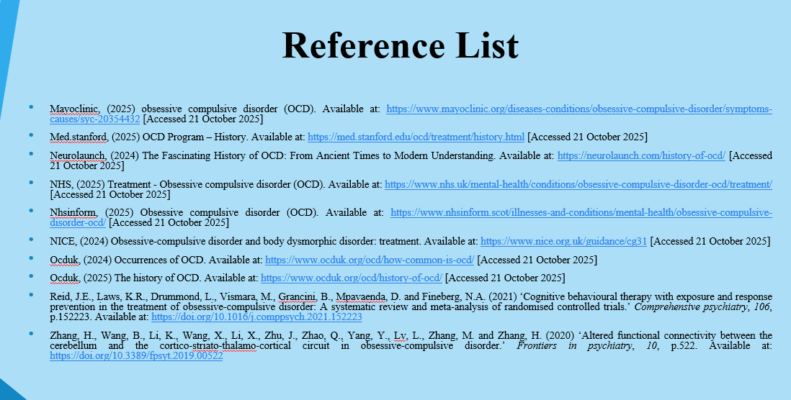
Araujo, R.C., Carneiro, W.S. and da Costa Duriguetto, G. (2020) ‘Obsessive neurosis in the Sigmund Freud approach.’ Biomedical Journal of Scientific & Technical Research, 12(1), pp.8962-8963. Available at: http://dx.doi.org/10.26717/BJSTR.2018.12.002196
Available at: https://www.instagram.com/p/DDWKEkmyVCP/ [Accessed 21 October 2025]
Beckham, A. (2024) Obsessive Compulsive Disorder (OCD). Available at: https://cms.bps.org.uk/sites/default/files/2024-11/Teacher%27s%20Toolkit%20-%20Obsessive%20Compulsive%20Disorder%20%28OCD%29.pdf [Accessed 21 October 2025]
Beyondocd, (2025) Facts about Obsessive Compulsive Disorder. Available at: https://beyondocd.org/ocd-facts [Accessed 21 October 2025]
Clark, D.A. (2020) Cognitive-behavioral therapy for OCD and its subtypes. Guilford Publications.
Crocq, M.A. (2020) ‘The history of generalized anxiety disorder as a diagnostic category.’ Dialogues in clinical neuroscience, 19(2), pp.107-116. Available at: https://doi.org/10.31887/DCNS.2017.19.2/macrocq
Csigó, K. (2023) ‘Obsessive position: the new psychoanalytic approach of obsessive-compulsive disorder.’ Current Psychology, 42(7), pp.5407-5414. Available at: https://link.springer.com/article/10.1007/s12144-021-01893-3
Dochtermann, N.A., Schwab, T., Anderson Berdal, M., Dalos, J. and Royauté, R. (2021) ‘The heritability of behavior: a meta-analysis.’ Journal of Heredity, 110(4), pp.403-410. Available at: https://doi.org/10.1093/jhered/esz023
Glazier, K., Swing, M. and McGinn, L.K. (2022) ‘Half of obsessive-compulsive disorder cases misdiagnosed: vignette-based survey of primary care physicians.’ The Journal of clinical psychiatry, 76(6), p.7995. Available at: https://doi.org/10.4088/JCP.14m09110
Gowland, A.M.T. (2020) Robert Burton, The Anatomy of Melancholy (1621–1651). De Gruyter.
Helpguide, (2025) Obsessive-Compulsive Disorder (OCD). Available at: https://www.helpguide.org/mental-health/anxiety/obssessive-compulsive-disorder-ocd [Accessed 21 October 2025]
ICD, (2025) Obsessive-compulsive or related disorders. Available at: https://icd.who.int/browse/2024-01/mms/en#1321276661 [Accessed 21 October 2025]
Iocdf, (2025) Medication Treatment for Obsessive Compulsive Disorder. Available at: https://iocdf.org/ocd-treatment-guide/medication/ [Accessed 21 October 2025]
Legislation.gov.uk, (2025) Equality Act 2010. Available at: https://www.legislation.gov.uk/ukpga/2010/15/contents [Accessed 21 October 2025]
Mayoclinic, (2025) obsessive compulsive disorder (OCD). Available at: https://www.mayoclinic.org/diseases-conditions/obsessive-compulsive-disorder/symptoms-causes/syc-20354432 [Accessed 21 October 2025]
Med.stanford, (2025) OCD Program – History. Available at: https://med.stanford.edu/ocd/treatment/history.html [Accessed 21 October 2025]
Neurolaunch, (2024) The Fascinating History of OCD: From Ancient Times to Modern Understanding. Available at: https://neurolaunch.com/history-of-ocd/ [Accessed 21 October 2025]
NHS, (2025) Treatment - Obsessive compulsive disorder (OCD). Available at: https://www.nhs.uk/mental-health/conditions/obsessive-compulsive-disorder-ocd/treatment/ [Accessed 21 October 2025]
Nhsinform, (2025) Obsessive compulsive disorder (OCD). Available at: https://www.nhsinform.scot/illnesses-and-conditions/mental-health/obsessive-compulsive-disorder-ocd/ [Accessed 21 October 2025]
NICE, (2024) Obsessive-compulsive disorder and body dysmorphic disorder: treatment. Available at: https://www.nice.org.uk/guidance/cg31 [Accessed 21 October 2025]
Ocduk, (2024) Occurrences of OCD. Available at: https://www.ocduk.org/ocd/how-common-is-ocd/ [Accessed 21 October 2025]
Ocduk, (2025) The history of OCD. Available at: https://www.ocduk.org/ocd/history-of-ocd/ [Accessed 21 October 2025]
Reid, J.E., Laws, K.R., Drummond, L., Vismara, M., Grancini, B., Mpavaenda, D. and Fineberg, N.A. (2021) ‘Cognitive behavioural therapy with exposure and response prevention in the treatment of obsessive-compulsive disorder: A systematic review and meta-analysis of randomised controlled trials.’ Comprehensive psychiatry, 106, p.152223. Available at: https://doi.org/10.1016/j.comppsych.2021.152223
Zhang, H., Wang, B., Li, K., Wang, X., Li, X., Zhu, J., Zhao, Q., Yang, Y., Lv, L., Zhang, M. and Zhang, H. (2020) ‘Altered functional connectivity between the cerebellum and the cortico-striato-thalamo-cortical circuit in obsessive-compulsive disorder.’ Frontiers in psychiatry, 10, p.522. Available at: https://doi.org/10.3389/fpsyt.2019.00522

