Introducing the Modern Workplace Assignment 2 2018 – Leading Individuals and Teams Effectively



23rd January 2018

MODULE NAME: INTRODUCING THE MODERN WORKPLACE: M4X00800
Name: Amy Collins, Rhodri Shepherd, Kate Oliver, Jack Gilmore JOnes & Cai ellis
Student Number: 1703573, 1702359, 1702582, 1706465 & 1706655

Table of Contents

Table of Contents
Background of The Organisation & Business Strategy Goals and Objectives – Rhodri Shepherd 3
Individual Differences, Diversity and Inclusion – Cai Ellis 5
Leadership and Management Behaviours – Kate Oliver (ECP) 6
Group and Team Behaviours – Jack Gilmore-Jones 6
Motivation and Perception – Amy Collins 8

Background of The Organisation & Business Strategy Goals and Objectives – Rhodri Shepherd

Background of the Organisation
This semester the group have been working with a charity called ‘The Rising Stars’. This organisation is not-for-profit therefore the way they motivate people is not monetary. The charity offers individuals the chance to express themselves through the medium of drama and dance weekly, and perform in front of an audience in yearly shows. According to the National Office of Statistics, “more than 10 million are reported to have activity limiting health problems in 2011”. (Office for National Statistics, 2013) This then backs up what the charity is doing such as providing disadvantaged children and adults an opportunity that they may not have elsewhere.

Business Strategy
Andrews (2012) describes business strategy as “the pattern of major objectives, purposes or goals and essential policies or plans for achieving those goals, stated in such a way as to define what business the company is in or is to be in and the kind of company it is or is to be.” (Lynch, 2012, p. 7) Overall, a strategic analysis answers these three important questions; the what, the why, and the how. The answers to these questions are in the vision statement, the mission statement, and a company’s values.

A vision statement “provides the overall frame of reference of what the organisation would like to reach and how it will look.” (Mullins, 2016, p. 509). While the vision statement is providing a more in-depth look at where an organisation would like to reach, the mission statement expresses an organisation’s purpose overall, which is then linked to the stakeholders and company values. (Johnson & Scholes, 2002). Whilst working with The Rising Stars the group created a vision statement which is to break the stereotype of children with learning difficulties, and spread the word of how theatre helps children who normally struggle in social situations. Also, the mission statement the group made was to promote, maintain, improve and advance the health, well-being, education, and citizenship of young people and adults with learning difficulties, particularly those within the Neath Port Talbot, Swansea and the surrounding areas. The difference in the vision and mission statements above is that the vision statement is more direct in what the group would like to achieve, whereas the mission statement is much vaguer. The importance of mission and vision statements are that they can promote the uniqueness and the way the organisation is different compared to the competition. The statements are available to the stakeholders, and are important to creating a strong brand identity. (Ingenhoff & Fuhrer, 2010)

Strategic choices are the steps that an organisation should take in order to use all the resources that are available. These resources include: financial and human resources, and the distribution channel. (Chron, n.d).
Miles and Snow’s Theory (1978) identified four business level strategies. These include, the defender, prospector, analyser, and reactor. A defender’s main focus is on maximising their current product portfolio and profits, and they do not look for new opportunities elsewhere. As a result of focusing mainly on what they have already, they can’t cope well with change, and find it difficult to adapt to new changes. Prospectors are the opposite to defenders, they can adapt well to change, but can lose efficiency elsewhere while doing this. They are more innovative rather than practical. The analysers instead of coming up with their own ideas, they adapt the ideas of competitors, and carry on with the ones they believe to be successful. Instead of making the mistakes, they let the prospectors make them first in order to avoid making the same mistakes. Lastly are the reactors, they are prepared to change if necessary, but aren’t necessarily prepared to do so without planning first. Miles and Snow (1978) see the reactors as failures because no planning has gone into their strategy. (Kew & Stredwick, 2005). A popular saying from Benjamin Franklin to support this is “by failing to prepare, you are preparing to fail” (Business Insider, 2011). This theory applies to more profit-making company as one of its main goals is to maximise profits. The Rising Stars is a not-for-profit organisation; therefore, money is not their main aim. The Rising Stars can adapt to change, but may lose efficiency elsewhere when doing so, this is because they would learn new scripts for new shows, but they would possibly find it difficult to implement the change in a short amount of time.

Goals and Objectives
Organisations that manage their goals effectively perform better. This is because all employees are set on specific tasks and projects in order to achieve an organisational goal, and therefore feel motivated because of this. (Halogen, 2014) After deciding what strategic approach the organisation is going to take, they can then set out the goals and objectives they would like to achieve. According to Sanchez et al (1996) “firms are distinguished by their distinctive set of goals, as well as by their individual approaches to achieving those goals.” Therefore, this shows that different organisations have different ways of achieving their goals.

The project objectives were:
- Recruit at least 5 committee members.
- Promote their next show which is on the 4th of March
- Create a Newspaper advertisement to show what they do for the community.
- Arrange an event with Ysgol Crug Glas.

When creating goals and objectives, an organisation must assure that they are SMART. According to Watson and Gallagher (2005) “are they stretching/specific, measurable, likely to be agreed/achievable, realistic and time-related?” (Watson & Gallagher, 2005, p. 114) If an organisation has an objective that is not SMART, then this can demotivate the workforce and therefore decrease the quality of the product or service. Because of miscommunication this effected the delivery of objectives, therefore not all of them were specific and achievable in the time we had available.

To conclude, an organisation must have a clear understanding of the strategic choice that they are going to make in order to determine the goals and objectives they are trying to achieve. Without a clear strategic choice, this can lead to poor goals being set which are not measurable and achievable. Therefore, without clear goals being set, an organisation is preparing to fail because when they are at full capacity, they will not know how to deal with stress and change.

Individual Differences, Diversity and Inclusion – Cai Ellis

In this section I will be discussing individual differences, diversity, and inclusion all in relation to Tuckman’s (1965) key stages of team development. Five stages exist within Tuckman’s theory, these are Forming, Storming, Norming, Performing, and Adjourning. Forming relates to the creation of the group, where different individuals will be sizing each other up so to speak. This is where roles for each member will be assigned on the basis of an individual’s strengths. Group members will be seeking to gain acceptance with their new partners, and will be sure to avoid any friction in order to ensure good relationship. As a result of a predetermined designated leader there was no conflict regarding the leadership role within the group. Lecturers took a unique approach towards arranging groups for students, they appointed a number of project managers to take charge of these groups. They then separated the other students by creating groups based upon different preferred roles, for example students would choose whether they are a team worker, a resource investigator, or a finisher. The leader would then pitch different students their project in an attempt to attract them to be a member, and can assemble a team with various specialties. This way of assembling groups helped avoid a number of problems between assigning roles to each member, as the members could’ve clashed on which roles they’d like to be.

The next stage of Tuckman’s theory is Storming, in this section group dynamics and initial problems may occur as the team are getting to know each other. Our group experienced these possibilities, friction arose when the project manager was unable to attend many group meeting, and even missed a group presentation. On occasions like these another member was forced to take the role of team leader, members found this unacceptable. This friction continued through the subsequent stages. Norming follows the storming stage, this is where each team member gains a better understanding of their role within the group, and the responsibilities which come with it. In this stage, certain members still clashed over how the group approached different assignments, a compromise often had to be made between members in order to proceed. Two different types of conflict exist, functional and dysfunctional (1967), the conflict that arose between members was always dysfunctional. Functional conflict is when the problem is solved, and all members learn from the experience. However, our conflict was dysfunctional as members did not experience growth as a result of it, and it divided our group. It was especially hard for our group as much of the conflict centered around the project manager, making it hard to manage for the other members of the group who had to continually intervene. After some time, the group will naturally transition into the Performing stage. This staged is reached when the group can work in harmony, the group are now familiar with one another. If conflict arises a solution can be made which benefits members, and helps improve the overall efficiency of the group. Our group is in this current stage, after a meeting to settle any differences or problems members experienced with each other our group was able to develop to this stage. Our team is always ready to perform and work on any task, an example of this was the stand we created to showcase our ongoing collaborative efforts with The Rising Stars Theatre Company. Each member contributed in the arranging and assembling of our stand, including how we would design our station, the information we chose to share, and how we should all present ourselves at the exhibit.
The final stage of Tuckman’s theory is Adjourning, this is where the group have completed all set tasks and are disbanding, our group is almost at this stage. However, I believe that when more group work arises our members will request to arranged together. As all problems are in the past we would return to previous form, and with the group in the performing stage from the beginning we could accomplish much more work, also to a high standard.

In hindsight, I believe our group should’ve held a meeting to discuss options each time conflict arose. In these meetings with every member present we could all evaluate the problem and come up with a solution which benefits the group. If we used this approach to conflict management then the group would’ve functioned much more efficiently, and a tremendous amount of time would be saved.

Leadership and Management Behaviours – Kate Oliver (ECP)

Group and Team Behaviours – Jack Gilmore-Jones
A work group is “Any number of people who: Interact with one another, Are psychologically aware of one another or Perceive themselves to be a group” (Schein 1988)
Working as a group or team can be very difficult and can lead to conflict as different opinions and personalities may clash, but working as a team can reap great rewards, as it may lead everyone to become more efficient in their work.
I feel that our team have been functioning as an authentic team, although we were previously functioning as a pseudo team since there was conflict within our group.
“An authentic team values responsibility, curiosity, authentic feelings and appreciation, pseudo teams, can have a name, roles and a budget but pseudo teams have conflict and operate at the cost of the individual mental state.”
I feel our group have moved from a pseudo team to an authentic team, as we no longer have conflict, and each take responsibility for the roles that we have within our group.
“The Johari window was created in 1955 and is a combination of names of the creators, psychologists Joseph Luft and Harry Ingham” (Mindtools). The Johari window is “A framework dividing information about oneself into four quadrants in an overall grid, mapping what other people do and do not know about me against what I know and do not know about myself” (Chandler and Munday)
Additionally, I feel that we are within the open area of the Johari Window, The Johari window is separated into 4 areas, “blind (information others might see in you but you can’t see yourself), unknown (information no one including yourself knows about you), hidden (within this area is what you know about yourself but others don’t know about you) and open (information accessible to all).” (mindtools video)
I feel like our team has greatly expanded the open area as we now discuss personal feelings with each other and have developed a great amount of trust. This has led us to improve our group communication skills and has allowed us to complete tasks with ease.
“5 Dynamics is a method, a way to work. Using this method, employees consider their work as a process.” (M. Sturm and Dr. P Nelson page 1)
The model tries to emphasise empowering the co-workers, firstly he would explore the co-workers understanding relationships with them and then the individuals. Next excite, he would get the team excited about the idea and then build the team, next he would examine, which would mean build schedules, budgets and try to predict problems. Now he would execute “Aggressively implement the plan. Hold people accountable. Measure performance. Compete. Strive for completion”. Finally, he would evaluate the success of the project evaluating the costing and the efficiency. (inspired from M. Sturm and Dr. P Nelson page 6)
The 5 dynamics model links together similar people to have the greatest work efficiency, where as the Belbin roles theory, brings together people with different characteristics to use their entire skill set to complete the task, which the 5 dynamics model says would cause conflict.
“When people work in effective combinations they achieve so much more than when they're working alone” (Dr. Meredith Belbin)
Belbin developed 9 evolved team roles Plant, Resource investigator, Co-ordinator, Shaper, Monitor-evaluator, Implementer, Team Worker, Specialist and finally Completer Finisher, Belbin suggests that these would match the majority of peoples personalities, and as long as that there was no more than one per group, and it was a combination of them in a team of no more than 5, then your group should have maximum efficiency and be able to solve problems within the work place.
“A team-role is a pattern of behaviour, characteristic of the way in which one team member interacts with another whose performance serves to facilitate the progress of the team as a whole.” (Dr. Meredith Belbin)
Belbin roles, mean that teams can pick and choose what type of people the team leader would want in their group, for example “It’s crucial to have team members that will drive the team to action: Shapers, Implementers, and Completer Finishers are results-focused, and will help the team get things done.” So, it implies that each group would need people who would cover all areas and create a balance within the group. But the 5 dynamics would argue that these different personalities within the group, would lead to differences of opinions due to the different perspectives, which may mean that time would be wasted arguing over little decisions, as well as potential difficulties within relationships of members of the groups. To summarise, Belbin roles and the 5 dynamics are somewhat opposites.
Within our groups we were assigned with Belbin roles, and team leaders were handpicked, the team leader then had the choice of people but told only there Belbin role and what that means. So, we all have our different skill sets, but I feel that it has worked out for the best, although as the 5 dynamics model suggests different personalities causes conflict, time and good team communication solved our problems leading to a more productive team and additionally the creation of an authentic team.
To conclude I feel that our team now performs as an authentic team, due to the Belbin Roles theory, and the team now has dependability, meaning “If someone says they are stuck, almost always 1-3 people will offer help. Often if that requires code change, that person will volunteer to just do it that day.” (P. Setty) So, we have not treated our Belbin roles as bounds, we have adjusted and gained flexibility through them.

Motivation and Perception – Amy Collins

“In general terms, motivation can be described as the direction and perception of action”. (Mullins, 2007. P 250)

“One view…is that satisfaction leads to performance. An alternative view is that performance leads to satisfaction”. (Mullins, 2007. P 277)

There are a variety of factors that contribute to motivating individuals at work. According to Forbes (2012) the top five factors are:

- Trustworthy Leadership
- Being Relevant
- Proving Others Wrong
- Career Advancements
- No Regrets

(Llopis, 2012)

Looking back at the previous semester, it was clear to see the group worked well within the Blumberg and Pringle’s (1982) criteria for motivation and job performance, resulting in excellent grades for each individual. As part of their individual attributes, every member of the group had the ability to perform to their best as well as being willing to perform and do well. The incentive for good grades really focused the group and motivated them to complete the work to the highest standard. The university gave the group their support and provided them with every opportunity to perform, motivating them and ensuring they were recognised for their hard work. (Blumberg & Pringle, 1982)

There are a wide range of theories that try to explain motivation, but due to the scope of this assignment, I am only able to discuss two approaches, content theories and process theories. Content theories include aspects such as Maslow’s hierarchy of needs and Herzberg’s hygiene factors which focus on the internal factors affecting individual’s motivation. However, the process theories focus on aspects such as expectancy and equity theories. (Joy, 2016)

Maslow’s (1943) theory illustrates how each level can motivate an individual, explaining that once the lowest level of need has been satisfied, it would no longer be considered to be a motivator to that individual. Figure 1 shows Maslow’s theory of the hierarchy of needs.

Figure 1. (McLeod, 2017)
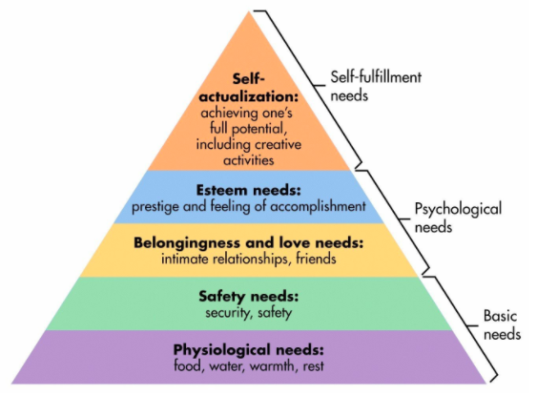
When the group was introduced to the task, their first intentions were to satisfy the basic needs before moving on to the psychological needs of building relations with each other for the deadlines ahead. After a week or two, the group started to build their relationships and began to perform like a team as each individual’s goals were the same. After receiving numerous results from other lecturers, the group’s esteem needs began to be satisfied. At this moment in time, with a showcase giving the group the opportunity to present themselves and their achievements, they are striving for the self-fulfilment needs.

The equity theory is part of the process theories that focuses on being fair. This theory is undertaken by individuals who compare their input- output ratio to others and find fairness and equity if the ratio balances. The theory is based on what is perceived to be fair, which can differ from person to person. (Beugre, 2007) Figure 2 demonstrates the equity theory in terms of individual’s inputs and outputs.

Figure 2. (Kandpal, 2015)
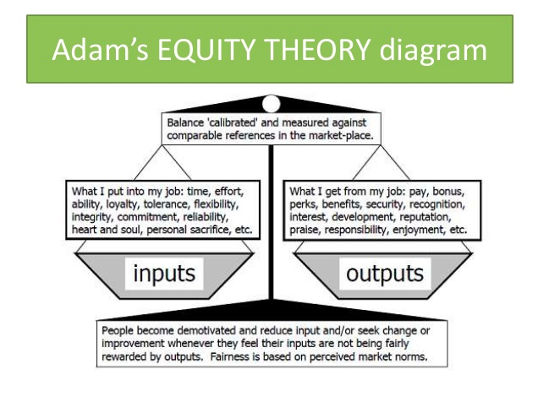
The work the group has done can be used in reference to Adam’s equity theory. The group has put in a lot of time and effort when working on their projects with their chosen organisation and have really been committed to the task given. In return for their efforts, they expect recognition, good grades, personal development as well as more responsibility for future tasks. (Kandpal, 2015)

“Perception is defined as the ability to see, hear, or become aware of something through the senses”. (Kris, 2015)

There are a variety of factors that affect people’s perception and it differs from person to person. Every individual has a particular way of seeing things and they understand it in their own way. (Mullins, 2016) In relation to working with The Rising Stars Theatre Company, the group began to see that some people often have bad perceptions of individuals with learning difficulties. That is why the group chose that organisation so they could raise awareness and potentially change people’s bad perceptions of the people who are involved in the organisation.
Previous experiences have been seen to affect people’s perception of things. It can start from stimuli from the environment and then it is selected at the beginning of the processing of information, to then be translated, resulting in an action. Figure 3 illustrates the process of processing information. (Mullins, 2007)
Figure 3. (Mullins, 2007)
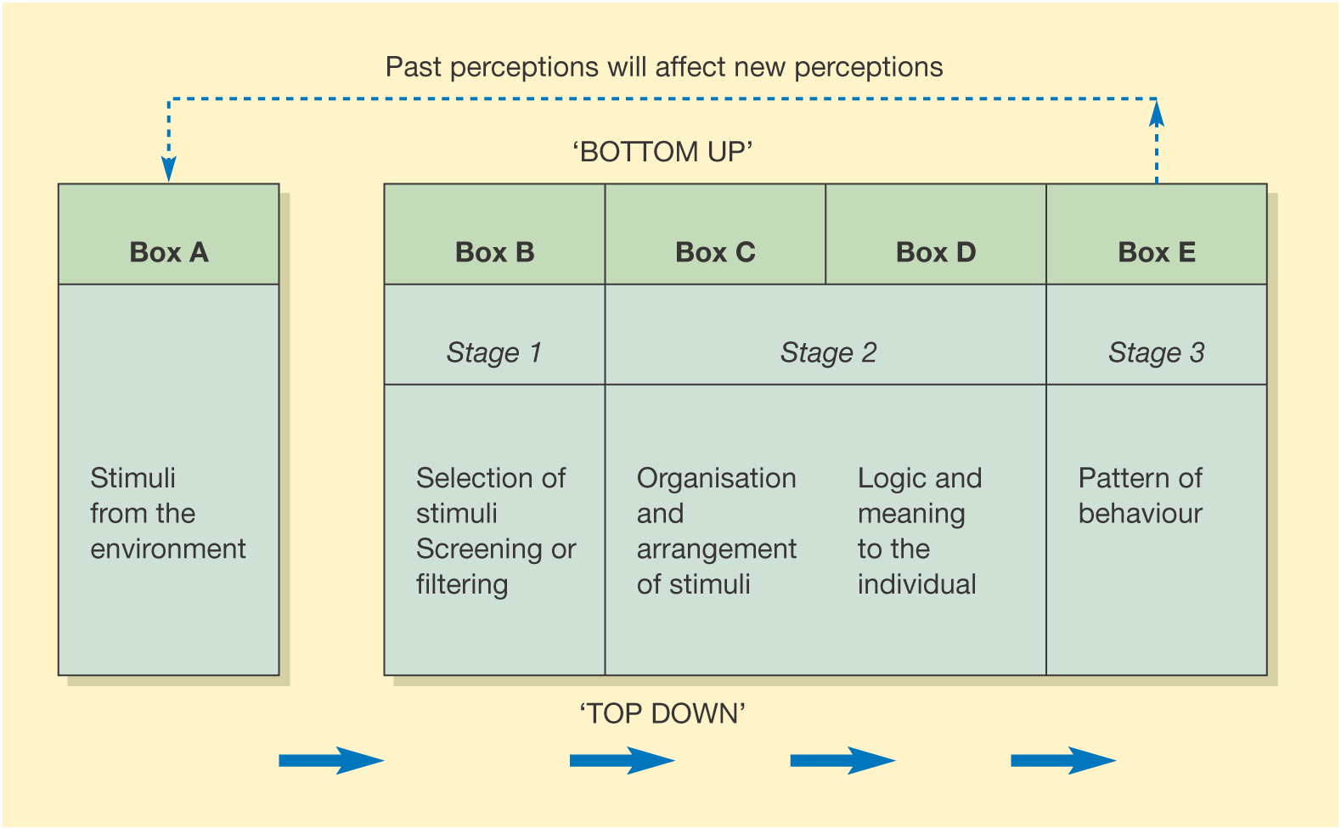
Intelligence, personality, past experiences and goals are just a handful of factors that affect an individual’s perception. Personality tests can be undertaken to demonstrate how individuals see things in different ways compared to others. (Mullins, 2007)
“A stereotype is a fixed general image or set of characteristics that a lot of people believe represent a particular type of person or thing.”. (Collins Dictionary, n.d)

The individuals at The Rising Stars Theatre company will be placed into a stereotype by certain individuals. This is where they are judge by categories such as their ethnicity or disability.
In society today, there has seen to be a rusty halo effect surrounding disadvantaged children. The rusty halo effect is where assumptions are made about individuals and perceive them to have negative characteristics. (Mullins, 2007) People perceive disadvantaged children to be different to other children, which is wrong. They may perceive this about them from past experiences, inherited the judgement from family or seen something in the media. (Talbot, n.d)
Overall, it is clear to see that there are many factors that drive motivation and not just money. Career advancements and trustworthy leaders are just two of the other factors that influence people’s motivation. Maslow’s (1943) hierarchy of needs suggests that all of the basic needs have to be met before motivation begins.

References
Rhodri Shepherd – Business Strategy, Goals and Objectives
Business Insider, 2011. 7 Must Read Life Lessons from Benjamin Franklin. [Online]
Available at: http://www.businessinsider.com/7-must-read-life-lessons-from-benjamin-franklin-2011-6?IR=T
[Accessed 22 January 2018].

Chron, n.d. Setting Objectives & Making Strategic Choices. [Online]
Available at: http://smallbusiness.chron.com/setting-objectives-making-strategic-choices-50236.html
[Accessed 21 January 2018].

Halogen, 2014. How to excel at goal management, s.l.: Halogen Software.

Ingenhoff, D. & Fuhrer, T., 2010. Ingenhoff, D. and Fuhrer, T., 2010. Positioning and differentiation by using brand personality attributes: Do mission and vision statements contribute to building a unique corporate identity?. Corporate Communications: An International Journal, 15(1), pp. 83-101.

Johnson, G. & Scholes, K., 2002. Exploring Corporate Strategy. 6th ed. s.l.:Financial Times Prentice Hall.

Kew, J. & Stredwick, J., 2005. Business Environment: Managing in a Strategic Context. 2nd ed. London: Chartered Institute of Personnel and Development.

Lynch, R., 2012. Strategic Management. 6th ed. s.l.:Pearson Education Limited.

Mullins, L. J., 2016. Management and Organisational Behaviour. 11th ed. Harlow: Pearson Education Limited.

Office for National Statistics, 2013. Disability in England and Wales. [Online]
Available at: https://www.ons.gov.uk/peoplepopulationandcommunity/healthandsocialcare/disability/articles/disabilityinenglandandwales/2013-01-30
[Accessed 22 January 2018].

Watson, G. & Gallagher, K., 2005. Managing for Results. 2nd ed. London: Chartered Institute of Personnel and Development.

Cai Ellis – Individual Differences, Diversity, and Inclusion

Lejk, M. and Wyvill, M., 2001. The effect of the inclusion of self-assessment with peer assessment of contributions to a group project: A quantitative study of secret and agreed assessments. Assessment & Evaluation in Higher Education, 26(6)

Pelled, L.H., Eisenhardt, K.M. and Xin, K.R., 1999. Exploring the black box: An analysis of work group diversity, conflict and performance. Administrative science quarterly

Pondy, L.R., 1967. Organizational conflict: Concepts and models. Administrative science quarterly

Tuckman, B., 2012. Conducting Educational Research. 1st ed. Maryland: Rowman & Littlefield Publishers

Van Knippenberg, D., De Dreu, C.K. and Homan, A.C., 2004. Work group diversity and group performance: an integrative model and research agenda. Journal of applied psychology

Jack Gilmore-Jones – Work Groups and Teams

Belbin North America. 2018. The Top 5 Ways Belbin Will Help Your Team Exceed Expectations. [ONLINE] Available at: http://belbin.improvingteams.com/blog/5-ways-belbin-will-help-your-team/. [Accessed 23 January 2018]
Chandler and Munday, D. R, 2011. A dictionary and media of communication. 1st ed. N/A: Oxford.
Dr Meredith Belbin. N/A. Why use Belbin?. [ONLINE] Available at: http://www.belbin.com/about/why-use-belbin/. [Accessed 23 January 2018].
Mindtools. 2018. The Johari Window. [ONLINE] Available at: https://www.mindtools.com/CommSkll/JohariWindow.htm. [Accessed 22 January 2018].
Mindtoolsvideo. (2014). Johari Window Video: Improve Communication and Trust and Learn About Your Team. [Online Video]. 19 August 2014. Available from: https://www.youtube.com/watch?v=skKBI8wcMaA. [Accessed: 22 January 2018].
Schein 1988
Setty, P., 2016. Goal Summit 2016: The science behind effective teams. [Online] Available at: https://www.youtube.com/watch?v=0K5Sr8MIcnU&t=1097s [Accessed 16 January 2018]. (11:27)
Sturm and Nelson, M and Dr. P, 2011. N/A. Foundations of the 5 Dynamics Model and Assessment, [Online]. 1, 1. Available at: https://www.5dynamics.com/wp-content/uploads/2012/06/5DynamicsFoundationsWhitePaperA090911.pdf [Accessed 22 January 2018].
Sturm Nelson, M and Dr. P, 2011. N/A. Foundations of the 5 Dynamics Model and Assessment, [Online]. 1, 6. Available at: https://www.5dynamics.com/wp-content/uploads/2012/06/5DynamicsFoundationsWhitePaperA090911.pdf [Accessed 23 January 2018].
The Conscious Leadership Group. (2017). Pseudo vs Authentic teams. [Online Video]. 8 February 2017. Available from: https://www.youtube.com/watch?v=pXEbzq3eRKM. [Accessed: 22 January 2018].
Amy Collins – Motivation and Perception
Beugre, C.D. (2007) ‘A Cultural Perspective of Organizational Justice’. North Carolina: IAP.
Blumberg, M. & Pringle, C. (1982) ‘The Missing Opportunity in Organizational Research: Some Implications for a Theory of Work Performance’. Academy of Management Review 1982 Vol.7, No. 4, 560-569.
Collins Dictionary. (n.d) ‘Definition of stereotype’ (Online) Available at: https://www.collinsdictionary.com/dictionary/english/stereotype (Accessed: 23 January 2018)
Joy, G. (2016) ‘Content Theory and Process Theory of Motivation’. (Online) Available at: https://www.linkedin.com/pulse/content-theory-process-motivation-gheethu-maria-joy (Accessed: 15 January 2018)
Kandpal, J. (2015) ‘Equity Theory of Motivation’ (Online) Available at: https://www.slideshare.net/JyotiKandpal2/equity-theory-of-motivation-53432579 (Accessed: 16 January 2018)
Kris, K. (2015) ‘What Is Perception’. (Online) Available at: https://www.quora.com/What-is-perception (Accessed: 12 January 2018)
Llopis, G. (2012) ‘The Top 9 Things That Ultimately Motivate Employees To Achieve’. (Online) Available at: https://www.forbes.com/sites/glennllopis/2012/06/04/top-9-things-that-ultimately-motivate-employees-to-achieve/2/#6b311087297c (Accessed: 13 January 2018)
McLeod, S. (2017) ‘Maslow’s Hierarchy of Needs’. (Online) Available at: https://www.simplypsychology.org/maslow.html (Accessed: 15 January 2018)
Mullins, L. (2007) ‘Management and Organisational Behaviour’. London: Pearson Education.
Talbot, S. (n.d) ‘How does media affect people and shape their perception of reality?’. (Online) Available at: https://www.quora.com/How-does-media-affect-people-and-shape-their-perception-of-reality (Accessed: 23 January 2018)

Appendices

Duties

The Rising Stars Theatre Company Report
Cover Page | Rhodri Shepherd
Contents Page | Amy Collins
Business Strategy, Goals and Objectives | Rhodri Shepherd
Groups and Teams | Jack Gilmore Jones
Motivation and Perception | Amy Collins
Individual differences, Diversity, and Inclusion | Cai Ellis
Leadership and Management | Kate Oliver
Checked Order and Format of References | Amy Collins and Rhodri Shepherd
Putting the Document Together | Amy Collins and Rhodri Shepherd

