Assessment Form

Module: Preparing for Professional Policing
Student Name: Connor Sturgess
Module Tutor (s): Kelly Andrews
Question | 1  Situation | 2  Task | 3.  Action | 4.  Result |  | Total Mark
1 | 3/5 | 1/5 | 9/15 | 2/5 |  | 15/30
2 | 4/5 | 4/5 | 14/15 | 4/5 |  | 26/30
3 | 3/5 | 1/5 | 13/15 | 2/5 |  | 19/30
 |  |  |  |  |  | Total Mark 60/90
Key
No Reference | Minimum | Satisfactory | Exceptional
0 | 0-4 | 5-10 | 11-15

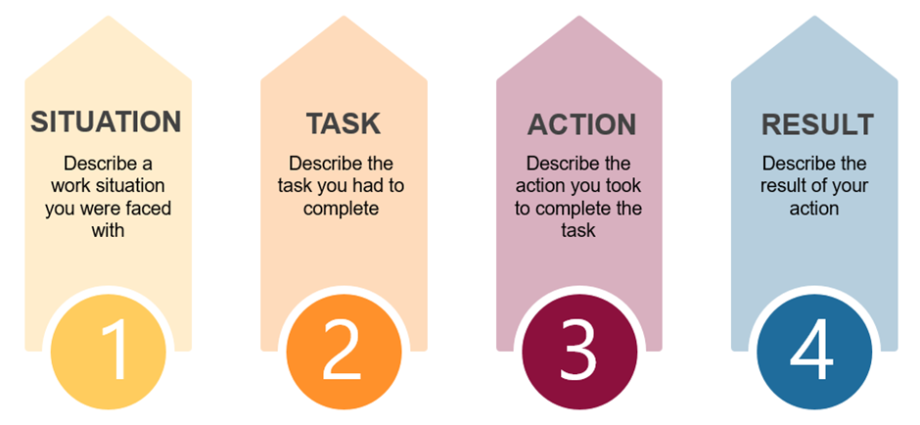

Question | Comments
1 | Q1  Work example – working in Tesco – only seven people working, busy because it was delivery day. I took control of the situation – created groups of who was in the store.  Allocated people to different role.  Task – needed to explain task in more detail.  Actions: Provided good level of detail – explained what could happen if the decisions would not have been made.  Result – everything was finished on time – needed a prompt for result.  Speak slowly so that you can be understood fully
2 | Q2  Special constable example:  Situation: Off duty – women crying saying he is dead. Boy on the floor – boy was purple – introduced myself as an off duty officer – it was very challenging. Needed more detail in situation section.  Task - needed to take control –  Actions: 8 CPR compressions – boy came back. I felt if I had not done this there wasn’t anyone else there who could have resolved it positively.  Result: Boy survived.  Very good example – remember to slow down and provide detail.
3 | Q8:  Special Constable example.  Situation: Victim of domestic violence – not willing to speak to officers at first.  Actions:  Sat down with her – reassured her. Use I not we. Took the time to explain the process to her, actively listened to her. Got her trust through actively listening. Went through the dash form with her. Took a statement took a lot of information. Highlighted not raising voice, which was good, no judgement building trust.  Needed to highlight task session in detail.  Result: Victim provided a complaint and male went to court.  .

.

.

