Placement Research Project

Matthew Childs

2128038

BMIH6006,6008

Ben Ka Po Chong

3rd March 2025

Word Count: 7050

References: 79

How does Premier Inn implement Sustainability and assess the impact that Generation- Z travellers have on the hotel industry?

‘I confirm that I have not used any AI tools in the research and creation of this assignment. I confirm that I have not presented any AI generated materials as my own work. I confirm I have copies of my drafts, notes, and other resources I used, which I may be asked to provide in evidence.’

Contents Page
- Cover page
- Contents Page
- Executive Summary
- Introduction
- Introduction
- Literature Review
- Literature Review
- Literature Review
- Literature Review
- Methods
- Methods
- Case Study Hotel Overview and Findings
- Case Study Hotel Overview and Findings
- Case Study Hotel Overview and Findings
- Case Study Hotel Overview and Findings
- Case Study Hotel Overview and Findings
- Case Study Hotel Overview and Findings
- Case Study Hotel Overview and Findings
- Case Study Hotel Overview and Findings
- Case Study Hotel Overview and Findings
- Discussion
- Discussion
- Discussion
- Discussion
- Discussion
- Discussion
- Conclusion
- Recommendations
- Recommendations
- Recommendations
- - 39. References

Executive Summary

This placement project endeavours to assess the sustainable practices within the Premier Inn placement hotel. The use of case study method and netnography has led to a deep dive of knowledge into the sustainable methods implemented by Premier Inn as well as the benefits and limitations of these. Generation-Z travellers have been found to be crucial targets when advertising and implementing strategies involving sustainability, this due to Gen-Z being defined as the ‘sustainable generation’. Howarth (2024) found that "Gen Z’s global purchasing power is $450 billion". It was found that remaining competitive within the market must be a priority to do this, hotels are required to follow trends and guest requirements with sustainability. Sustainability has became one of the hotel sector's biggest aims and goals while providing complications due to numerous legislations in place such as the Environment Act 2021 and the Waste management laws in place to ensure that all hotels operate sustainably within the community making this hugely important for the likes of Premier Inn, this is where they created their Force For Good sustainability model.

Gen-Z travelers typically choose sustainable stays creating a huge market where Premier Inn can advertise their sustainable practices to Gen-Z guests as well as there are huge costs associated with sustainability and the implementation of it. Hollander (2024) reported that hotels which show sustainable practices are chosen by 81% of people. It has been found that Premier Inn Hartlepool do operate sustainably and lead the way in the industry however there are threats and opportunities to be aware of and prepare for and work on these in order to be the best they can be, these discussed further below.

Introduction

This paper aims to answer ‘How does Premier Inn implement Sustainability and assess the impact that Generation- Z travellers have on the hotel industry?’. This research project is based on the Premier Inn Hartlepool Marina hotel in the North East of England, Premier Inn is part of the Whitbread chain who both own and operate all of their sites spanning across the UK, Germany and the UAE (Premier Inn, 2025). This placement project will review Sustainability within Premier Inn Hartlepool and specifically determine the impact Generation- Z travellers have on the hotel industry, Oxford languages (2025) defines Generation- Z as the “generation born in the late 1990s or the early 21st century, perceived as being familiar with the use of digital technology, the internet, and social media from a very young age”. Harvard Business School (2018) defines “sustainability in business as carrying out business activities without adversely impacting the environment, local community, or humankind”. This is especially important due to government legislations and EU policies in place in order to ensure that Premier Inn operates sustainably. In order to remain competitive within the market Premier Inn must show a commitment to being sustainable due to the fact that Sustainability is still one of the most commonly voiced movements in the hospitality sector (Kim, 2019). Premier Inn (2025) have shown a commitment to sustainability in the previous years with their sustainability scheme, Force For Good, this outlines their targets in what they endeavour to achieve, the biggest being Net Zero by 2030. They already boast numerous sustainable practices including sustainable energy supplies including the use of solar panels, which Premier Inn Hartlepool Marina have, as well as using 100% renewable energy within all of its hotels through their choice of supplier (Scottish Power) who power all Premier Inn hotels with 100% renewable electricity. Due to being a south facing coastal hotel, Premier Inn Hartlepool is a perfect site for solar powered energy.

Research by Khatter (2021) found that there are considerable obstacles to implementing and maintaining sustainability within the hotel sector including time, finance, available resources and the vision of hotel owners and shareholders, this shows that in order to be sustainable as a Hotel there are many barriers in the way however i believe that the benefits of being sustainable outweigh the difficulties. Once the owners and shareholders are on-board with implementing sustainability half of the battle is complete and therefore moving forward to becoming sustainable should become s priority. Given the strict guidelines and laws set by the government and other environmental officials, such as The Environment Act 2021 (Legislation.gov.uk, 2021). it is mandatory to be in some way sustainable and can even be vastly profitable for the business if they were to become certified sustainable as guests look to book sustainable hotels as trends change with Gen-Z travelers becoming the future of sustainability (Forbes, 2021). In addition, Hollander (2024) reported that 81% of people choose a hotel based on their willingness to apply sustainable practices.

This research project aims to assess the impacts Sustainability has on the hospitality industry as well as examining exactly how Premier Inn have implemented sustainable practices within their daily operations. Due to being on placement at the Premier Inn in Hartlepool I gained a first hand experience around the sustainable practices therefore utilising my personal experiences alongside thorough research this paper should form a very interesting read and be vastly educational.

Literature Review
Houndre (2008) set out the idea that the objective is to determine a way to operate the hotel using the “triple bottom line” model which combines profits within operations while showing attention to the community who use and work in the hotel as well as focusing on careful consideration and use of resources, being sustainability. While this report was issued 17 years ago I still find it to be highly relevant as still to this day this is the most important first step in becoming sustainable. Once a brand has highlighted its triple bottom line they can start to work towards a sustainable future while protecting their profitability and its stakeholders. Houndre (2008) recognises that in order for a hotel to become sustainable all stakeholders must be on board in order to make it work, otherwise if even one housekeeper isn't on board with the new systems they can single-handedly ‘mess up’ the whole vision of sustainability in the brand. Ozturkoglu (2021) stated that companies should prioritise focus on “environmental entrepreneurship and brand management dimensions” in order to gain competitive advantage through the use of the triple bottom line model. With Premier Inn specifically they seem to have utilised the triple bottom line approach within their operations where they still provide the expected level of service without compromising the needs of the future generations. Policies such as removing disposable toiletries alongside all single use plastics such as straws and stirrers from all sites by 2025, Premier Inn (2019). This demonstrates Premier Inn’s ongoing commitment to sustainability across their sites. The removal of single use toiletries does not affect the service guests receive as these have been replaced by wall mounted toiletries but it does positively affect the environment with reduced waste as well as costs, saving Premier Inn money in the long run therefore benefiting stakeholders as well as their sustainability activities.
As seen with Premier Inn (2025) they have embraced sustainability throughout their brand with their model ‘Force For Good’. This model works to introduce sustainable practices and set goals for the future in becoming more sustainable. Dani (2021) expressed that in order to meet increasing requirements of tourists, it’s essential to implement sustainable practices into hospitality procedures while still offering hotel amenities and service. This expresses the need to provide a high quality service as expected without threatening the needs of the future generations as with the ethos of Sustainability, where sustainability is the concern for the longevity of future generations as well as in particular natural resources which are diminishing (Kuhlman, 2010).
In a recent survey by Sakshi (2020) from 312 managers operating in the hospitality and tourism sector, results revealed that hotel’s environmental policies and training procedures are linked to sustainability where when environmental policies are in place there's a better chance of a hotel being sustainable certified. Environmental policies have an equal impact on resource and energy conservation, and it was found that both resource and energy preservation has a vastly positive result for both sustainable and economic/ fiscal performance thus meaning that implementation of sustainable practices are proven to positively impact profitability as well as the community in which they serve. Due to hospitality being such a huge market across the world it is essential that hotels such as Premier Inn operate to their maximum level of sustainability to demonstrate a willingness to change and positively affect the local community.
Through the use of sustainable practices it is expected to see an increase in reservations. Hollander (2024) announced 81% of guests select a hotel which implements and advertises their sustainable policies. This demonstrates that REVPAR should increase due to higher capacity meaning higher turnover therefore higher profitability. While implementing sustainable practices costs the hotel money there can be a high return on investment while looking after the environment. There are simple cost savings through removing single use amenities and also reduced costs in relation to linen and staffing costs for room servicing. Therefore due to the vast size of Premier Inn’s operations the cost saving should hugely outweigh the initial outlay cost, this in the long run being hugely beneficial to Premier Inn to implement sustainable activities into their daily operations. Of course the implementation of sustainability is not going to please all demographics of guests however it must be explained why the action is being taken and management must educate guests and staff on the negative impact previous hotel actions had on the environment. However it's important to sustain a high level of service, the whole ethos of the hospitality sector, therefore it is important to find a middle-ground between service and sustainability and educate reluctant guests around the need for change.
Bruns-Smith (2015) started the discussion that the hotel industry’s continued efforts to reduce expenditure through the implementation of sustainable measures such as reducing water and energy usage which has received increased support due to guests becoming more educated and showing concern when looking to reduce their consumption and improve their individual effect on the environment therefore hotels should embrace this change and advertise these practices. However due to the scale of the hospitality sector hotels still use a huge amount of energy and resources, however that opens the need and possibility of further sustainability efforts which can benefit the chain massively. Even if Premier Inn were to decrease electricity usage by 10% it would be a huge saving across the chain’s 800+ hotels this would allow them to reduce room rates therefore remain more competitive and even gain a larger market share, this pleasing stakeholders and shareholders in return.
Numerous Laws and Regulations have been created in which Premier Inn must follow in order to remain lawful. These including The Environment Act (2021) which was created with the target to conserve the environment (Legislation.gov.uk, 2021) and United Nations Goals with summits held with 198 world leaders to create guidance on operating sustainably alongside other targets such as clean water supplies and homelessness (United Nations, 2025). As Premier Inn operates within the UK they are tied to following UK laws which may be different from laws in Germany and the UAE therefore the chain must individually cater hotels in different regions to ensure laws are followed.
Following on from the earlier introduction, GEN-Z travellers are emerging as the sustainable generation where mostly have been brought up introduced to sustainability as opposed to GEN-X who would never recycle or operate sustainably with coal fires, steam trains etc whereas many sustainable options have been introduced however there can be a reluctance to change for older travellers in making the change to sustainable options. This should be a priority to premier Inn where as such a large brand they have the option to promote sustainable tourism this could be through a loyalty scheme where each night opted out of room servicing earns a point to use towards future stays etc, this can encourage hotel guests to become more sustainable through the possibility of a reward. As GEN-Z travellers are more acceptable to sustainable methods it may be an investment opportunity for Premier Inn to create carbon zero hotels where these can appeal to travellers looking to make a difference and if Premier Inn are first to do this they can already gain a huge market share in a highly saturated market.

Methods

This research paper was created with the use of secondary data from various online sources including the IOH (Institute of Hospitality), other online articles also details taken directly from the Premier Inn website, as well as the Case Study Method approach which includes the use of “in-depth, multi-faceted explorations of complex issues in their real-life settings” (PMC, 2011) and Netnography which is a method of research which “examines online communities with their behavior and activities carried out, an innovative approach to ethnography which entails the systematic observation, analysis, and interpretation of online data” (Dovetail, 2023). During my project I utilised both qualitative data and quantitative data to analyse my findings from various different sources, due to using online sources it was important to check with other data to ensure reliability of a source this can be by using only academically published articles as well as sources direct from a hotel chain’s website in order to gain reliable data to assess the subject of Sustainability. During my research I would endeavour to find the statistics listed on multiple sources in order to determine reliability. Doing so creates a reliable and trustworthy research project which can be referred to in the future. The advantages of using secondary research include the information being instantly available as well as cost effective and easy to analyse making this a great option for this research project as large amounts of research can be accessed instantly and assessed easily and used within this report to back up my initial findings. However there are of course disadvantages to using secondary research, these are that the data can be out of date, this is something i found regularly that often scholarly articles can be written 10-20 years ago meaning that it was important to filter through information and determine the validity of data found to ensure that information is up to date and relevant to the current climate. (BBC, 2025)

As I was placed within the hotel (Premier Inn Hartlepool Marina) I also used primary data collected from management, employees and the online systems available to me in order to gain first hand knowledge and expertise on the topic of sustainability directly from the source. I found this method to be important to my research task as it allowed me to reliably gain knowledge directly relating to the hotel and the chain rather than solely relying on secondary data, this has allowed me to back-up secondary research sources with my personal experiences and research meaning that any research and analysis documented is highly reliable. Primary research also has advantages as well as limitations. (BBC, 2025) The advantages to this is that all information is relative to the business, therefore any findings shown are relevant and appropriate as they are directly from Premier Inn first hand. Also , this method allows the collection of both qualitative and quantitative data which again solidifies research and knowledge on the subject. However there are of course limitations with primary research being time consuming as well as sometimes difficult to collect. However as I am based in the hotel directly it allows me to gain a behind the scenes vision of how the hotel operates and the specific measures in place in regards to sustainability.

Within my assignment I will be utilising the PESTLE analysis framework to evaluate the political, economical, sociological, technological, legal and environmental impacts based on sustainability in the hotel sector. CIPD (2024). The PESTLE analysis has created a more detailed examination in to the internal and external limitations aswell as both internal and external factors which all affect the sector related to sustainability, this is also due to legislations as well as community impact, thus allows hotel chains to determine any external factors affecting their capacity to operate sustainably which can be positively or negatively, making PESTLE a fantastic framework to allow the breakdown of external factors which affect Premier Inn’s ability and commitment to sustainability.

Case Study Hotel Overview and Findings

Premier Inn Hartlepool Marina is located on the North East coast of England as shown in figure 2 below. There are numerous transport links with a large train station and bus station within walking distance of the hotel as shown on the map (figure 1) the local train station and bus station with direct routes to major cities such as London and Newcastle meaning this hotel is a fantastic spot for both leisure and business guests. In relation to the topic of sustainability, this hotel has implemented numerous sustainable practices into its day to day running including the hotel being powered by Solar panels, room servicing only on request and also has energy saving light bulbs installed with key card systems operating these.
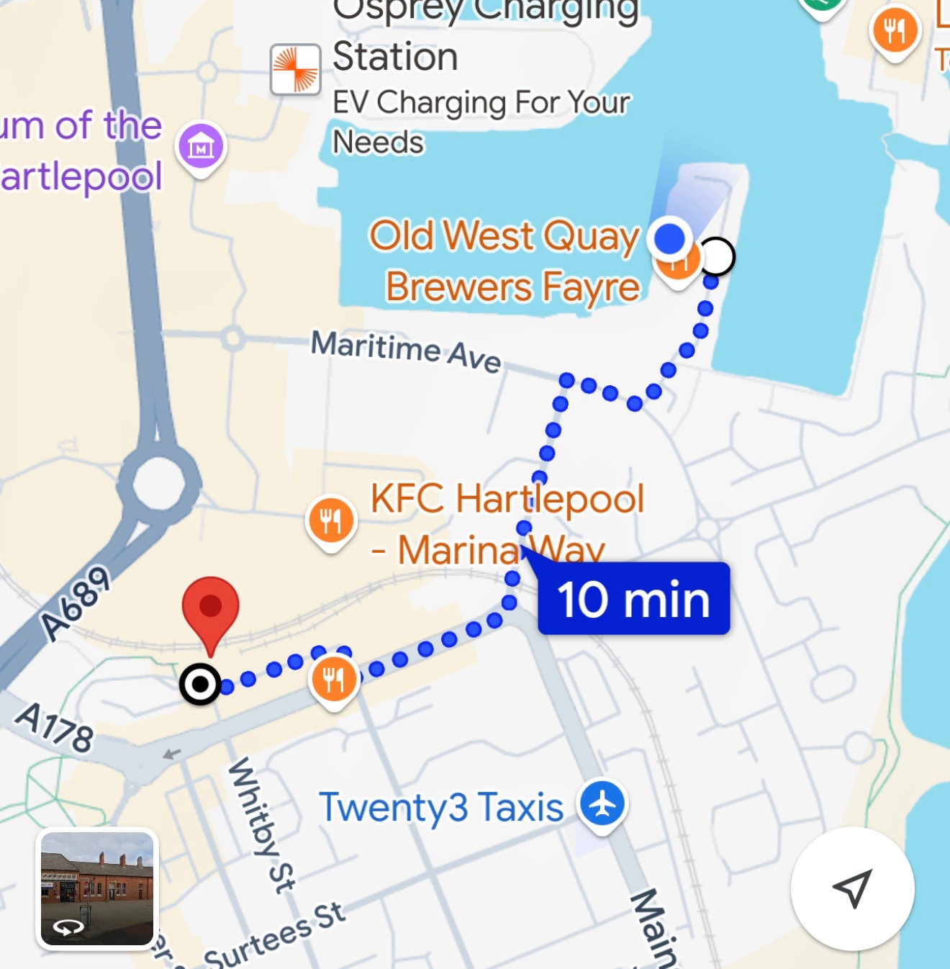
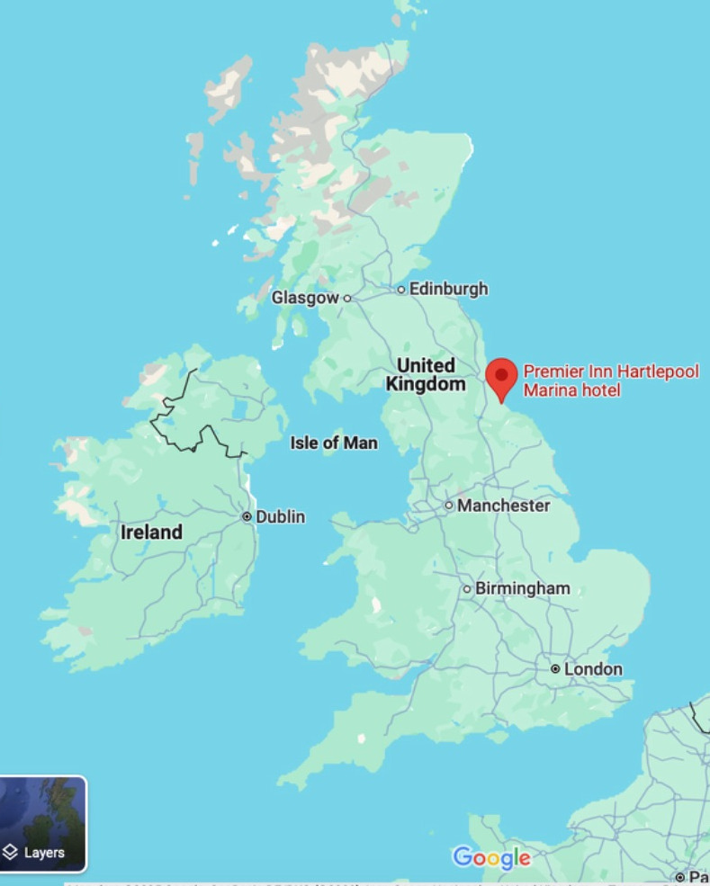

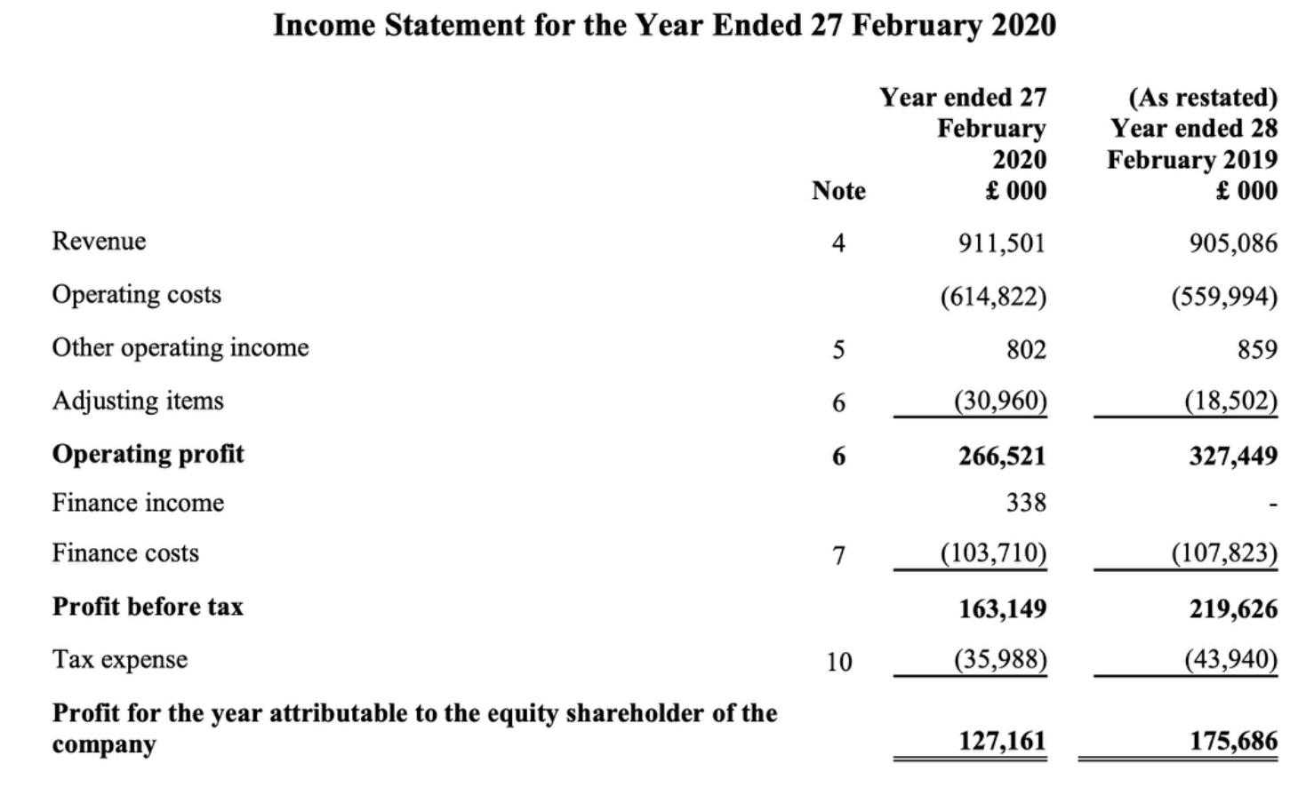
Figure 1 (Google Maps, 2025) Figure 2 (Google Maps, 2025)
Premier Inn Hartlepool Marina is one of over 800 Premier Inn hotels (Premier Inn, 2025) owned and operated by Whitbread alongside companies Beefeater, Brewers Fayre and Table Table and numerous more. As this is a large chain there are numerous levels of management and employees where each hotel has a hotel Manager as well as reception management, food and beverage management and housekeeping managers who are all overseen by the general manager, however the general manager reports to an area manager who operates four sites who also has management above them. This creates a very long chain of command where any orders or requests from senior management take time to filter down to employees and employees may feel less obliged to complete a task if they feel the request has came from high up without personalisation as its highly unlikely staff will ever meet senior management unlike small hotels who work alongside management and become friendly creating a more comfortable workplace. Staffing levels are high due to the size of the hotels, the Hartlepool site has 98 bedrooms with a very high REVPAR due to being in very high demand and being fully booked most weekday nights, reflecting the fact that this hotel is primarily used for business purposes. The Premier Inn in Hartlepool employs 12 receptionists, 14 housekeepers and 1 maintenance employee. This is alongside the food and beverage team operating within the Brewers Fayre attached to the hotel. In 2021 Whitbread announced their Annual Report and Financial Statements and announced a turnover of £911.5million with a profit of £127.2million. As demonstrated in figure 3.
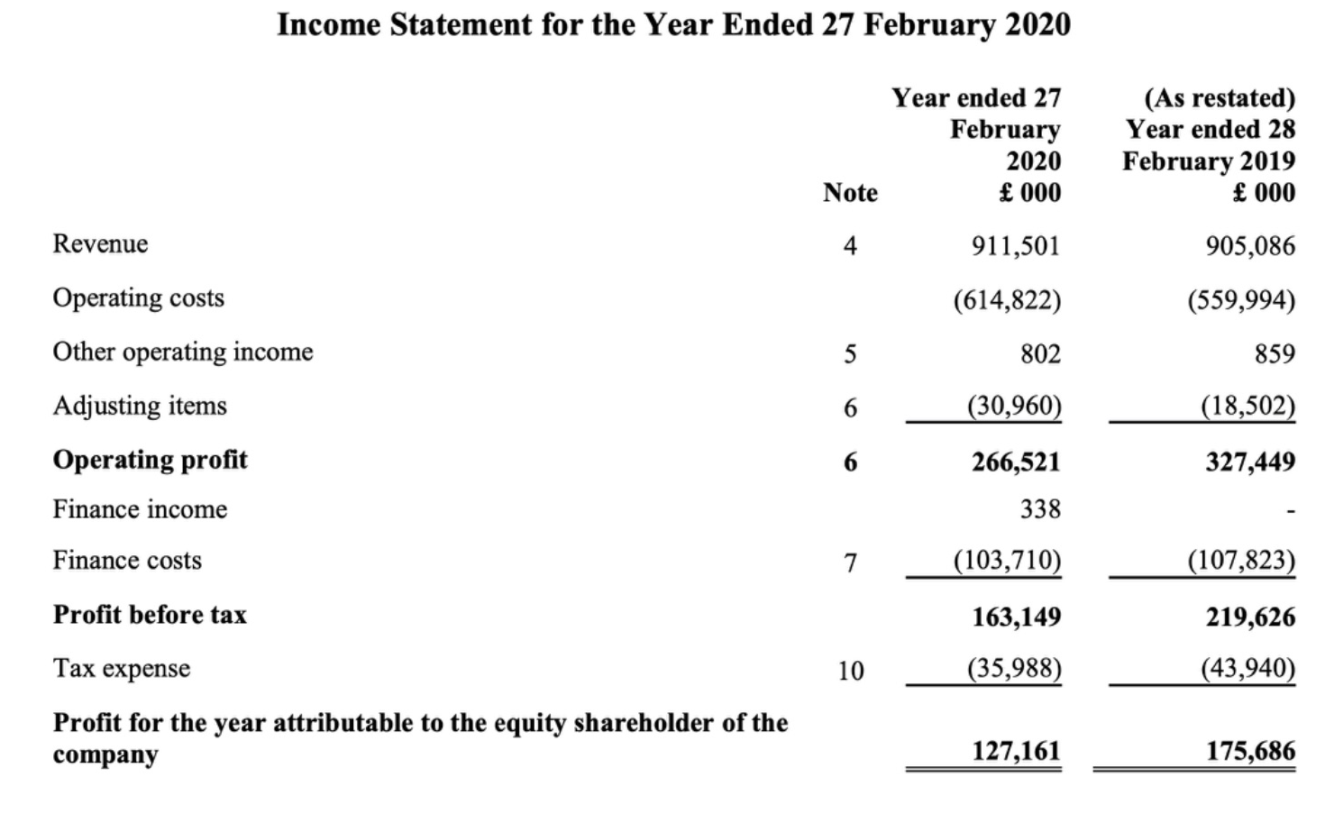
Figure 3 (Whitbread, 2021)

These financial details demonstrate the capital available to Whitbread in order to invest in sustainable practices, which is not available to small locally owned hotels, therefore Whitbread should pave the way in sustainability ensuring that they are operating mindfully as well as sustainably in order to remain competitive and appealing to guests including Generation-Z guests who have already been referred to as the future of sustainability generation.
SWOT Analysis

SWOT Analysis discusses and identifies the strengths, weaknesses, opportunities and threats (Leigh, 2009). There are many ways in which this is beneficial to the hotel and competitors as it allows progress and flags areas for improvement to work on which may not be picked up on prior to research of specific issues.

Strengths  - Premier Inn lead the way with sustainability through their Force For Good model promoting sustainable business and showing commitment to becoming Net Zero (Premier Inn, 2025)  - Premier Inn already have implemented fantastic sustainable practices including room servicing on request, saving water and chemicals as well as implementing renewable energy sources either through their supplier Scottish Power or solar panels with these being installed on 20% of the chains hotels (Premier Inn, 2021) | Weaknesses  - With the huge funding options available to Whitbread it is disappointing that only 20% of hotels utilise solar energy. Although there is a high cost of installation the positive impacts for the environment and future financial savings should outweigh this.  - Lack of consistency between locations, due to management being different, certain protocols may not be followed and are difficult to track and trace. (Osum, 2024)
Opportunities  - Gen-Z travellers are more likely to partake in sustainable activities and support sustainable businesses therefore advertising towards these as sustainable can increase bookings and reputation of the chain. (Prayag, 2022)  - Sustainability benefits the local community in prolonging the environment and creating a nicer atmosphere for the local residents, this can lead to excellent reputations with the local community and reputation of the brand if marketed and communicated well. (Astawa, 2022)  - Loyalty scheme relating to sustainability can bring guests on board where they are rewarded for fewer room cleans or less energy usage ect, this saving money on expense and increasing sustainability | Threats  - Due to the increasingly high costs of operating a hotel implementing sustainable practices and equipment may fall in priority and therefore sustainable conscious consumers may book elsewhere  - Competitor hotels can overtake Premier Inn on sustainability therefore become more desirable for guests who look to stay at sustainable verified hotels  - High cost of investment on sustainable practices may be compromised if legislation changes where a huge investment may be required in order to remain compliant with up to date laws.

PESTLE Analysis

PESTLE Analysis is a framework used specifically in research and presentation to display the factors, internally and externally directly relating to the subject matter. (CIPD, 2024)

Political- It is the law in numerous parts of the world that hotels are made to follow guidance to introduce sustainability. Within the UK The Environment Act (2021) was created with the vision of protecting the environment (Legislation.gov.uk, 2021). This also relates to financial help made available by the government where in specific areas can be grants for sustainable investments including installation of solar panels or energy efficient lightbulbs etc. The UK government announced that “Around £5 billion of funding has been announced to support UK businesses in becoming greener as part of the government’s commitment to achieve net zero emissions by 2050” (Gov.uk, 2021). This can be utilised by Whitbread to invest in increasing their number of energy self-sufficient hotels beyond the 20% already converted (Whitbread, 2025).

Economic- With Whitbread being a vast hotel chain around the entirety of the UK and Germany also the United Arab Emirates, this means that they have an increased availability of funding available to invest into sustainable practices including energy saving light bulbs, key-card powered electrics and renewable energy sources such as solar panels plus room servicing on request to decrease use of water and chemicals (Premier Inn, 2025). All of which Premier Inn have installed as a part of their Force For Good campaign and sustainable operations within the hospitality industry which have of course had an economic effect on the company as implementing these measures will have cost a substantial amount of money however the return on investment should be high due to cost saving on room servicing where housekeeping hours can be reduced as well as reduced laundry costs in comparison to daily cleaning. Furthermore, the financial benefit of a hotel having solar panels is fantastic due to reduced usage of grid power saving large amounts of money which over the years pays for the investment two, five or ten times depending on usage.

Sociological- Sociological refers to people and their attitude towards sustainability. If a guest is focused on being more sustainable then they will likely pay more for a hotel which is sustainable certified. PWC (2024) reported that “guests are willing to pay 9.7% more for sustainable certified services”, such as hotels like the Premier Inn. People showing willingness to pay more only solidifies my argument that consumers are changing to become more sustainable. This means that hotels must follow trends and guest expectations to remain competitive in a highly saturated and competitive market. As discussed earlier Gen-Z travellers are being branded as the future generation of sustainability (Iderdrola, 2024) where they believe in sustainability being a priority therefore marketing towards these as a target audience can prove highly profitable. (Forbes, 2021). Customer attitude is another major contributor to sustainability, older generations may be reluctant to change due to receiving a certain level of service for years and this becomes an expectation, relating to room servicing, however guests who believe sustainability is the future and the now then the hotel must try to cater for both groups by creating a ‘middle ground’ to appeal to all guests.

Technological- Technological is arguably one of the most important factors in sustainability and hospitality as without it a vast majority of sustainable practices wouldn't be possible, all the way from key-card powered electric to solar panels which all wouldn't be possible without implementation of technology. Premier Inn operates online systems such as Bedroom Genie (Premier Inn, 2025) which gives reception staff and housekeeping management the ability to record housekeeping jobs to ensure that quality of service remains high while also operating sustainability by ensuring and tracking that laundry such as shower curtains and bedroom curtains are washed when needed and not before. Alongside this, technology can be a huge investment for any hotel with varying sizes however for Premier Inn specifically it is essential that technology is a priority investment to ensure operations run smoothly. Innovation in Business (2024) reported that there are technologies including automated lighting, climate control, and occupancy sensors available to the hotel sector to implement sustainability.

Legal- As discussed above there are numerous laws and regulations in place by the UK government as well as COP Summits which Whitbread must follow in order to be both compliant and to do their part in being sustainable. In 2021, the Environment Act became law meaning all businesses must comply with the strict environmental laws set out to avoid penalty. The Environment Act was created with the target to “improve air and water quality, reduce waste, increase levels of recycling, halt the decline of species, and improve our natural environment.” (Gov.uk 2021). Alongside this, more previously the Waste Regulations 2011 promotes sustainability and resource efficiency. This requires hotels to separate and recycle waste wherever possible, reducing the amount that ends up in landfills (Waste Managed, 2011).

Environmental- World Sustainable Hospitality Alliance (2022) reported that “hotel operations consume up to 8x more water than local communities in some areas” this shows the huge impact the hospitality sector has on the local community therefore implementing sustainable practices must be of high importance to show a commitment to becoming more sustainable. Due to the hospitality sector's size within the UK we use a vast level of resources such as gas, electric and water and creating food waste. Hills Waste (2019) reported that the hospitality sector contributed 12% of the UK’s total food waste showing the size of the issue within hospitality where the sector must work together to reduce waste and usage in order to become more sustainable. The sector also contributes to 15% of greenhouse gasses in the UK meaning that if the entire sector can work together to decrease this then the UK’s total greenhouse gasses will decrease dramatically. (British Business Bank, 2025) This can be through the implementation of many of the energy saving devices discussed above as well as the installation of solar panels and wind turbines.
Directly relating to Premier Inn Hartlepool Marina where I was on placement I observed numerous sustainable practices being utilised specifically solar panels as well as room servicing on demand to name a couple. However one of the limitations I observed was the amount of one-night stays that was a lot therefore there were an increased amount of room servicing where many of the facilities had not been used such as spare pillows or towels however due to company policy they are changed whereas there could be a simple resolution to this where rooms are only set up due to arriving guests such as if there is only one single traveller which is a majority from my observations within the time at Premier inn, therefore there should only be one set of towels and a maximum of two pillows in order to save unessential laundry.

Discussion

As already discussed Generation-Z travellers are viewed as the Sustainable Generation, GoodMakerTales(2021) found that “64% of 18-22 year olds consider it important for their employers to act sustainably”, this including hospitality businesses where not only do guests want their employer to be certified sustainable but also when enjoying social time in hotels or F&B they also look for places where they are sustainably certified. Ensuring that a hospitality business is sustainable increases the value of a hotel towards Gen-Z guests and therefore improves brand reputation through word of mouth reviews with family and friends and should increase bookings and REVPAR as a result of this in comparison to a non sustainable hotel. With the placement hotel, Premier Inn, they advertise massively their sustainability tactics with their Force For Good scheme as well as numerous signs and posters throughout the hotel and rooms explaining their sustainable practices. Premier Inn is a well known brand suitable for all ages therefore Gen-Z guests can be a huge market for Premier Inn where younger guests are more prone to contributing to the economy than Gen-X. A study from Howarth (2024) found that “Generation Z’s global purchasing power equates to 450 billion dollars” demonstrating the huge influence Gen-Z guests have on the market, it could be due to reduced commitments and expenditure compared to Gen-X with mortgages and dependents. Further to this it was found that “64% of Generation Z are willing to pay extra to buy from companies they feel loyal towards”, this opens a huge opportunity for Premier Inn to introduce a loyalty scheme, if they can capture Gen-Z as loyal customers they will benefit from a huge increase in sales thus leading to increased profits in the long run. Alongside this introducing a loyalty scheme will not only benefit Generation-Z but in broader terms Forbes (2022) stated that “customers who are members of a loyalty program are 62% more likely to spend more on the brand”, this implementation of a loyalty scheme can have a huge benefit on the brand loyalty and therefore sales as well as guest satisfaction. As a result of ever changing technology and trends it has been found that “74% of Gen Z prefer shopping on phones over other devices” therefore implementing a booking system into a loyalty app can further increase bookings and likeliness of brand loyalty. From all of this research it can be interpreted that Generation-Z travellers show a willing to spend more money impulsively as long as brands match expectations in relation to brand image and sustainability. Also the implementation of technology in booking and operations is essential as well as loyalty programmes in order to appeal to the Generation Z guests to create increased brand loyalty and therefore increased sales leading to increased profits overall for the brand. However there are of course limitations to marketing towards Gen-Z travellers, Forbes 2021 stated that the “Gen- Z demographic have more than $140 billion in spending power”, who can completely change the hotel industry and the way it operates, this has made hotels adapt in order to cater for the upcoming generation however while doing so they may have forgotten about Generation X and Boomers, these are also a huge market which must also be catered to sufficiently. Often older generations are stereotypically expecting increased respect from younger generations which can lead to upset where they feel they are mistreated with a level of service opposed to the expectations. It's essential for hotels to determine a middle-ground where the majority of guests can be appealed to without compromising the expectations of others.

Moving on to Premier Inn with their Force For Good model. As discussed earlier Premier Inn with Whitbread introduced numerous policies under the model of Force For Good, these are commitments from the brand for all hotels to follow in order to align with sustainability targets. Premier Inn Hartlepool offers numerous sustainable practices including the use of renewable energy with solar panels and also other energy saving options such as water usage reducers, energy saving light bulbs and keycard activated electrics. These sustainable practices are demonstrated to guests where applicable with in-room advertisement as well as signage and information available both in reception and online. As Premier Inn have implemented these changes in order to become sustainable as a business it has increased their reputation and also appeal to the brand due to showing commitment to the future of hospitality with improved procedures which extend the life of the community in which they operate. Due to the implementation of this, guests can feel a sense of pride from staying in a hotel which is operating sustainably and allow guests to move towards a carbon free lifestyle which many people are striving for. Of course there are limitations to becoming sustainable where there are always going to be skeptical people who don't believe in sustainability and are stuck in their ways of how things should be done especially when it affects service, this especially relates to room servicing which many guests would expect daily as a standard service of hotels therefore not providing this can create a negative view for potential guests. This may be a small minority of guests however the opinion of all guests must be considered therefore it’s important for options to be available which is exactly what Premier Inn offer, upon guest check in at the placement hotel we were to explain to guests that rooms will not automatically be serviced however you can request a clean the evening before at reception, this allows guests to decide themselves and if people opt out of servicing the choice is theirs, this allows Premier Inn to remain an expected level of service while opting for sustainability.

Fei, Kim and Kim (2024) demonstrated that Generation Z “consumers appreciate sustainability as well as affordable accommodation. In order to target Gen-Z and gain a competitive edge, hotels should perform socially responsible practices. The process of implementing a thorough CSR plan sets the path for sustainable development which should lead to enhancing long-term financial performance of hotel companies.” This further solidifies previous research suggesting that in order to be financially successful in the long run then hotels, in this case Premier Inn, should specifically target and advertise towards Gen-Z travellers in order to increase bookings and profitability. As suggested its important to remain competitively priced within the market which Premier Inn are well known for but by advertising their sustainable practices alongside this it can be highly lucrative for Whitbread. Again, while they state this there are however limitations, with Gen-Z been such a technological generation there are huge costs to advertising to these demographics, TV adverts on BBC at 7pm are unlikely to reach the correct audience however a rolling TikTok advert or instagram Reel may prove much more efficient in advertising to 18-25 year olds. The other limitation I have found is that while placed within the Premier Inn Hartlepool Marina I noticed the demographic of people to be a majority of Gen-X who are predominantly business travellers, this could very well be different in large cities such as London or Manchester however for town hotels especially i think it's important to treat guests how they deserve to be treat as opposed to marketing for a new demographic. In cities the Gen-Z marketing may be perfect however I believe that the marketing needs to be very carefully targeted to specific areas and people and interests to ensure there is no unnecessary expenditure without return.

Generation Z is well known for their strong beliefs, values and opinions especially related to sustainability and environmental issues. (World Economic Forum, 2022). In relation to hotels it is essential for chains to ensure they exceed the needs and expectations of Generation-Z travellers to avoid losing the entire demographic to competitor hotels. Alongside this while being sustainably aware Gen-Z are also highly price conscious (Forbes, 2022) this means that while focusing on sustainability the hotel must offer a middle ground compromise between sustainability and remaining competitively priced as expected with Premier Inn. One main influence when relating to Generation-Z is the Social Media influence, apps like TikTok and Instagram are much more likely to influence Gen-Z guests when advertising Premier inn with sustainable activities than traditional advertising methods like postal or radio adverts, this is where it's essential that in order to attract the right customers they must advertise through the correct channels. (Emarketer, 2024). Gen Z Guests also show a demand for authenticity meaning that in order to advertise efficiently then the hotels must appropriately advertise truthfully to avoid a negative reputation and especially being accused of ‘greenwashing’ which is the practice of making brands appear more sustainable than they really are. (Akepa, 2025). This can have a detrimental impact on guest booking rates as if a hotel is found to be greenwashing they will be deemed untrustworthy and ultimately guests will be annoyed , especially Gen-Z, about being lied to and attracted under false information.

Furthermore, Market differentiation is a huge factor where within a competitive market sustainability provides a major selling point or USP. where hotels successfully communicate with guests about their Sustainability efforts which can differentiate themselves from competitors in an already saturated market. With Gen-Z travellers posing a huge opportunity of bookings due to being eco-conscious guests it's a great USP to advertise market differentiation with comparisons of what Premier Inn offers compared to other major chains.

Overall, Sustainability affects hotels, specifically Premier inn by influencing operations, guest expectations, laws and regulations and financially. It is essential in this day and age for hotels to embrace sustainability in order to remain compliant and competitive. Specifically for Gen-Z guests sustainable practice is crucial in remaining competitive and appealing to a wider range of guests.

Conclusion

During my placement and research completed it has come to my attention that in the interest of remaining competitive within the market hotels are expected to follow trends and appeal to guest expectations based on sustainability. Sustainability has become one of the sector's most significant barriers due to increasing legislations in place including the Environment Act 2021 and the Waste management laws which are in place to ensure that all hotels and hospitality businesses operate sustainably within the community. There are numerous PESTLE factors which I researched and discussed including Generation-Z guests typically opting for sustainable stays as well as the Economic and fiscal factors with the huge costs associated with sustainability and the implementation of it. Overall I have found that Premier Inn Hartlepool do operate sustainably and lead the way in the industry however there are threats and opportunities to be aware of and prepare for and work on these in order to be the best they can be.

With Premier Inn, they are a huge chain with over 800 hotels across the UK this offers great opportunities for Premier Inn to operate to the maximum of their capacity and gain a larger market share through a few simple changes in order to improve their sustainability. Due to their market size they have great potential and can lead the way in the market forcing other chains like Travelodge and Holiday Inn to improve their sustainability to a similar level to remain competitive, this can only be good for the hospitality trade as they increase brand reputation and awareness and people feel more confident that they are making a difference. With models such as triple bottom line there is potential for Premier Inn to combine sustainability with meeting the expectations of guests and its stakeholders, this method works in a way that it can please everyone as much as possible.

Recommendations

Mellissen (2018) stated that actual sustainability performance of most companies, and the industry as whole, is still rather disappointing. I must agree on this, where as well as the hospitality industry are trying to implement change there is still major work to carry out over the coming years. One example being within F&B where i noticed the constant use and waste of single use sauce sachets, it is such a small aspect however if every one of Premier Inn’s 800+ hotels made the change to recyclable bottles not only would it be cost saving in the long run as opposed to buying hundreds of thousands of single use plastic sachets but it would make a huge impact of waste, of which hospitality create a huge amount of waste, Business Waste Management (2025) explained that “A 200-room hotel uses around 300,000 bits of single-use plastic every month”, highlighting the drastic need for change. This change should be a simple change and only require a short term plan, contacting companies such as Heinz and Hellmans to create a contract based on reusable bottles as opposed to sachets will decrease waste as well as decreasing costs.

Furthermore I would advise towards the implementation of sustainable practices with the installation of solar panels across its remaining 80% of hotels, while this is a huge financial commitment, the long term benefit of doing so will be far greater. Even setting a time scale such as one site per month to receive installation, this is SMART as it is a specific, measurable as you can track each installation as well as achievable, there are many firms nationwide who install solar panels therefore this allows the goals to be realistic and timely. One site per month may only be a drop in the ocean for the remaining 600+ hotels however every install is one step closer to a sustainable and greener future for Premier Inn and Whitbread. While costs are exceptionally high involving installation of solar panels there may be government initiatives available such as “Around 5 billion pounds of funding made available to support UK businesses become greener as part of the government’s commitment to reach net zero emissions by 2050” (Gov.uk, 2021) demonstrating a fantastic commitment from the UK government into the support towards the hotel sector in being more sustainable, while also reducing the impact which the huge implementation costs have.

There are many SDG’s (Sustainable Development Goals) which are created by the UN (United Nations) during the COP summit where 198 parties from across the world vote in order to implement new laws and targets based on sustainability, climate change and other pressing social matters, these compose 17 goals with 169 targets (SDGG, 2025). It is essential for Premier Inn to ensure these are followed and targets are met and the hotel sector must work closely to ensure they are protecting the environment in which they operate as well as remaining lawful within operations. Following these guidelines does not only allow Premier Inn to remain lawful but will also improve reputation as a hotel who follows regulations and even exceeds them will gain positive publicity promoting the brand as a sustainable hotel chain working towards a greener future.

Finally, I would ensure that the Gen-Z demographic are one of the main targets within advertising and attraction. Due to their social and ecological beliefs, pushing sustainability can prove highly lucrative and beneficial both financially and with the reputation of the brand. One of the most successful methods in creating and retaining loyalty are loyalty schemes. Creating a loyalty system where guests can earn rewards for participating in green activities such as declining room servicing or using renewable electricity at certain times etc. this may take a lot of work to implement however in the long run it can prove very popular especially for gen-z guests who are typically more careful with their spending habits.

References

Astawa, I.K., Widhari, C.I.S., Budarma, I.K. and Mudana, I.G., 2022, March. Green hotel promotion strategy in Bali: a study using SWOT analysis. In International Conference on Applied Science and Technology on Social Science 2021 (iCAST-SS 2021) (pp. 460-466). Atlantis Press.

Akepa (2025) Greenwashing. Available at: https://thesustainableagency.com/blog/greenwashing-examples/#:~:text=Greenwashing%20is%20the%20practice%20of,use%20unsustainable%20ingredients%20or%20practices. (Accessed: 5 March 2025)

BBC (2025) Advantages and Disadvantages of Secondary Research. Available at: https://www.bbc.co.uk/bitesize/guides/z6y9rj6/revision/4 (Accessed: 25 February 2025)

BBC (2025) Advantages and Disadvantages of Primary Research. Available at: https://www.bbc.co.uk/bitesize/guides/z6y9rj6/revision/3 (Accessed: 25 February 2025)

Bianco, S., Bernard, S. and Singal, M., 2023. The impact of sustainability certifications on performance and competitive action in hotels. International Journal of Hospitality Management, 108, p.103379.

British Business Bank (2025) Greenhouse Gasses Caused by the Hospitality sector in the UK. Available at: https://www.hills-waste.co.uk/news/managing-waste-costs-for-the-hospitality-sector (Accessed: 25 February 2025)

Business Waste (2025) Hospitality Waste. Available at: https://www.businesswaste.co.uk/sectors/hotel-waste-management/hotel-waste-statistics/ (Accessed: 27 February 2025)

Bruns-Smith, A., Choy, V., Chong, H. and Verma, R., 2015. Environmental sustainability in the hospitality industry: Best practices, guest participation, and customer satisfaction.

Brand, B.M., Rausch, T.M. and Brandel, J., 2022. The importance of sustainability aspects when purchasing online: comparing generation X and generation Z. Sustainability, 14(9), p.5689.

Bujan, I. and Kecek, D., 2019. The application of Triple Bottom Line concept in tourism with the emphasis on the hotel industry. Economic and Social Development: Book of Proceedings, pp.322-329.

Chen, R.J., 2015. From sustainability to customer loyalty: A case of full service hotels’ guests. Journal of Retailing and Consumer Services, 22, pp.261-265.

CIPD (2024) Pestle Analysis. Available at: https://www.cipd.org/uk/knowledge/factsheets/pestle-analysis-factsheet/ (Accessed: 25 February 2025)

Cozzio, C., 2019. The Concept of Sustainability in Hotel Industry: Current dominant orientations and future issues. International Journal of Sustainable Development, 22(1-2), pp.61-87.

Dani, R., Tiwari, K. and Negi, P., 2021. Ecological approach towards sustainability in hotel industry. Materials Today: Proceedings, 46, pp.10439-10442.

Duric, Z. and Potočnik Topler, J., 2021. The role of performance and environmental sustainability indicators in hotel competitiveness. Sustainability, 13(12), p.6574.

Dragolea, L.L., Butnaru, G.I., Kot, S., Zamfir, C.G., Nuţă, A.C., Nuţă, F.M., Cristea, D.S. and Ştefănică, M., 2023. Determining factors in shaping the sustainable behavior of the generation Z consumer. Frontiers in Environmental Science, 11, p.1096183.

Dovetail (2023) Netnography. Available at: https://dovetail.com/research/netnography/ (Accessed: 8 March 2025)

EMarketer (2024) Generation Z Marketing. Available at: https://www.emarketer.com/learningcenter/guides/generation-z-facts/#:~:text=Gen%20Zers%20are%20known%20for,from%20ICSC%20and%20Big%20Village. (Accessed: 5 March 2025)

Exploding Topics (2024) Stats on Gen Z Spending and Buying Habits. Available at: https://explodingtopics.com/blog/gen-z-spending (Accessed: 4 March 2025)

First Insight (2025) Gen-Z demanding Sustainability. Available at: https://www.firstinsight.com/white-papers-posts/gen-z-shoppers-demand-sustainability (Accessed: 5 March 2025)

Forbes (2021) How Hotels can connect with Gen-Z Travellers. Available at: https://www.forbes.com/councils/forbesbusinesscouncil/2021/08/10/how-the-hotel-industry-can-connect-with-gen-z-in-the-new-normal/ (Accessed: 4 March 2025)

Forbes (2022) Loyalty Programs Benefits. Available at: https://www.forbes.com/councils/forbestechcouncil/2022/11/18/loyalty-programs-what-works-and-what-doesnt/ (Accessed: 4 March 2025)

Forbes (2022) Gen-Z Price Consciousness. Available at: https://www.forbes.com/sites/gregpetro/2022/03/05/gen-z-is-driving-growth-in-new-shopping-formats-but-are-retailers-paying-attention/ (Accessed: 5 March 2025)

Forbes (2023) Gen-Z Changing the Hotel Industry. Available at: https://www.forbes.com/councils/forbesagencycouncil/2023/11/30/how-is-gen-z-reshaping-hospitality-and-travel/ (Accessed: 5 March 2025)

Google Maps (2025) Premier Inn Hartlepool to Train Station. Available at: https://www.google.com/maps (Accessed: 25 February 2025)

Google Maps (2025) Premier Inn Hartlepool marina Location. Available at: https://www.google.com/maps (Accessed: 25 February 2025)

Gov.uk (2021) Funding available towards sustainable practices. Available at: https://www.gov.uk/guidance/find-funding-to-help-your-business-become-greener (Accessed: 25 February 2025)

Gov.uk (2021) Environment Act 2021. Available at: https://www.gov.uk/government/news/world-leading-environment-act-becomes-law (Accessed: 25 February 2025)

Good Maker Tales (2021) Gen-Z Travelers with Sustainability. Available at: https://goodmakertales.com/does-gen-z-care-about-sustainability/#:~:text=Gen%20Z%20shows%20an%20increased,their%20employers%20to%20act%20sustainably. (Accessed: 4 March 2025)

Harvard Business School (2018) Sustainability Definition. Available at: https://online.hbs.edu/blog/post/what-is-sustainability-in-business (Accessed: 25 February 2025)

Hills Waste (2019) Food waste in the hospitality sector. Available at: https://www.hills-waste.co.uk/news/managing-waste-costs-for-the-hospitality-sector (Accessed: 25 February 2025)

Houdré, H., 2008. Sustainable development in the hotel industry.

Houdré, H., 2008. Sustainable development in the hotel industry.

Hotel Tech Report (2024) Sustainability Findings. Available at: https://hoteltechreport.com/news/hotel-sustainability-statistics (Accessed: 25 February 2025)

Iderdrola (2024) Generation X and Generation Z. Available at: https://www.iberdrola.com/talent/generation-x-y-z (Accessed: 25 February 2025)

Innovation In Business (2024) Enhancing Sustainability. Available at: https://www.innovationinbusiness.com/four-ways-innovative-technology-can-boost-sustainability-in-the-hospitality-sector/#:~:text=Enhancing%20Sustainability,using%20energy%20when%20absolutely%20necessary. (Accessed: 25 February 2025)

Jones, P., Hillier, D. and Comfort, D., 2014. Sustainability in the global hotel industry. International Journal of Contemporary Hospitality Management, 26(1), pp.5-17.

Kim, Y.H., Barber, N. and Kim, D.K., 2019. Sustainability research in the hotel industry: Past, present, and future. Journal of Hospitality Marketing & Management, 28(5), pp.576-620.

Kamenidou, I., Mamalis, S., Bara, E.Z., Mylona, I. and Pavlidis, S., 2022, April. Segmenting the Generation Z Cohort Based on Evaluation of Hotel’s Environmental Policy. In Transcending Borders in Tourism Through Innovation and Cultural Heritage: 8th International Conference, IACuDiT, Hydra, Greece, 2021 (pp. 119-132). Cham: Springer International Publishing.

Kara, A. and Min, M.K., 2024. Gen Z consumers’ sustainable consumption behaviors: influencers and moderators. International Journal of Sustainability in Higher Education, 25(1), pp.124-142.

Khatter, A., McGrath, M., Pyke, J., White, L. and Lockstone-Binney, L., 2019. Analysis of hotels’ environmentally sustainable policies and practices: Sustainability and corporate social responsibility in hospitality and tourism. International Journal of Contemporary Hospitality Management, 31(6), pp.2394-2410.

Khatter, A., White, L., Pyke, J. and McGrath, M., 2021. Barriers and drivers of environmental sustainability: Australian hotels. International Journal of Contemporary Hospitality Management, 33(5), pp.1830-1849.

Kuhlman, T. and Farrington, J., 2010. What is sustainability?. Sustainability, 2(11), pp.3436-3448.

Leigh, D., 2009. SWOT analysis. Handbook of Improving Performance in the Workplace: Volumes 1‐3, pp.115-140.

Legislation.gov (2021) Environment Act. Available at: https://www.legislation.gov.uk/ukpga/2021/30/contents (Accessed: 25 February 2025)

Mucharreira, P.R., Antunes, M.G., Abranja, N., Justino, M.R.T. and Quirós, J.T., 2019. The relevance of tourism in financial sustainability of hotels. European Research on Management and Business Economics, 25(3), pp.165-174.

O’Malley, L., 1998. Can loyalty schemes really build loyalty?. Marketing intelligence & planning, 16(1), pp.47-55.

Osum (2024) Weaknesses of Premier Inn In Sustainability. Available at: https://blog.osum.com/premier-inn-weaknesses/ (Accessed: 25 February 2025)

Ozturkoglu, Y., Sari, F.O. and Saygili, E., 2021. A new holistic conceptual framework for sustainability oriented hospitality innovation with triple bottom line perspective. Journal of Hospitality and Tourism Technology, 12(1), pp.39-57.

Oxford languages (2025) Generation-Z Definition. Available at: https://languages.oup.com/google-dictionary-en/ (Accessed: 8 March 2025)

Prayag, G., Aquino, R.S., Hall, C.M., Chen, N. and Fieger, P., 2022. Is Gen Z really that different? Environmental attitudes, travel behaviours and sustainability practices of international tourists to Canterbury, New Zealand. Journal of Sustainable Tourism, pp.1-22.

Pryce, A., 2001. Sustainability in the hotel industry.

Premier Inn (2025) About Us. Available at: https://www.premierinn.com/gb/en/home.html?cid=KNC_Brn_G_UK_UK_Eng_PureBrand_null_null&mckv=s_dc%7Cpcrid%7C691666593832%7Ckword%7Cpremier%20inn%7Cmatch%7Ce%7Cplid%7C%7Cpgrid%7C134309012578%7Cptaid%7Caud-2194326126220:kwd-33595692%7C&s_kwcid=AL!9693!3!691666593832!e!!g!!premier%20inn!16130455905!134309012578&ef_id=Cj0KCQiA8fW9BhC8ARIsACwHqYqBxBXRlVcwb3_NqnJSSXpq5q26PE2_jtSv-wUrQMArbWAcBPIMBNUaAoXBEALw_wcB:G:s&gad_source=1&gclid=Cj0KCQiA8fW9BhC8ARIsACwHqYqBxBXRlVcwb3_NqnJSSXpq5q26PE2_jtSv-wUrQMArbWAcBPIMBNUaAoXBEALw_wcB (Accessed 21 February 2025)

Premier Inn (2025) Force For Good. Available at: https://www.premierinn.com/gb/en/why/force-for-good.html (Accessed: 25 February 2025)

Premier Inn (2021) Solar panel Installation on Hotels. Available at: https://www.premierinn.com/gb/en/news/2021/net-zero-carbon-emissions.html
(Accessed: 25 February 2025)

Premier Inn (2019) Removal of Single Use Plastics. Available at: ​​https://www.premierinn.com/gb/en/news/2019/plastics.html (Accessed: 27 February 2025)

Premier Inn (2024) ESG Report 2022-23. Available at: https://cdn.whitbread.co.uk/media/2023/05/Whitbread_ESG_Report_FY22_23-1.pdf (Accessed: 6 February 2025)

PMC (2011) The case study method. Available at: https://pmc.ncbi.nlm.nih.gov/articles/PMC3141799/ (Accessed: 8 March 2025)

PWC (2024) Consumers Willingness To Pay more for sustainable goods and services. Available at: https://www.pwc.com/gx/en/news-room/press-releases/2024/pwc-2024-voice-of-consumer-survey.html (Accessed: 25 February 2025)

Rue, P., 2018. Make way, millennials, here comes Gen Z. About Campus, 23(3), pp.5-12.

Rasheed, A.F. and Balakrishnan, J., 2023. Going green and staying loyal: how different are generation Z travellers towards green brand loyalty of hotels. Tourism Review.

Sakshi, Shashi, Cerchione, R. and Bansal, H., 2020. Measuring the impact of sustainability policy and practices in tourism and hospitality industry. Business Strategy and the Environment, 29(3), pp.1109-1126.

Sarwari, D.S., 2024. The Role of Sustainable Management Practices and Social Media in Shaping Generation Z's Preferences for Environment-Friendly Hotels. Journal of Hospitality and Tourism Management, 7(2), pp.10-53819.

Saul, L. and Heo, C.Y., 2023. Generation Z tourists' perception of hotels' green practices. In Gen Z, Tourism, and Sustainable Consumption (pp. 103-115). Routledge.

Science Direct (2024) Gen Z and Sustainability. Available at: https://www.sciencedirect.com/science/article/abs/pii/S0278431923002529 (Accessed: 5 March 2025)

Seyfi, S., Hall, C.M. and Strzelecka, M. eds., 2023. Gen Z, tourism, and sustainable consumption: The most sustainable generation ever?. Taylor & Francis.

Sustainable Development Goals (2025) SDG. Available at: https://sdgs.un.org/goals (Accessed: 27 February 2025)

Thomas, G., 2022. Corporate social responsibility as a sustainable business practice: a study among generation Z customers of Indian luxury hotels. Sustainability, 14(24), p.16813.

United Nations (2025) UN Climate Summit. Available at: https://www.un.org/en/climatechange/un-climate-conferences (Accessed: 26 February 2025)

United Nations Climate Change (2024) COP Summit. Available at: https://unfccc.int/cop29 (Accessed: 26 February 2025)

United Nations (2025) Greenwashing. Available at: https://www.un.org/en/climatechange/science/climate-issues/greenwashing (Accessed: 5 March 2025)

Wang, T.C., Cheng, J.S., Shih, H.Y., Tsai, C.L., Tang, T.W., Tseng, M.L. and Yao, Y.S., 2019. Environmental sustainability on tourist hotels’ image development. Sustainability, 11(8), p.2378.

Walters, P., 2021. Are generation Z ethical consumers?. In Generation Z Marketing and Management in Tourism and Hospitality: The Future of the Industry (pp. 303-325). Cham: Springer International Publishing.

Waste Managed (2011) Hotel waste laws. Available at: https://www.wastemanaged.co.uk/our-news/hotel/hotel-waste-laws-and-regulations-in-the-uk/#:~:text=of%20your%20waste.-,Waste%20(England%20%26%20Wales)%20Regulations%202011,that%20ends%20up%20in%20landfills. (Accessed: 25 February 2025)

Whitbread (2021) Financial Report. Available at: https://cdn.whitbread.co.uk/media/2021/02/12122648/pihl-accounts-final-signed.pdf (Accessed: 25 February 2025)

World Sustainable Hospitality Alliance (2022). Available at: https://sustainablehospitalityalliance.org/how-environmental-is-your-hotel/ (Accessed: 25 February 2025)

World Economic Forum (2022) Gen Z Strong Beliefs. Available at: https://www.weforum.org/stories/2022/03/generation-z-sustainability-lifestyle-buying-decisions/ (Accessed: 5 March 2025)

Yang, Z., Nguyen, T.T.H., Nguyen, H.N., Nguyen, T.T.N. and Cao, T.T., 2020. Greenwashing behaviours: Causes, taxonomy and consequences based on a systematic literature review. Journal of business economics and management, 21(5), pp.1486-1507.

Zhang, J.J., Joglekar, N. and Verma, R., 2010. Developing measures for environmental sustainability in hotels: An exploratory study.

