
AcAdemic and professional Development – ACCA4039
Video Presentation

Sam Lewis (2501827)
BA computer games design

Contents
Self-Evaluation 2
Personal Development Plan 4
Reflection 5
Video Presentation 6

Self-Evaluation
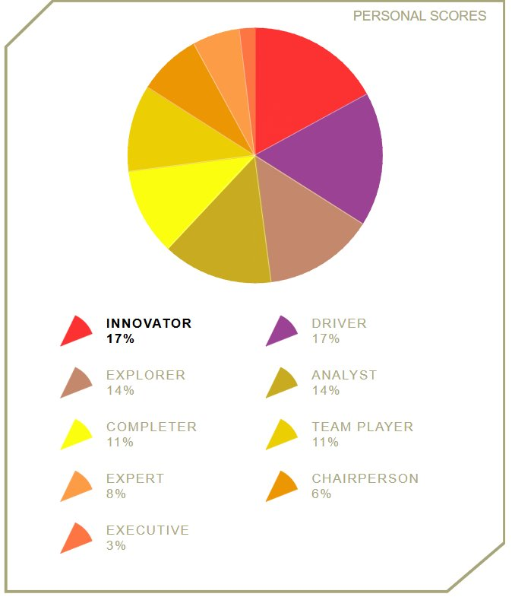
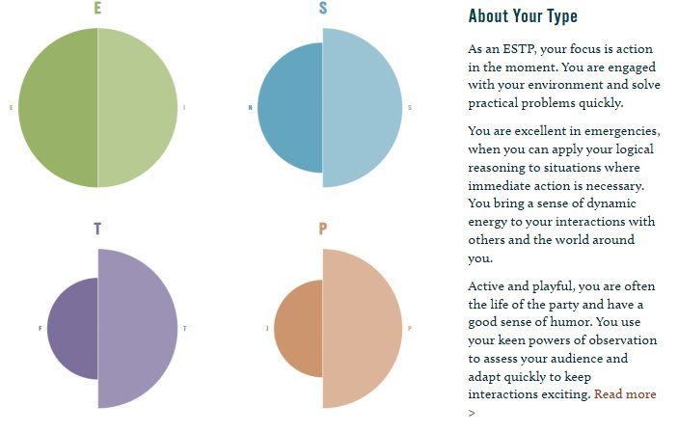

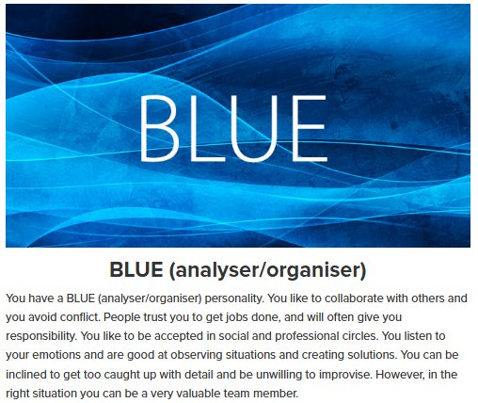

Personal Development Plan

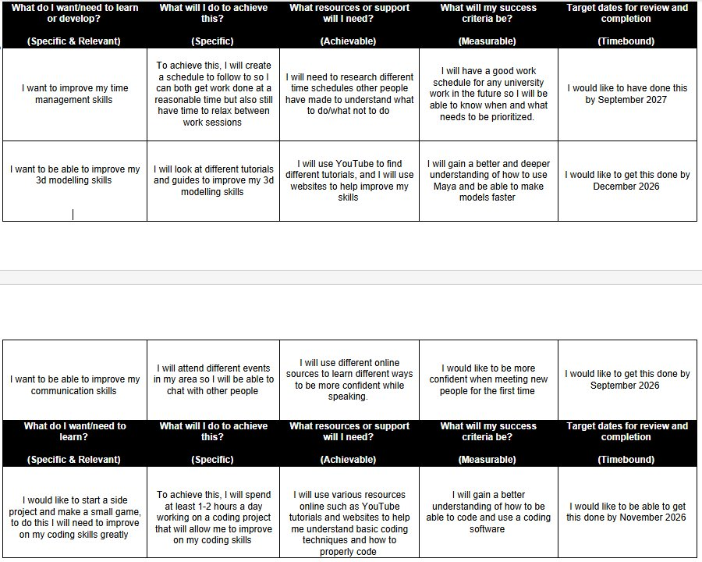

Reflection

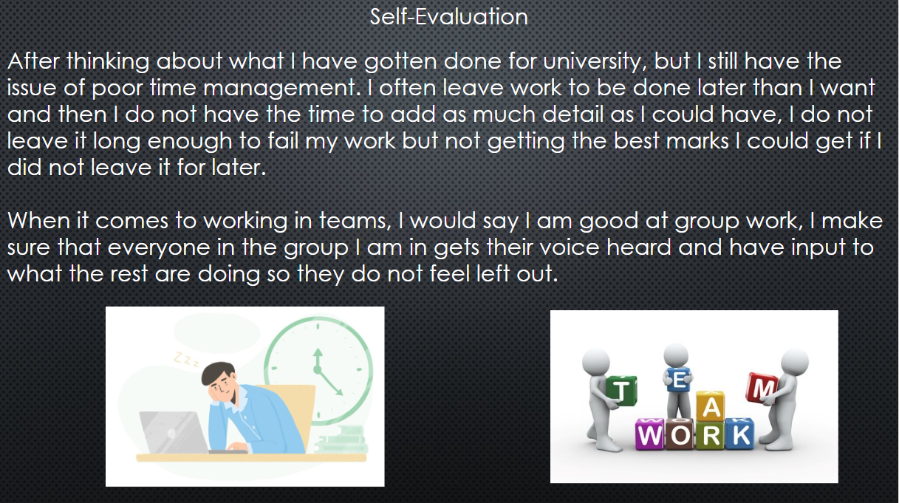

Video Presentation
https://youtu.be/_kAqYnooBjI?si=wiarFVrWpEKb3rpw

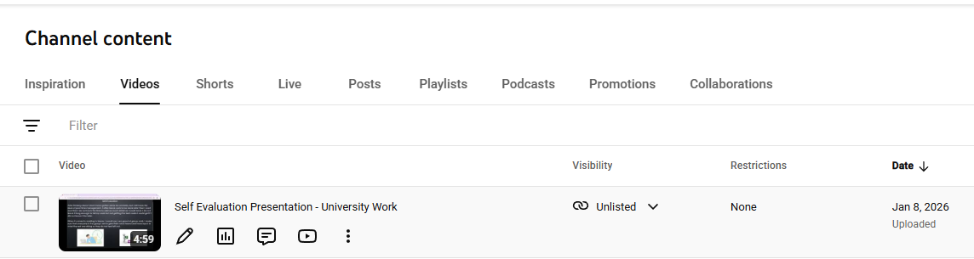

Self Evaluation Powerpoint.pptx

