QUESTION 1

- Determine the reduced state diagram for the state diagram given below.
[8 Marks]
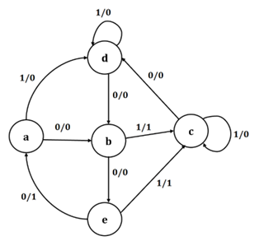
SOLUTIONS

State Table for given state diagram

Present State | Next State , Output | Next State , Output
Present State | (X=0) | (X=1)
a | b , 0 | d , 0
b | e , 0 | c , 1
c | d , 0 | c , 0
d | b , 0 | d , 0
e | a , 1 | c , 1

[2Marks]

Reduced State Table
Present State | Next State , Output | Next State , Output
Present State | (X=0) | (X=1)
a | b , 0 | a , 0
b | e , 0 | c , 1
c | a , 0 | c , 0
e | a , 1 | c , 1
[2 Marks]
Reduced State Diagram
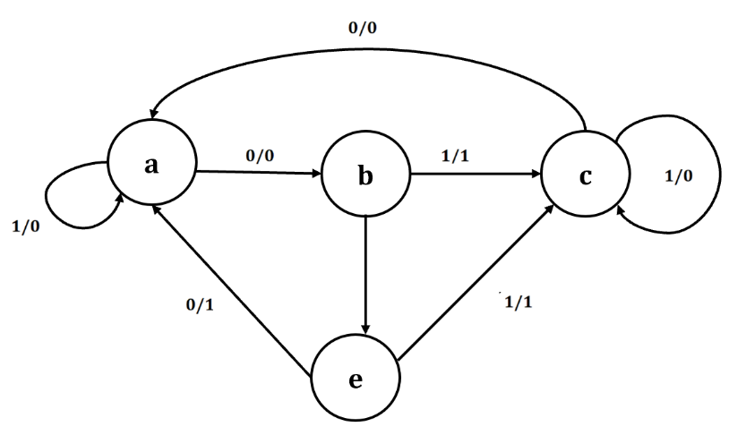
[4 Marks]
- For the Obtained reduced state diagram
  - Show its state Assignment. [2 Marks]
  - Obtain the State Table. [3 Marks]
  - Obtain Excitation Table using any Flip- flop. [4 Marks]
  - Output Expressions [3 Marks]
  - Logic Circuit [5 Marks]
SOLUTION
- Show its state Assignment.
a ---> 00
b ---> 01
c ---> 10
e ---> 11 [2 Marks]
- Obtain the State Table.
Present State | Input | Next state | Output
A B | X | A B | Y
0 0 | 0 | 0 1 | 0
0 0 | 1 | 0 0 | 0
0 1 | 0 | 1 1 | 0
0 1 | 1 | 1 0 | 1
1 0 | 0 | 0 0 | 0
1 0 | 1 | 1 0 | 0
1 1 | 0 | 0 0 | 1
[3 Marks]
- Obtain Excitation Table using any Flip- flop.
Present State | Input | Next state | Output | D- Flip flops
A B | X | A B | Y | D1 D2
0 0 | 0 | 0 1 | 0 | 0 1
0 0 | 1 | 0 0 | 0 | 0 0
0 1 | 0 | 1 1 | 0 | 1 1
0 1 | 1 | 1 0 | 1 | 1 0
1 0 | 0 | 0 0 | 0 | 0 0
1 0 | 1 | 1 0 | 0 | 1 0
1 1 | 0 | 0 0 | 1 | 0 0

[ 4 Marks]
- Output Expressions
Output Expressions from K Map
$$D_{1}=\overline{A}B+AX$$
$$D_{2}=\overline{A}.\overline{X}$$
$Y=AB+BX$ [3 Marks]
- Logic Circuit
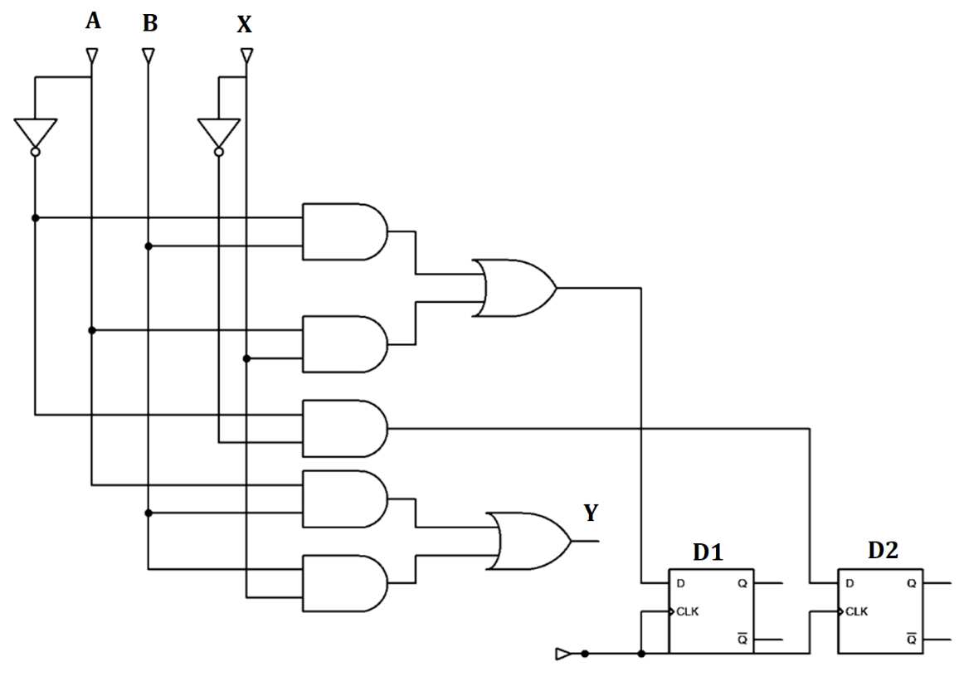
[5 Marks]

QUESTION 2
- Design a 3- bit Johnson Counter using D- Flipflop for a Synchronous sequential circuit. This counter will be used to monitor operational stages in a digital control system-based appliance. Your Solution Should include the following.
- State Diagram to illustrate state transitions. [5 Marks]
- State transition table [4 Marks]
- Excitation Table for determining input requirements. [5 Marks]
- Simplified K-Map Expressions for logic minimization. [6 Marks]
- Logic Diagram to represent the final gate-level design. [5 Marks]
- State Diagram to illustrate state transitions. [4 Marks]
SOLUTION
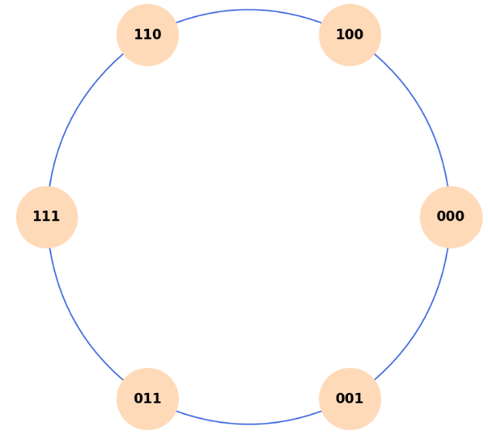
[5 Marks]
- State transition table [4 Marks]
SOLUTION
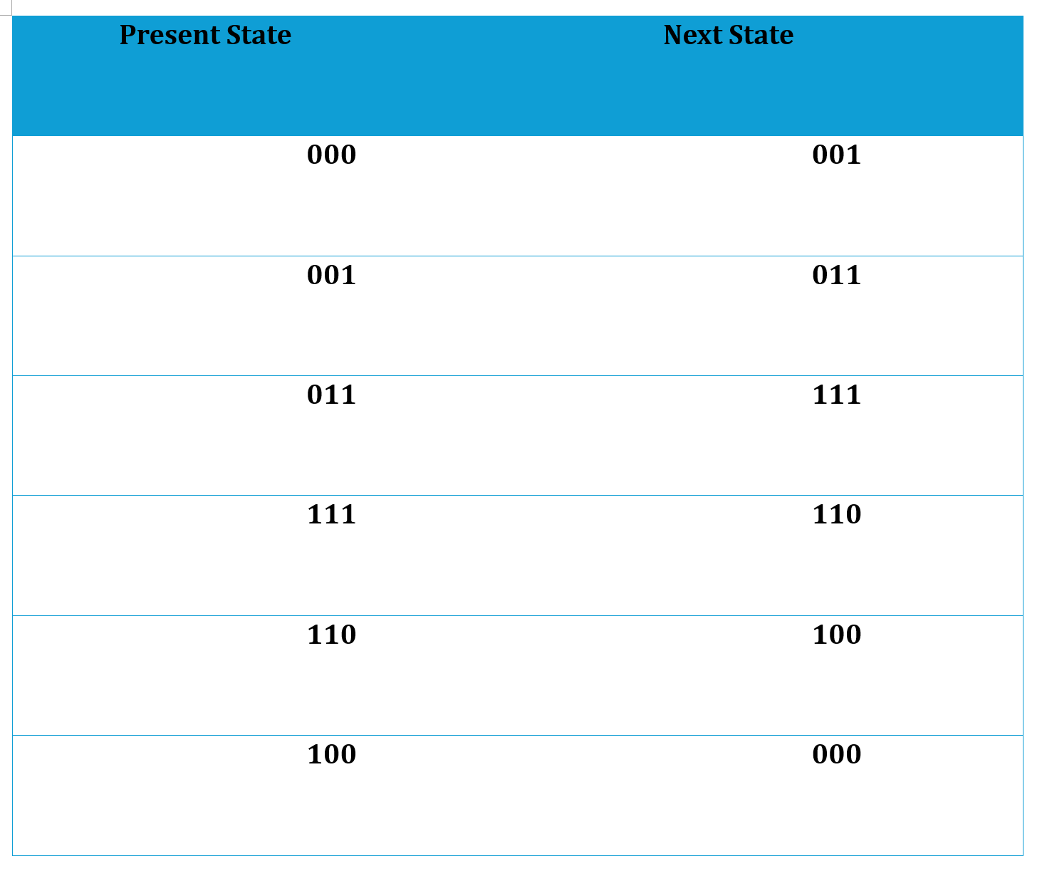
[5 Marks]
- Excitation Table for determining input requirements. [5 Marks]
SOLUTION
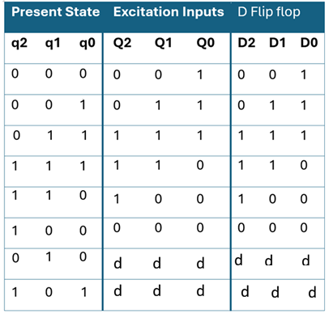
[5 Marks]

- Simplified K-Map Expressions for logic minimization. [6 Marks]
SOLUTION
${D }_{0}= {q̅}_{2}$ [2 Marks]
$D₁ = q_{0}$ [2 Marks]
$D_{2} = q₁$ [2 Marks]
- Logic Diagram to represent the final gate-level design. [4 Marks]
SOLUTION
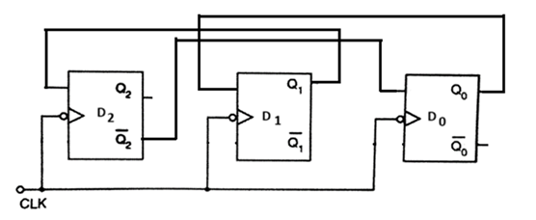
Correct Gates / Flipflops [2 Marks]
Right Connections [1 Mark]
Clock [1 Mark]

QUESTION 3
- For a 3- input LUT of an FPGA Logic block and determine the bits to be stored in its storage cell by using the function $f= \overline{A}\overline{B}\overline{C}+\overline{A}B\overline{C}+A\overline{B}\overline{C}+ABC$ to realize by answering the following
  - Truth Table [3 Marks]
  - With the help of the above truth table, design a 3- input LUT. [8 Marks]
  - Also, explain its operation in detail by assuming the values of inputs to be 001. [9 Marks]
- Program FPGA for the functions $f= f_{1}$+ $f_{2}$ by considering ${ f}_{1}= x_{2}x_{3} andf_{2}= {\overline{x}}_{1}x_{3}$ [5 Marks]

- For a 3- input LUT of an FPGA Logic block and determine the bits to be stored in its storage cell by using the function $f= \overline{A}\overline{B}\overline{C}+\overline{A}B\overline{C}+A\overline{B}\overline{C}+ABC$ to realize by answering the following
  - Truth Table [3 Marks]
  - With the help of the above truth table, design a 3- input LUT. [8 Marks]
  - Also, explain its operation in detail by assuming the values of inputs to be 001. [9 Marks]
SOLUTIONS
- Truth Table
SOLUTION

A | B | C | f
0 | 0 | 0 | 1
0 | 0 | 1 | 0
0 | 1 | 0 | 1
0 | 1 | 1 | 0
1 | 0 | 0 | 1
1 | 0 | 1 | 0
1 | 1 | 0 | 0
1 | 1 | 1 | 1
[3 Marks]
- 3- input LUT
SOLUTION
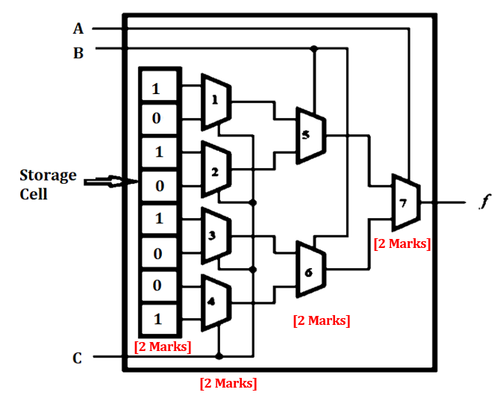
- For the input 001
SOLUTION
- An FPGA Look Up Table is the combination of flipflops (storage cells) and series of Muxs (Multipliers ) interconnected.
- Each cell is capable of holding a single logic value, either 0 or 1. The stored value is produced as the output of the storage cell.
- A three-variable truth table has 8 rows, this LUT has 8 storage cells.
- One cell corresponds to the output value in each row of the truth table.
- The input variables A, B and C are used as the select inputs of three stages of multiplexers, which, depending on the value of A, B and C [3 Marks]
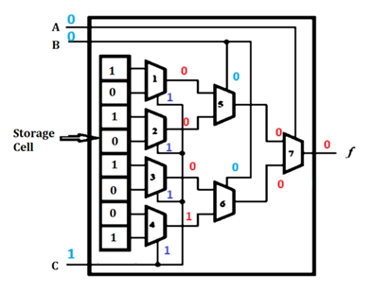
[2 Marks for the logic values , can be included in the previous diagram]

Operation
- When C is given 1, the select inputs for the mux ranging from 1 to 4 will be 1. If the Mux has the select inputs to be 1, the bottom storage level will be the output of the mux.
- When B=0, the select inputs for the mux ranging from 5 and 6 is logic 0.
- When C= 0, the select inputs for the mux from 7 is also logic 0.
- Hence the upper inputs of the previous mux will be the present mux output. Providing access to the contents of storage cells and the output of f will be 0. [4 Marks]
- Program FPGA for the functions $f= f_{1}$+ $f_{2}$ by considering ${ f}_{1}= x_{1}x_{2} andf_{2}= {\overline{x}}_{2}x_{3}$
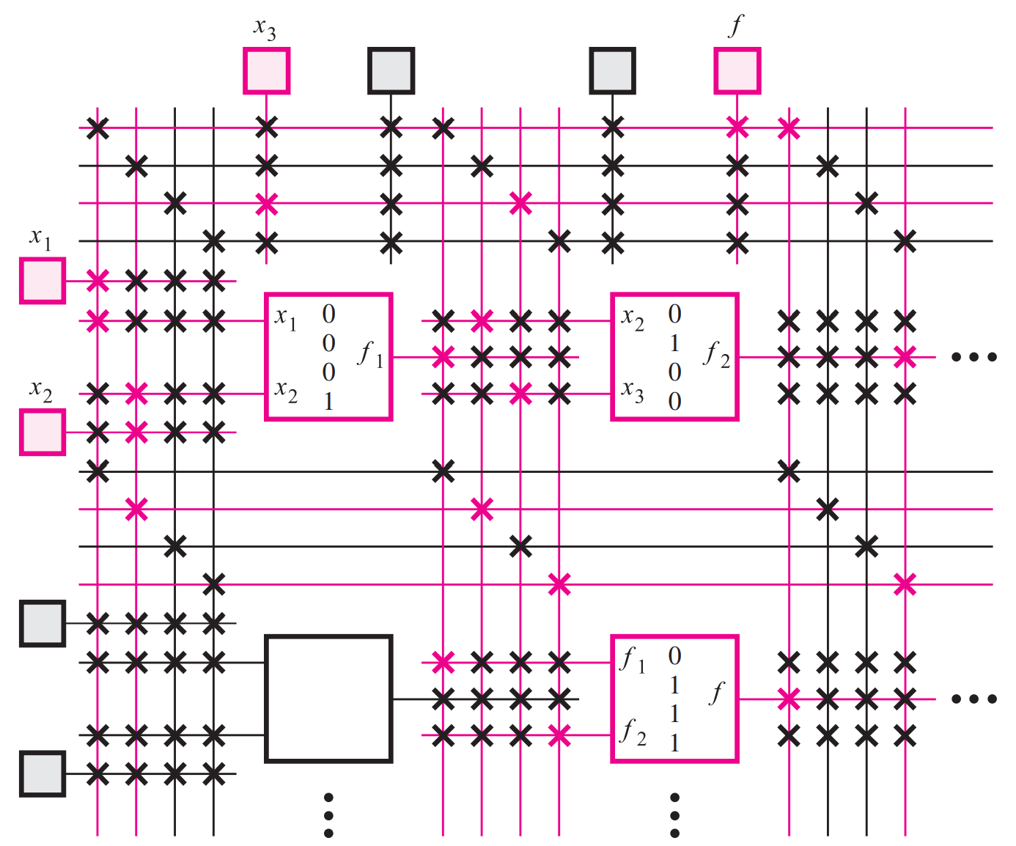
Structure [2 Marks]
Proper values [2 Marks]
Variables [1 Mark]

QUESTION 4

- For the functions the $w\text{ (A, B, C)=}∑_{m}\text{ (4,5,6,7)}$ and $z\text{ (A, B, C)=}∑_{m}\text{ (1, 2, 3)}$.
Answer the following.
  - Illustrate the implementation of functions 𝑤 and 𝑧 using a single decoder.
[6 Marks]
  - Present the truth tables and the fundamental Boolean expressions for both $w$ and$z$. [5 Marks]
  - Derive and show the simplified Boolean logic expressions for $w$ and$z$.
[4 Marks]
  - Design $w$ and$z$ using Programmable Logic Array (PLA). [10 Marks]

SOLUTIONS
- Illustrate the implementation of functions 𝑤 and 𝑧 using a single decoder.

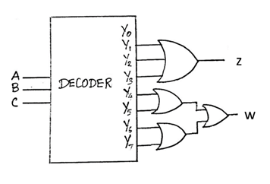 [6 Marks]
- Present the truth tables and the fundamental Boolean expressions for both $w$ and$z$.
$$A$$ | $$B$$ | $$C$$ | $$w$$ | $$z$$
0 | 0 | 0 | 0 | 0
0 | 0 | 1 | 0 | 1
0 | 1 | 0 | 0 | 1
0 | 1 | 1 | 0 | 1
1 | 0 | 0 | 1 | 0
1 | 0 | 1 | 1 | 0
1 | 1 | 0 | 1 | 0
1 | 1 | 1 | 1 | 0
[3 Marks]
Logic Expressions
$w=A\overline{B}\overline{C}+A\overline{B}C+$AB$\overline{C}+ABC$ [1 Mark]
$z=\overline{A}\overline{B}C+\overline{A}B\overline{C}+\overline{A}BC$ [1 Mark]

- Derive and show the simplified Boolean logic expressions for $w$ and$z$.

For w

$w=A\overline{B}\overline{C}+A\overline{B}C+$AB$\overline{C}+ABC$
$w=A\overline{B}\overline{C}+A\overline{B}C+$AB$(\overline{C}+C)$
$w=A\overline{B}\overline{C}+A\overline{B}C+$AB
$w=A\overline{B}\overline{(C}+C)+$AB
$w=A\overline{B}+$AB
$w=A( \overline{B}+$B)
$w=A$ [2 Marks]

Fow z,
$z=\overline{A}\overline{B}C+\overline{A}B\overline{C}+\overline{A}BC$
$z=\overline{A}\overline{B}C+\overline{A}B(\overline{ C}+C)$
$z=\overline{A}\overline{B}C+\overline{A}B$
$z=\overline{A}(\overline{B}C+B)$
$z=\overline{A}(C+B)$
$z=\overline{A}C+\overline{A}B$ [2 Marks]

- Design $w$ and$z$ using Programmable Logic Array (PLA). [10 Marks]

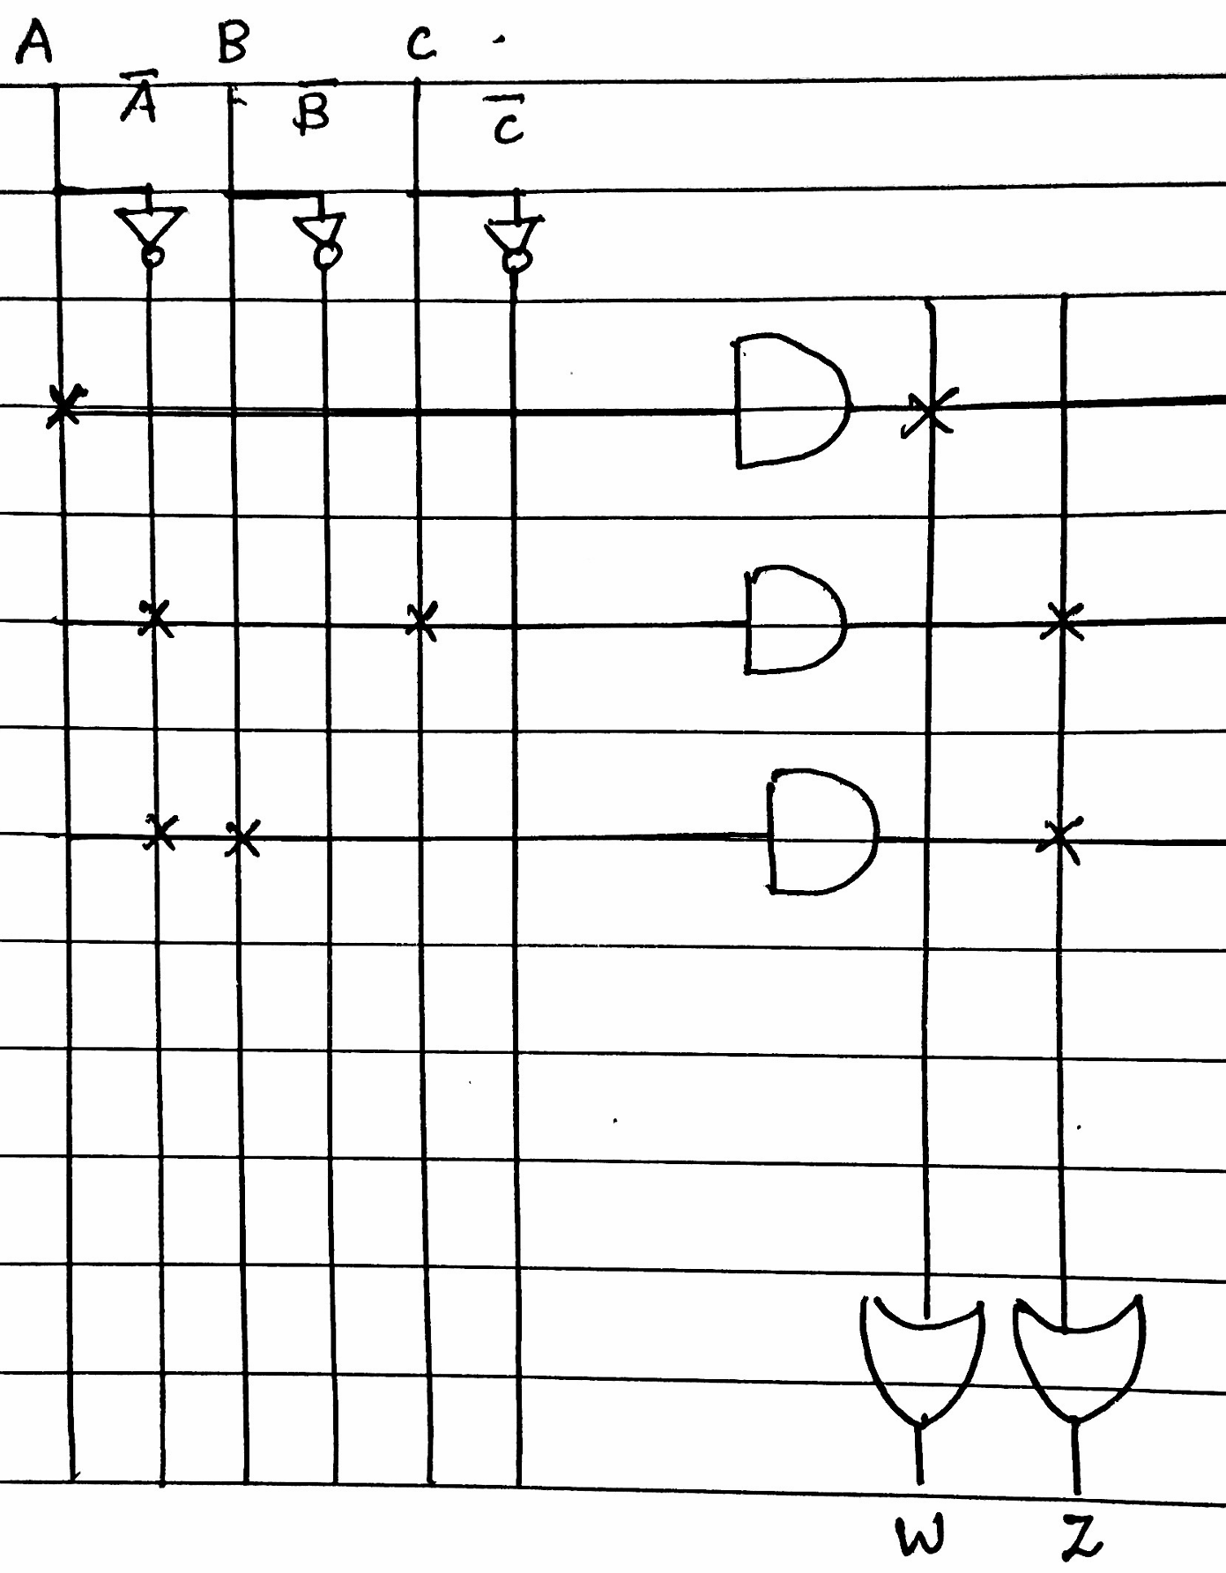
- Specifying the correct Inputs in the Diagram [1 Mark]
- Correct Mapping with AND Planes [3 Marks]
- Correct Mapping at the OR Plans [3 Marks]
- Correct output Variable [1 Mark]
- Diagram Clarity [2 Marks]

Diwedd/End

